在wifi局域网下，手机可以和电脑通过socket通信。手机做服务端，电脑做客户端；也可以反过来，电脑做服务端，手机做客户端。
下面介绍的是手机作为服务端，电脑使用MFC编程作为客户端，原理是，手机建立一个ServerSocket，并获取自己的ip地址和端口port；然后电脑通过socket连接手机的ip：port。
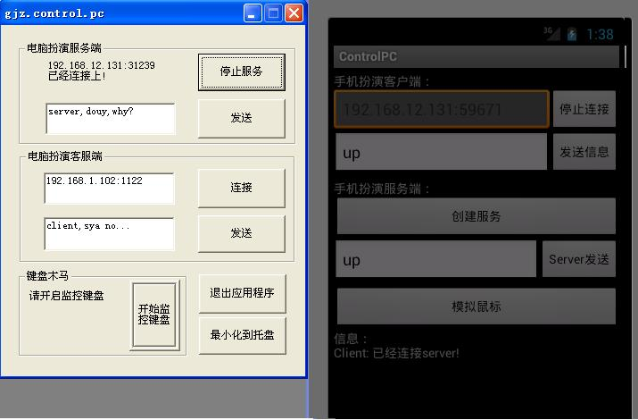
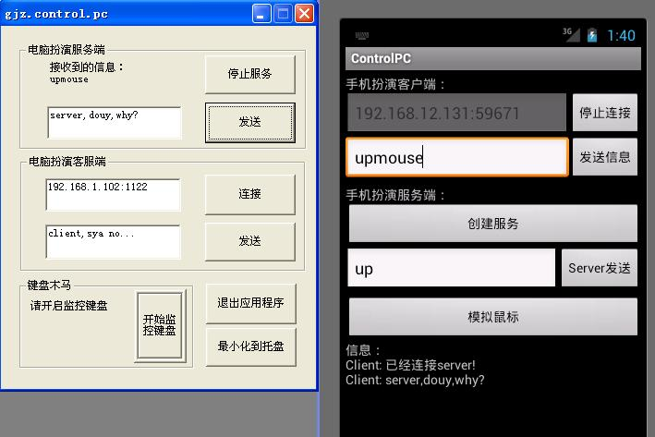
手机建立socketServer代码
- private ServerSocket serverSocket = null;
- private Runnable mcreateRunnable = new Runnable()
- {
- public void run()
- {
- try {
- serverSocket = new ServerSocket(0);//系统分配端口
- getLocalIpAddress();//获得手机的ip地址
- //方法用于等待客服连接
- mSocketServer = serverSocket.accept();
- //接受客服端数据BufferedReader对象
- mBufferedReaderServer = new BufferedReader(new InputStreamReader(mSocketServer.getInputStream()));
- //给客服端发送数据
- mPrintWriterServer = new PrintWriter(mSocketServer.getOutputStream(),true);

- } catch (IOException e) {
- // TODO Auto-generated catch block
- e.printStackTrace();
- }
- }
- };
复制代码
手机上获取的ip地址代码
- public String getLocalIpAddress()
- {
- try {
- for (Enumeration en=NetworkInterface.getNetworkInterfaces(); en.hasMoreElements();)
- {
- NetworkInterface intf = en.nextElement();
- for (Enumeration enumIpAddr=intf.getInetAddresses();enumIpAddr.hasMoreElements();)
- {
- InetAddress inetAddress = enumIpAddr.nextElement();
- //if (!inetAddress.isLoopbackAddress())
- {
- //if(inetAddress.isSiteLocalAddress())
- {
- String ip = "请连接IP："+inetAddress.getHostAddress()+":"
- + serverSocket.getLocalPort()+ "";
- }
- }
- }
- }
- }
- catch (SocketException ex) {
- ex.printStackTrace(); }
- }
复制代码
电脑上使用的是MFC编程，socket代码如下
- DWORD clientThreadID;
- SOCKET clientSock;
- char server_address[50] = {0};
- char recv_message_client[256] = {0};
- struct sockaddr_in server_ip;
- BOOL clientThreadRun = false;
- //client
- BOOL InItClientSock()
- {
- //Define Variable
- WORD wVersionrequested;
- WSADATA wsaData;

- wVersionrequested = MAKEWORD(2,0);

- //Start Sock
- int err = WSAStartup(wVersionrequested,&wsaData);
- if (err == -1)
- {
- MessageBox(0,"WSAStartup err", "error",MB_OK);
- return FALSE;
- }
- return TRUE;
- }
- BOOL ConnectSock()
- {
- SOCKET clientSockConnect;
- u_short port;

- //Ini Sock
- clientSock = socket(AF_INET,SOCK_STREAM,0);
- if (ServerSock < 0)
- {
- MessageBox(0,"scoker err",
- "err",MB_OK);
- return FALSE;
- }

- char *strPort = strstr(server_address, ":");

- if( (strPort!=NULL) && (strlen(strPort)>2) )
- {
- port = atoi(strPort+1);
- if(port==0)
- {
- MessageBox(0, "IP端口不对, 参考例子：192.168.12.134:8981", "提示", MB_OK);
- return FALSE;
- }
- memset(strPort, 0, sizeof(strPort));
- }
- else
- {
- MessageBox(0, "IP地址不对, 参考例子：192.168.12.134:8981", "提示", MB_OK);
- return FALSE;
- }

- //Connect
- server_ip.sin_family = AF_INET;
- server_ip.sin_port = ((port&0xff00)>>8)|((port&0x00ff)<<8);
- server_ip.sin_addr.S_un.S_addr = inet_addr(server_address);

- clientSockConnect = connect(clientSock,(struct sockaddr*)&server_ip,sizeof(server_ip));
- if (clientSockConnect!=0)
- {
- CString temp;
- temp.Format("系统拒绝连接，可能是输入IP地址或端口不对：%s:%d", server_address, server_ip.sin_port);
- SetDlgItemText( FindWindow(NULL, WINDOWNHANDLERNAME), IDC_STATIC_IP, temp);
- MessageBox(0, "系统拒绝连接，可能是输入IP地址或端口不对 ", "提示", MB_OK);
- return FALSE;
- }
- return TRUE;
- }

- DWORD WINAPI clientThreadFunc(LPVOID threadNum)
- {
- int length;
- CString temp;

- if(!InItClientSock())
- return 0;
- if(!ConnectSock())
- return 0;

- //等待连接的时候，连接可能被取消。
- if(clientThreadRun)
- SetDlgItemText(FindWindow(NULL, WINDOWNHANDLERNAME), IDC_STATIC_IP, "已经连接上！");
- else
- {
- SetDlgItemText(FindWindow(NULL, WINDOWNHANDLERNAME), IDC_STATIC_IP, "请启动服务！");
- return 0;
- }

- //send(NewSock,(char*)&FALG,sizeof(FALG)+1,MSG_OOB);
- while(clientThreadRun)
- {
- if( (length = recv(clientSock,(char*)recv_message_client,sizeof(recv_message_client),0))>0)
- {
- //MessageBox(0, recv_message, "接收到的信息", MB_OK);
- temp.Format("接收到的信息：%s",recv_message_client);
- SetDlgItemText(FindWindow(NULL, WINDOWNHANDLERNAME), IDC_STATIC_IP, temp);

- analyseCommand(recv_message_client);
- memset(recv_message_client, 0, sizeof(recv_message_client));
- }
- temp.Format("接收到的信息：%s",recv_message_client);
- }

- return 0;
- }
复制代码

