Salary and career paths after the apprenticeship
Benjamin Madani, Automobilmechatroniker EFZ (from August 2026)
27 June 2026 · Zürich area · Gross figures incl. 13th salary · Estimates, not financial advice
This looks at three things: what a first job pays straight out of the apprenticeship, where the salary can get to within five years, and how the main career paths change the picture over five to ten years. Because Benjamin has been thinking about diagnostics, that route gets its own section. All numbers are gross, include the 13th salary, and are typical bands for the Zürich area; real pay varies with employer, brand and performance, so treat them as a guide rather than a promise.

1. The first job: what to expect
A freshly qualified Automobilmechatroniker EFZ in the Zürich area can expect roughly CHF 5'000 to 5'600 a month, which is about CHF 65'000 to 73'000 a year with the 13th salary. The Swiss median across all experience levels is around CHF 70'000, with a typical range of CHF 58'000 to 89'000. A first job sits at the lower-to-middle part of that band; experience is what moves it up.
- Two things push his first salary toward the top of the entry band: his HV/EV certification (still scarce) and a premium brand. Premium dealers such as Porsche pay roughly 5 to 15% more than independent workshops.
- The Zürich and Zug region sits about 5 to 8% above the Swiss average, mostly because living costs are higher.

2. Five years in, if he stays on the tools
Salaries in this trade rise fastest in the first five years after qualifying, typically by 20 to 30%. An experienced mechatroniker at a good brand in Zürich reaches roughly CHF 6'300 to 6'800 a month (about CHF 82'000 to 88'000 a year). Brand certifications, a Master Technician track, and deeper HV and assistance-system work are what lift him within that band without any further formal exam. Beyond that point, staying purely on the tools tends to flatten out, which is where the paths below come in.

3. Career paths at a glance
The Swiss system is built to let him climb in steps. The table compares the main routes. The diagnostics row, his current interest, is highlighted.
Path | What it is / how to qualify | Time & cost | Typical pay (now, then 5 to 10 yrs)
Mechatroniker, brand & HV specialist | Stay on the tools, add brand and HV/E-mobility certifications and a Master Technician track. | On the job; employer-funded courses. | CHF 6'000 to 6'800/mth now; ~CHF 7'000 long term.
Automobildiagnostiker (eidg. Fachausweis) | Berufsprüfung. The workshop's technical specialist; often paired with deputy workshop lead. Builds directly on the mechatroniker. | 2 to 3 yrs part-time; ~CHF 12'000 to 17'000 fees, 50% refunded by the Confederation. | Median ~CHF 6'000/mth (CHF 78'000/yr); ~CHF 7'000 to 8'000 as deputy lead.
Werkstattleiter / Werkstattkoordinator | Run the workshop and the team. Often reached via diagnostics plus a few years of experience; Werkstattkoordinator is a separate Fachausweis on the organisational side. | Experience + BP; a few years. | CHF 8'000 to 12'000/mth for an established manager.
Betriebsleiter / dipl. Betriebswirt (HFP) | Höhere Fachprüfung, eidg. Diplom. Runs a whole garage operation. Top of the trade ladder. | After BP; ~CHF 10'500 federal refund available. | ~CHF 10'000 to 14'000/mth at a larger operation (estimate).
Serviceberater / Kundendienstberater (eidg. FA) | Customer-facing service desk role; a parallel track if he enjoys the people side. | BP; 1 to 2 yrs part-time. | Comparable to an experienced mechatroniker, with bonus potential (estimate).
Engineering: dipl. Techniker HF / Bachelor FH | HF Fahrzeug-/Maschinentechnik (no Berufsmatura needed) or a Bachelor FH in Automobiltechnik (needs Berufsmatura). Opens roles at importers, makers, suppliers, R&D and motorsport engineering. | HF ~3 yrs part-time; FH 3 to 4 yrs (add BM2 first). | HF technician ~CHF 6'500/mth (CHF 85'000/yr); FH engineer ~CHF 7'000 to 8'500+ (estimate).
Motorsport mechanic (F1 / premium tuner) | Race-team or specialist tuner work. A different trajectory; the payoff is rare experience and a network, not early pay. | Direct entry from the apprenticeship. | Moderate at entry, heavy travel and overtime; opens premium and senior roles later.

4. The diagnostics route, in detail
Automobildiagnostiker mit eidg. Fachausweis is the natural next step from a mechatroniker, and it fits Benjamin well. It is the specialist who finds the hard faults, signs off complex repairs, advises customers and often stands in as deputy workshop lead. The median pay is about CHF 78'000 a year (~CHF 6'000 a month), and roles that combine it with deputy workshop lead pay more.

What it takes
- Admission: the Automobilmechatroniker EFZ plus two years of work experience. So he would start the course about two years into his first job.
- Prerequisites include the Berufsbildner course, a refrigerant licence, and the High-Voltage 1 and 2 certificates. He already holds HV certification, so part of this is done.
- Format: 2 to 3 years part-time, about one school day a week plus roughly five weeks of practical blocks. The exams (modules Z1 to Z4 and a final integrated exam) are held in Bern.
- Cost: roughly CHF 12'000 to 17'000 in course fees depending on the school. The Confederation refunds 50% of eligible fees after you sit the exam, up to CHF 9'500, and AGVS member firms or the industry fund can add up to about CHF 4'000. Net cost can come down to a few thousand francs.
- Timing: courses usually start around August, and several providers run it in the Zürich area. Registration for the federal exam runs months ahead, so it is worth planning early.
Where it leads: specialist, then deputy or full workshop lead, and it is the base for the Betriebswirt (HFP) if he later wants to run an operation. It is the highest-leverage, best-subsidised single step open to him.

5. How the paths play out over ten years
The chart shows illustrative monthly pay for four routes from his first day on the job. The lines are midpoints; real bands are wide, and a premium brand or the Zürich region shifts everything up by roughly 5 to 15%.
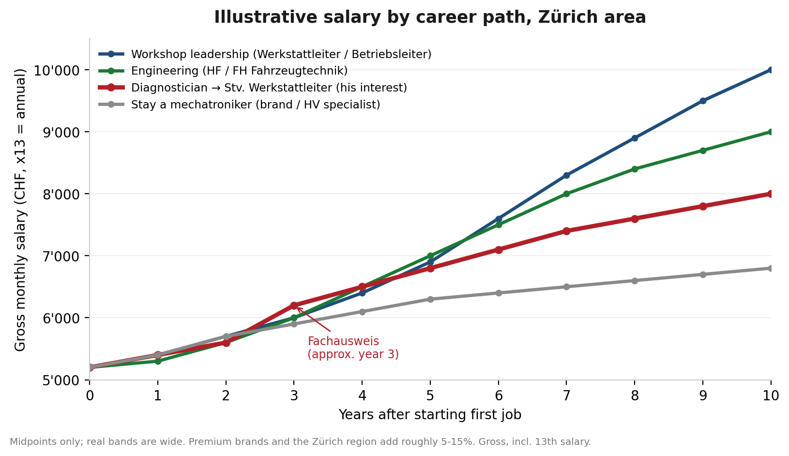
Reading it simply: staying purely on the tools is steady but flattens. Diagnostics lifts him onto a higher line within about three years and feeds straight into deputy workshop lead. Workshop and operations leadership has the highest ceiling but takes the longest and is a management job, not a hands-on one. Engineering tracks alongside leadership on pay and opens a different world (importers, makers, motorsport engineering), at the cost of more years of study and, for the FH route, a Berufsmatura first.

6. A sensible sequence
- Years 0 to 2: bank experience at a strong brand. Use the HV certification and AMG background to land somewhere premium and earn near the top of the entry band.
- Around year 2: start the Automobildiagnostiker course. He hits the experience bar, his HV certificate covers a prerequisite, and the Confederation pays half. This is the clear first move.
- Years 3 to 5: qualify, then step into a diagnostician or deputy workshop-lead role. Pay moves toward CHF 7'000 to 8'000.
- Then choose the ceiling: workshop and operations leadership (highest pay, management focus), or the engineering route if the design and development side appeals (add Berufsmatura for the FH option). Both build cleanly on the diagnostics base.
Worth a thought: if the motorsport idea wins out, an F1 or tuner spell early on is a once-in-a-career experience rather than a pay move. He could also do it first and add diagnostics later; the order is flexible.

Sources and notes
Salary bands: AGVS-based figures via mechaniker.ch (2026), lohncheck.ch (Q1 2026), lohnanalyse.ch, jobs.ch salary, and indeed.ch. Diagnostics course details: autoberufe.ch (AGVS), AGVS section pages, gibb.ch, ibW and the SBFI page on federal contributions. Figures are gross, include the 13th salary, and are typical Zürich-area bands; the leadership, Betriebsleiter, service-advisor and FH-engineer numbers are estimates and vary widely. This is information to help him plan, not financial advice.
- mechaniker.ch salary 2026 · lohncheck.ch (mechatroniker) · jobs.ch (diagnostiker)
- AGVS diagnostics qualification · SBFI federal 50% refund

