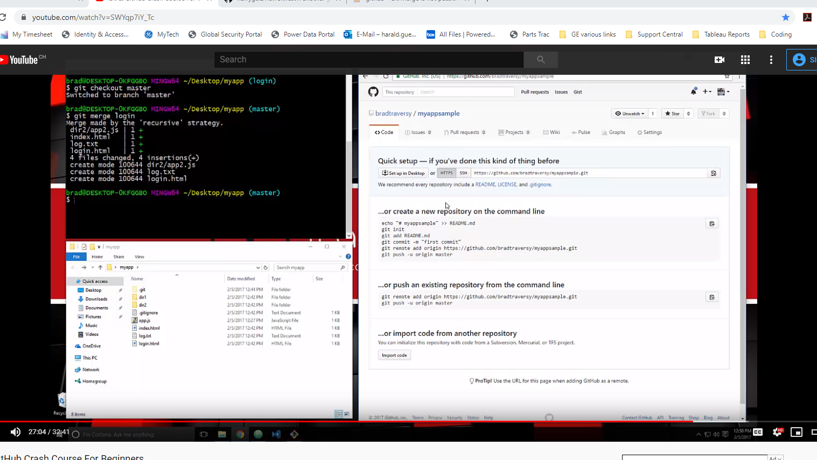

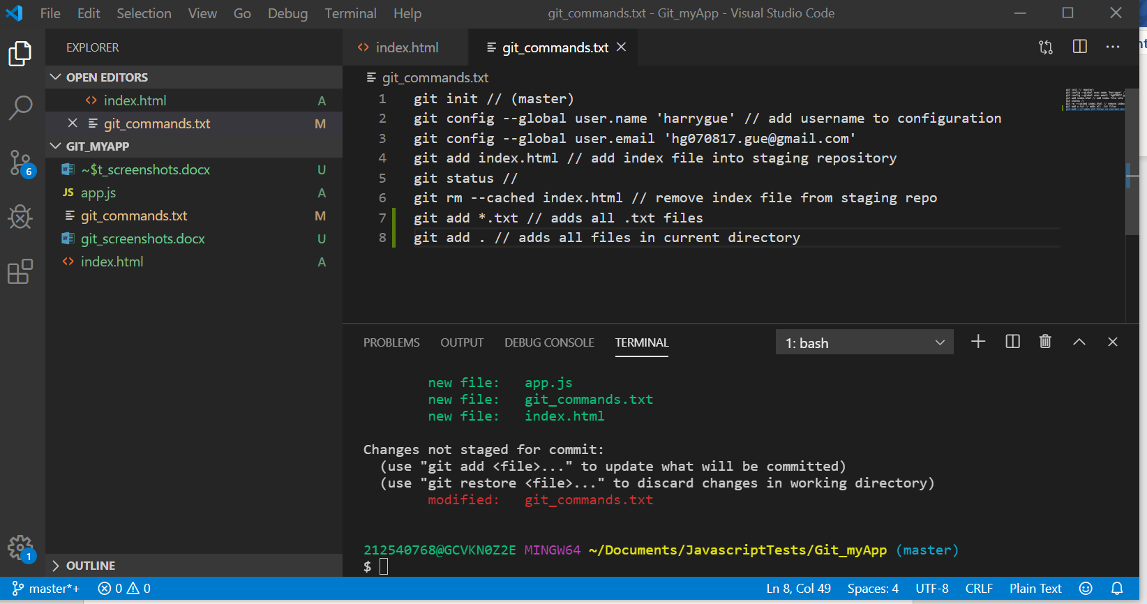

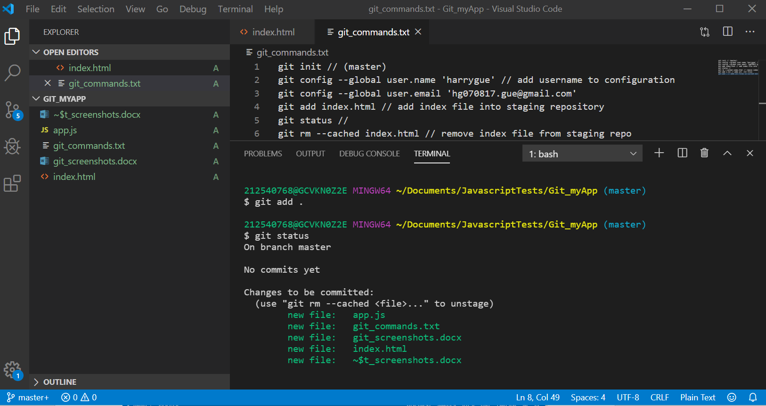

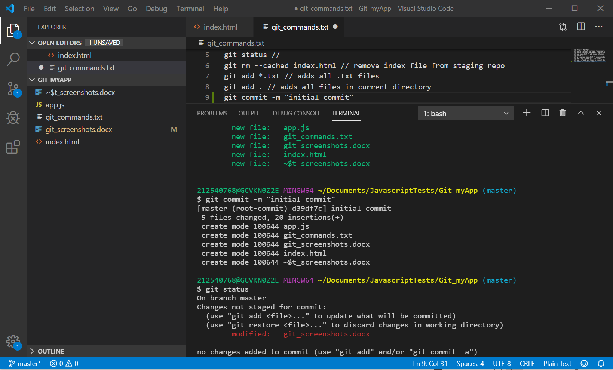

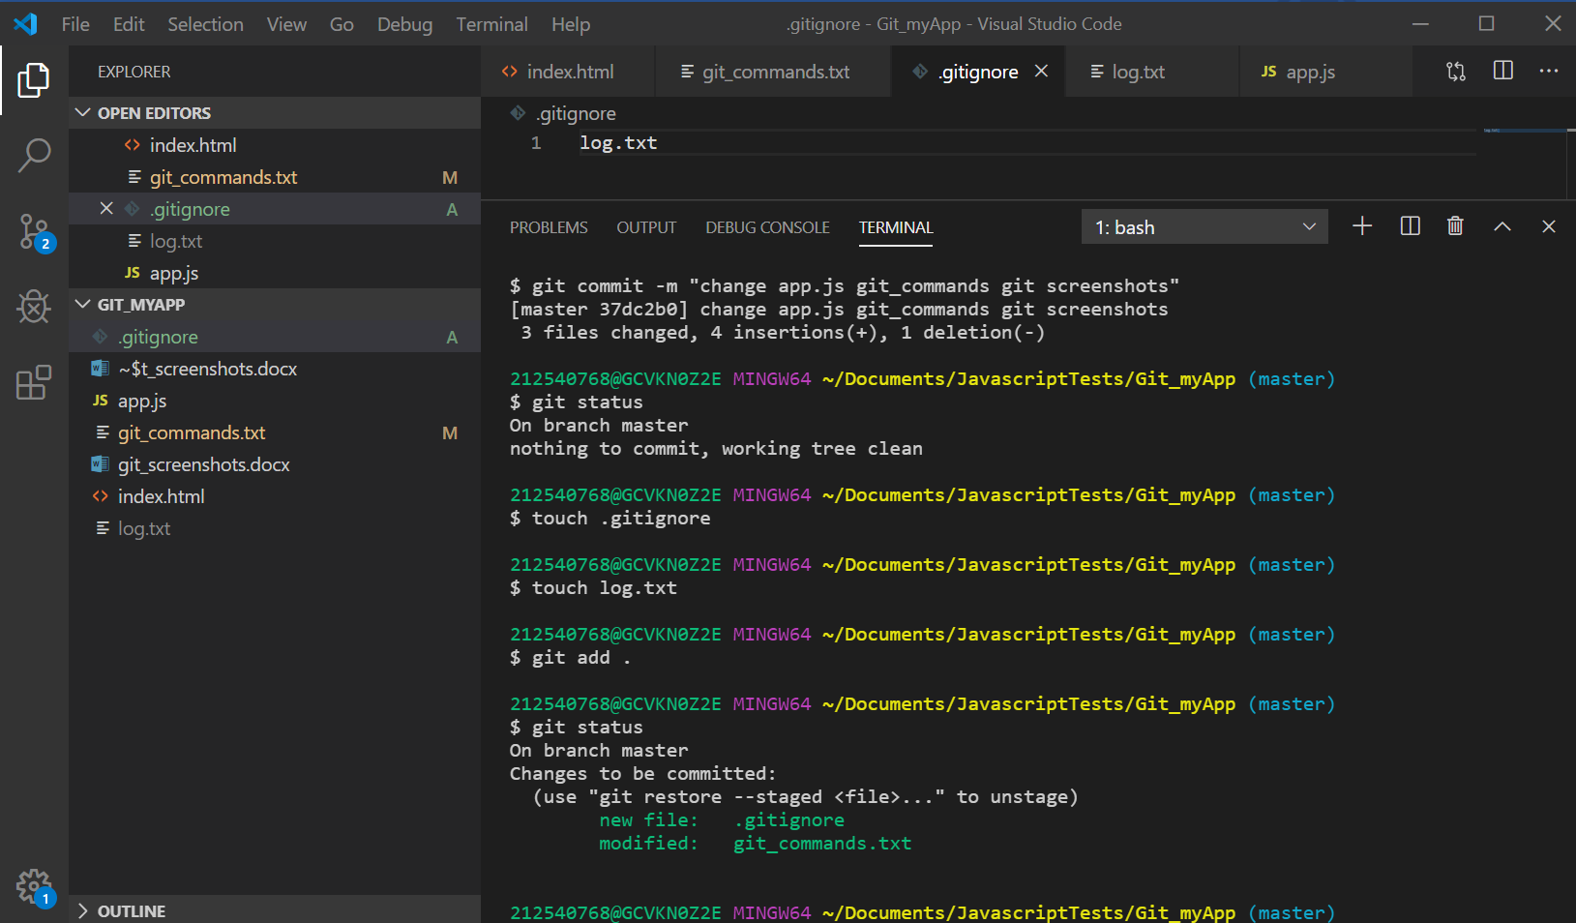

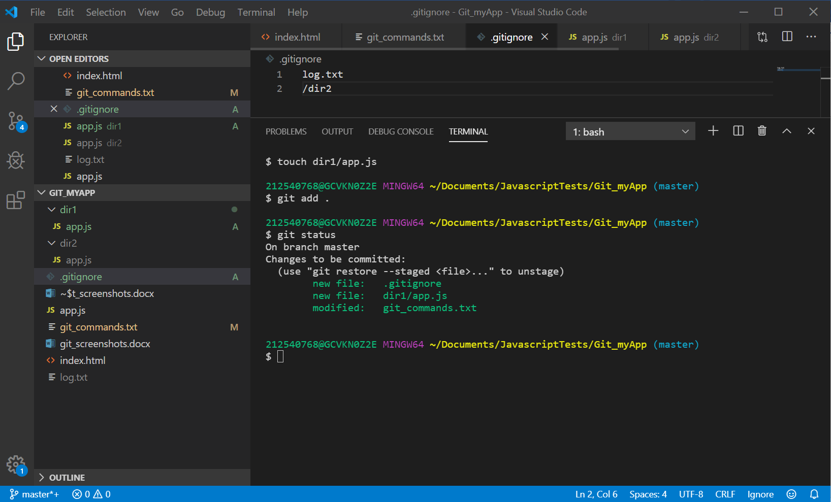

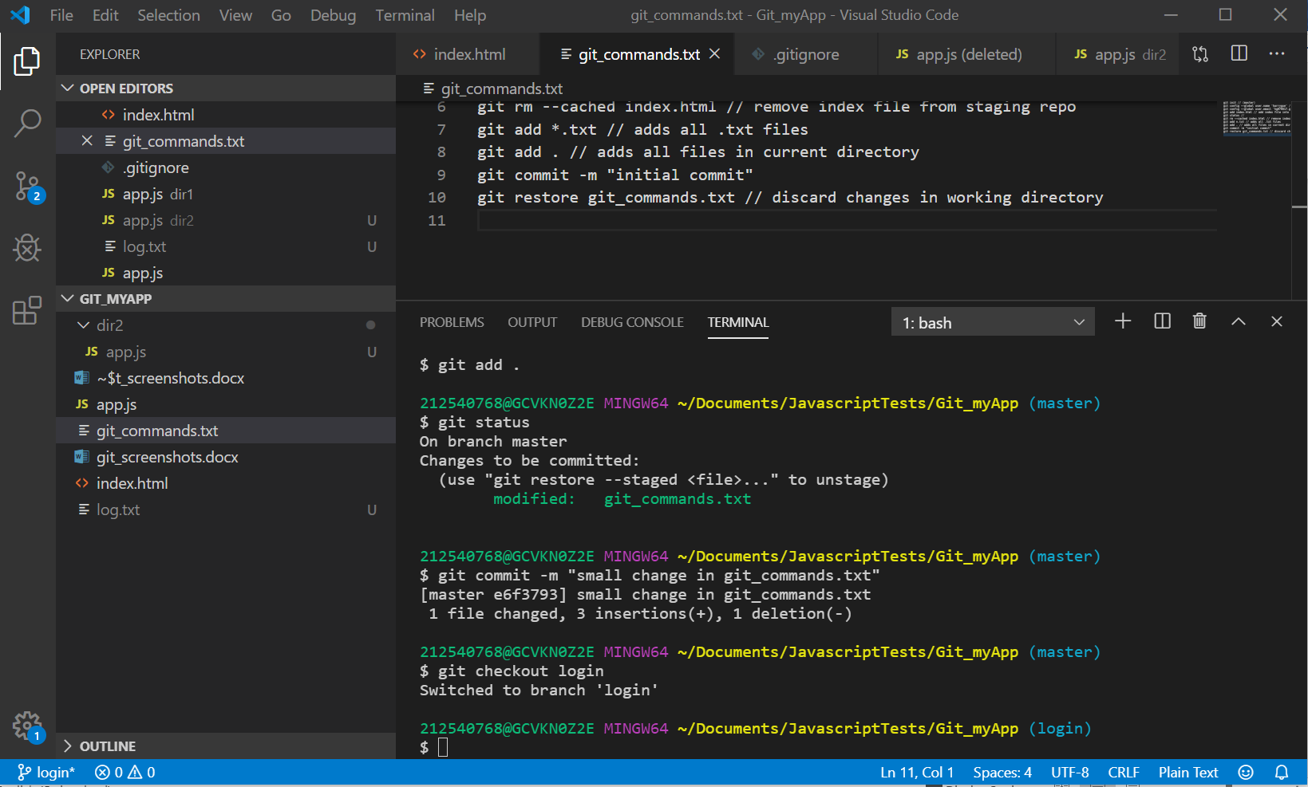

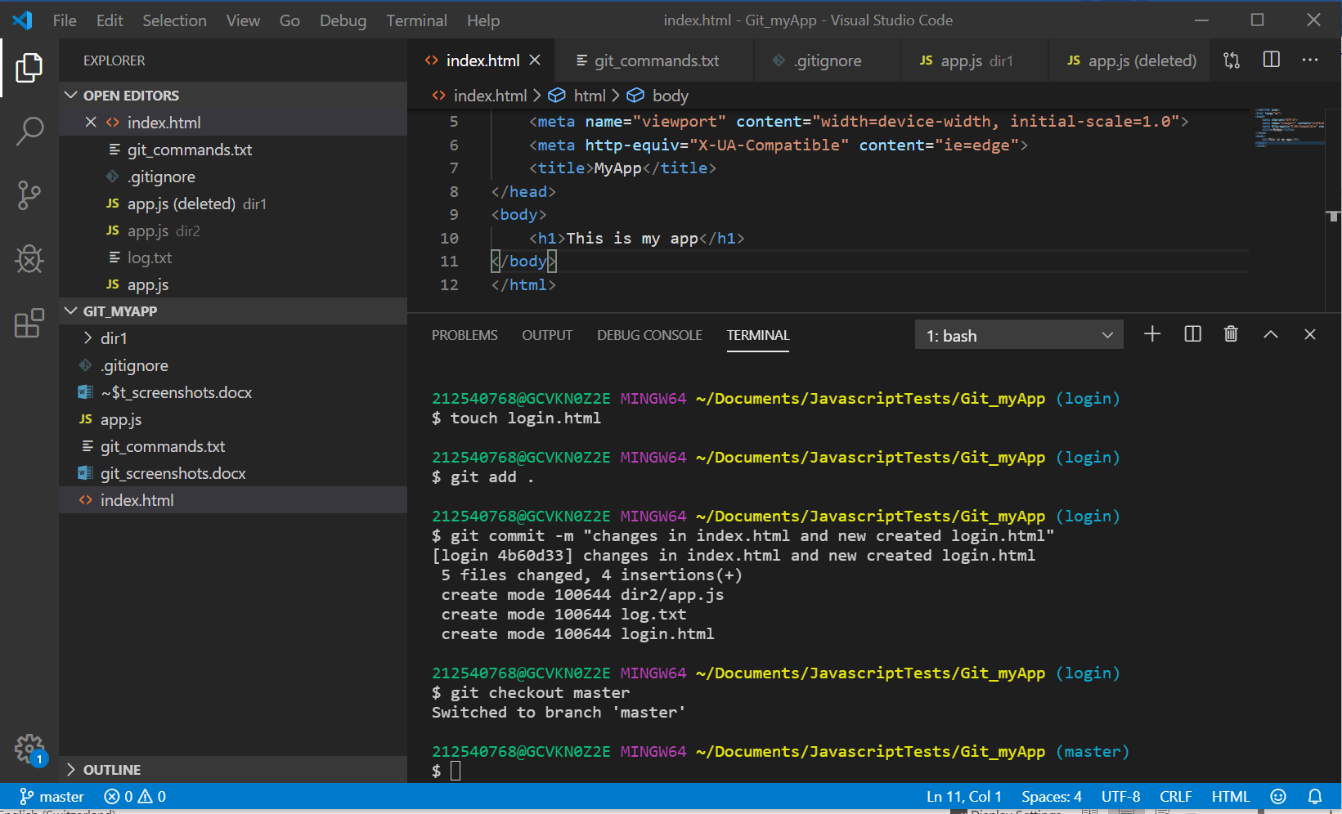

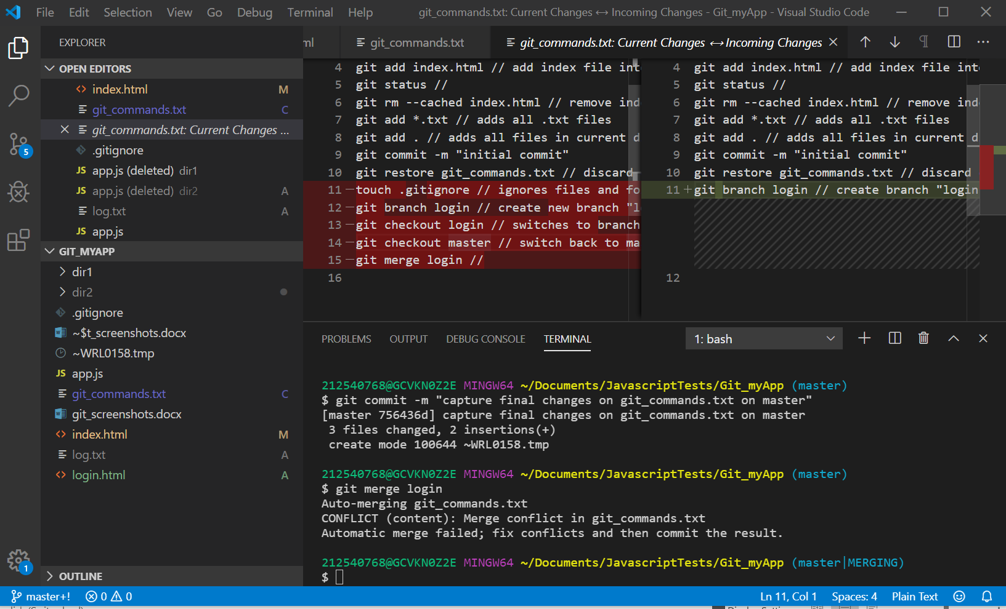

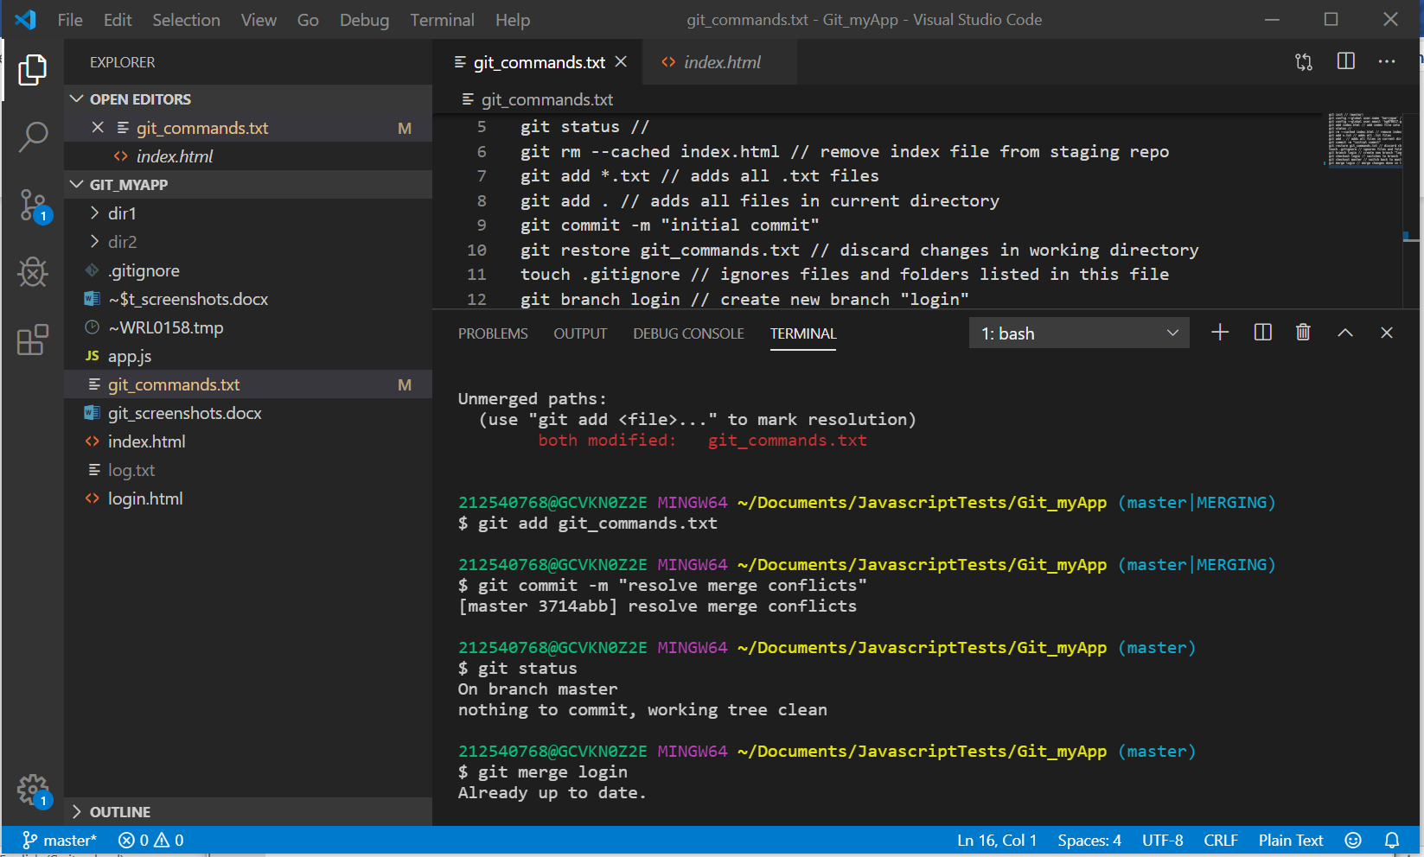

212540768@GCVKN0Z2E MINGW64 ~/Documents/JavascriptTests/Git_myApp

$ git init

Initialized empty Git repository in C:/Users/212540768/Documents/JavascriptTests/Git_myApp/.git/

212540768@GCVKN0Z2E MINGW64 ~/Documents/JavascriptTests/Git_myApp (master)

$ touch index.html

212540768@GCVKN0Z2E MINGW64 ~/Documents/JavascriptTests/Git_myApp (master)

$ touch app.js

212540768@GCVKN0Z2E MINGW64 ~/Documents/JavascriptTests/Git_myApp (master)

$ git config --global user.name 'harrygue'

212540768@GCVKN0Z2E MINGW64 ~/Documents/JavascriptTests/Git_myApp (master)

$ git config --global user.email 'hg070817.gue@gmail.com'

212540768@GCVKN0Z2E MINGW64 ~/Documents/JavascriptTests/Git_myApp (master)

$ git add index.html

212540768@GCVKN0Z2E MINGW64 ~/Documents/JavascriptTests/Git_myApp (master)

$ git status

On branch master

No commits yet

Changes to be committed:

(use "git rm --cached <file>..." to unstage)

new file: index.html

Untracked files:

(use "git add <file>..." to include in what will be committed)

app.js

git_commands.txt

212540768@GCVKN0Z2E MINGW64 ~/Documents/JavascriptTests/Git_myApp (master)

$ git rm --cached index.html

rm 'index.html'

212540768@GCVKN0Z2E MINGW64 ~/Documents/JavascriptTests/Git_myApp (master)

$ git status

On branch master

No commits yet

Untracked files:

(use "git add <file>..." to include in what will be committed)

app.js

git_commands.txt

index.html

nothing added to commit but untracked files present (use "git add" to track)

212540768@GCVKN0Z2E MINGW64 ~/Documents/JavascriptTests/Git_myApp (master)

$ git add *.txt

212540768@GCVKN0Z2E MINGW64 ~/Documents/JavascriptTests/Git_myApp (master)

$ git status

On branch master

No commits yet

Changes to be committed:

(use "git rm --cached <file>..." to unstage)

new file: git_commands.txt

Untracked files:

(use "git add <file>..." to include in what will be committed)

app.js

index.html

212540768@GCVKN0Z2E MINGW64 ~/Documents/JavascriptTests/Git_myApp (master)

$ git add *.html

212540768@GCVKN0Z2E MINGW64 ~/Documents/JavascriptTests/Git_myApp (master)

$ git status

On branch master

No commits yet

Changes to be committed:

(use "git rm --cached <file>..." to unstage)

new file: git_commands.txt

new file: index.html

Untracked files:

(use "git add <file>..." to include in what will be committed)

app.js

212540768@GCVKN0Z2E MINGW64 ~/Documents/JavascriptTests/Git_myApp (master)

$ git add .

212540768@GCVKN0Z2E MINGW64 ~/Documents/JavascriptTests/Git_myApp (master)

$ git status

On branch master

No commits yet

Changes to be committed:

(use "git rm --cached <file>..." to unstage)

new file: app.js

new file: git_commands.txt

new file: index.html

212540768@GCVKN0Z2E MINGW64 ~/Documents/JavascriptTests/Git_myApp (master)

$ git status

On branch master

No commits yet

Changes to be committed:

(use "git rm --cached <file>..." to unstage)

new file: app.js

new file: git_commands.txt

new file: index.html

Changes not staged for commit:

(use "git add <file>..." to update what will be committed)

(use "git restore <file>..." to discard changes in working directory)

modified: git_commands.txt

212540768@GCVKN0Z2E MINGW64 ~/Documents/JavascriptTests/Git_myApp (master)

$ git add .

212540768@GCVKN0Z2E MINGW64 ~/Documents/JavascriptTests/Git_myApp (master)

$ git status

On branch master

No commits yet

Changes to be committed:

(use "git rm --cached <file>..." to unstage)

new file: app.js

new file: git_commands.txt

new file: git_screenshots.docx

new file: index.html

new file: ~$t_screenshots.docx

212540768@GCVKN0Z2E MINGW64 ~/Documents/JavascriptTests/Git_myApp (master)

$ git commit -m "initial commit"

[master (root-commit) d39df7c] initial commit

5 files changed, 20 insertions(+)

create mode 100644 app.js

create mode 100644 git_commands.txt

create mode 100644 git_screenshots.docx

create mode 100644 index.html

create mode 100644 ~$t_screenshots.docx

212540768@GCVKN0Z2E MINGW64 ~/Documents/JavascriptTests/Git_myApp (master)

$ git status

On branch master

Changes not staged for commit:

(use "git add <file>..." to update what will be committed)

(use "git restore <file>..." to discard changes in working directory)

modified: git_screenshots.docx

no changes added to commit (use "git add" and/or "git commit -a")

212540768@GCVKN0Z2E MINGW64 ~/Documents/JavascriptTests/Git_myApp (master)

$ git restore git_commands.txt

212540768@GCVKN0Z2E MINGW64 ~/Documents/JavascriptTests/Git_myApp (master)

$ git status

On branch master

Changes not staged for commit:

(use "git add <file>..." to update what will be committed)

(use "git restore <file>..." to discard changes in working directory)

modified: git_screenshots.docx

no changes added to commit (use "git add" and/or "git commit -a")

212540768@GCVKN0Z2E MINGW64 ~/Documents/JavascriptTests/Git_myApp (master)

$ git status

On branch master

Changes not staged for commit:

(use "git add <file>..." to update what will be committed)

(use "git restore <file>..." to discard changes in working directory)

modified: app.js

modified: git_commands.txt

modified: git_screenshots.docx

no changes added to commit (use "git add" and/or "git commit -a")

212540768@GCVKN0Z2E MINGW64 ~/Documents/JavascriptTests/Git_myApp (master)

$ git add .

212540768@GCVKN0Z2E MINGW64 ~/Documents/JavascriptTests/Git_myApp (master)

$ git status

On branch master

Changes to be committed:

(use "git restore --staged <file>..." to unstage)

modified: app.js

modified: git_commands.txt

modified: git_screenshots.docx

212540768@GCVKN0Z2E MINGW64 ~/Documents/JavascriptTests/Git_myApp (master)

$ git commit -m "change app.js git_commands git screenshots"

[master 37dc2b0] change app.js git_commands git screenshots

3 files changed, 4 insertions(+), 1 deletion(-)

212540768@GCVKN0Z2E MINGW64 ~/Documents/JavascriptTests/Git_myApp (master)

$ git status

On branch master

nothing to commit, working tree clean

212540768@GCVKN0Z2E MINGW64 ~/Documents/JavascriptTests/Git_myApp (master)

$ touch .gitignore

212540768@GCVKN0Z2E MINGW64 ~/Documents/JavascriptTests/Git_myApp (master)

$ touch log.txt

212540768@GCVKN0Z2E MINGW64 ~/Documents/JavascriptTests/Git_myApp (master)

$ git add .

212540768@GCVKN0Z2E MINGW64 ~/Documents/JavascriptTests/Git_myApp (master)

$ git status

On branch master

Changes to be committed:

(use "git restore --staged <file>..." to unstage)

new file: .gitignore

modified: git_commands.txt

212540768@GCVKN0Z2E MINGW64 ~/Documents/JavascriptTests/Git_myApp (master)

$ mkdir dir1

212540768@GCVKN0Z2E MINGW64 ~/Documents/JavascriptTests/Git_myApp (master)

$ mkdir dir2

212540768@GCVKN0Z2E MINGW64 ~/Documents/JavascriptTests/Git_myApp (master)

$ touch dir1/app.js

212540768@GCVKN0Z2E MINGW64 ~/Documents/JavascriptTests/Git_myApp (master)

$ git add .

212540768@GCVKN0Z2E MINGW64 ~/Documents/JavascriptTests/Git_myApp (master)

$ git status

On branch master

Changes to be committed:

(use "git restore --staged <file>..." to unstage)

new file: .gitignore

new file: dir1/app.js

modified: git_commands.txt

212540768@GCVKN0Z2E MINGW64 ~/Documents/JavascriptTests/Git_myApp (master)

$ git branch login

212540768@GCVKN0Z2E MINGW64 ~/Documents/JavascriptTests/Git_myApp (master)

$ git commit -m "another change to display how .gitignore works"

[master 80d43ac] another change to display how .gitignore works

3 files changed, 4 insertions(+)

create mode 100644 .gitignore

create mode 100644 dir1/app.js

212540768@GCVKN0Z2E MINGW64 ~/Documents/JavascriptTests/Git_myApp (master)

$ git checkout login

error: Your local changes to the following files would be overwritten by checkout:

git_commands.txt

Please commit your changes or stash them before you switch branches.

Aborting

212540768@GCVKN0Z2E MINGW64 ~/Documents/JavascriptTests/Git_myApp (master)

$ git add .

212540768@GCVKN0Z2E MINGW64 ~/Documents/JavascriptTests/Git_myApp (master)

$ git add .

212540768@GCVKN0Z2E MINGW64 ~/Documents/JavascriptTests/Git_myApp (master)

$ git status

On branch master

Changes to be committed:

(use "git restore --staged <file>..." to unstage)

modified: git_commands.txt

212540768@GCVKN0Z2E MINGW64 ~/Documents/JavascriptTests/Git_myApp (master)

$ git commit -m "small change in git_commands.txt"

[master e6f3793] small change in git_commands.txt

1 file changed, 3 insertions(+), 1 deletion(-)

212540768@GCVKN0Z2E MINGW64 ~/Documents/JavascriptTests/Git_myApp (master)

$ git checkout login

Switched to branch 'login'

212540768@GCVKN0Z2E MINGW64 ~/Documents/JavascriptTests/Git_myApp (login)

$ touch login.html

212540768@GCVKN0Z2E MINGW64 ~/Documents/JavascriptTests/Git_myApp (login)

$ git add .

212540768@GCVKN0Z2E MINGW64 ~/Documents/JavascriptTests/Git_myApp (login)

$ git commit -m "changes in index.html and new created login.html"

[login 4b60d33] changes in index.html and new created login.html

5 files changed, 4 insertions(+)

create mode 100644 dir2/app.js

create mode 100644 log.txt

create mode 100644 login.html

212540768@GCVKN0Z2E MINGW64 ~/Documents/JavascriptTests/Git_myApp (login)

$ git checkout master

Switched to branch 'master'

212540768@GCVKN0Z2E MINGW64 ~/Documents/JavascriptTests/Git_myApp (master)

$ git merge login

error: Your local changes to the following files would be overwritten by merge:

git_commands.txt

Please commit your changes or stash them before you merge.

Aborting

212540768@GCVKN0Z2E MINGW64 ~/Documents/JavascriptTests/Git_myApp (master)

$ git commit -m "capture final changes on git_commands.txt on master"

On branch master

Changes not staged for commit:

modified: git_commands.txt

modified: git_screenshots.docx

Untracked files:

~WRL0158.tmp

no changes added to commit

212540768@GCVKN0Z2E MINGW64 ~/Documents/JavascriptTests/Git_myApp (master)

$ git add .

212540768@GCVKN0Z2E MINGW64 ~/Documents/JavascriptTests/Git_myApp (master)

$ git commit -m "capture final changes on git_commands.txt on master"

[master 756436d] capture final changes on git_commands.txt on master

3 files changed, 2 insertions(+)

create mode 100644 ~WRL0158.tmp

212540768@GCVKN0Z2E MINGW64 ~/Documents/JavascriptTests/Git_myApp (master)

$ git merge login

Auto-merging git_commands.txt

CONFLICT (content): Merge conflict in git_commands.txt

Automatic merge failed; fix conflicts and then commit the result.

212540768@GCVKN0Z2E MINGW64 ~/Documents/JavascriptTests/Git_myApp (master|MERGING)

$ git merge login

error: Merging is not possible because you have unmerged files.

hint: Fix them up in the work tree, and then use 'git add/rm <file>'

hint: as appropriate to mark resolution and make a commit.

fatal: Exiting because of an unresolved conflict.

212540768@GCVKN0Z2E MINGW64 ~/Documents/JavascriptTests/Git_myApp (master|MERGING)

$ git merge login

error: Merging is not possible because you have unmerged files.

hint: Fix them up in the work tree, and then use 'git add/rm <file>'

hint: as appropriate to mark resolution and make a commit.

fatal: Exiting because of an unresolved conflict.

212540768@GCVKN0Z2E MINGW64 ~/Documents/JavascriptTests/Git_myApp (master|MERGING)

$ git checkout login

error: you need to resolve your current index first

git_commands.txt: needs merge

212540768@GCVKN0Z2E MINGW64 ~/Documents/JavascriptTests/Git_myApp (master|MERGING)

$ git pull origin master

error: Pulling is not possible because you have unmerged files.

hint: Fix them up in the work tree, and then use 'git add/rm <file>'

hint: as appropriate to mark resolution and make a commit.

fatal: Exiting because of an unresolved conflict.

212540768@GCVKN0Z2E MINGW64 ~/Documents/JavascriptTests/Git_myApp (master|MERGING)

$ git fetch

212540768@GCVKN0Z2E MINGW64 ~/Documents/JavascriptTests/Git_myApp (master|MERGING)

$ git merge origin master

error: Merging is not possible because you have unmerged files.

hint: Fix them up in the work tree, and then use 'git add/rm <file>'

hint: as appropriate to mark resolution and make a commit.

fatal: Exiting because of an unresolved conflict.

212540768@GCVKN0Z2E MINGW64 ~/Documents/JavascriptTests/Git_myApp (master|MERGING)

$ git status

On branch master

You have unmerged paths.

(fix conflicts and run "git commit")

(use "git merge --abort" to abort the merge)

Changes to be committed:

new file: dir2/app.js

modified: index.html

new file: log.txt

new file: login.html

Unmerged paths:

(use "git add <file>..." to mark resolution)

both modified: git_commands.txt

212540768@GCVKN0Z2E MINGW64 ~/Documents/JavascriptTests/Git_myApp (master|MERGING)

$ git add git_commands.txt

212540768@GCVKN0Z2E MINGW64 ~/Documents/JavascriptTests/Git_myApp (master|MERGING)

$ git commit -m "resolve merge conflicts"

[master 3714abb] resolve merge conflicts

212540768@GCVKN0Z2E MINGW64 ~/Documents/JavascriptTests/Git_myApp (master)

$ git status

On branch master

nothing to commit, working tree clean

212540768@GCVKN0Z2E MINGW64 ~/Documents/JavascriptTests/Git_myApp (master)

$ git merge login

Already up to date.

212540768@GCVKN0Z2E MINGW64 ~/Documents/JavascriptTests/Git_myApp (master)

$ git remote

212540768@GCVKN0Z2E MINGW64 ~/Documents/JavascriptTests/Git_myApp (master)

$ git remote add origin https://github.com/harrygue/newGitTest1.git

212540768@GCVKN0Z2E MINGW64 ~/Documents/JavascriptTests/Git_myApp (master)

$ git remote

origin

212540768@GCVKN0Z2E MINGW64 ~/Documents/JavascriptTests/Git_myApp (master)

$ git push -u origin master

fatal: unable to access 'https://github.com/harrygue/newGitTest1.git/': Could not resolve host: github.com

212540768@GCVKN0Z2E MINGW64 ~/Documents/JavascriptTests/Git_myApp (master)

$ git push -u origin master

To https://github.com/harrygue/newGitTest1.git

! [rejected] master -> master (fetch first)

error: failed to push some refs to 'https://github.com/harrygue/newGitTest1.git'

hint: Updates were rejected because the remote contains work that you do

hint: not have locally. This is usually caused by another repository pushing

hint: to the same ref. You may want to first integrate the remote changes

hint: (e.g., 'git pull ...') before pushing again.

hint: See the 'Note about fast-forwards' in 'git push --help' for details.

212540768@GCVKN0Z2E MINGW64 ~/Documents/JavascriptTests/Git_myApp (master)

$ git pull origin master

warning: no common commits

remote: Enumerating objects: 3, done.

remote: Counting objects: 100% (3/3), done.

remote: Total 3 (delta 0), reused 0 (delta 0), pack-reused 0

Unpacking objects: 100% (3/3), done.

From https://github.com/harrygue/newGitTest1

* branch master -> FETCH_HEAD

* [new branch] master -> origin/master

fatal: refusing to merge unrelated histories

212540768@GCVKN0Z2E MINGW64 ~/Documents/JavascriptTests/Git_myApp (master)

$ git pull origin master --allow-unrelated-histories

From https://github.com/harrygue/newGitTest1

* branch master -> FETCH_HEAD

Merge made by the 'recursive' strategy.

README.md | 2 ++

1 file changed, 2 insertions(+)

create mode 100644 README.md

212540768@GCVKN0Z2E MINGW64 ~/Documents/JavascriptTests/Git_myApp (master)

$ git merge origin origin/master

merge: origin - not something we can merge

212540768@GCVKN0Z2E MINGW64 ~/Documents/JavascriptTests/Git_myApp (master)

$ git add .

212540768@GCVKN0Z2E MINGW64 ~/Documents/JavascriptTests/Git_myApp (master)

$ git status

On branch master

Changes to be committed:

(use "git restore --staged <file>..." to unstage)

modified: git_commands.txt

modified: git_screenshots.docx

212540768@GCVKN0Z2E MINGW64 ~/Documents/JavascriptTests/Git_myApp (master)

$ git commit -m "final commit"

[master 7233a26] final commit

2 files changed, 1 insertion(+), 1 deletion(-)

212540768@GCVKN0Z2E MINGW64 ~/Documents/JavascriptTests/Git_myApp (master)

$ git status

On branch master

nothing to commit, working tree clean

212540768@GCVKN0Z2E MINGW64 ~/Documents/JavascriptTests/Git_myApp (master)

$ git add .

212540768@GCVKN0Z2E MINGW64 ~/Documents/JavascriptTests/Git_myApp (master)

$ git commit -m "final commit"

[master 7fab860] final commit

1 file changed, 2 insertions(+)

212540768@GCVKN0Z2E MINGW64 ~/Documents/JavascriptTests/Git_myApp (master)

$ git push -u origin master

Enumerating objects: 44, done.

Counting objects: 100% (44/44), done.

Delta compression using up to 8 threads

Compressing objects: 100% (35/35), done.

Writing objects: 100% (43/43), 1.79 MiB | 1.69 MiB/s, done.

Total 43 (delta 19), reused 0 (delta 0)

remote: Resolving deltas: 100% (19/19), done.

To https://github.com/harrygue/newGitTest1.git

0315a6d..7fab860 master -> master

Branch 'master' set up to track remote branch 'master' from 'origin'.

212540768@GCVKN0Z2E MINGW64 ~/Documents/JavascriptTests/Git_myApp (master)

$