In this section, we implement some popular MCMC diagnostics methods to evaluate our result precision. The ideal sampling result will have a low autocorrelation with a high effective sample size as to obtain a stationary Markov chain. We calculate the effective sample size for the simulated $β$ s very closed to the simulation iteration. The autocorrelation function plot and trace plot for $β$ s are shown below. Noticed that here we only show the posterior sample for incumbency effect, other results are displayed in the Appendix.

Diagnostic plots for the first Bayesian model, we pick the sampling result for year 1984:

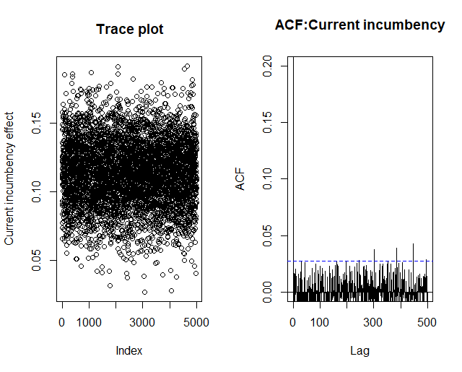

Diagnostic plots for the Bayesian hierarchical model:

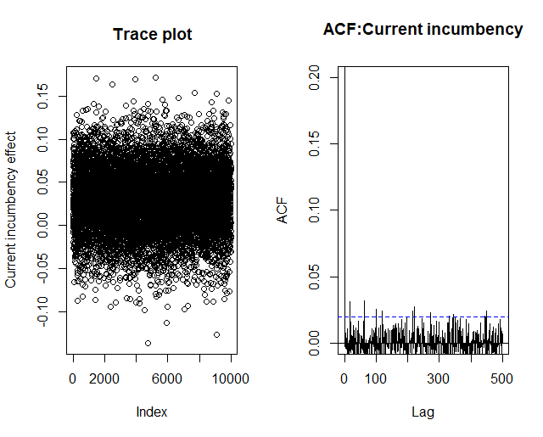

The above two figures both show us an immediate convergence and a low degree of autocorrelation. For the first 500 lags, the autocorrelation function values are essentially equal to zero for approximation purposes. These plots indicate an approximately independently sampled sequence for incumbency effect. The Gibbs sampler for both plain Bayesian model and Bayesian hierarchical model performs quite well.