MADEIRA
Hiking Adventure
An 8-Day Trail & Coast Itinerary
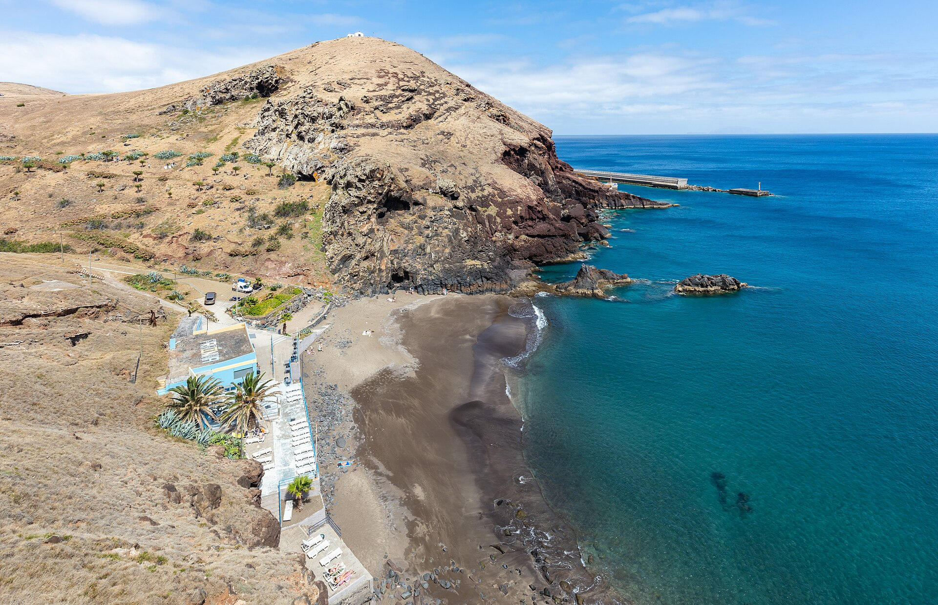
Ponta de São Lourenço — the wild eastern tip of the island
Eight days of ridge walks, laurel forests, ocean pools and mountain summits —
a walker's tour of Portugal's Atlantic island.
Itinerary adapted from traveltribe.com/trips/madeira-hiking

Trip Overview
Madeira packs an astonishing variety of landscapes into a single small island: jagged volcanic peaks, ancient cloud-forests, cliff-top skywalks and natural pools carved from lava. This week-long itinerary strings together the very best of them, mixing signature summit treks with gentle levada walks, ocean adventures and time to relax in the island's famous volcanic pools.
At a glance: 8 days · 6 signature hikes · whale watching · canyoning · natural pools & gardens

DAY 1 Welcome to Madeira
Funchal & the Mercado dos Lavradores
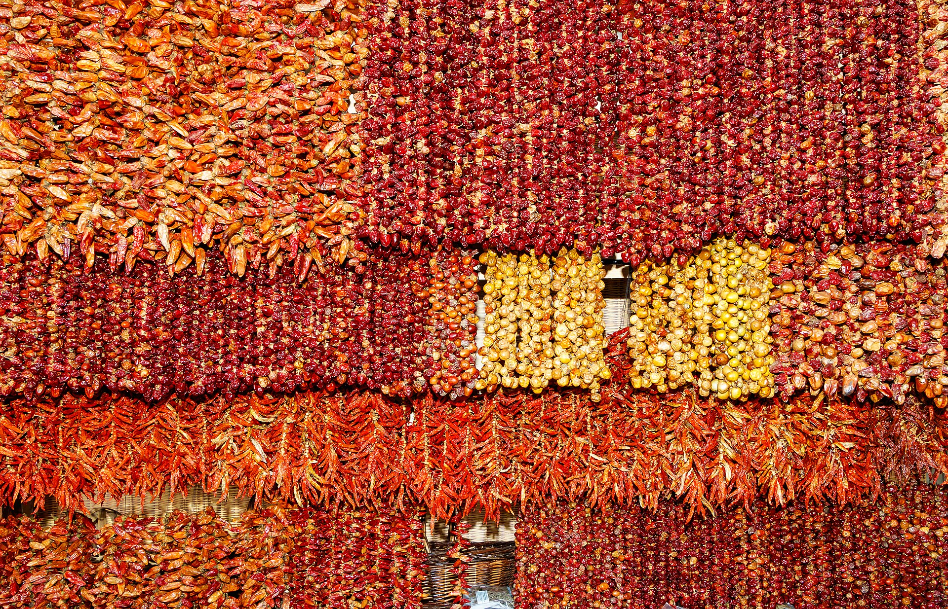
Fresh produce on display at Funchal's Mercado dos Lavradores
Arrive on the island, check into your hotel and pick up your rental car in Funchal. Spend the afternoon wandering the capital's historic streets and the colourful painted doors of the Old Town, then dive into the vibrant atmosphere of the Mercado dos Lavradores — the Farmers' Market — piled high with tropical fruit, flowers and the day's catch. The evening brings a welcome dinner where you meet your fellow hikers.

DAY 2 Coastal Trails & Ocean Giants
Ponta de São Lourenço hike

The red-and-ochre cliffs of Ponta de São Lourenço
TRAIL 10 km · 3.5 hrs · Easy
Lace up for the Ponta de São Lourenço trail, a dramatic ridge walk out to the easternmost point of Madeira. Here the island trades its usual green for wind-sculpted red and ochre cliffs plunging into a turquoise Atlantic — the most striking coastal scenery on Madeira.
Whale-watching catamaran
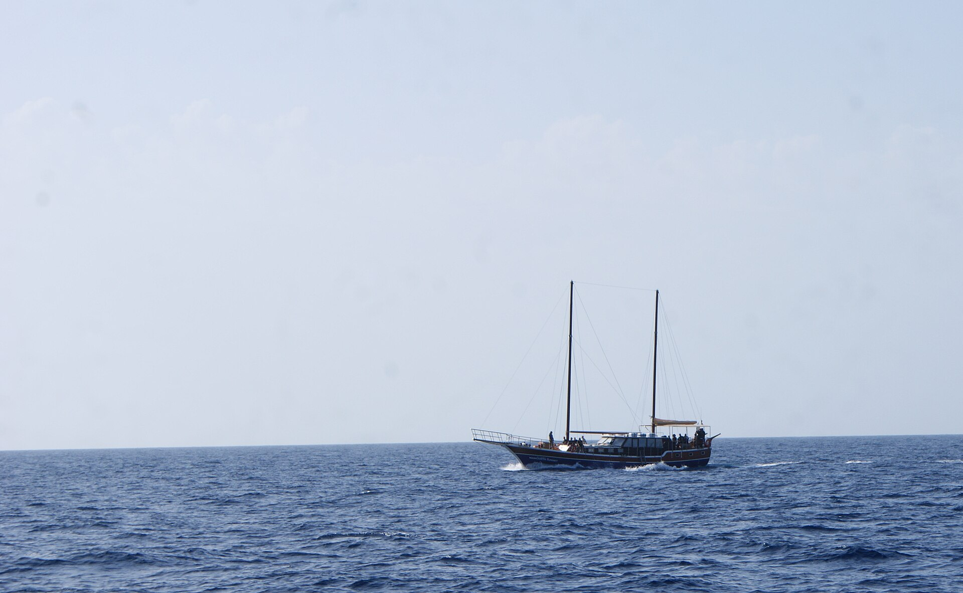
A whale-watching catamaran heading out into Madeira's deep coastal waters
In the afternoon, set sail on a whale-watching catamaran in search of the dolphins, pilot whales and other ocean giants that patrol Madeira's deep offshore waters — a memorable way to spend the hours before sunset.

DAY 3 Mountain Challenge & Natural Pools
Pico do Areeiro to Pico Ruivo
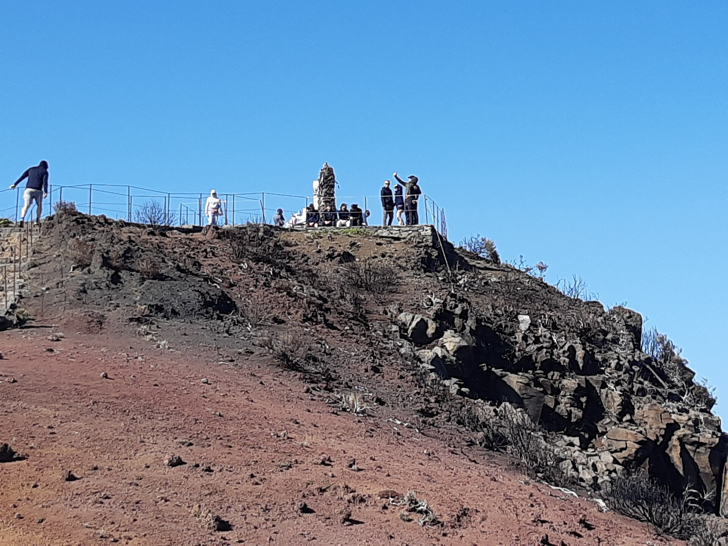
The high mountain traverse toward Pico Ruivo, Madeira's highest peak
TRAIL 12 km · 5 hrs · Hard · 1,000 m ascent
Today is the island's signature trek: the high mountain traverse from Pico do Areeiro to Pico Ruivo, Madeira's highest summit. Expect knife-edge ridges, staircases and tunnels carved through the rock, and cloud-forest views that feel like walking above the sky. It is demanding but unforgettable.
Doca do Cavacas natural pools
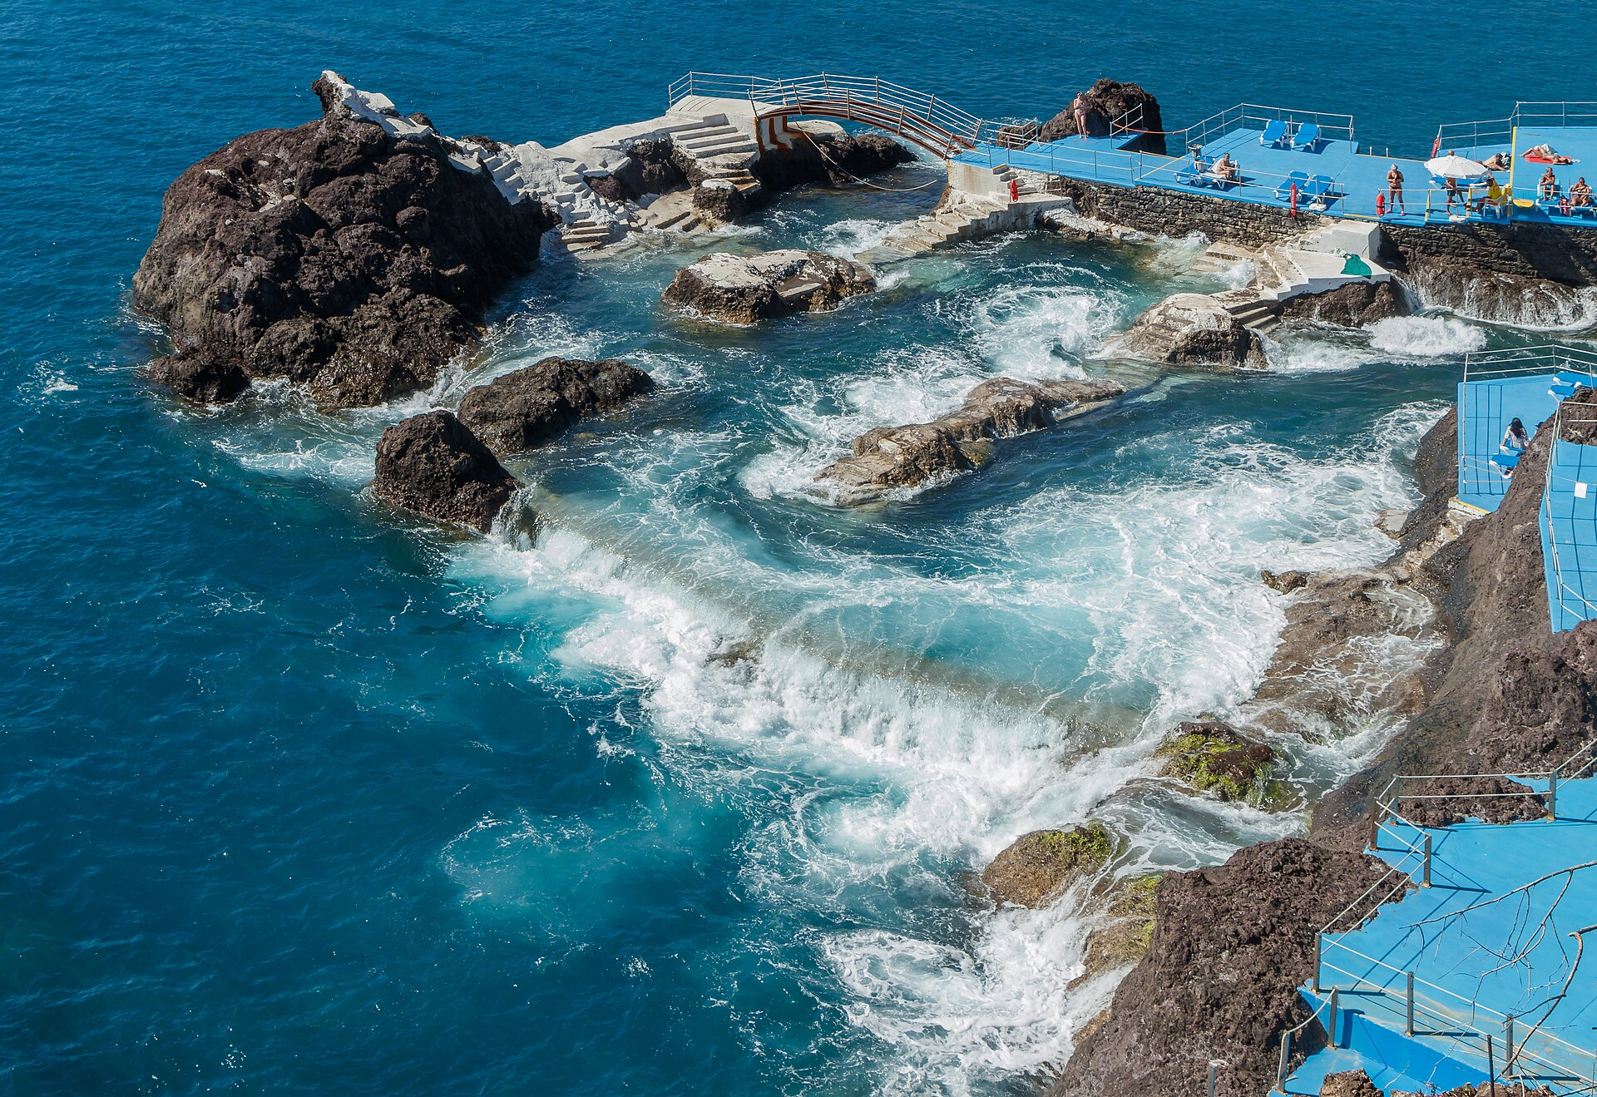
The volcanic rock pools of Doca do Cavacas on the Funchal coast
Reward tired legs in the natural pools of Doca do Cavacas — volcanic rock pools on the Funchal coast where the Atlantic filters in to create calm, therapeutic bathing basins ringed by black lava rock.

DAY 4 Canyoning Adventure & Coastal Charm
Canyoning through gorges & waterfalls
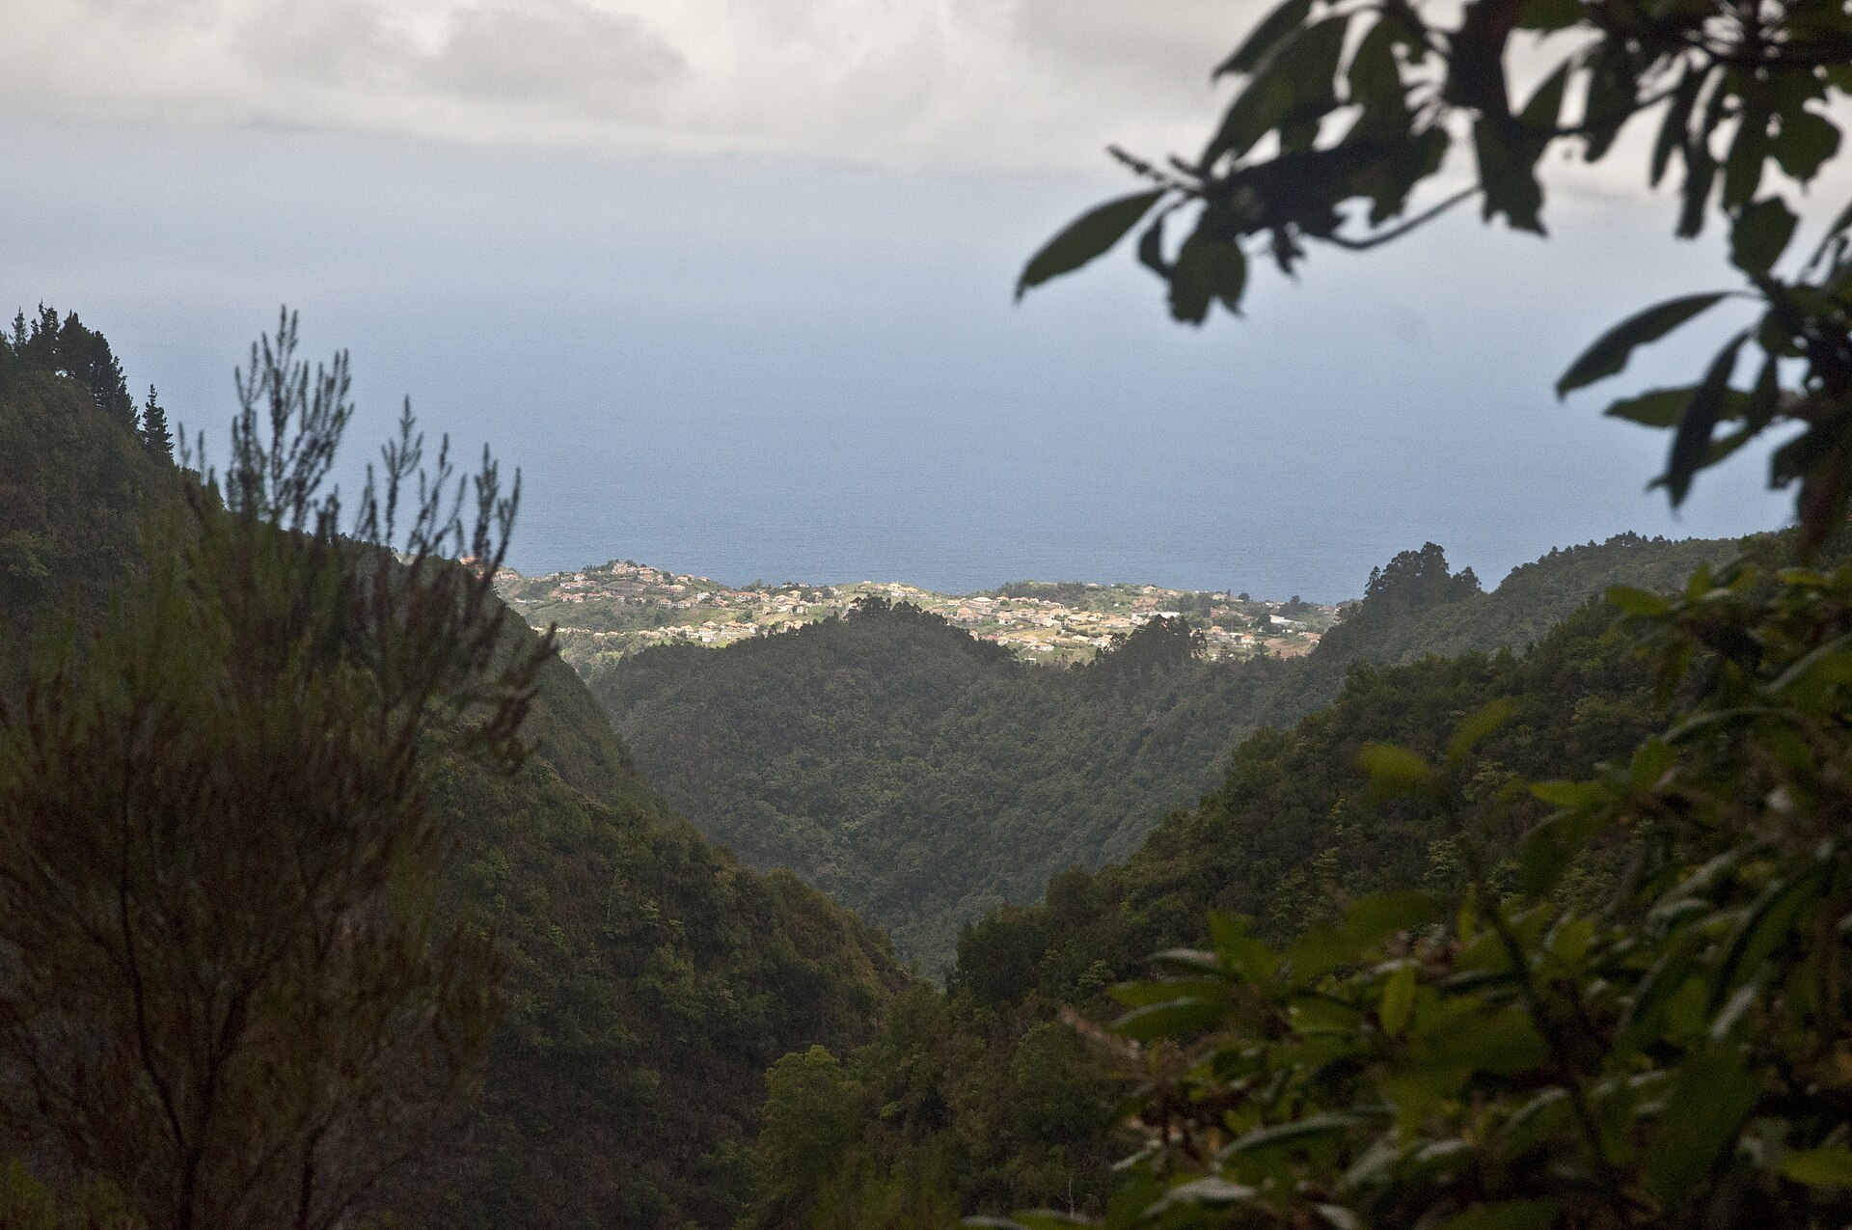
Lush gorges and waterfalls in Madeira's green interior
Swap the trail for a canyoning adventure, working your way down through gorges and waterfalls by scrambling, sliding and abseiling past cascades deep in Madeira's lush interior — a hands-on way to experience the island's wild water world.
Machico & the Capela dos Milagres
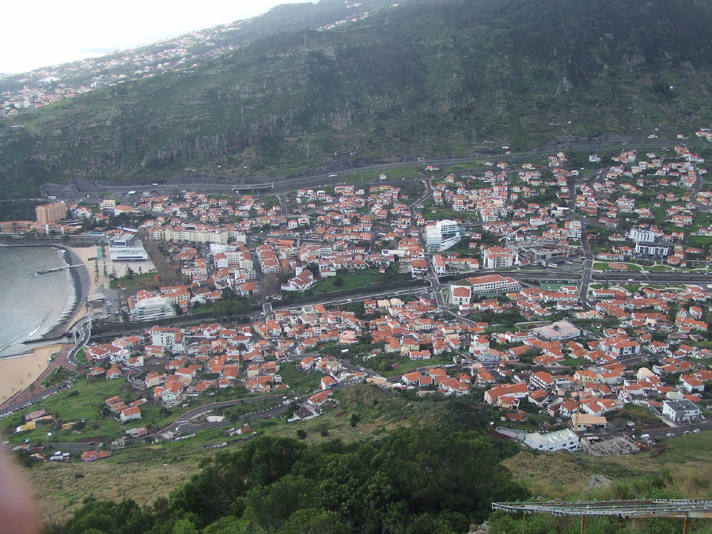
The seaside town of Machico, Madeira's first capital
The afternoon is gentler. Explore Machico, the island's first capital, with its golden-sand beach and the 15th-century Capela do Senhor dos Milagres (Chapel of the Lord of Miracles). Round off the day with sunset from a coastal viewpoint.

DAY 5 Misty Forests & Coastal Pools
Véu da Noiva waterfall
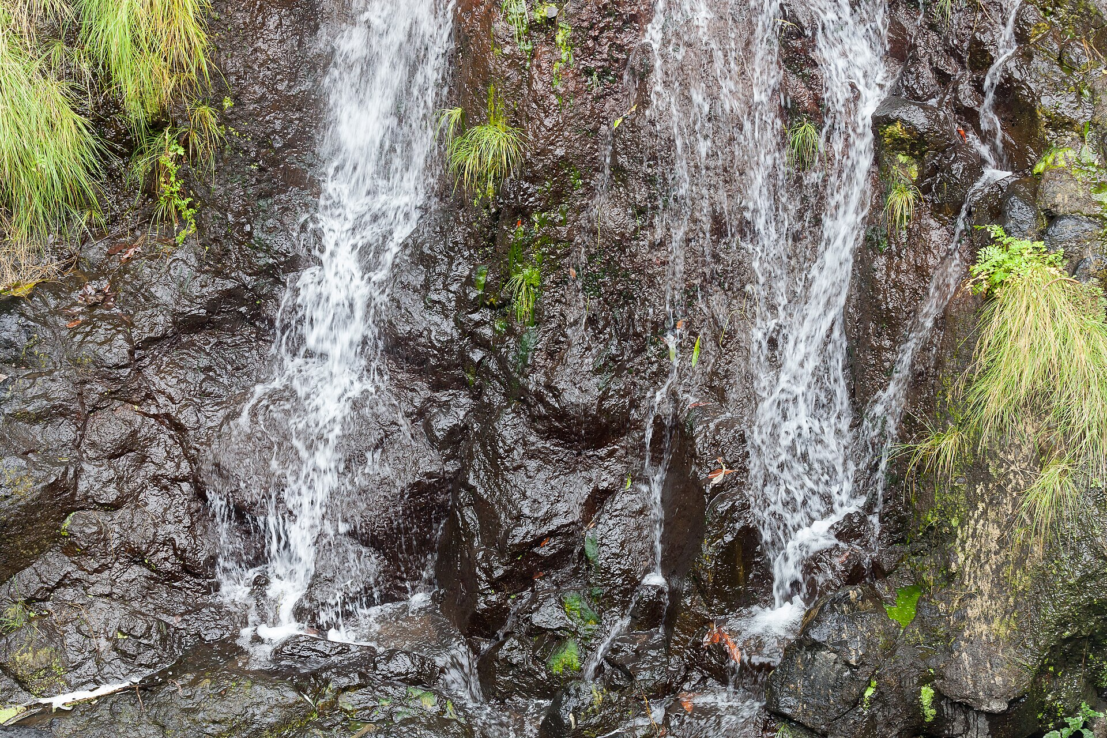
Water tumbling toward the sea near the Véu da Noiva viewpoint
Begin at the Véu da Noiva — the 'Bride's Veil' — a 30-metre ribbon of water that cascades straight toward the ocean on the island's rugged north coast.
Fanal Forest trail
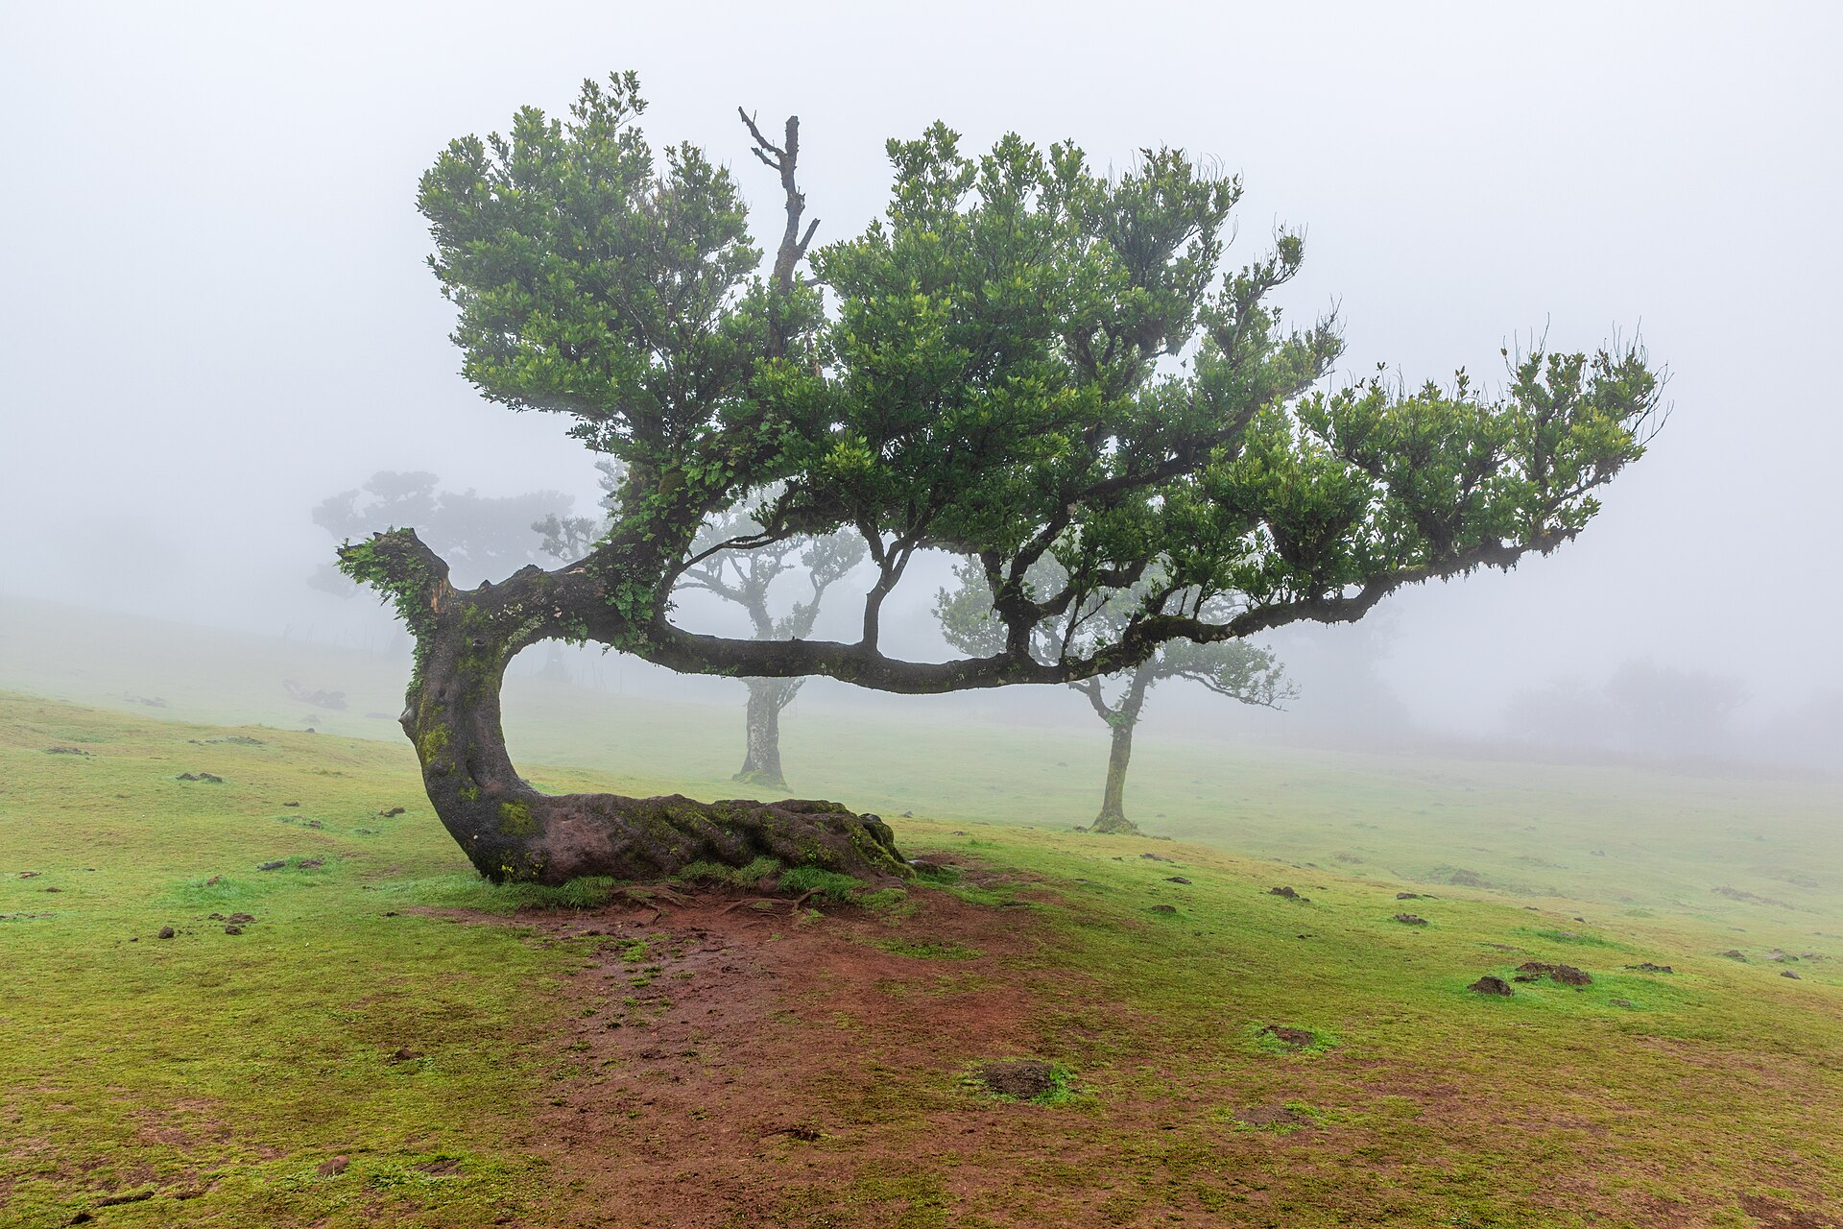
The ancient, mist-wrapped laurel forest of Fanal
TRAIL 15 km · 5.5 hrs · Easy
Then walk the ancient Fanal Forest, a UNESCO-listed laurisilva of gnarled, moss-draped trees that appear and vanish in the drifting mist — one of the most atmospheric places anywhere on the island.
Porto Moniz natural pools
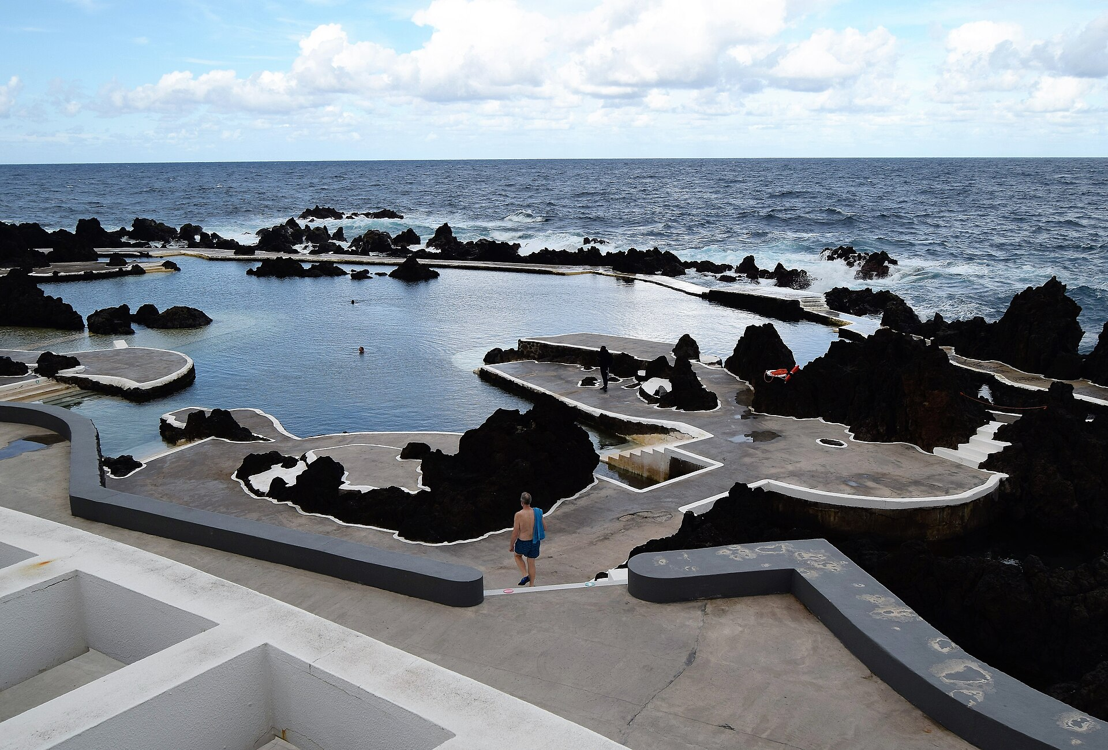
The famous natural swimming pools at Porto Moniz
Finish by cooling off in the famous Porto Moniz natural swimming pools, set among rugged volcanic rock at Madeira's north-western tip, where waves break just beyond the sheltered water.

DAY 6 Coastal Cliffs & Sunset Views
Lombada da Ponta do Sol
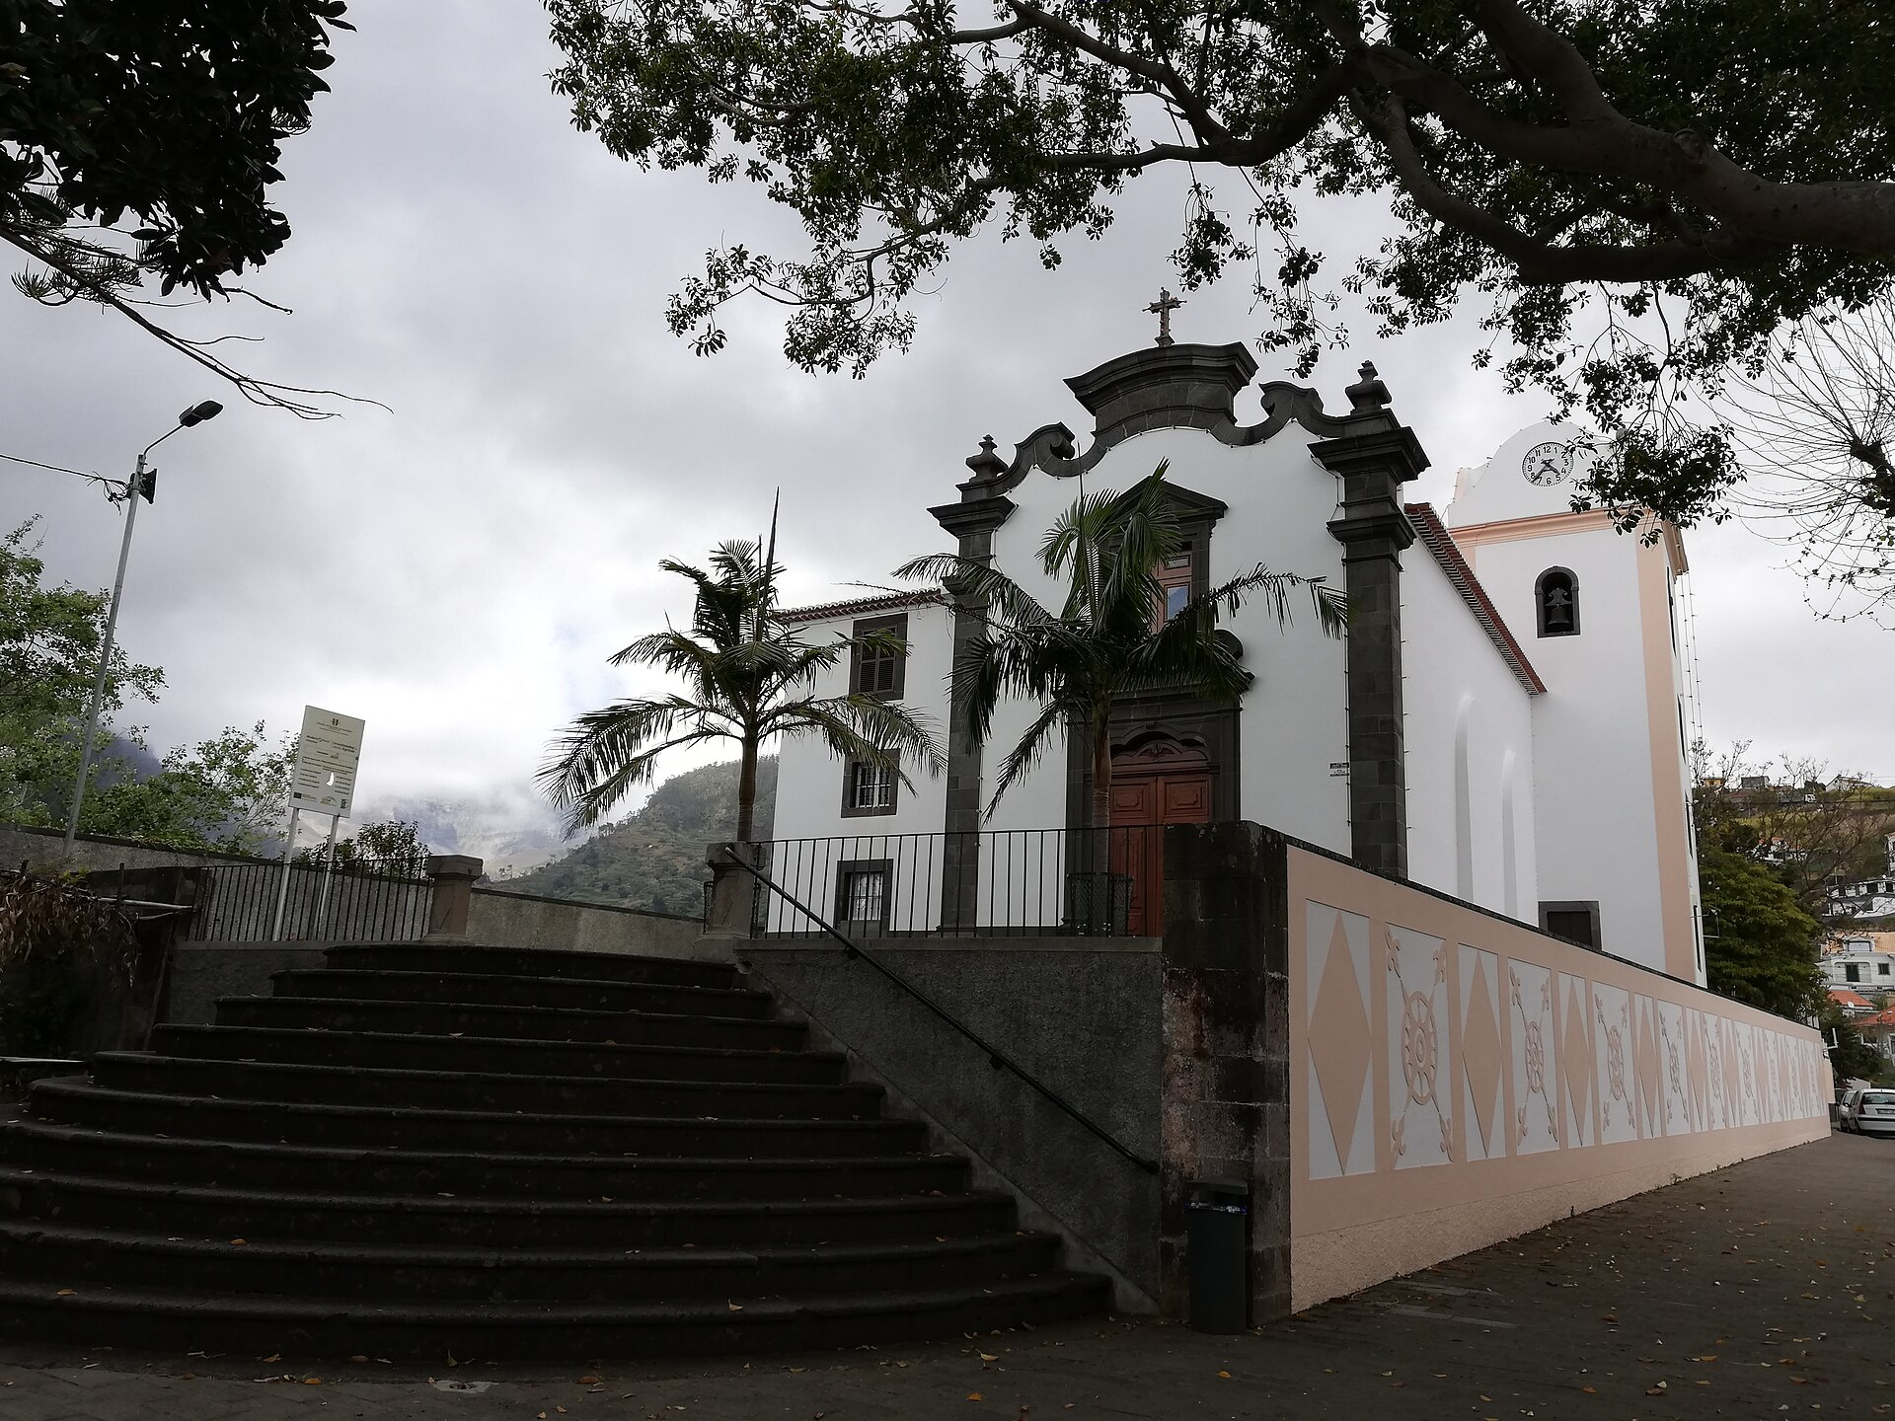
Terraced hillsides and chapels above Ponta do Sol
TRAIL 7.8 km · 3.5 hrs · Medium
A scenic levada walk along the Lombada da Ponta do Sol, threading through terraced hillsides, banana groves and sleepy villages on the sunny south-western coast.
Cabo Girão Skywalk
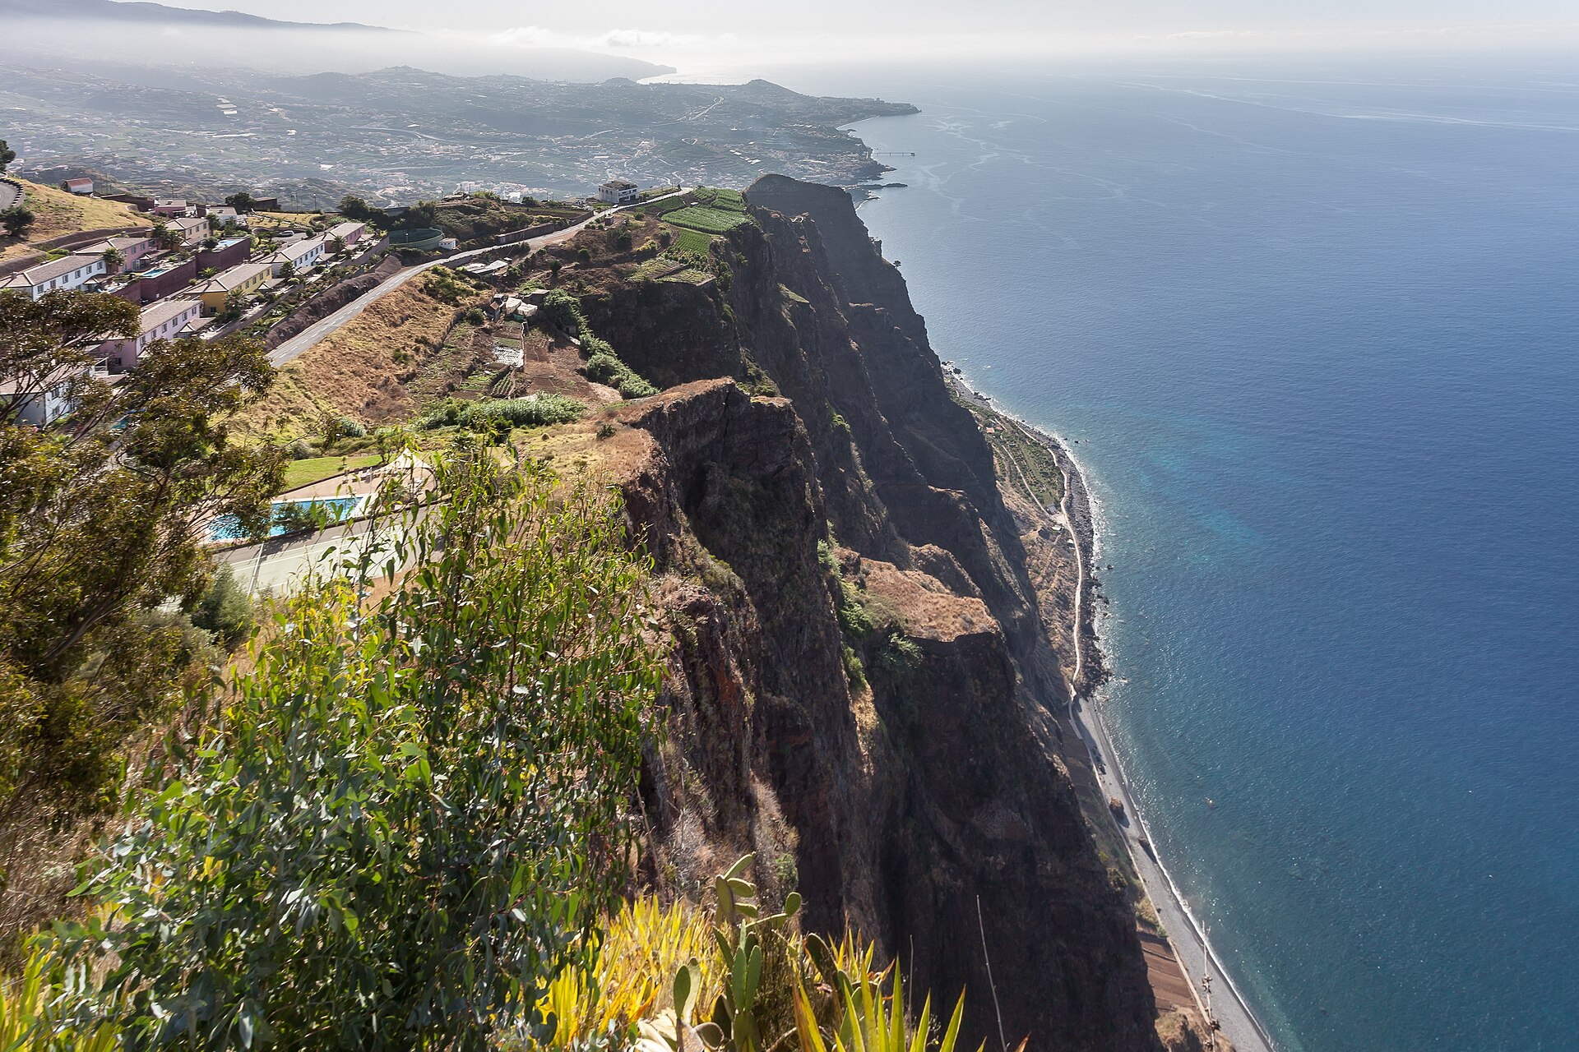
The towering sea cliffs at Cabo Girão
Test your nerve on the Cabo Girão Skywalk, a glass-floored platform suspended 580 metres above the sea — Europe's highest cliff skywalk, with dizzying views straight down to the terraces and shoreline below.
Ponta do Pargo lighthouse
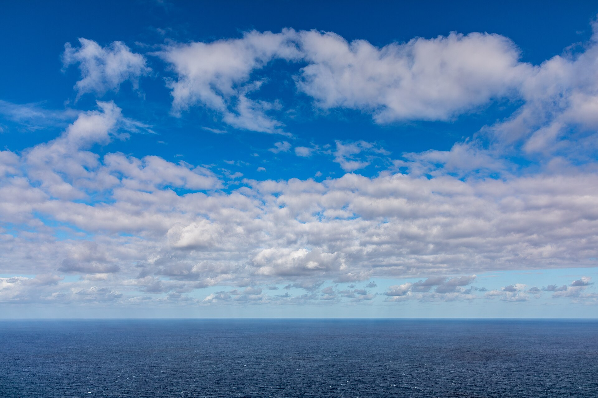
The lighthouse at Ponta do Pargo on the western cliffs
End the day at the Ponta do Pargo lighthouse, perched on the island's westernmost cliffs — one of the finest spots on Madeira to watch the sun drop into the Atlantic.

DAY 7 Levada Walks & Garden Paradise
25 Fontes levada walk
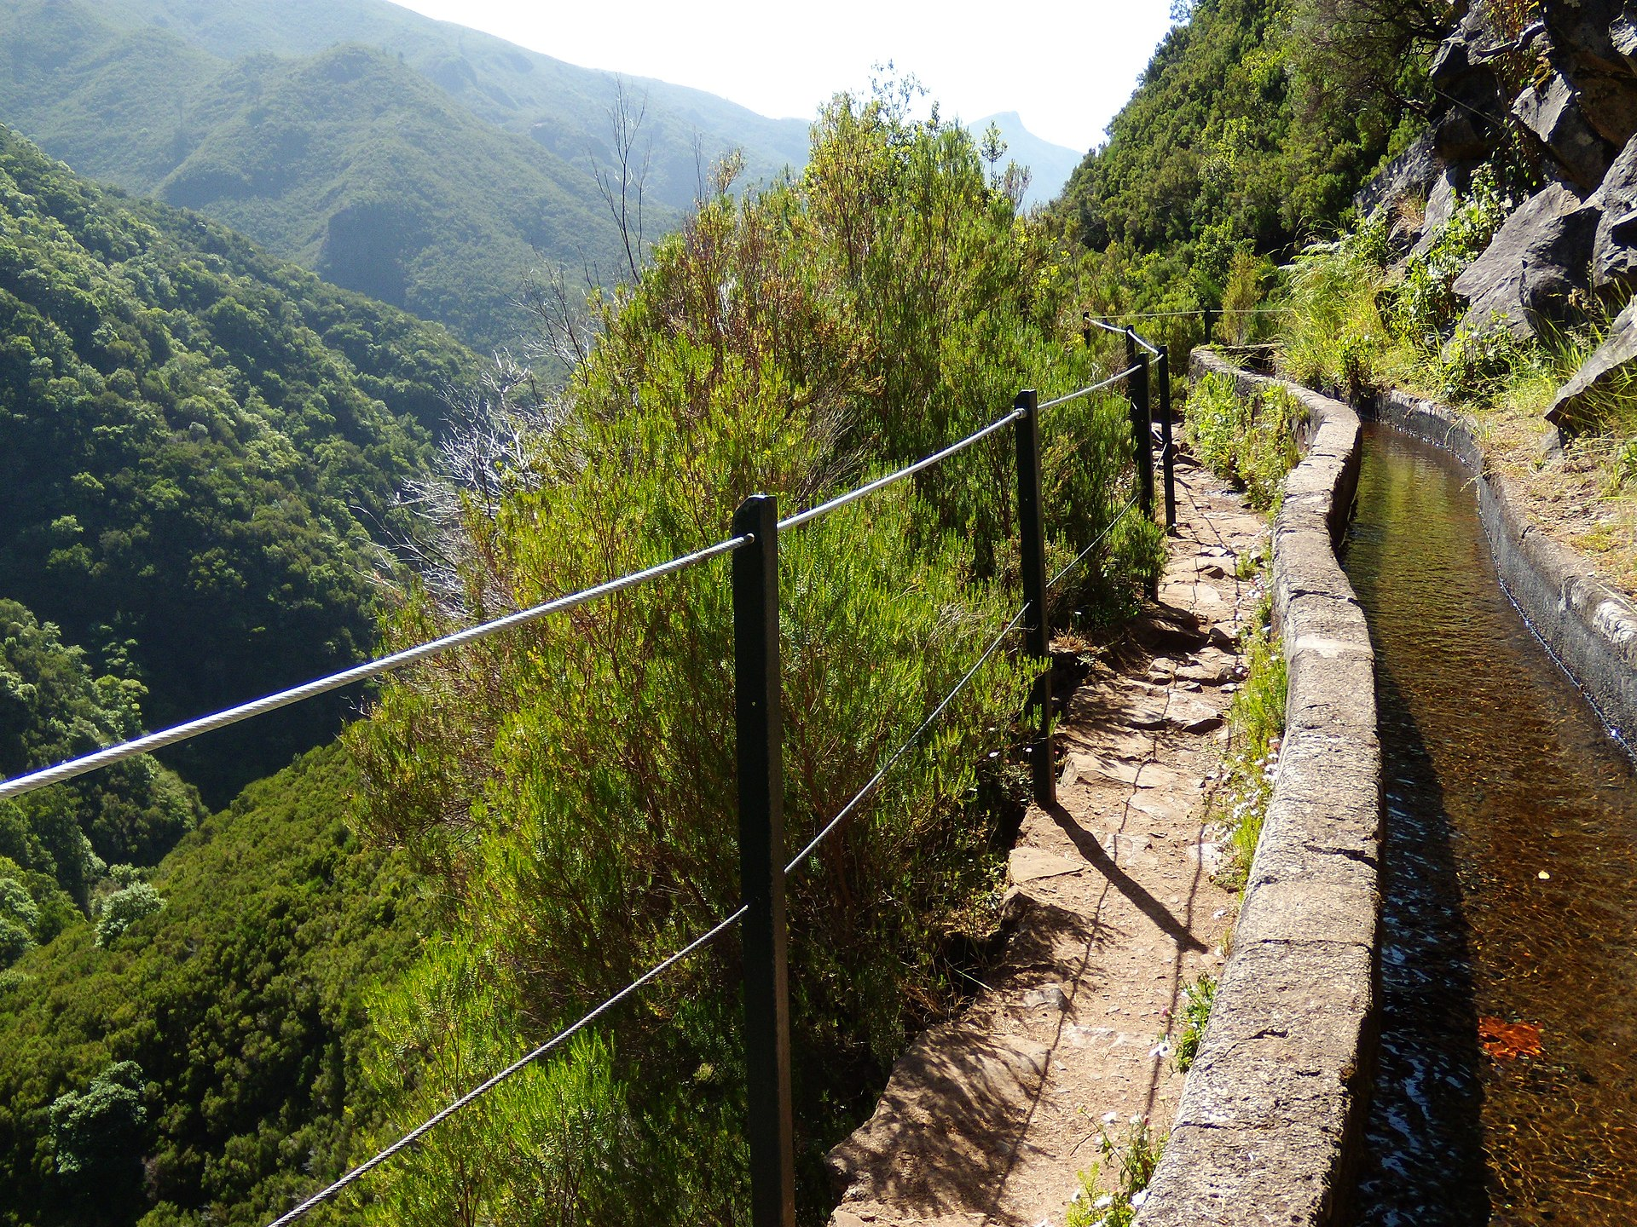
The green levada path leading to the 25 Fontes springs
TRAIL 8.6 km · 3 hrs · Easy
Follow the classic 25 Fontes levada, one of Madeira's best-loved walks, tracing a hand-built irrigation channel through the forest to a natural amphitheatre where twenty-five springs feed a crystal-clear lagoon.
Monte Palace Tropical Garden
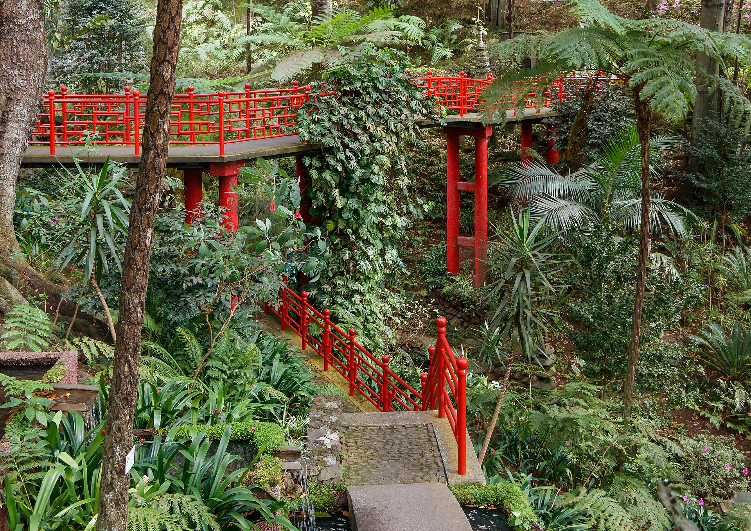
Oriental bridges and lush planting at the Monte Palace Tropical Garden
Explore the Monte Palace Tropical Garden on the hillside above Funchal — a lush terraced paradise of exotic plants gathered from around the world, koi ponds, tilework and vivid oriental bridges.
The Monte toboggan ride
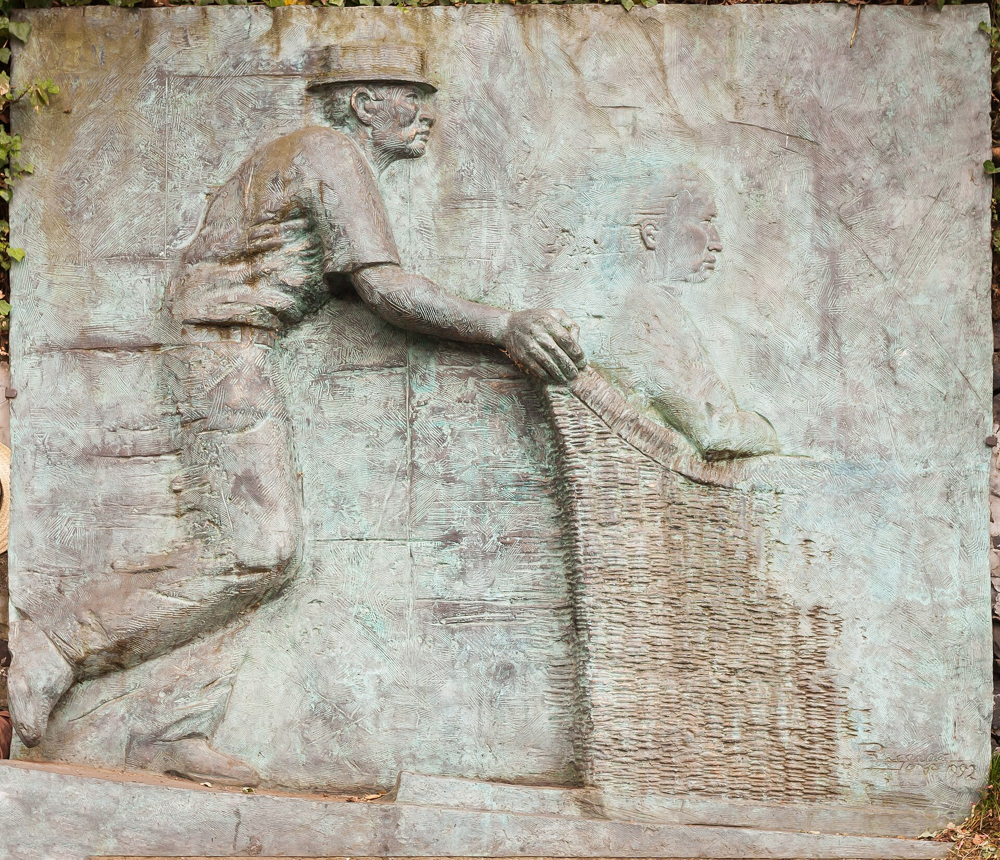
The traditional wicker toboggans (carros de cesto) of Monte
Cap the week with the traditional Monte sledge ride: a wicker-toboggan descent through the streets of Monte, steered by straw-hatted drivers in a Madeiran tradition dating back nearly two centuries. A farewell dinner brings the group together one last time.

DAY 8 Farewell to Madeira
A final morning to reflect on the week's adventures. Enjoy some last-minute shopping or a gentle stroll through Funchal before heading to the airport for your departure. Até já, Madeira — until next time.

Photo Credits
All photographs are sourced from Wikimedia Commons and reproduced here under their respective licences. Titles link to the source file.
Capsicum - Mercado Municipal Funchal 02.jpg — H. Zell · CC BY-SA 3.0
Ponta de São Lourenço, Madeira, Portugal, 2019-05-28, DD 10.jpg — Diego Delso · CC BY-SA 4.0
Madeira-Atlantic-Margarita Sunset-Whale and Dolphin Watching Tours-01ASD.jpg — Asurnipal · CC BY-SA 4.0
Madeira-Santana-Pico Ruivo-hiking trail PR 1-2 (top)-01ASD.jpg — Asurnipal · CC BY-SA 4.0
Doca do Cavacas - Funchal 01.jpg — H. Zell · CC BY-SA 3.0
Levada do Caldeirão Verde, Madeira - Aug 2012 - 01.jpg — cudi · CC BY 2.0
Machico, Madeira.jpg — <<graham>> · CC BY 2.0
2016- Corga próxima ao Véu da Noiva. Madeira. Portugal-5.jpg — Luis Miguel Bugallo Sánchez (Lmbuga) · CC BY-SA 4.0
Fanal (Madeira, Portugal), Lorbeerwald -- 2025 -- 1517.jpg — Dietmar Rabich · CC BY-SA 4.0
Madseira. Porto Moniz – North Coast, natural swimming pools. These are probably the most famous pools in Madeira. This pool is not natural and a fee is required. (51859649088).jpg — Anne and David from Kent, England UK · Public domain
Capela do Espírito Santo, Lombada, Ponta do Sol, Madeira - IMG 20190411 163629.jpg — PESP/ Wikimedia · CC BY-SA 4.0
2016. Cabo Girão. Madeira. Portugal.jpg — Luis Miguel Bugallo Sánchez (Lmbuga) · CC BY-SA 4.0
Ponta do Pargo (Madeira, Portugal), Farol da Ponta do Pargo, Blick auf den Atlantik -- 2025 -- 1805.jpg — Dietmar Rabich · CC BY-SA 4.0
Levada 25 Fontes, Madeira, Portugal, June-July 2011 - panoramio (30).jpg — anagh · CC BY-SA 3.0
Monte Palace Tropical Garden - Oriental Gardens 03.jpg — H. Zell · CC BY-SA 3.0
2016. Carros de cesto do Monte. Monte. Funchal. Madeira. Portugal.jpg — Luis Miguel Bugallo Sánchez (Lmbuga) · CC BY-SA 4.0

