- Remark – Could you please make the “Remark” box with two visible rows. Now it 3 rows. The box look too big.
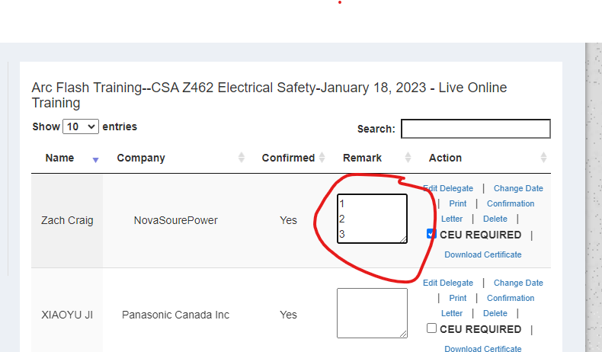

- Change Date and Course – I see this “Change Date” is listed based on the order of the dates. Could you please list based on the Course Name Alphabetically which is more easy to find out the course. Please refer to the second screen shot.

- Question-1: the course and the date, we always change them time to time. If this list will be changed accordingly?

- Question -2: I saw that the courses listed are all for 2023. If at the end of the year, student want to transfer to next year 2024 course. What should I do?
- 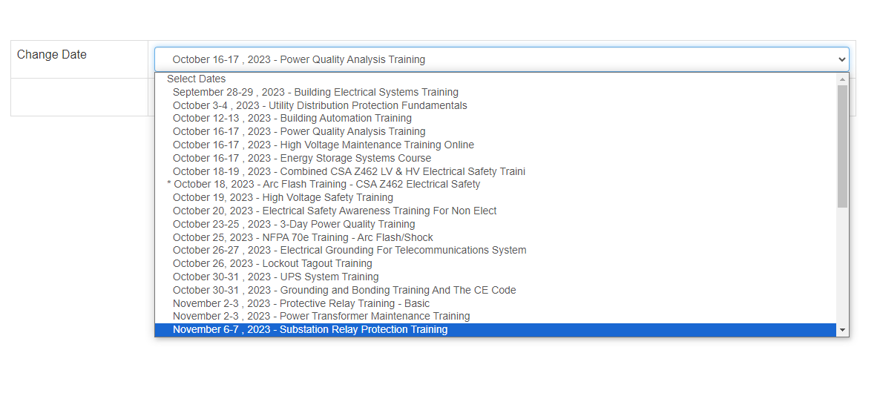

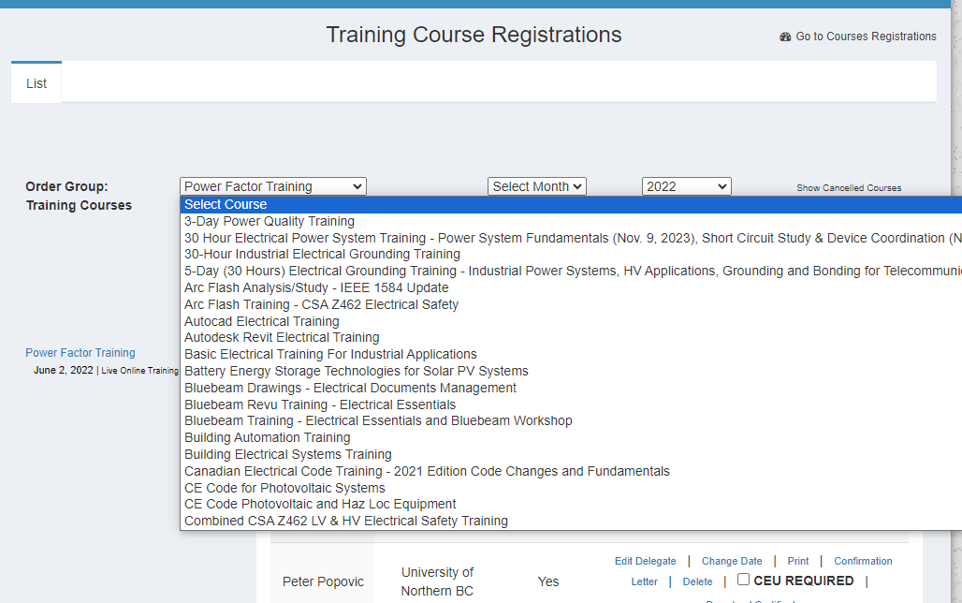

For example, looks like this:

Arc Flash CSA Z462 - October 3, 2023
Arc Flash CSA Z462 - November 8, 2023
Arc Flash CSA Z462 - December 12, 2023
Basic Electrical Testing - Oct 2-3, 2023
Basic Electrical Testing - December 12-13, 2023
CE Code Training - October 5-6, 2023
CE Code Training - November 23-24, 2023

