BCPR203 Database Management Systems

Assignment One:

Signal Tester Log Database Analysis

for Vector Advanced Metering Services (AMS)

Student: Harry Lo

Table of Contents

1. Introduction 2

2. Version Control 2

3. Data Cleansing 3

4. Database Normalisation 3

4.1. First and Second Normal Form 3

4.1.1. Composite Primary Key Representing Logfile 4

4.1.2. Multivalued Attributes 4

4.1.3. Composite Attribute in Multivalued Attribute 4

4.1.4. Constant-Value Attribute 4

4.1.5. Introduced Synthetic Keys (Primary, Foreign and Unique Keys) 5

4.1.6. Derivable Attribute 5

4.1.7. Additional Frequency Band Data Set 6

4.1.8. Suggestion 2 of Normalisation 6

4.2. Third Normal Form 7

5. Entity Relationship 7

5.1. Entity 7

5.2. Identify Entity Relationship Diagram 7

5.3. Unique Key 8

5.4. Job and Log relationship 8

6. Database Building 8

6.1. Data Dictionary 8

6.2. Implementation 8

7. Suggestions 9

Appendix 1: Logfiles after Data Cleansing (corrected data are highlighted in yellow) 29

List of Figures

Figure 1a: 1st & 2nd Normal Form (Suggestion 1)……………………………………………10

Figure 1b: 1st & 2nd Normal Form (Suggestion 2)……………………………………………11

Figure 2a: 3rd Normal Form (Suggestion 1)…………………………………………..………12

Figure 2b: 3rd Normal Form (Suggestion 2)……………………………………………..……13

Figure 3a: Entity Relationship (Suggestion 1)…………………………………………..……14

Figure 3b: Entity Relationship (Suggestion 2)…………………………………………..……15

Figure 4a: Entity Relationship Diagram (Suggestion 1)…………………………….…..……16

Figure 4b: Entity Relationship Diagram (Suggestion 2)………………………………...……17

Figure 5: Entity Relationship Diagram by MySQL Workbench Reverse Engineer……...……18

Figure 6: Correlations between signal strength and quality in different frequency bands……19

Figure 7: Example of Amendment Record in Repository for Version Control ………………19

List of Tables

Table 1: Data Cleansing Records…………………………………….……..…………...……20

Table 2: Data Dictionary for AMS Signal Tester Log Database Analysis (Suggestion 1) ……22

# Introduction

A client requested for conducting a study to examine the feasibility of building a database for handling their radio frequency signal test data. Six sample signal test logfiles were given for initial reference.

This report performed data cleansing, normalisation, database building and database testing including data insertion and queries. Two normalisations (refer to suggestion 1 and suggestion 2 hereinafter) are suggested. Suggestion 1 is to solely consider the given logfiles to show the feasibility of building a valid and workable database for the client’s purpose. Suggestion 2 is to propose a database system to show the feasibility of matching with an assumed existing database system. Due to the limited resources in this preliminary stage, only the database for suggestion 1 was actually built for demonstrating the feasibility. For suggestion 2, a simplified entity relationship diagram was created for presenting the initial idea. MySQL scripts for creating the database, inserting the data and preforming queries were written in files for record.

This study shows that the database for suggestion 1 is workable and for suggestion 2 should be feasible. All the materials produced for this report were kept in a repository below for reference.

# Version Control

All the information produced by this report is kept under a GitHub in a repository <https://github.com/harrykhlo/DatabaseAnalysis> for a version control and your reference.

In the repository, the composed final report combining all materials (i.e. including a signed cover sheet, draft report and Table 2: data dictionary) except the script files is in HarryBCPR203FinalReport.pdf; the draft report is in HarryBCPR203AssignmentReport.docx; the diagrams of normalisations and entity relationships are given in NormalizationERD.vsdx and NormalizationERD.pdf (note: pdf format for who don’t have Visio to read vsdx format); the data dictionary for the suggestion 1 of the entity relationships is given in DataDictionaryERDs1.doc; the SQL scripts for building the database and tables (Suggestion 1) are given in SignalTesterLogTables.sql; the SQL scripts for inserting the data of the six sample logfiles are given in SignalTesterLogData.sql; the SQL scripts for writing queries are given in SignalTesterLogQueries.sql; the Entity Relationship Diagram by MySQL Workbench Reverse Engineer is given in MySQL-ERD.pdf; Four graphs plotting the correlations between signal strength and signal quality in term of frequency bands as shown in Figure 6 is given in CorelationBtwSignalStrengthQuality.xlsx; the draft assignment cover sheet is in AssignmentCoverSheet.docx.

In the repository, all the file amendments are being recorded. For example, every time I changed the entity relationship diagram in the file NormalizationERD.vsdx, then I upload it and put down commit on the record in which you can see what and when I have changed as shown in Figure 7. In this repository, I can get back any outdated copies of the files that I have uploaded according to the records (e.g. Figure 7).

# Data Cleansing

There were some incorrect and inaccurate data in the given logfiles, so data cleansing was conducted to modify the corresponding data in order to improve the data integrity in the new database I built for this report. The incorrect or inaccurate data found in the logfiles as well as the corresponding amendments are given in the Table 1. The corrected sample logfiles after the data cleansing are shown in Appendix 1 in which the modified data are highlighted in yellow.

# Database Normalisation

This report suggested two normalisations. Suggestion 1 is to solely consider the given logfiles to show the feasibility of building a valid and workable database for the client’s purpose. Suggestion 2 is to propose a database system to show the feasibility of matching with an assumed existing database system. The following subsections will discuss the common issues in the both suggestions, and also there will be a subsection further discussing the suggestion 2. The normalisations and entity relations of the both suggestions are shown in Figure 1a, Figure 1a, Figure 2a, Figure 2b, Figure 3a, Figure 3b, Figure 4a and Figure 4b accordingly. However, due to the limited resources in this stage, only the database for suggestion 1 was actually built for demonstrating the feasibility.

## First and Second Normal Form

In a special situation of this data set, this report found that the first and second normal forms are the same. This report determined a composite key as shown in Figure 1a and Figure 1b to uniquely represent a logfile. The determination of this composite key will be further discussed in the subsection below. This composite key enables all the items of the logfile to depend on this composite key. In other word, there is only one partial dependency in this data system as shown in Figure 1a and Figure 1b. The second normal from is to separate the partial dependencies. There is only one partial dependency, so no separation of partial dependencies can be done. Therefore, the first and second normal forms are the same as shown in Figure 1a and Figure 1b.

For the first normal form, there should not be multivalued and composite attributes. This report eliminated those multivalued and composite attributes such as Raw Array items and BT Signal item as shown in Figure 1a and Figure 1b. The elimination of those multivalued and composite attributes will be further discussed in the subsection below.

There are derivable attributes in the logfiles. They should be removed from the database. However, they are temporarily retained in the database as shown in Figure 1a and Figure 1b for a verification purpose. These derivable attributes will be further discussed in the subsection below.

There is a set of constant parameters in the logfiles. The method of handling these constant-value attributes will be further discussed in the subsection below.

### Composite Primary Key Representing Logfile

A composite primary key consisting of the Bluetooth Name, the Work Order and the Date (note: this date item in the logfile is actually a datetime attribute) as shown in Figure 1a and Figure 1b was chosen to represent an entire individual signal tester logfile. For convenient propose, a synthetic primary key named logId (note: this will be further discussed in the following subsection) was introduced to represent this composite key. The representatives from Vector mentioned that the Bluetooth Name in the logfile is unique and the combination of the Work Order and Date in the logfile is unique too. However, I have reservation about the uniqueness of the either the Bluetooth name or the combination of the Work Order and Date. I suspect the Bluetooth name would be repeated in a certain period of long time but I believe that it would not be repeated in a short period of time such as one second. The combination of the work order and the date might be duplicated if there were two different users working on the same work order and recording the logfile at the same time for different tests. Although the possibility of recording the logfile at the same time is low, it should be considered. This timing drawback to the work-order-date combination can be overcome by incorporating the Bluetooth name (note: it is unique at a short period of time such as one second) into the composite key. In other word, even if two users working on the same work order and recording the logfile at the same time for different tests, the Bluetooth names are not the same because the Bluetooth name cannot repeat at the same time. In this case, this combination of composite primary key can create the uniqueness. Hence, I suggested to use the composite primary key of the three attributes that are the Bluetooth Name, the Work Order and the Date (i.e. an aforementioned datetime attribute) to uniquely represent the logfile.

### Multivalued Attributes

There are two sets of multivalued attributes in the logfiles. They are Raw Array items (i.e. 42nd to 46th items of logfiles) and BT Signal item (i.e. 47th item of logfiles). In order to effectively handle those multivalued attributes, Raw Array items and BT Signal item were split into a number of attributes and a number of tuple (or data) as shown in Figure 1a and Figure 1b. Those corresponding attributes have a transitive dependency relationship.

There is a foreign key and a synthetic primary key introduced into the group of the separated attributes of the multivalued attributes to form a transitive dependency. This introduction of keys will be further discussed in the subsection below.

### Composite Attribute in Multivalued Attribute

In side the multivalued Raw Array items (i.e. 42nd to 46th item of logfiles), each value is a composite component consisting of signal strength, signal quality and frequency number. These parameters are required to be separated into the individual attributes among which there are transitive dependencies as shown in Figure 1a and Figure 1b.

### Constant-Value Attribute

In the logfiles, there is a set of constant parameters which are threshold items (i.e. 26th to 31st item of logfiles). They are repeated the same set of values in all given sample logfiles. There are transitive dependencies among those constant-value attributes as shown in Figure 1a and Figure 1b. There is a synthetic primary key introduced into this group of attributes. This synthetic primary key will be further discussed in the subsection below.

### Introduced Synthetic Keys (Primary, Foreign and Unique Keys)

There were the multivalued attributes, the constant-value attributes and the composite primary key discussed above in which synthetic keys were introduced.

A synthetic primary key named logId was introduced to represent the composite key consisting of the Bluetooth Name, the Work Order and the Date as shown in Figure 1a and Figure 1b. This logId conveniently and uniquely represented the combination of the aforementioned three crucial attributes. A transitive dependency is also created between them, they will be separated from the group of partial dependency in the third normal form in which this logId will act as a primary, foreign and unique keys in various tables. These keys will further be discussed in the subsection of third normal form below.

Other synthetic primary keys were introduced to uniquely represent the corresponding groups of multivalued attributes and constant-value attributes accordingly as shown in Figure 1a and Figure 1b. The synthetic primary key for the constant-value attributes will also become a foreign in another group of attributes in the coming third normal form which will be discussed below. Each corresponding group of attributes with its synthetic primary key formed a transitive dependency which will be separated in the third normal form and discussed in the subsection of third normal form below.

In general, the primary key is to represent the uniqueness of the group of attributes with either the transitive dependency or the partial dependency; the foreign key is to maintain the relationships between various groups of attributes; the unique key is to creates a unique relationship between two group of attributes (i.e. two entities). These will be discussed in the subsection of third normal form below.

### Derivable Attribute

There are derivable attributes in the logfiles. They are Antenna Test Type, Signal Result, RSSI, RSCP and RSRP items (i.e. 5th to 25th item of logfiles). They should be removed from the database. However, they are temporarily retained in the database as shown in Figure 1a and Figure 1b for a verification purpose.

The antenna test type can be found from the modem status items (i.e. 60th to 64th item of logfiles).

The Signal Results can be determined whether pass or fail by comparing the corresponding RSSI, RSCP or RSRP items with the corresponding Threshold items (i.e. 26th to 31st item of the logfiles).

The RSSI, RSCP and RSRP items are an average value of particular set of signal strength values in the Raw Array items (i.e. 42nd to 46th item of logfiles). However, there are a lot of different scenarios and various sets of formulations for determining the average strength. In our limited data sets, I observed few of their relationship as below:

a) RSSI is an average signal strength of frequeny-i from external modem (refer to 4.txt file)

i) For example, in 4.txt file, the average signal strength of frequeny-i is 9 to be 9 x 30 / 30 = 9 from the raw array data.

b) RSCP is an average signal strength of either frequency-1, -2 or -3 and together with frequency-0 but the strength value 99 of frequency-0 is ignored.

i) For example, in 2.txt file, the Raw Array Vodafone Blade is ["39_33-1", "39_33-1", "39_37-1", "99_99-0", "99_99-0", "99_99-0", "99_99-0", "99_99-0", "40_18-4", "40_18-4", "40_18-4", "39_29-4", "39_23-4", "39_23-4", "40_29-4"]; and

ii) The corresponding RSCP Vodafone Blade is equal to 39 x 3 / 8 = 14.625 which is the sum of frequency-1 signal strength (i.e. 3 x 39 from the raw array above) divided by the total number of frequency-1 samples and frequency-0 samples from the raw array above (i.e. 3 + 5 = 8).

c) RSRP is an average signal strength of either frequency-4, -5, -6 or -7 and together with frequency-0 but the strength value 99 of frequency-0 is ignored.

i) For example, in the same Raw Array of the 2.txt file above; and

ii) The corresponding RSRP Vodafone Blade is equal to (4 x 40 + 3 x 39)/12 = 23.083 which is the sum of frequency-4 signal strength (i.e. 4 x 40 + 3 x 39 from the raw array above) divided by the total number of frequency-4 samples and frequency-0 samples from the raw array above (i.e. 7 + 5 = 12).

However, those are only parts of their relationship. This report recommends that those aforementioned derivable attributes should be removed once the verifications of those relationships have been satisfied. For now, this report suggests that they are temporarily retained in the database as shown in Figure 1a and Figure 1b for a testing and clarifying purpose.

### Additional Frequency Band Data Set

The frequency band data set does not exist in the logfile. However, the client required the frequency band can be found in the system. There is the frequency number attribute in the Raw Array items (i.e. 42nd to 46th items of logfiles) referring to the frequency band. This frequency band data set can be added into the database to have a transitive dependency with the frequency number attribute as shown in Figure 1a and Figure 1b.

### Suggestion 2 of Normalisation

This report suggested two normalisations in Figure 1a and Figure 1b respectively. The suggestion 1 is to solely consider the given logfiles in order to show the feasibility of building a valid and workable database. Suggestion 2 is to propose a database system in order to show the feasibility of extension to match an assumed existing database system.

The existing database system is assumed to have material (or equipment) inventory database, vendor database and human resource database. In the inventory, I suppose there would be every equipment to be an entity. In the human resource system, there would be employee entities. In the vendor database, there would be supplier (or network provider) entities. In order to match the existing database, the similar entities also be suggested to be created in the suggestion 2 of the normalisations. The potential entities, which can be found in the existing logfile for this case, are TechUser for matching existing human resource database, and also Vodafone and Telstra for matching the vendor database, as well as Tablet, Signal Tester Device, Modem, SIM, Antenna for matching the material inventory database. The suggestion 2 is only for illustration propose to show the idea, so there are only few entities are created for simplifying the illustration of the idea. In the first and second normal forms of the suggestion 2 shown in Figure 1b, there are some additional transitive dependencies (compared with the suggestion 1 in Figure 1a) among the attributes relating to the aforementioned entities in the assumed existing system. The created entities for the suggestion 2 will be more easily and clearly illustrated in the subsection of third normal form below. This approach to match the existing system would avoid anomalies because the additional transitive dependencies are created. The transitive dependencies will be separated to from different tables in the third normal form.

For derivable attributes in the suggestion 2 of normalisation, this report suggests to separate them out from the other parts of the database in order to easily remove it in the further development. The removal would effectively reduce the database size. The separation would avoid a risk of anomalies in the further development when the derivable attributes are removed.

## Third Normal Form

In third normal form, all the transitive dependencies have to be separated. In the subsections above, I defined the transitive dependencies for the composite primary key, multivalued attributes, composite attributes, constant-value attribute as well as the corresponding primary keys, foreign keys and unique key. For second suggestion of normalisation in the subsection above, I defined the transitive dependencies for the entities related to the assumed existing systems.

The particular transitive dependencies described above and shown in Figure 1a and Figure 1b are separated to form the third normal form as shown in Figure 2a and Figure 2b.

# Entity Relationship

## Entity

Every group of the attributes produced from the third normal from as shown in Figure 2a and Figure 2b is an entity in the database this report designs. This report gave every attribute group a descriptive name regarding their nature. In the suggestion 1 of normalisation, there are Log, Job, Threshold, Rf, Bluetooth Signal and Raw Data entities as shown in Figure 2a. In the suggestion 2 of normalisation, other than the entities in the suggestion 1, there are additional entities as mentioned in the subsection of the suggestion 2 of normalisation above to be Antenna, Tablet, Signal Tester Device, SIM set, Modem, Temporary Derivable Result entities as shown in Figure 2b. For suggestion 2, there can be more other entities but, for simplicity, those entities are only used for illustration purpose.

## Identify Entity Relationship Diagram

Those entities would have a relationship between one and others. The cardinality on each individual relationship was carefully examined. Their all individual relationships together with the cardinality are described and illustrated one by one in Figure 3a for the suggestion 1 and in Figure 3b for the suggestion 2.

Those individual relationships are combined in the Entity Relationship Diagram (ERD) in Figure 4a for the suggestion 1 and in Figure 4b for the suggestion 2.

The synthetic keys introduced into the attribute groups in the aforementioned subsections play an important role to link the related entities together as shown in the Entity Relationship Diagrams in Figure 4a and Figure 4b.

The unique key is introduced in the ERD to make the relationship precise between the Job entity and Log entity. This will be discussed in the following subsection.

The entity relationship diagram for Suggestion 1 is implemented in the MySQL in which the diagram is shown in Figure 5. Although the effect of the unique key (i.e. the one to one relationship between Job and Log entities) could not be reflected in the diagram of MySQL workbench which showed one to many relationships, the one to one relationship is performed well in the actual database and tables implemented in this report. The performance of the unique key was tested to be reasonable by using the MySQL scripts. The diagram of MySQL workbench even cannot show the unique key. This might be a shortcoming of MySQL workbench.

## Unique Key

The unique key is introduced in the Job entity (see Figure 4a or Figure 4b) and assigned to the logId which is the foreign key at the same time. I used this unique key to create a one to one relationship between Job and Log entities which will be discussed in the following subsection. In the actual database created by using the script in SignalTesterLogTables.sql, the logId in the Job table cannot be repeated because of this unique key. In the Log table, the logId is a primary key which is unique and cannot be repeated too. The uniqueness of logId in the both Job and Log tables creates the well one to one relationship between them in the actual database created.

## Job and Log relationship

A job is what the user (who name was given in the logfiles) does to get one logfile. Most of the time, the job includes doing two tests using the internal modem with the same antenna to connect to two different network providers. One of the tests connects to Vodafone and the other connects to Telstra. But sometime the job only does one test through the external modem with an unknow antenna connecting to an unknown network. After the tests, the user controls the equipment to send out the logfile, then one job was done. Therefore, one job has one logfile; one log is given by one job. This is the one to one relationship between Jog and Log entities.

# Database Building

## Data Dictionary

In according to the entity relationship diagram (suggestion 1) in Figure 4a, a data dictionary is created in Table 2. The data dictionary gives the information for building the database. The information includes all table names and all attributes’ parameters of the tables such as all the attribute names, descriptions, data types, data lengths, data constraints and key information. In the data constraint column, the information about data cleansing is also included for making sure the database building and data insertion match the data cleansing.

## Implementation

The designed database according to the entity relationship diagram (suggestion 1) in Figure 4a and the data dictionary in Table 2 can be effectively built by using MySQL script in the SignalTesterLogTables.sql file stored in the aforementioned repository <https://github.com/harrykhlo/DatabaseAnalysis>. The data of the 6 sample logfiles (after data cleansing) can be easily inserted by using MySQL script in the SignalTesterLogData.sql file in the repository. Six required queries were written by using MySQL script in the SignalTesterLogQueries.sql to be working in an acceptable condition. This script is also in the repository. One of the queries required to plot the correlations between the signal strength and quality in different frequency bands. The required data for plotting the correlations was extracted by using the script in the file and the correlations are plotted in Figure 6 using Microsoft Excel.

# Suggestions

The report proved that building a valid and workable database for the logfile is feasible. Therefore, further improvement is possible. This report believes that the suggestion 2 of the normalisation would be working well to match the existing database system in the client company as long as the entities discussed in subsection of suggestion 2 above and shown in Figure 4b are correctly chosen to match the existing system.

The derivable attributes and the corresponding derivation have to verify before the removal.

This report expects that the database size would be reduced if a network provider entity and an antenna entity are added. It is because the blank items of some items (e.g. Timeout, SIM, Modem Status and so on) in the logfiles can be removed. Although this reduction might be not significant in a single logfile, the effect of reduction definitely becomes considerable while the number of logfiles is increasing.

Although the effect of the unique key in the actual database was working well for this report, the unique key and its effect are unable to be shown in the diagram (i.e. Figure 5) given by the database reverse engineer of MySQL Workbench. This report therefore suggests to further look into the way to show the unique key in the diagram given by MySQL Workbench.

Further study should be conducted to verify the feasibility of these suggestions.

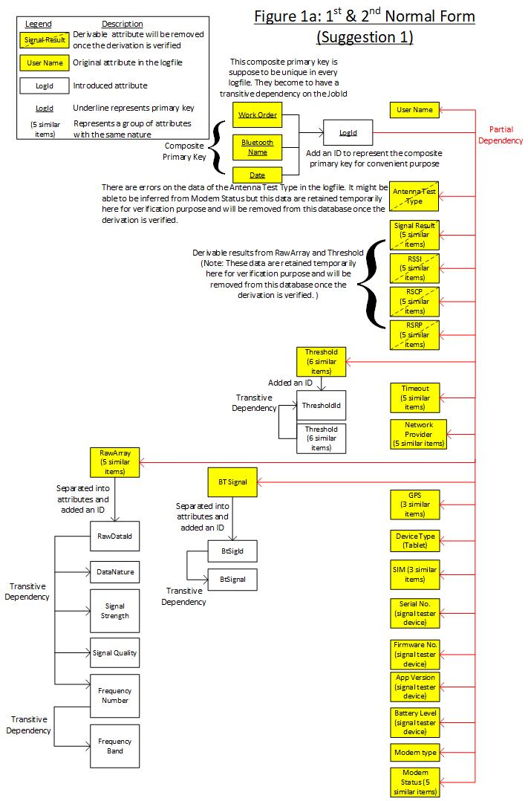

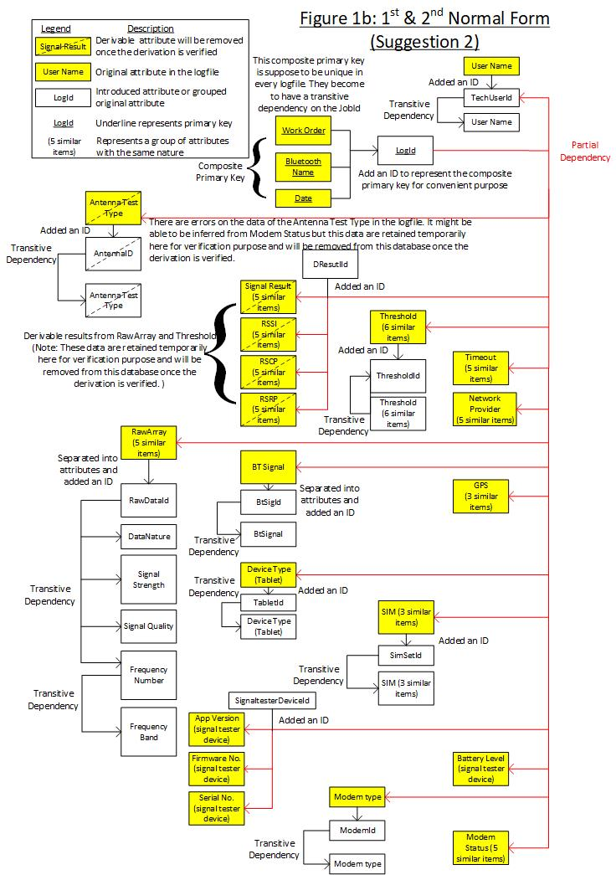

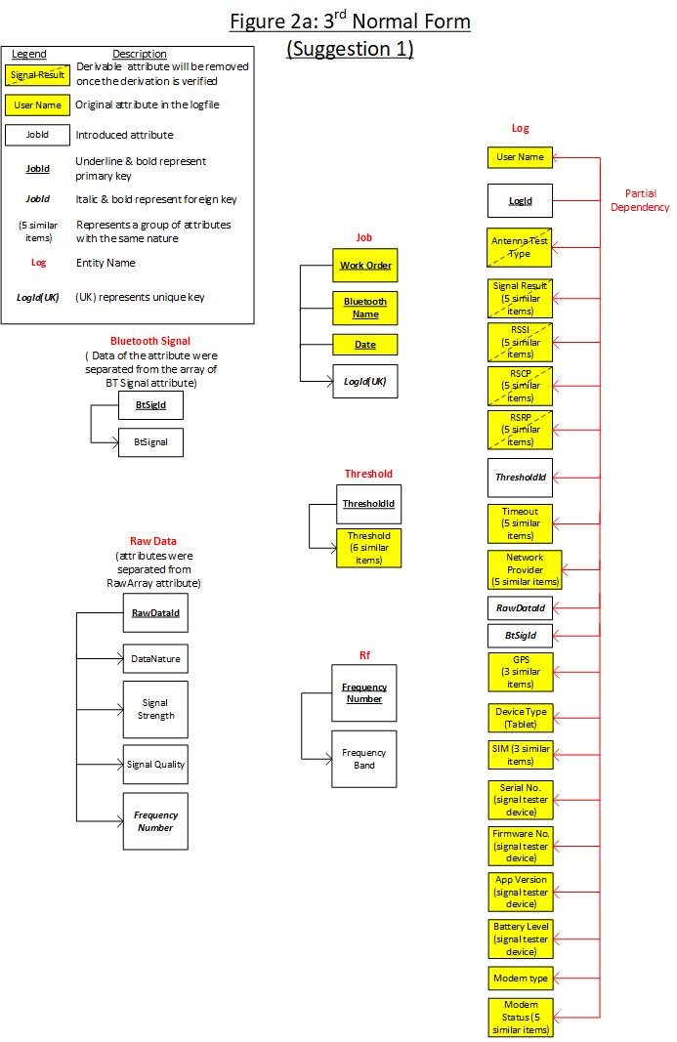

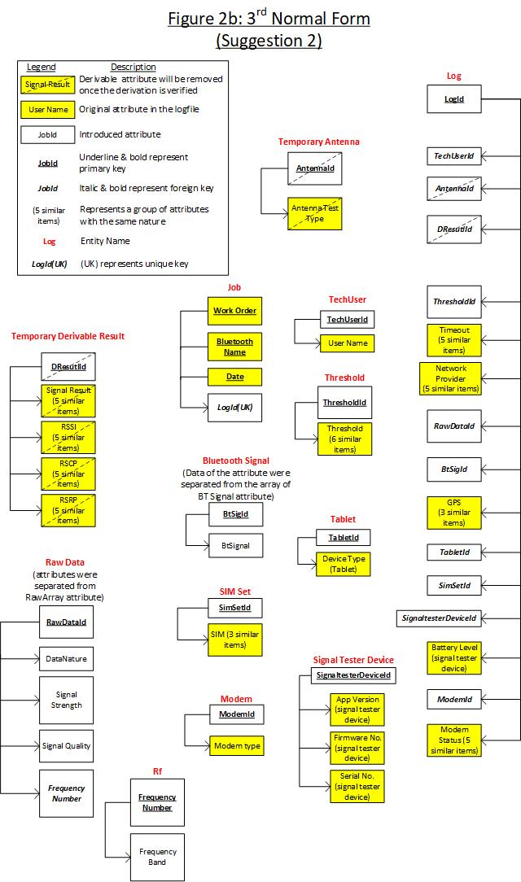

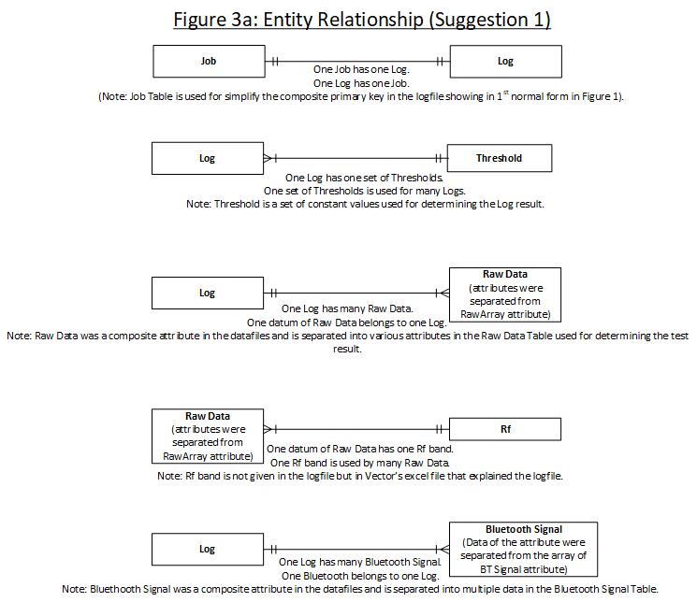

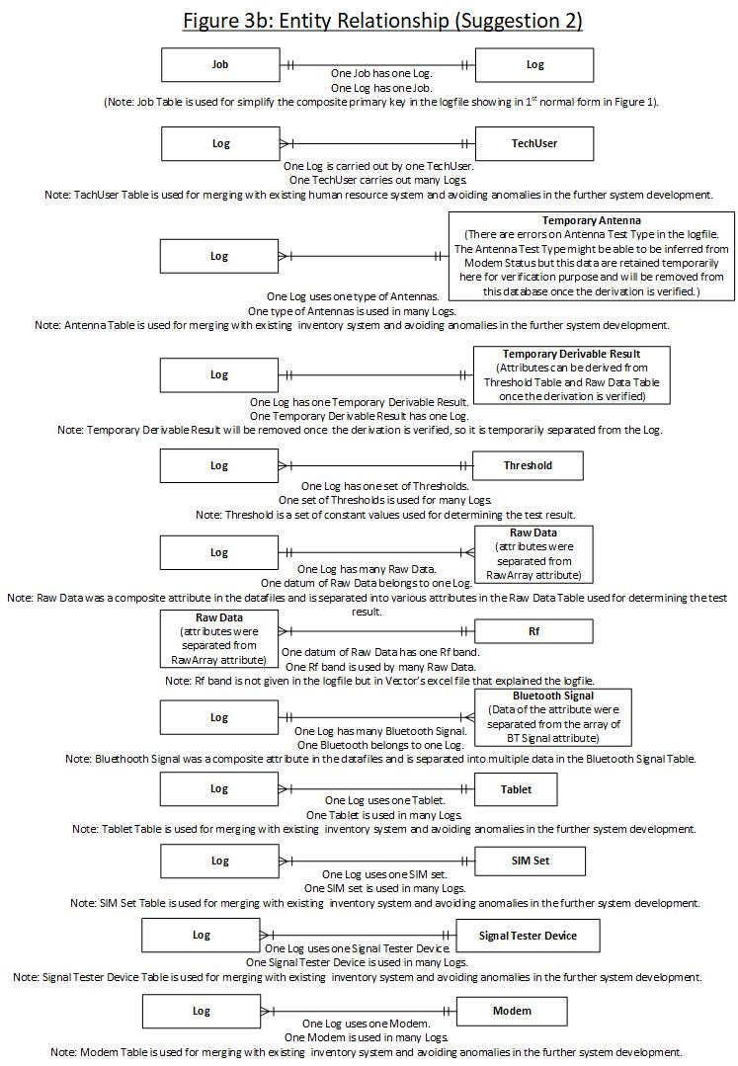

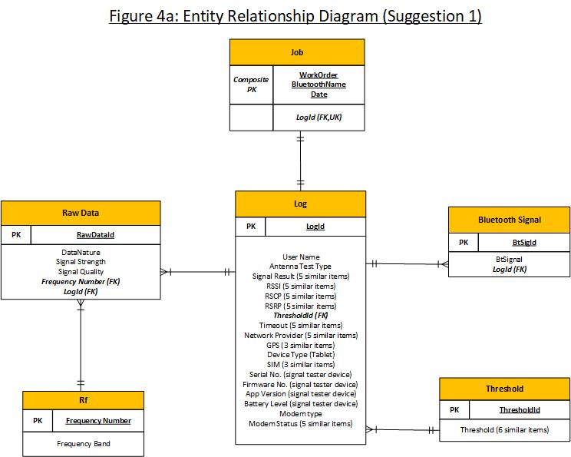

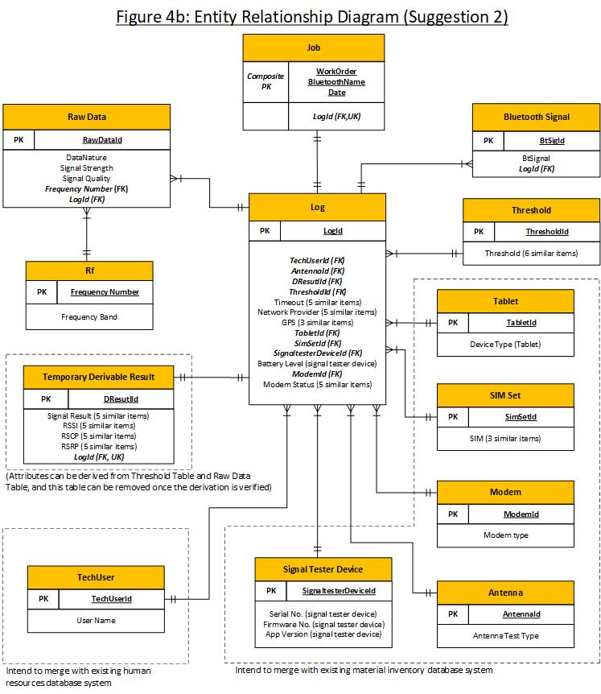

Figure 5: Entity Relationship Diagram by MySQL Workbench Reverse Engineer (Note the Reverse Engineer cannot show the unique key, so the one to one relationship between Job and Log is unable to be displayed correctly here. (See Section 5.2, 5.3 and 5.4 above for further information)

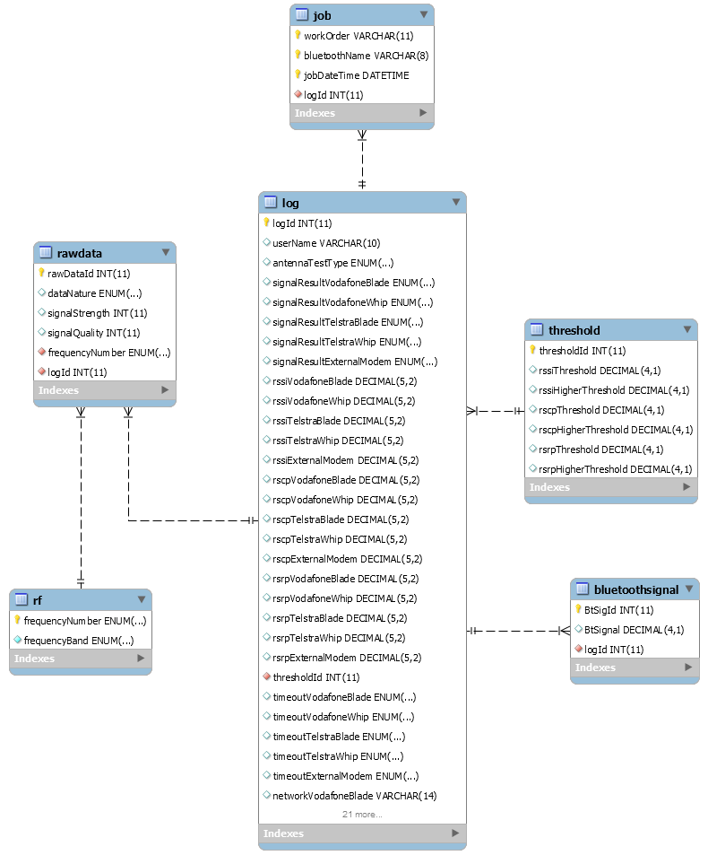

Figure 6: Correlations between signal strength and quality in different frequency bands

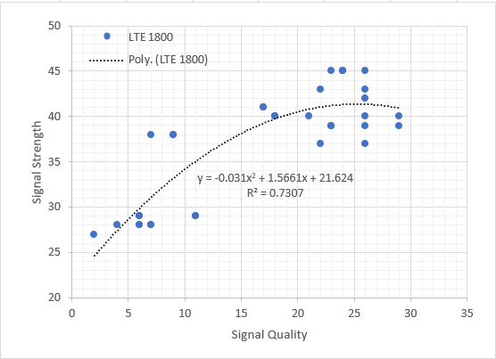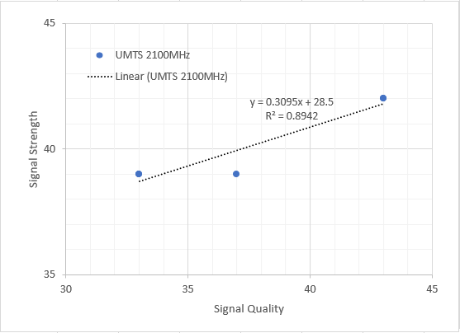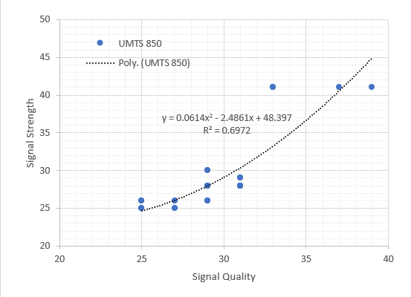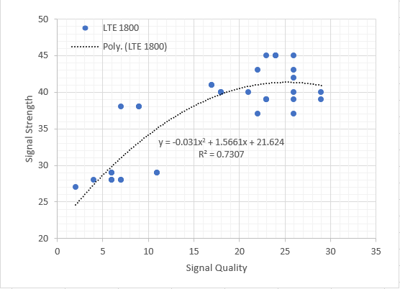

Figure 7: Example of Amendment Record in Repository for Version Control

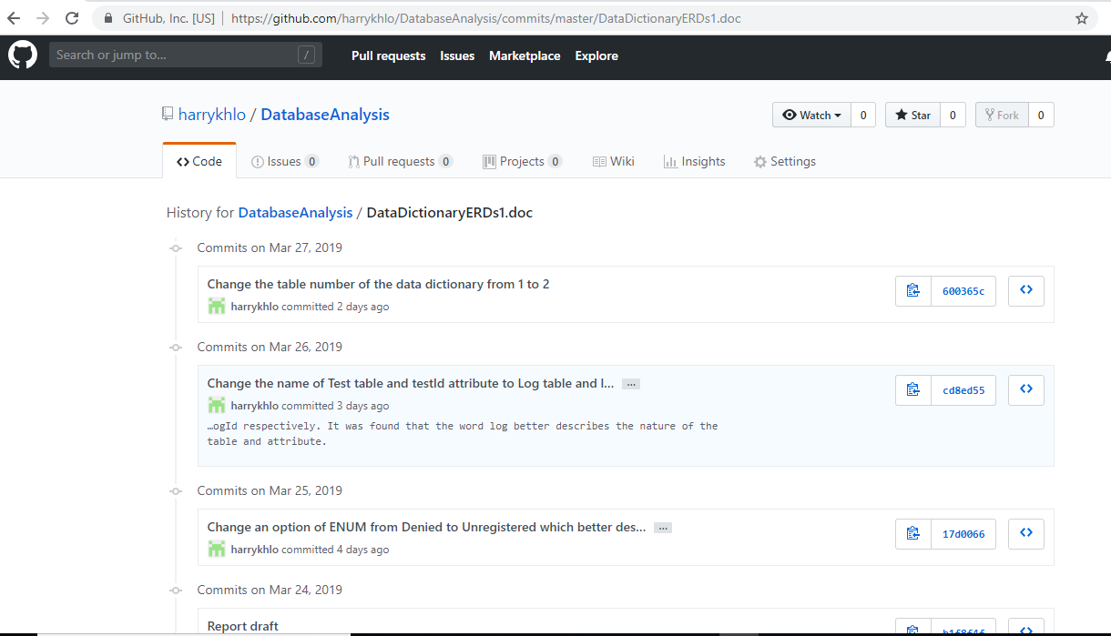

Table 1: Data Cleansing Records

|  |  |  |
| --- | --- | --- |
|  | Incorrect or inaccurate data in given logfiles. | Amended data for building new database. |
| 1 | The value gave at 5th item in logfiles (i.e. Antenna Test Type: Blade and/or Whip). | The value of this item should be either Blade or Whip. This report corrected this value by using the modem status in 60th to 64th item. (Note: Although the client is doing test either for the blade or whip, the test equipment has ability to test blade and whip antennas at the same log. Hence, the data type is prepared to allow the data to be 'Blade', 'Whip' and 'Blade&Whip'). |
| 2 | Signal Results at 6th to 10th item in the logfile showed fail even if the corresponding test was not conducted or network was unregistered. | The incorrect-fail value of these items was changed to “NotTested” or “Unregistered” in according to modem status in 60th to 64th item. |
| 3 | The header name, Signal Result Telstra Blade, at 9th item of the logfile. | This header name was change Signal Result Telstra Whip instead of Blade. |
| 4 | Some zero values at RSSI, RSCP & RSRP items (i.e. 11th to 25th item in logfiles) were not a genuine zero reading. | The RSSI, RSCP & RSRP items are calculated by using Raw Arrays at 42nd to 47th item in logfiles. The ungenuine-zero values at RSSI, RSCP & RSRP items were changed to NULL if the corresponding Raw Array is blank. |
| 5 | For the RSSI, RSCP & RSRP items (i.e. 11th to 25th item in logfiles), client required to round the numerical values to 2 decimal points. | All the valid values were rounded to 2 decimal points. |
| 6 | Some false values at Timeout items (i.e. 32nd to 36th item in logfiles) were not a genuine false value. | Some values of False were not because the tests got False but because the tests were not conducted. The ungenuine-False values were changed to Null. |
| 7 | The Unknown values at Network items (i.e. 37th to 40th item in logfiles) did not reflect the correct situation. | Some Unknown values implied it was not tested; some represented a known network was denied or unable to be registered. The improper Unknown values were changed to NULL or Unregistered for a not-tested case or an unable-registered network respectively in according to the Modem Status items (i.e. 60th to 64th item of logfiles). |
| 8 | Empty arrays [] at the Raw Array items (i.e. 42nd to 46th item of logfiles) were because the tests were not conducted or not able to be conducted. | These empty arrays can be ignored without input in the new database designed in this report. (see the RawData Table in the following Sections). |
| 9 | 16 data were found in the Raw Array (i.e. 42nd to 46th item of logfiles) in 2.txt file and 5.txt file. | This is just a note for noticing the inconsistent number of data. In according to client information, this should be either 15 or 30 data. However. It is not sure if it would need to modified or not. |
| 10 | Frequency number I in Raw Array (i.e. 42nd to 46th item of logfiles) does not have a corresponding frequency band. | The data of frequency band for the frequency number was temporarily given to be NotGiven which will be corrected it once the correct frequency is clarify. |
| 11 | Blank GPS Long and Blank GPS Lat items (i.e. 48th to 49th item of logfiles) were found. | The blank values were changed to NULL. |
| 12 | Blank SIM items (52nd to 54th item of logfiles) were found. | The blank values represented there is no SIM used, so the blank values were changed to NULL. |
| 13 | Blank Modem Status items (60th to 64th item of logfiles) were found. | The blank values represented there is no modem used, so the blank values were changed to NULL. |

Table 2: Data Dictionary for AMS Signal Tester Log Database Analysis (Suggestion 1)

(Note: Table 2, which is in DataDictionaryERDs1.doc, will be incorporated into this report after the report is converted into pdf format)

# Appendix 1: Logfiles after Data Cleansing (corrected data are highlighted in yellow)

Logfile: 1.txt

User Name: Eevee

Work Order: WO-00251301

Bluetooth Name: REAPER

Date: 19-2-2019--13-14

Antenna Test Type: Blade

Signal Result Vodafone Blade: Denied

Signal Result Vodafone Whip: NotTested

Signal Result Telstra Blade: Pass

Signal Result Telstra Whip: NotTested

Signal Result External Modem: NotTested

RSSI Vodafone Blade: NULL

RSSI Vodafone Whip: NULL

RSSI Telstra Blade: NULL

RSSI Telstra Whip: NULL

RSSI External Modem: NULL

RSCP Vodafone Blade: NULL

RSCP Vodafone Whip: NULL

RSCP Telstra Blade: NULL

RSCP Telstra Whip: NULL

RSCP External Modem: NULL

RSRP Vodafone Blade: NULL

RSRP Vodafone Whip: NULL

RSRP Telstra Blade: 61.13

RSRP Telstra Whip: NULL

RSRP External Modem: NULL

RSSI Threshold: 6.0

RSSI Higher Threshold: 12.0

RSCP Threshold: 15.0

RSCP Higher Threshold: 30.0

RSRP Threshold: 10.0

RSRP Higher Threshold: 20.0

Timeout Vodafone Blade: True

Timeout Vodafone Whip: NULL

Timeout Telstra Blade: False

Timeout Telstra Whip: NULL

Timeout External Modem: NULL

Network Vodafone Blade: Denied

Network Vodafone Whip: NULL

Network Telstra Blade: "Telstra Mobile"

Network Telstra Whip: NULL

Network External Modem: NULL

Raw Array Vodafone Blade: Ignored (not going to insert into database)

Raw Array Vodafone Whip: Ignored (not going to insert into database)

Raw Array Telstra Blade: ["58_12-6", "61_19-6", "61_30-6", "61_30-6", "62_30-6", "62_32-6", "62_32-6", "61_26-6", "61_26-6", "61_30-6", "61_29-6", "61_21-6", "62_27-6", "62_27-6", "61_31-6"]

Raw Array Telstra Whip: Ignored (not going to insert into database)

Raw Array External Modem: Ignored (not going to insert into database)

BT Signal: [-59.0, -52.0]

GPS Long : NULL

GPS Lat: NULL

GPS Accuracy: kCLLocationAccuracyKilometer

Device Type: iPad6,12

SIM Vodafone: 89314404000248157530

SIM Telstra: 89610180002243817774

SIM External: NULL

Serial No: SDS-196B

Firmware No: GAT-17R3

App Version No: 2.2.5

Battery Level: 3.92

Modem Type: EWM400

Modem Status Vodafone Blade: Registeration Denied

Modem Status Vodafone Whip: NULL

Modem Status Telstra Blade: Registered, home network

Modem Status Telstra Whip: NULL

Modem Status External: NULL

Logfile: 2.txt

User Name: Pikachu

Work Order: WO-00104116

Bluetooth Name: CORSSRAY

Date: 1-5-2018--8-5

Antenna Test Type: Blade

Signal Result Vodafone Blade: Pass

Signal Result Vodafone Whip: NotTested

Signal Result Telstra Blade: Pass

Signal Result Telstra Whip: NotTested

Signal Result External Modem: NotTested

RSSI Vodafone Blade: NULL

RSSI Vodafone Whip: NULL

RSSI Telstra Blade: NULL

RSSI Telstra Whip: NULL

RSSI External Modem: NULL

RSCP Vodafone Blade: 14.65

RSCP Vodafone Whip: NULL

RSCP Telstra Blade: 20.5

RSCP Telstra Whip: NULL

RSCP External Modem: NULL

RSRP Vodafone Blade: 23.08

RSRP Vodafone Whip: NULL

RSRP Telstra Blade: 21.77

RSRP Telstra Whip: NULL

RSRP External Modem: NULL

RSSI Threshold: 6.0

RSSI Higher Threshold: 12.0

RSCP Threshold: 15.0

RSCP Higher Threshold: 30.0

RSRP Threshold: 10.0

RSRP Higher Threshold: 20.0

Timeout Vodafone Blade: False

Timeout Vodafone Whip: NULL

Timeout Telstra Blade: False

Timeout Telstra Whip: NULL

Timeout External Modem: NULL

Network Vodafone Blade: "vodafone AU"

Network Vodafone Whip: NULL

Network Telstra Blade: "Telstra Mobile"

Network Telstra Whip: NULL

Network External Modem: NULL

Raw Array Vodafone Blade: ["39_33-1", "39_33-1", "39_37-1", "99_99-0", "99_99-0", "99_99-0", "99_99-0", "99_99-0", "40_18-4", "40_18-4", "40_18-4", "39_29-4", "39_23-4", "39_23-4", "40_29-4"]

Raw Array Vodafone Whip: Ignored (not going to insert into database)

Raw Array Telstra Blade: ["41_33-2", "41_33-2", "41_33-2", "99_99-0", "99_99-0", "99_99-0", "28_6-4", "29_6-4", "29_6-4", "28_4-4", "28_7-4", "27_2-4", "28_6-4", "29_11-4", "29_11-4", "28_7-4"]

Raw Array Telstra Whip: Ignored (not going to insert into database)

Raw Array External Modem: Ignored (not going to insert into database)

BT Signal: [-76.0, -72.0, -66.0]

GPS Long :152.752432376289

GPS Lat: -27.6047716895375

GPS Accuracy: kCLLocationAccuracyKilometer

Device Type: iPad Air

SIM Vodafone: 89314404000248186935

SIM Telstra: 89610180002249048341

SIM External: NULL

Serial No: SDS-043C

Firmware No: GAT-17R3

App Version No: 2.2.5

Battery Level: 3.92

Modem Type: EWM400

Modem Status Vodafone Blade: Registered, Roaming

Modem Status Vodafone Whip: NULL

Modem Status Telstra Blade: Registered, home network

Modem Status Telstra Whip: NULL

Modem Status External: NULL

Logfile: 3.txt

User Name: Celebi

Work Order: WO-00105349

Bluetooth Name: DIXIE

Date: 30-4-2018--14-48

Antenna Test Type: Blade

Signal Result Vodafone Blade: Denied

Signal Result Vodafone Whip: NotTested

Signal Result Telstra Blade: Pass

Signal Result Telstra Whip: NotTested

Signal Result External Modem: NotTested

RSSI Vodafone Blade: NULL

RSSI Vodafone Whip: NULL

RSSI Telstra Blade: NULL

RSSI Telstra Whip: NULL

RSSI External Modem: NULL

RSCP Vodafone Blade: NULL

RSCP Vodafone Whip: NULL

RSCP Telstra Blade: 27.2

RSCP Telstra Whip: NULL

RSCP External Modem: NULL

RSRP Vodafone Blade: NULL

RSRP Vodafone Whip: NULL

RSRP Telstra Blade: NULL

RSRP Telstra Whip: NULL

RSRP External Modem: NULL

RSSI Threshold: 6.0

RSSI Higher Threshold: 12.0

RSCP Threshold: 15.0

RSCP Higher Threshold: 30.0

RSRP Threshold: 10.0

RSRP Higher Threshold: 20.0

Timeout Vodafone Blade: True

Timeout Vodafone Whip: NULL

Timeout Telstra Blade: False

Timeout Telstra Whip: NULL

Timeout External Modem: NULL

Network Vodafone Blade: Denied

Network Vodafone Whip: NULL

Network Telstra Blade: "Telstra Mobile"

Network Telstra Whip: NULL

Network External Modem: NULL

Raw Array Vodafone Blade: Ignored (not going to insert into database)

Raw Array Vodafone Whip: Ignored (not going to insert into database)

Raw Array Telstra Blade: ["28_31-2", "26_27-2", "26_27-2", "26_25-2", "26_25-2", "26_25-2", "25_27-2", "25_27-2", "28_31-2", "28_31-2", "28_31-2", "30_29-2", "30_29-2", "25_25-2", "25_25-2", "25_25-2", "26_29-2", "26_29-2", "26_29-2", "28_29-2", "28_29-2", "28_29-2", "28_29-2", "28_29-2", "29_31-2", "29_31-2", "28_31-2", "28_31-2", "28_31-2", "29_31-2"]

Raw Array Telstra Whip: Ignored (not going to insert into database)

Raw Array External Modem: Ignored (not going to insert into database)

BT Signal: [-83.0, -74.0, -79.0]

GPS Long :139.34259429587

GPS Lat: -35.6776790181507

GPS Accuracy: kCLLocationAccuracyKilometer

Device Type: iPad Air

SIM Vodafone: 89314404000266650267

SIM Telstra: 89610180002249046930

SIM External: NULL

Serial No: SDS-061C

Firmware No: GAT-17R3

App Version No: 2.2.5

Battery Level: 3.88

Modem Type: EWM400

Modem Status Vodafone Blade: Not Registered, searching for network

Modem Status Vodafone Whip: NULL

Modem Status Telstra Blade: Registered, home network

Modem Status Telstra Whip: NULL

Modem Status External: NULL

Logfile: 4.txt

User Name: Snorlax

Work Order: WO-00110610

Bluetooth Name: ASSAM

Date: 17-4-2018--10-41

Antenna Test Type: Blade

Signal Result Vodafone Blade: NotTested

Signal Result Vodafone Whip: NotTested

Signal Result Telstra Blade: NotTested

Signal Result Telstra Whip: NotTested

Signal Result External Modem: Pass

RSSI Vodafone Blade: NULL

RSSI Vodafone Whip: NULL

RSSI Telstra Blade: NULL

RSSI Telstra Whip: NULL

RSSI External Modem: 9.0

RSCP Vodafone Blade: NULL

RSCP Vodafone Whip: NULL

RSCP Telstra Blade: NULL

RSCP Telstra Whip: NULL

RSCP External Modem: NULL

RSRP Vodafone Blade: NULL

RSRP Vodafone Whip: NULL

RSRP Telstra Blade: NULL

RSRP Telstra Whip: NULL

RSRP External Modem: NULL

RSSI Threshold: 6.0

RSSI Higher Threshold: 12.0

RSCP Threshold: 15.0

RSCP Higher Threshold: 30.0

RSRP Threshold: 10.0

RSRP Higher Threshold: 20.0

Timeout Vodafone Blade: NULL

Timeout Vodafone Whip: NULL

Timeout Telstra Blade: NULL

Timeout Telstra Whip: NULL

Timeout External Modem: False

Network Vodafone Blade: NULL

Network Vodafone Whip: NULL

Network Telstra Blade: NULL

Network Telstra Whip: NULL

Network External Modem: "vodafone AU"

Raw Array Vodafone Blade: Ignored (not going to insert into database)

Raw Array Vodafone Whip: Ignored (not going to insert into database)

Raw Array Telstra Blade: Ignored (not going to insert into database)

Raw Array Telstra Whip: Ignored (not going to insert into database)

Raw Array External Modem: ["9_99-I", "9_99-I", "9_99-I", "9_99-I", "9_99-I", "9_99-I", "9_99-I", "9_99-I", "9_99-I", "9_99-I", "9_99-I", "9_99-I", "9_99-I", "9_99-I", "9_99-I", "9_99-I", "9_99-I", "9_99-I", "9_99-I", "9_99-I", "9_99-I", "9_99-I", "9_99-I", "9_99-I", "9_99-I", "9_99-I", "9_99-I", "9_99-I", "9_99-I", "9_99-I"]

BT Signal: [-91.0, -87.0, -81.0, -70.0, -86.0, -74.0, -76.0]

GPS Long :152.984367638172

GPS Lat: -27.4171041995673

GPS Accuracy: kCLLocationAccuracyKilometer

Device Type: iPad6,12

SIM Vodafone: NULL

SIM Telstra: NULL

SIM External: 89314404000266723023

Serial No: SDS-008C

Firmware No: GAT-17R3

App Version No: 2.2.5

Battery Level: 3.94

Modem Type: EWM1000

Modem Status Vodafone Blade: NULL

Modem Status Vodafone Whip: NULL

Modem Status Telstra Blade: NULL

Modem Status Telstra Whip: NULL

Modem Status External: Registered, Roaming

Logfile: 5.txt

User Name: Charizard

Work Order: WO-00110925

Bluetooth Name: DAIBRAVE

Date: 26-4-2018--10-31

Antenna Test Type: Blade

Signal Result Vodafone Blade: Pass

Signal Result Vodafone Whip: NotTested

Signal Result Telstra Blade: Pass

Signal Result Telstra Whip: NotTested

Signal Result External Modem: NotTested

RSSI Vodafone Blade: NULL

RSSI Vodafone Whip: NULL

RSSI Telstra Blade: NULL

RSSI Telstra Whip: NULL

RSSI External Modem: NULL

RSCP Vodafone Blade: 12.0

RSCP Vodafone Whip: NULL

RSCP Telstra Blade: 16.4

RSCP Telstra Whip: NULL

RSCP External Modem: NULL

RSRP Vodafone Blade: 26.92

RSRP Vodafone Whip: NULL

RSRP Telstra Blade: 30.79

RSRP Telstra Whip: NULL

RSRP External Modem: NULL

RSSI Threshold: 6.0

RSSI Higher Threshold: 12.0

RSCP Threshold: 15.0

RSCP Higher Threshold: 30.0

RSRP Threshold: 10.0

RSRP Higher Threshold: 20.0

Timeout Vodafone Blade: False

Timeout Vodafone Whip: NULL

Timeout Telstra Blade: False

Timeout Telstra Whip: NULL

Timeout External Modem: NULL

Network Vodafone Blade: "vodafone AU"

Network Vodafone Whip: NULL

Network Telstra Blade: "Telstra Mobile"

Network Telstra Whip: NULL

Network External Modem: NULL

Raw Array Vodafone Blade: ["42_43-1", "42_43-1", "99_99-0", "99_99-0", "99_99-0", "99_99-0", "99_99-0", "41_17-4", "41_17-4", "43_22-4", "45_24-4", "45_26-4", "45_23-4", "45_24-4", "45_24-4"]

Raw Array Vodafone Whip: Ignored (not going to insert into database)

Raw Array Telstra Blade: ["41_37-2", "41_39-2", "99_99-0", "99_99-0", "99_99-0", "37_22-4", "40_21-4", "43_26-4", "39_23-4", "38_9-4", "38_9-4", "38_7-4", "42_26-4", "37_26-4", "40_26-4", "39_26-4"]

Raw Array Telstra Whip: Ignored (not going to insert into database)

Raw Array External Modem: Ignored (not going to insert into database)

BT Signal: [-76.0, -69.0, -69.0, -76.0, -73.0, -76.0]

GPS Long :153.024695282944

GPS Lat: -27.1806907654062

GPS Accuracy: kCLLocationAccuracyKilometer

Device Type: iPad7,2

SIM Vodafone: 89314404000248233075

SIM Telstra: 89610180002249047685

SIM External: NULL

Serial No: SDS-049C

Firmware No: GAT-17R3

App Version No: 2.2.5

Battery Level: 3.69

Modem Type: EWM400

Modem Status Vodafone Blade: Registered, Roaming

Modem Status Vodafone Whip: NULL

Modem Status Telstra Blade: Registered, home network

Modem Status Telstra Whip: NULL

Modem Status External: NULL

Logfile: 6.txt

User Name: Mewtwo

Work Order: WO-00248593

Bluetooth Name: CARIVOU

Date: 19-2-2019--8-42

Antenna Test Type: Blade

Signal Result Vodafone Blade: Denied

Signal Result Vodafone Whip: NotTested

Signal Result Telstra Blade: Pass

Signal Result Telstra Blade: NotTested

Signal Result External Modem: NotTested

RSSI Vodafone Blade: NULL

RSSI Vodafone Whip: NULL

RSSI Telstra Blade: NULL

RSSI Telstra Whip: NULL

RSSI External Modem: NULL

RSCP Vodafone Blade: NULL

RSCP Vodafone Whip: NULL

RSCP Telstra Blade: NULL

RSCP Telstra Whip: NULL

RSCP External Modem: NULL

RSRP Vodafone Blade: NULL

RSRP Vodafone Whip: NULL

RSRP Telstra Blade: 46.07

RSRP Telstra Whip: NULL

RSRP External Modem: NULL

RSSI Threshold: 6.0

RSSI Higher Threshold: 12.0

RSCP Threshold: 15.0

RSCP Higher Threshold: 30.0

RSRP Threshold: 10.0

RSRP Higher Threshold: 20.0

Timeout Vodafone Blade: True

Timeout Vodafone Whip: NULL

Timeout Telstra Blade: False

Timeout Telstra Whip: NULL

Timeout External Modem: NULL

Network Vodafone Blade: Denied

Network Vodafone Whip: NULL

Network Telstra Blade: "Telstra Mobile"

Network Telstra Whip: NULL

Network External Modem: NULL

Raw Array Vodafone Blade: Ignored (not going to insert into database)

Raw Array Vodafone Whip: Ignored (not going to insert into database)

Raw Array Telstra Blade: ["43_19-6", "43_19-6", "47_23-6", "47_23-6", "47_18-6", "47_18-6", "46_19-6", "46_19-6", "46_19-6", "44_12-6", "47_26-6", "47_23-6", "47_25-6", "47_28-6", "47_28-6"]

Raw Array Telstra Whip: Ignored (not going to insert into database)

Raw Array External Modem: Ignored (not going to insert into database)

BT Signal: [-76.0, -85.0]

GPS Long :152.971914761231

GPS Lat: -27.0792295037818

GPS Accuracy: kCLLocationAccuracyKilometer

Device Type: iPad Air

SIM Vodafone: 89314404000281178914

SIM Telstra: 89610180002249045296

SIM External: NULL

Serial No: SDS-026C

Firmware No: GAT-17R3

App Version No: 2.2.5

Battery Level: 3.88

Modem Type: EWM400

Modem Status Vodafone Blade: Registeration Denied

Modem Status Vodafone Whip: NULL

Modem Status Telstra Blade: Registered, home network

Modem Status Telstra Whip: NULL

Modem Status External: NULL