Change My local host to <http://localhost:60236>

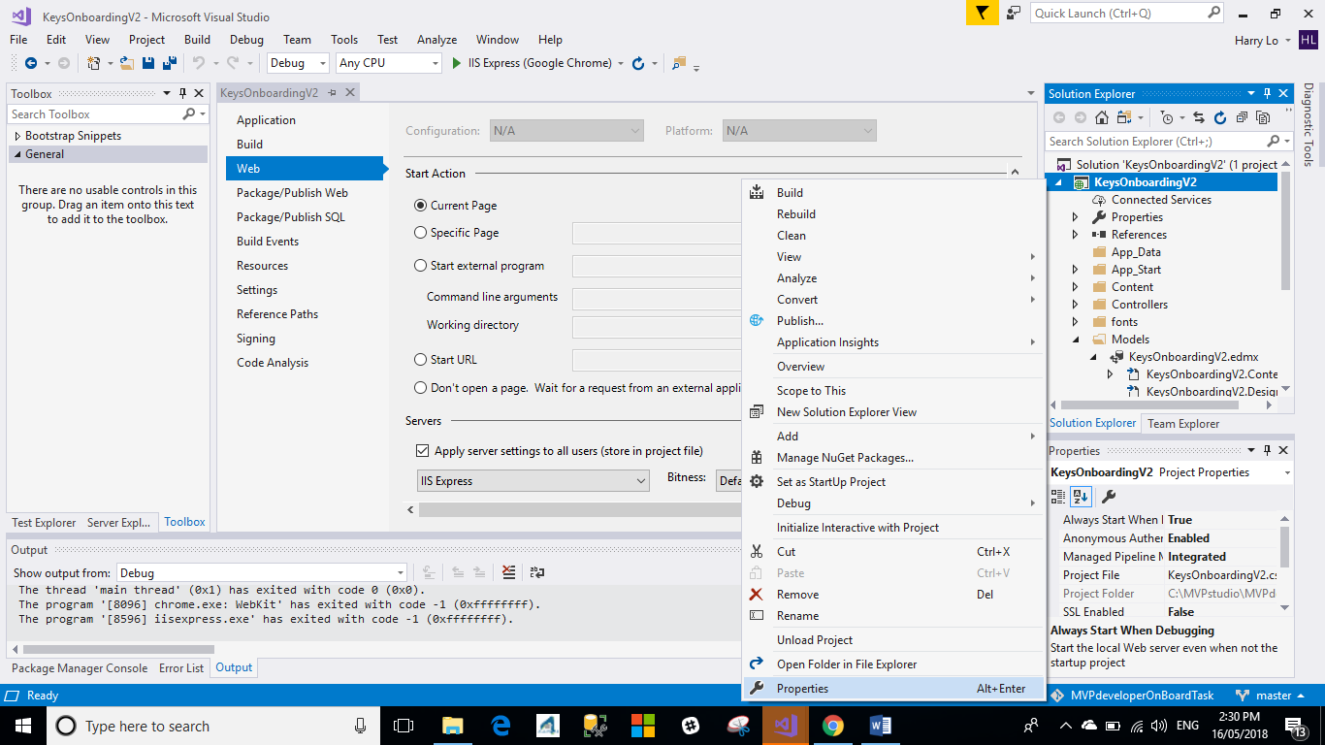

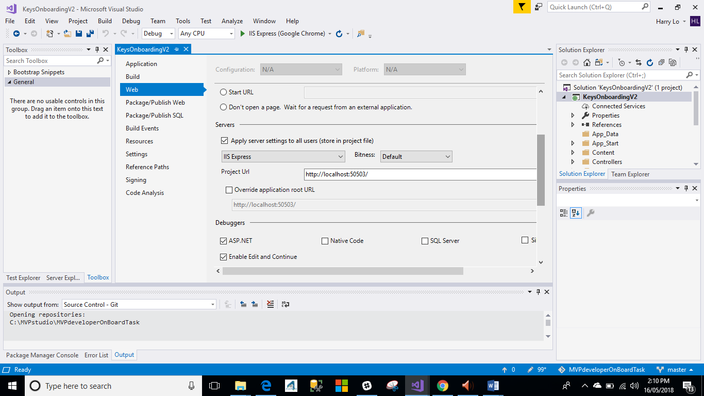

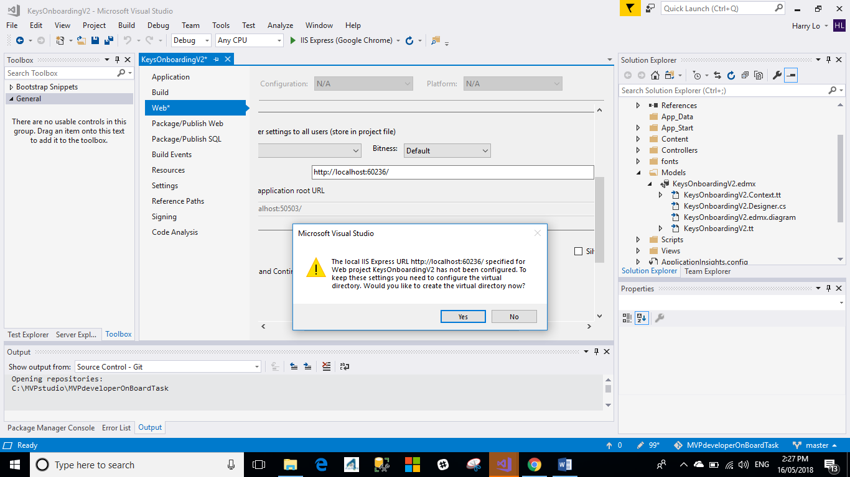

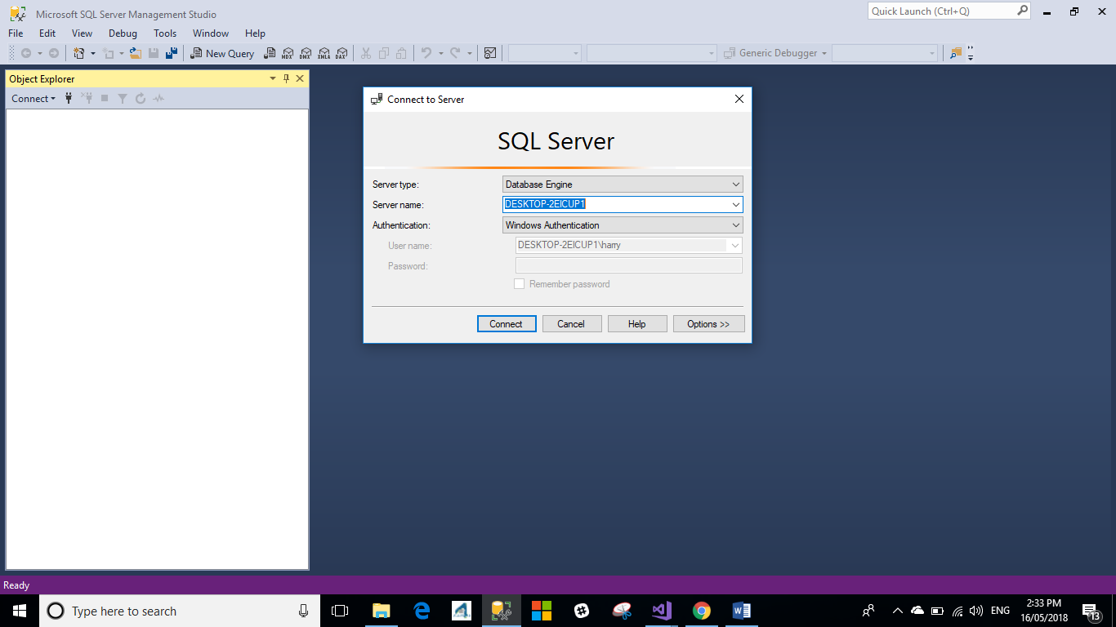

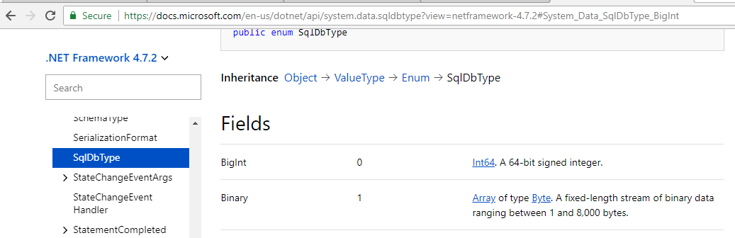



metadata=res://\*/Models.KeysOnboardingV2.csdl|res://\*/Models.KeysOnboardingV2.ssdl|res://\*/Models.KeysOnboardingV2.msl;provider=System.Data.SqlClient;provider connection string="data source=DESKTOP-2EICUP1;initial catalog=KeysOnboardingV2;integrated security=True;MultipleActiveResultSets=True;App=EntityFramework"

<add name="KeysOnboardingV2Entities" connectionString="metadata=res://\*/Models.KeysOnboardingV2.csdl|res://\*/Models.KeysOnboardingV2.ssdl|res://\*/Models.KeysOnboardingV2.msl;provider=System.Data.SqlClient;provider connection string=&quot;data source=DESKTOP-CBO2T26\SQLEXPRESS;initial catalog=KeysOnboardingV2;integrated security=True;MultipleActiveResultSets=True;App=EntityFramework&quot;" providerName="System.Data.EntityClient" />

