A New Smartphone App Prototype Provides Education of Healthy Food Lifestyle for bringing Healthy Weight

Harry Lo

harrykhlo@gmail.com

ABSTRACT

A prototype of a new proposed user-friendly smartphone application named AppetiteForLife App is built for supplementing an Appetite For Life (AFL) course to improve young adult’s healthy. One of the key objectives is for the participants to learn to have a healthy food lifestyle and enjoy the process of maintaining their weight loss instead of imposing an impossible weight loss goal (Appetite For Life, 2012). This could help with overcoming obesity. The Octalysis framework of gamification is applied to this mobile app design to create user’s core drives of motivation.

**Keywords**: Obesity, young adult, weight loss, user-friendly interface, Octalysis framework of gamification

# INTRODUCTION

Obesity is a considerable issue in New Zealand (e.g. Ministry of Health, 2019a & b). Health weight of children and senior adults have been taken care by Ministry of Health and Pegasus Health respectively (Ministry of Health, 2015 & Pegasus Health, 2019). Pegasus Health are extending these services to about 20-year-old young adults, developing an Appetite For Life (AFL) program (Pegasus Health, 2019). It is a 6-week healthy lifestyle course taught by specifically trained facilitators. An AFL website and Facebook page for the services have been built but there still is a room for improvement.

Smartphones are becoming the nation’s most popular device (Research New Zealand, 2015). Young adults are significantly influenced by smartphones (e.g. Heintzelman, 2018). A mobile app is suggested to be a supplement of AFL course for improving the young adult.

The author of this report proposes and builds an AppetiteForLife App prototype as a user-friendly trial tool for delivering relevant knowledge, encouraging heathy lifestyle, facilitating communication and creating core drives of motivations in order to supplement AFL course to improve the user’s healthy.

The background situation is described in Section 2; The app design accomplishing the AFL objectives is depicted in Section 3 in which there are main screen shots and schematic diagram of the design idea in Figure 2 and Figure 3 respectively. The use of Octalysis framework of gamification is stated in Section 3.5. Software used here is given in Section 4. Author’s gains in this study, design summary, and potential extension to similar and other purposes are concluded in Section 5

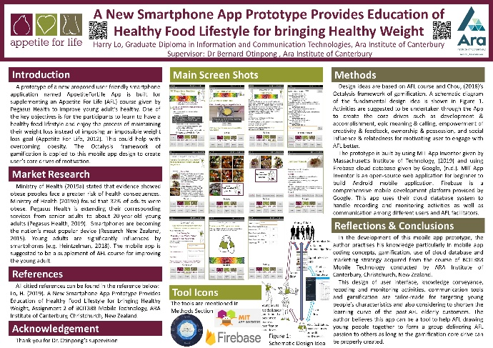

# BackGround

Ministry of Health (2019a) stated that evidence showed obese peoples face a greater risk of health consequences. Ministry of Health (2019b) found that 32% of adults were obese. The rate of increase was significant from 27% in 2006/07 to 32% in 2017/18. In contrast, there are only 12% of children to be obese. This relatively low percentage of child obesity might give the credit to a childhood obesity plan conducted by Ministry of Health (2015) for people up to 18 years old.

A Healthy Life Team of Pegasus Health is contributing to encourage senior and elderly with healthy food lifestyle very well. They are extending these services to about 20-year-old young adults, developing an Appetite For Life (AFL) program (Pegasus Health, 2019). The participants of the AFL program learn to have a healthy food lifestyle and enjoy the process of maintaining their weight loss instead of imposing an impossible weight loss goal (Appetite For Life, 2012).

Pegasus Health has built an AFL website and a Facebook page for the services, believing still a room for improvement. Research New Zealand (2015) found that smartphones are becoming the nation’s most popular device. Young adults are significantly influenced by smartphones (e.g. Heintzelman, 2018). A new smartphone application prototype named AppetiteForLife App is proposed and built to convey knowledge of nutrition, healthy food lifestyle and weight loss as well as gather users engaging in AFL’s activities.

AFL is a 6-week healthy lifestyle course taught by specifically trained facilitators who are practice nurses or health professionals. The course aims for small lifestyle changes, health gain, achieving & maintaining a healthy weight and learning about why we eat & what is in our food (Pegasus Health, 2019). The proposed AppetiteForLife App is a tool as a supplement of AFL course. The objectives of the AppetiteForLife App are to:

* Improve participant’s knowledge, skill and lifestyle behaviours in the subject matters
* Provide ongoing support for current AFL participants and other senior and elderly post-AFL clients.

# App design

To fulfil the Pegasus Health’s objective given in Section 2, this app design is divided into five parts which makes this app to be a user-friendly tool to draw young people together to build a passionate team via gamification core drives to learn, care and share the healthy gain. The five parts are user interface, knowledge conveyance, recording and monitoring activities, communication and Gamification. This design implements 5 cores drives of Octalysis framework given by Chou, (2016). The main screen shots are shown in Figure 1 and a schematic diagram of proposed AppetiteForLife App idea is shown in Figure 2.

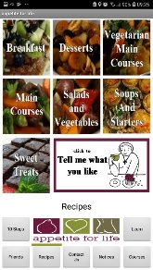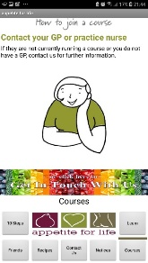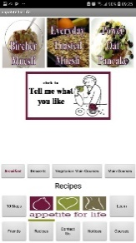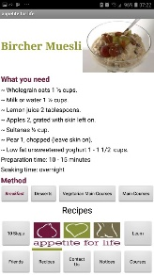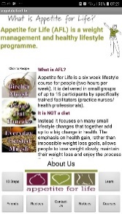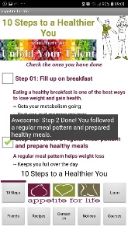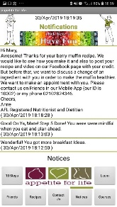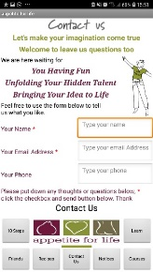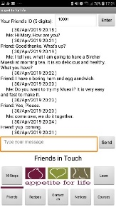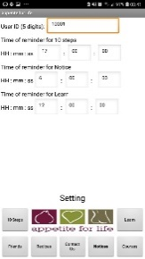

About Us

10 Steps

Learn

Notices

Recipes

Recipes

Recipes

Courses

Friends

Contact Us

Setting

**Figure 2: Main screen shots of proposed AppetiteForLife App prototype**



Young Adults

AFL App

Firebase Cloud Database



Join to build a passionate team via gamification core drives

Communication, data and knowledge flow

Data flow

Action flow

AFL facilitators, practice nurses or health professionals

**Figure 3: Schematic diagram of proposed AppetiteForLife App idea**

## User Interface

Static navigation buttons as shown in Figure 2 are located at the most convenient place at the bottom of the screen (e.g. Babich, n.d.). Users can use the app with one hand and the other is free for anything, for example, taking a spoon for eating or a cup for drinking during lunch time without hassle. This is particularly for targeting busy young adult’s characteristics. It is expected that can encourage reflection on their food while eating. These static navigation buttons can also greatly shorten the learning curve of elderly post-AFL clients. When the user is exploring the navigation menu, the user eye sight focuses on the buttons. The Appetite for Life logo will be on a way of the user’s eye sight. After the user choose a page by pressing the button, user eye sight moves upward to the main contents of the page and is very likely passing through the logo and page name. This experience creates an impression on the logo.

## Knowledge Conveyance

Knowledge of various subject matters such as nutrition, weight loss, cooking and recipes is divided into small pieces placed on 10 Steps page, Recipes page and Learn page as shown in Figure 2. On Learn page, the small pieces of knowledge are conveyed one at a time. This makes the knowledge easy to sneak into user’s daily life without affecting their normal daily activities. This is particularly for targeting busy young adult’s characteristics. For example, on learn page, first piece of knowledge gives few bullet points of breakfast ideas. Once users got it, click the checkbox. Another new piece of knowledge is added in. It is a 46 seconds video telling your how to make a healthy burrito. In the final product of this App, this page will be continuously feeding the new knowledge in this manner.

## Recording and Monitoring Activities

On 10 Steps page as shown in Figure 2, there is a daily check list of the 10 steps to healthier weight and the rationale behind. Participants follow these ten simple steps to reach their healthy weight without feeling deprived (Appetite For Life, 2012). Users check the ones they have done every day. These daily activities are recorded on Notice page as shown in Figure 2 and in a cloud database as shown in Figure 3 for monitoring purposes. Apart from this, the user’s activities on the aforementioned Learn page are also recorded on Notice and in the cloud database. The user can set a time of reminder on Setting page for the activities on 10 Steps, Learn and Notice pages. At the set time, the corresponding button will blink to remind the users to do those activities.

## Communication Tools

The facilitators, practice nurses or health professionals can monitor the user’s activities through the cloud database. Based on the record, they can send the user tailor-made feedback and encouraging messages on Notice page (e.g. see Section 3.5.2) and also can encourage the user to chat on Friends page as shown on Figure 2 with them or other users in order to build good relations among users and them. Connection with others and the world via smartphone is a crucial characteristic of young people (Heintzelman, 2018).

## Gamification

### Core Drive of Development and Accomplishment

The divided little pieces of knowledge scatters in various pages such as the pages of 10 Steps, Learn, Recipes, Notices and Friends. The number of piecewise knowledges will be gradually increased through the pages of Learn, Notice (AFL messages), Friends and Recipes. Daily reminders are given to the user by blinking buttons of 10 Steps, Learn and Notices. Encourage messages are given in various ways as awards. This incremental tiny amount of contents with encourage messages as awards helps user easy to acquire the knowledge. The user’s feeling of knowledge gains creates a user’s core drive of development and accomplishment. This make users feeling like themselves being improved to achieve mastery (Chou, 2016).

### Core Drive of Epic Meaning and Calling

Various places in the App have colorful or beauty buttons with an encouraging phrase bringing user to Contact Us page as shown in Figure 2. The phrases encourage the user feeling bigger than themselves, for example, unfolding your hidden talent. The author suggests the AFL encourages and helps the users with producing some contents of AFL’s website, mobile app, Facebook page and etc. with the users’ credit. For example, send message to user, say that, “I do believe you did and learnt very well here. We want to support you to publish your idea, receipt or cooking video on our mobile app and Facebook page with your credit. Please contact us on the friend page (our ID is 10002) or my phone 02102824346 for arranging a meeting.” The author expects the publication can be on recipe page, learn page or Facebook page. In this production process, additional knowledge is given to the users. These publication and production give users feeling bigger than themselves. This creates user’s core drive of epic meaning & calling (Chou, 2016).

### Core Drive of Empowerment of Creativity and Feedback

The incremental tiny number of knowledges in Section 3.5.1 are becoming a building blocks for the publications and productions in Section 3.5.2. The user can use their creativity to try different combination of the piecewise knowledges to produce the AFL’s published contents with their credit. The user will see feedback and adjust themselves. These creates an engagement through the core drive of empowerment of creativity and feedback (Chou, 2016).

### Core Drive of Ownership and Possession

Giving the user credit in Section 3.5.2 and Section 3.5.3 makes the user feeling like owning the AFL’s published contents which they want to improve and protect. This creates the user’s core drive of ownership and possession (Chou, 2016).

### Core Drive of Social Influence and Relatedness

Friends page as mentioned in Section 3.4, Section 3.5.1 and Section 3.5.2 provides users communicate with others users, facilitators, practice nurses and health professionals. Proper use of this Friends page by AFL can create a powerful social influence and relatedness between users. This can create the user’s core drive of social influence and relatedness (Chou, 2016).

# Software development

This smartphone app prototype is built by using MIT App Inventor given by Massachusetts Institute of Technology, (2019) and using Firebase cloud database given by Google, (n.d.).

# Conslusion

In the development of this mobile app prototype, the author practises his knowledge particularly in mobile app coding concepts, gamification, use of cloud database and marketing strategy acquired from the course of BCIT388 Mobile Technology conducted by ARA Institute of Canterbury, Christchurch, New Zealand.

The user interface, knowledge conveyance, recoding and monitoring activities, communication tools and gamification are tailor-made for targeting young adult’s characteristics and also considering to shorten the learning curve of the post-AFL elderly customers. The author believes this app can be a tool to help AFL drawing people together to form a group delivering AFL passion to others as long as the gamification core drive can be properly created.

The author considers this app has a large room for extension in this subject matters and other areas. For example, the author (Lo, 2019) suggested a better additional interface, the chatting bubble as shown in Figure 4, for suiting young adult and implementing shopping list, and a chatbot for implementing parts of the operations.

The author also thinks this app can combine with the idea that he proposed in Robert Walters 2018 Graduate Hackathon to use a chatbot (called BuddyBot) guiding user getting into the five ways to be wellbeing suggested by Mental Health Foundation (Lo, 2018). His team got first runner up and one of his presentation PowerPoint is shown in Figure 5.

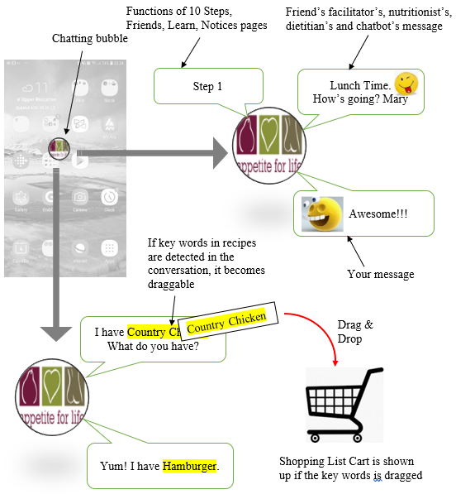

**Figure 4: Suggested additional chatting bubble user interface with chatbot and shopping list functions (Lo, 2019).**

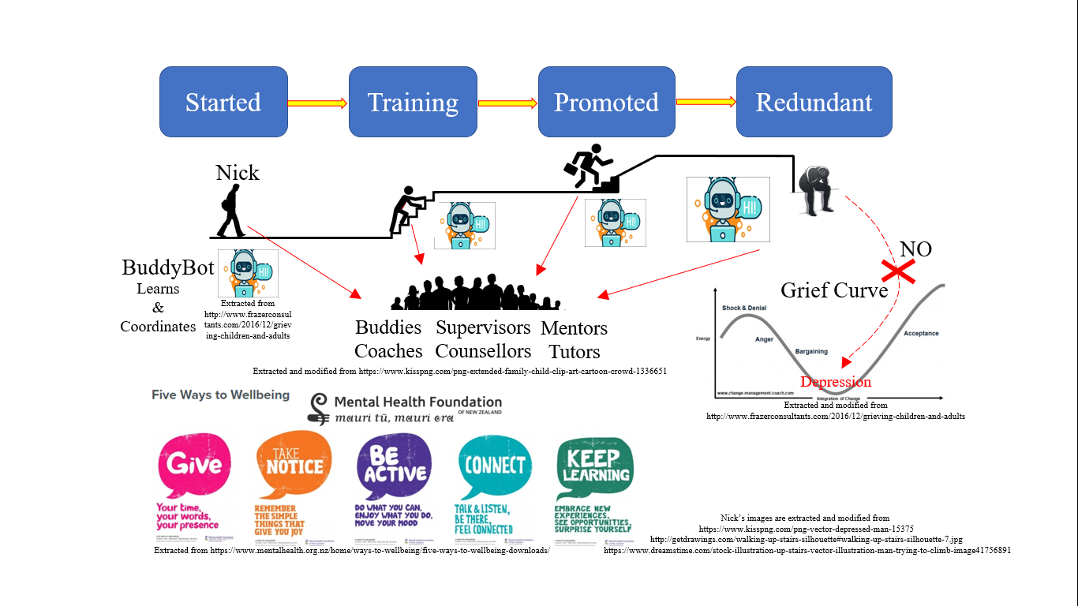

**Figure 5: Potential extension to author proposed chatbot leading to the five ways to be wellbeing suggested by Mental Health Foundation presented in Robert Walters 2018 Graduate Hackathon (Lo, 2018).**

# REFERENCES

Appetite For Life (2012). What is Appetite For Life? Retrieved from https://www.appetiteforlife.org.nz/what-is-appetite-for-life.

Babich, N. (n.d.). UX Design for Mobile: Bottom Navigation, Retrieved from http://babich.biz/perfect-bottom-navigation-for-mobile-app.

Chou, Yu-kai (2016). Gamification to improve our world: Yu-kai Chou at TEDxLausanne, Retrieved from TEDx Talks in YouTube website: https://www.youtube.com/watch?v=v5Qjuegtiyc.

Google. (n.d.). Firebase. Retrieved from https://firebase.google.com.

Heintzelman, C. (2018). Smartphones and the Relationships Between Young Adults. Retrieved from https://www.psychologytoday.com/us/blog/great-kids-great-parents/201811/smartphones-and-the-relationships-between-young-adults.

Lo, H. (2019). Report for Assignment 1 of BCIT388 Mobile Technology, ARA Institute of Canterbury, Christchurch, New Zealand.

Lo, H (2018). IAG IT Bud (a team with Farid, Isha, Ruqyah handling different parts), Presentation Proposing BuddyBot in Robert Walters 2018 Graduate Hackathon, Auckland, New Zealand.

Pegasus Health (2019). Appetite For Life. Presentation in a Lecture of BCIT388 Mobile Technology, ARA Institute of Canterbury, Christchurch, New Zealand.

Research New Zealand. (2015). A Report on a Survey of New Zealanders’ Use of Smartphones and other Mobile Communication Devices 2015. Retrieved from http://www.researchnz.com/pdf/Special%20Reports/Research%20New%20Zealand%20Special%20Report%20-%20Use%20of%20Smartphones.pdf.

Massachusetts Institute of Technology. (2019). MIT App Inventor. Retrieved from https://appinventor.mit.edu.

Ministry of Health. (2019a). Obesity. Retrieved from https://www.health.govt.nz/our-work/diseases-and-conditions/obesity.

Ministry of Health. (2019b). Annual Update of Key Results 2017/18: New Zealand Health Survey, Obesity Statistics. Retrieved from https://www.health.govt.nz/nz-health-statistics/health-statistics-and-data-sets/obesity-statistics.

Ministry of Health. (2015). Childhood obesity plan. Retrieved from https://www.health.govt.nz/our-work/diseases-and-conditions/obesity/childhood-obesity-plan.