<https://intradev.sus.ebc.gov.on.ca/ecor/dist/welcome.html>

Here is the link to our app.

file://gsdptovsshfs009.cihs.ad.gov.on.ca/EBC_SHARED/Projects/eVISTA/_DevTeam/_info/ecorInfo.html

If you cannot access above URL, then you can use the following:

EcorLocal : <https://on34c02217480:9457/ecor/dist/welcome.html>

EcorDemo: <https://on34c02217480:9461/ecor/dist/welcome.html>

EcorDev: <https://intradev.sus.ebc.gov.on.ca/ecor/dist/welcome.html>

If you cannot access above URL, then you can use the following:

EcorLocal : <https://on34c02217480:9457/ecor/dist/welcome.html>

EcorDemo: <https://on34c02217480:9461/ecor/dist/welcome.html>

EcorDev: <https://intradev.sus.ebc.gov.on.ca/ecor/dist/welcome.html>

The name is Ecor – Dashboard, URL: <http://10.160.200.171:8080/secure/Dashboard.jspa?selectPageId=11000>

Following QA meeting discussion, I upload QA summary release note and few manuals(VSTS and Mobile Testing) into VSTS WIKI:

<https://cac-eab.visualstudio.com/QA%20Training/_wiki/wikis/QA%20Training.wiki?wikiVersion=GBwikiMaster&pagePath=%2FQA%20Documents%20and%20Manuals&_a=edit>

Ecor Database connection:

Connection name: ECOR

User name and password: ecor

Hostname: gscgikdcdbrac01.service.cihs.gov.on.ca

Port:1525

Service name: CAC_COMMON

**Subject:** RE: Please create a new branch for Release 5.0 by the end of today

New repo has been created, to get it by:

*mkdir ec-r5.0*

*cd ec-r5.0*

*git init*

*git remote add origin* [*https://cac-eab.visualstudio.com/CAC/_git/Ecor_Source*](https://cac-eab.visualstudio.com/CAC/_git/Ecor_Source)

*git config http.proxy* [*http://204.40.194.129:3128*](http://204.40.194.129:3128)

*git pull origin EC-R5.0*

*git branch EC-R5.0*

*git checkout EC-R5.0*

<https://github.com/join/plan>

[harrylei2012@gmail.com](mailto:harrylei2012@gmail.com)

* Collaborative code review
* Issue tracking
* Open source community
* Unlimited public repositories
* Join any organization

Click “Insert Link” to be failed to add http link for Email body, and got System Error

When no clients exists, the Response document dropdown option “Sent AT” should be disabled

Reproduce Steps:  
1. Login eCorrDeV as PF user - Cliod CU Writer **Dirodsp**

User Role Translation Coordinator

Organization Administrative Office (MAG)

2. Click to open “Cases” module, and check Outgoing One Email case, here as case ID: 152-2018-60  
3. Click to open Email Response Template

4. Click the “Link” icon to insert link: URL and Text to display <http://www.cbcnews.com>

Title: cbcnews.com

5. Click to submit

Expected: Able to insert link and submit

Actual: An unexpected error has occurred. Log off or refresh the page and try again. If the error persists, please contact the system administrator.

Retested and verified the main features on Stage v 4.0.34,

Verified manual and scheduled email imports

Verified Inbox module

Verified Intake module

Verified to create Single case,

Verified to Add to Single case, Event case, Volume case, and Multi cases

Verified Cases Module

Verified to create and perform Single case, Event case, Volume case,

Verified to Create and perform Multi cases, and Outgoing cases

Verify to add and edit case documents

Verified to add case Tasks and response tasks

Verified to Complete, Claim, Assign, Reassign and Terminate Tasks as PF user

Verified to add and update user and templates as Tenant Administrator

Verified as PF user to work with Inbox, Intake, Cases, Tasks and Clients modules

Verified to add or update case documents, Complete, Claim, Assign and Reassign Tasks as PA user

Verified to create a case and perform a Task with COG

Show Stopper Issue 1, Outgoing – One Post, The response document dropdown list missed “**Edit**”, “**Sent At**”, “Upload New Version” features.

Reproduce Steps:  
1. Login eCorr Stage as PF user - Acoveyduck CU Coordinator **Empfcu** User Role Portfolio Coordinator, Organization Public Affairs and New Media (MCI)

2. Click to open “Cases” module, and check to view one Event case details, here as 114-2018-65   
3. Click to change case status from OPEN into ON HOLD

4. Click the button OK to confirm to update status

Expected: Click to update case status from OPEN to ON HOLD, and then able to have case status ON HOLD

Actual: Click to update case status from OPEN to ON HOLD, after confirm to submit, still was able to click status OPEN again to update, and then got error message: Cannot close case instance with id 05f09199-fa27-11e7-a8b3-00144ffb3ba7. (E5007)

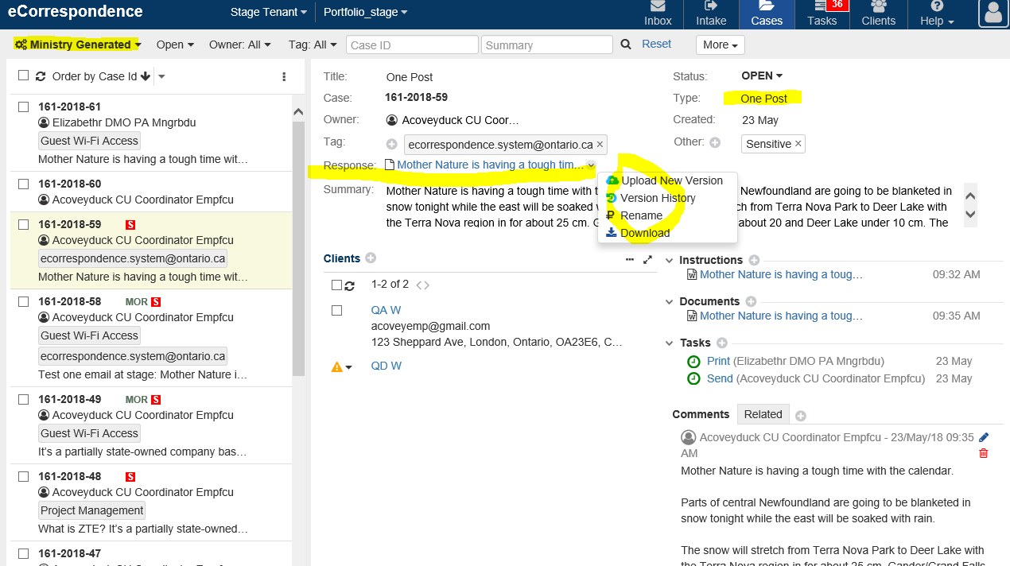

Issue 2, failed to create and open “Case Summary report”

Issue 3, Created “Task Aging report”, and got “No data is available”

Please let me know if you have any questions.

For Help testing

test

<br/>

<a href="#" to="ONLINE_HELP_GROUP2.SECTION1">TEST</a>

Code: WYNNE

Label: Wynne Government

State: Active

JSON data: {

"name" : "Wynne Government",

"abrvn" : "W",

"party" : "Liberal",

"premier" : "Kathleen Wynne",

"businessFrom" : "2013-01-24 00:00:00 AM -0400",

"businessTo" : "2018-07-29 00:00:00 AM -0400"

}

UAT Smoking Test Report

Created Politics portfolio and Non-politics successful,

Verified manual and scheduled email imports, included Active Politics Portfolio under Current Government, Active Non-Politics Portfolio with Inactive Government

Checked and verified with PF user – Project coordinator for Inbox, Intake, Cases, and tasks modules respectively

Checked and verified with Tenant admin to add user and templates, there are a few know defects as

Stage Sanity testing report

Verified to

* Integration with Exchange server for inbound emails  (verify manual and scheduled email imports)
* Integration with OMS WS (verify that Users and ORGS can be derived)
* Integration with Camunda (verify that new Case can be created; new Tasks can be submitted; all operations can be performed for new and existing Tasks)
* Integration with Exchange server for outbound emails (verify that new and existing Email Responses received by internal and external Clients)
* Integration with Crystal reporting server (verify that all 3 reports can be generated)
* Integration with Video Help (verify that Video Help is working for logged-in Users and for non-logged in Users)
* Create and complete a Single case, Event case, Volume case
* Create and complete a Multi Post and email cases,
* Create outgoing one email, one post, separate email and separate post cases
* Document context menu options (verify that all context menu options are working, verify that edit is working for multiple concurrent Users on Win 10 machines)
* Email notifications (verify that 3 notifications are triggered and received for two-step Tasks for two Users)

Issue 1, Missing to addOn role “Politics Access”

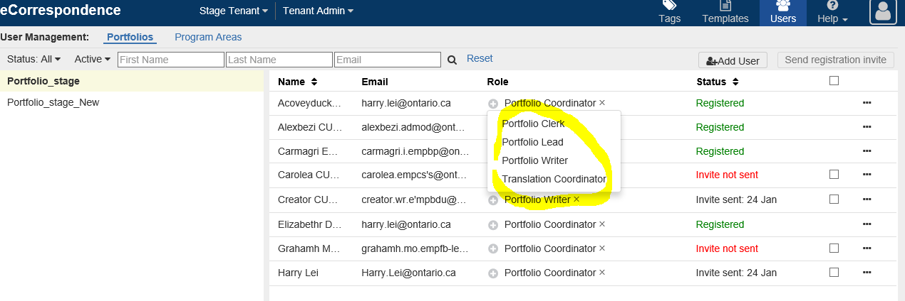

Note: Case Overdue column will never display negative number.

New Legend should look like this:  
X=Case Overdue  
Green, X=0 Amber, X="Due Today" Red, X>0

**Case Overdue=X**  
Case Overdue= Report generated- Case Due date

As PA user, should be able to Download Response for Separate Post - Review clients

'Add Document from Template' should be Merged into 'Add Document' modals together for single case, and not displayed on

Reproduce Steps:  
1. Login eCorrDeV as PA user –   
Elizabethr DMO PA Mngrbdu   
User Role Program Area Coordinator - MEDG   
2. Click to open Portfolio - MEDG   
3. Click to open “Cases” module  
4. Click to open “Single” case , here caseID 114-2018-472   
5. Click to add Email with “Blank Email”

Expected: Able to add Email with Blank Email

Actual: Tried to add Email with Blank Email, and then got message: Data constrain error, contact System Administrator for help. (E0009)

Reproduce Steps:  
1. Login eCorrDeV – Tenant MEDG – “Test Portfolio” as PF user -

Cliod CU Writer **Dirodsp**

User Role Translation Coordinator

2. Click to open “Test Portfolio “ - “Clients ” module  
3. Click to open one client to Edit Client

4. Click to update one email address to submit

Expected:   Able to update client email address to submit

Actual: Tried to Edit client email address to submit, and got error message: An unexpected error has occurred. Please refresh the page by pressing the F5 key or log in again. If the error persists, contact the System Administrator for help. (E0001)

**From:** eCorrespondence [mailto:ecorrespondence.system@ontario.ca]   
**Sent:** Tuesday, April 24, 2018 1:40 PM  
**To:** Lei, Harry (TBS)  
**Subject:** eCorrespondence - Task Review Case in Case 152-2018-2 was completed (DEV)

The task Review Case in Case 152-2018-2 was completed by Elizabethr DMO PA Mngrbdu of Freedom of Information, Privacy and Information Management.

As PF user, failed to add response task

Reproduce Steps:  
1. Login eCorrDeV as PF user - Acoveyduck CU Coordinator **Empfcu**

User Role Portfolio Coordinator

2. Click to open “Cases” module, here case details: 114-2018-249   
3. Select case response extension menu to add new task  

Expected: Able to add a new response task

Actual: Failed to add a new response task, and got an unexpected fatal error message,

Click OK button to reloads app.

and doc name: “Response_Acoveyduckfirst_Acoveyducklast_2018_Apr_19_03_26_PM.eml”

For Multi separate email/post, the response naming convention should be 'Response 102-2018-234-Completed-Case-102-2018-161-Client-Alice Gong 2018-04-12T20_43_53.eml'  
For Outgoing separate email/post, the response naming convention should be 'Response 102-2018-234-Sent-Client-Alice Gong 2018-04-12T20_43_53.eml'

Expected: To update the case status from “OPEN” to “Closed”, and then get message:

Client Mcdonald AAA is in the status NEW, please sent it before close Outgoing Case. (V1079)

Client CBC Mr. AD is in the status REVIEW GENERATED, please sent it before close Outgoing Case. (V1079)

Actual: Tried to update the case status from “OPEN” to “Closed”, and then got message:

Client Mcdonald AAA is in the status NEW, please sent it before close Outgoing Case. (V1079)

Client CBC Mr. AD is in the status GENERATED, please sent it before close Outgoing Case. (V1079)

Here, Client CBC Mr. AD is in the status REVIEW not GENERATED

After Separate Email case “CLOSED”, Case “Template” should be able to “Version History”

Reproduce Steps:

1. Login eCorrDeV as PF user - Acoveyduck CU Coordinator Empfcu

2. Click to open Portfolio - MEDG

3. Click to open “Cases” module,

4. Click to view “Ministry Generated” with Status: CLOSED, and Type “Separate Email”

5. Click to select Separate Email case, here as 114-2018-298-O

6. Click to read Email Template using “Version History”

Expected: After Separate Email case “CLOSED”, Case “Template” should be able to “Version History”

Actual: After Separate Email case “CLOSED”, Case “Template” was disabled to “Version History”

When Task “Terminated”, “Clients” from “Review” list, it’s able to click to “Re-generate” or “Mark Post Sent At” or “Delete”

Reproduce Steps:  
1. Login eCorrDeV as PF user - Cliod CU Writer **Dirodsp**

User Role Translation Coordinator   
2. Click to open Portfolio - MEDG   
3. Click to open “Cases” module   
4. Click to search “Outgoing” cases with status: Re-Open,

5. Check to view Case details – 114-2018-384 - O

6. Check to view Clients – Review, Sent respectively.

Expected:

Actual: When Task “Terminated”, select any one “Clients” from “Review” list, it’s able to click to “Re-generate” or “Mark Post Sent At” or “Delete”

Failed to select clients from Sent list, and no extension menu to click to download response

Reproduce Steps:  
1. Login eCorrDeV as PF user - Acoveyduck CU Coordinator Empfcu   
2. Click to open Portfolio - MEDG   
3. Click to open “Cases” module   
4. Click to select a Single Case from the list

5. Click to select one “Sent” clients

6. Click clients extension menu to Download Response

Login as Portfolio Coordinator

Select a Single Case from the list  
Click the arrow beside the uploaded doc under the Response and select Sent At.

In the Mark Post Sent At modal, "Contact Mechanism" should be renamed to "Client" according to the latest mock-ups (see attachment)

Expected: Able to select clients from Sent list, and download response

Actual: Failed to select clients from Sent list, and no extension menu to download response

Tried to search “Case ID” for Outgoing cases, and to check case details to pop up an unexpected error

For Separate Post, after updated “Client contact mechanism”, “Review” clients did not get notice: Client contact mechanism has been changed since last generation, please re-generate response for this client.

After Client contact address changed, the case client still displayed the original address, and no notice to be appearing at the clients

Reproduce Steps:  
1. Login eCorrDeV as PF user - Acoveyduck CU Coordinator Empfcu   
2. Click to open Portfolio - MEDG   
3. Click to open “Cases” module,

4. Navigate into view “Outgoing” case with Type: Separate Post, here as 114-2018-379-O   
5. Check to verify the New, Review and Sent existing clients

6. And then from Client module to update one client contact address and get the notification

7. Navigate into above case and Review client to view Client Contact details

Expected: Review clients get notice: Client contact mechanism has been changed since last generation, please re-generate response for this client.

Actual: After Client contact address changed, the case client still displayed the original address, and no notice to be appearing at the clients

For Multi or Outgoing to Add Case Reference, “More” section should only contain Sensitive and Rush

Reproduce Steps:  
1. Login eCorrDeV as PF user - Acoveyduck CU Coordinator Empfcu   
2. Click to open Portfolio - MEDG   
3. Click to open “Cases” module,   
4. Click to select one Single case, here as 114-2018-123   
5. Click to add “Related” – “Internal Reference”, and open to Add Case Reference  
6. Click to search “Multi” case  
7. Verify that “More” section only contains “Sensitive” and “Rush”

Reproduce above steps replace at step 6 search "Outgoing" case, and then to verify

Expected: “More” section only contains Sensitive and Rush

Actual: Click to search “Multi” case, “and “More” section not only contains Sensitive and Rush, but also Client Name, From Email and Email Subject