**Pterosoar Position and Altitude Verification – Addendum**

**Table of Contents**

Section 1: Introduction

Section 2: Data and Analysis/Results

**Section 1: Introduction**

A new configuration for the Pterosoar GPS system has been developed, making use of dual u-blox F9P modules for GPS heading and position. This was motivated by the magnetic environment of the Arctic supplying insufficient signal to the drone’s magnetometer.

The new GPS modules are Helical models manufactured by Holybro. The same test methodology used with the Here3 GPS was used to confirm the lateral accuracy of the dual Holybro GPS system. GPS altitude accuracy was not measured as we have been using the barometric altimeter for altitude, which has not been altered.

**Section 2: Data and Analysis/Results**

The drone with the dual GPS system was hiked to 10 locations around the McGill downtown campus. At each location, the drone’s GPS position was checked against the position reported by Google Maps.

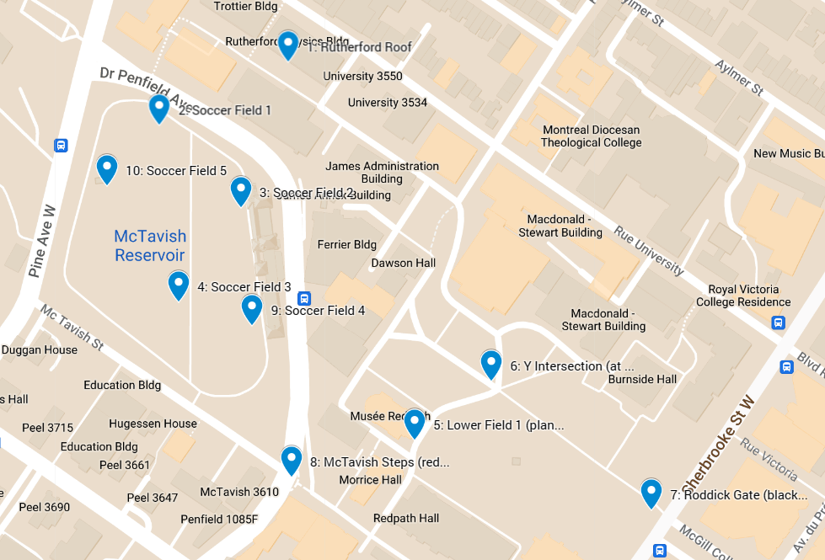

Pterosoar dual GPS position verification test locations

**Data**

|  |  |  |  |  |  |
| --- | --- | --- | --- | --- | --- |
| Position Verification | | | | | |
| Point # | Map lat | Map lon | GPS lat | GPS lon | GPS Error (m) |
| 1 | 45.5070086 | -73.5785776 | 45.506963 | -73.5785979 | 5.3 |
| 2 | 45.5065575 | -73.5798866 | 45.506558 | -73.5798795 | 0.6 |
| 3 | 45.5059728 | -73.5790551 | 45.505962 | -73.5790614 | 1.3 |
| 4 | 45.5052980 | -73.5796894 | 45.505287 | -73.5796909 | 1.2 |
| 5 | 45.5043129 | -73.5772902 | 45.504301 | -73.5772899 | 1.3 |
| 6 | 45.5047340 | -73.5765070 | 45.504738 | -73.5765044 | 0.5 |
| 7 | 45.5038129 | -73.5748655 | 45.503818 | -73.5748693 | 0.6 |
| 8 | 45.5040460 | -73.5785455 | 45.504031 | -73.5785444 | 1.6 |
| 9 | 45.5051382 | -73.5789371 | 45.505096 | -73.5788923 | 5.8 |
| 10 | 45.5061288 | -73.5804230 | 45.506116 | -73.5804170 | 1.5 |

GPS position verification test data

**Analysis/Results**

**GPS Position**

GPS position error was determined by calculating the great-circle distance between the Google Maps position and the drone’s reported GPS position using the haversine formula.

The GPS position accuracy was measured to be, to a 95% confidence level, 2.0m +/- 1.4m.

The measured GPS position accuracy meets the 10m requirement of CAR 901.69, 901.76, and Standard 922.

**Conclusion**

Pterosoar has demonstrated that it’s lateral position accuracy with the dual GPS system meets and in fact surpasses the position requirements of the CARs and Standard 922. This report addendum will be kept on file in accordance with CAR 901.79.