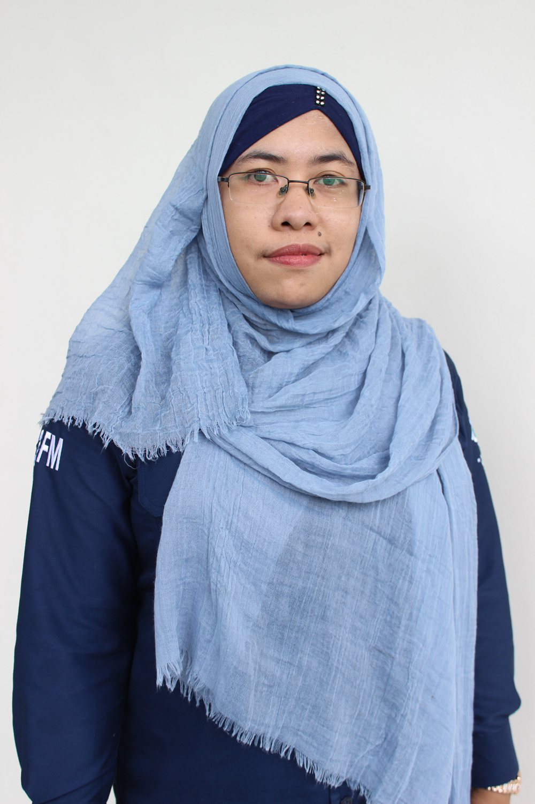

MENGETAHUI:

H. Moch. Ali Bin Dadlan

Kancanta Radio

[Street Address, City, ST ZIP Code]

**Tel** 0821231213

**Fax** (0376) 292597

*www.kancantaradio.com*

GREETING CONRATULATION

NAMA :

PANGGILAN :

ALAMAT :

JABATAN :

Rp. 1.500.000

YOU DESERVE TO GET SALARY INCREASE:

“We are *Very Proud* having you.”

CONRATULATION

-BEST EMPLOYEE EVER-

[You can add an abstract or other key statement here. An abstract is typically a short summary of the document content.]

# Contact Information

To replace a photo with your own, right-click it and then choose Change Picture.

|  |  |  |  |  |  |  |
| --- | --- | --- | --- | --- | --- | --- |
| Name Title |  | Name Title | |  | Name Title | |
| Sample person image |  | Sample person image | |  | Sample person image | |
| **Tel** [Telephone]  **Fax** [Fax]  [Email Address] | |  | **Tel** [Telephone]  **Fax** [Fax]  [Email Address] | |  | **Tel** [Telephone]  **Fax** [Fax]  [Email Address] |

# Company Information

Kancanta Radio

[Street Address, City, ST ZIP Code]

**Tel** 0821231213

**Fax** (0376) 292597

www.kancantaradio.com

