REVIEW OF KANCANTA’S EMPLOYEE

Getting the perfect job might be challenging, but a great-looking résumé doesn’t have to be! We’ve provided a few quick tips to help you get started. To replace any tip text with your own, just click it and start typing.

Need another experience or education entry? You got it. Just click in the sample entries below and then click the plus sign that appears. Looking for a matching cover letter? All you had to do was ask! On the Insert tab, click Cover Page.

QUOTE:

“TERSERAH LOE DAH”

KONTAK

1

**TH**



0821-1234-XXXX

Owiexs@gmail.com

Karang Sukun, Tanjung, Labuhan Haji , Lombok Timur

LAMA MENGABDI:

PROFILE:

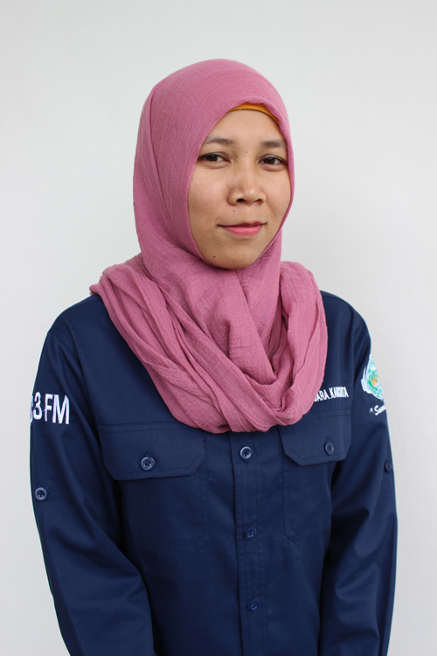

**GOOD**



BROADCASTING:

**GOOD**



BROADCASTING:

SKILL:



03-08-2017

PENYIAR

FREE LANCE

OWIEXS

(RABIATUL ADAWIYAH)

~~KADIV~~

OVERVIEW: