**The test data set**

**Cell Cultures**

For the test data set, 13C labeling experiments were performed using YSBN1 yeast strain cultures, grown in completely labelled glucose: 13.2 g of yeast nitrogen base (Sigma) and 40 g of Ammonium Sulphate (Sigma) was dissolved in 400 mL of autoclaved distilled water, which was then filter-sterilized, protected from light with aluminium foil and stored at 5 °C prior to use. The yeast nitrogen base was used to make Synthetic Minimum Media (SMM) containing 0.5% glucose: for isotope labelling experiments, universally-labelled 13C (U-13C) glucose (Cambridge Isotope Laboratories Inc., MA, USA) was employed, whereas for control experiments natural abundance D-(+) glucose (Sigma) was used. The yeast cultures were grown in the described media for 24 hours, and the lipids were extracted using a slight modification of the Folch method. Briefly, about 50 mg of cell material was placed in a 2 mL screw top tube, together with about 200 mg of glass beads. 1 mL of Chloroform:Methanol (2:1) was added, and the yeast cell wall was broken using a TissueLyser (Time: 8 min, Frequency: 240 Hz). The samples were sonicated for 5 min, followed by addition of 400 μL water and vortexing for 60 s. The mixture was centrifuged for 10 min at 13200 rpm, and the organic phase was withdrawn and dried overnight in a fume hood. For the mass spectrometric analysis, 500 μL of Chloroform:Methanol (1:1) was added to the dried lipid extract, and the obtained solution was diluted 20 times using Isopropanol:Methanol:Water (2:1:1).

**LC-MS Measurements**

The samples were analyzed in positive ionization mode using a Waters Xevo G2 quadrupole time of flight (Q-ToF) combined with an Acquity Ultra Performance Liquid Chromatogram (UPLC) (Waters Corporation, Manchester, UK). 10 μL of the sample was injected onto an Acquity UPLC® Charged Surface Hybrid (CSH) C18 column (1.7 µm x 2.1 mm x 100 mm) (Waters Corporation) held at 55 °C. The binary solvent system (flow rate 0.4 mL/min) consisted of solvent A containing HPLC grade acetonitrile-water (60:40) with 10 mM ammonium formate and solvent B consisting of LC-MS grade acetonitrile-isopropanol (10:90) and 10 mM ammonium formate. The gradient started from 60% A/40% B, reached 99% B in 18 min, then returned back to the starting condition, and remained there for the next 2 min. The data was collected over the *m/z* range 105-1800 with a scan duration of 0.2 s. The source temperature was set at 120 °C and nitrogen was used as the desolvation gas (900 L/h). The voltages of the sampling cone, extraction cone and capillary were 30 kV, 3.5 kV and 2 kV respectively, with a collision energy of 6 V for each single scan. As lock mass, a solution of 2 ng/μL acetonitrile-water (50:50) leucine enkephaline (*m/z* 556.2771) with 0.1% formic acid was infused into the instrument every 30 s.

**Data Conversion**

The 8 LC-MS *.raw files were converted to the *.mzML format using MSConvert (from ProteoWizard) and then pre-processed with *xcms*. They are provided as an *xcmsSet* object in the package.

**Scheme of *IsotopicLabelling***

The following Figure is a summary of the steps involved in the isotopic pattern analysis, with the results for two of the samples (control and labelled). The vertical black lines are the extracted patterns, whereas the red dots are the fitted patterns. The estimated 13C abundance is also given (the labelling isotope is called X).

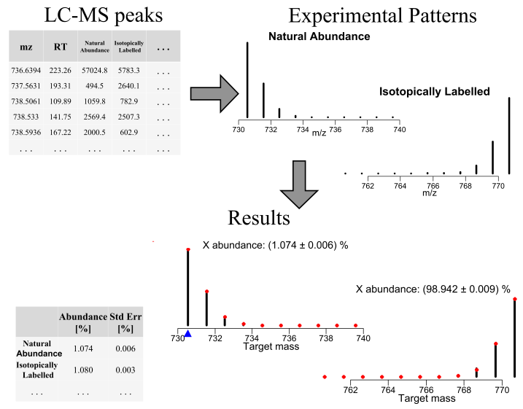

**Minimum Detectable Degree of Enrichment**

*IsotopicLabelling* was tested over simulated data in order to get an estimate of the lowest 13C abundance below which *IsotopicLabelling* is not able to find a significant difference with respect to the natural 13C occurrence (1.07%).

Two critical parameters for the sensitivity of the approach are *(i)* analyte size and *(ii)* signal-to-noise ratio (SNR), and therefore they both were taken into consideration during the simulation: as for the analyte, saturated carboxylic acids were considered, with acyl chains ranging from C2 to C26 (*m/z* from 61.02 to 397.40). On the other hand, SNR values were considered within the range 10 to 104, where such values are defines as the ratio between the intensity of the monoisotopic peak to the standard deviation of the noise.

For each condition, the theoretical 13C abundance was gradually increased, starting from the natural occurrence; for each value, 50 noisy spectra were simulated and fitted by means of *IsotopicLabelling,* in order to find an averaged 13C occurrence with related standard deviation. The procedure of increasing 13C was repeated until a value (13C abundance) was found for which the 95% confidence interval did not include the natural 13C occurrence.

The overall results are exemplified in the Figure below: to the left is the minimum 13C abundance as a function of the (*m/z*, SNR) pair. To the right are the related standard deviations.

Briefly, it can be seen that the values are strongly dependent on both *m/z* and SNR: as the SNR increases, so does the sensitivity of the approach, since the noise level decreases and the patterns become less and less noisy. At the same time, the sensitivity also increases as the analyte size increases, a direct consequence of large analytes having broader isotopic profiles.

