**Change of Layout**

The feedback from the tutor and usability/feasibility requirements I made a design decision to change the design. The steps and changes are listed below:

**Main screen changes and layout**

**Before:**

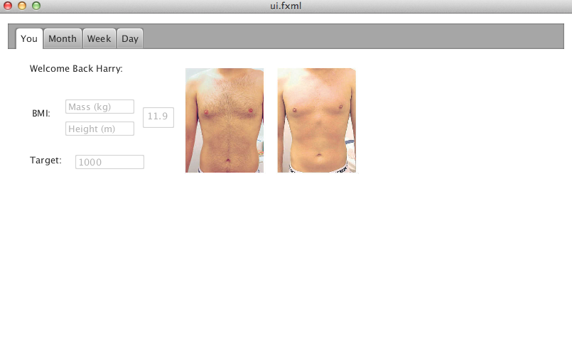

**After**

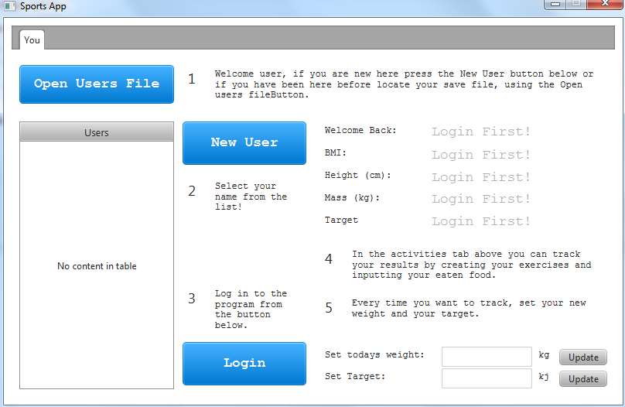

**Justification**

1. The BMI text boxes were restyled, through replacement and font tweaks to look more pleasing to the user’s eye.
2. Multi-user Support needed to have a list full of users, which was placed on screen for ease of use on selection.
   1. Login and New user buttons were created because of this which populates the table with data.
   2. A create user dialog was created and presented when the new user button is selected.
3. Helpful labels were created to direct the user towards the goal of creating a new user.
4. Weight and target editable boxes were created rather than labels, because they needed to be able to be clearly editable for the user.
5. The other tabs are hidden on start-up which makes the program idiot proof by creating less possibility for the users to crash the program.

**Create User Added**

Because of the multi-user support I needed to implement a Create User dialog which is presented below:

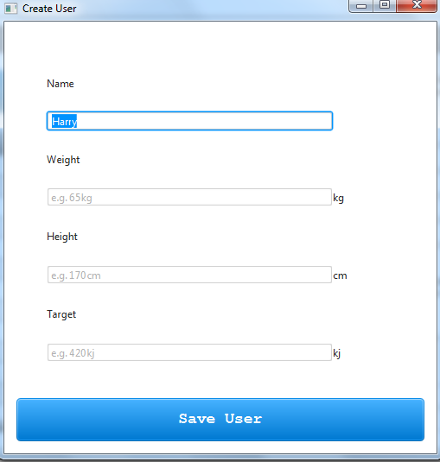

**Activity Tab:**

**Before**

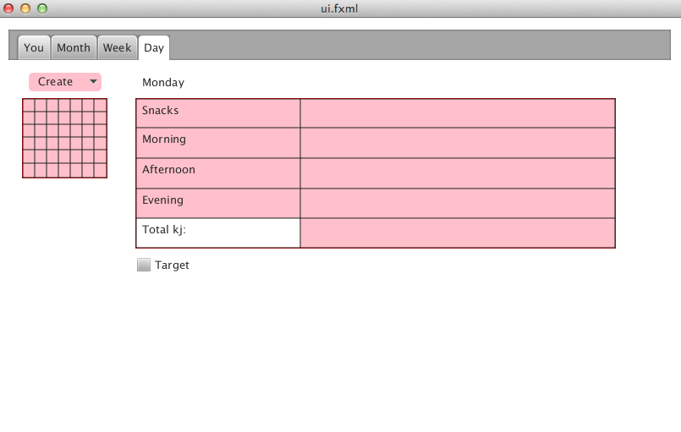

**After**

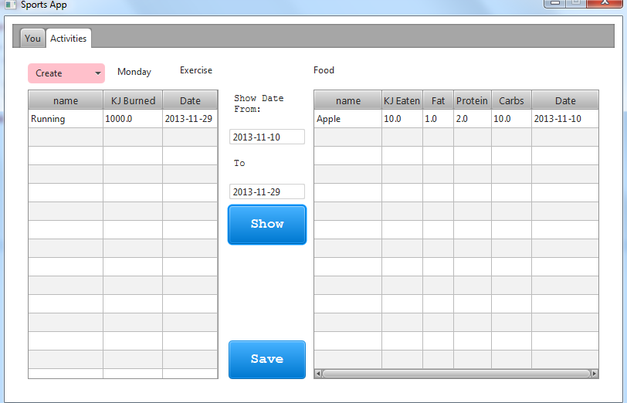

**Justification**

1. Month, Day and Year Tabs were merged to a single tab, Activity. Because of ease of use, as it deem unorganised to have different set dates in each tab.
   1. 2 Tables split up the data, instead of a single table, shows the user clearly the separation between both sets.
2. A date from-to is added to differentiate between Month Year and Day in this tab rather than individual tabs.
3. A save button is added so users can save their data to an xml file.

**User Regression Tests**

The below tests were conducted on outside developers with no or little knowledge of computer programs.

I asked the user to conduct the given activity and then get them to base the ease of their actions on a scale of 1-5. With 1 being hard and 5 stating that the action was easy to complete.

|  |  |  |  |
| --- | --- | --- | --- |
| User1 | User2 | User3 | Activity |
| 5 | **5** | **5** | Create a new user called “Fred”. |
| 5 | **5** | **5** | Log the user “Fred” into the program. |
| 5 | **5** | **5** | Create a new running exercise that you went on today, where you burnt 500kj. |
| 4 | **3** | **4** | You forgot to track some Hula Hoops you ate yesterday, track this now. The packet contains: (Fat: 11.4g, KJ: 912kj, Protein: 1.4g). |
| 4 | **5** | **5** | Display only your activity from yesterday. |
| 3 | **5** | **4** | Create a new user called “Rose”. |
| 5 | **4** | **4** | Rose went swimming and burnt 200kj. Track this now. |
| 5 | **3** | **3** | Freds gained some weight today set this now. |
| 4 | **5** | **4** | Save the file. |
| 5 | **5** | **4** | Load the file. |
| 5 | **5** | **5** | Track the walk “Fred” just did which burnt 50kj |
| 5 | **5** | **5** | Check to see if the data has loaded properly. |

**User Feedback**

“When trying to create an exercise, I misclicked and forgot to set the date, this data cannot be editable and I was annoyed because I had to then recreate another exercise“

**Evaluation**

From the regression tests and the user feedback I found 3 major points that users struggled slightly with:

1. Finding the set weight button
   1. This can be enlarged with colourful fonts to attract the users eye when they first open the program so they recognise and remember where it is placed.
2. Tracking items dates
   1. When users created Exercises or Foods, they were often mislead by the date, because it is automatically placed into the textbox as todays date. This leads the users to thinking that this value cannot be changed or set. To fix this a date checker library function could be called to physically show the users that you can change the date.
3. Changing item dates
   1. From the user feedback, many users tried to edit the previously created exercise or food because they made a mistake with the date editing and so want to simply edit the date. To change this edit, functionality of the exercise and food tables would need to be implemented.