True Muonium Simulation Report

# 1. Overview

This report presents a detailed Monte Carlo simulation of true muonium production, decay, and detector interactions...

# 2. Visualizations and Results

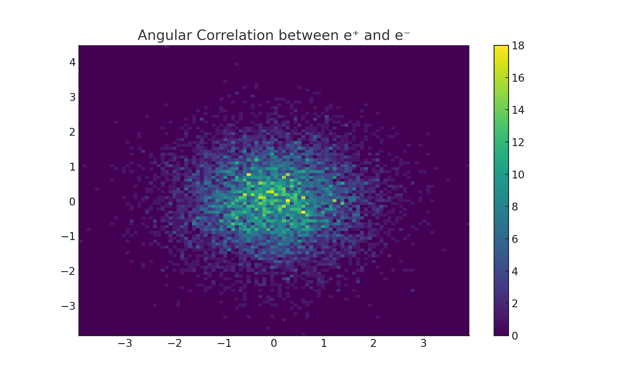

Figure 1: Angular correlation between e⁺ and e⁻.

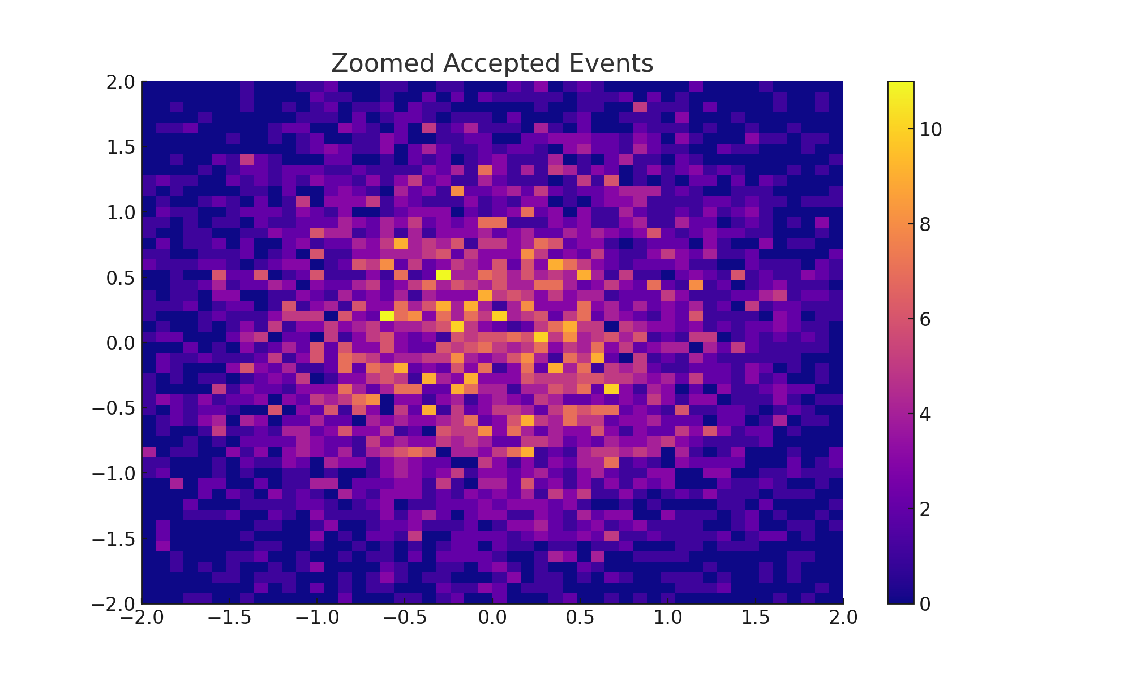

Figure 2: Zoomed-in view of accepted events (7.5–30 mrad).

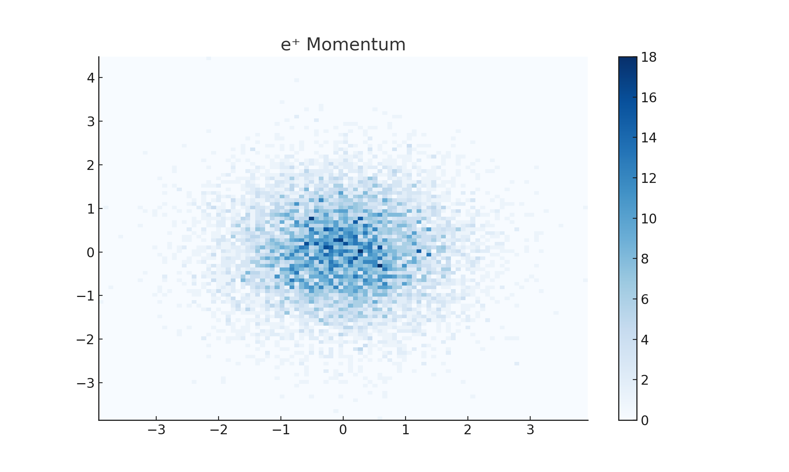

Figure 3: e⁺ momentum: p_y vs p_z.

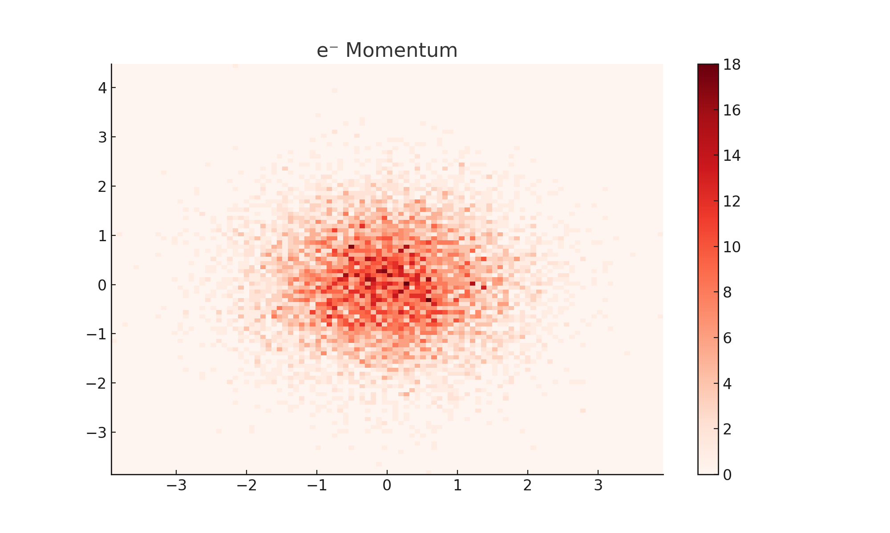

Figure 4: e⁻ momentum: p_y vs p_z.

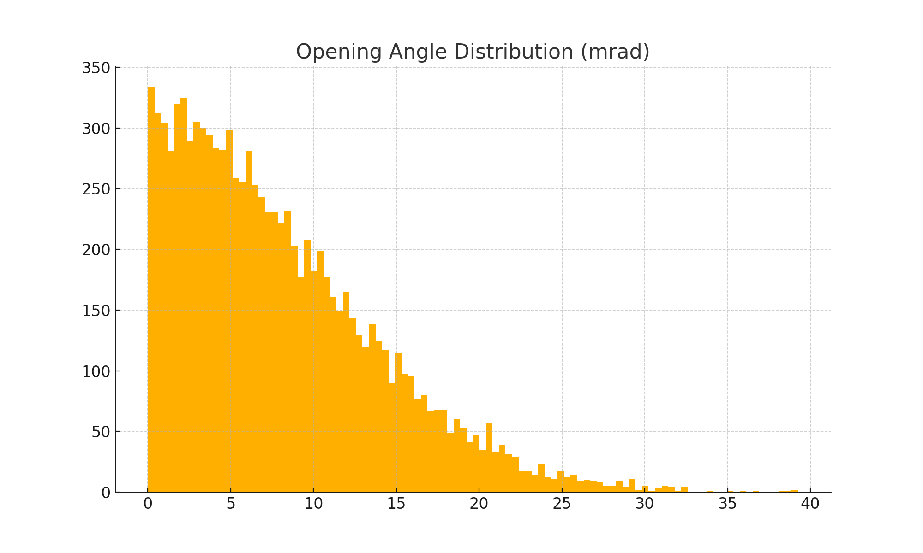

Figure 5: Opening angle distribution (mrad).

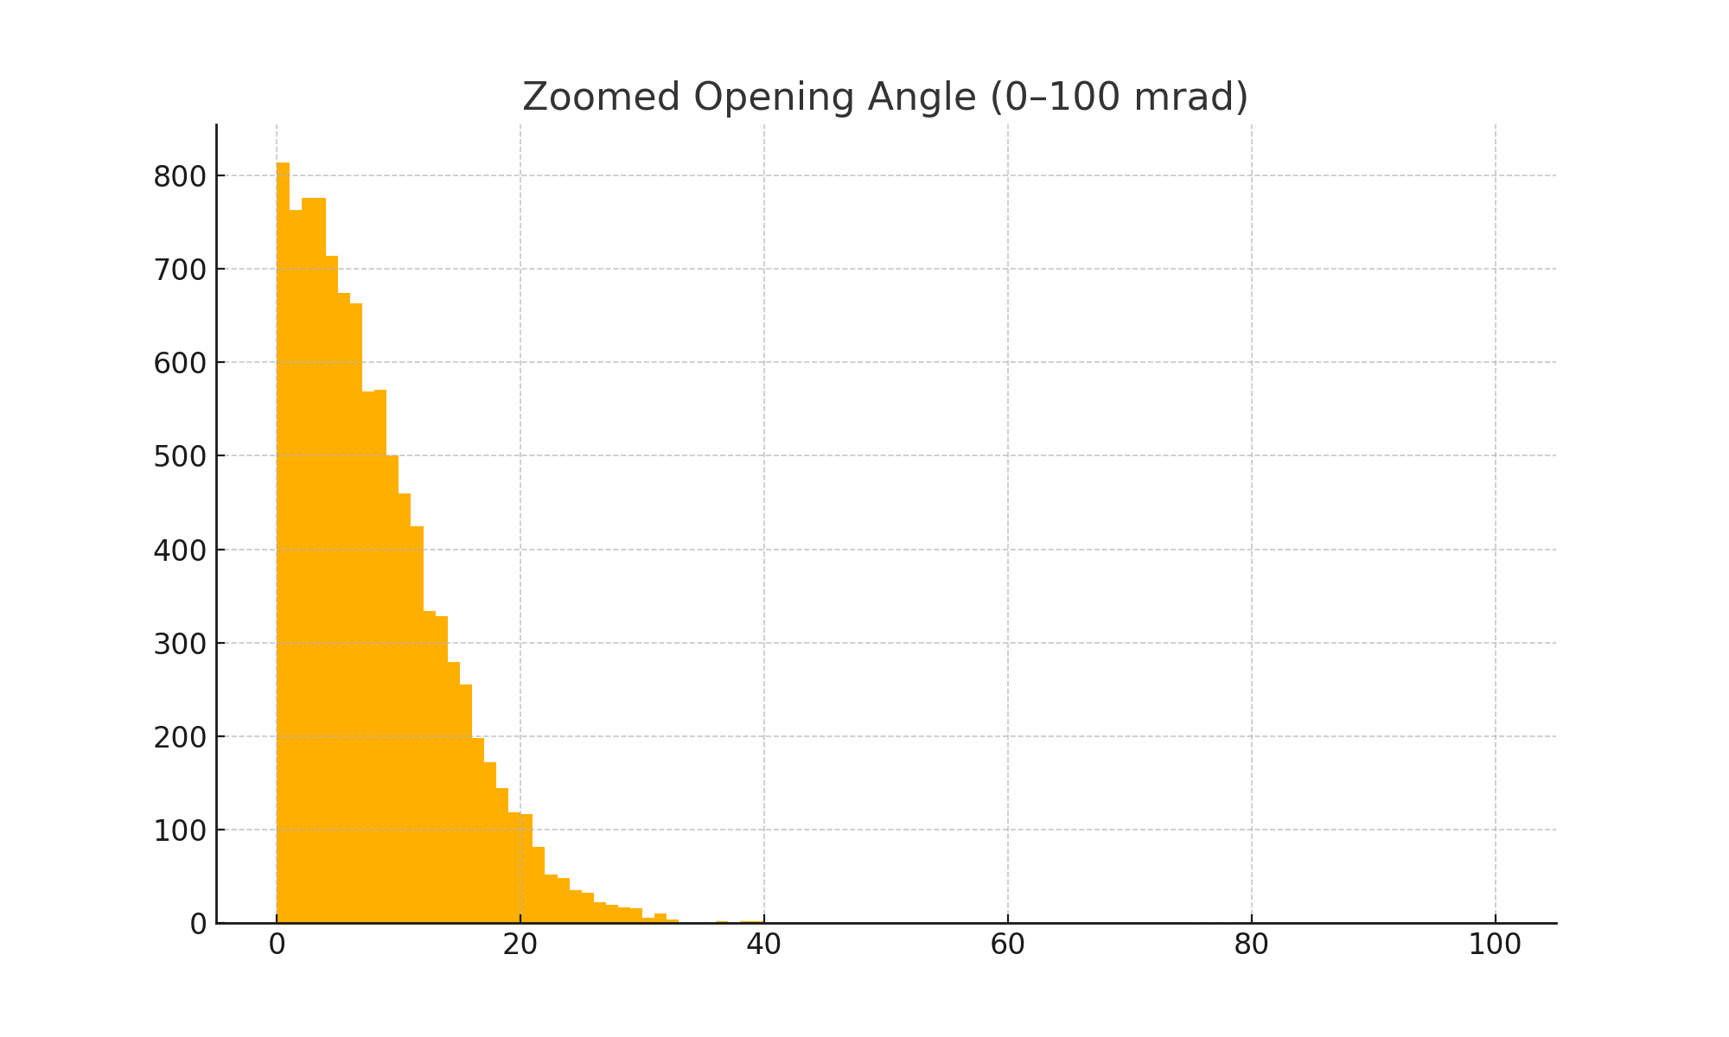

Figure 6: Zoomed opening angle (0–100 mrad).

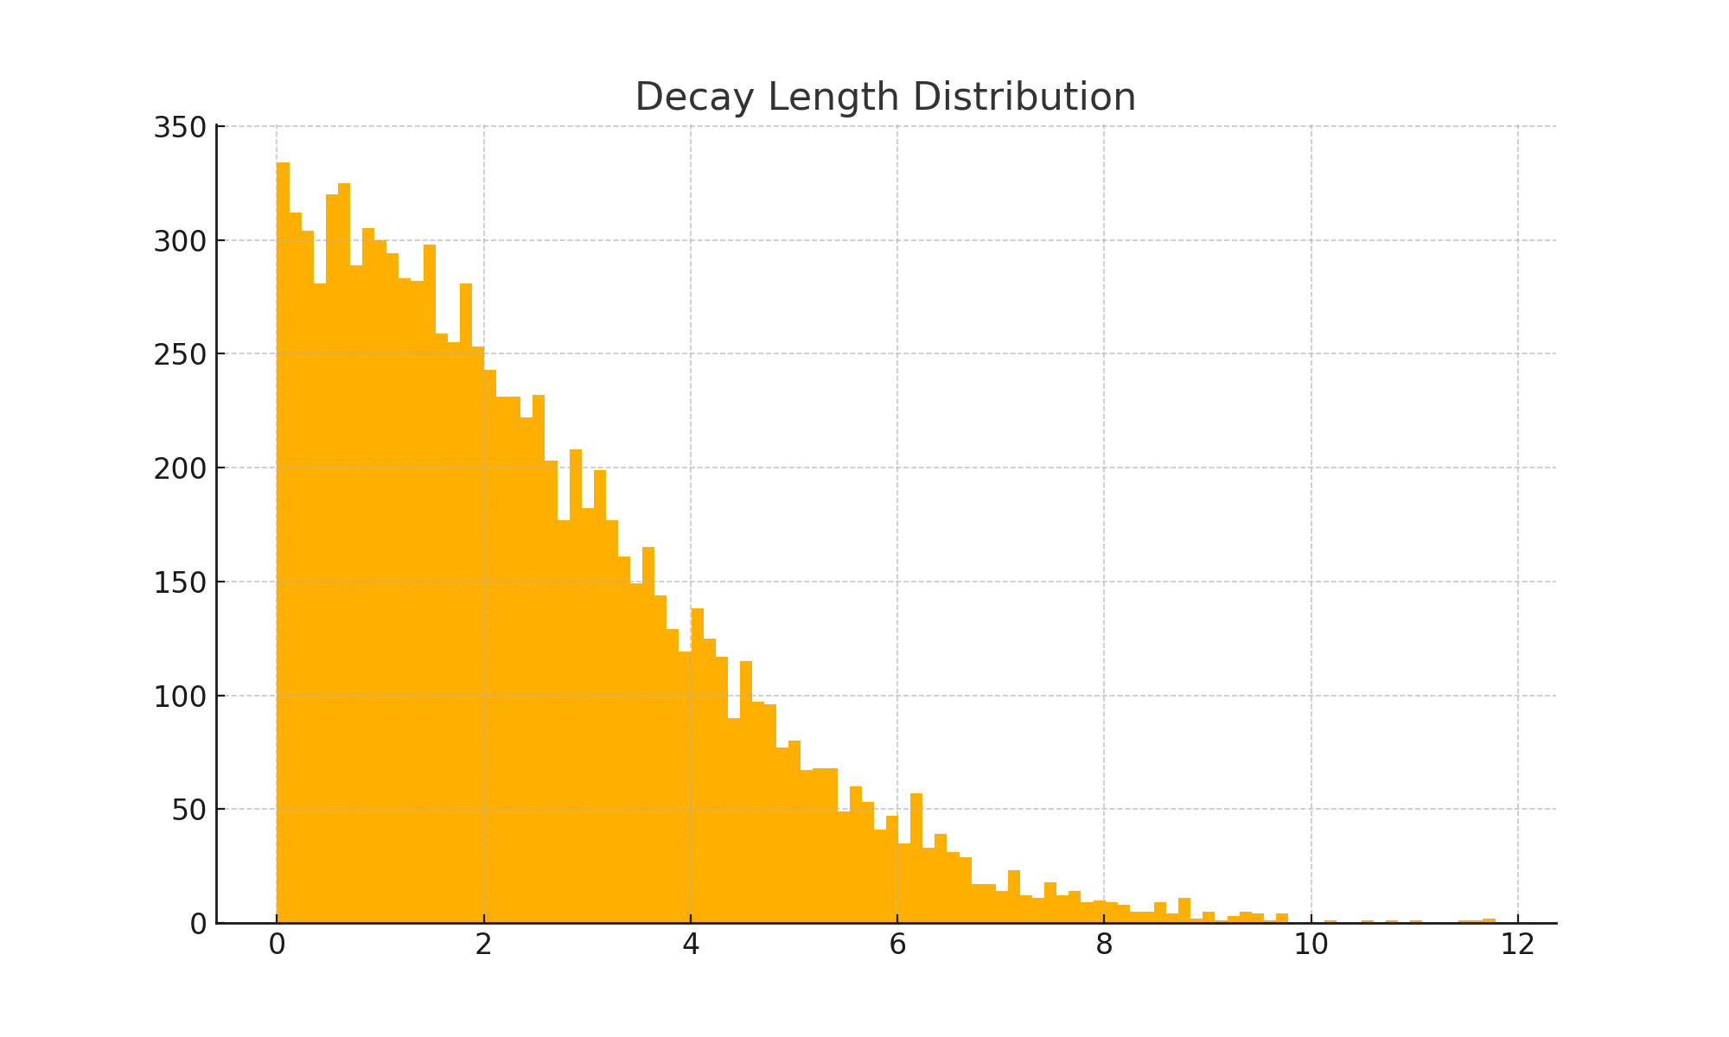

Figure 7: Distribution of decay lengths in mm.

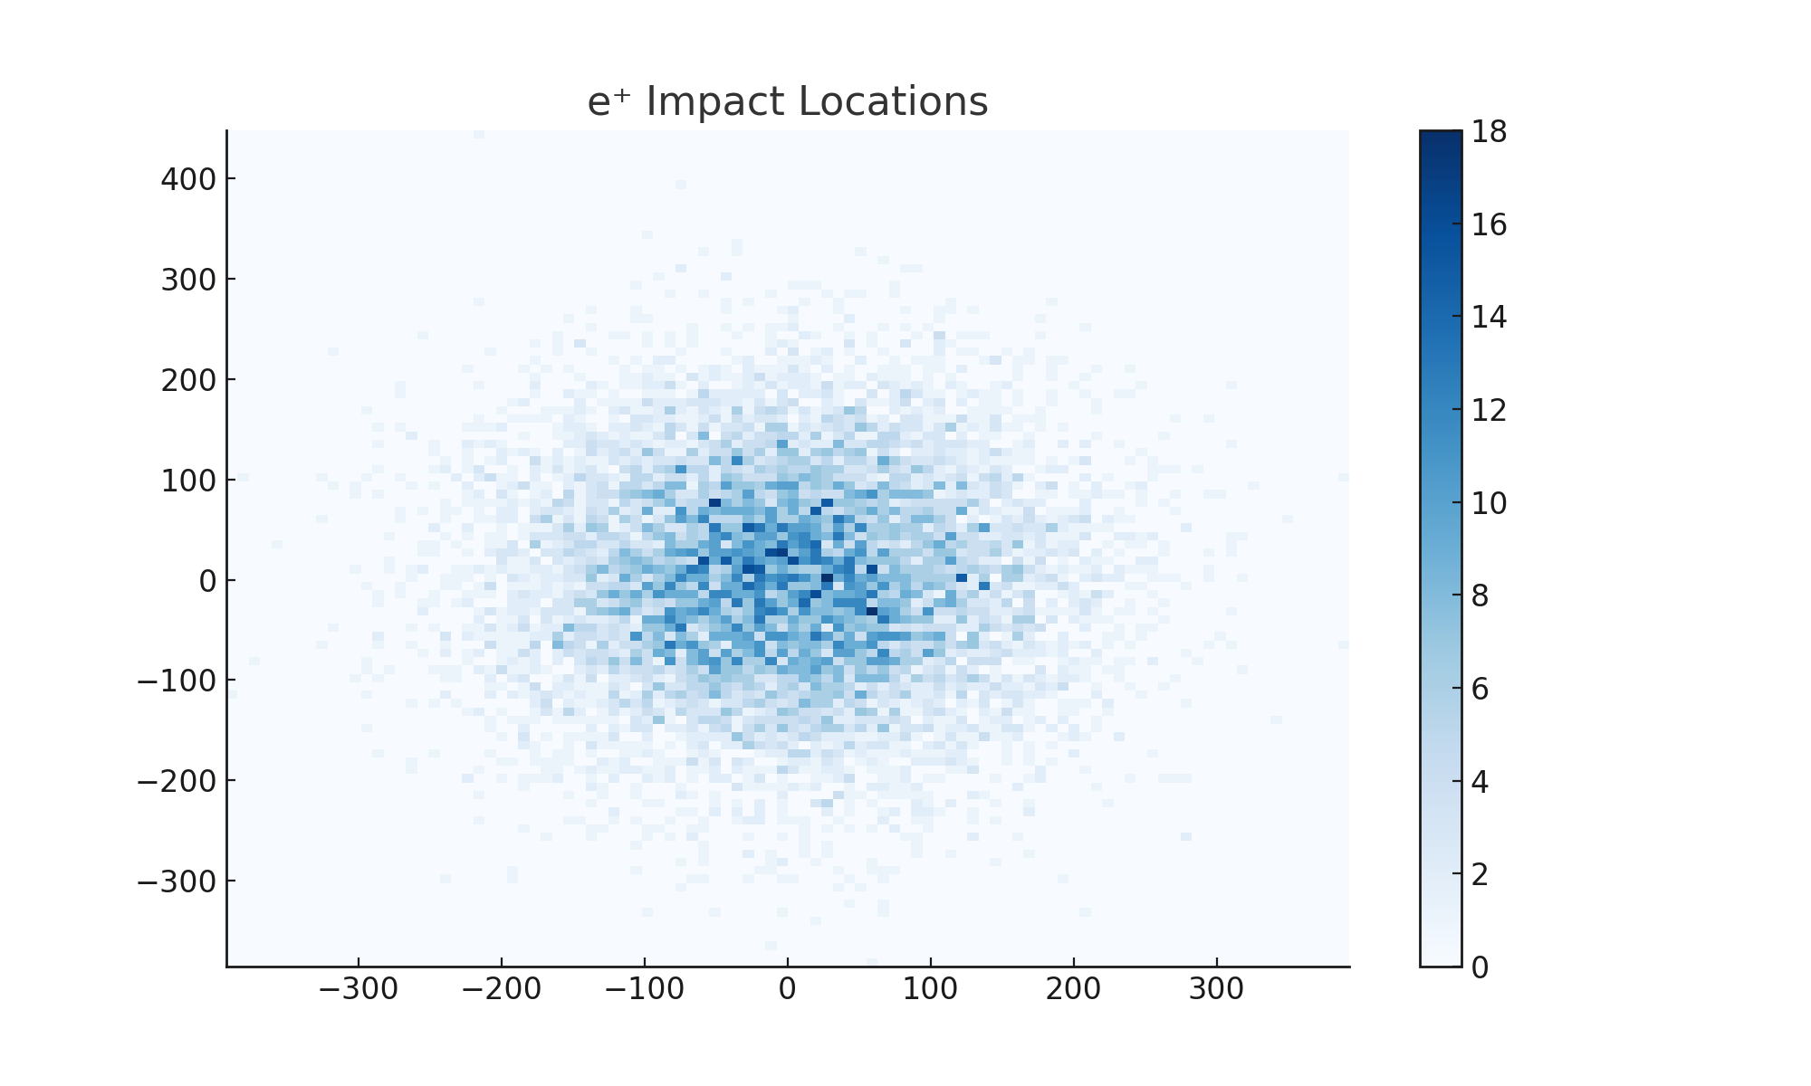

Figure 8: e⁺ impact locations at z = 0.5 m detector plane.

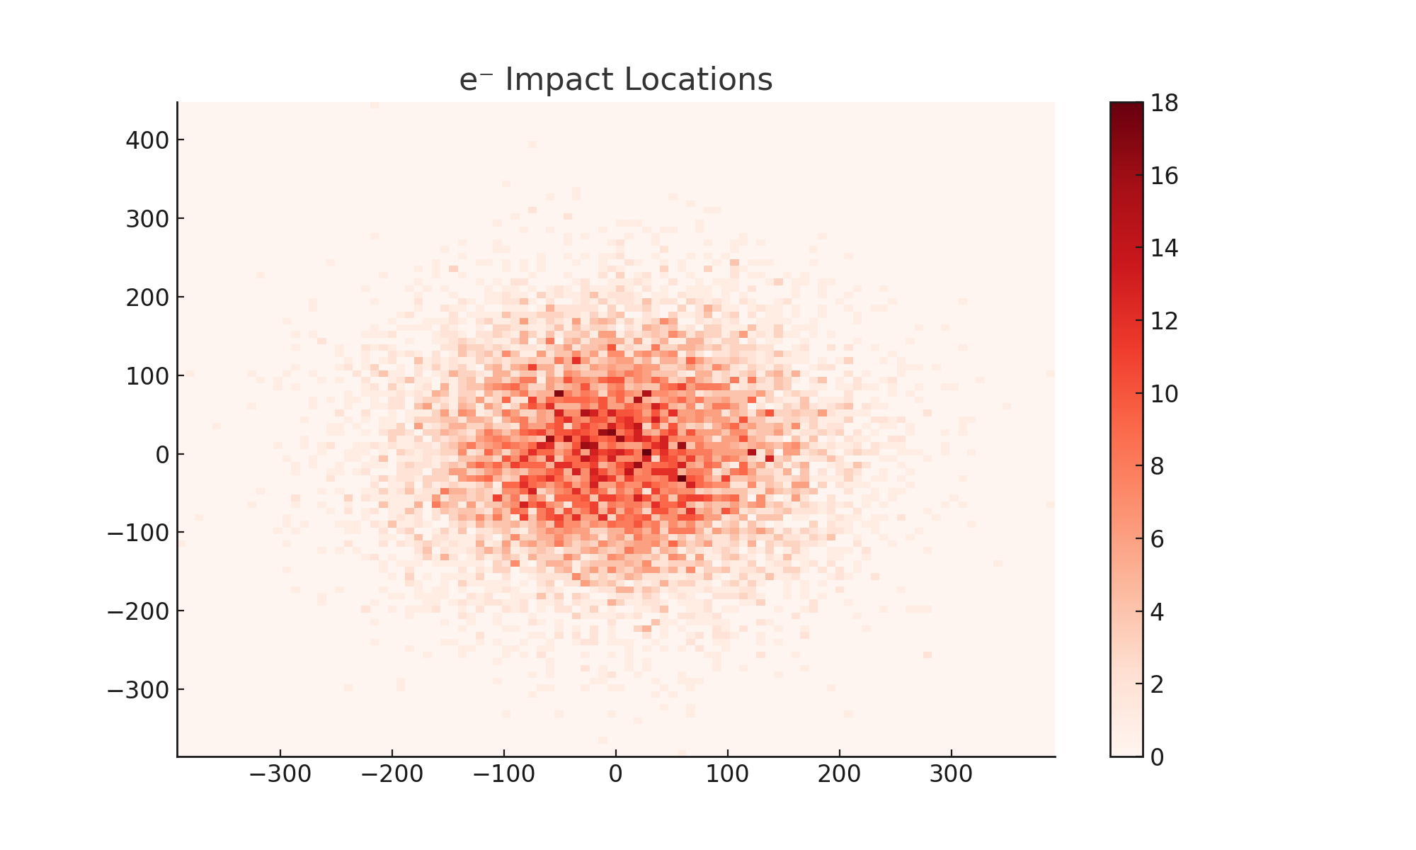

Figure 9: e⁻ impact locations at z = 0.5 m detector plane.

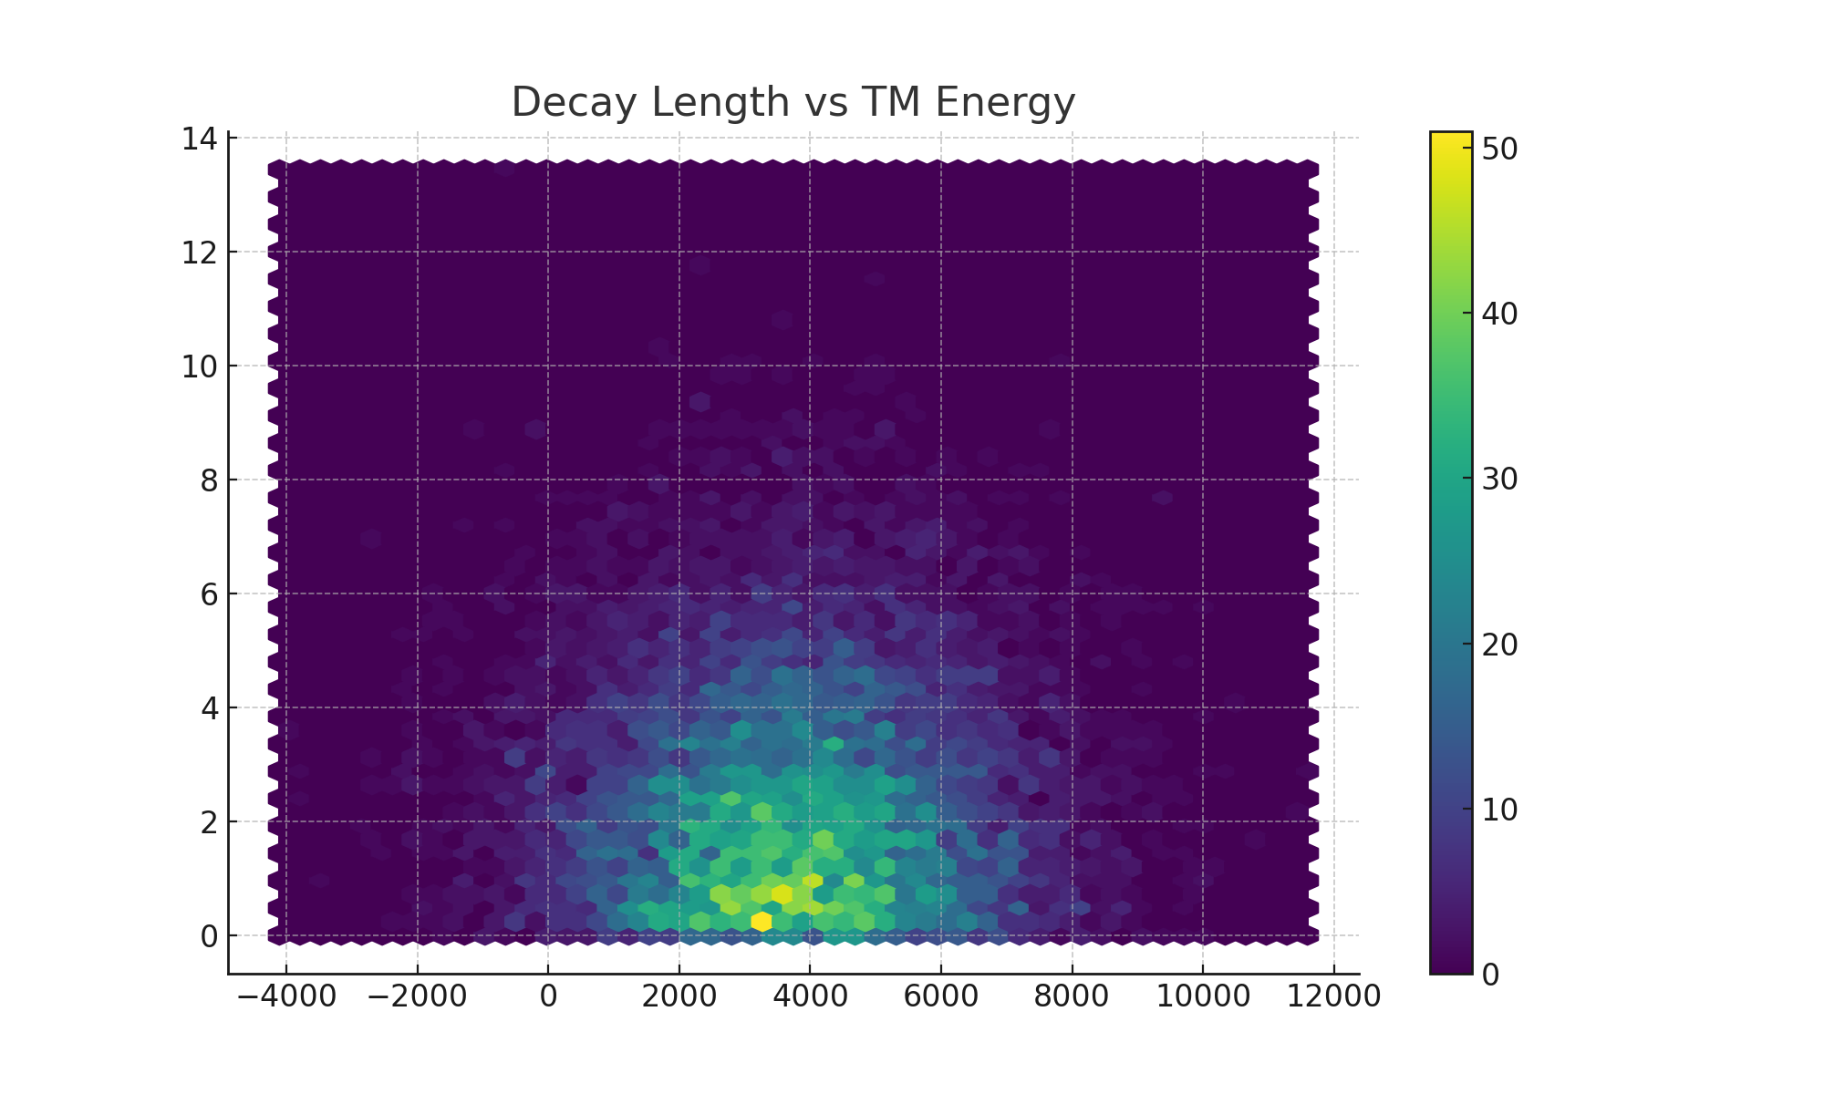

Figure 10: Correlation between TM energy and decay length.

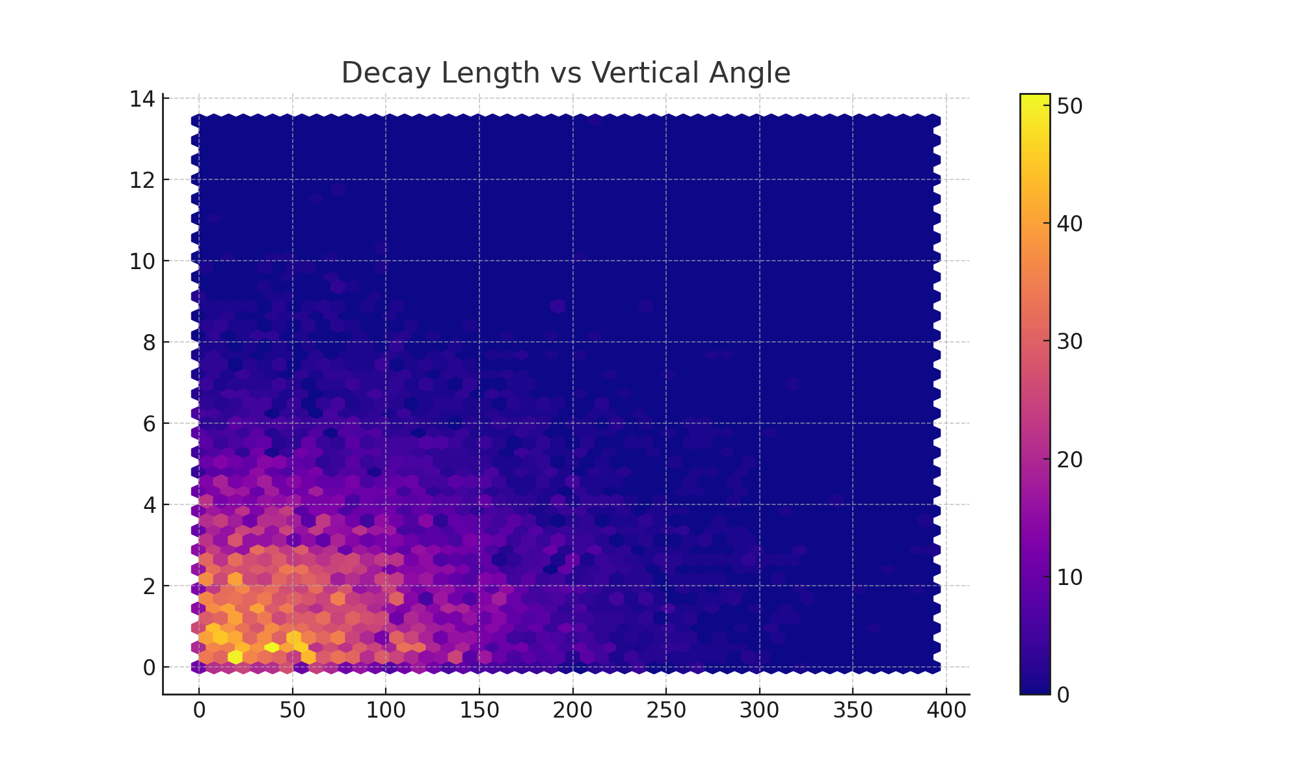

Figure 11: Correlation between e⁺ vertical angle and TM decay length.