Hazz Karaoke Hoster v1.7 Beginner Guide
Made For KJ/DJ's By A KJ/DJ
Step by step instructions for the current release and retained features.
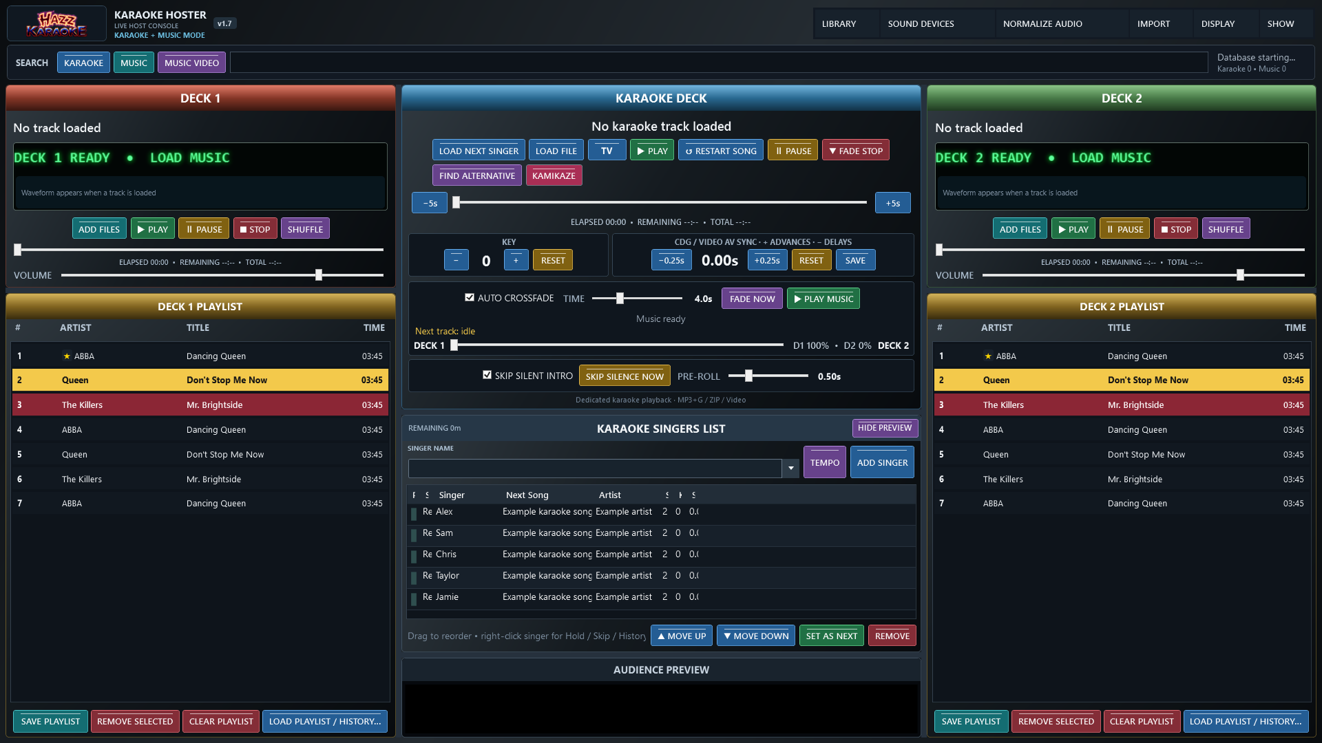
Current Classic layout with illustrative sample rows. Other skins retain the same controls.

Audience display controls
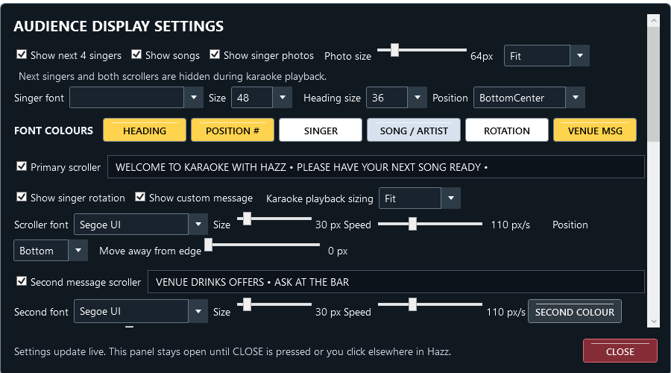
The v1.7 scrollable settings panel at laptop size. Scroll down for background, transparency and other controls; CLOSE remains visible.

Complete audience preview
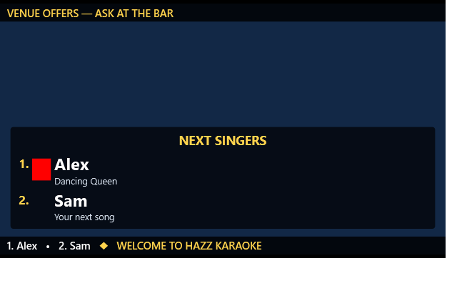
Actual preview rendering with sample singers, messages and a coloured test image in the photo position.

Hazz Karaoke Hoster v1.7 display and sync guide
Made For KJ/DJ's By A KJ/DJ
Audience settings on smaller screens: open DISPLAY > Audience Settings. Controls keep your chosen GUI text size instead of shrinking to fit the whole panel. Use the mouse wheel or the vertical scrollbar to reach the lower settings. CLOSE stays visible at the bottom. At 1366×768 you do not need to reduce Windows scaling to use this panel.
Version 1.7 adds video AV Sync, a complete audience preview and optional transparent CD+G backgrounds. Existing playback, singer history, venue profiles, two scrollers and Fit/Stretch controls remain available. Transparency starts off.

Correct karaoke video timing with AV Sync
1. Load and play a karaoke video. Listen to the sound and watch the audience picture or preview.
2. Find CDG / VIDEO AV SYNC on the karaoke deck.
3. Press +0.25s when the picture or displayed lyrics are late. A positive value moves the picture ahead of the audio. For example, at audio time 10 seconds, +1 second shows video time 11 seconds.
4. Press −0.25s when the picture is early. A negative value delays the picture. At audio time 10 seconds, −1 second shows video time 9 seconds.
5. Use small steps until it looks right. The available range is −10 to +10 seconds. Sound continues normally; the control adjusts the picture.
6. Press SAVE to keep that track default. Press RESET for zero; press SAVE afterwards if you want zero to replace the saved default.
The same controls still adjust CD+G graphics. Video AV Sync works with Windows and VLC audience video, including pause, resume, seeking and the preview. Negative offsets hold the opening picture until audio reaches the required point; positions cannot run before the start or beyond the end of a video. This corrects a consistent offset, not a badly edited recording whose timing varies throughout the song. It does not adjust ordinary music-deck videos.
The track default is used when loading the file directly and is also saved to its library record when available. Existing queued singer/song sync preferences remain independent and take precedence when loading that singer's request. Adjust those in the singer's song/history window or while that singer's song is loaded. File-based defaults are matched by the original path, including the original ZIP path for zipped karaoke; moving or renaming a file changes that match. Saving does not rewrite the media file.

Preview the whole audience screen
1. Press SHOW PREVIEW above the singers list if the preview is hidden.
2. The panel now shows AUDIENCE PREVIEW. Between songs it includes your background, singer names and photos, logo, both enabled scrollers and any Kamikaze announcement.
3. Open DISPLAY > Audience Settings and change your messages or layout. The preview follows the actual audience scene, including the same scroller positions and slideshow item.
4. Start karaoke or a music video. The preview follows playback and the audience overlay visibility rules. During karaoke, singer lists and scrollers remain hidden as configured by Hazz's normal karaoke display behaviour.
5. Press HIDE PREVIEW to recover space and release its extra video decoder. Showing it again reconnects to the current scene.
The preview works without opening a TV window, using a 16:9 preparation scene until an audience window supplies its size. When the audience window is open, the preview fits its proportions. It never sends an audience window to another display by itself. Normal TV and display-selection buttons still control where the audience sees the show.
The preview's video decoder is muted, so it cannot add a second copy of the audio. Native video is mirrored using a separate muted decoder and can differ by a few frames; this is a monitoring preview, not a frame-accurate recording. Backgrounds, photos and text use the shared audience scene. A powerful video may need more resources with preview enabled, so hide the preview if your laptop is struggling.

Put your own background behind CD+G lyrics
1. Open DISPLAY > Audience Settings.
2. Enable Singer-view background. Choose an image, GIF or video, or choose a folder for the existing one-minute slideshow.
3. Enable Transparent CD+G background.
4. Leave Remove colour on Auto first. Hazz removes the colour identified by the CD+G memory-preset background instructions.
5. Play the CD+G song and check AUDIENCE PREVIEW. The chosen background now continues behind the remaining graphics during karaoke.
6. If Auto removes the wrong area, try Palette 0 through Palette 15 in Remove colour. These are the song's sixteen colour slots, not fixed names such as black or white. Choose the slot that removes the background while keeping the words readable.
7. Adjust Background opacity to dim your artwork towards black. Adjust Lyrics opacity separately; 100% keeps the remaining CD+G graphics fully visible.
8. Use the existing background Screen fit and GIF speed controls as needed. Karaoke Fit/Stretch still controls the CD+G picture itself.
CD+G is a coloured pixel image, not a separate lyrics layer. Any artwork or lyric pixels using the selected colour can also disappear. Lyrics opacity affects all remaining CD+G graphics, including title cards and drawings. Check each song and keep the background calm enough for the words to stay readable. This feature does not remove backgrounds from MP4 or other ordinary karaoke videos.

Keep a CD+G adjustment for one song
1. Load the CD+G song and adjust transparency, colour slot and both opacity sliders.
2. Press SAVE FOR THIS SONG. Hazz stores that combination against the original song path. It works for a CDG/audio pair or a karaoke ZIP, without modifying either file.
3. Load the song again to recall the saved combination. The controls show the recalled settings.
4. Press USE DEFAULTS to remove that song's override and return to the general CD+G display defaults.
5. Press RESTORE ORIGINAL for an immediate opaque, full-opacity CD+G picture. If the song already has a saved override, press SAVE FOR THIS SONG afterwards to keep the restored appearance for future loads.
When no song override is active, changing these controls changes the general default. When an override is active, changes are temporary until SAVE FOR THIS SONG is pressed. Close Hazz normally to keep general settings. Venue profiles save the display settings under the existing venue save rules; an older profile without these options uses transparency off. Read the status line after saving: if storage is unavailable, Hazz leaves the show running and asks you to retry.

Downloads and testing
The normal Windows folder ZIP and optional Single EXE ZIP contain the same features. Close your old Hazz, extract the new download and launch it. Keep every runtime folder with the normal ZIP. Both versions use your existing Hazz data location. The single EXE extracts its bundled runtime automatically. No separate VLC installation is required.
For Visual Studio 2026, install the .NET desktop development workload and .NET 10, open HazzKaraokeHoster.sln and build Release / x64. The normal package is produced in RELEASE/HazzKaraokeHoster, and the optional executable in RELEASE/SingleFile.
Validation covers compilation, CD+G alpha/keying and seek reset, saved-setting preservation, preview-only composition, four-skin layouts, Windows/VLC AV Sync, pause, seek, preview muting and fallback. Please rehearse on your own laptop, audience display and sound devices before using the update at a live show; a multi-hour hardware show test is not part of these automated checks.
Copyright © 2026 Hazz Karaoke. All rights reserved in the original Hazz Karaoke Hoster code, documentation, branding and artwork. Third-party components remain subject to their respective licences.

Retained features and instructions

Hazz Karaoke Hoster v1.6 audience display guide
Version 1.6 adds Fit or Stretch for karaoke playback, separate rotation and message switches, and a second independent scrolling message. The existing Fit display and combined primary scroller remain the defaults. The second scroller starts switched off.

Fill the audience screen with karaoke
1. Open DISPLAY, then Audience Settings — Backgrounds, Logo, Scroller.
2. Find Karaoke playback sizing beside the scroller switches.
3. Choose Fit to show the entire picture in its original proportions. A square or 4:3 song on a widescreen TV will have side borders.
4. Choose Stretch to fill the audience display. This changes the picture proportions, so faces and lettering may look wider or taller.
5. Play a CD+G or karaoke video and check the TV. The setting applies to both Windows and VLC karaoke video engines, including Windows fallback. It can also be changed during playback.
This setting affects the audience karaoke picture, not ordinary music videos or idle artwork; the audience preview now mirrors this sizing. The existing Screen fit control under Singer-view background still controls images, GIFs and background videos. Black borders recorded inside a video remain part of that video; Stretch cannot remove them independently. Crisp or smooth CD+G remains available.

Show a message without revealing the singer order
1. Open DISPLAY > Audience Settings.
2. Leave Primary scroller switched on.
3. Switch off Show singer rotation.
4. Leave Show custom message switched on and type your announcement into the message box beside Primary scroller.
5. If you also want to hide the separate upcoming-singers panel, switch off Show next 4 singers at the top of this panel.
Only the announcement now scrolls. You can rearrange the singers privately. To show the order again, enable Show singer rotation. Both content switches can be on together; rotation comes first and the message follows. Turning Primary scroller off hides the entire first bar. Turning both content switches off also hides it. An empty message adds no text. When rotation is enabled but there are no singers, the bar says Singer rotation empty.

Add a second scrolling message
1. Switch on Second message scroller.
2. Enter the second message in its box, for example DRINKS OFFERS — ASK AT THE BAR. A blank message keeps this bar hidden.
3. Choose Second font. Drag its Size slider to choose 16–120 pixels; the number beside it shows the selected size.
4. Drag the second Speed slider to choose how fast that message moves. This does not change the primary scroller speed.
5. Press SECOND COLOUR to choose this message's colour.
6. Use the second Move away from edge slider if the TV cuts off the edge of the message.
The second message works even when Primary scroller is off. Each bar has its own font, size, speed and inset. Primary rotation and message colours still use the ROTATION and VENUE MSG buttons. Existing primary text outline settings continue to apply.

Keep the two bars apart
1. Use Position in the primary scroller controls to choose Top or Bottom.
2. The second bar automatically uses the opposite edge. Primary Bottom means second Top; primary Top means second Bottom. This also determines the second bar's edge when the primary is off.
3. Try the edge-inset sliders while looking at the audience TV. A larger number moves that bar inward.
Hazz limits the effective inset so each bar stays in its own half of the audience screen. The requested slider value is retained, but may be reduced on a short display or with large fonts to keep the bars apart. Extremely short windows can clip large text; enlarge the audience window or reduce its font size. The upcoming-singers panel keeps clearance from visible bars.

What happens during songs and when saving
Both scrollers and the upcoming-singers panel hide during karaoke playback and the Kamikaze announcement, as the original scroller did. They return afterwards. To show enabled scrollers over ordinary music videos, tick Both scrollers under SHOW DURING MUSIC VIDEOS. Leave it off for an unobstructed music video. Permanent logo behaviour is unchanged.
Settings apply live. Press CLOSE to dismiss the panel. Close Hazz normally to retain your display choices; do not end it using Task Manager. When using venue profiles, save or update that profile to keep these choices with the venue, following the existing venue save rules. An older profile without the new fields uses Fit, enables both primary content switches, and leaves the second bar off. Existing singers, favourites and playlists are not changed by these options.

Update or build v1.6
Download the normal Windows ZIP and extract the entire folder, or choose the optional Single EXE ZIP. Close the old Hazz before launching the new copy. Both use your existing Hazz data location. Keep all runtime folders with the normal download. The single EXE extracts its bundled runtime automatically. No separate VLC installation is needed.
To build yourself, install Visual Studio 2026 with .NET desktop development and .NET 10, open HazzKaraokeHoster.sln, select Release / x64 and build. The normal app is in RELEASE/HazzKaraokeHoster and the optional single executable is in RELEASE/SingleFile.
Copyright © 2026 Hazz Karaoke. All rights reserved in the original Hazz Karaoke Hoster code, documentation, branding and artwork. Third-party components remain subject to their respective licences.

Retained features and instructions

Hazz Karaoke Hoster v1.5
Version 1.5 adds a folder-only Kamikaze pool and drag-edge scrolling, and brings the newer playback, search, layout and data-protection fixes into the main release. Your existing singers, favourites, venue settings and music handover choices are retained.

Choose the songs used by Kamikaze
1. Put the songs you want into one folder. For a five-song game, put those five songs directly in the folder.
2. In Hazz, open SHOW, then Kamikaze song source, then Choose folder only.
3. Select that folder. Hover over the menu choice or KAMIKAZE button to see its saved path.
4. Add singers normally. Press KAMIKAZE to choose for the next singer, or right-click a singer and choose KAMIKAZE FOR THIS SINGER.
5. Hazz picks one supported song at random from that folder. Press KAMIKAZE again to change the selection; it avoids the previous choice when another song is available. This is not a shuffle-bag: earlier songs may return on later picks.
6. Press karaoke PLAY when ready. The existing announcement, loading and music handover behaviour still applies.
7. To return to the usual pool, choose SHOW > Kamikaze song source > Entire karaoke library (default).
Only files directly in the chosen folder are used. Subfolders are excluded. A matching CDG and audio file count as one song. ZIP karaoke, supported video and audio files are accepted; an orphan CDG, unsupported file or unreadable ZIP is skipped. Use karaoke content in this folder: Hazz cannot determine whether a video or audio recording contains vocals. A single-song folder always selects its one song, even on repeat presses.
The folder choice is saved across restarts. No bulk import is needed: the selected song is added to the library if it is not already indexed, so ordinary singer history still works. If the folder is empty or unavailable, Hazz reports it and does not choose from the full library. Reconnect the drive or choose another folder. A supported file can still fail playback if its media content or codec is damaged; test the pool before the show.

Drag through a long list
1. Start dragging a song or singer normally and keep the mouse button held.
2. Hold the pointer near the top of the destination list to scroll up, or near the bottom to scroll down.
3. Keep holding to continue through the list. Move into the middle to stop scrolling.
4. Release over the required position to drop. Escape cancels the drag.
This works with both music decks, the side list, singer rotation, a singer's queued songs and the virtual-folder tree. Existing move/copy rules stay the same. It scrolls existing rows; it does not turn the library browser's separate search pages.

Choose a console skin and working mode
Open DISPLAY > Console Skin and choose Classic, Midnight, Copper or Daylight. Classic keeps the original layout. Midnight stacks music decks beside karaoke; Copper places playlists above controls; Daylight provides a light background and a different arrangement. The same controls are used in every skin.
Under SHOW, Karaoke Only hides music decks, Single Deck uses Deck 2 as a side list, and Karaoke Focus puts singers in the area normally used by Deck 2 and enlarges the karaoke preview. Focus uses Deck 1 for music. Leaving Focus keeps Single Deck enabled until you turn that option off. Your skin choice also affects where these panels sit. Host text size and automatic fitting remain available.

Seek karaoke and correct CDG sync
Drag the karaoke progress slider to choose a position, or use the minus/plus five-second buttons. CDG graphics rebuild for the selected position. Pause remains pause; seeking does not replace the loaded song.
For CDG sync, positive values advance the graphics and negative values delay them. Use the 0.25-second buttons and RESET to return to zero. For example, plus 1 second displays the graphics for second 11 when the audio is at second 10. Check any saved adjustments made while using earlier test versions with reversed sync behaviour; saved numbers are not automatically changed.

Track lengths and remaining show time
Karaoke search shows known track lengths and reads up to 80 uncached results in the background. Unknown lengths may remain blank. Repeat searches can use the saved length. REMAINING above the singer list adds queued requests and the current karaoke song's remaining time. Held singers are excluded. An unknown length uses a four-minute estimate and a tilde marks an estimate. This is a guide, not a guaranteed finish time; tempo changes, introductions and breaks can change the real duration.

Search cleanup and singer history export
Search accepts apostrophes and other punctuation. Right-click a result to mark it as a favourite or remove its database entry. Remove missing results affects the current displayed results only. Database removal does not delete the media file or the singer's history. Existing yellow favourite stars remain available.
To export history, open a singer's songs/history window, type a filter if wanted, then press EXPORT CSV. Choose where to save it. The file contains the displayed history, including singer, song, artist, date, count, key, sync and file path.

Choose the download format
The normal Windows ZIP contains the app and its runtime folders. Extract it and keep the whole folder together. The optional Single EXE ZIP contains one app EXE plus instructions; it automatically extracts its bundled runtime when launched. Both formats use the same existing Hazz data location and do not create separate singer libraries. No separate VLC installation is required.
For Visual Studio 2026, install the .NET desktop workload and .NET 10 SDK, open the solution and build Release. RELEASE/HazzKaraokeHoster contains the normal app; RELEASE/SingleFile contains the optional EXE. BUILD-EXE.cmd and BUILD-SINGLE-EXE.cmd build each format separately.

Saved data and reliability fixes
Skin selection saves independently of audience controls. Settings retain unknown options and recovery copies; failed reads cannot overwrite them with defaults. Startup guards protect queues and venue snapshots before recovery succeeds. Newer fixes also cover Karaoke Focus music return, scrolling deck LEDs, stale search refreshes, right-click selection, ZPB catalogue names and crossfade preferences when entering Focus.
Compilation, temporary-data regression tests and layout checks pass. Actual sound devices, external TVs and multi-hour playback depend on your hardware and still require a rehearsal before a live show. Doctor integration remains a separate development project.
Copyright © 2026 Hazz Karaoke. All rights reserved in the original Hazz Karaoke Hoster code, documentation, branding and artwork. Third-party components remain subject to their respective licences.

Earlier features retained in v1.5

Hazz Karaoke Hoster v1.4 — new features and instructions
Version 1.4 adds music handover choices, real deck waveforms, venue singer photos and favourites in search. Doctor integration remains separate.

Build with Visual Studio 2026
1. Extract the entire ZIP to a new folder.
2. Install the .NET desktop development workload and .NET 10 SDK.
3. Open HazzKaraokeHoster.sln, allow NuGet restore, select Release / x64.
4. Choose Build > Rebuild Solution. Keep the Release project enabled.
5. Use RELEASE/HazzKaraokeHoster/Hazz Karaoke Hoster.exe. Keep all accompanying DLLs and the libvlc folder.
BUILD-EXE.cmd is the alternative publish command.

Choose what music does when karaoke starts
1. Open SHOW > Music when karaoke starts.
2. Choose one:
- Fade and stop — next queued track (default): existing behaviour; the interrupted music is consumed and queued music returns.
- Fade then pause — resume same track: music fades using the crossfade duration, pauses at that point, then fades back from that position.
- Fade then keep playing silently: the music continues advancing at zero volume. When karaoke ends, it fades back at its current position.
3. Start a music track on Deck 1 or Deck 2, then press karaoke PLAY.
4. Use karaoke STOP or PLAY MUSIC to return. The existing karaoke STOP return fade is 1.5 seconds.
The choice is saved. Changing it during a karaoke song applies to the next handover.
If a silent track ends, Hazz waits for karaoke to finish then uses queued music; it does not loop or start another track silently.
During a crossfade, the incoming deck is retained and the outgoing track is finished.
This option applies to the regular music decks. Space-bar search preview keeps its existing stop behaviour.

Waveforms
Load/play music on either deck. An overview is generated in the background.
Click the waveform to seek. Unsupported files show a message; the position slider remains available.

Singer photos
Right-click a singer in the main list and choose CHOOSE SINGER PHOTO.
The webcam action opens Windows Camera; take/save the picture and select it afterwards.
Photos are stored by singer name and active venue; no venue uses the default collection.
In DISPLAY > audience settings, enable Show singer photos and adjust Photo size and Fit, Fill/crop, Stretch or Center.
Photos appear in the main singer list and beside the upcoming singers on the TV. The upcoming list follows existing hide-during-karaoke behaviour.

Search favourites
Right-click a search result to mark/unmark it as a favourite. Music search supports multiple selected rows.
Saved favourites have a yellow star in search results.

Testing
The exact packaged source passed Release compilation with zero warnings/errors.
Automated handover logic checks passed for pause, mute, default, early return, ended-track fallback, crossfade and setting changes.
These checks use simulated music devices. Test pause/resume and silent playback with your actual sound devices before a live show.
Copyright © 2026 Hazz Karaoke. All rights reserved in the original Hazz Karaoke Hoster code, documentation, branding and artwork. Third-party components remain subject to their respective licences.
---
The sections below cover the existing controls. Earlier screenshots are labelled with their original version.

Hazz Karaoke Hoster Dummy Guide
Copyright © 2026 Hazz Karaoke. All rights reserved in the original Hazz Karaoke Hoster code, documentation, branding and artwork. Third-party components remain subject to their respective licences.
Simple steps for a first live show.
New in v0.97 test: Show > Venue Profiles can save different singer lists. Create a named profile with SAVE CURRENT, then SAVE SINGER LIST. On returning, APPLY its settings and LOAD SINGER LIST. Leave history ticked to restore songs sung previously. Saving or loading a named singer list enables automatic updates when requested, before switching singers and at shutdown. With no venue, history still saves in the main database. See the step-by-step venue guide for starting blank, keeping regulars and backups. Manual rotation remains the default; computer sorting must be explicitly enabled in Show > Rotation Settings.

The ten minute setup

The ten minute setup
- Connect your second screen or projector and set Windows to Extend these displays.
- Open Hazz Karaoke Hoster.exe.
- Choose Import, Import Karaoke Folders and select your karaoke folder.
- Choose Import, Import Music Folders if you want interval music.
- Press TV. The audience picture should appear full screen on Display 2.
- Choose Show, New Show when you are ready to start a fresh night.

Add the first singer

Add the first singer
- Click the singer-name box in the centre.
- Type the singer's name.
- Press Add Singer.
- Search in Karaoke mode for the requested artist or song.
- Drag the result onto the singer's row.

Play the singer

Play the singer
- Press Load Next Singer.
- Read the singer and song shown in the Karaoke Deck.
- Press the green Play button.
- Use yellow Pause if needed.
- Use red Fade Stop to lower karaoke for 1.5 seconds; returning music then fades in for 1.5 seconds.
- To load without a singer assignment, drag a Karaoke search result or karaoke file directly onto the Karaoke Deck, check it, then press Play.

Keep the queue fair

Keep the queue fair
- Drag a singer to change the order, or use Move Up and Move Down.
- Set As Next puts the selected singer first.
- Right-click and choose Hold when a singer has gone outside.
- Use Skip Once if they should be passed over only this time.

Use a previous singer

Use a previous singer
- Open the singer-name dropdown. It opens with recent singers instead of loading thousands at once.
- Type part of the name to search all saved singers.
- Select the name and add them to tonight's rotation.
- Open Songs and History to reuse one of their old songs.

Run interval music

Run interval music
- Drag Music search results to Deck 1 or Deck 2.
- Shift-click a range or Ctrl-click individual tracks, then drag the selection or use a deck button.
- Press Select All or Ctrl+A to queue every visible result from a folder search.
- Press the green Play button on a deck.
- Pause keeps the exact position; press Pause or Play to resume. Drag the timeline to seek.
- Import a music-video folder through Import, Import Music / Video Folders. Video tracks automatically appear full-screen and muted on the singer display while deck audio plays normally.
- Press Music Video at the top to search only the imported videos. Add or drag the result to a music deck, or press Space for quick play.
- Singer lists, scrollers, venue text, backgrounds and the logo hide automatically while the music video is on the singer display.
- Enable Auto Crossfade if you want the decks to alternate.
- For one-player operation, choose Show, Single Deck + Side List Mode. The right panel becomes a proper side list with Add, Load, Save, Select, Move, Send to Deck 1, Shuffle, Remove and Clear controls.
- Starting karaoke pauses the music plan; Play Music resumes the next scheduled track.
- In Music search, Space quickly plays the highlighted result and Space again stops it.

Make the audience screen look good

Make the audience screen look good
- Open Display, Overlay and Next Singer Settings.
- Choose whether to show the next four singers and their songs.
- Choose a background image, GIF or silent video, or choose a whole slideshow folder.
- Use Fit for the whole image, Fill for edge-to-edge cropping, or Stretch to fill everything.
- Move the singer scroller to the top if it blocks artwork at the bottom.

If something goes wrong

If something goes wrong
- No second-screen picture: press TV again and confirm Windows sees Display 2.
- Missing file: reconnect the drive, then rescan the watched folder.
- Red or broken song: choose another version; Hazz has marked the failed file so you can repair it later.
- Lyrics early or late: use the CDG minus or plus 0.25-second buttons.
- Wrong pitch: use Key minus or plus, then Reset when needed.
- Cramped controls: maximise Hazz or hide the preview.

Finish safely

Finish safely
- Let the current media stop.
- Close Hazz from the main window.
- Answer Yes to the shutdown question.
- Wait until Hazz closes before disconnecting a library drive or shutting down Windows.

Virtual Folders — Beginner Walkthrough

Virtual folders in plain English
A virtual folder is a list of shortcuts to your songs. It helps you group songs without moving or copying the actual files. Deleting a virtual folder does not delete your music or karaoke files.
Illustration: Virtual folder controls

Make an 80s / Rock folder
1. Open Library > Browse Library.
2. Press New Folder, type 80s, and create it.
3. Click 80s in the left panel.
4. Press New Subfolder, type Rock, and create it.
5. Click All Library Tracks.
6. Choose Music and find the songs you want.
7. Hold Ctrl while clicking separate songs, or use Shift to select a range.
8. Press Add Selected to Folder….
9. Choose 80s / Rock, then press Add Tracks.
10. Click Rock in the left tree to see your collection.

Bring folders over from BPM Studio
1. Close BPM Studio.
2. Choose Import > Import BPM Studio in Hazz.
3. Select the BPM Studio data/archive folder.
4. Confirm the import.
5. When it finishes, open Library > Browse Library and expand BPM Studio.
The source is read-only. Hazz creates links to the tracks and leaves every original file alone.
If several .GRP files have the same name, Hazz uses only the newest copy. Repeat imports skip files that have not changed. On a large library, let the progress window finish the Linking, Saving and Finalizing stages before starting another import.

The safe buttons
- Rename changes the folder's label.
- Remove from Folder removes selected shortcuts from the open folder.
- Empty removes all direct shortcuts from the folder.
- Delete Selected Folder removes the folder and its child folders.
All four actions leave the physical song files and main Hazz library untouched.

If it does not look right
- Click All Library Tracks to reset the view.
- Clear the search box.
- Check whether Karaoke or Music is selected.
- Open the child folder; the parent does not automatically show all child tracks.
- Maximise the Library Browser if a button is clipped.
Hazz Karaoke Hoster v0.90
Audience Display Settings now includes SHOW DURING MUSIC VIDEOS with independent options for:
- Permanent logo
- Both scrollers
- Next singers
- Kamikaze message
Check an option to retain that overlay during music videos. Its normal display settings must also be enabled. Leave all options unchecked for an unobstructed video, matching v0.80 behaviour. Changes apply live and are saved for the next launch. Background artwork remains hidden behind music videos.
All v0.80 features and fixes remain included.

