Hazz Karaoke Hoster Complete Manual
Setup operation imports live shows audience display and troubleshooting
Windows x64 | Version 0.17.20 | September 2026
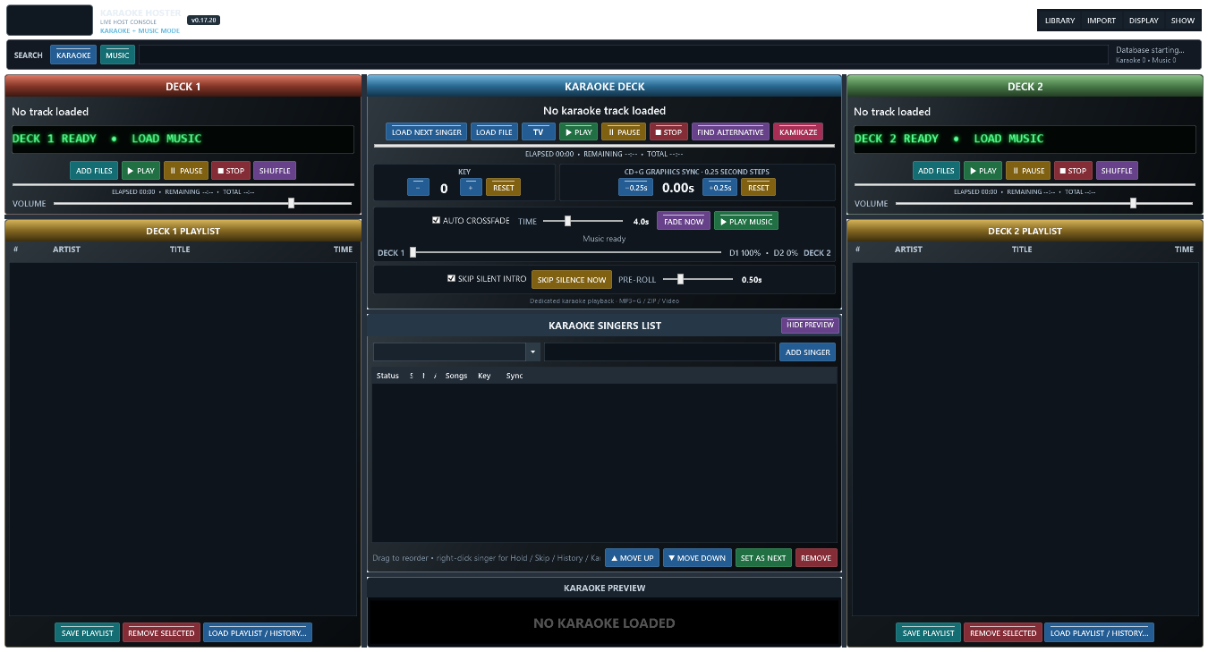
Hazz Karaoke Hoster

About this manual
This manual explains how to set up and operate Hazz Karaoke Hoster for a complete live karaoke show. It covers the host console, song libraries, singer rotation, history migration, music decks, audience display, recovery, troubleshooting and the Visual Studio 2026 build. New users should read sections 1 through 7 before running a public show.

Contents
- 1 Getting started
- 2 The live console
- 3 Build the song libraries
- 4 Import from other programs
- 5 Search for songs
- 6 Manage singers and requests
- 7 Play karaoke
- 8 Run background music
- 9 Audience display
- 10 Show safety and recovery
- 11 Backups and data
- 12 Troubleshooting
- 13 Visual Studio 2026 build
- 14 Live show checklist

Quick control reference
Colour | Meaning
Green | Play or confirm
Red | Stop remove or clear
Yellow | Pause timing or reset
Blue | Load or navigate
Teal | Add or save
Purple | Special action shuffle fade or alternative

1 Getting started

What Hazz Karaoke Hoster does
Hazz Karaoke Hoster is a Windows live-show console for running a singer rotation, playing CD+G and video karaoke, and managing two background-music decks. It keeps the host controls on the main display and can place the singer output full screen on a second display.

Before your first show
- Use a Windows 64-bit computer and connect the audience television or projector before opening Hazz.
- Keep karaoke and music files on drives that will remain connected during the show.
- Test Windows sound output, the second display, and several representative song formats before guests arrive.
- Keep a current database backup and avoid moving indexed files immediately before a show.

Run the supplied build
Open RELEASE\HazzKaraokeHoster and double-click Hazz Karaoke Hoster.exe. The release is a self-contained single file; no separate .NET installation is required.

2 The live console

Main areas
Deck 1 and Deck 2 hold background-music queues. The centre Karaoke Deck loads and controls the current singer song. The Karaoke Singers List is the running order. The Search bar switches between Karaoke and Music results. Library, Import, Display and Show menus contain setup and show-management commands.

Button colours
- Green starts or confirms playback.
- Red stops, removes or clears.
- Yellow pauses or changes timing.
- Blue loads or navigates.
- Teal adds or saves.
- Purple runs special actions such as shuffle, fade and alternatives.
- A brighter button and glow show an active function.

Automatic fitting
The console scales to the available host display. If space is limited, deck sections provide scrolling and the preview can be hidden. The splitters between columns and centre rows can be dragged, and the chosen layout is remembered.

3 Build the song libraries

Import karaoke folders
Choose Import, then Import Karaoke Folders. Select one or more folders. Hazz scans ZIP and CDG karaoke, companion audio plus CDG pairs, and supported video karaoke. The selected folders are watched for new files while Hazz is running.

Import music folders
Choose Import, then Import Music Folders. Select folders containing ordinary background music. Hazz keeps music separate from karaoke so Music search and the music decks do not become mixed with the singer library.

Supported media
Audio includes MP3, WAV, WMA, M4A, AAC, FLAC, OGG, AIF and AIFF. Video includes MP4, MKV, AVI, MOV, MPEG, MPG, WMV, M4V, VOB, TS, M2TS, WEBM and DIVX. Karaoke packages include ZIP and CDG with a matching audio file.

Rescan and browse
Use Library, Browse Library to inspect indexed songs. Use Library, Rescan Watched Folders after files were added while Hazz was closed or if Windows reported a watcher overflow.

4 Import from other programs

Smart Import
Choose Import, Smart Import, then Detect from File or Detect from Application Folder. Hazz previews the detected program and sample records before importing. The source is opened read-only.

Recognised sources
Detection covers common exports and databases from MediaMonkey, CompuHost, Lyrx, KaraFun, Siglos and PowerKaraoke, VirtualDJ, OpenKJ, Karma, BPM Studio, PCDJ DEX, MTU Hoster, SongBookDB, kJams, JustKaraoke, Sax and Dottys, TriceraSoft, Serato, Mixxx, djay Pro, Winamp, rekordbox and Apple Music or iTunes.

Singer history import
Choose Import, Smart Import, Import Singer History. Select a CSV, TSV, TXT, JSON, XML, SQLite, MDB, ACCDB or KDB history export. Check the detected singer, artist, title, path and date mapping in the preview. Matching songs link to the Hazz library; unmatched performances remain in the singer history. Reimporting the same source replaces its earlier imported rows.

Large imports
Leave Verify files exist off for the fastest database migration. Turn it on only when you need Hazz to check every stored path. Imports run away from the interface and can be cancelled safely.

5 Search for songs

Karaoke search
Press Karaoke beside the Search box, then type part of an artist, title, manufacturer or disc ID. Drag a result onto a singer or use the available add action. Results leave the singer rotation visible.

Music search
Press Music and enter an artist or title. Drag results to Deck 1 or Deck 2. Music results appear over the centre so both deck playlists remain visible.

Space-bar quick play
In Music search, highlight a result and press Space to play it immediately without adding it to a deck. If music is already playing, Hazz fades into the selected result. Press Space again to stop quick play. Hazz then waits for Play Music or the next karaoke song.

Broken results
A missing or unplayable file is tagged as broken and colour-coded. The tag records the failure reason so the host can avoid retrying it during the show.

6 Manage singers and requests

Add a singer
Type or choose the singer name above the Karaoke Singers List and press Add Singer. Opening the previous-singer list shows a capped recent set immediately; typing searches the full singer database in the background.

Add songs
Drag a Karaoke search result onto the singer. Double-click the singer, or use the singer right-click menu, to open Songs and History. Songs may be reordered, removed, or adjusted for key and CD+G sync.

Change the rotation
Drag singers, use Move Up or Move Down, or press Set As Next. The right-click menu also provides Move to Top. Remove deletes the singer from the current show after confirmation where applicable.

Hold and skip
Hold keeps the singer visible but causes Load Next Singer to pass over them until released. Skip Once passes over that singer one time. These controls are useful for a temporary absence without losing requests.

Past songs
Songs and History shows previous performances with last-sung date, times sung, key and sync. Search by artist or title. Double-click or drag a history item to request it again. Hazz warns about a song already performed during the current show, but the host can continue.

7 Play karaoke

Normal sequence
- Press Load Next Singer to load the first eligible singer request.
- Check the singer and song shown in the Karaoke Deck.
- Press TV if the audience screen is not already full screen on Display 2.
- Press Play. Hazz records the performance in singer history when playback begins.
- At the end, Hazz advances the show state and restores background music when configured.

Pause and stop
Pause resumes from the same position. Stop ends the loaded performance. Starting karaoke stops Music Search quick play and suspends normal background music.

Key
Use minus, plus and Reset to change the singer key from minus 6 to plus 6 semitones. The value is saved with the request. Live pitch change depends on whether the audio format can be loaded by the pitch engine; Hazz reports when only the saved preference is available.

CDG graphics sync
Use minus 0.25 seconds to display lyrics earlier and plus 0.25 seconds to display them later. Reset returns to the original CDG timing. The adjustment is saved for the singer request.

Alternative and Kamikaze
Find Alternative loads another library version with the same artist and title. Kamikaze assigns a random karaoke song to the next singer and shows the configured audience message until playback starts.

8 Run background music

Load a deck
Press Add Files, drag Music search results into a deck, or use Load Playlist or History. The scrolling LED shows the deck state, artist and title.

Queue controls
Play starts the selected or scheduled track. Pause, Stop and Shuffle affect that deck. Remove Selected removes unplayed entries without deleting files. Delete performs the same action when the list has focus. The current playing entry is protected.

Save and reload
Save Playlist stores the remaining unplayed order under a name. Reusing a name replaces that Hazz playlist. Music History and Lists can load saved, imported or daily history into either deck.

Crossfade
When Auto Crossfade is enabled, Hazz prepares the other deck and fades near the end of the active track. The Time slider controls the fade length. Fade Now starts the transition immediately. Play Music starts the next scheduled background track after karaoke.

9 Audience display

Open safely
Use Display, Open Audience Display. Choose Send Full Screen To and select the intended display, or use the TV button for one-click full screen on Display 2. If Display 2 is missing, TV warns and does not place the audience output on Display 1.

Windowed mode
Use Windowed, Move and Resize while setting up. Move the audience window to the projector, check overscan and scaling, then select full screen.

Next singers
Display settings can show the next four singers and optionally their songs. Choose font, size, position and colours. Hazz hides next-singer and rotation information automatically during karaoke playback.

Scroller
Enable the full rotation scroller, enter an optional venue message, and choose font, size, speed, colour and top or bottom placement.

Backgrounds
Choose one image, GIF or muted video, or choose a folder for a slideshow. Every folder item receives a one-minute slot; video loops silently within its slot. GIF speed is adjustable from 0.25 to 4 times. Fit shows the whole picture, Fill crops edges, Stretch fills the display, and Center keeps original size.

Logo
Choose a transparent PNG or other supported image as a persistent audience logo. Set its position and width. It remains above CDG and video karaoke when enabled.

10 Show safety and recovery

New Show
Choose Show, New Show to clear the current rotation and begin a new duplicate-song window. Confirm the prompt before the list is cleared.

Karaoke Only Mode
Choose Show, Karaoke Only Mode to hide both music decks and expand the singer workspace. Enabling this mode safely stops hidden music. Turning it off restores the deck queues.

Recovery
Hazz saves the live singer rotation and unplayed music queues. If the previous session ended unexpectedly, Hazz can offer to restore the last show. A fresh checkpoint is written regularly during long shows.

Closing
Closing the main window asks for confirmation. Choose No if the close was accidental. Normal shutdown releases media resources and records a clean end state.

11 Backups and data

Database backup
Choose Library, Database, Backup Database and save the copy to another drive. Back up before a large import and before making major file-location changes.

Data locations
The main database is stored under %LOCALAPPDATA%\Hazz Karaoke Hoster\hazz-hoster.db. Layout, queue recovery, broken-media information, diagnostics and temporary extracted ZIP content are stored under the same application area.

Keep sources safe
Third-party imports are read-only. Hazz writes imported data to its own SQLite database. Do not delete the original program data until you have checked searches, paths and history in Hazz and kept a backup.

12 Troubleshooting

A file is missing
Reconnect its drive or restore the file to the indexed path. The red broken-file tag protects the show from repeated attempts. Rescan the watched folder after correcting the file location.

Video or audio will not play
Test the file in Windows Media Player and install a suitable Windows codec if required. Try another file of the same format. Hazz records playback failure details in its broken-media registry and diagnostic log.

No audience picture
Open Display and confirm the audience window exists. Verify Windows Extended desktop mode, then explicitly send full screen to Display 2. Check the projector input and cable.

Lyrics are early or late
Use the CDG sync buttons in 0.25-second steps. Use Key controls only for pitch; they do not alter CDG timing.

The interface looks cramped
Maximise Hazz, hide the karaoke preview, drag the splitters, or enable Karaoke Only Mode. The interface scales and scrolls its control areas on smaller screens.

An import is slow
For very large third-party catalogues, leave file verification off and allow the database import to finish. MediaMonkey and BPM Studio use optimised bulk paths. Cancel only from the displayed import control.

13 Visual Studio 2026 build

Requirements
Install Visual Studio 2026 with .NET Desktop Development and the .NET 10 SDK. Open HazzKaraokeHoster.sln, select Release and x64, then choose Rebuild Solution.

Release output
A successful Release x64 build creates RELEASE\HazzKaraokeHoster\Hazz Karaoke Hoster.exe. This is the self-contained single executable. BUILD-EXE.cmd produces the same publish output from the command line.

If no release appears
Confirm Release and x64 are selected, restore NuGet packages, close any running copy of the EXE, and rebuild. Review the first actual compiler or publish error rather than the final MSB3073 wrapper message.

14 Live show checklist

Before doors open
- Connect and test Display 2.
- Select the correct Windows audio output.
- Open a karaoke ZIP, a CDG pair and a video karaoke file.
- Load and play one track on each music deck.
- Check microphone and mixer levels outside Hazz.
- Confirm the database backup date.
- Set the audience background, logo and scroller.
- Start a New Show only after the correct rotation is clear.

During the show
- Load and verify the next singer before pressing Play.
- Use Hold or Skip Once when someone is away.
- Avoid disconnecting library drives.
- Use coloured broken-file warnings instead of repeatedly retrying a failed track.
- Let Hazz complete normal shutdown after the final song.

