Hazz Karaoke Hoster Dummy Guide
A simple step by step guide for running your first show
Windows x64 | Version 0.17.20 | September 2026
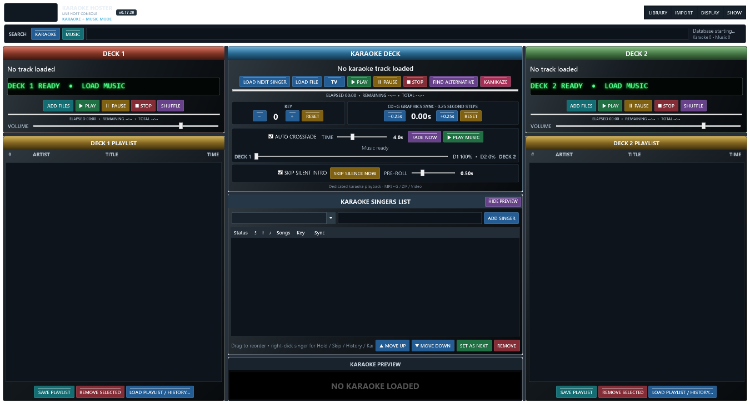
Hazz Karaoke Hoster

Read this first
This guide gives you the shortest safe route from opening Hazz to playing singers. Follow the steps in order during your first practice session. The Complete Manual explains every option in more detail.

The three rules
- Keep the Hazz controls on Display 1 and the audience picture on Display 2.
- Load and check the next singer before pressing Play.
- Do not disconnect karaoke or music drives while Hazz is open.

The ten minute setup
- Connect your second screen or projector and set Windows to Extend these displays.
- Open Hazz Karaoke Hoster.exe.
- Choose Import, Import Karaoke Folders and select your karaoke folder.
- Choose Import, Import Music Folders if you want interval music.
- Press TV. The audience picture should appear full screen on Display 2.
- Choose Show, New Show when you are ready to start a fresh night.

Add the first singer
- Click the singer-name box in the centre.
- Type the singer's name.
- Press Add Singer.
- Search in Karaoke mode for the requested artist or song.
- Drag the result onto the singer's row.

Play the singer
- Press Load Next Singer.
- Read the singer and song shown in the Karaoke Deck.
- Press the green Play button.
- Use yellow Pause if needed.
- Use red Stop only when you really want to end the song.

Keep the queue fair
- Drag a singer to change the order, or use Move Up and Move Down.
- Set As Next puts the selected singer first.
- Right-click and choose Hold when a singer has gone outside.
- Use Skip Once if they should be passed over only this time.

Use a previous singer
- Open the singer-name dropdown. It opens with recent singers instead of loading thousands at once.
- Type part of the name to search all saved singers.
- Select the name and add them to tonight's rotation.
- Open Songs and History to reuse one of their old songs.

Run interval music
- Drag Music search results to Deck 1 or Deck 2.
- Press the green Play button on a deck.
- Enable Auto Crossfade if you want the decks to alternate.
- Starting karaoke pauses the music plan; Play Music resumes the next scheduled track.
- In Music search, Space quickly plays the highlighted result and Space again stops it.

Make the audience screen look good
- Open Display, Overlay and Next Singer Settings.
- Choose whether to show the next four singers and their songs.
- Choose a background image, GIF or silent video, or choose a whole slideshow folder.
- Use Fit for the whole image, Fill for edge-to-edge cropping, or Stretch to fill everything.
- Move the singer scroller to the top if it blocks artwork at the bottom.

If something goes wrong
- No second-screen picture: press TV again and confirm Windows sees Display 2.
- Missing file: reconnect the drive, then rescan the watched folder.
- Red or broken song: choose another version; Hazz has marked the failed file so you can repair it later.
- Lyrics early or late: use the CDG minus or plus 0.25-second buttons.
- Wrong pitch: use Key minus or plus, then Reset when needed.
- Cramped controls: maximise Hazz or hide the preview.

Finish safely
- Let the current media stop.
- Close Hazz from the main window.
- Answer Yes to the shutdown question.
- Wait until Hazz closes before disconnecting a library drive or shutting down Windows.

Quick control reference
Colour | Meaning
Green | Play or confirm
Red | Stop remove or clear
Yellow | Pause timing or reset
Blue | Load or navigate
Teal | Add or save
Purple | Special action shuffle fade or alternative

One page show checklist
- Display 2 tested
- Sound output tested
- Karaoke search returns songs
- Music decks tested
- Audience background and scroller checked
- Database backup current
- New Show started
- First singer and song loaded

