+91 8837787856



1 77777 66666

Singh.harpreet.hs012@gmail.com

HARPREET SINGH

www.linkedin.com/in/harpreet-happy



FRONT- END DEVELOPER

Phagwara, Punjab



[Harpreet](https://sdgjekxzr/)



SUMMARY

As a front-end developer, I am skilled in creating intuitive and visually appealing user interfaces using web technologies such as HTMl ,CSS and javascript . My Expertise lies in developing responsive web designs that seamlessly across multiple devices

TECHNICAL SKILLS

Programming languages: Java, JavaScript, C, C++

Web Technologies:

HTML5, CSS, Bootstrap

Platforms:

Window7, Window 10

CERTIFICATIONS

Mastering Data Structure & Algorithms Using C and C++ | UDEMY | Jan '23

Six weeks Industrial Training In C & C++ | GOVT. Certified

GTB Computer Education |

July '2018

POWER SKILLS

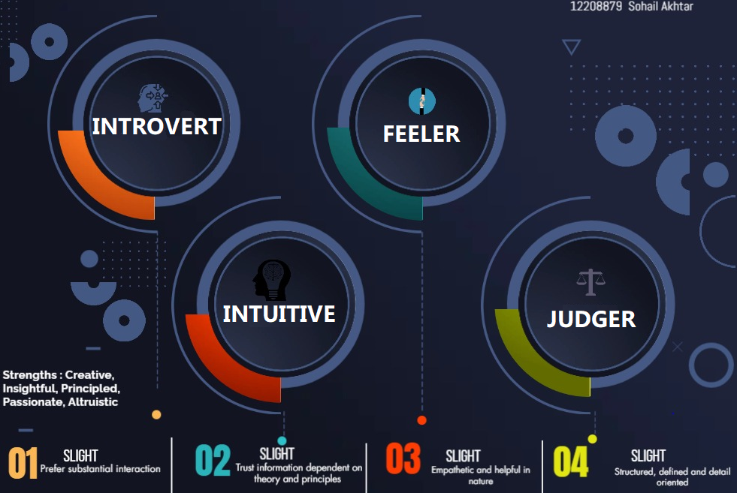

EXTRA CURRICULAR ACTIVITIES

Mathematics Tutor| working on Problem solving Approach

EPFO Counselor – Had solved More than 100 Queries

PROJECTS

Online Banking System Aug '20

Domain: Web Application Programming Languages: HTML, JavaScript, CSS, PHP |

The Main Objective of the Banking System is to manage the details of Accounts,

Internet Banking, Transaction, Balance, Statement

EDUCATION

Masters of Computer Application Sep '22 – Present

Lovely Professional University | Phagwara, IN

CGPA 7.87

B.Sc. In Information Technology Apr '17 – Dec ‘20

Guru Nanak Dev University | Amritsar, IN

CGPA 7.75

Higher Secondary Feb '16 - Mar '17

Dayanand Model Sr Sec School

Jalandhar, IN

CGPA 8.8