**Homework Week #2**

**FINM 35910**

1. **Investment Hypothesis and Goals**

Our fund’s objective is to identify price discrepancies between highly correlated crypto assets and executing trades to capitalize on them reverting to the mean price, providing profitable trading opportunities. By identifying periods when crypto asset prices diverge significantly from their historical correlation, the strategy can profit from expected reversion. In the end, we aim to deliver superior risk adjusted returns in comparison to the benchmark (e.g. a simple BTC-ETH portfolio or holding BTC and/or ETH).

**Strategy Parameters**

* **Investment Universe:**
  + Currently, the strategy focuses solely on BTC/USD and ETH/USD trading pairs on the crypto exchange Coinbase. Coinbase was chosen for their compliance with U.S. regulations, high liquidity, and established trading history.
* **Return Definition:**
  + Returns are defined as the percentage gain or loss achieved by trading the BTC-ETH spread over the holding period. This return will be calculated net of transaction fees and slippage.
* **Rebalancing Frequency:**
  + The strategy will operate on 1-minute data to identify short-term arbitrage opportunities and potential mean-reversion events. It may re-adjust position every minute if signals indicate entry or exit conditions.
* **Transaction Costs:**
  + Coinbase charges transaction fees that vary with trading volume, typically around 0.40% to 1.20% depending on the fee tiers ([Coinbase Advanced Fees](https://www.coinbase.com/advanced-fees)). Slippage, especially on higher volume trades, will also be factored into our model to more accurately simulate live trading.
* **Testing Period:**
  + Our testing period will span from January 1, 2022 to Oct 31, 2024. Almost three years of Coinbase 1-minute data will provide enough variability for training and testing across various market regimes.
* **Benchmark:**
  + The benchmark is an equally weighted buy and hold portfolio of BTC and ETH. This baseline allows us to measure performance against a passive holding strategy.

**Strategy Hypothesis**

* **Hypothesis:**
  + BTC and ETH maintain a stable and long-term correlation. Any short-term deviations from this equilibrium represent temporary inefficiencies that we can exploit for a profit
* **Entry and Exit Criteria:**
  + Spread Calculation: We define the BTC-ETH spread as

$$BTC Price-β*ETH Price$$

where $β$ is calculated through cointegration analysis.

* + We will enter a long position on one asset and short position on the other when the spread deviates by more than a certain number of standard deviations from the mean.
  + We will close the positions when the spread reverts to its mean or within a range close to the mean.
  + To mitigate risk, we will implement a stop loss to limit losses if the spread continues to diverge.

**Market Impact and Liquidity Constraints**

* **Market Impact:**
  + Rebalancing on a 1-minute timeframe can lead to higher transaction costs due to slippage and market impact, particularly in volatile markets such as crypto. We will need to scale trading volumes to avoid excessive slippage.
* **Liquidity Constraints:**
  + We selected BTC and ETH for this strategy not only due to their high correlation and cointegration but also their high liquidity. While they are both very liquid assets, trading large volumes within a single minute could induce substantial slippage during high volatility markets. As a result, we will limit the strategies position sizes, especially during low liquidity periods such as weekends or after major news events.

1. **Portfolio Construction and Rebalancing**

**Historical Data**

* **About the Data**
  + Our strategy relies on 1-minute historical data for BTC and ETH. We sourced this data via API directly from Coinbase. The historical data includes the following fields: open, high, close, volume. Initially we are focusing on only the per minute close price for training and back testing, however, we plan to expand our model to incorporate volume and potential other metrics.
* **Data Preprocessing Steps**
  + Timestamp conversion: Converted the timestamp to US/Central time to avoid confusion throughout analysis.
  + Handling missing data: Filled missing timestamps uses forward filling as most were over short periods.
  + Log returns: Converted prices to log returns for statistical analysis, as this helps identify mean-reverting properties for our strategy.
  + Normalization: Due to the scale disparities between BTC and ETH prices, we will normalize the prices.
  + Stationarity test: Performed stationarity tests in the form of Engle-Granger and Augmented Dickey-Fuller test on the price ratio and spread between BTC and ETH to confirm suitability for pairs trading.

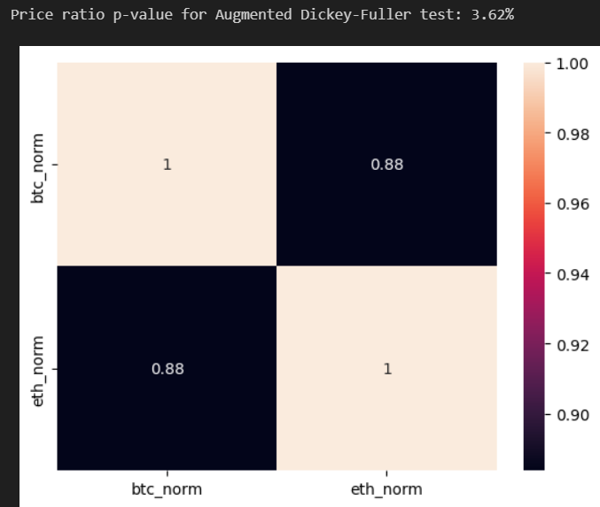

*Crypto assets are strongly correlated as shown above. P-value of 3.62% (<5.00%) supports cointegration between BTC and ETH price ratio*

**Transaction Cost Models**

To simulate real market conditions, we will incorporate the following transaction costs:

* **Market Impact:** Assuming we will experience price slippage in live trading, we will factor in a slippage cost of 0.05%-0.1% of the traded amount.
* **Exchange Fees:** As show below Coinbase charges fee tiers based on 30 day volume and asset balance. According to our investment philosophy and objectives we plan to maintain a 30-day volume greater than $500K but less than $1M. As a result, we will take the weighted average fee of 0.27% when factoring exchange fees in our model and back testing.

**Trade Execution and Rebalancing Frequencies**

We will enter trades when signal thresholds are met and close positions when the ratio revert to the mean or a stop-loss threshold is reached.

Rebalancing is not applicable for a 1-minute strategy. However, our model considers rolling means and rolling volatility, so it is somewhat built into the model. We will want to re-evaluate the model frequently to account for microstructure and relationship changes for BTC and ETH. Furthermore, we use Optuna to tune the hyperparameters for our trading model including entry threshold, exit threshold, and rolling window for our mean and standard deviations when calculating our Z-score. Potentially incorporating a more frequent tuning of these parameters in real-time could improve the model’s stability.

1. **Evaluate Backtesting Results**

For this initial evaluation, we back tested our model from January 1st, 2022 to September 30, 2024 on Coinbase sources 1-minute close price data. Below is the cumulative return of our strategy (84.20%) versus the benchmark of a buy-and-hold strategy in BTC (35.25%) and ETH (-29.13%) of the same period.

**Key Highlights:**

1. Cumulative returns: The trading strategy significantly outperformed BTC and ETH benchmarks over the evaluation period. We will continue to further validate this performance by considering rolling time periods and out of sample testing.
2. Risk-adjusted performance: The strategy achieved a Sharpe Ratio of 0.84, which indicates it provided higher return per unit of risk compared to BTC’s 0.26.
3. Mark Drawdown: The strategy saw a much lower Max Drawdown of -40% compared to BTC’s 74%.
4. Value-at-Risk (VaR): At a 95% confidence interval the strategy is expected to lose less than 0.0922% of its value in a single minute. This is superior to holding BTC which is expected to loss less than 0.0015% of its value.
5. Number of transactions:
   1. Long positions (Sell ETH, Buy BTC): 203,370
   2. Short positions (Sell BTC, Buy ETH): 204,301
   3. No positions: 393,811

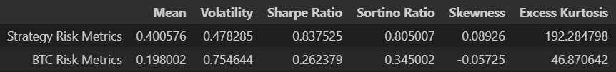



Overall, the back testing results highlight the potential strong performance of the trading strategy and ability to effectively balance return and risk. However, we will need to continue to confirm the strategy’s validity through thorough out of sample testing and researching it’s performance under the constantly changing crypto environment.