**[Hunter Scott](https://www.hscott.net/)** [**https://www.hscott.net/a-60-ghz-phased-array-for-10/**](https://www.hscott.net/a-60-ghz-phased-array-for-10/)

**A 60 GHz phased array for $10**

**In 2018, I gave an talk at Hackaday Supercon that was basically Phased Arrays 101.**

<https://www.youtube.com/watch?v=ytBmoL2wZLw>

**At the end of this talk, I mentioned that I was looking for collaborators to develop a small, low cost phased array using a really unique chip I found. That chip was the SB9210 from SiBeam. This part was originally intended to be used for WirelessHD, a protocol for wireless video streaming that never took off. The reason this part is so cool is that it’s an entire 60 GHz phased array on a chip, including antennas, with both transmit and receive capability. Bought straight from the manufacturer, it was $15 in single quantities.**

**Now the bad news: SiBeam was bought by Lattice Semiconductor, and right before I gave this talk, Lattice shut down the entire SiBeam organization and ended support and production of this part. I didn’t find out about this until months later, when I contacted the sales engineers I had been talking to about this part and they told me what happened.**

**But there’s some good news. You can still buy the SB9210 if you know where to look. While they’re not being produced anymore, at one time they were included in some smart TVs and in some high end laptops. If you know the right cryptic letters to type into ebay, you can find replacement boards for those laptops that contain the chip as well as the supporting circuitry. It’s basically a development board! I’ve seen the price of these get as low as about $6 each, and it’s not uncommon to find them for $10. The issue is how to talk to them.**

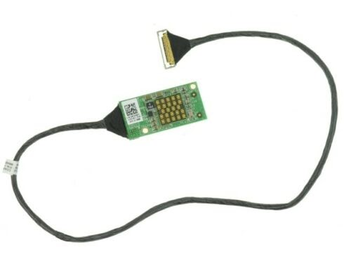

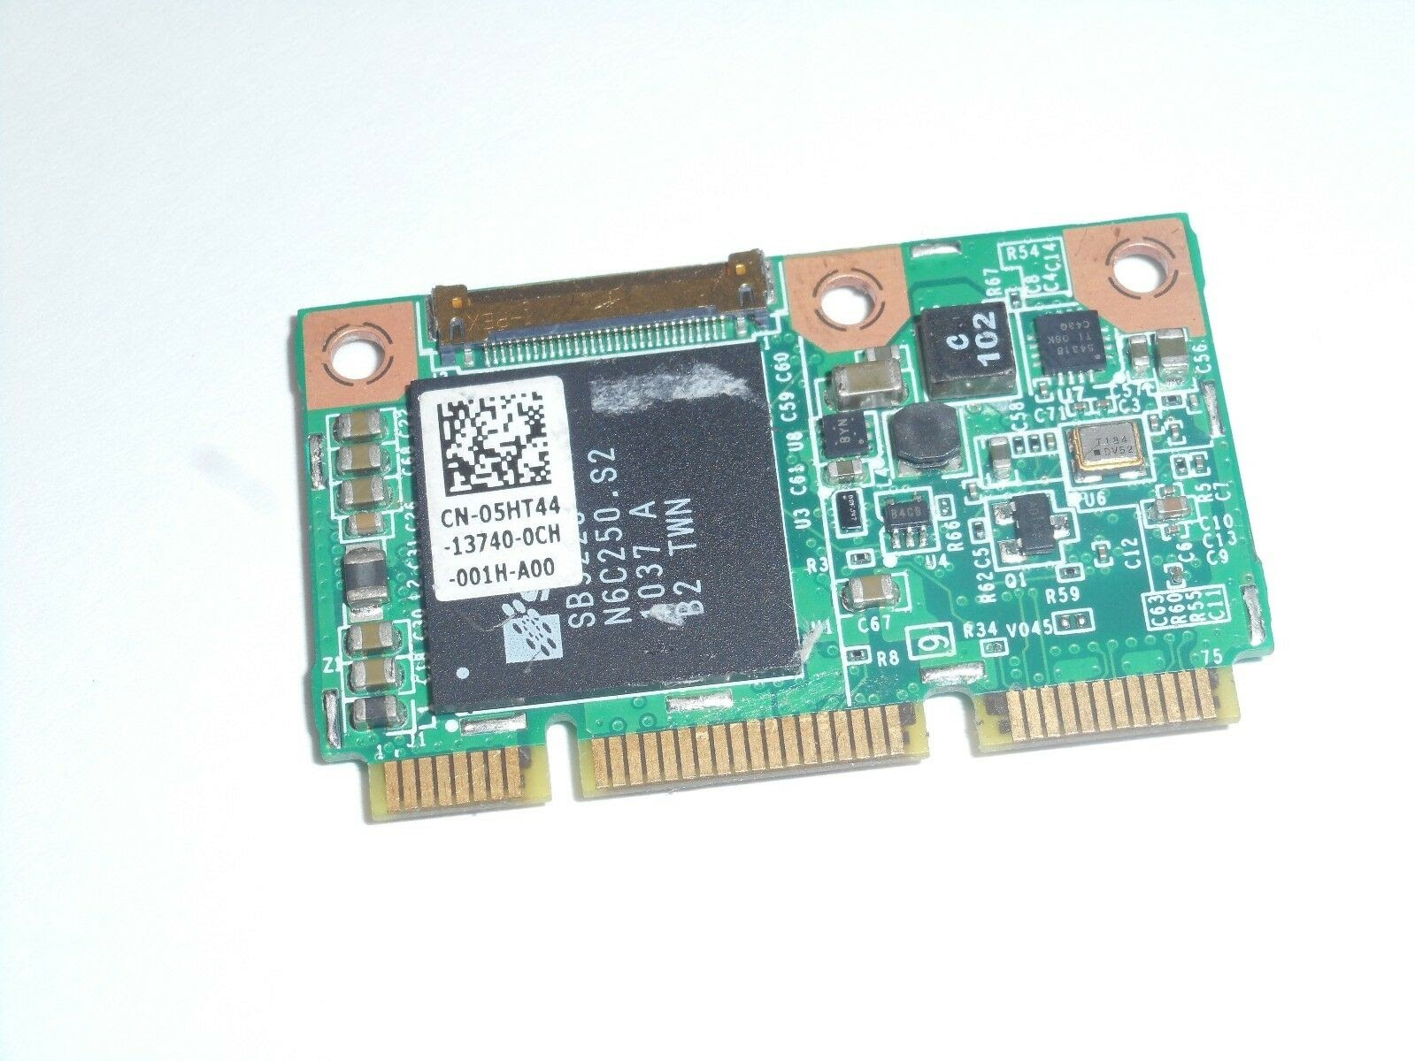

WirelessHD laptop daughterboard with SB9210 (those are itty bitty patch antennas!)

These chips use something like a QSPI bus to set control registers and move data on and off the chip. Despite looking for months, I have never been able to find a datasheet for the SB9210. The information I *have* been able to learn has come from the datasheets for later generation versions of the SB9210, the Sil6310. Before SiBeam was shut down, I was able to get full datasheets for this part and one more in the same family from their application engineers. These datasheets required an NDA, which I signed with my company. Even though SiBeam is shut down, Lattice still exists, and until I get permission from them, I can’t share those NDA’d datasheets. I’m hoping that the serial interface on the later versions of the chip are close enough to the SB9210 that a driver could be written using documentation from the Sil6310. I’ve only been able to find SB9210’s on ebay, not the Sil6310.

There might be another way to reverse engineer the communication interface with this chip. The SB9210 is the RF frontend, and there is a companion chip that controls it (also made by SiBeam). By sniffing the traces between these two ICs, it might be possible to figure out what commands are used to set up and tear down the transmitter, send data to be transmitted, and receive data. I believe it’s just I and Q samples that are sent to the SB9210.

This is the board that plugs into the cable coming off of the RF frontend board. That large chip is the SiBeam controller for the frontend. So here’s how to find these parts: search any of these terms on ebay to get the SB9210 (RF frontend chip): J4DFM wihd transmitter 0j4dfm m14x transmitter m17x transmitter m18x transmitter 039pkf 39pkf 6YC1W 4VWVN m18xr2 m17xr4 kvr0y 5ht44 208-1a b71 0ywxt1 ywxt1 wp6px To find the companion/controller chip, search for: WirelessHD WiHD Transmitter Card CHA01 5HT44 If you search for “wirelessHD”, you can also sometimes find products for making a wireless HDMI link, and those will have a full implementation of this part that might also be useful for sniffing/reverse engineering. I know there were other companies in the WirelessHD alliance, so I’m not sure if there are any competing chips. All I’ve seen so far is this one family from SiBeam. What would be really cool is to build a USB board that plugs into one of the SB9210 boards and connects to gnuradio. You could do all kinds of neat radar experiments, presence detection, beam forming, you name it. Kind of like a 60 GHz RTL-SDR. While I can’t give up the NDA datasheets I have yet, there is a lot of publicly available stuff out there if you look hard. The links below are some of what I’ve found on Google. If you want to help with this effort, or if you have any information about the SB9210, let me know! hunter at hscott.net or @hunterscott on twitter. A number of people have emailed me asking about how they could help with this project, which is really exciting.

I started a Discord server and am inviting everyone so we can all share what we learn together.

Here it is: <https://discord.gg/PwMK82a>

If you found this interesting and want to learn more about designing electronics, check out the book I’ve been working on: designingelectronics.com Dev Kit teardown from EDNDownload Russian article about WirelessHDDownload SiBEAM SK62xx-MOD Transceiver Module DatasheetDownload MOD6320-T product briefDownload Product selector guideDownload SB9220/SB9210 one pagerDownload MOD6321-R WirelessHD Receiver Module datasheetDownload MOD6210/MOD6211/MOD6212/MOD6213 Transceiver Module datasheet Download FCC testing documents for SB9210 Update: Other products that use this family of parts (aka failed products that used WirelessHD:

W2H Acer MWiHD1 -> <https://fccid.io/HLZMWIT1/Internal-Photos/Internal-Photos-2532935>

AzureWave WH064T -> <https://fccid.io/TLZ-WH064T/User-Manual/User-manual-2042485>

Other products via fccid.io -> <https://www.google.com/search?client=firefox-b-d&q=site%3Afccid.io+wirelesshd>