**RamSoft Full Stack Developer Assessment**

**Goal**

Create a simple task management app similar to Jira, Trello or Basecamp in a couple hours, including all necessary unit tests

**Options**

The stories below are all optional; you do not have to complete every story.  Please pick stories that you can complete in an hour or two that demonstrate your react.js or .Net Core development skills.  We would like each story to be well tested.

**Stories**

* Users can add new tasks to the task board
* Details include name, description, deadline
* Users can edit tasks and all details
* Users can delete tasks
* Users can attach images to tasks
* Users can drill into tasks to see all details
* Users can add columns to the task board representing different work states (ie. ToDo, In Progress & Done)
* Users can move tasks between columns
* Users can sort tasks in each column alphabetically by name
* Favorited tasks should be sorted to the top every time

**Technical Requirements**

* Use the following frameworks:

1. React.js and its hooks API
2. React router
3. Material UI
4. React Testing Library
5. Jest
6. .Net Core
7. Azure APIs
8. NUnit

* Use the yarn package manager
* The code should be thoroughly unit tested
* Push code to GitHub and share link.

BE:  
API list:

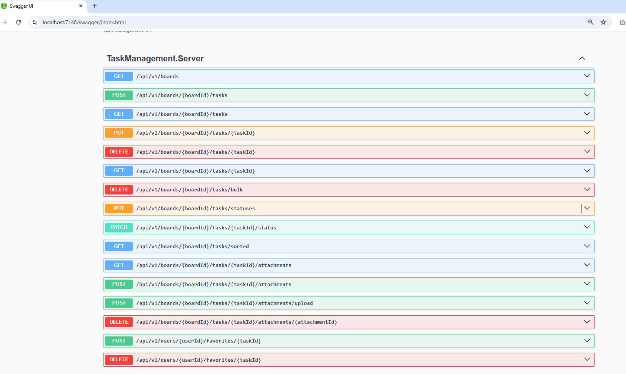  
  
FE:  
Home page with a few boards (dummy data)  
  
Can Select 1 Board and view list as kanban board  
On 1 task item, user can change the status

Select to edit for a task, can save data and set as favorite task  
