Selenium Tutorial

Selenium is a widely adopted open-source automation testing framework that is designed to help users test web applications across various browsers and platforms. Selenium is not just a single tool but a set of tools that helps testers to automate web-based applications more efficiently. This comprehensive tutorial will help you gain an in-depth understanding of Selenium and how to use it to streamline your testing processes.
Components of Selenium
In this tutorial, you will find a detailed description on the following four tools that form the Selenium suite −
- Selenium IDE − Selenium Integrated Development Environment (IDE) is a Firefox plugin that lets testers to record their actions as they follow the workflow that they need to test. It allows users to create test scripts without having to write codes manually. Although it offers a quick start, Selenium IDE is not usually recommended for testing complex scenarios.
- Selenium RC − Selenium Remote Control (RC) was the flagship testing framework that allowed more than simple browser actions and linear execution. It can help you use the full power of programming languages such as Java, C#, PHP, Python, Ruby and PERL to create more complex tests.
- Selenium WebDriver − Selenium WebDriver is the successor to Selenium RC which sends commands directly to the browser and retrieves results. WebDriver is meant for automating browser interactions. It provides a simple API for controlling the browsers and help users interact with web elements.
- Selenium Grid − Selenium Grid is meant for executing parallel tests across multiple machines. Due to the distribution of test execution across different environments, it can greatly minimize the testing time.

Key Features of Selenium
Here are some of the prominent features of Selenium that makes it so popular among testers and developers a like −
- Cross-browser Compatibility − You can use Selenium to execute tests on different browsers including Chrome, Firefox, Safari, and Internet Explorer. This ensures that your web application performs consistently across multiple platforms.
- Platform Independence − Selenium is not bound to any specific operating system. It can run on Windows, macOS, and Linux. Due to this platform independence, Selenium is the preferred choice for testing diverse applications.
- Support for Multiple Programming Languages − Selenium supports multiple programming languages including Java, Python, C#, Ruby, and JavaScript. This flexibility allows testers and developers to choose a language they are comfortable with.
- Extensibility − Selenium has features to enable users to incorporate additional functionalities through several plugins or extensions. One can easily customize Selenium to suit specific testing requirements.
A Sample Test Script Using Selenium WebDriver
Getting started with Selenium involves setting up the development environment, selecting the best fit programming language as per your expertise, and configuring the Selenium WebDriver. This tutorial will guide you through each step, providing hands-on examples wherever necessary.
Here's an example test case written in Python using Selenium WebDriver where we will open a web browser (Chrome), navigate to a website (www.tutorialspoint.com), get its title and print it on the console.
Example
Before you begin, make sure you have Python installed on your system along with the Selenium WebDriver library.
from selenium import webdriver

def first_test_script():
# Create an instance of the Chrome WebDriver
# you can use other browsers too
driver = webdriver.Chrome()

# navigate to the website
driver.get("https://www.tutorialspoint.com")

# Get the actual title of the page
title = driver.title

# Print the title of the website
print("Title: " + title)

# Close the browser window
driver.quit()

if __name__ == "__main__":
first_test_script()
Save the script to a file (e.g., selenium_example.py) and run it using −
python selenium_example.py
Output
We got the following output from this Python code −
Title: Online Tutorials, Courses, and eBooks Library | Tutorialspoint
Audience
This tutorial is designed for software testing professionals who would like to learn the basics of Selenium through practical examples. The tutorial contains enough ingredients to get you started with Selenium from where you can take yourself to higher levels of expertise.
Prerequisites
Before proceeding with this tutorial, you should have a basic understanding of Java or any other object-oriented programming language. In addition, you should be well-versed with the fundamentals of testing concepts.

Selenium - Overview
Introduction
Selenium is an open-source and a portable automated software testing tool for testing web applications. It has capabilities to operate across different browsers and operating systems. Selenium is not just a single tool but a set of tools that helps testers to automate web-based applications more efficiently.
Let us now understand each one of the tools available in the Selenium suite and their usage.
Sr.No. | Tool & Description
1 | Selenium IDE  Selenium Integrated Development Environment (IDE) is a Firefox plugin that lets testers to record their actions as they follow the workflow that they need to test.
2 | Selenium RC  Selenium Remote Control (RC) was the flagship testing framework that allowed more than simple browser actions and linear execution. It makes use of the full power of programming languages such as Java, C#, PHP, Python, Ruby and PERL to create more complex tests.
3 | Selenium WebDriver  Selenium WebDriver is the successor to Selenium RC which sends commands directly to the browser and retrieves results.
4 | Selenium Grid  Selenium Grid is a tool used to run parallel tests across different machines and different browsers simultaneously which results in minimized execution time.

Advantages of Selenium
QTP and Selenium are the most used tools in the market for software automation testing. Hence it makes sense to compare the pros of Selenium over QTP.
Selenium | QTP
Selenium is an open-source tool. | QTP is a commercial tool and there is a cost involved in each one of the licenses.
Can be extended for various technologies that expose DOM. | Limited add-ons and needs add-ons for each one of the technologies.
Has capabilities to execute scripts across different browsers. | Can run tests in specific versions of Firefox , IE, and Chrome.
Can execute scripts on various operating systems. | Works only with Windows.
Supports mobile devices. | Supports mobile devices with the help of third-party tools.
Executes tests within the browser, so focus is NOT required while script execution is in progress. | Needs Focus during script execution, as the tool acts on the browser (mimics user actions).
Can execute tests in parallel with the use of Selenium Grids. | QTP cannot execute tests in parallel, however integrating QTP with QC allows testers to execute in parallel. QC is also a commercial tool.
Disadvantages of Selenium
Let us now discuss the pitfalls of Selenium over QTP.
Selenium | QTP
Supports only web based applications. | Can test both web and desktop applications.
No feature such as Object Repository/Recovery Scenario | QTP has built-in object repositories and recovery scenarios.
No IDE, so the script development won't be as fast as QTP. | More intuitive IDE; automation can be achieved faster.
Cannot access controls within the browser. | Can access controls within the browser such as favorites bar, backward, and forward buttons.
No default test report generation. | Default test result generation within the tool.
For parameterization, users has to rely on the programming language. | Parameterization is built-in and easy to implement.

Selenium - Components
Selenium Components are often referred to as a suite of Selenium tools. There are a total of four tools which are together called the Selenium Components. Let us discuss the various components of Selenium −
- Selenium IDE
- Selenium RC
- Selenium Webdriver
- Selenium Grid
Selenium IDE
Selenium Integrated Development Environment is an important part of the Selenium suite. It was first developed as a Firefox plugin, however now it is available in both Firefox and Chrome browser. Some of the features of Selenium IDE are listed below −
- The recording, debugging, executing and editing of the functional tests can be done in Selenium IDE.
- The scripts in Selenium IDE are developed in Selenese which is a scripting language in Selenium.
- Selenium IDE commands help us to perform tasks like clicking a button or link, taking input in an edit box, obtaining a text from a webelement and so on.
- Selenium IDE tests can be converted to formats like Java, C#, Python, TestNG, and so on. Its default format is in .html.
- Selenium IDE tests can be exported and used in Selenium Webdriver and Selenium RC.
- Selenium IDE does not require technical or programming knowledge. Hence it can be used only testing simple scenarios and not used to cover any complex use cases.
- Selenium IDE does not give the feature of parameterization of tests for data driven testing.
- Maintenance of objects and other reusable components are difficult in Selenium IDE, in case it is being used for complex testing projects.

Selenium Remote Control
Selenium Remote Control is a server implemented in Java. It can accept commands for browsers using the HTTP. Selenium RC has a Selenium RC server and a Selenium RC client. Selenium RC is outdated and it has been deprecated by Selenium.
Some of the features of Selenium RC are listed below −
- Automation tests in Selenium RC can be developed in any programming languages like Java, Python, C#, and so on.
- Selenium RC can be used to write automated tests for testing web applications.
- Selenium RC comprises a proxy server which gives the provision to the browser to work as if that the application under test is available in the domain of the proxy server.
- To initiate test execution, we have to create an instance of the Selenium RC server.
Selenium WebDriver
Selenium WebDriver (began from Selenium version 2 onwards) is the successor to Selenium RC which sends commands directly to the browser and retrieves results, hence it is faster than Selenium RC. It receives commands and passes them to the browser. This is done with the help of the browser drivers that sends commands to the browser and obtains the results.
Selenium version 2 combined the useful features of Selenium RC and Selenium Webdriver into Selenium Webdriver. Later on Selenium 3, added more features to Selenium Webdriver.
Some of the features of Selenium Webdriver are listed below −
- Automation tests can be written in multiple programming languages like the Java, C#, Python, JavaScript, and so on.
- Selenium webdriver supports browsers like Chrome, Firefox, Safari, IE, and so on.
- Selenium webdriver works on more than one platforms like Windows, Mac, Linux, Android, and so on.
- Headless execution can be achieved with the help of the HTMLUnit Driver.
- Selenium webdriver does not require a server to initiate test execution and it communicates directly with the browser.
- Selenium webdriver is open-source and comes without any licensing cost.
- Selenium Webdriver does not have an IDE, hence it is time consuming to create test scripts.
- Selenium Webdriver supports only web based applications.
- Selenium Webdriver has no support to automate QR, captcha and barcode scenarios.
- Selenium Webdriver has no feature such as Object Repository/Recovery Scenario.
- Selenium Webdriver has no default test report generation.
- Selenium Webdriver requires programming and technical knowledge to develop automated tests.
- Selenium Webdriver requires time to be more compatible and stable with new browsers.
- Selenium Webdriver is difficult to set up since no vendor support is available.
- Selenium Webdriver can be extended for various technologies that expose DOM.
- Selenium Webdriver has a big community support for help in case of issues.
Selenium Grid
Selenium Grid is mainly used for parallel testing. It follows a hub (which is a central part and rest are considered as nodes) and node architecture. Selenium Grid enables us to execute varied tests in multiple machines simultaneously. Selenium Grid is used mostly with the intent of test execution rather than design.
Some of the features of Selenium Grid are listed below −
- Presence of a hub machine which directs the execution on multiple machines using the Selenium Grid. Also, there are more than one node machines where the actual execution takes place.
- Selenium Grid supports testing on multiple browsers and platforms.
Reduces execution time by allowing parallel execution of tests.
Currently the latest version of Selenium is on version 4. From the Selenium 4 version, the entire architecture is fully compatible with W3C - World Wide Consortium meaning Selenium 4 follows all the standards and guidelines given by W3C. We can get more information about W3C from the below link −
https://www.tutorialspoint.com/world-wide-web-consortium-w3c.
The basic difference between Selenium 3 and Selenium 4 is that, in Selenium 3 the communication between client and server is done by JSON Wire protocol, however, from Selenium 4, there is direct communication between the server and client, following the W3C guidelines.
Before Selenium 4, the communication between the client and server was carried on using the JSON Wire protocol over HTTP. However, there is no existence of JSON Wire protocol from Selenium 4,and there is direct communication between the client and server using the W3C protocols.
Also, Selenium 4 gives some additional locators (apart from the regular locators like id, class, xpath, and so on) called the Relative locators with the help of the methods - above, below, near, toRightOf, toLeftOf, and chaining of multiple Relative locators. Selenium 4 also gives access to the ChromeDevTools which help for debugging, network traffic analysis, and other features that help in automation.
Thus, in this tutorial, we had discussed various components of Selenium.

Selenium - Automation Testing
Selenium is used primarily to automate tests on web applications. It is free, does not require any licensing cost. Automation testing with Selenium is much more preferred than manual testing since the automation testing with Selenium has a better return on investment than manual effort.
Different Types of Selenium Tests
Selenium can be used to create different types of tests as listed below −
- Functional Tests − These tests help to check various new functionalities and features of the application or the product under test.
- Regression Tests − These tests help to check if code changes have broken an existing functionality of the application.
- Smoke Tests − These tests help to verify if a new build is stable enough to carry out testing activities on it.
- Integration Tests − These tests help to validate if the integration of all the modules are working together as a unit.
- Unit Tests − These tests are created by the developers to test their code.

Selenium Automation Testing Tools
Selenium comprises a group of tools often called the Selenium components. These tools are listed below −
- Selenium IDE − It is available as an addon for Chrome and Firefox browsers.
- Selenium Remote Control − It is server developed in Java and allows writing automation tests in multiple languages like Java, Perl, Python, and so on.
- Selenium Webdriver − It is a tool that can be integrated with other frameworks like TestNG, JUnit, and so on and can be used with multiple programming languages.
- Selenium Grid − It is a tool that helps to achieve parallel execution across various platforms and browsers.
Differences Between Selenium Version 3.x and 4.x
The latest version of Selenium is on version 4. From the Selenium 4 version, the entire architecture is fully compatible with W3C - World Wide Consortium meaning Selenium 4 follows all the standards and guidelines given by W3C.
The basic difference between Selenium 3.x and Selenium 4.x is that, in Selenium 3 the communication between client and server is done by JSON Wire protocol, however, from Selenium 4, there is direct communication between the server and client, following the W3C guidelines.
Before Selenium 4, the communication between the client and server was carried on using the JSON Wire protocol over HTTP. However, there is no existence of JSON Wire protocol from Selenium 4, and there is direct communication between the client and server using the W3C protocols.
Also, Selenium 4 gives some additional locators(apart from the regular locators like id, class, xpath, and so on) called the Relative locators with the help of the methods - above, below, near, toRightOf, toLeftOf, and chaining of multiple Relative locators. Selenium 4 also gives access to the ChromeDevTools which help for debugging, network traffic analysis, and other features that help in automation.
Selenium Web Driver architecture as per version 4.0 in a simplified diagram is described below −
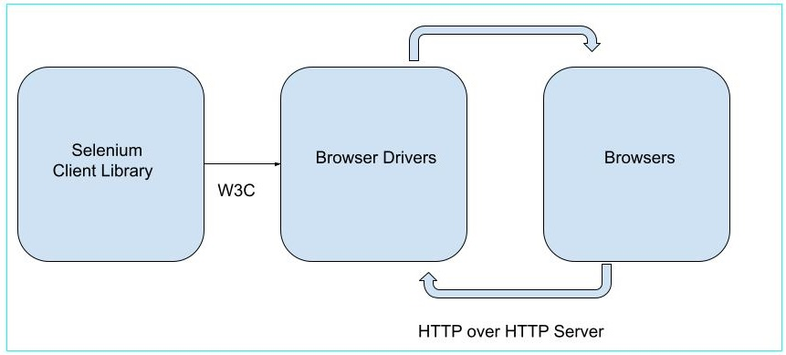
Why Selenium is Used for Automating Testing?
- Automation tests using Selenium can be written in multiple programming languages like the Java, C#, Python, JavaScript, and so on.
- Selenium webdriver supports browsers like Chrome, Firefox, Safari, IE, and so on.
- Selenium webdriver works on more than one platforms like Windows, Mac, Linux, Android, and so on.
- Headless execution can be achieved with the help of the HTMLUnit Driver.
- Selenium webdriver does not require a server to initiate test execution and it communicates directly with the browser.
- Selenium is open-source and comes without any licensing cost.
- Selenium can be extended for various technologies that expose DOM.
- Selenium has a big community support to resolve issues.
Disadvantages of Using Selenium
- Selenium supports only web based applications.
- Selenium should not be used to automate tests on QR, captcha and barcode scenarios.
- Selenium does not have an in-built object repository or recovery scenario.
- Selenium has no default test report generation.
- Selenium Webdriver requires programming and technical knowledge to develop automated tests.
- Selenium Webdriver requires time to be more compatible and stable with new browsers.
- Selenium Webdriver is difficult to set up since no vendor support is available.
Run Selenium Automation Testing in Different Languages
Selenium can be used to test web applications using multiple browsers, platforms, and devices using different programming languages like Java, Python, Ruby, JavaScript, and so on. Based on the language we are using, the preconditions required to configure the Selenium tests also change. The below links will help to set up and run automation testing in Selenium in different languages −
- Selenium with Java Tutorial
- Selenium with Python Tutorial
- Selenium with C# Tutorial
- Selenium with JavaScript Tutorial
- Selenium with Kotlin Tutorial
This concludes our comprehensive take on the tutorial on Selenium - Automation. Weve started with describing what Selenium is, different types of Selenium Tests, Selenium automation testing tools, differences between Selenium 3.x and Selenium 4.x, why Selenium is used for automating testing, disadvantages of Selenium, and how to run automation testing in Selenium in different languages.
This equips you with in-depth knowledge of the Selenium - Automation Testing. It is wise to keep practicing what youve learned and exploring others relevant to Selenium to deepen your understanding and expand your horizons.

Selenium - Environment Setup
Selenium Webdriver can be used to automate tests on web applications. Selenium can be used with multiple languages like Java, Python, Ruby, and so on.
Let us discuss how to do the environment setup of Selenium with Java. Selenium Installation can be achieved with the following steps −
Step 1 − We would need to download and then install Java in our local system. This can be done by navigating to the below link −
https://www.oracle.com/java
To get a more detailed view on how set up Java, we can refer to the below link −
https://www.youtube.com/watch?v=bxIZ1GVWYkQ
Once we have successfully installed Java, we can confirm its installation by running the following command: java, from the command prompt.
C:\java
It will display the following information on the screen −
Usage: java [options] <mainclass> [args...]
(to execute a class)
or java [options] -jar <jarfile> [args...]
(to execute a jar file)
or java [options] -m <module>[/<mainclass>] [args...]
java [options] --module <module>[/<mainclass>] [args...]
(to execute the main class in a module)
or java [options] <sourcefile> [args]
(to execute a single source-file program)

Arguments following the main class, source file, -jar <jarfile>,
-m or --module <module>/<mainclass> are passed as the arguments to
main class.

where options include:

-cp <class search path of directories and zip/jar files>
-classpath <class search path of directories and zip/jar files>
--class-path <class search path of directories and zip/jar files>
A ; separated list of directories, JAR archives,
and ZIP archives to search for class files.
-p <module path>
--module-path <module path>...
A ; separated list of directories, each directory
is a directory of modules.
--upgrade-module-path <module path>...
A ; separated list of directories, each directory
is a directory of modules that replace upgradeable
modules in the runtime image
--add-modules <module name>[,<module name>...]
root modules to resolve in addition to the initial module.
<module name> can also be ALL-DEFAULT, ALL-SYSTEM,
ALL-MODULE-PATH.
--enable-native-access <module name>[,<module name>...]
modules that are permitted to perform restricted native operations.
<module name> can also be ALL-UNNAMED.
--list-modules
list observable modules and exit
-d <module name>
--describe-module <module name>
describe a module and exit
--dry-run create VM and load main class but do not execute main method.
The --dry-run option may be useful for validating the
command-line options such as the module system configuration.
--validate-modules
validate all modules and exit
The --validate-modules option may be useful for finding
conflicts and other errors with modules on the module path.
-D<name>=<value>
set a system property
-verbose:[class|module|gc|jni]
enable verbose output for the given subsystem
-version print product version to the error stream and exit
--version print product version to the output stream and exit
-showversion print product version to the error stream and continue
--show-version
print product version to the output stream and continue
--show-module-resolution
show module resolution output during startup
-? -h -help
print this help message to the error stream
--help print this help message to the output stream
-X print help on extra options to the error stream
--help-extra print help on extra options to the output stream
-ea[:<packagename>...|:<classname>]
-enableassertions[:<packagename>...|:<classname>]
enable assertions with specified granularity
-da[:<packagename>...|:<classname>]
-disableassertions[:<packagename>...|:<classname>]
disable assertions with specified granularity
-esa | -enablesystemassertions
enable system assertions
-dsa | -disablesystemassertions
disable system assertions
-agentlib:<libname>[=<options>]
load native agent library <libname>, e.g. -agentlib:jdwp
see also -agentlib:jdwp=help
-agentpath:<pathname>[=<options>]
load native agent library by full pathname
-javaagent:<jarpath>[=<options>]
load Java programming language agent, see java.lang.instrument
-splash:<imagepath>
show splash screen with specified image
HiDPI scaled images are automatically supported and used
if available. The unscaled image filename, e.g. image.ext,
should always be passed as the argument to the -splash option.
The most appropriate scaled image provided will be picked up
automatically.
See the SplashScreen API documentation for more information
@argument files
one or more argument files containing options
--disable-@files
prevent further argument file expansion
--enable-preview
allow classes to depend on preview features of this release
To specify an argument for a long option, you can use --<name>=<value> or
--<name> <value>.
Next, we would confirm the version of the Java installed by running the following command −
java version
It will show the following output −
openjdk version "17.0.9" 2023-10-17
OpenJDK Runtime Environment Homebrew (build 17.0.9+0)
OpenJDK 64-Bit Server VM Homebrew (build 17.0.9+0, mixed mode, sharing)
The output of the command executed signified that the java version installed in the system is 17.0.9.
We would also need to install Maven in our system using the below link −
https://maven.apache.org/download.cgi.
To get a more detailed view on how set up Maven, we can refer to the below link −
https://www.tutorialspoint.com/maven/maven_environment_setup.htm
Next, we would confirm the version of the Maven installed by running the following command −
mvn version
It will show the following output −
Apache Maven 3.9.6 (bc0240f3c744dd6b6ec2920b3cd08dcc295161ae)
Maven home: /opt/homebrew/Cellar/maven/3.9.6/libexec
Java version: 21.0.1, vendor: Homebrew, runtime: /opt/homebrew/Cellar/openjdk/21.0.1/libexec/openjdk.jdk/Contents/Home
Default locale: en_IN, platform encoding: UTF-8
OS name: "mac os x", version: "14.0", arch: "aarch64", family: "mac"
The output of the command executed signified that the Maven version installed in the system is Apache Maven 3.9.6.
Step 2 − Next, we would install the IntelliJ editor to run the Selenium test. There are several editors available in the market for example: Eclipse, IntelliJ, Atom, and so on. Using these editors, we can start working on a Java project to start our test automation. Today, we will discuss how to set up our Selenium code in IntelliJ.
For IntelliJ installation, the latest version of Java should be installed.
Lets begin −
Step 1 − Navigate to the official website of IntelliJ (which is a product of Jetbrains) using the below link and then click on Download −
https://www.jetbrains.com/idea/.

Step 2 − Once we navigate to the next page, we will get the option to download IntelliJ in various operating systems, like Windows, macOS, and Linux. Click on the tab based on the operating system you are currently using in your system.
IntelliJ comes in two versions, Paid and Community(which is free).
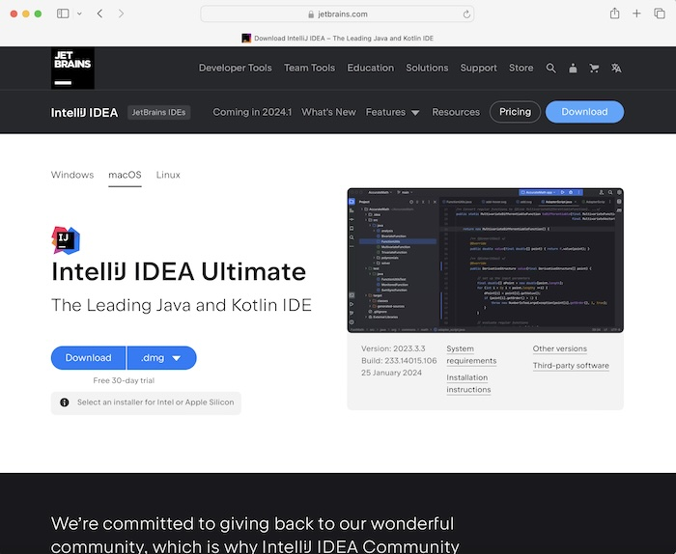
We would download the Community version. For that we would navigate to the IntelliJ IDEA Community Edition section and then click on Download.
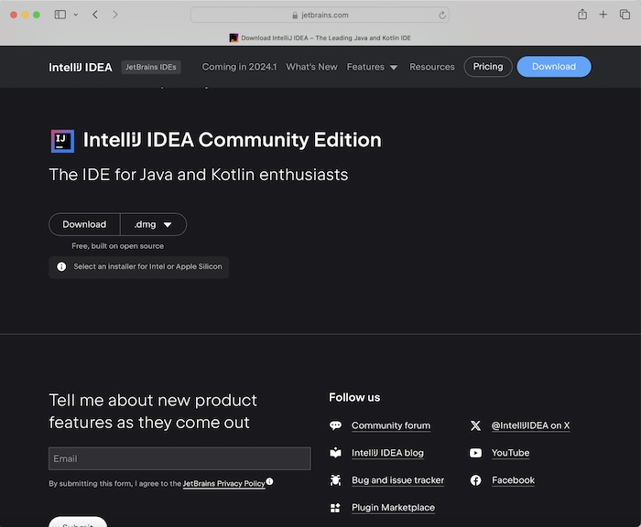
After downloading was completed in the macOS, we dragged the IntelliJ IDEA CE file from the Downloads folder to Applications folder.
Step 3 − IntelliJ logo should display for a few seconds, and next the JETBRAINS COMMUNITY EDITION TERMS should appear. Click the checkbox to accept the terms and conditions, then click on Continue.
Step 4 − Welcome to IntelliJ IDEA should appear. Clicked on the New Project button.
Step 5 − Enter a name under Name: field. Select Language as Java, Build System as Maven, and JDK version, then click on Create.
Step 6 − Enter an ArtifactId and click on Create.
Step 7 − IntelliJ editor setup should be completed successfully.
Step 8 − Next, we would add the Selenium Maven dependencies from the below link −
https://mvnrepository.com
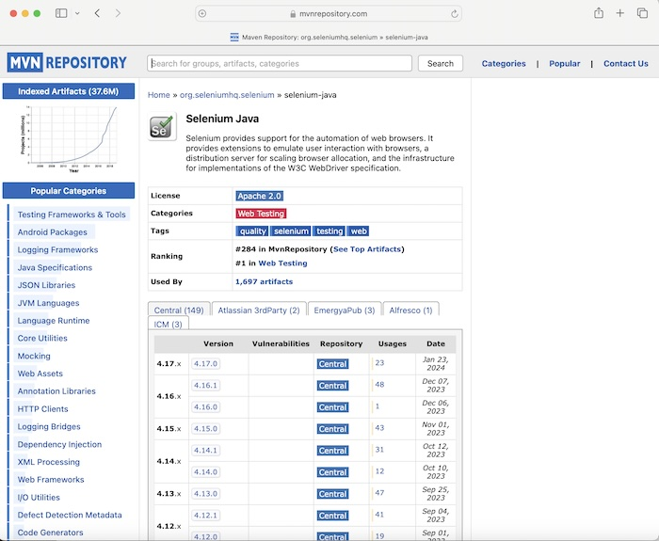
Step 9 − Selected and clicked on a version link under the Central tab. We navigated to the Selenium Java>&gt<version> page. Copied the dependency under Maven tab.
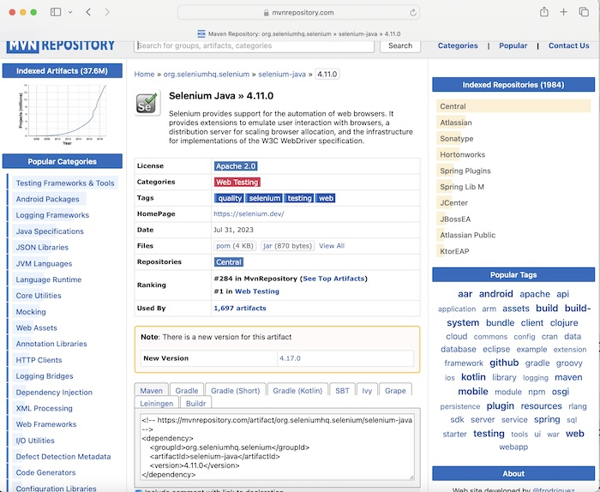
Dependency example −
<!-- https://mvnrepository.com/artifact/org.seleniumhq.selenium/selenium-java -->
<dependency>
<groupId>org.seleniumhq.selenium</groupId>
<artifactId>selenium-java</artifactId>
<version>4.11.0</version>
</dependency>
Step 10 − Pasted the dependency copied in Step9 in the pom.xml file(available under the Maven Project created in the IntelliJ workspace).
Step 11 − Add the below code in the Main.java file.
Example
Code Implementation on Main.java class file −
package org.example;

import org.openqa.selenium.WebDriver;
import org.openqa.selenium.chrome.ChromeDriver;
import java.util.concurrent.TimeUnit;

public class Main {
public static void main(String[] args) throws InterruptedException {

// Initiate the Webdriver
WebDriver driver = new ChromeDriver();

// adding implicit wait of 15 secs
driver.manage().timeouts().implicitlyWait(15, TimeUnit.SECONDS);

// URL launch
driver.get("https://www.google.com");

// get browser title after browser launch
System.out.println("Browser title: " + driver.getTitle());

}
}
Dependencies added in pom.xml file −
<?xml version="1.0" encoding="UTF-8"?>
<project xmlns="http://maven.apache.org/POM/4.0.0"
xmlns:xsi="http://www.w3.org/2001/XMLSchema-instance"
xsi:schemaLocation="http://maven.apache.org/POM/4.0.0
http://maven.apache.org/xsd/maven-4.0.0.xsd">
<modelVersion>4.0.0</modelVersion>

<groupId>org.example</groupId>
<artifactId>SeleniumJava</artifactId>
<version>1.0-SNAPSHOT</version>

<properties>
<maven.compiler.source>16</maven.compiler.source>
<maven.compiler.target>16</maven.compiler.target>
<project.build.sourceEncoding>UTF-8</project.build.sourceEncoding>
</properties>

<!-- https://mvnrepository.com/artifact/org.seleniumhq.selenium/selenium-java -->
<dependencies>
<dependency>
<groupId>org.seleniumhq.selenium</groupId>
<artifactId>selenium-java</artifactId>
<version>4.11.0</version>
</dependency>
</dependencies>
</project>
Step 11 − Right click and select Run Main.main() option. Waited till the run was completed.
Step 12 − Chrome browser got launched, and we had got the output in the console- Browser Title: Google with the message Process finished with exit code 0, signifying successful execution of the code.
Output
Browser title: Google

Process finished with exit code 0
Along with that Chrome browser got launched with the message Chrome is being controlled by automated test software at the top.
To get a more detailed view on how set up Eclipse, we can refer to the below link −
https://www.tutorialspoint.com/eclipse/index.htm
Selenium can also be configured with Python for which we would require the PyCharm editor. To get a more detailed view on how set up PyCharm, we can refer to the below link −
https://www.tutorialspoint.com/pycharm/index.htm.
Let us take another example, where we would launch the browser and open an application, finally quit the browser.

Example
Code Implementation on MainBrowserQuit.java class file.
package org.example;

import org.openqa.selenium.WebDriver;
import org.openqa.selenium.chrome.ChromeDriver;
import java.util.concurrent.TimeUnit;

public class MainBrowserQuit {
public static void main(String[] args) throws InterruptedException {

// Initiate the Webdriver
WebDriver driver = new ChromeDriver();

// adding implicit wait of 15 secs
driver.manage().timeouts().implicitlyWait(15, TimeUnit.SECONDS);

// URL launch and get the browser title
driver.get("https://www.tutorialspoint.com/selenium/practice/selenium_automation_practice.php");
System.out.println( "Browser title after launch: " + driver.getTitle());

// close browser
driver.quit();

}
}
Output
Browser title after launch: Selenium Practice - Student Registration Form

Process finished with exit code 0
In the above example, we had first launched the Chrome browser then retrieved the browser title and then quitted the browser, and in the console received the message − Browser title after launch: Selenium Practice - Student Registration Form.
Finally, the message Process finished with exit code 0 was received, signifying successful execution of the code.
Thus we had successfully completed the environment setup for Selenium In this tutorial.

Selenium - Remote Control (RC)

Previous
Quiz
Next
Selenium is an open-source and a portable automated software testing tool for testing web applications. It has capabilities to operate across different browsers and operating systems. Selenium is not just a single tool but a set of tools that helps testers to automate web-based applications more efficiently. Selenium is often referred to as a suite of Selenium tools. There are a total of four tools which are together called the Selenium Components. They are known as −
- Selenium IDE
- Selenium RC
- Selenium Webdriver
- Selenium Grid
What is Selenium Remote Control?
Selenium Remote Control is a part of the Selenium suite and comprises the client libraries, and a server that opens and terminates the browser by default. It is a server implemented in Java. It can accept commands for browsers using the HTTP. In the current version of Selenium, Selenium Remote Control is outdated and it has been deprecated by Selenium.
Automation tests in Selenium Remote Control can be developed in any programming languages like Java, Python, C#, and so on. Selenium Remote Control can be used to write automated tests for testing web applications. Selenium Remote Control comprises a proxy server which gives the provision to the browser to work as if that the application under test is available in the domain of the proxy server. To initiate test execution, we have to first create an instance of the Selenium Remote Control server.
Selenium Remote Control (RC) was the main Selenium project that sustained for a long time before Selenium WebDriver(Selenium 2.0) came into existence. Now. Selenium Remote Control is hardly in use, as WebDriver offers more powerful features, however users can still continue to develop scripts using Selenium Remote Control.
It allows us to write automated web application UI tests with the help of full power of programming languages such as Java, C#, Perl, Python and PHP to create more complex tests such as reading and writing files, querying a database, and emailing test results.

Architecture of Selenium Remote Control
The architecture of Selenium Remote Control is described in the below diagram −
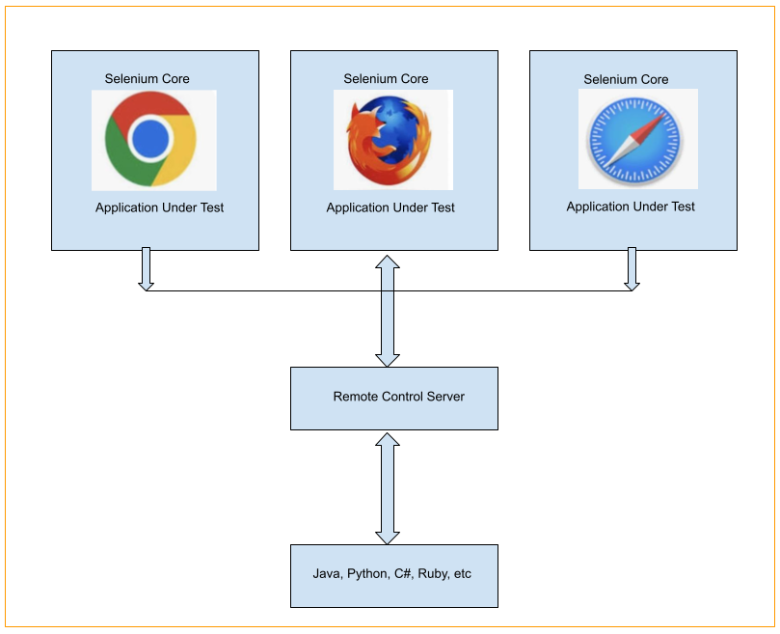
Selenium Remote Control architecture is not straightforward. In order to trigger tests in Selenium Remote Control, we would need to install and set up the Remote Control Server in our system. It is similar to a bridge between the web browser and the commands. Selenium Remote Control server puts the Selenium Core(a program in JavaScript) within the browser. Post this, the Selenium Core gets the message from the Selenium Remote Control server as per tests in the form of JavaScript commands. The browsers perform the commands received from the Selenium Core, and send test responses back to the server.
The Selenium Server acts as the central processor for your entire application. It receives the script for the test cases to be executed, interprets the command and reports back the test execution result. RC server binds the Selenium Core and automatically injects the script in the browser. All these actions are performed only after the test program has executed the browser using a client library API. The server works by receiving selenese commands which are transmitted over HTTP network in the action type as GET and POST, this makes us use any programming language to be used to pass these commands to the server.
The client libraries are the programming language-specific libraries which are used by testers to create the test scripts. These libraries are different for each language. They provide functions, which execute the selenium command. Each of the Selenese commands has corresponding functions already defined.
Limitations of Selenium Remote Control
The limitation of Selenium Remote Control is because of its complicated architecture. Besides, the test execution takes a lot of time and performance is not up to the mark. This is because the Selenium RC takes JavaScript commands as directions to the browser. The headless execution can not be implemented using the Selenium RC and its APIs are less object-oriented.
Installing Selenium Remote Control with Java
Prerequisites before installing the Selenium Remote Control −
Step 1 − Download and install Java from the below link −
https://www.oracle.com/java/technologies/downloads/.
To get a more detailed view on how set up Java, refer to the below link −
https://www.youtube.com/watch?v=bxIZ1GVWYkQ.
Once we have successfully installed Java, we can confirm its installation by running the command: java, from the command prompt.
C:\java
It will display the following information on the screen −
Usage: java [options] <mainclass> [args...]
(to execute a class)
or java [options] -jar <jarfile> [args...]
(to execute a jar file)
or java [options] -m <module>[/<mainclass>] [args...]
java [options] --module <module>[/<mainclass>] [args...]
(to execute the main class in a module)
or java [options] <sourcefile> [args]
(to execute a single source-file program)

Arguments following the main class, source file, -jar <jarfile>,
-m or --module <module>/<mainclass> are passed as the arguments to
main class.

where options include:

-cp <class search path of directories and zip/jar files>
-classpath <class search path of directories and zip/jar files>
--class-path <class search path of directories and zip/jar files>
A ; separated list of directories, JAR archives,
and ZIP archives to search for class files.
-p <module path>
--module-path <module path>...
A ; separated list of directories, each directory
is a directory of modules.
--upgrade-module-path <module path>...
A ; separated list of directories, each directory
is a directory of modules that replace upgradeable
modules in the runtime image
--add-modules <module name>[,<module name>...]
root modules to resolve in addition to the initial module.
<module name> can also be ALL-DEFAULT, ALL-SYSTEM,
ALL-MODULE-PATH.
--enable-native-access <module name>[,<module name>...]
modules that are permitted to perform restricted native operations.
<module name> can also be ALL-UNNAMED.
--list-modules
list observable modules and exit
-d <module name>
--describe-module <module name>
describe a module and exit
--dry-run create VM and load main class but do not execute main method.
The --dry-run option may be useful for validating the
command-line options such as the module system configuration.
--validate-modules
validate all modules and exit
The --validate-modules option may be useful for finding
conflicts and other errors with modules on the module path.
-D<name>=<value>
set a system property
-verbose:[class|module|gc|jni]
enable verbose output for the given subsystem
-version print product version to the error stream and exit
--version print product version to the output stream and exit
-showversion print product version to the error stream and continue
--show-version
print product version to the output stream and continue
--show-module-resolution
show module resolution output during startup
-? -h -help
print this help message to the error stream
--help print this help message to the output stream
-X print help on extra options to the error stream
--help-extra print help on extra options to the output stream
-ea[:<packagename>...|:<classname>]
-enableassertions[:<packagename>...|:<classname>]
enable assertions with specified granularity
-da[:<packagename>...|:<classname>]
-disableassertions[:<packagename>...|:<classname>]
disable assertions with specified granularity
-esa | -enablesystemassertions
enable system assertions
-dsa | -disablesystemassertions
disable system assertions
-agentlib:<libname>[=<options>]
load native agent library <libname>, e.g. -agentlib:jdwp
see also -agentlib:jdwp=help
-agentpath:<pathname>[=<options>]
load native agent library by full pathname
-javaagent:<jarpath>[=<options>]
load Java programming language agent, see java.lang.instrument
-splash:<imagepath>
show splash screen with specified image
HiDPI scaled images are automatically supported and used
if available. The unscaled image filename, e.g. image.ext,
should always be passed as the argument to the -splash option.
The most appropriate scaled image provided will be picked up
automatically.
See the SplashScreen API documentation for more information
@argument files
one or more argument files containing options
--disable-@files
prevent further argument file expansion
--enable-preview
allow classes to depend on preview features of this release
To specify an argument for a long option, you can use --<name>=<value> or
--<name> <value>.
Step 2 − Next, we would confirm the version of the Java installed by running the following command −
java version
It will show the following output −
openjdk version "17.0.9" 2023-10-17
OpenJDK Runtime Environment Homebrew (build 17.0.9+0)
OpenJDK 64-Bit Server VM Homebrew (build 17.0.9+0, mixed mode, sharing)
The output of the command executed signified that the java version installed in the system is 17.0.9.
The installation of Selenium Remote Control with Java is done by following the below steps −
Step 1 − Download Selenium Java client from the below link −
https://www.selenium.dev/downloads/.
Step 2 − Extract the jar file for selenium-java.
Step 3 − Install any code editor like IntelliJ, Eclipse, and so on to write and run the Selenium test. There are several editors available in the market for example: Eclipse, IntelliJ, Atom, and so on. Using these editors, we can start working on a Java project to start our test automation.
To get a more detailed view on how set up IntelliJ, refer to the below link −
https://www.tutorialspoint.com/selenium/intellij_selenium.htm.
Step 4 − Create a java project within the installed editor.
Step 5 − Add the selenium-java.jar files to the class path and references.
Step 6 − Create a Selenium test in Java.
Step 7 − Download and extract the Java jar file - selenium-server- standalone.jar in a location.
Step 8 − Navigate to the location where the Java jar file - selenium-server-standalone.jar is extracted.
Step 9 − Run the below command in the command line −
java -jar selenium-server-standalone-<version-number>.jar.
Step 10 − Execute the Selenium test developed in Step6 from the editor or from the command line.
This concludes our comprehensive take on the tutorial on Selenium - Remote Control (RC). Weve started with describing what is Selenium Remote Control, what is the architecture of Selenium Remote Control, what are the limitations of Selenium Remote Control, and how to install Selenium Remote Control with Java.
This equips you with in-depth knowledge of the Selenium - Remote Control (RC). It is wise to keep practicing what youve learned and exploring others relevant to Selenium to deepen your understanding and expand your horizons.

Selenium IDE - Introduction

Previous
Quiz
Next
The Selenium-IDE (Integrated Development Environment) is an easy-to-use Firefox and Chrome plug-in to develop Selenium test cases. It is typically used for the record and play feature with which the test cases can be developed.
What is Selenium IDE?
Selenium Integrated Development Environment is a very easy tool to learn and use for testing any web application. It is open-source and not heavily dependent on any specific software and can be installed very easily. The latest version of Selenium Integrated Development Environment can be used both in Firefox and Chrome browsers.
Selenium Integrated Development Environment basically provides a Graphical Interface which enables the user to record all the actions that are performed on the application under test.
Selenium Integrated Development Environment can be used very well for the purpose of debugging scripts by setting up breakpoints in and around any test steps for troubleshooting errors in test cases.
The logic put up for a particular test case can be re-utilised in another test case with the help of the run command in Selenium Integrated Development Environment.

Benefits of Using Selenium IDE
Selenium Integrated Development Environment also gives the feature to use more than one locator to identify elements which make it an easy choice tool for automating tests. Selenium Integrated Development Environment is based on the Selenese commands with which it comprehends what activities it needs to perform for the purpose of testing.
Because of the ease of use, the Selenium Integrated Development Environment can be used by any one to develop automated test cases without requiring any technical expertise.
How to Use Selenium IDE?
Selenium Integrated Development Environment(IDE) can be used by installing its Addon available from the Chrome and Firefox web store store. As a precondition for Selenium Integrated Development Environment installation, we would need the browsers Chrome and Firefox installed in the local machine.
To begin the installation of Selenium Integrated Development Environment in Chrome and Firefox, we can make use of the below link −
https://www.selenium.dev/selenium-ide/.
Why to Use Selenium IDE?
The test scripts generated by simply recording a test in the Selenium Integrated Development Environment can either be used directly or edited as per other test cases. Moreover, the recorded scripts can be converted into various programming languages supported by Selenium and the scripts can be executed on other browsers as well. As a result, the Selenium Integrated Development Environment can be used as the initial tool to kick off automation testing for any simple web application.
When to Use Selenium IDE?
Selenium Integrated Development Environment can be used heavily by the testers who are testing a web application manually and performing redundant steps over a large amount of time. Its record and play, and other suitable features has made it a very popular tool. It does not require a high end programming knowledge, which makes it an easy choice for early adaptation of automated testing in any project.
Thus, we had discussed some of the features of Selenium Integrated Development Environment which would help us to understand the tool.

Selenium IDE - Features

Previous
Quiz
Next
Selenium Integrated Development Environment is a plugin available currently for Chrome and Firefox browsers. It is used as a tool for automation testing on web based applications. Selenium Integrated Development Environment is convenient to use, and install. The test cases can be quickly designed and executed using the Selenium Integrated Development Environment.
Selenium Integrated Development Environment basically provides a Graphical Interface which enables the user to record all the actions that are performed on the application under test. Selenium Integrated Development Environment can be used very well for the purpose of debugging scripts by setting up breakpoints in and around any test steps for troubleshooting errors in test cases.
Key Features of Selenium IDE
Selenium Integrated Development Environment has a lot of features out of which some of them are listed below −
Record and Playback
Selenium Integrated Development Environment has the feature which allows recording of the user actions performed on the application under test. The recording of these user actions can be replayed and used as a test. If not required, the record and playback feature may not be used, and test scripts can be developed from scratch. Also, the test created by recording, can be modified as per the requirement.
Validations
The Selenium Integrated Development Environment test can be used more effectively by adding various assert and verify commands. They are available in the Selenium Integrated Development Environment by default and help to increase the test coverage.
Selenese Commands
Every command used in Selenium Integrated Development Environment is known as the Selenese commands. Using the Selenese commands we perform all the testing activities on a web application. Selenese commands are of three types −
- Actions − The action commands are used to manipulate the state of the application under test. For example, click, type, open, close, and so on.
- Accessors − The accessor commands are used to assess the state of the application under test and store it in variables. For example, store title, store text, and store value.
- Assertions − The assertion commands are used to check the state of the application under test. It has three sub-types namely, assert, verify, and waitfor.
Third Party Plugins
Many Third Party Plugins can be installed within the Selenium Integrated Development Environment to perform additional actions.
CI/CD Support
The Selenium Integrated Development Environment tests can run from the side-runner (i.e from the command line) using the .side file of Selenium Integrated Development Environment test. This makes it easily configurable with the CI/CD tools like Jenkins, CircleCI, and so on.
Cross Browser Testing
The Selenium Integrated Development Environment tests can be executed across multiple browsers like Chrome, Firefox, Safari, Edge, and so on to confirm that the application under test is compatible with all the browsers.
Responsiveness
The tests designed with the Selenium Integrated Development Environment can be executed on the Visual Grid which comprises multiple variations of devices, viewport sizes, and browsers.

Components of Selenium IDE
Selenium IDE has the below components as listed below −
Menu Bar
The Menu Bar comprises the project name, option to create a new project or to open an existing project, to save a project, and three dots to change some Selenium Integrated Development Environment settings. The Selenium Integrated Development Environment Menu Bar section is highlighted in the below image.
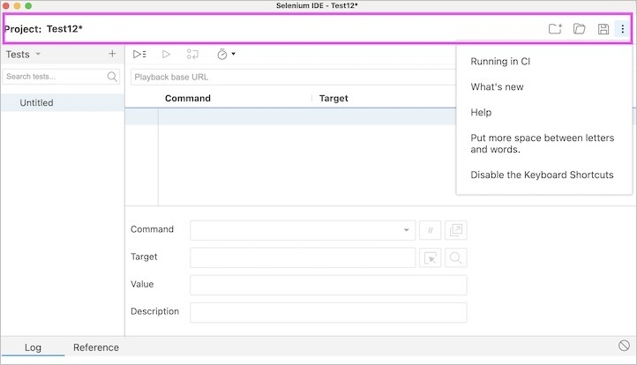
Tool Bar
The Tool Bar comprises of the Test execution speed option which controls the speed of the test execution, the Step over current command option that is used to step through the tests, the Run current test option to execute the presently selected test, and the Run all tests option to run every test in the test suite. The Selenium Integrated Development Environment Tool Bar section is highlighted in the below image.
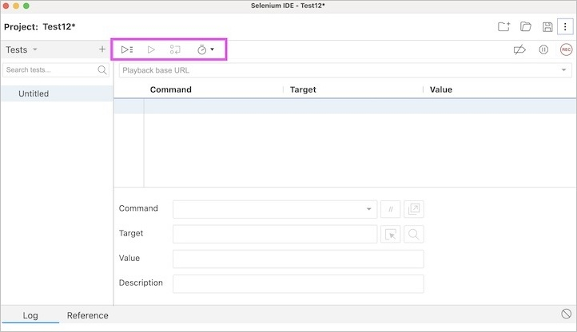
Address Bar
The Address Bar has a dropdown menu which saves every previous value for the base url. The Selenium Integrated Development Environment Address Bar section is highlighted in the below image.
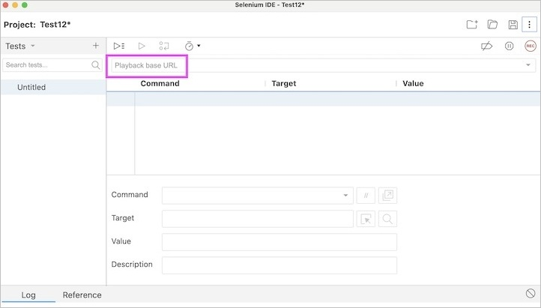
Test Case Pane
The Test Case Pane contains every test that the Selenium IDE has recorded. The Selenium Integrated Development Environment Test Case Pane section is highlighted in the below image.
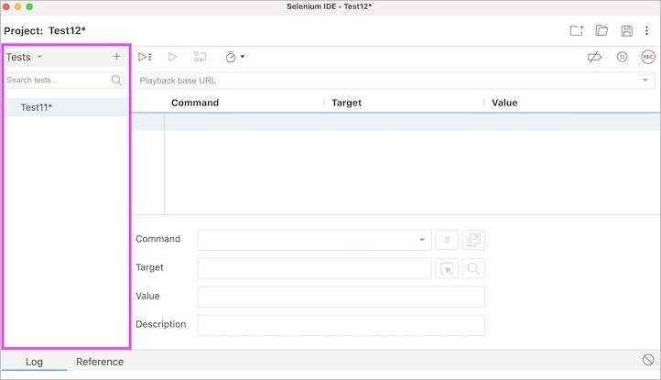
Test Script Editor Box
The Test Script Editor Box contains the actual test steps, user actions, validations, and so on either recorded or designed in the Selenium Integrated Development Environment.
The Test Script Editor Box has the components, namely the Command which takes care of the action to be performed on the web element for the application under test, the Target (optional field) which pinpoints to a web element on which an action is to be performed by mentioning an elements attribute name and value, the Value (optional field) is used to pass value or parameter, the Comment (optional field) to add comment to a test step, the Enable/Disable command, the Add new window configuration, select Target in page, and the Find target in page.
The Selenium Integrated Development Environment Test Script Editor section is highlighted in the below image.
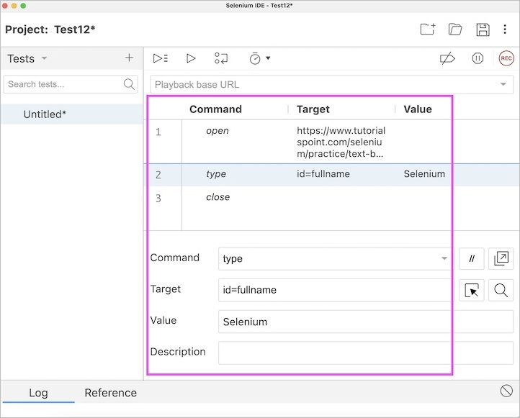
Recording Button
The Recording button is used to start and stop recording of tests in Selenium Integrated Development Environment. The Selenium Integrated Development Environment Recording section is highlighted in the below image.
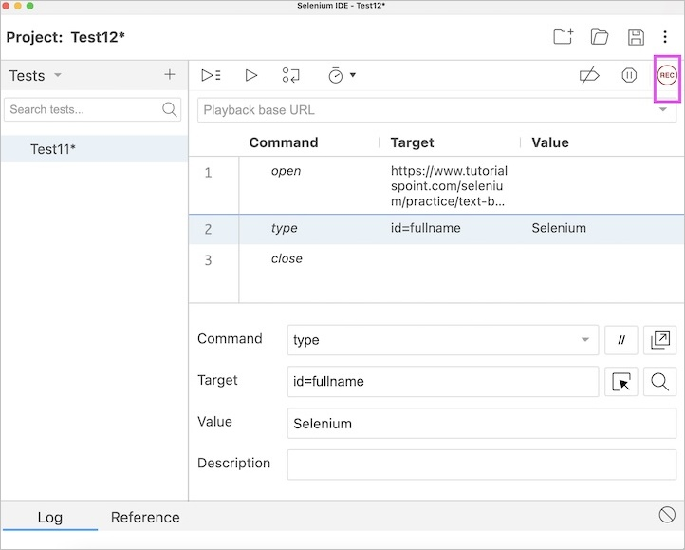
Log
The Log section captures the execution messages, information, warnings (if any), and errors. It denotes if a particular step passed or failed with a green OK or a red Failed indication and final outcome of the test case (passed or failed). The Selenium Integrated Development Environment Log section is highlighted in the below image.
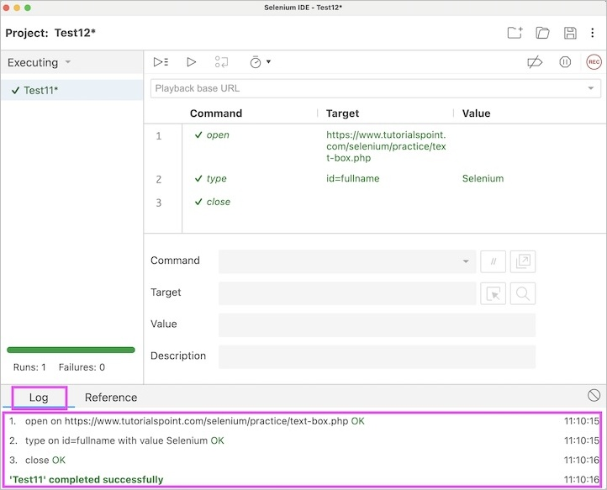
Reference
The Reference section displays every information of the currently selected command in the test step within the Test Script Editor, the arguments to be passed, locator, value, and so on. The Selenium Integrated Development Environment the Reference section is highlighted in the below image.
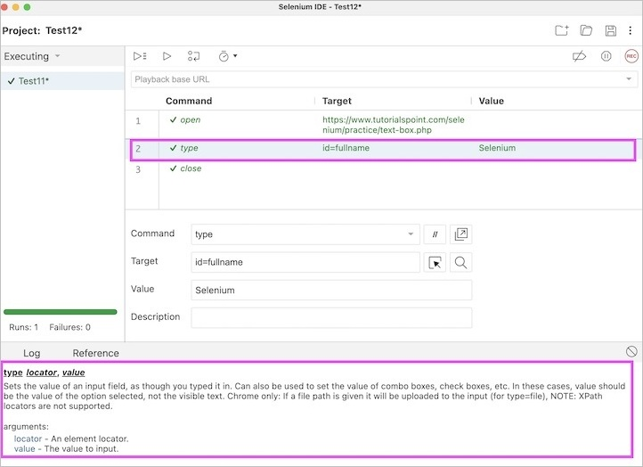
Conclusion
This concludes our comprehensive take on the tutorial on Selenium IDE Features. Weve started with describing key features of Selenium IDE, and components of Selenium IDE. This equips you with in-depth knowledge of the features in Selenium IDE. It is wise to keep practicing what youve learned and exploring others relevant to Selenium to deepen your understanding and expand your horizons.

Selenium IDE - Limitations

Previous
Quiz
Next
Selenium IDE is an easy and open source tool which can be used extensively for automation. However, it has certain limitations as listed below −
- Selenium Integrated Development Environment is not the best choice to test complex applications which require heavy interaction with data.
- Database testing can not be achieved using the Selenium Integrated Development Environment.
- Selenium Integrated Development Environment can not work with dynamic elements which undergo change after each page load.
- Screenshot capturing cannot be done using the Selenium Integrated Development Environment.
- Default report generation after execution of tests can not be performed using the Selenium Integrated Development Environment.
- Selenium Integrated Development Environment is currently available to Chrome and Firefox only.
- Selenium Integrated Development Environment tests do not include tests which need to be run on multiple iterations and conditions.
- Error handling feature is not available with the Selenium Integrated Development Environment.
- Grouping of testing with respect to functionalities and types can not be done using the Selenium Integrated Development Environment.
- Regression testing can not be performed using the Selenium Integrated Development Environment.
Thus we have discussed the limitations of Selenium Integrated Development Environment.

Selenium IDE - Installation

Previous
Quiz
Next
Selenium Integrated Development Environment(IDE) installation is available from the Chrome and Firefox store. As a precondition for Selenium Integrated Development Environment installation, we would need the browsers Chrome and Firefox installed in the local machine.
To complete the installation of Selenium Integrated Development Environment in Chrome let us follow the below steps −
Install Chrome Extension for Selenium IDE
Step 1 − Navigate to the link below and select the CHROME DOWNLOAD tab.
https://www.selenium.dev/selenium-ide/.
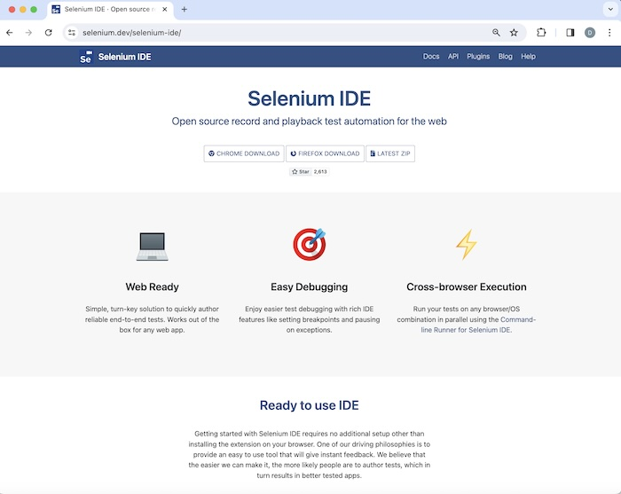
Step 2 − We would be navigated to the Chrome web store, Extensions page for Selenium Integrated Development Environment. Then we would click on Add to Chrome.
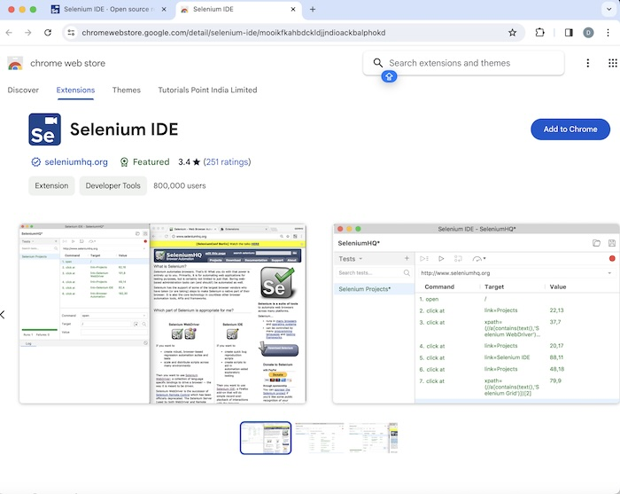
Step 3 − Click on Add extension button on the pop-up.
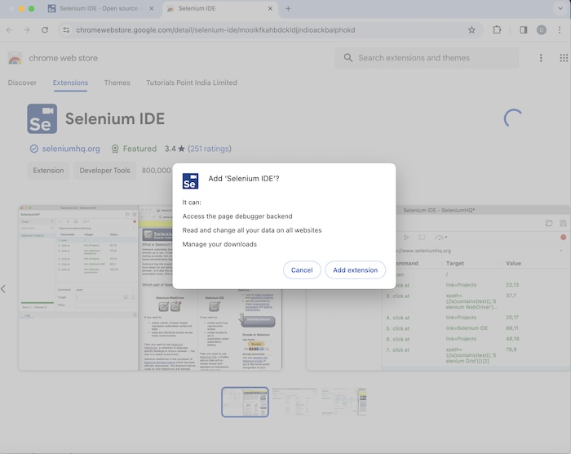
Step 4 − Selenium Integrated Development Environment should be installed successfully after which we would be able to launch it.
Step 5 − It is recommended that we restart the browser after Step4. Then the Selenium Integrated Development Environment icon would appear on the right upper corner of the Chrome browser, we would need to click it in order to launch.

Launch Selenium IDE in Chrome
In the above image, we can see, after the Selenium Integrated Development Environment was launched from the Chrome plugin, a welcome message should be displayed along with the version of the tool. Here, the version installed is 3.17.2.
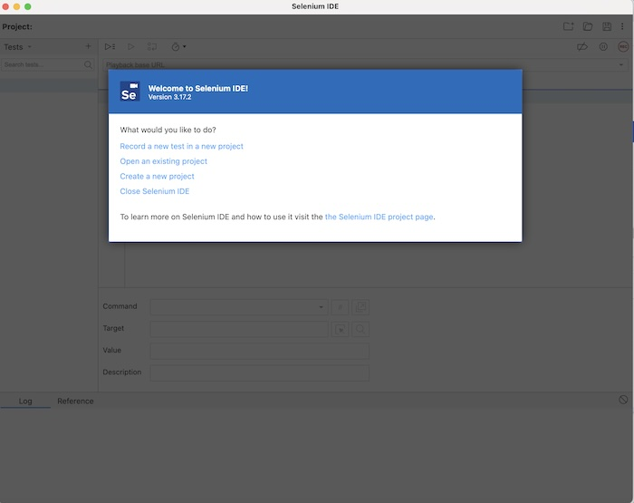
Along with this, it gives us the option to select what we would like to do with the tool, like Record a new test in a new project, Open an existing project, Create a new project, and Close it.
Also, a link with the text - the Selenium IDE project page is provided, which on clicking would land us to the Selenium Integrated Development Environment documentation page.
https://www.selenium.dev/selenium-ide/
Install Firefox Extension for Selenium IDE
Step 1 − Navigate to the link below and select the FIREFOX DOWNLOAD tab.
https://www.selenium.dev/selenium-ide/.
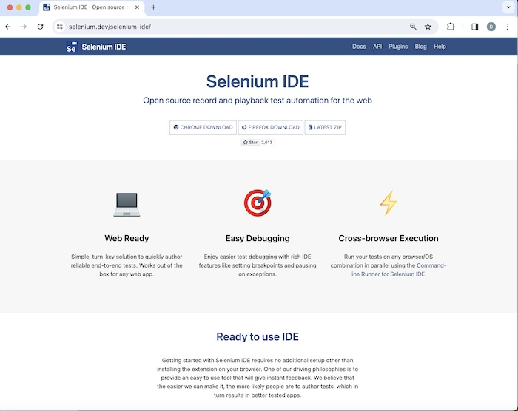
Step 2 − We would be navigated to the Firefox web store, Extensions page for Selenium Integrated Development Environment. Then we would click on Add to Firefox.
Step 3 − A pop-up window would appear. We would need to click on the Add button on the pop-up.
Step 4 − Selenium Integrated Development Environment should be installed successfully after which we would be able to launch it.
Step 5 − It is recommended that we restart the browser after Step 4. Then Selenium Integrated Development Environment icon would appear on the right upper corner of the Firefox browser, we would need to click it in order to launch.
Launch Selenium IDE in Firefox
In the above image, we can see, after the Selenium Integrated Development Environment was launched from the Firefox plugin, a welcome message should be displayed along with the version of the tool. Here, the version installed is 3.17.2.
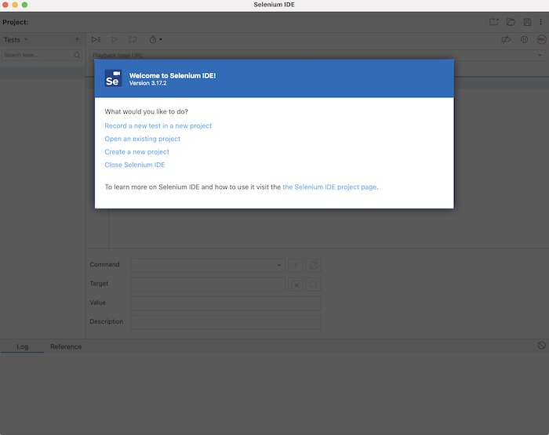
Along with this, it gives us the option to select what we would like to do with the tool, like Record a new test in a new project, Open an existing project, Create a new project, and Close it.
Also, a link with the text - the Selenium IDE project page is provided, which on clicking would land us to the Selenium Integrated Development Environment documentation page.
https://www.selenium.dev/selenium-ide/
Thus, we see that installation of Selenium Integrated Development Environment is a very simple process, and it does not require any particular software to do the Selenium Integrated Development Environment set up in a local machine.

Selenium IDE - Creating Tests

Previous
Quiz
Next
Selenium IDE can be used to create tests for automation. The latest version of Selenium IDE is available as extensions for both Chrome and Firefox. In order to create tests on Selenium IDE, the basic prerequisite would be to download the Chrome or Firefox extension for Selenium IDE from their respective web stores.
Creating a Test in Selenium IDE
The steps to create a test in Selenium IDE are listed below −
Step 1 − Click on the Selenium IDE extension visible on the browser after its installation.
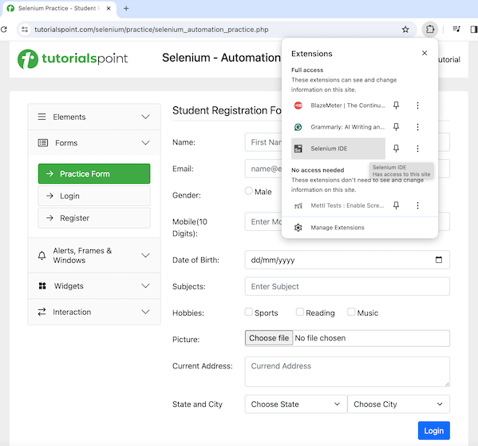
Step 2 − Selenium IDE should be launched along with it, a welcome message should be displayed with the version of the tool. In the below image, the version installed is 3.17.2.
Along with this, it gives us the option to select what we would like to do with the tool, like Record a new test in a new project, Open an existing project, Create a new project, and Close Selenium IDE.
Also, a link with the text - the Selenium IDE project page is provided, which on clicking would land us to the Selenium Integrated Development Environment documentation page.
https://www.selenium.dev/selenium-ide/
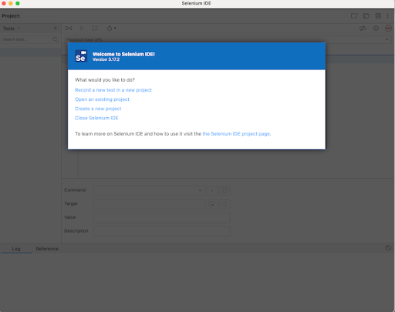
Step 3 − We would click on the option Record a new test in a new project. After which we would need to enter the PROJECT NAME, say SeleniumIDE1. Finally, we would click OK.
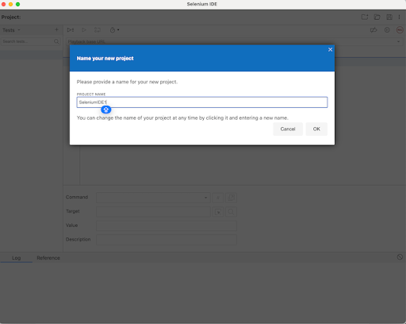
Step 4 − Before starting with creating a test in Selenium IDE, we would need to specify the application Base URL, where we would record and create the test. In the below image, we had entered the Base URL: https://www.tutorialspoint.com/selenium/. Finally, we would need to click on the Start Recording.
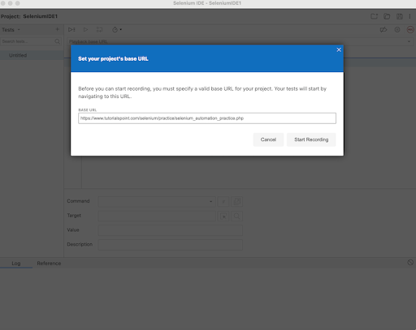
Step 5 − The corresponding application whose Base URL had been provided in Step4 should be opened with Selenium IDE logo and Selenium IDE recording message in red. Also, a red icon(highlighted in the below image) should be visible at the top of the Selenium IDE, denoting recording is in progress in the application.
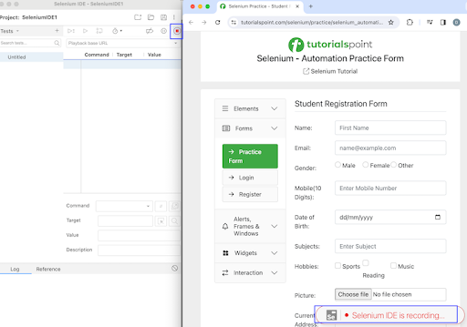
Step 6 − We would perform some steps on the application and corresponding steps would be recorded in the Selenium IDE as well.
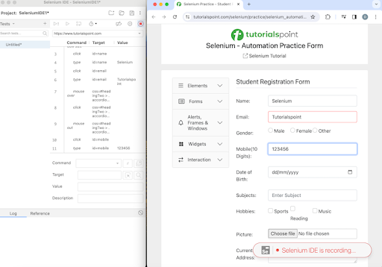
Step 7 − Once all the tests have been performed, we would stop the recording by clicking on the red icon as mentioned above in Step5. After which, we would need to enter a name for the test. In the below image, we had entered the TEST NAME as TestCase1. Finally, we would click on the OK.
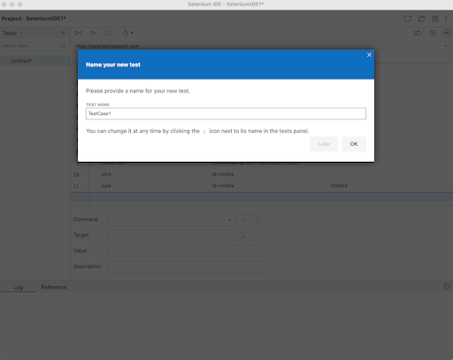
Step 8 − All the steps that we had performed on the application would be recorded in the Selenium IDE under the Command, Target, and Value fields. Also, the test case name - TestCase1, would be visible to the left pane along with a REC button to the top right.
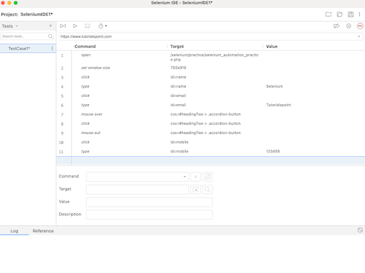
Step 9 − Once the test would be created, we would be able to get the details on that step, by clicking on it. Once done, it would be visible under the Command, Target, and Value fields at the bottom. In the below example, we had clicked on the fourth step, where the values of Command, Target, and Value fields are type, id=name, and Selenium respectively. In this step, we had basically entered the text Selenium in an input box which was identified with the id locator having the value as name.
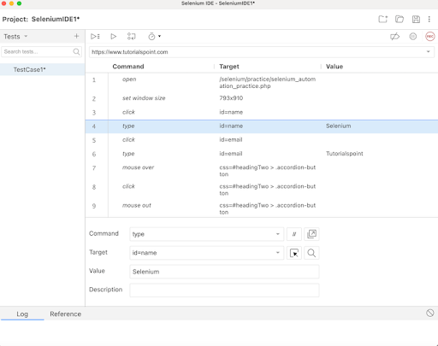
Step 10 − If we would click on the dropdown in the Target field, we would observe that Selenium IDE while recording was successful in capturing all the other locator values for an element. In the below example, we had clicked on the fourth step, where the values of Command, Target, and Value fields were type, id=name, and Selenium respectively. In this step, other locator values like the name, css, and so on for that element were visible within the Target dropdown.
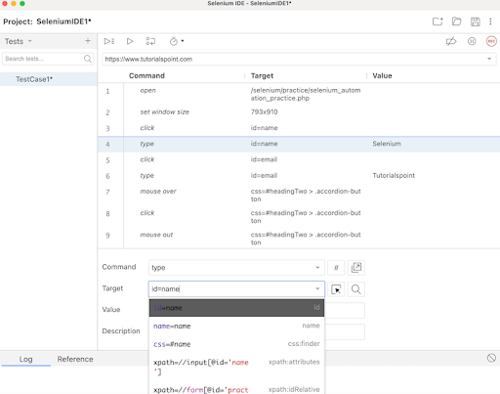
Step 11 − Once we would click on any step of the test we had created, we would get the details of the command and the action taken place, by navigating to the Reference tab at the below.
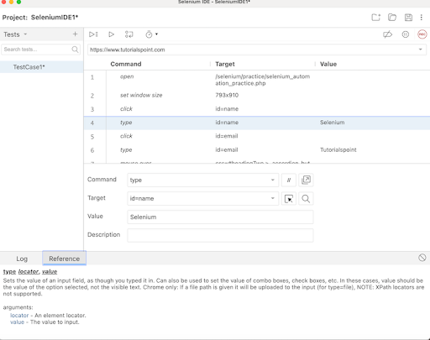
Step 12 − We can right click on any step and get the option to manually insert a new command(for addition of a new step), cut, copy, clear, Toggle breakpoint(used for debugging) on a step, and so on.
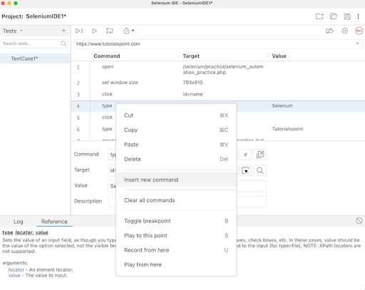
Step 13 − To run the test created, we would click on the Run current test button at the top as shown in the below image.
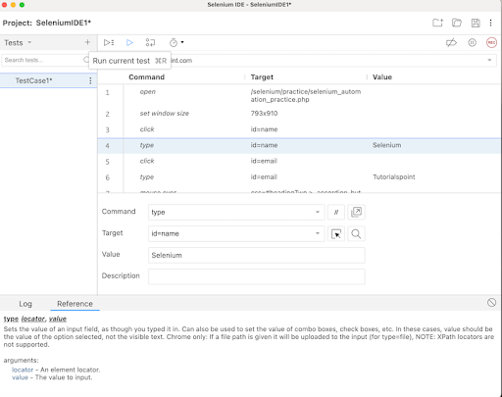
In case, there are multiple tests, we would need to click on the Run all tests button as shown in the below image.
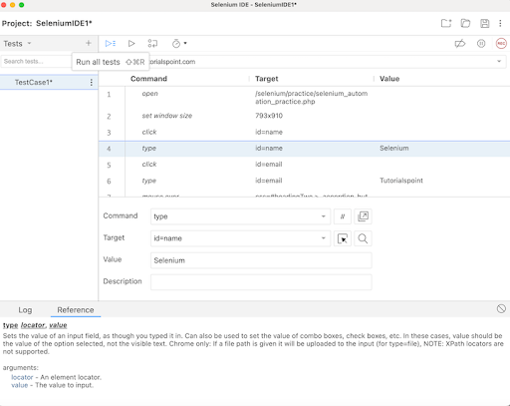
In case, there are breakpoints added to steps, we would need to click on the Step over current command button as shown in the below image where the steps 2, and 4 have breakoints.
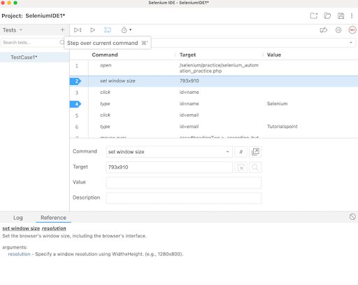
Step 14 − We can control the speed of test execution using the Test execution speed button as shown in the below image .
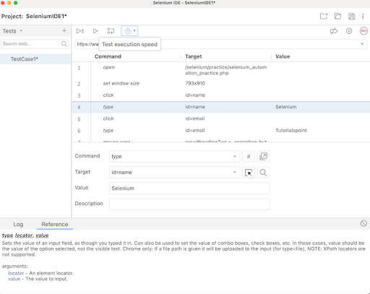
By default, the speed is set to Fast in Selenium IDE.
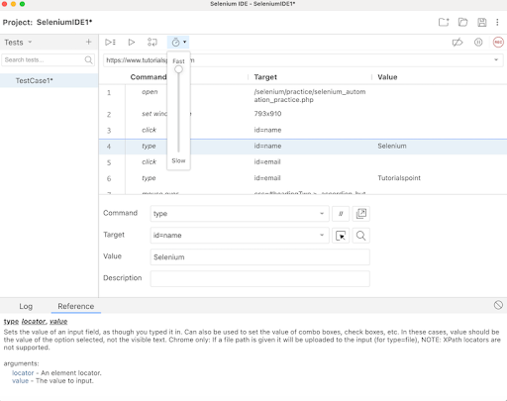
Step 15 − Selenium IDE gives the option to Create, Open and Save a project using the icons at the top right upper corner as highlighted on the below image.
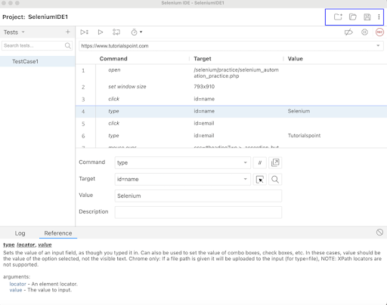
We would Save our project and continue. Once saved, we would be required to give a Name and location where our project would be saved.
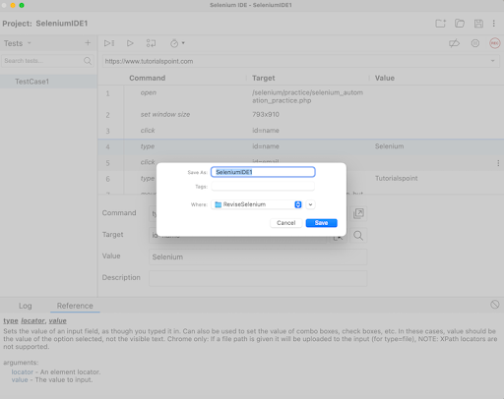
Step 16 − We would run the test - TestCase1 using the Run current test button.
Step 17 − Once the execution would be completed, we would get the message of the result. In case, the test passed, we would get the message - <TEST NAME> completed successfully under the Log tab at the bottom of the Selenium IDE. Here, our test name was TestCase1, hence received the message - TestCase1 completed successfully.
Apart from that, the all the test steps, along with the test case name turned green, reflecting a PASS for all the steps. All the steps which reflected under the Log tab, showed an OK in green.
Thus, in Selenium IDE, we would get the information about the test results both at the test step level and only if all the steps would be executed successfully, we would get a PASS at the test case level as well.
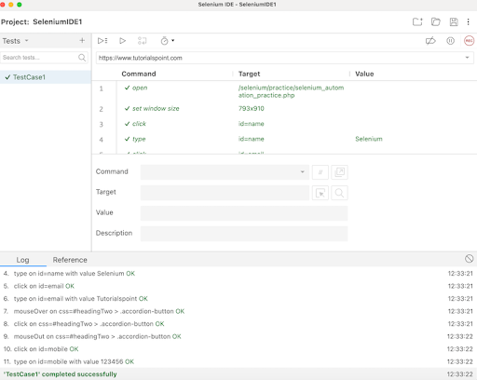
Thus, in this tutorial, we had discussed about how to create a test using the Selenium IDE.

Selenium IDE - Creating Script

Previous
Quiz
Next
Selenium IDE can be used to create test scripts for automation. The latest version of Selenium IDE is available as extensions for both Chrome and Firefox. In order to create tests on Selenium IDE, the basic prerequisite would be to download the Chrome or Firefox extension for Selenium IDE from their respective web stores.
Once we would start creating a script in Selenium IDE, we would get hold of the test script editor box where each part of the script editor box has a specific functionality to perform.
Creating a Test Script in Selenium IDE
The steps to create a test script in Selenium IDE are listed below −
Step 1 − Click on the Selenium IDE extension visible on the browser after its installation.
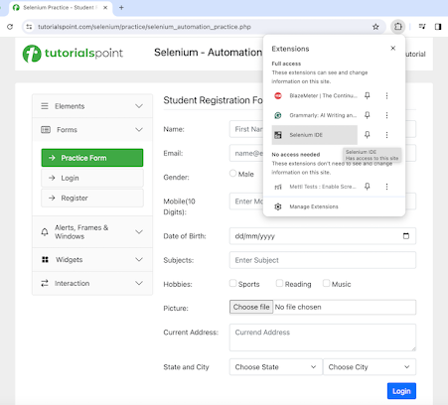
Step 2 − Selenium IDE should be launched along with it, a welcome message should be displayed with the version of the tool. In the below image, the version installed is 3.17.2.
Along with this, it gives us the option to select what we would like to do with the tool, like Record a new test in a new project, Open an existing project, Create a new project, and Close Selenium IDE.
Also, a link with the text - the Selenium IDE project page is provided, which on clicking would land us to the Selenium Integrated Development Environment documentation page.
https://www.selenium.dev/selenium-ide/

Step 3 − We would click on the option Record a new test in a new project. After which we would need to enter the PROJECT NAME, say SeleniumIDE1. Finally, we would click OK.

Step 4 − Before starting with creating a test in Selenium IDE, we would need to specify the application Base URL, where we would record and create the test. In the below image, we had entered the Base URL: https://www.tutorialspoint.com/selenium/. Finally, we would need to click on the Start Recording.

Step 5 − The corresponding application whose Base URL had been provided in Step4 should be opened with Selenium IDE logo and Selenium IDE recording message in red. Also, a red icon (highlighted in the below image) should be visible at the top of the Selenium IDE, denoting recording is in progress in the application.

Step 6 − We would perform some steps on the application and corresponding steps would be recorded in the Selenium IDE as well.

Step 7 − Once all the tests have been performed, we would stop the recording by clicking on the red icon as mentioned above in Step5. After which, we would need to enter a name for the test. In the below image, we had entered the TEST NAME as TestCase1. Finally, we would click on the OK.

Step 8 − All the steps that we had performed on the application would be recorded in the Selenium IDE under the Command, Target, and Value fields. Also, the test case name - TestCase1, would be visible to the left pane along with a REC button to the top right.
The portion highlighted in the below image depicts the Text Script Editor Panel in Selenium IDE. It comprises user interactions that are recorded in the form of test steps that are recorded while recording is enabled. The Text Script Editor Panel also has three columns - Command, Target, and Value.
The Command column comprises Selenium commands, Target column contains locator values, URL, and so on. Finally, the Value column can be used to pass on the value to be entered.
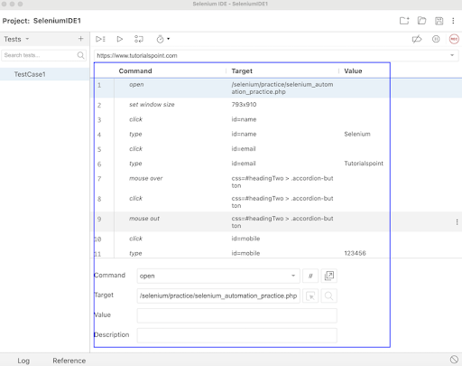
If a particular step is selected (just like the step 3 in the below image), the Enable/Disable command option would be enabled. On selecting it, that specific step command would get disabled with a // sign at the left.
Once the test is triggered, all the steps excluding the disabled command would get executed. We can enable the same step by clicking the Enable/Disable command button again and // sign would also disappear. So the Enable/Disable command is another important part of the Text Script Editor.
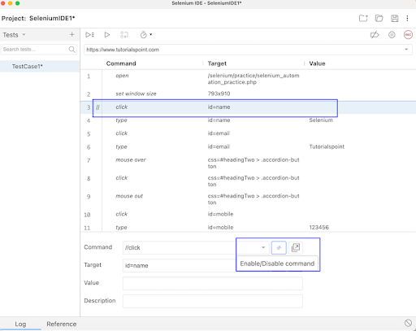
In some cases, it is observed that on clicking a link/button on a web page, a new window would appear, this type of situation can be handled using the Add new window configuration button as highlighted in the below image.
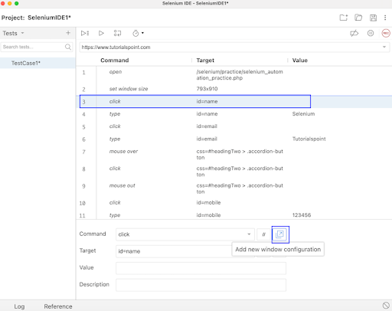
On clicking it, a popup with the message New Window Configuration would appear. We would need to check the checkbox New Window Configuration Enabled, enter a WINDOW NAME, and click on Confirm.
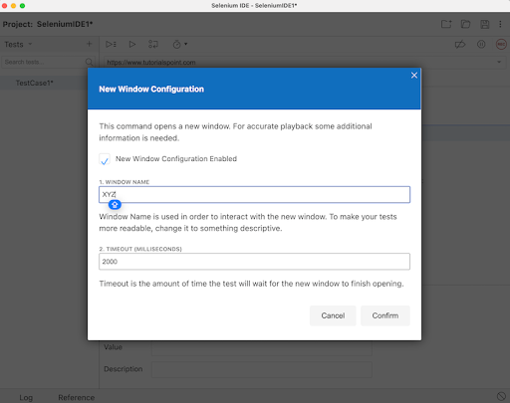
In order to locate an element automatically by Selenium IDE, we can use the Select target in page button.
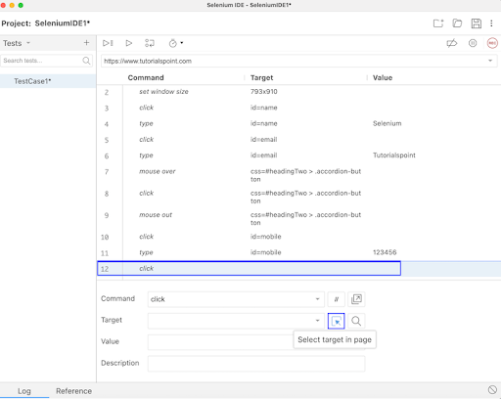
Once clicked, it would give the user the option to Select an element, and based on that, its locator value will be generated automatically by Selenium IDE.
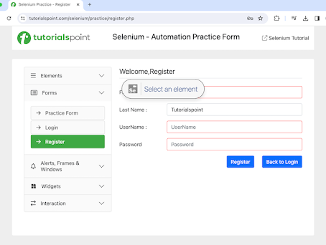
The corresponding locator value would be generated in the Target. Also, after which, if the Find target in page is selected, the element whose locator value is generated, will be highlighted.
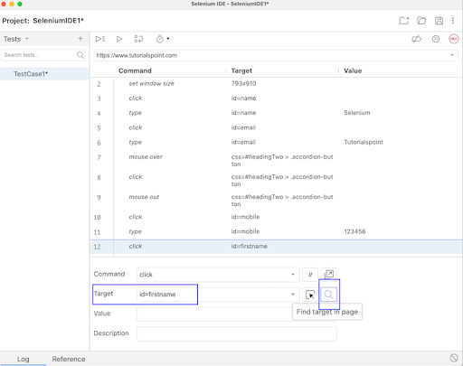
Please note that, the buttons - Find target in page, Select target in page, Add new window configuration, and Enable/Disable command become enabled only if we have something in the Command field else they remain disabled as highlighted in the below image.
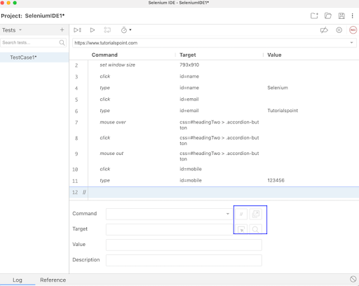
Step 9 − Once the test would be created, we would be able to get the details on that step, by clicking on it. Once done, it would be visible under the Command, Target, and Value fields at the bottom. In the below example, we had clicked on the fourth step, where the values of Command, Target, and Value fields are type, id=name, and Selenium respectively. In this step, we had basically entered the text Selenium in an input box which was identified with the id locator having the value as name.
Within the Text Script Editor Panel, we can edit Command, Target, and Value by selecting a step.

Step 10 − If we would click on the dropdown in the Target field, we would observe that Selenium IDE while recording was successful in capturing all the other locator values for an element. In the below example, we had clicked on the fourth step, where the values of Command, Target, and Value fields were type, id=name, and Selenium respectively. In this step, other locator values like the name, css, and so on for that element were visible within the Target dropdown.

Step 11 − Once we would click on any step of the test we had created, we would get the details of the command and the action taken place, by navigating to the Reference tab at the below.

Step 12 − We can right click on any step and get the option to manually insert a new command(for addition of a new step), cut, copy, clear, Toggle breakpoint (used for debugging) on a step, and so on.

Step 13 − To run the test created, we would click on the Run current test button at the top as shown in the below image.

In case, there are multiple tests, we would need to click on the Run all tests button as shown in the below image.

In case there are breakpoints added to steps, we would need to click on the Step over current command button as shown in the below image where the steps 2, and 4 have breakpoints.

Step 14 − We can control the speed of test execution using the Test execution speed button as shown in the below image.

By default, the speed is set to Fast in Selenium IDE.

Step 15 − Selenium IDE gives the option to Create, Open and Save a project using the icons at the top right upper corner as highlighted on the below image.

We would Save our project and continue. Once saved, we would be required to give a Name and location where our project would be saved.

Step 16 − We would run the test - TestCase1 using the Run current test button.
Step 17 − Once the execution would be completed, we would get the message of the result. In case the test passed, we would get the message - <TEST NAME> completed successfully under the Log tab at the bottom of the Selenium IDE. Here, our test name was TestCase1, hence received the message - TestCase1 completed successfully.
Apart from that, all the test steps, along with the test case name turned green, reflecting a PASS for all the steps. All the steps which reflected under the Log tab, showed an OK in green.
Thus, in Selenium IDE, we would get the information about the test results both at the test step level and only if all the steps would be executed successfully, we would get a PASS at the test case level as well.

Thus, in this tutorial, we had discussed creating a script using the Selenium IDE.

Selenium IDE - Control Flow

Previous
Quiz
Next
Selenium IDE commands contain features with which the conditional statements and looping can be added to the tests. This helps to run some steps only if specific conditions are satisfied or to execute the same steps multiple times depending on the particular criteria.
JavaScript Expressions
The conditions in the application under test can be verified with the help of the JavaScript expressions. The commands execute script and execute async script are used to execute a JavaScript code within our test and save the result to a variable for future use. These variables can be used in control flow commands as well. Moreover, the JavaScript expressions can be utilized with the control flow commands.
Read More:Selenium IDE - JavaScript Functions

Basic Control Flow Commands on Conditional Branching
The basic control flow commands along with their companions are listed below −
if
This is the starting command on conditional branching and can be used along with a JavaScript command to be evaluated or with the variables created before a JavaScript command. This is a part of the Target input field of the if command.
If the expression returns a true value, then the test will run the steps after if expression till the next control flow commands like the else, else if, or end is encountered. If the expression returns a false value, it will jump to the following conditional commands like the else, else if, or end.
else if
This command is used inside an if command block. Similar to an if command, the else if command accepts a JavaScript command to be evaluated. This is a part of the Target input field of the else if command.
If the expression returns a true value, then the test will run the steps after if expression till the next control flow commands like the else, else if, or end is encountered. If the expression returns a false value, it will jump to the following conditional commands like the else, or end.
else
This command is used to accommodate the last condition within the if block. If none of the previous conditions are met, the else command is executed.
end
This command is used to end the conditional command block. Without an end command in a conditional block, will give errors while running the Selenium IDE test.
Basic Control Flow Commands on Looping
The basic control flow commands on looping (that allows to repeat a group of command/commands execution) are listed below −
times
This command is used to define the count of iterations of an action/actions that need to be performed. The count of iterations is fed to the Target input field with this command. A times command should be ended with the end command.
do
This command is used to begin a loop. After the do command, the steps to be performed are declared. A do command should be ended with the repeat if command. The repeat if accepts the JavaScript expression that will be executed within the target input field. The commands post the do command will be executed initially followed by the action in the repeat if command.
If the expression returns a true value, then the test execution moves to the next do command and redo the pattern. This goes on till the condition is not satisfied anymore or in an event of infinite loop. The default number of attempts is 1000. This default number can be modified, by setting a number in the Value field of the repeat if command.
while
In this command, the JavaScript expression to be executed is provided in the Target field. If the expression returns a true value, the command block runs till the end command. Again, the control jumps back to the while command to repeat the same pattern(checking each time if a JavaScript expression yields a true or false value). A while command should terminate with the end command.
forEach
This command is used to loop through a collection and refer to individual items within a collection. In the Target field, the variable name that points to the array to be iterated is to be mentioned. Within the Value field, iterator variable name.
Example 1
Let us take an example of the below page, where we would check the text - Welcome, Login In appearing at the top using the conditional branching control flow commands.
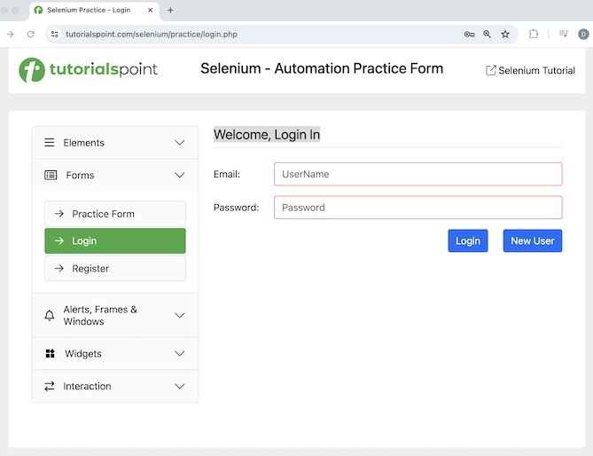
The steps to be followed are listed below −
Step 1 − Click on the Selenium IDE extension visible on the browser after its installation.
Step 2 − Selenium IDE should be launched along with it, a welcome message should be displayed with the version of the tool. In the below image, the version installed is 3.17.2.
Along with this, it gives us the option to select what we would like to do with the tool, like Record a new test in a new project, Open an existing project, Create a new project, and Close Selenium IDE.
Also, a link with the text - Selenium IDE project page is provided, which on clicking would land us to the Selenium Integrated Development Environment documentation page.
https://www.selenium.dev/selenium-ide/.
Step 3 − Click on the Create a new project link, then enter a project name, say, Test12 under the Please provide a name for your new project. Finally, we would click on the OK button.
Step 4 − We would have the workspace ready in the Selenium IDE now.
Step 5 − Enter open in the Command field, and selenium in the Target field, to launch the application.
Step 6 − Enter store text in the Command field, xpath=//*[@id="signInForm"]/h1 in the Target field and val in the Value field. Please note, xpath=//*[@id="signInForm"]/h1 is the locator value of the text and val is the variable which we would use to store the text.
Step 7 − Enter if in the Command field and ${val}==="Welcome, Login In" in the Target field.
Step 8 − Enter echo in the Command field and Correct Verification in the Target field.
Step 9 − Enter else if in the Command field and ${val}==="Welcome, Register" in the Target field.
Step 10 − Enter echo in the Command field and InCorrect Verification in the Target field.
Step 11 − Enter else Command field.
Step 12 − Enter echo in the Command field and InValid Test in the Target field.
Step 13 − Enter end in the Command field.
Step 14 − Enter close in the Command field to close the browser window.
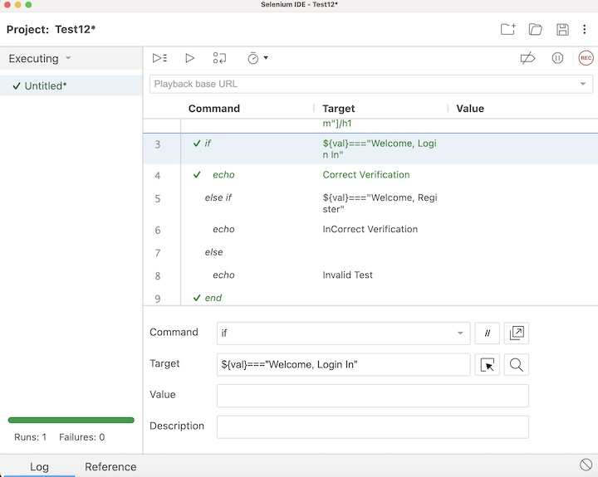
Step 15 − Click on the Run all tests from the top, and wait for the test execution to complete. In our example, we would see Runs: 1, Failures: 0, and a green bar denoting the test ran successfully without any failures. Also, the message that the completed successfully appeared under the Log.
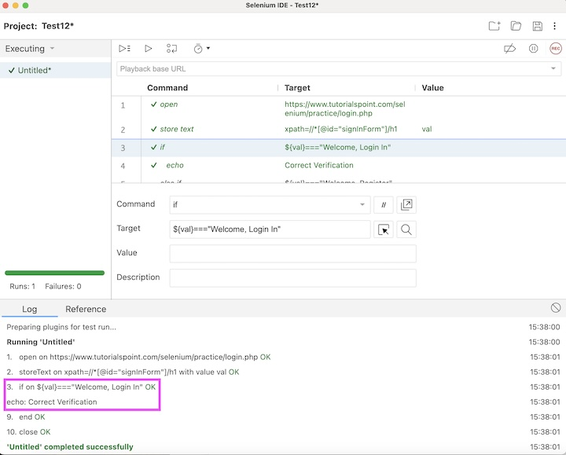
In the example above, we had verified the text - Welcome, Login In and printed the message in the console - Correct Verification. Besides, we got a green tick at the top, signifying a passed test.
Example 2
Let us take an example where we would use one of the looping control flow commands called while.
The steps to be followed are listed below −
Step 1 − Follow steps 1 to 4 as mentioned in Example 1.
Step 2 − Enter execute script in the Command field, return 1 in the Target field, and val in the Value field.
Step 3 − Enter while in the Command field, and ${val} < 3 in the Target field.
Step 4 − Enter echo in the Command field, and ${val} in the Target field.
Step 5 − Enter execute script in the Command field, return ${val} + 1 in the Target field, and val in the Value field.
Step 6 − Enter end in the Command field.
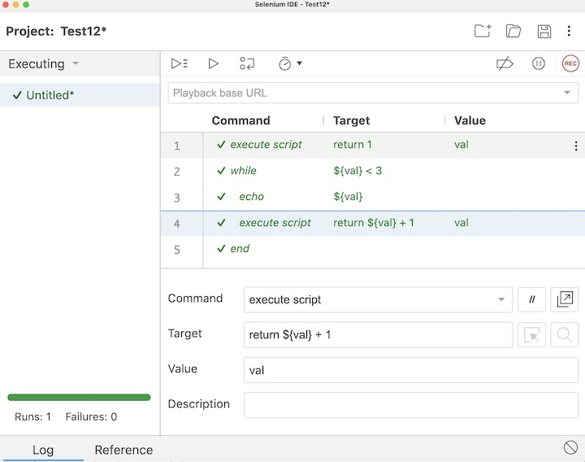
Step 7 − Click on the Run all tests from the top, and wait for the test execution to complete. In our example, we would see Runs: 1, Failures: 0, and a green bar denoting the test ran successfully without any failures. Also, the message that the completed successfully appeared under the Log.
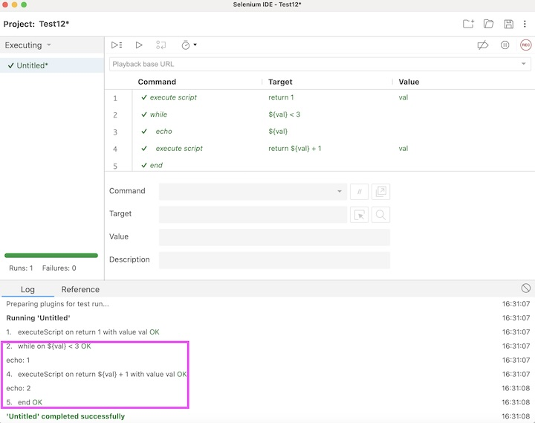
Conclusion
This concludes our comprehensive take on the tutorial on Selenium IDE - Control Flow. Weve started with describing JavaScript Expressions, basic Control Flow Commands on Conditional Branching, Basic Control Flow Commands on Looping, and examples to walk through how to use these commands along with Selenium.
This equips you with in-depth knowledge of the Control Flow in Selenium IDE. It is wise to keep practicing what youve learned and exploring others relevant to Selenium to deepen your understanding and expand your horizons.

Selenium IDE - Store Variables

Previous
Quiz
Next
Selenium Integrated Development Environment can be used to store and access variables while creating a test for automation. To store variables and to access them, we can use the store and its related commands in Selenium IDE. We use the command echo to print the stored value of the variable under the Logs tab in Selenium IDE. We can also access an element on a web page and obtain its text using the store Text command and obtain the value of an element using the store Value command.
Example
Let us take an example of the below page, where we would enter the text Selenium beside the First Name: label and Tutorialspoint beside Last Name: label. Also, we would obtain the text Selenium - Automation Practice Form using the Selenium IDE taking the help of the store variables feature of this tool.
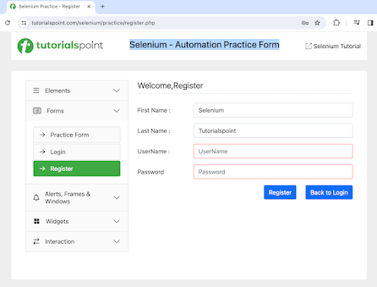

Storing and Accessing Variables in Selenium IDE
The steps to store variables and access them in Selenium IDE are listed below −
Step 1 − Click on the Selenium IDE extension visible on the browser after its installation.
Step 2 − Selenium IDE should be launched along with it, a welcome message should be displayed with the version of the tool. In the below image, the version installed is 3.17.2.
Along with this, it gives us the option to select what we would like to do with the tool, like Record a new test in a new project, Open an existing project, Create a new project, and Close Selenium IDE.
Also, a link with the text - the Selenium IDE project page is provided, which on clicking would land us to the Selenium Integrated Development Environment documentation page.
https://www.selenium.dev/selenium-ide/
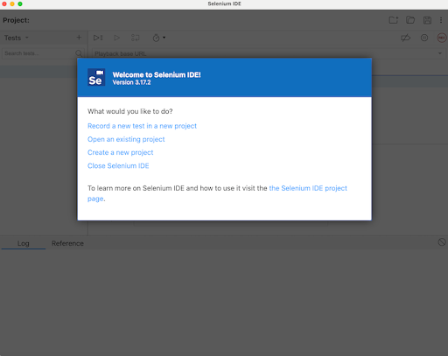
Step 3 − Click on the Create a new project link, then enter a project name under the Please provide a name for your new project. Finally, we would click OK.
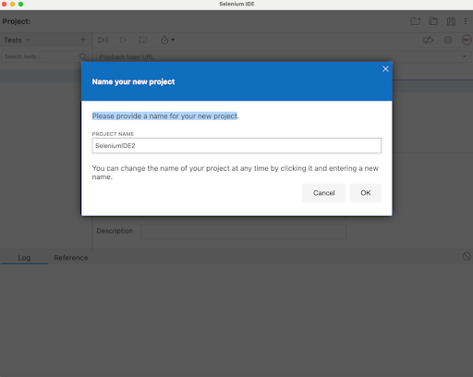
Step 4 − We would have the workspace ready in the Selenium IDE as shown in the below image.
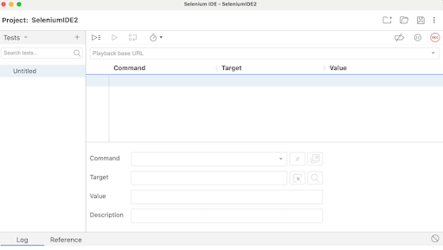
Step 5 − Enter open in the Command field, and https://www.tutorialspoint.com/selenium/ in the Target field, to launch the application.
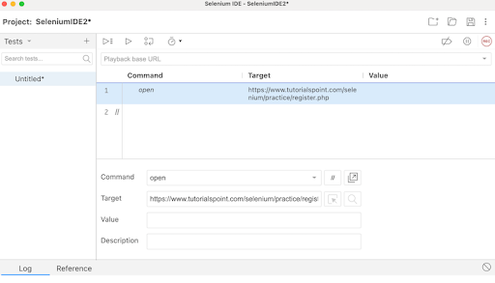
Step 6 − Enter store in the Command field, Selenium in the Target field, and i in the Value field. Please note, Selenium is the value we would like to enter using the variable i.
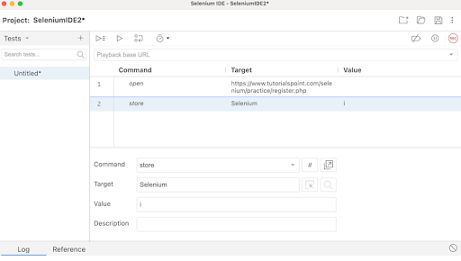
Step 7 − Enter type in the Command field, id=firstname in the Target field, and ${i} in the Value field. Please note, id=firstname is the locator value of the input box and ${i} is used to refer to the variable value we would enter using the variable i.
Step 8 − Enter store in the Command field, Tutorialspoint in the Target field, and j in the Value field. Please note, Tutorialspoint is a value we would like to enter using the variable j.
Step 9 − Enter type in the Command field, id=lastname in the Target field, and ${j} in the Value field. Please note, id=lastname is the locator value of the input box and ${j} is used to refer to the variable value we would enter using the variable j.
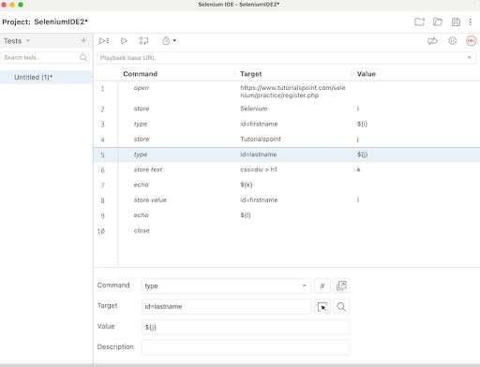
Step 10 − Enter store Text in the Command field, css=div > h1 in the Target field, and k in the Value field. Please note, css=div > h1 is the locator value of the text that we would obtain and k is used to refer to the variable value where we would store the text obtained.
Step 11 − Enter echo in the Command field, ${k} in the Target field. Please note, this would print the text we accessed in Step10 on the web page under the Logs in Selenium IDE.
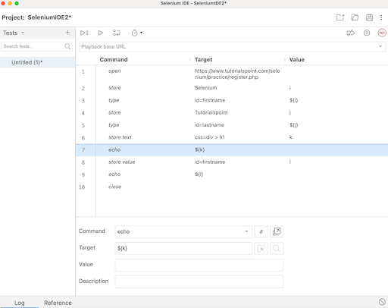
Step 12 − Enter store value in the Command field, id=firstname in the Target field, and l in the Value field. Please note, id=firstname is the locator value of the input box and l is used to refer to the variable we would use to obtain the value entered in the input box.
Step 13 − Enter echo in the Command field, ${l} in the Target field. Please note, this would print the value entered in Step7 on the web page under the Logs in Selenium IDE.
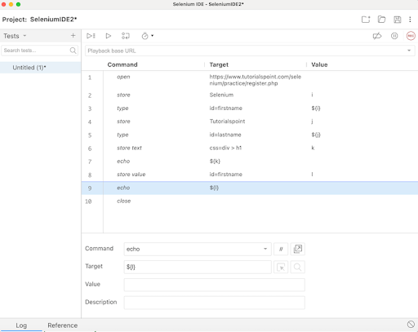
Step 14 − Enter close in the Command field to close the browser window.
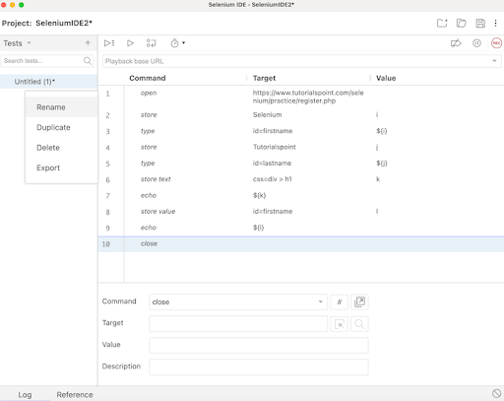
Step 15 − Click on the three dots appearing at the left pane, then select the Rename option.
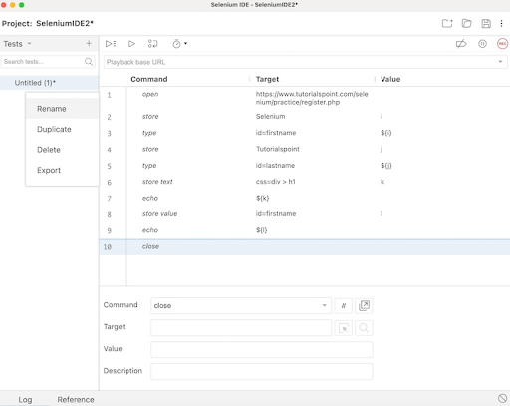
Step 16 − Enter a name, say TestCase2 under the Rename Test case field, then click on Rename. The entered name would appear on the left of Selenium IDE.
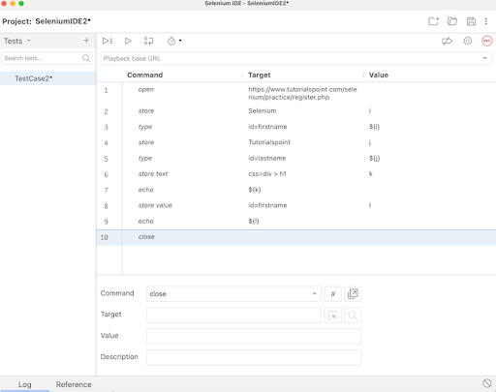
Step 17 − Click on the Run all tests from the top, and wait for the test execution to complete. In our example, we would see Runs: 1, Failures: 0, and a green bar denoting the test ran successfully without any failures. Also, the message TestCase2 completed successfully appeared under the Logs.
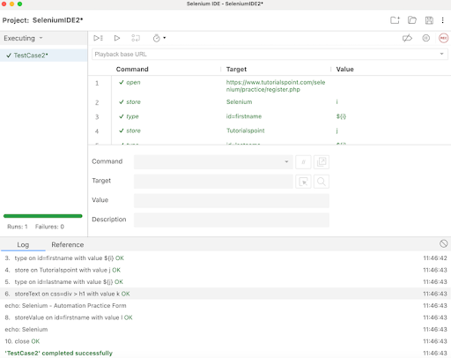
In the example above, we obtained the text Selenium - Automation Practice Form which appeared on the web page, and also retrieved the value entered in the input box beside the First Name: label - Selenium under the Logs. Besides, we got a green tick beside the test case name - TestCase2 at the top, signifying a passed test.
Apart from that, all the test steps, along with the test case name turned green, reflecting a PASS for all the steps. All the steps which reflected under the Log tab, showed an OK in green.
Thus, in Selenium IDE, we would get the information about the test results both at the test step level and only if all the steps would be executed successfully, we would get a PASS at the test case level as well.
Moreover, we would infer that variables used in one step can be accessed further in other steps using the syntax: ${<variable name>}. In the Steps6, 7, 8, 9, 10, 11, 12, and 13, we followed this approach in our test. Also, we had used store and store related commands like store Text, store Value, and so on to store the variables. The echo command was used to print those values under the Logs tab.
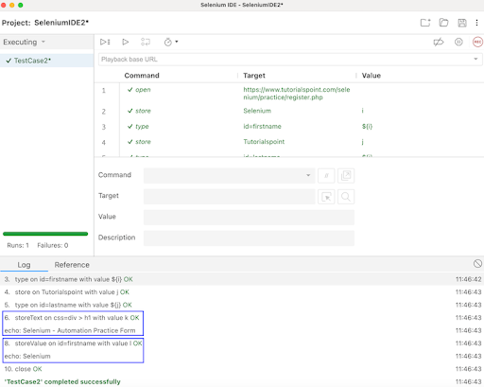
Thus, in this tutorial, we had discussed how to store variables using the Selenium IDE.

Selenium IDE - Alerts & Popups

Previous
Quiz
Next
Selenium IDE can be used to handle alerts and popups. An alert on a web page is designed to show a warning message, or information, or to get the user authorization to proceed for further actions.
Selenium IDE Commands for Alerts and Popups
The various commands for alerts and popups are listed below −
- Webdriver answer on visible prompt − This command is used to input text in the prompt and then click on the OK button inside the prompt.
- Webdriver choose ok on visible confirmation − This command is used to click on the OK button within a confirmation dialogue box.
- Webdriver choose cancel on visible confirmation − This command is used to click on the Cancel button within a confirmation dialogue box.
- Webdriver choose cancel on visible prompt − This command is used to cancel the prompt.
- Answer on next prompt − This command is used to plan and answer the prompt before it is displayed.
- Choose cancel on next prompt − This command is used to plan, then choose and click on the Cancel button on the prompt before it is displayed.
- Choose ok on next confirmation − This command is used to plan, then choose and click on the OK button on the confirmation dialogue box before it is displayed.
- Assert prompt(text) − This command is used to verify if a prompt has been rendered. If assert did not pass, then the execution will stop at the point of mismatch.
- Assert alert(alert text) − This command is used to verify if an alert has the text matching the alert text. If assert did not pass, then the execution will stop at the point of mismatch.
- Assert confirmation(text) − This command is used to verify if a confirmation has been rendered. If assert did not pass, then the execution will stop at the point of mismatch.

Example 1
Let us take an example of the below page, where on clicking the last Click Me button we would get the prompt, and we would input the text Tutorialspoint and finally click on the OK button using the webdriver answer on visible prompt command.
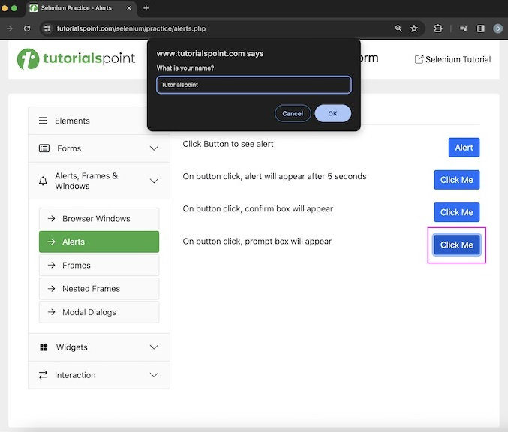
Then we would click on the Alert button, which would generate an alert with text - Hello World!. We would verify alert text with the assert alert command.
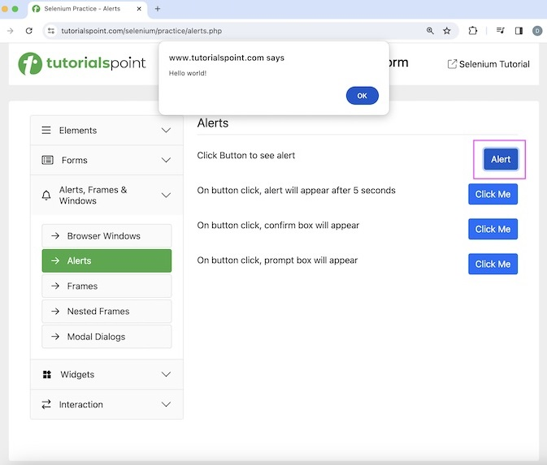
The steps to be followed are listed below −
Step 1 − Click on the Selenium IDE extension visible on the browser after its installation.
Step 2 − Selenium IDE should be launched along with it, a welcome message should be displayed with the version of the tool. In the below image, the version installed is 3.17.2.
Along with this, it gives us the option to select what we would like to do with the tool, like Record a new test in a new project, Open an existing project, Create a new project, and Close Selenium IDE.
Also, a link with the text - the Selenium IDE project page is provided, which on clicking would land us to the Selenium Integrated Development Environment documentation page.
https://www.selenium.dev/selenium-ide/.
Step 3 − Click on the Create a new project link, then enter a project name, say, Test12 under the Please provide a name for your new project. Finally, we would click on the OK button.
Step 4 − We would have the workspace ready in the Selenium IDE now.
Step 5 − Enter open in the Command field, and https://www.tutorialspoint.com/selenium/ in the Target field, to launch the application.
Step 6 − Enter answer on next prompt in the Command field, and Tutorialspoint in the Value field. Please note, Tutorialspoint is the text entered in the visible prompt.
Step 7 − Enter click in the Command field, xpath=/html/body/main/div/div/div[2]/div[4]/button in the Target field. Please note, xpath=/html/body/main/div/div/div[2]/div[4]/button is the locator value of the Click Me button.
Step 8 − Enter click in the Command field, xpath=/html/body/main/div/div/div[2]/div[1]/button in the Target field. Please note, xpath=/html/body/main/div/div/div[2]/div[1]/button is the locator value of the Alert button.
Step 9 − Enter assert alert in the Command field, and Hello World! in the Value field. Please note, Hello World! is the alert text being verified.
Step 10 − Enter close in the Command field to close the browser window.
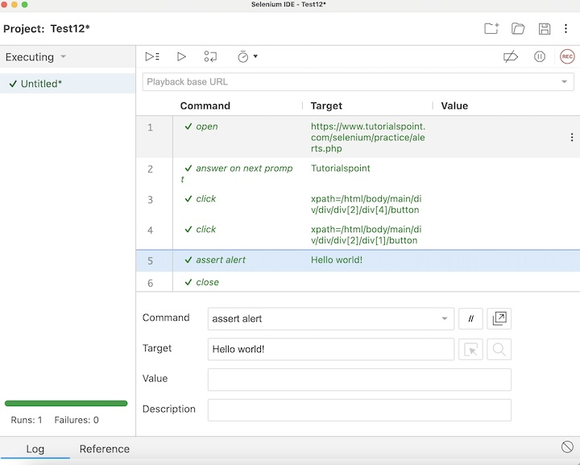
Step 11 − Click on the Run all tests from the top, and wait for the test execution to complete. In our example, we would see Runs: 1, Failures: 0, and a green bar denoting the test ran successfully without any failures. Also, the message that the completed successfully appeared under the Log.
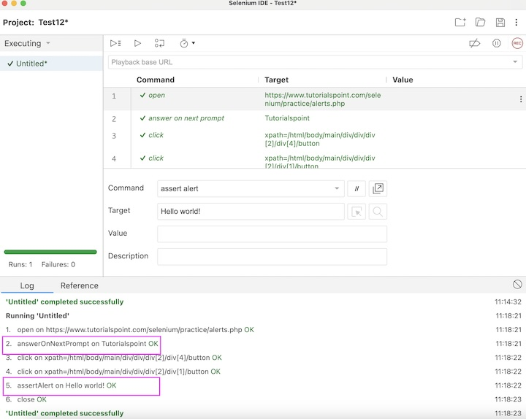
In the example above, we had launched the application with open command and entered the text - Tutorialspoint on the prompt also verified the alert text - Hello World!. Besides, we got a green tick at the top, signifying a passed test.
Example 2
Let us take an example of the below page, where on clicking the third Click Me button we would get the confirmation dialogue box, and we would click on the OK button using the choose ok on next confirmation command.
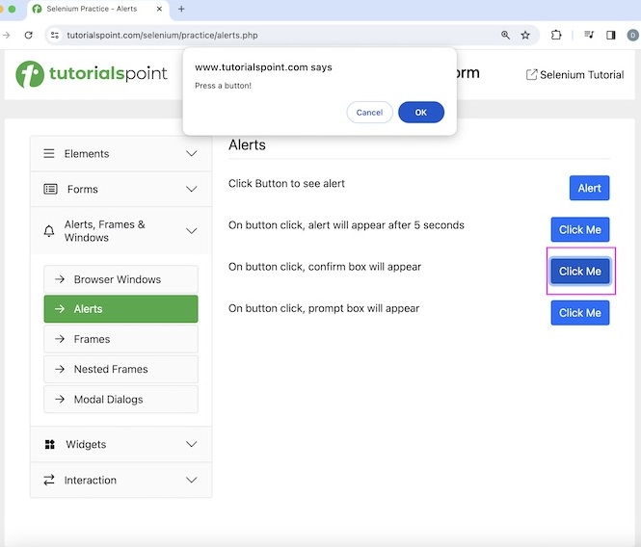
Once the confirmation dialogue box is closed, we would get the text - You pressed OK! on the web page.
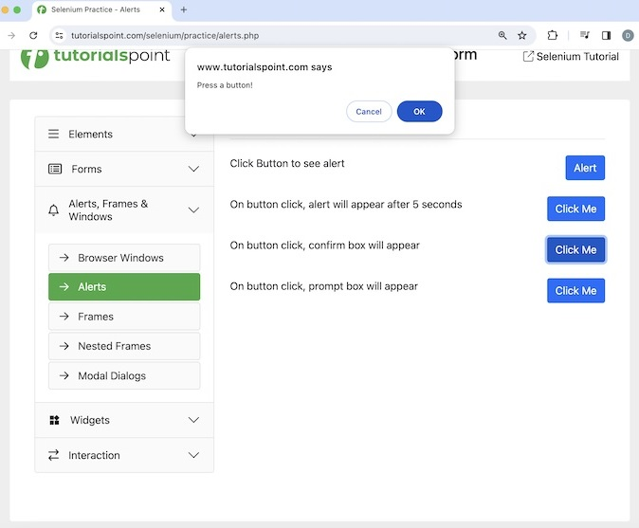
The steps to be followed are listed below −
Step 1 − Follow steps 1 to 5 as mentioned in Example 1.
Step 2 − Enter choose ok on next confirmation in the Command field.
Step 3 − Enter click in the Command field,
xpath=/html/body/main/div/div/div[2]/div[3]/button in the Target field. Please note, xpath=/html/body/main/div/div/div[2]/div[3]/button is the locator value of the Click Me button.
Step 4 − Enter assert text in the Command field, xpath=//*[@id="desk"] in the Target field, and You pressed OK! in the Value field.
Step 5 − Enter close in the Command field to close the browser window.
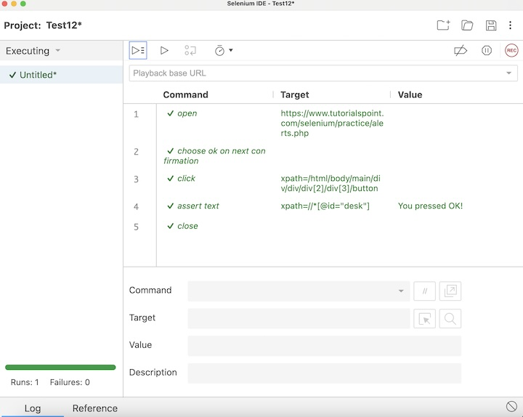
Step 6 − Click on the Run all tests from the top, and wait for the test execution to complete. In our example, we would see Runs: 1, Failures: 0, and a green bar denoting the test ran successfully without any failures. Also, the message that the completed successfully appeared under the Log.
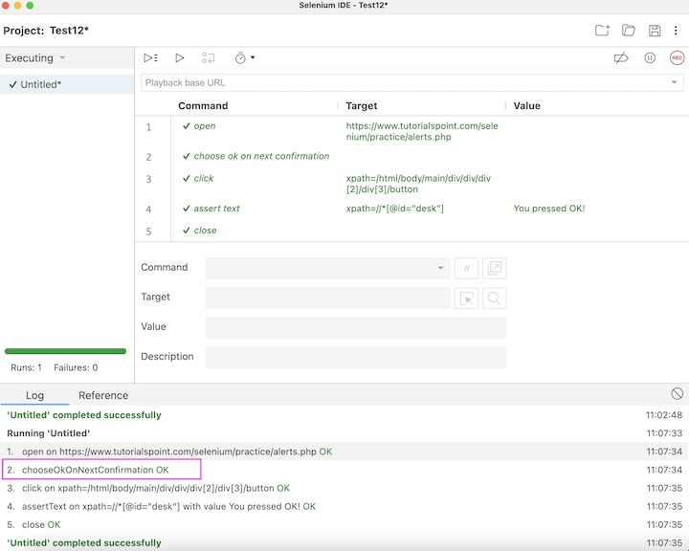
In the example above, we had launched the application with an open command and clicked on the OK button on the confirmation dialogue. Besides, we got a green tick at the top, signifying a passed test.
This concludes our comprehensive take on the tutorial on Selenium IDE - Alerts & Popups. Weve started with describing various commands to handle alerts and popups and examples to walk through how to use these commands along with Selenium.
This equips you with in-depth knowledge of the Alerts & Popups in Selenium IDE. It is wise to keep practicing what youve learned and exploring others relevant to Selenium to deepen your understanding and expand your horizons.

Selenium IDE - Selenese Commands

Previous
Quiz
Next
Every command used in Selenium IDE is known as the Selenese commands. Using the Selenese commands we perform all the testing activities on a web application. Selenese commands are of three types −
- Actions Command
- Accessors Command
- Assertions Command
Thus Selenese is a language which is used to create test automation using Selenium IDE. We can also define Selenese in Selenium IDE commands. These Selenese commands can be used extensively to test the functionalities of the web applications.
Basic Actions Commands
The action commands are used to manipulate the state of the application under test. There various types of actions commands available in Selenium IDE.
- click(locator)
- check(locator)
- uncheck(locator)
- choose cancel on next confirmation
- choose cancel on next prompt
- choose ok on next confirmation
- click At(locator, coordinateString)
- close
- debugger
- double click(locator)
- double click at(locator)
- drag and drop to object(source locator, destination locator)
- echo(message)
- edit content(locator, value)
- execute script(script, variable name)
- execute async script(script, variable name)
- mouse down(locator)
- mouse down at(locator, coordinateString)
- mouse move at(locator, coordinateString)
- mouse out(locator)
- mouse over(locator)
- mouse up(locator)
- mouse up at(locator, , coordinateString)
- open(url)
- pause(wait time)
- remove selection(locator, option)
- run(test case)
- select(locator, option)
- select frame(locator)
- select window(window handle)
- set window size(resolution)
- type(locator)

Basic Accessors Commands
The accessors commands are used to manipulate the state of the application under test.
The following are the accessors command −
- store(text, variable)
- store attribute(locator, variable)
- store text(locator, variable)
- store title(text, variable)
- store value(locator, variable)
- store window handle(window handle)
- store xpath count(xpath, variable)
Basic Assertions Commands
The assertion commands are used to check the state of the application under test. There various types of assertions commands available in Selenium IDE.
- assert(variable, expected value)
- assert alert(alert text)
- assert checked(locator)
- assert confirmation(text)
- assert editable(locator)
- assert element present(locator)
- assert element not present(locator)
- assert not checked(locator)
- assert not editable(locator)
- assert not selected value(locator, text)
- assert not text(locator, text)
- assert prompt(text)
- assert selected value(locator, text)
- assert selected label(locator, text)
- assert text(locator, text)
- assert title(text)
- assert value(locator, text)
- verify(variable, expected value)
- verify checked(locator)
- verify editable(locator)
- verify element present(locator)
- verify element not present(locator)
- verify not editable(locator)
- verify not selected value(locator, text)
- verify not text(locator, text)
- verify selected label(locator, text)
- verify selected value(locator, text)
- verify text(locator, text)
- verify value(locator, text)
- wait for element editable(locator, wait time)
- wait for element not editable(locator, wait time)
- wait for element not present(locator, wait time)
- wait for element not visible(locator, wait time)
- wait for element present(locator, wait time)
- wait for element visible(locator, wait time)
Example
Let us take an example of the below page, where we would capture the page title Selenium Practice - Radio Button taking the help of the accessors commands. Then click on the radio button beside the Yes label using the actions commands.
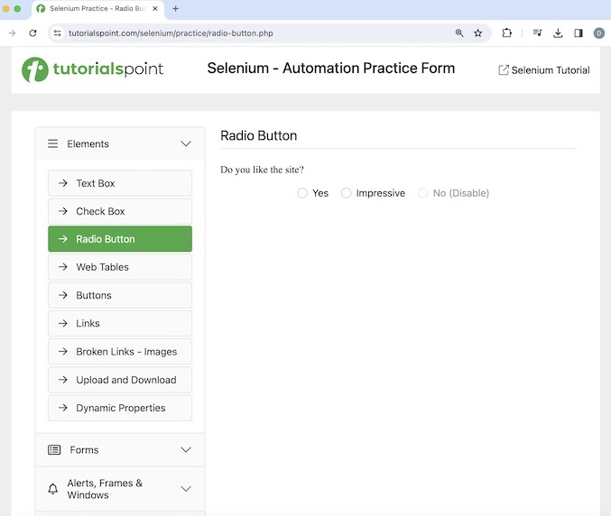
After selecting the radio button, we would get the text - You have checked Yes, which we would verify using the assertions command.
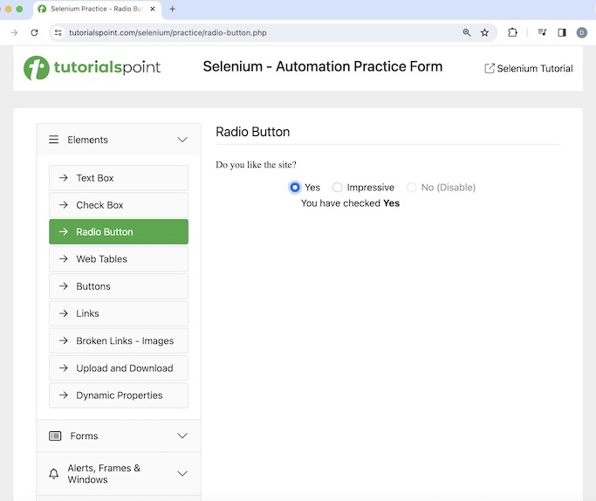
The steps to be followed are listed below −
Step 1 − Click on the Selenium IDE extension visible on the browser after its installation.
Step 2 − Selenium IDE should be launched along with it, a welcome message should be displayed with the version of the tool. In the below image, the version installed is 3.17.2.
Along with this, it gives us the option to select what we would like to do with the tool, like Record a new test in a new project, Open an existing project, Create a new project, and Close Selenium IDE.
Also, a link with the text - the Selenium IDE project page is provided, which on clicking would land us to the Selenium Integrated Development Environment documentation page.
https://www.selenium.dev/selenium-ide/.

Step 3 − Click on the Create a new project link, then enter a project name, say, Test8 under the Please provide a name for your new project. Finally, we would click on the OK button.
Step 4 − We would have the workspace ready in the Selenium IDE now.
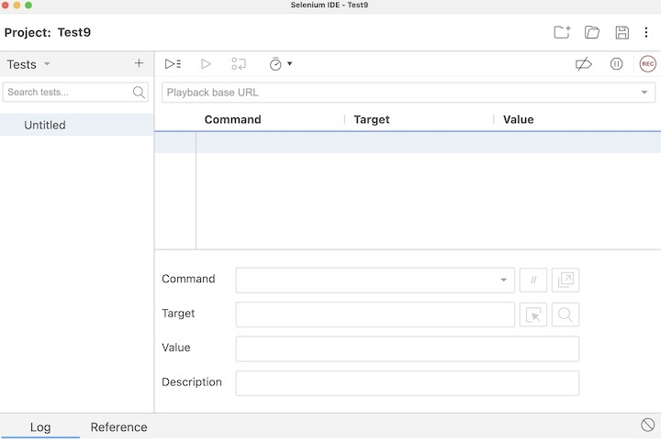
Step 5 − Enter open in the Command field, and Selenium Automation Practice Form in the Target field, to launch the application.
Step 6 − Enter store title in the Command field, and pageTitle in the Value field. Please note, pageTitle is variable to capture the title of the page launched.
Step 7 − Enter echo in the Command field, ${pageTitle} in the Target field. Please note, this would print the text we obtained in Step6 under the Log in Selenium IDE.
Step 8 − Enter click in the Command field, xpath=/html/body/main/div/div/div[2]/form/div[1]/input in the Target field. Please note, xpath=/html/body/main/div/div/div[2]/form/div[1]/input is the locator value of the radio button.
Step 9 − Enter assert element present in the Command field, xpath=//*[@id="check"] in the Target field. Please note, xpath=//*[@id="check"] is the locator value of the text - You have checked Yes.
Step 10 − Enter close in the Command field to close the browser window.
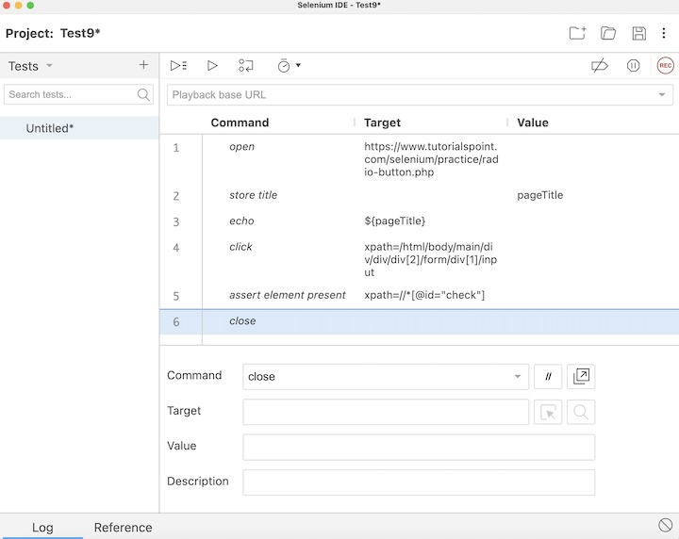
Step 11 − Click on the three dots appearing at the left pane, then select the Rename option.
Step 12 − Enter a name, say Test9 under the Rename Test case field, then click on Rename. The entered name would appear on the left of Selenium IDE.
Step 13 − Click on the Run all tests from the top, and wait for the test execution to complete. In our example, we would see Runs: 1, Failures: 0, and a green bar denoting the test ran successfully without any failures. Also, the message that the completed successfully appeared under the Log.
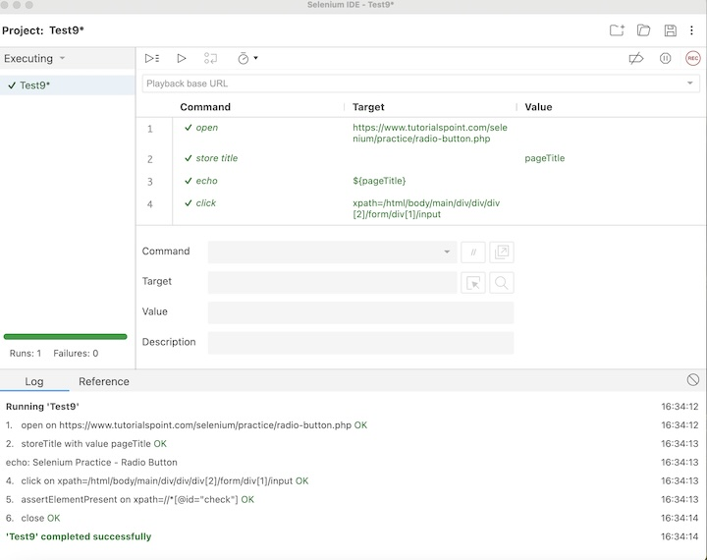
In the example above, we had launched the application with open command and obtained the page title Selenium Practice - Radio Button under the Log with the help of the store title command. We clicked on the radio button using the click command and verified the text - You have checked Yes with the help of the assert element present command. Besides, we got a green tick beside the test case name - Test9 at the top, signifying a passed test.
This concludes our comprehensive take on the tutorial on Selenium IDE - Selenese Commands. Weve started with describing a Selenese command, and various accessors, actions, and assertions commands and an example to walk through how to use the Selenese commands along with Selenium.
This equips you with in-depth knowledge of the Selenese commands in Selenium IDE. It is wise to keep practicing what youve learned and exploring others relevant to Selenium to deepen your understanding and expand your horizons.

Selenium IDE - Actions Commands

Previous
Quiz
Next
All commands in Selenium IDE are known as the Selenese commands. With the help of the Selenese Commands we perform every activity on a web application. Selenese commands are of three types −
- Actions
- Accessors
- Assertions
Basic Actions Commands
The various types of action commands are listed below −
- click(locator) − This command is used to click on a link, button, checkbox or radio button.
- check(locator) − This command is used to check a radio button or checkbox.
- uncheck(locator) − This command is used to uncheck a radio button or checkbox.
- choose cancel on next confirmation − This command is used to deal with the next confirmation alert. It will cancel it.
- choose cancel on next prompt − This command is used to deal with the next alert prompt . It will cancel it.
- choose ok on next confirmation − This command is used to deal with the next confirmation alert. It will accept it.
- click At(locator, coordinateString) − This command is used to click on a link, button, checkbox or radio button at a specific location.
- close − This command is used to close the current window.
- debugger − This command is used to pause test execution for debugging tests.
- double click(locator) − This command is used to double click on a link, button, checkbox or radio button.
- double click at(locator) − This command is used to double click on a link, button, checkbox or radio button at a specific location.
- drag and drop to object(source locator, destination locator) − This command is used to drag an element from the source locator to the destination locator.
- echo(message) − This command is used to print the message. It is most commonly used for debugging purposes.
- edit content(locator, value) − This command is used to enter the value of an editable web element.
- execute script(script, variable name) − This command is used to execute a JavaScript command within the window or frame in focus.
- execute async script(script, variable name) − This command is used to execute an async JavaScript command within the window or frame in focus.
- mouse down(locator) − This command is used to simulate pressing the left mouse button by user(without release).
- mouse down at(locator, coordinateString) − This command is used to simulate pressing the left mouse button by user(without release) at a specific location.
- mouse move at(locator, coordinateString) − This command is used to simulate pressing the mouse button by the user at a specific location.
- mouse out(locator) − This command is used to simulate moving the pointer of the mouse away by user.
- mouse over(locator) − This command is used to simulate mouse hovering on an element identified by the locator.
- mouse up(locator) − This command is used to simulate release of the mouse button.
- mouse up at(locator, , coordinateString) − This command is used to simulate release of mouse button at a specific location.
- open(url) − This command is used to open a url and wait for the page to load.
- pause(wait time) − This command is used to stop the execution for some time.
- remove selection(locator, option) − This command is used to deselect an option in a multi-select dropdown.
- run(test case) − This command is used to run a test case.
- select(locator, option) − This command is used to select an option in a dropdown.
- select frame(locator) − This command is used to select a frame within the window in focus.
- select window(window handle) − This command is used to select a popup window with the help of the window handle id.
- set window size(resolution) − This command is used to specify the window size of the browser along with the browser interface.
- type(locator) − This command is used to enter text in an input box.
Example
Let us take an example of the below page, where we would launch the application and enter text Selenium in the input box near Name: using the action commands open, type, and close.
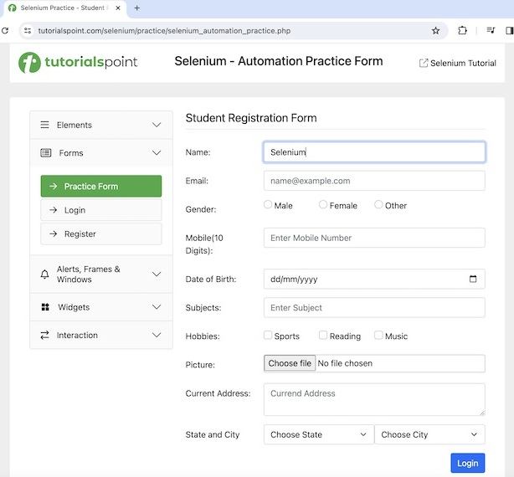
The steps to be followed are listed below −
Step 1 − Go through the Steps 1 to 4 as described in the link Selenium IDE Store Variables.
Step 2 − The workspace is ready in the Selenium IDE now.
Step 3 − Enter open in the Command field, and Selenium Automation Practice Form in the Target field, to launch the application.
Step 4 − Enter type in the Command field, id=name in the Target field, and Selenium in the Value field. Please note, id=name is the locator value of the input box and Selenium is the value to be entered.
Step 5 − Enter close in the Command field to close the browser window.
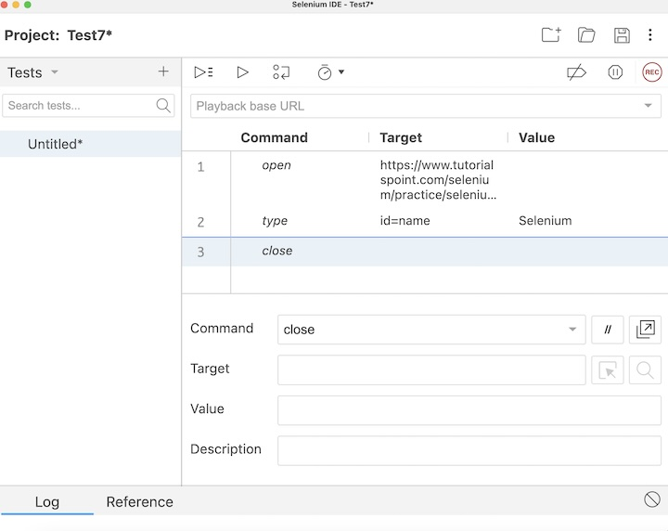
Step 6 − Click on the three dots appearing at the left pane, then select the Rename option.
Step 7 − Enter a name, say Test7 under the Rename Test case field, then click on Rename. The entered name would appear on the left of Selenium IDE.
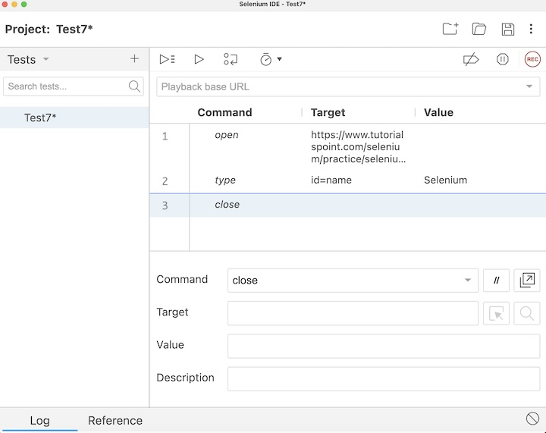
Step 8 − Click on the Run all tests from the top, and wait for the test execution to complete. In our example, we would see Runs: 1, Failures: 0, and a green bar denoting the test ran successfully without any failures. Also, the message Test7 completed successfully appeared under the Log.
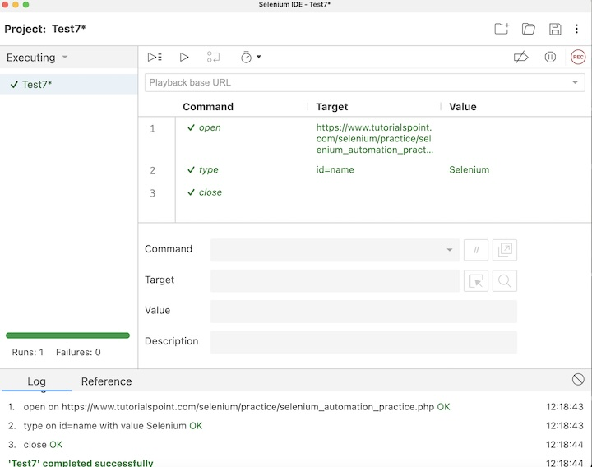
In the example above, we entered the text Selenium in the input box using the id locator beside the First Name: label which appeared under the Log. Besides, we got a green tick beside the test case name - Test7 at the top, signifying a passed test. All these were performed successfully using the actions commands like open, type, and close.

Conclusion
This concludes our comprehensive take on the tutorial on Selenium IDE Actions Commands. Weve started with describing various actions commands and an example to walk through how to use the actions commands along with Selenium. This equips you with in-depth knowledge of the actions commands in Selenium IDE. It is wise to keep practicing what youve learned and exploring others relevant to Selenium to deepen your understanding and expand your horizons.

Selenium IDE - Accessors Commands

Previous
Quiz
Next
Selenium IDE consists of three kinds of commands known as the Actions, Accessors, and Assertions. An accessor command is used to check the application state and then store the outcome in a variable.
How to get the Accessors Command?
We can get hold of the Accesor commands in Selenium IDE, by entering the store within the Command field. Once entered, all the commands related to the store will be available for selection.
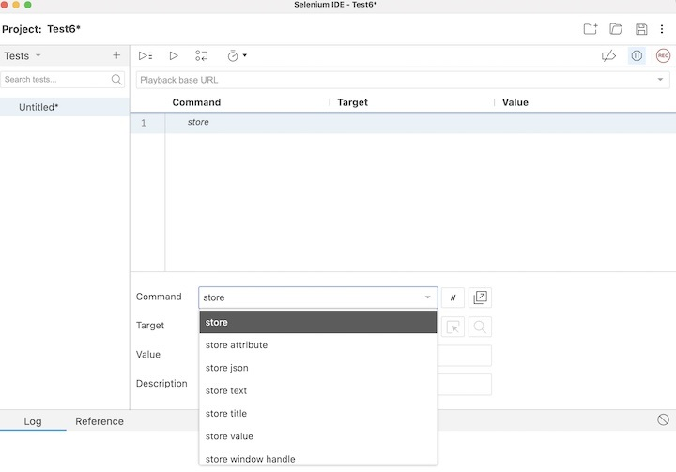
Example 1
Let us take an example of the below page, where we would enter the text Selenium beside the First Name: label and Tutorialspoint beside Last Name: label. Also, we would obtain the text Selenium - Automation Practice Form using the Selenium IDE taking the help of the Accessors commands.
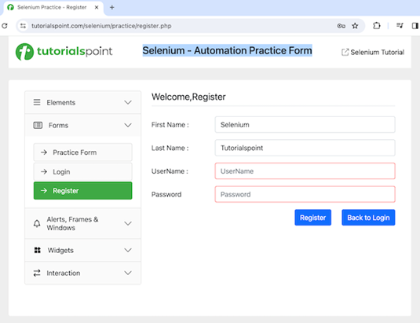
The steps to be followed are listed below −
Step 1 − Repeat the Steps 1 to 4 as described in the link Selenium IDE Store Variables.
Step 2 − The workspace is now ready in the Selenium IDE.
Step 3 − Enter open in the Command field, and Selenium Automation Practice Form in the Target field, to launch the application.
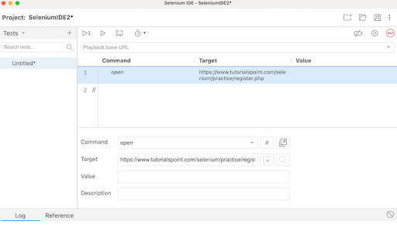
Step 4 − Enter store in the Command field, Selenium in the Target field, and i in the Value field. Please note, Selenium is the value we would like to enter using the variable i.
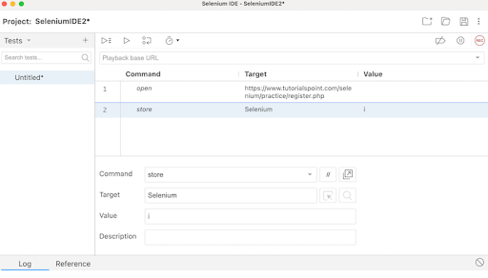
Step 5 − Enter type in the Command field, id=firstname in the Target field, and ${i} in the Value field. Please note, id=firstname is the locator value of the input box and ${i} is used to refer to the variable value we would enter using the variable i.
Step 6 − Enter store in the Command field, Tutorialspoint in the Target field, and j in the Value field. Please note, Tutorialspoint is a value we would like to enter using the variable j.
Step 7 − Enter type in the Command field, id=lastname in the Target field, and ${j} in the Value field. Please note, id=lastname is the locator value of the input box and ${j} is used to refer to the variable value we would enter using the variable j.

Step 8 − Enter store Text in the Command field, css=div > h1 in the Target field, and k in the Value field. Please note, css=div > h1 is the locator value of the text that we would obtain and k is used to refer to the variable value where we would store the text obtained.
Step 9 − Enter echo in the Command field, ${k} in the Target field. Please note, this would print the text we accessed in Step10 on the web page under the Log in Selenium IDE.

Step 10 − Enter store value in the Command field, id=firstname in the Target field, and l in the Value field. Please note, id=firstname is the locator value of the input box and l is used to refer to the variable we would use to obtain the value entered in the input box.
Step 11 − Enter echo in the Command field, ${l} in the Target field. Please note, this would print the value entered in Step7 on the web page under the Log in Selenium IDE.

Step 12 − Enter close in the Command field to close the browser window.

Step 13 − Click on the three dots appearing at the left pane, then select the Rename option.

Step 14 − Enter a name, say TestCase2 under the Rename Test case field, then click on Rename. The entered name would appear on the left of Selenium IDE.

Step 15 − Click on the Run all tests from the top, and wait for the test execution to complete. In our example, we would see Runs: 1, Failures: 0, and a green bar denoting the test ran successfully without any failures. Also, the message TestCase2 completed successfully appeared under the Log.

In the example above, we obtained the text Selenium - Automation Practice Form which appeared on the web page, and also retrieved the value entered in the input box beside the First Name: label - Selenium under the Log. Besides, we got a green tick beside the test case name - TestCase2 at the top, signifying a passed test.
Thus, in Selenium IDE, we would get the information about the test results both at the test step level and only if all the steps would be executed successfully, we would get a PASS at the test case level as well.
Moreover, we would infer that variables used in one step can be accessed further in other steps using the syntax: ${<variable name>}. In the Steps 6, 7, 8, 9, 10, 11, 12, and 13, we followed this approach in our test. Also, we had used store and store related commands like store Text, store Value, and so on to store the variables. The echo command was used to print those values under the Log tab.

Example 2
Let us take another example of the below page, where we would capture the page title Selenium Practice - Radio Button taking the help of the Accessors commands.
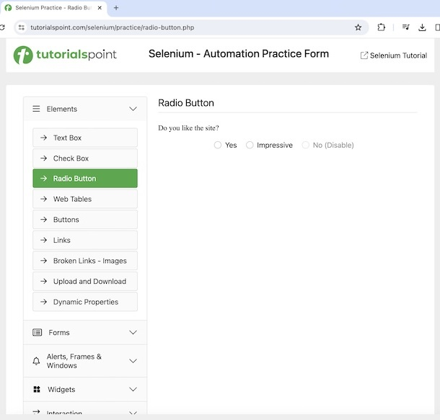
The steps to capture the browser title are listed below −
Step 1 − Follow steps 1 to 4 from the previous example.
Step 2 − Enter open in the Command field, and Selenium Automation Practice Form in the Target field, to launch the application.
Step 3 − Enter store title in the Command field, and pageTitle in the Value field. Please note, pageTitle is variable to capture the title of the page launched.
Step 4 − Enter echo in the Command field, ${pageTitle} in the Target field. Please note, this would print the text we obtained in Step3 under the Log in Selenium IDE.
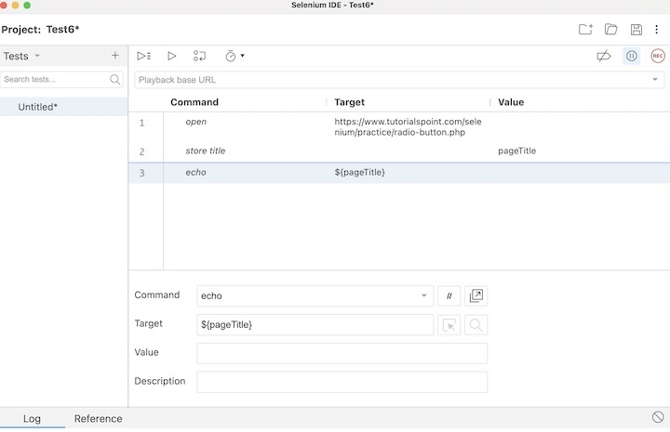
Step 5 − Follow steps 14 to 17 from the previous example.
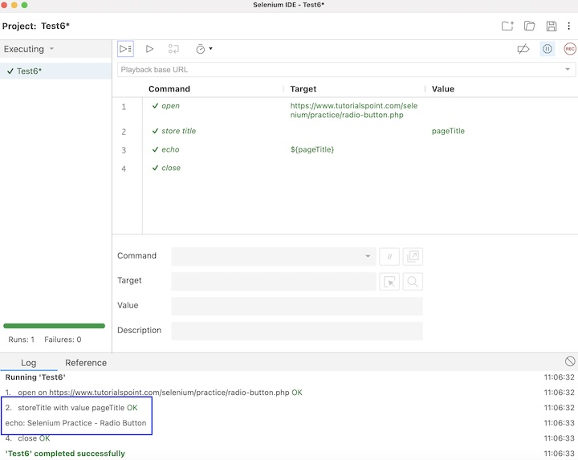
In the example above, we obtained the page title Selenium Practice - Radio Button under the Log. Besides, we got a green tick beside the test case name - Test6 at the top, signifying a passed test.
Moreover, we would infer that variables used in one step can be accessed further in other step using the syntax: ${<variable name>}. In the Steps 2, and 3, we followed this approach in our test along with the store title command to get the page. The echo command was used to print that value under the Log tab.

Conclusion
This concludes our comprehensive take on the tutorial on Selenium IDE Accessors Commands. Weve started with describing how to access Accessor commands in Selenium IDE, and walked through the different Accessor commands like store, store text, store title, and so on and illustrated how to use them along with Selenium. This equips you with in-depth knowledge of the Accessors Commands in Selenium IDE. It is wise to keep practicing what youve learned and exploring others relevant to Selenium to deepen your understanding and expand your horizons.

Selenium IDE - Assertions Commands

Previous
Quiz
Next
All commands in Selenium IDE are called the Selenese. With the help of the Selenese commands, all actions can be performed on the web application. Selenese commands are of multiple variants −
- Actions − The action commands are used to change the state of the application. For example, close, click, type, open, and so on.
- Accessors − The accessor commands are used to gauge the state of the application and store it in variables. For example, store, store title, store text, store value, and so on.
- Assertions − The assertion commands are used to verify the state of the application. It has sub-types like the assert, verify, and waitfor.
Basic Assertions Commands
The various types of assertions commands are listed below −
- assert(variable, expected value) − This command is used to verify if the variable is matching the expected value. The variable is converted to string for comparison. If assert did not pass, then the execution will stop at the point of mismatch.
- assert alert(alert text) − This command is used to verify if an alert has the text matching the alert text. If assert did not pass, then the execution will stop at the point of mismatch.
- assert checked(locator) − This command is used to verify if the target element with the locator value is checked. If assert did not pass, then the execution will stop at the point of mismatch.
- assert confirmation(text) − This command is used to verify if a confirmation has been rendered. If assert did not pass, then the execution will stop at the point of mismatch.
- assert editable(locator) − This command is used to verify if the target element with the locator value is editable. If assert did not pass, then the execution will stop at the point of mismatch.
- assert element present(locator) − This command is used to verify if the target element with the locator value is available on the web page. If assert did not pass, then the execution will stop at the point of mismatch.
- assert element not present(locator) − This command is used to verify if the target element with the locator value is not available on the web page. If assert did not pass, then the execution will stop at the point of mismatch.
- assert not checked(locator) − This command is used to verify if the target element with the locator value is not checked. If assert did not pass, then the execution will stop at the point of mismatch.
- assert not editable(locator) − This command is used to verify if the target element with the locator value is not editable. If assert did not pass, then the execution will stop at the point of mismatch.
- assert not selected value(locator, text) − .This command is used to verify if the value attribute of the selected option of the target dropdown element does not have the given text. If assert did not pass, then the execution will stop at the point of mismatch.
- assert not text(locator, text) − This command is used to verify if the target element with the locator value does not have the given text.
- assert prompt(text) − This command is used to verify if a prompt has been rendered. If assert did not pass, then the execution will stop at the point of mismatch.
- assert selected value(locator, text) − This command is used to verify if the value attribute of the selected option of the target dropdown element has the given text. If assert did not pass, then the execution will stop at the point of mismatch.
- assert selected label(locator, text) − This command is used to verify if the label of the selected option of the target dropdown element has the given text. If assert did not pass, then the execution will stop at the point of mismatch.
- assert text(locator, text) − This command is used to verify if the target element with the locator value has the given text. If assert did not pass, then the execution will stop at the point of mismatch.
- assert value(locator, text) − This command is used to verify the value of an edit box. For a radio button/checkbox, the value will be set to on/off provided it is selected or not. If assert did not pass, then the execution will stop at the point of mismatch.
- verify(variable, expected value) − This command is used to verify if the variable is matching the expected value. The variable is converted to string for comparison. It is a soft assert and execution will not stop in case of a mismatch.
- verify checked(locator) − This command is used to verify if the target element with the locator value is checked. It is a soft assert and execution will not stop in case of a mismatch.
- verify editable(locator) − This command is used to verify if the target element with the locator value is editable. It is a soft assert and execution will not stop in case of a mismatch.
- verify element present(locator) − This command is used to verify if the target element with the locator value is available on the web page. It is a soft assert and execution will not stop in case of a mismatch.
- verify element not present(locator) − This command is used to verify if the target element with the locator value is not available on the web page. It is a soft assert and execution will not stop in case of a mismatch.
- verify not editable(locator) − This command is used to verify if the target element with the locator value is not editable. It is a soft assert and execution will not stop in case of a mismatch.
- verify not selected value(locator, text) − This command is used to verify if the value attribute of the selected option of the target dropdown element does not have the given text. It is a soft assert and execution will not stop in case of a mismatch.
- verify not text(locator, text) − This command is used to verify if the target element with the locator value does not have the given text. It is a soft assert and execution will not stop in case of a mismatch.
- verify selected label(locator, text) − This command is used to verify if the label of the selected option of the target dropdown element has the given text. It is a soft assert and execution will not stop in case of a mismatch.
- verify selected value(locator, text) − This command is used to verify if the value attribute of the selected option of the target dropdown element has the given text. It is a soft assert and execution will not stop in case of a mismatch.
- verify text(locator, text) − This command is used to verify if the target element with the locator value has the given text. It is a soft assert and execution will not stop in case of a mismatch.
- assert title(text) − This command is used to verify if the alert generated has the given alert text. If assert did not pass, then the execution will stop at the point of mismatch.
- verify value(locator, text) − This command is used to verify the value of an edit box. For a radio button/checkbox, the value will be set to on/off provided it is selected or not. It is a soft assert and execution will not stop in case of a mismatch.
- wait for element editable(locator, wait time) − This command is used to wait for the given wait time(in milliseconds) for the target element with the locator value to be editable.
- wait for element not editable(locator, wait time) − This command is used to wait for the given wait time(in milliseconds) for the target element with the locator value not to be editable.
- wait for element not present(locator, wait time) − This command is used to wait for the given wait time(in milliseconds) for the target element with the locator value to be unavailable on the web page.
- wait for element not visible(locator, wait time) − This command is used to wait for the given wait time(in milliseconds) for the target element with the locator value to be invisible on the web page.
- wait for element present(locator, wait time) − This command is used to wait for the given wait time(in milliseconds) for the target element with the locator value to be available on the web page.
- wait for element visible(locator, wait time) − This command is used to wait for the given wait time(in milliseconds) for the target element with the locator value to be visible on the web page.
Example
Let us take an example of the below page, where we would click on the Created link.
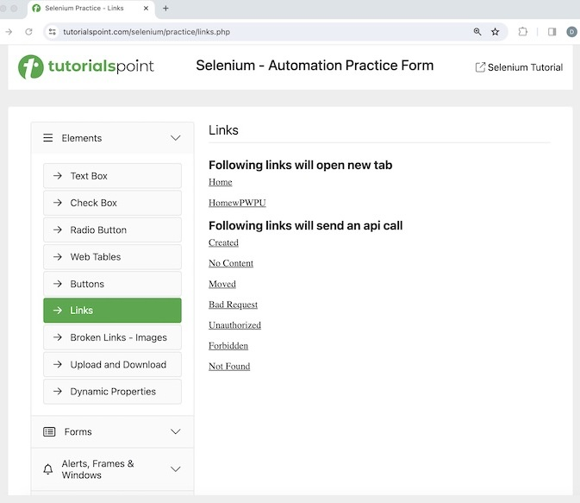
We would verify its page title which is Selenium Practice - Links. After clicking the Created link, we would also verify the text - Link has responded with status 201 and status text Created.
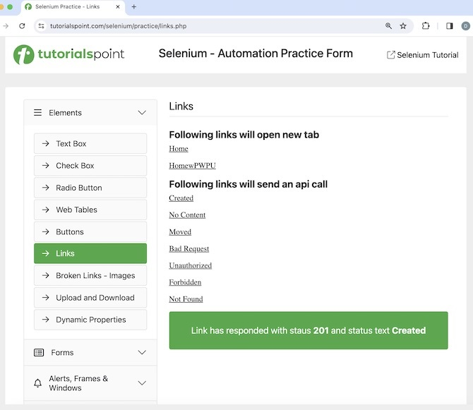
The steps to be followed are listed below −
Step 1 − Perform the Steps 1 to 4 as described in the link Selenium IDE Store Variables
Step 2 − Enter open in the Command field, and Selenium Automation Practice Form in the Target field, to launch the application.
Step 3 − Enter verify title in the Command field and Selenium Practice - Links in the Target field.
Step 4 − Enter click in the Command field, xpath=//*[@id="created"] in the Target field. Please note, xpath=//*[@id="created"] is the locator value of the link.
Step 5 − Enter wait for element visible in the Command field, xpath=/html/body/main/div/div/div[2]/div[1] in the Target field and 30000 in the Value field. Please note, xpath=/html/body/main/div/div/div[2]/div[1] is the locator value of the text to be visible.
Step 6 − Enter assert text in the Command field, xpath=/html/body/main/div/div/div[2]/div[1] in the Target field and Link has responded with status 201 and status text Created in the Value field. Please note, xpath=/html/body/main/div/div/div[2]/div[1] is the locator value of the text.
Step 7 − Enter close in the Command field to close browser.
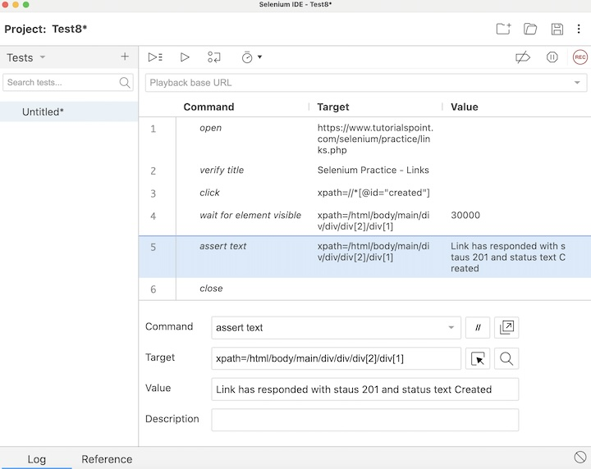
Step 8 − Click on Run all tests from the top, and hold back for the test execution to end.
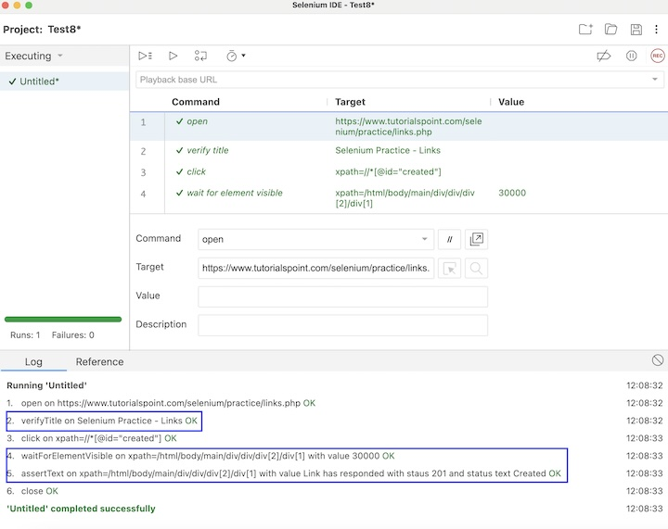
In the example above, we had launched the application and verified its page title Selenium Practice - Links using the assertions command verify title. Then clicked on the Created link, and waited for text Link has responded with status 201 and status text Created to be visible with the assertion command wait for element visible and verified the text with another assertion command assert text.

Conclusion
This concludes our comprehensive take on the tutorial on Selenium IDE Assertion Commands. Weve started with describing various assertions commands and an example to walk through how to use the assertions commands along with Selenium. This equips you with in-depth knowledge of the assertions commands in Selenium IDE. It is wise to keep practicing what youve learned and exploring others relevant to Selenium to deepen your understanding and expand your horizons.

Selenium IDE - Assert/Verify Methods

Previous
Quiz
Next
Selenium IDE uses assert and verify methods to check if a certain text, element, page title, and so on matches with the requirements. These two methods basically help us to conclude if a test has passed or failed based on the verification points added (in the form of assert and verify commands).
What is an Assert Command?
In Selenium IDE, an assert command is used to verify if a certain situation is matching with the specification document. In case, they are not matching, the test execution stops at the point of a mismatch.
Example with Assert Command
Let us take an example of the below page, where we would capture the page title Selenium Practice Radio Button and check if the correct page title is displayed using the assert command.
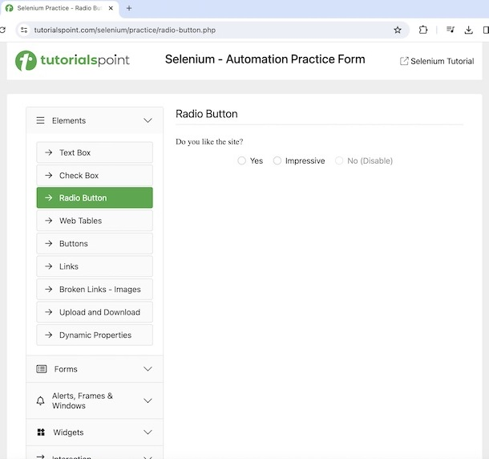
The steps to use an assert command are listed below −
Step 1 − Follow the Steps 1 to 4 as described in the link Selenium IDE Store Variables.
Step 2 − Enter open in the Command field, and Selenium Automation Practice Form in the Target field, to launch the application.
Step 3 − Enter store title in the Command field, and pageTitle in the Value field. Please note, pageTitle is variable to capture the title of the application launched.
Step 4 − Enter assert title in the Command field, ABC in the Target field. Please note, in this step we are verifying if the page tile is ABC.
Step 5 − Enter echo in the Command field, ${pageTitle} in the Target field. Please note, this would print the text we obtained in Step6 under the Log in Selenium IDE.
Step 6 − Enter close in the Command field to close the browser window.
Step 7 − Click on the three dots appearing at the left pane, then select the Rename option.
Step 8 − Enter a name, say Test6 under the Rename Test case field, then click on Rename. The entered name would appear on the left of Selenium IDE.
Step 9 − Click on the Run all tests from the top, and wait for the test execution to complete. In our example, we would see Runs: 1, Failures: 1, and a red bar denoting the test ran unsuccessfully with failures. Also, the message Test6 ended with 1 error(s) would appear under the Log.
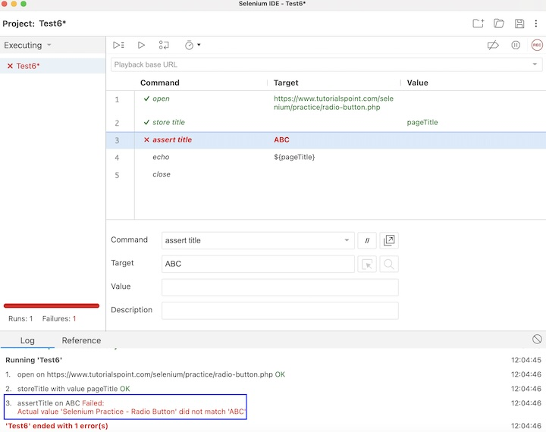
In the example above, we had obtained the page title which is Selenium Practice Radio Button. However, we had added the assert title command to check if the page title is equal to ABC. Hence the actual and the expected values did not match. Moreover, due to the assert command, the execution halted and the steps 4, and 5 did not execute.

What is a Verify Command?
In Selenium IDE, a verify command is also used to verify if a certain situation is matching with the specification document. In case, they are not matching, the test execution does not stop at the point of a mismatch. The error is captured at the Log in Selenium IDE and the steps after the error IS encountered also get executed.
Example with Verify Command
Let us take the same above example, where we would capture the page title Selenium Practice Radio Button and check if the correct page title is displayed using the verify command.
The steps to capture the browser title are listed below −
Step 1 − Follow the Steps 1 to 4 as described in the link Selenium IDE Store Variables.
Step 2 − Follow steps 2 and 3 from the previous example.
Step 3 − Enter verify title in the Command field, ABC in the Target field. Please note, in this step we are verifying if the page tile is ABC.
Step 4 − Follow steps 8,9, 10, 11, and 12 from the previous example.
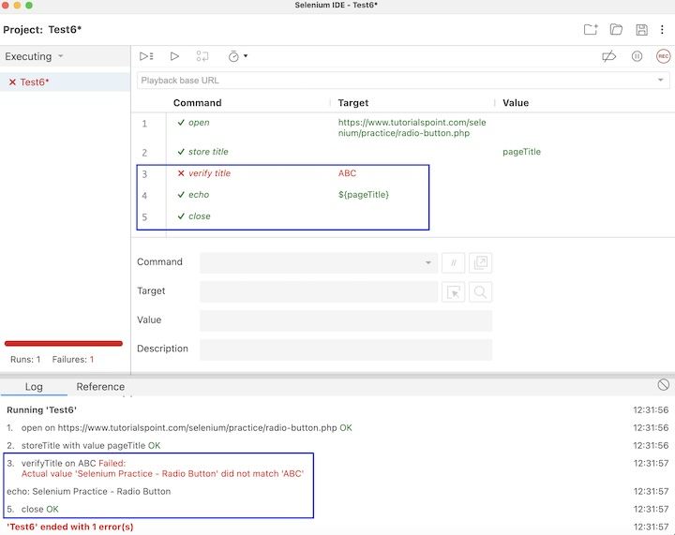
In the example above, we had obtained the page title which is Selenium Practice Radio Button. However, we had added the verify title command to check if the page title is equal to ABC. Hence the actual and the expected values did not match. Moreover, even after encountering failure in step3 the steps 4, and 5 executed and the execution did not stop in between, simultaneously, the error also got recorded under the Log.
Difference between Assert and Verify Commands
From the above examples, we can infer that both assert and verify commands can be used for verification purposes. But in case of errors encountered in a test, the execution stops at the failed step, and remaining steps do not get executed while assert command is used. However, the execution continued even after encountering a failed step, while we are using the verify command. The error encountered is also recorded under the Log in Selenium IDE for both the commands.
Conclusion
This concludes our comprehensive take on the tutorial on Selenium IDE Assert/Verify methods. Weve started with describing what is an assert and a verify command in Selenium IDE, and walked through examples having an assert command and a verify command, illustrated how to use them, and the basic differences between the two commands along with Selenium. This equips you with in-depth knowledge of the assert and verify methods in Selenium IDE. It is wise to keep practicing what youve learned and exploring others relevant to Selenium to deepen your understanding and expand your horizons.

Selenium IDE - Locating Strategies

Previous
Quiz
Next
Selenium IDE has multiple locating strategies which help to automate test cases. However, Selenium IDE can not identify elements on a web page by default. In order to locate elements, we would need the help of the locators like id, name, css, and xpath.
In addition to the above locators, the older versions of Selenium IDE supported other locators like DOM, and identifier, however, they are deprecated in the latest versions.
Example
Let us take an example of the below page, where we would enter the text Selenium beside the First Name: label. This can be achieved by first locating the elements using various locators.
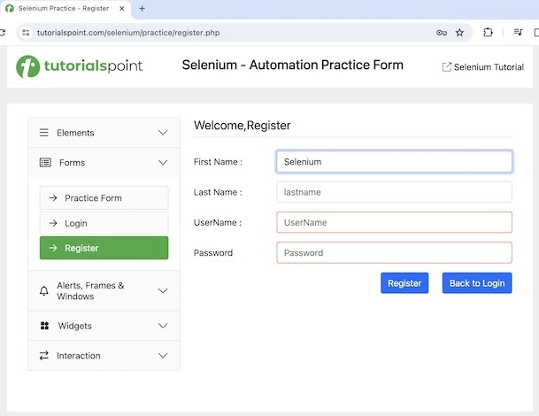

Identify Web Elements
Right click on the webpage, and click on the Inspect button in the Chrome browser, post this action the HTML code for the web page will be accessible. For inspecting an element on a page, click on the left upward arrow as highlighted below.
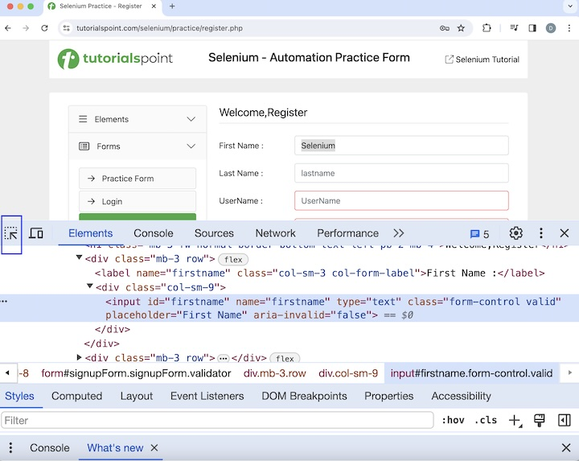
Once we had clicked and pointed the arrow to the input box(highlighted in the below image), its HTML code appeared.
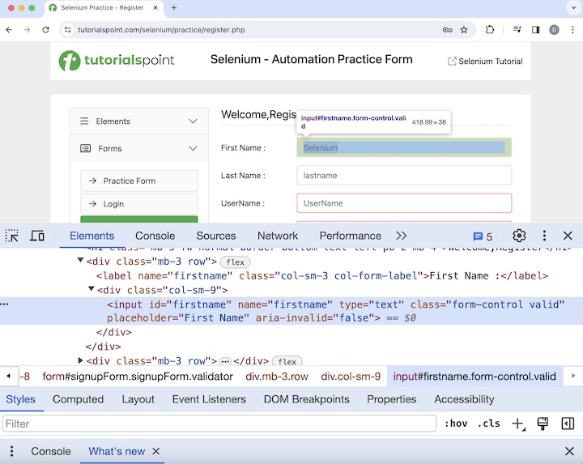
Features to Locate Element in Selenium IDE
Once a test would be created after recording in Selenium IDE, we would be able to get the details of any particular step in that test, by clicking on it. Click on the dropdown in the Target field, Selenium IDE while recording successfully captures all the locators like id, name, css, xpath, and so on for an element.
Click on the 4th step, having the values of Command, Target, and Value fields as type, id=name, and Selenium respectively. The other locator values like the name, css, and so on for that element were visible within the Target dropdown.

All the steps that we had performed on the application would be recorded in the Selenium IDE under the Command, Target, and Value fields with a REC button to the top right.
The section highlighted below image denotes the Text Script Editor Pane. It has all the user interactions that had been recorded in the form of test steps when the recording was enabled.

To identify a web element by default in Selenium IDE, click on the Select target in page button as highlighted in the below image.

After clicking the Select target in page button, the user would get the button Select an element on the web page. Once an element is selected, its locator value gets populated by the Selenium IDE.
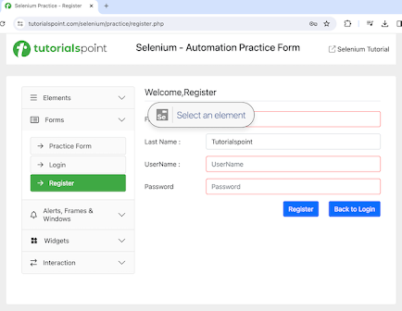
The corresponding locator value of the selected web element was generated in the Target. Then, if the Find target in page button is clicked, the element whose locator value is populated, gets highlighted on the page.

Please note that, the buttons - Find target in page, and Select target in page, become enabled only if we have a valid value in the Command field else they remain disabled as highlighted in the below image.

Locator ID
The steps to locate the input box using id locator and then enter the text Selenium in Selenium IDE are listed below −
Step 1 − Perform the Steps 1 to 4 of Storing and Accessing Variables.
Step 2 − Enter open in the Command field, and Selenium Automation Practice Form in the Target field, to launch the application.
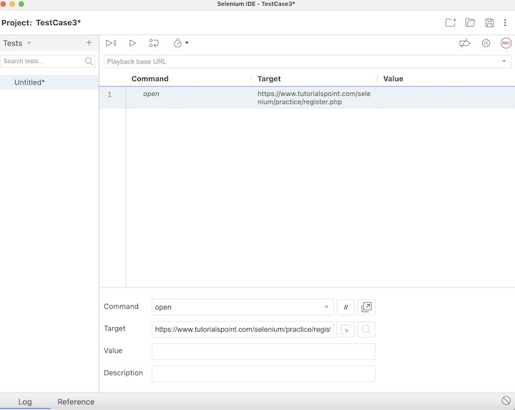
Step 3 − Enter type in the Command field, id=firstname in the Target field, and Selenium in the Value field. Please note, id=firstname is the id locator and its value as firstname for the input box and Selenium is the value to be entered.
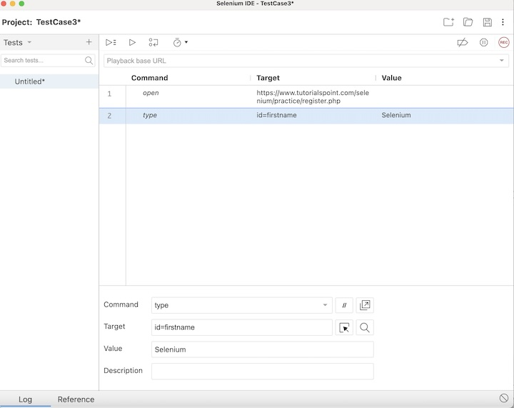
Step 4 − Enter close in the Command field to terminate the browser.
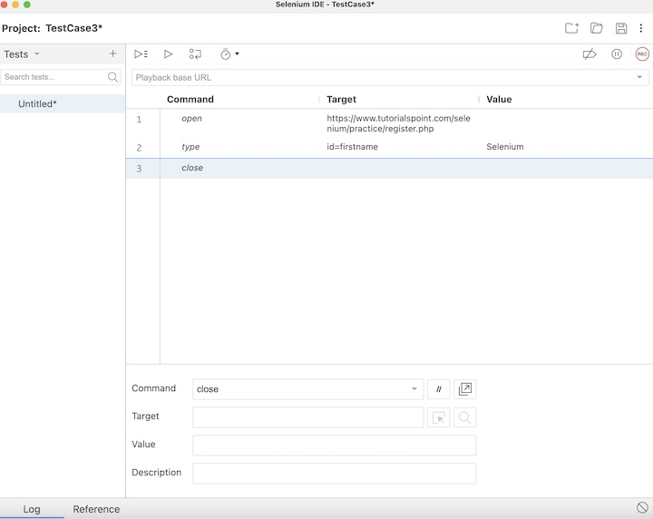
Step 5 − Click on the Run all tests button.
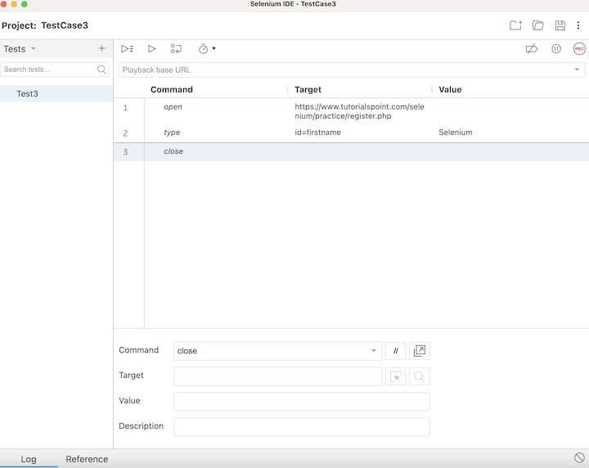
In the example above, we entered the text Selenium in the input box using the id locator beside the First Name: label which appeared under the Log. Besides, we got a green tick at the top, signifying a passed test
Locator Name
The steps to locate the input box using name locator and then enter the text Selenium in Selenium IDE are listed below −
Step 1 − Click on the second step created in the above example and enter type in the Command field, name=firstname in the Target field, and Selenium in the Value field. Please note, name=firstname is the name locator, and its value is firstname of the input box and Selenium is the value to be entered.
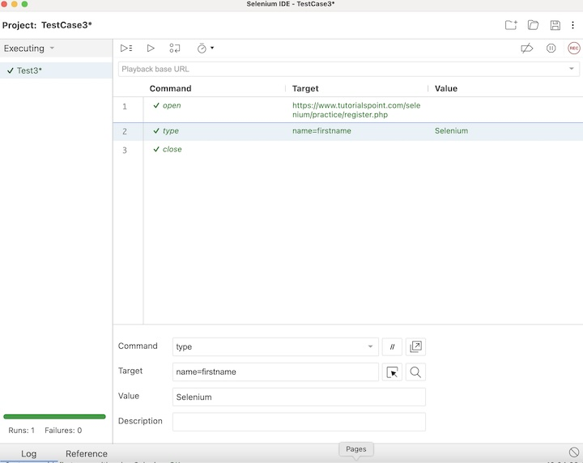
Step 2 − Click on Run all tests, and hold back for the test execution to finish.
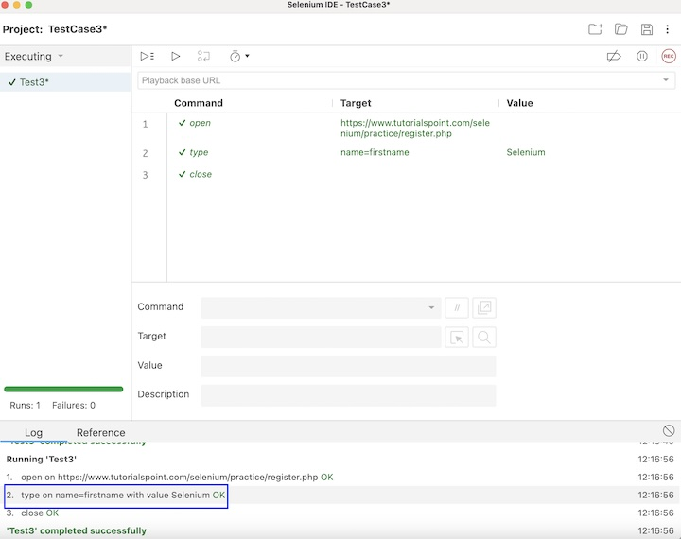
In the example above, we entered the text Selenium in the input box using the name locator beside the First Name: label which appeared under the Log.
Locator CSS
The steps to locate the input box using css locator and then enter the text Selenium in Selenium IDE are listed below −
Step 1 − Click on the second step created in the above example and enter type in the Command field, css=input#firstname in the Target field, and Selenium in the Value field. Please note, css=input#firstname is the css locator and its value is input#firstname for the input box and Selenium is the value to be entered.
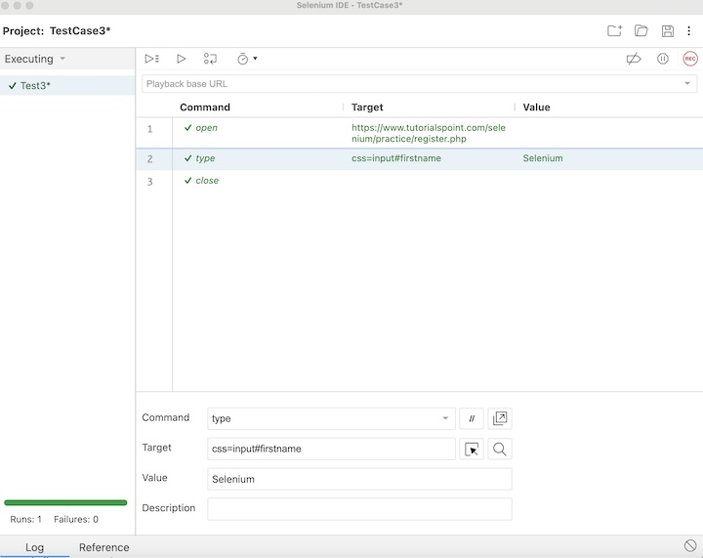
Step 2 − Click on Run all tests.
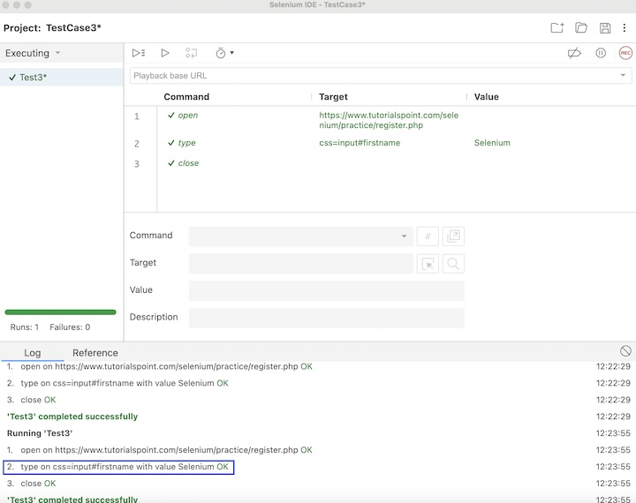
In the example above, we entered the text Selenium in the input box using the css locator beside the First Name: label which appeared under the Log.
Locator Xpath
The steps to locate the input box using xpath locator and then enter the text Selenium in Selenium IDE are listed below −
Step 1 − Click on the second step created in the above example and enter type in the Command field, xpath=//input[@id='firstname'] in the Target field, and Selenium in the Value field. Please note, xpath=//input[@id='firstname'] is the xpath locator and its value is //input[@id='firstname'] of the input box and Selenium is the value to be entered.
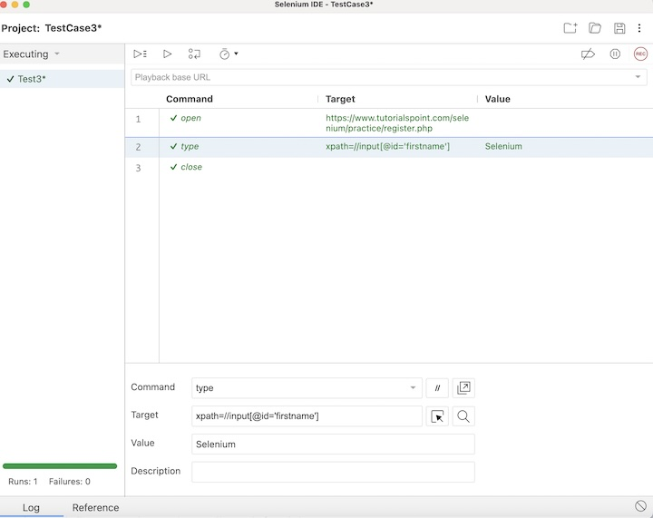
Step 2 − Click on Run all tests at the top.
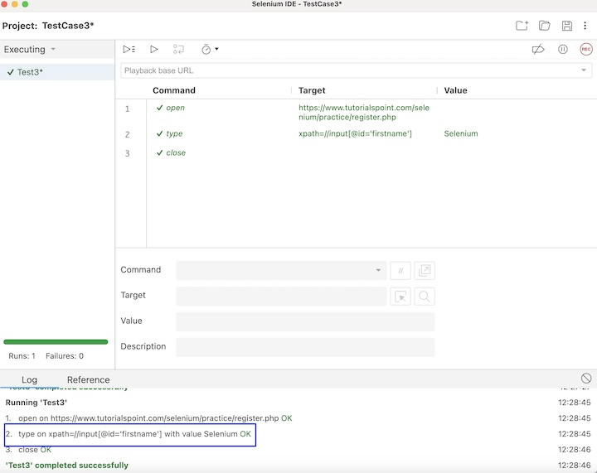
In the example above, we entered the text Selenium in the input box using the xpath locator beside the First Name: label which appeared under the Log.
Conclusion
This concludes our comprehensive take on the tutorial on Selenium IDE Locating Strategies. Weve started with describing an example and walked through the different locating strategies, and illustrated how to use them along with Selenium. This equips you with in-depth knowledge of the locating Strategies in Selenium IDE. It is wise to keep practicing what youve learned and exploring others relevant to Selenium to deepen your understanding and expand your horizons.

Selenium IDE - Script Debugging

Previous
Quiz
Next
Selenium IDE provides multiple script debugging options with the help of which we can troubleshoot scripts on failures, or for any other purposes. A debugging of a script is done to ensure that the script should run as it is intended to do by investigating and solving errors, if any.
There are multiple debugging techniques and features available in Selenium IDE.
Step-By-Step Execution
The Step over current command button allows you to run the test step by step and examine if something is not working.
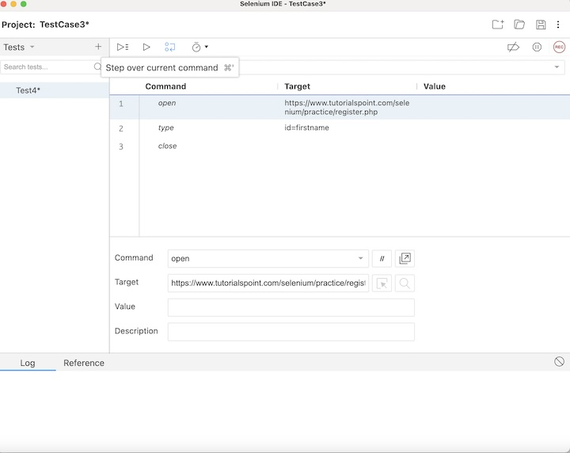
On clicking on this button repeatedly, we can see if any of the test steps are not working as expected. In the below image, the step 1 executed successfully, after we clicked the Step over current command button. Then Paused in debugger appeared along with the next step to be executed(here the step2) became yellow.
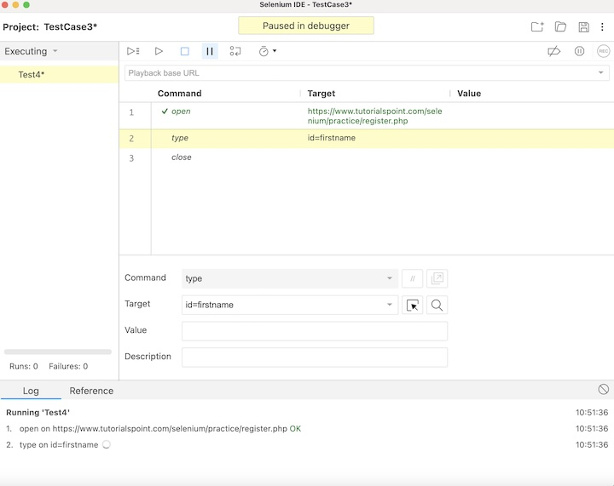
In the below image now it shows another button Resume test execution. We can also click on it and re-trigger the execution.
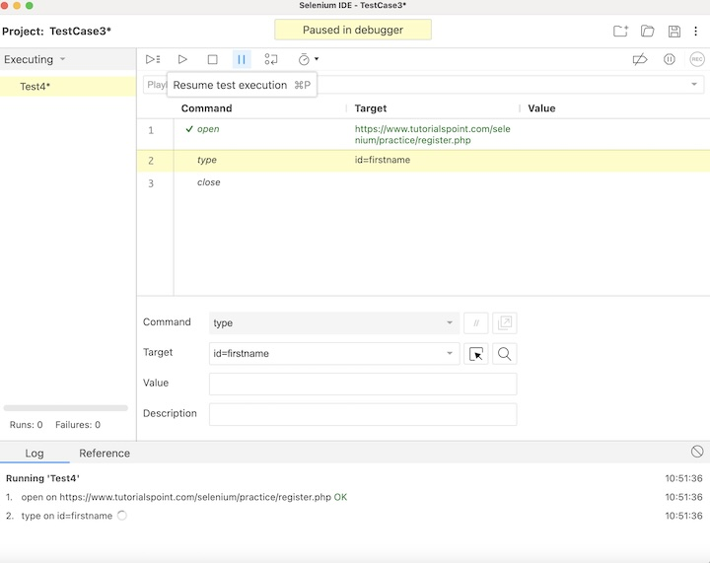
Once again when the Step over current command button is clicked, the step2 will be executed, and so on.
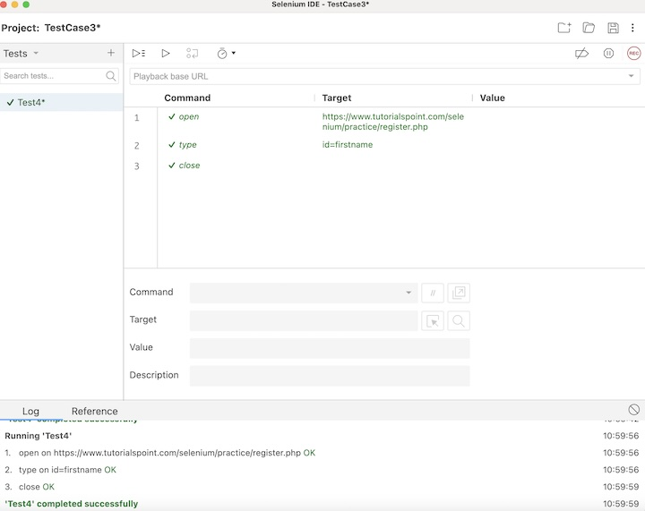
As the execution has been completed, we would get the message of the result. In case the test passed, we would get the message - <TEST NAME> completed successfully under the Log tab at the bottom of the Selenium IDE. Here, our test name is Test4, hence received the message - Test4 completed successfully.
Apart from that, all the test steps, along with the test case name turned green, reflecting a PASS for all the steps. All the steps which reflected under the Log tab, showed an OK in green.

Adding Breakpoints
We can click on the line numbers in the test to add breakpoints in order to debug test steps in Selenium IDE. In the below image, we have added breakpoints to line numbers 2, and 3 (highlighted in blue in Selenium IDE).
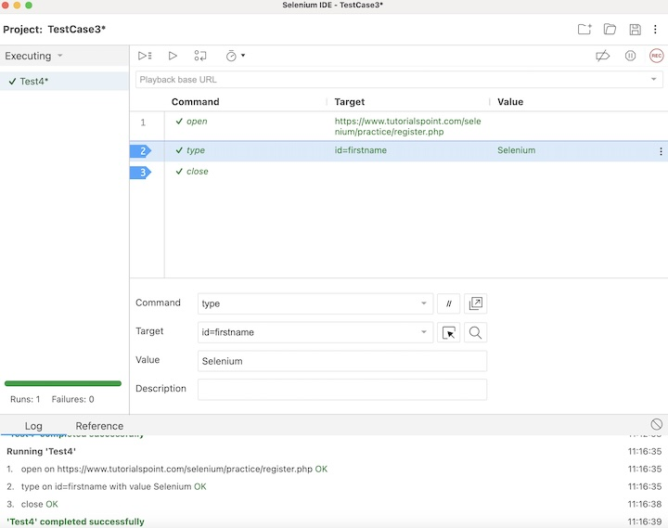
After which, when we run the test, the execution will first automatically stop in line 2. Then the Paused in debugger appeared along with the next step to be executed (here the step2) becomes yellow.
We will click again on the Step over current command button which will help us to continue with the next step of execution.
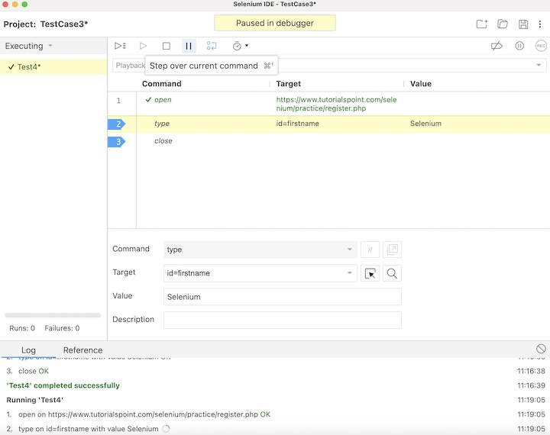
The same process will be repeated, once we move to the next step.
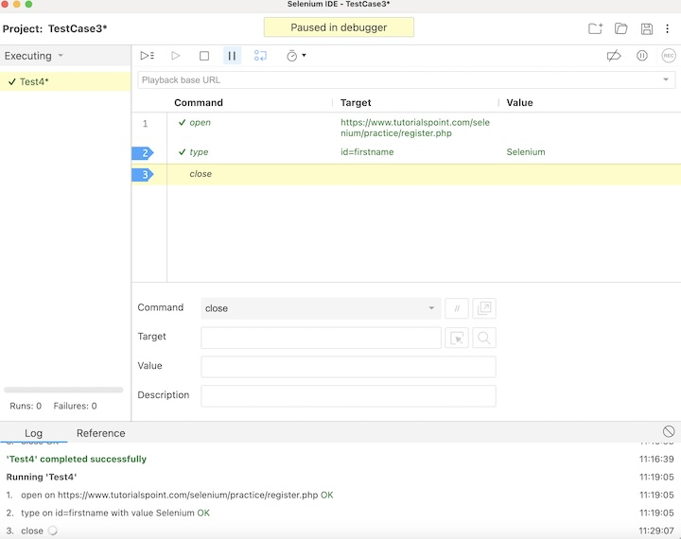
Once the execution would be completed, we would get the message of the result. In case the test passed, we would get the message - <TEST NAME> completed successfully under the Log tab at the bottom of the Selenium IDE. Here, our test name is Test4, hence received the message - Test4 completed successfully.
Apart from that, all the test steps, along with the test case name turned green, reflecting a PASS for all the steps. All the steps which reflected under the Log tab, showed an OK in green.
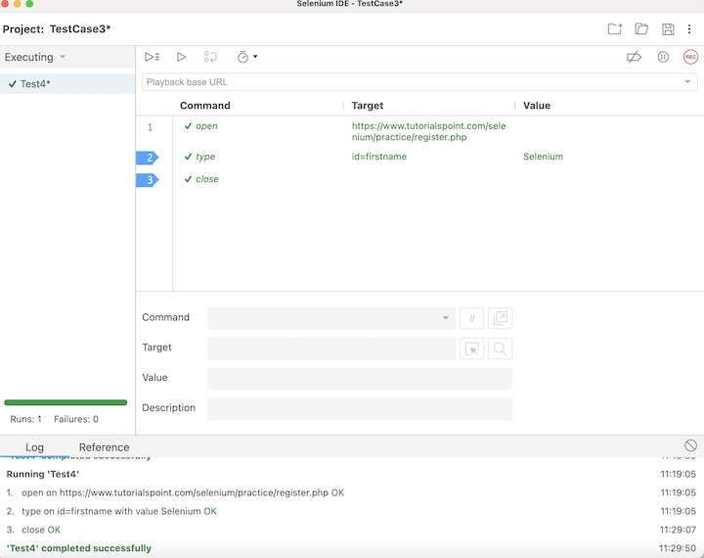
We can disable all the breakpoints by clicking the Disable breakpoints button. All breakpoints would get enabled on clicking the same button again.
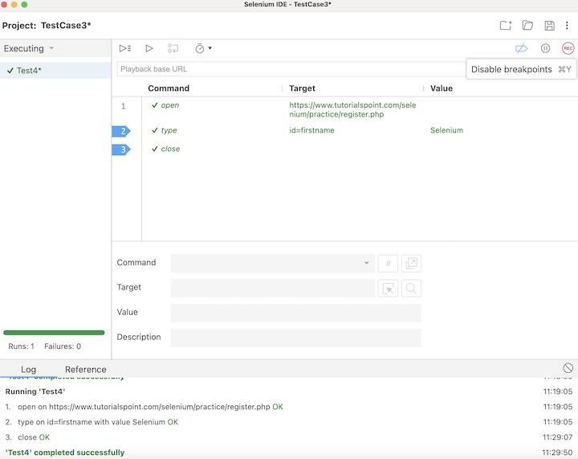
The breakpoints can also be removed/added to steps by right clicking on any step, and selecting the option Toggle Breakpoint.
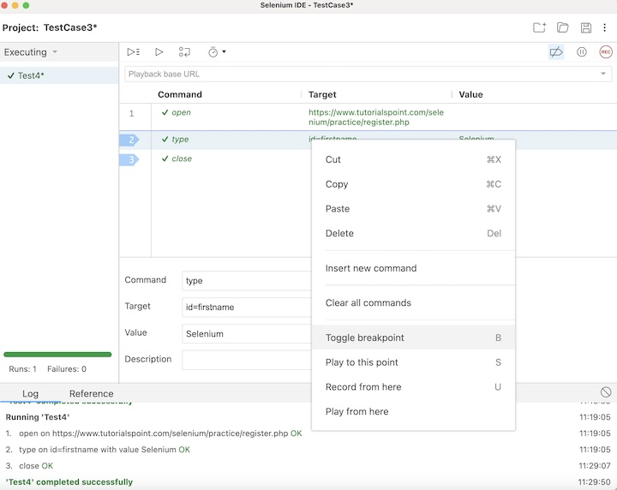
Debugger Command
We can programmatically pause Selenium IDE tests by using the JavaScript command debugger. We would need to right click on a step and select the option Insert new command.
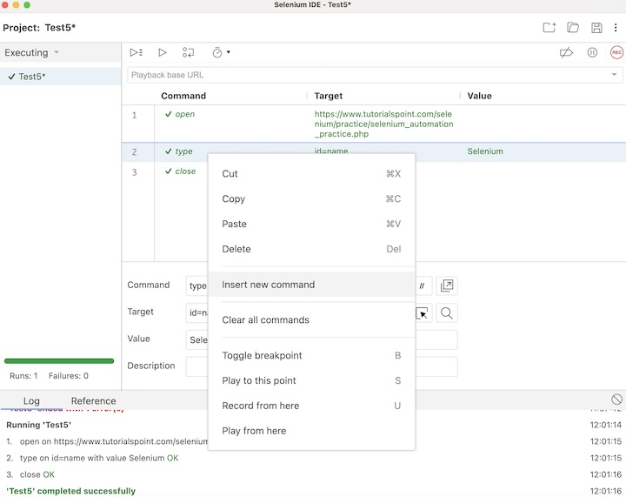
Enter debugger in the Command field to pause the execution.
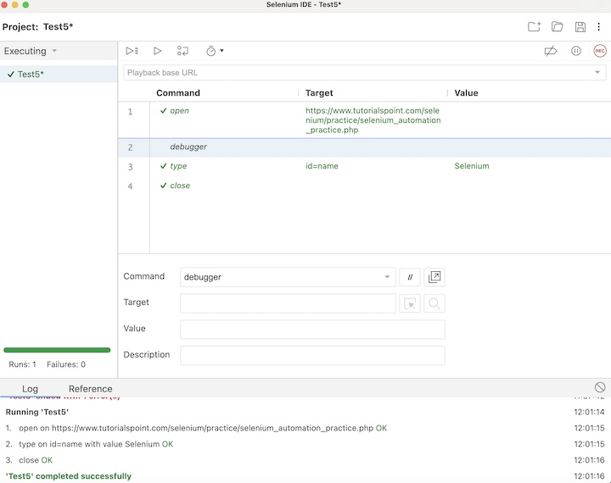
Once the test execution is triggered, the control will stop in the debugger step and we will need to resume execution using the Resume test execution button. Then the Paused in debugger along with the test name would become yellow.
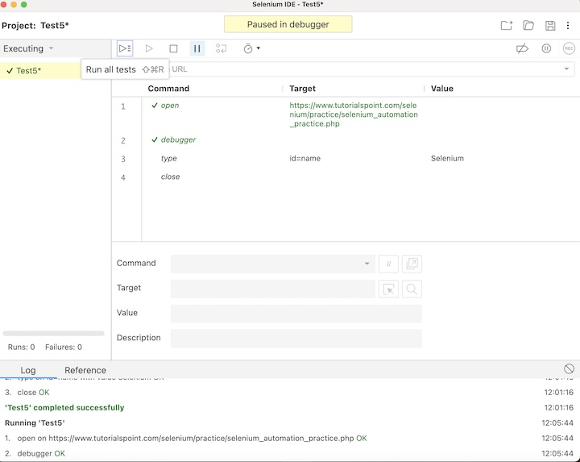
Once the execution would be completed, we would get the message of the result. In case the test passed, we would get the message - <TEST NAME> completed successfully under the Log tab at the bottom of the Selenium IDE. Here, our test name is Test5, hence received the message - Test5 completed successfully.
Apart from that, all the test steps, along with the test case name turned green, reflecting a PASS for all the steps. All the steps which reflected under the Log tab, showed an OK in green.
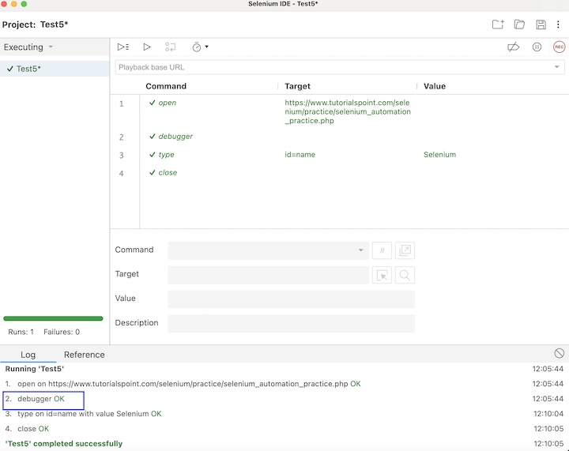
Pause on Exceptions
The Pause on Exception feature in Selenium IDE helps to pause the exception of a test in case an error is encountered. Once paused, we can rectify the step and resume execution.
Let us take the example discussed previously, and intentionally we would fail a step in that test case, by changing the locator id value in line 2. Here, we have changed the locator value to id=names.
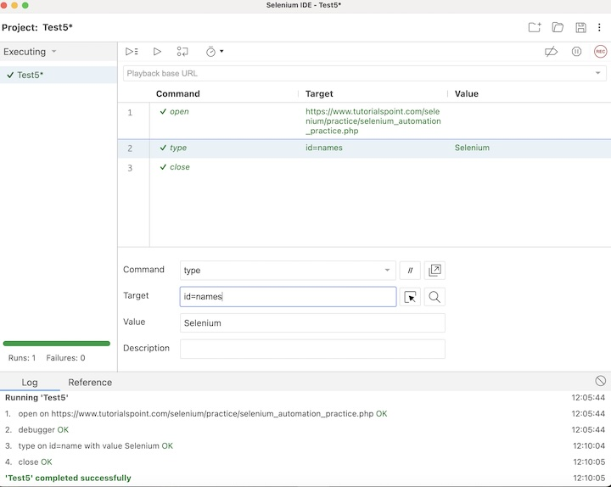
Once the execution is completed, we would get the failed test and the rest of the test steps after the failed step would not get executed.
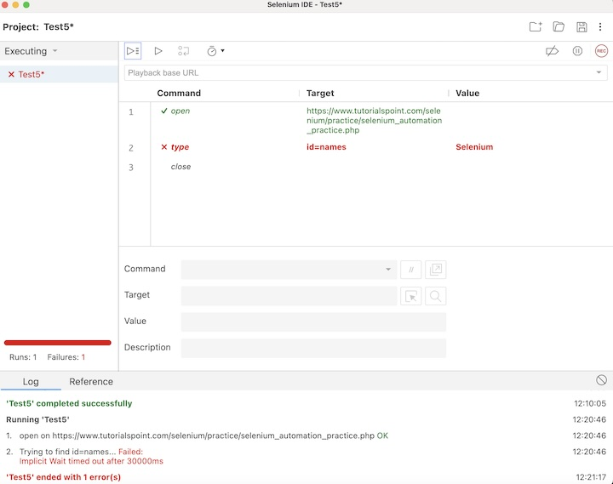
However, to prevent the execution from being aborted, we would need to click on the Pause on exceptions button, and then run the test again.
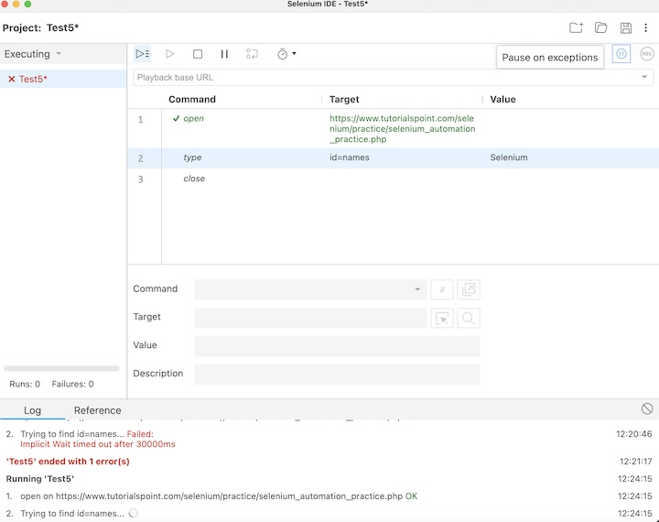
In the below image, the execution stopped at line 2 (due to incorrect locator value) with the Paused in debugger along with the test name turning yellow.
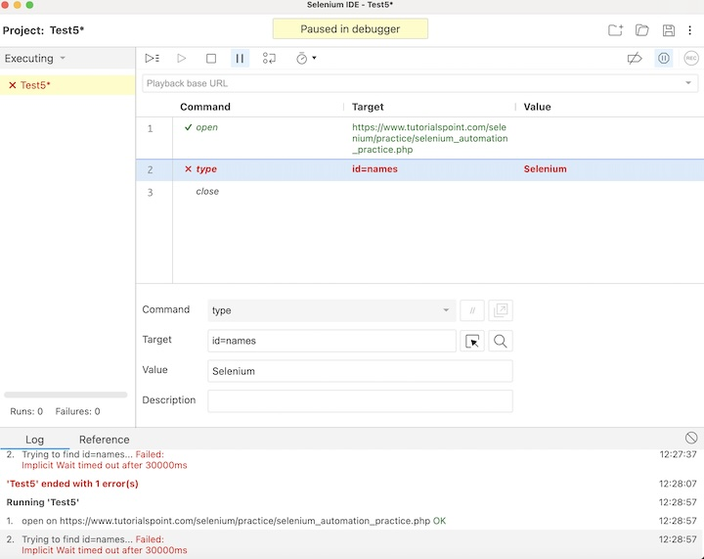
We will correct the locator value from id=names to id=name and again click on the Resume test execution button.
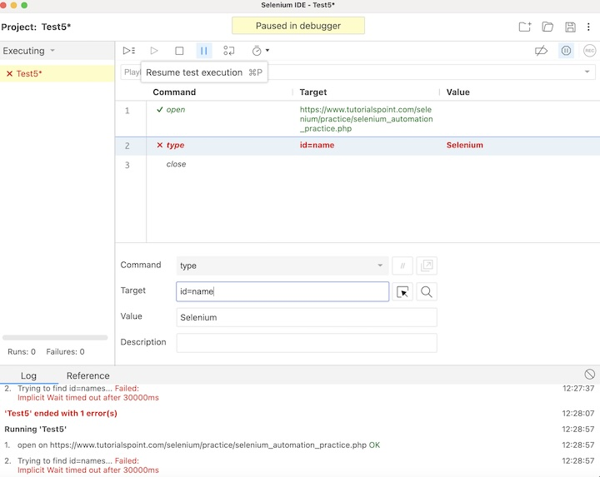
Once the execution would be completed, we would get the message of the result. In case the test passed, we would get the message - <TEST NAME> completed successfully under the Log tab at the bottom of the Selenium IDE. Here, our test name is Test5, hence received the message - Test5 completed successfully.
Apart from that, all the test steps, along with the test case name turned green, reflecting a PASS for all the steps. All the steps which reflected under the Log tab, showed an OK in green.
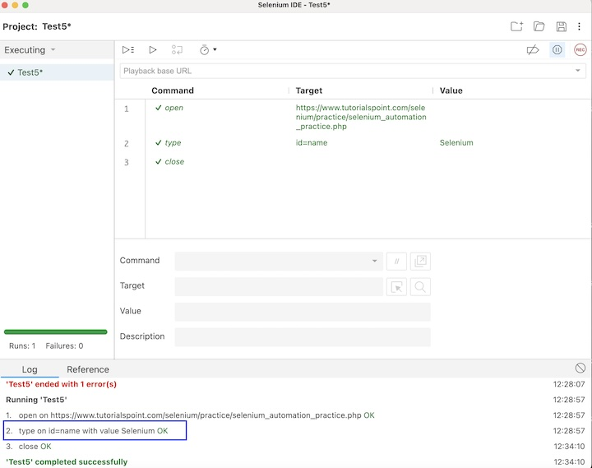
This concludes our comprehensive take on the tutorial on Selenium IDE - Script Debugging. Weve started with describing an example and walked through the different debugging strategies like the step-by-step execution, adding breakpoints, debugger command, Pause on exceptions, and illustrating how to use them along with Selenium. This equips you with in-depth knowledge of the debugging strategies in Selenium IDE. It is wise to keep practicing what youve learned and exploring others relevant to Selenium to deepen your understanding and expand your horizons.

Selenium IDE - Verification Points

Previous
Quiz
Next
Selenium IDE allows adding multiple verification points within the test case to check if the application is working as expected. Every command used in Selenium IDE is known as the Selenese commands. Using the Selenese commands we perform all the testing activities on a web application in Selenium IDE.
Selenese commands are composed of three types - actions, assertions, and accessors. The assertions commands help to add verification points in the Selenium IDE tests. The assertion commands are used to check the state of the application under test. It has three sub-types namely, assert, verify, and waitfor.
How to Insert Verification Points While Recording?
The verification points can be added to tests in Selenium IDE while recording a test. In the below image, we have added the verification point - assert, by right clicking on the input box beside the Name: label. Then we have selected the option Selenium IDE, and finally, we have to select the option Assert. By doing so, all the available assert commands will be ready to be selected.
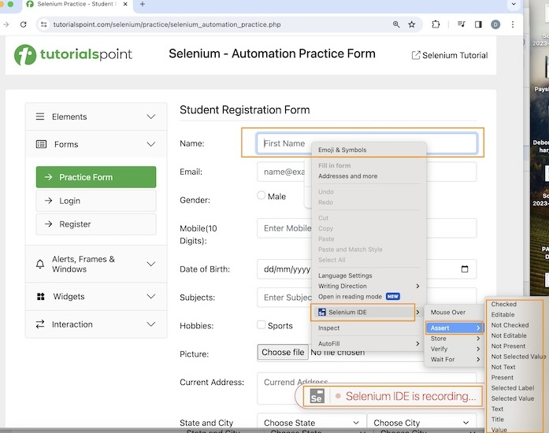
In the below image, we have added the verification point verify, by right clicking on the input box beside the Name: label. Then we have selected the option Selenium IDE, and finally, we have to select the option Verify. By doing so, all the available verify commands will be ready to be selected.
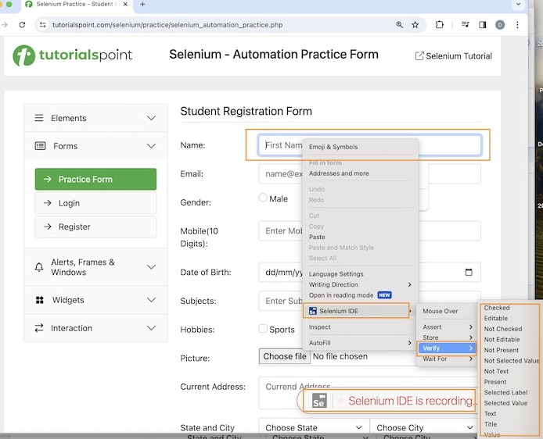
In the below image, we have added the verification point wait for, by right clicking on the input box beside the Name: label. Then we have selected the option Selenium IDE, and finally, we have to select the option Wait For. By doing so, all the available wait for commands will be ready to be selected.
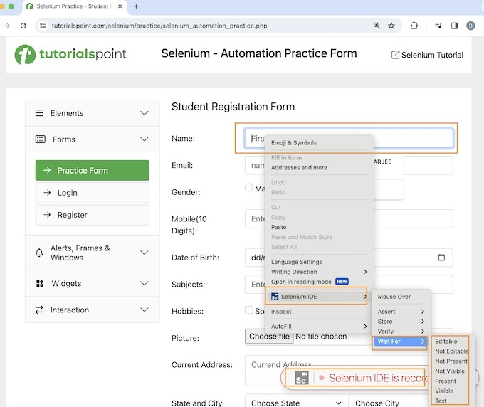
To get a more detailed view on how to set up of Selenium IDE, please refer to the link − Selenium IDE Installation.

Basic Verification Commands in Selenium IDE
The following are the various types of verification commands available in Selenium IDE −
- assert(variable, expected value)
- assert alert(alert text)
- assert checked(locator)
- assert confirmation(text)
- assert editable(locator)
- assert element present(locator)
- assert element not present(locator)
- assert not checked(locator)
- assert not editable(locator)
- assert not selected value(locator, text)
- assert not text(locator, text)
- assert prompt(text)
- assert selected value(locator, text)
- assert selected label(locator, text)
- assert text(locator, text)
- assert title(text)
- assert value(locator, text)
- verify(variable, expected value)
- verify checked(locator)
- verify editable(locator)
- verify element present(locator)
- verify element not present(locator)
- verify not editable(locator)
- verify not selected value(locator, text)
- verify not text(locator, text)
- verify selected label(locator, text)
- verify selected value(locator, text)
- verify text(locator, text)
- verify value(locator, text)
- wait for element editable(locator, wait time)
- wait for element not editable(locator, wait time)
- wait for element not present(locator, wait time)
- wait for element not visible(locator, wait time)
- wait for element present(locator, wait time)
- wait for element visible(locator, wait time)
Example
Let us take an example of the below page, where we would click on the Created link.
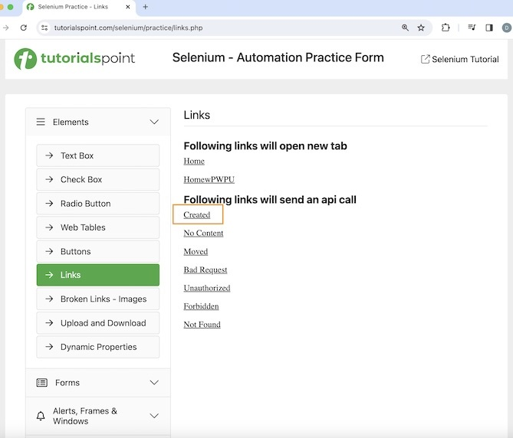
We would verify its page title which is Selenium Practice - Links. After clicking the Created link, we would also verify the text - Link has responded with status 201 and status text Created.
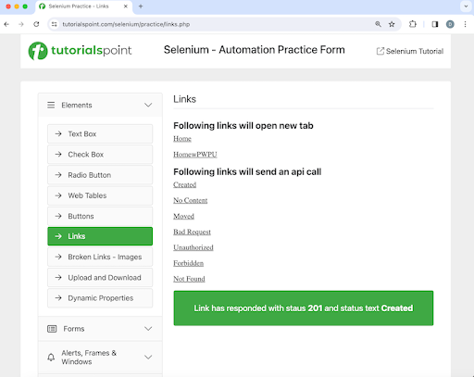
The steps to be followed are listed below −
Step 1 − Click on the Selenium IDE extension visible on the browser after its installation.
Step 2 − Selenium IDE should be launched along with it, a welcome message should be displayed with the version of the tool. In the below image, the version installed is 3.17.2.
Along with this, it gives us the option to select what we would like to do with the tool, like Record a new test in a new project, Open an existing project, Create a new project, and Close Selenium IDE.
Also, a link with the text - the Selenium IDE project page is provided, which on clicking would land us to the Selenium Integrated Development Environment documentation page.
https://www.selenium.dev/selenium-ide/.
Step 3 − Click on the Create a new project link, then enter a project name, say, Test8 under the Please provide a name for your new project. Finally, we would click on the OK button.
Step 4 − We would have the workspace ready in the Selenium IDE now.
Step 5 − Enter open in the Command field, and Selenium Automation Practice Form in the Target field, to launch the application.
Step 6 − Enter verify title in the Command field and Selenium Practice - Links in the Target field.
Step 7 − Enter click in the Command field, xpath=//*[@id="created"] in the Target field. Please note, xpath=//*[@id="created"] is the locator value of the link.
Step 8 − Enter wait for element visible in the Command field, xpath=/html/body/main/div/div/div[2]/div[1] in the Target field and 30000 in the Value field. Please note, xpath=/html/body/main/div/div/div[2]/div[1] is the locator value of the text to be visible.
Step 9 − Enter assert text in the Command field, xpath=/html/body/main/div/div/div[2]/div[1] in the Target field and Link has responded with status 201 and status text Created in the Value field. Please note, xpath=/html/body/main/div/div/div[2]/div[1] is the locator value of the text.
Step 10 − Enter close in the Command field to close the browser window.
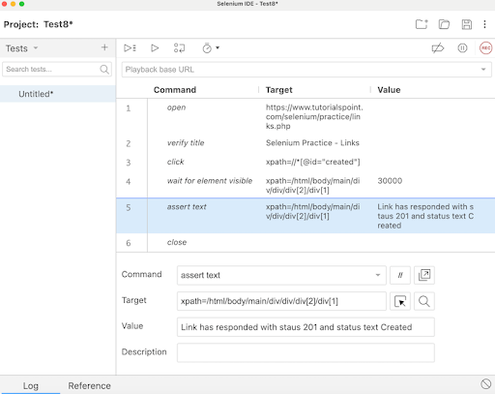
Step 11 − Click on the three dots appearing at the left pane, then select the Rename option.
Step 12 − Enter a name, say Test8 under the Rename Test case field, then click on Rename. The entered name would appear on the left of Selenium IDE.
Step 13 − Click on the Run all tests from the top, and wait for the test execution to complete. In our example, we would see Runs: 1, Failures: 0, and a green bar denoting the test ran successfully without any failures. Also, the message that the completed successfully appeared under the Log.
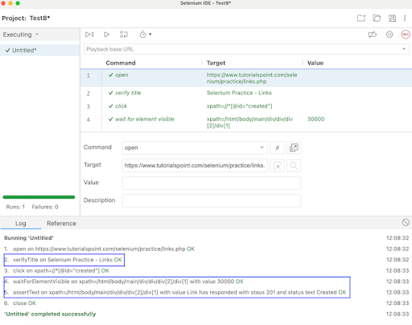
In the example above, we had launched the application and verified its page title - Selenium Practice - Links using the assertions command verify title. Then clicked on the Created link, and waited for text Link has responded with status 201 and status text Created to be visible with the assertion command wait for element visible and verified the text with another assertion command assert text.
Apart from that, all the test steps, along with the test case name turned green, reflecting a PASS for all the steps. All the steps which reflected under the Log tab, showed an OK in green.
This concludes our comprehensive take on the tutorial on Selenium IDE - Verification Points. Weve started with describing what are verification points, how to insert verification points, basic verification commands, and an example to walk through how to use the verification commands along with Selenium.
This equips you with in-depth knowledge of the verification points in Selenium IDE. It is wise to keep practicing what youve learned and exploring others relevant to Selenium to deepen your understanding and expand your horizons.

Selenium IDE - Pattern Matching

Previous
Quiz
Next
Selenium IDE can be used for pattern matching for the tests especially for tests requiring verification scenarios. Like locators, patterns are a type of parameter frequently used by Selenium. It allows users to describe patterns with the help of special characters. Many times, the text that we would like to verify is dynamic, in that case, pattern matching is very useful.
Pattern matching is commonly used with all the verification point commands like verify text, verify not text, verify title, verify value, verify, assert text, assert alert, assert not text, assert prompt, assert selected value, assert title, assert not selected value, assert selected label, and so on.
Different Ways of Pattern Matching
- Globbing
- Regular Expressions
- Exact Matching

-
00:00
Globbing
Globbing is used to match a string with respect to a glob(which is the wild character expression). It is commonly used for file matching patterns in Linux or Windows while searching for a certain file type like *.doc, *.jpg, and so on.
There are multiple ways to use globbing in Selenium like * which is used to match any count or order of characters ? which is used to match a unique character, and [] which is used to match any one character provided within the brackets. It is a character class. For example, [0-9] will match any digit. The pattern matching with globbing is by default available in Selenium and it is optional to mention the keyword glob in the test step in the Selenium IDE.
Let us take the example of the below page, where we would verify the text Alerts and header Selenium - Automation Practice using the globbing pattern matching.
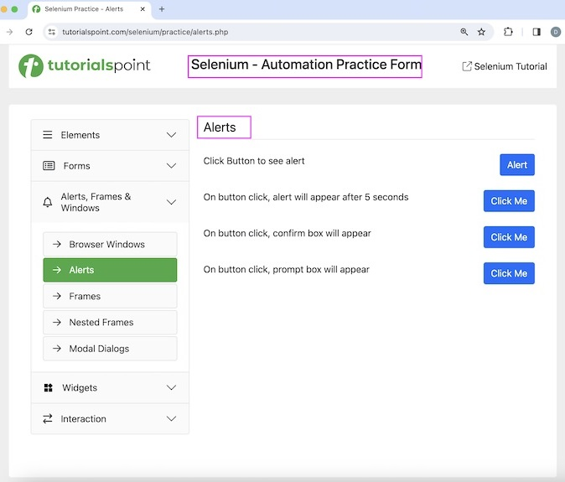
The steps to be followed are listed below −
Step 1 − Click on the Selenium IDE extension visible on the browser after its installation.
Step 2 − Selenium IDE should be launched along with it, a welcome message should be displayed with the version of the tool. In the below image, the version installed is 3.17.2.
Along with this, it gives us the option to select what we would like to do with the tool, like Record a new test in a new project, Open an existing project, Create a new project, and Close Selenium IDE.
Step 3 − Click on the Create a new project link, then enter a project name, say, Test7 under the Please provide a name for your new project. Finally, we would click on the OK button.
Step 4 − We would have the workspace ready in the Selenium IDE now.
Step 5 − Enter open in the Command field, and https://www.tutorialspoint.com/selenium/ in the Target field to launch the application.
Step 6 − Enter assert text in the Command field, xpath=/html/body/main/div/div/div[2]/h1 in the Target field, and glob: Alert* in the Value field. Please note, xpath=/html/body/main/div/div/div[2]/h1 is the text and glob: Alert* is the value to be a matched pattern.
Step 7 − Enter assert text in the Command field, xpath=/html/body/div/header/div[2]/h1 in the Target field, and glob: Selenium - Automation* in the Value field. Please note, xpath=/html/body/div/header/div[2]/h1 is the header and glob: Selenium - Automation* is the value to be a matched pattern.
Step 8 − Enter close in the Command field to close the browser window.
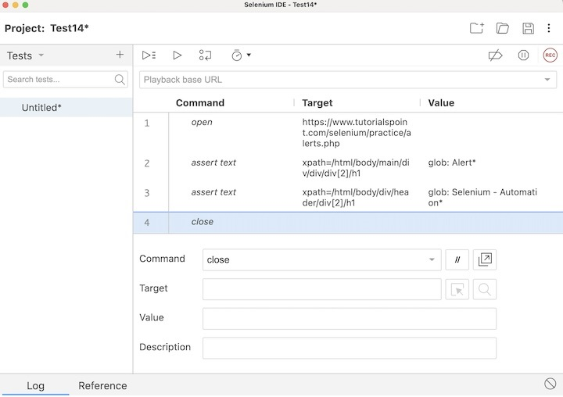
Step 9 − Click on the three dots appearing at the left pane, then select the Rename option.
Step 10 − Enter a name, say Test14 under the Rename Test case field, then click on Rename. The entered name would appear on the left of Selenium IDE.
Step 11 − Click on the Run all tests from the top, and wait for the test execution to complete. In our example, we would see Runs: 1, Failures: 0, and a green bar denoting the test ran successfully without any failures. Also, the message Test14 completed successfully appeared under the Log.
In the example above, we had verified the texts with the help of the globbing.
Exact Matching
Exact matching is used to match a string as it is present. For example, if an exact match with the string value is required, the exact pattern can be used. In exact matching, the operator * works as a normal character rather than for pattern matching wildcard characters. Let us take the same example as discussed above and use exact pattern technique.
The steps to be followed are listed below −
Step 1 − Follow Steps 1 to 5 of the previous example.
Step 2 − Enter assert text in the Command field, xpath=/html/body/main/div/div/div[2]/h1 in the Target field, and exact: Alerts in the Value field. Please note, xpath=/html/body/main/div/div/div[2]/h1 is the text and exact: Alerts is the value to be matched exactly.
Step 3 − Enter assert text in the Command field, xpath=/html/body/div/header/div[2]/h1 in the Target field, and exact: Selenium - Automation Practice in the Value field. Please note, xpath=/html/body/div/header/div[2]/h1 is the header and exact: Selenium - Automation Practice is the value to be matched exactly.
Step 4 − Follow Steps 8 to 11 of the previous example.
Regular Expressions
Regular expressions are the most useful among the pattern matching techniques available. Selenium supports the complete set of regular expression patterns that Javascript supports. Hence the users are no longer limited by *, ? and [] globbing patterns.
To use RegEx patterns, we need to prefix with either "regexp:" or "regexpi:". The prefix "regexpi" is case-insensitive. The glob: and the exact: patterns are the subsets of the Regular Expression patterns. Everything that is done with glob: or exact: can be accomplished with the help of RegExp.
There is more information on regular expressions available in the below link −
https://www.tutorialspoint.com/javascript/javascript_regexp_object.htm
This concludes our comprehensive take on the tutorial on Selenium IDE - Pattern Matching. Weve started with describing different ways of Pattern Matching like globbing, regular expression, and exact match and how to use them with Selenium.
This equips you with in-depth knowledge of the Pattern Matching in Selenium IDE. It is wise to keep practicing what youve learned and exploring others relevant to Selenium to deepen your understanding and expand your horizons

Selenium IDE - JSON Data File

Previous
Quiz
Next
Selenium IDE can be used to work with the JSON Data file. JavaScript Object Notation or JSON is a data interchange format and is of lightweight nature. It has an easy readable pattern and machines can analyze and produce JSON data quickly.
Selenium IDE 'store json' Command
Selenium IDE can be used to work with the JSON data file using the store json command. It is an accessor command which is used to store the JSON data in a variable.

-
00:00
Store JSON Data to a Variable in Selenium IDE
Let us take an example where we will store the JSON data to a variable using the Selenium IDE taking the help of the accessors command - store json.
The steps to store json data and access them in Selenium IDE are listed below −
Step 1 − Click on the Selenium IDE extension visible on the browser after its installation.
Step 2 − Selenium IDE should be launched along with it, a welcome message should be displayed with the version of the tool. In the below image, the version installed is 3.17.2.
Along with this, it gives us the option to select what we would like to do with the tool, like Record a new test in a new project, Open an existing project, Create a new project, and Close Selenium IDE.
Also, a link with the text - the Selenium IDE project page is provided, which on clicking would land us to the Selenium Integrated Development Environment documentation page.
https://www.selenium.dev/selenium-ide/.
Step 3 − Click on the Create a new project link, then enter a project name under the Please provide a name for your new project. Finally, we would click OK.
Step 4 − We would have the workspace ready in the Selenium IDE.
Step 5 − Enter open in the Command field, and https://www.tutorialspoint.com/selenium/ in the Target field, to launch the application.
Step 6 − Enter store json in the Command field, {"Language":"Java","Name":"Selenium"} in the Target field, and val in the Value field. Please note, {"Language":"Java","Name":"Selenium"} is the json data we would like to store using the variable val.
Step 7 − Enter echo in the Command field, ${val} in the Target field. Please note, this would print the json object we accessed in Step6 under the Log in Selenium IDE.
Step 8 − Enter close in the Command field to close the browser window.
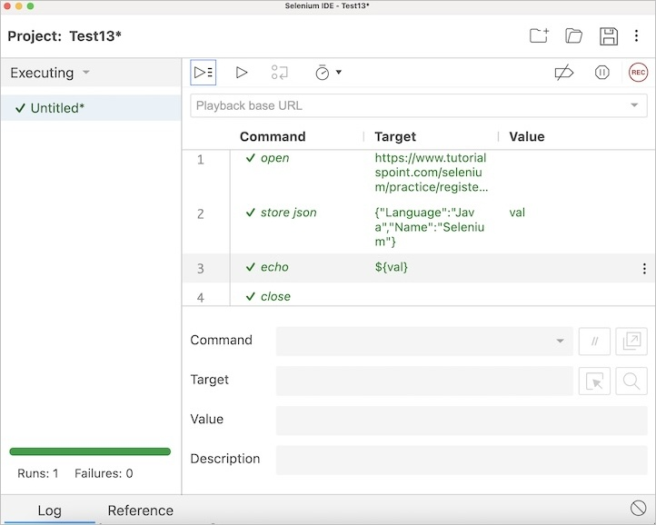
Step 9 − Click on the Run all tests from the top, and wait for the test execution to complete. In our example, we would see Runs: 1, Failures: 0, and a green bar denoting the test ran successfully without any failures. Also, the message test completed successfully appeared under the Log.
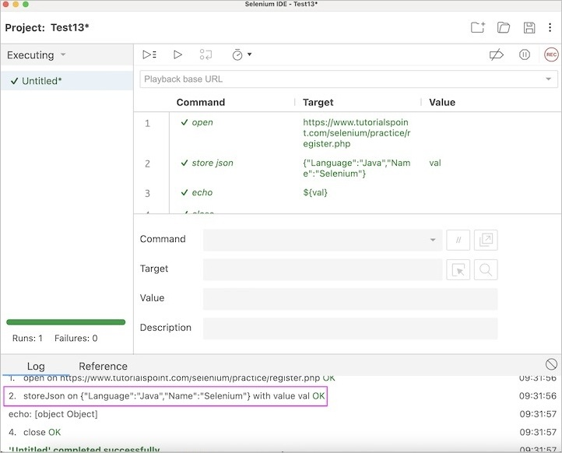
In the example above, we obtained the json data under the Log. Besides, we got a green tick beside the test case at the top, signifying a passed test.
Apart from that, all the test steps, along with the test case name turned green, reflecting a PASS for all the steps. All the steps which reflected under the Log tab, showed an OK in green.
Thus, in Selenium IDE, we would get the information about the test results both at the test step level and only if all the steps would be executed successfully, we would get a PASS at the test case level as well.
Moreover, we would infer that variables used in one step can be accessed further in other steps using the syntax: ${<variable name>}. In Step2 we followed this approach in our test. The echo command was used to get the JSON objects under the Log tab.
Once the test was executed, the project would be saved in a file having .side extension. Here, we had saved the project with the name Test13.side. On opening this file in Notepad, Notepad++, or any text file format, we would get the data and other information of the test in JSON format.
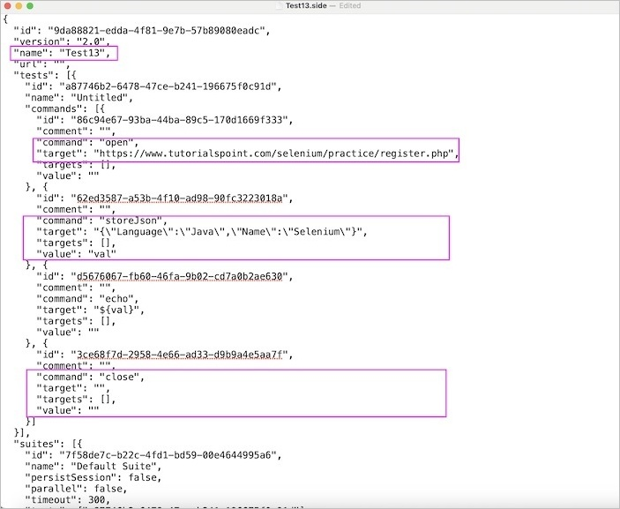
The complete JSON data received from the test .side file −
{
"id": "9da88821-edda-4f81-9e7b-57b89080eadc",
"version": "2.0",
"name": "Test13",
"url": "",
"tests": [{
"id": "a87746b2-6478-47ce-b241-196675f0c91d",
"name": "Untitled",
"commands": [
{
"id": "86c94e67-93ba-44ba-89c5-170d1669f333",
"comment": "",
"command": "open",
"target": "https://www.tutorialspoint.com/selenium/practice/register.php",
"targets": [],
"value": ""
}, {
"id": "62ed3587-a53b-4f10-ad98-90fc3223018a",
"comment": "",
"command": "storeJson",
"target": "{\"Language\":\"Java\", \"Name\":\"Selenium\"}",
"targets": [],
"value": "val"
}, {
"id": "d5676067-fb60-46fa-9b02-cd7a0b2ae630",
"comment": "",
"command": "echo",
"target": "${val}",
"targets": [],
"value": ""
}, {
"id": "3ce68f7d-2958-4e66-ad33-d9b9a4e5aa7f",
"comment": "",
"command": "close",
"target": "",
"targets": [],
"value": ""
}
]
}],
"suites": [{
"id": "7f58de7c-b22c-4fd1-bd59-00e4644995a6",
"name": "Default Suite",
"persistSession": false,
"parallel": false,
"timeout": 300,
"tests": ["a87746b2-6478-47ce-b241-196675f0c91d"]
}],
"urls": [],
"plugins": []
}
In the above example, we had four test steps, with the commands open, store json, echo, and close. All these commands along with their Target, and Value had been captured in the JSON file. The JSON data {"Language":"Java", "Name":"Selenium"} passed in the test had also been captured in the json file.
This concludes our comprehensive take on the tutorial on Selenium IDE - JSON Data File. Weve started with describing how to access a json data using the store json command in Selenium IDE, and walked through an example to illustrate how to use the store json command and the file with side format to save the Selenium IDE test, and later access the same file to get the test information in a json format.
This equips you with in-depth knowledge of the JSON Data file in Selenium IDE. It is wise to keep practicing what youve learned and exploring others relevant to Selenium to deepen your understanding and expand your horizons.

Selenium IDE - Browser Execution & Command-line Runner

Previous
Quiz
Next
The test case developed in Selenium IDE should be able to run in multiple browsers like Chrome, Firefox, Safari, Edge, and so on with minor updates to the test case. This helps to check if the application under test is working as per the requirements in all the browsers.
Why is Cross Browser Execution Beneficial?
Often on working on any applications for example, e-commerce or on travel reservations, and so on, we observe that while doing the payment, or adding products to cart, the applications are taking too much time for page load on a specific browser.
As a user, we promptly infer that there may be an error or an ongoing issue in that application, and we move towards a different company website having the similar products and functionalities.
Read More - Selenium Webdriver Cross Browser Testing

Prerequisites for Selenium IDE cross browser execution
- Install Selenium IDE in the local system in Chrome or Firefox. To get more information about its installation, please refer to the link Selenium IDE Installation.
- Install Node.js(version above 10) using the link https://nodejs.org/en/download/.
- Check Node.js installed successfully by running the command in the terminal: node -v. The version of Node.js installed should be returned. Along with the Node.js installation, the npm should be installed as well. Check npm has been installed by running the command in the terminal: npm -v. The version of npm installed should be returned.
- Install Selenium side runner, by running the command in the terminal: npm install -g selenium-side-runner.
How to run Selenium IDE tests in multiple browsers?
Step 1 − Click on the Selenium IDE extension visible on the browser after its installation.
Step 2 − Selenium IDE should be launched along with it, a welcome message should be displayed with the version of the tool. In the below image, the version installed is 3.17.2.
Along with this, it gives us the option to select what we would like to do with the tool, like Record a new test in a new project, Open an existing project, Create a new project, and Close Selenium IDE.
Also, a link with the text - the Selenium IDE project page is provided, which on clicking would land us to the Selenium Integrated Development Environment documentation page.
https://www.selenium.dev/selenium-ide/.

Step 3 − Click on the Create a new project link, then enter a project name, say, Test7 under the Please provide a name for your new project. Finally, we would click on the OK button.
Step 4 − We would have the workspace ready in the Selenium IDE now.
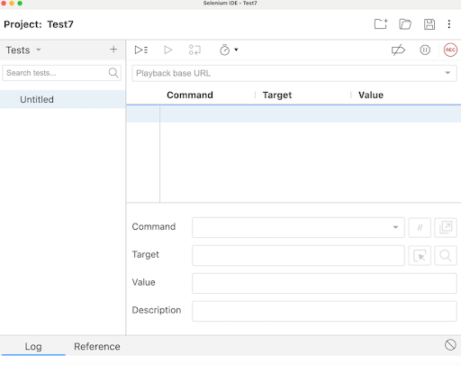
Step 5 − Enter open in the Command field, and https://www.tutorialspoint.com/selenium/ in the Target field, to launch the application.
Step 6 − Enter type in the Command field, id=name in the Target field, and Selenium in the Value field. Please note, id=name is the locator value of the input box and Selenium is the value to be entered.
Step 7 − Enter close in the Command field to close the browser window.
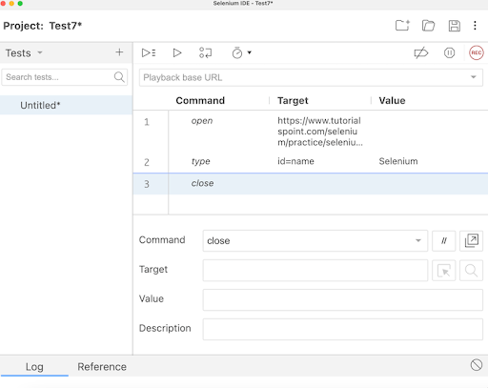
Step 8 − Click on the three dots appearing at the left pane, then select the Rename option.
Step 9 − Enter a name, say Test7 under the Rename Test case field, then click on Rename. The entered name would appear on the left of Selenium IDE.
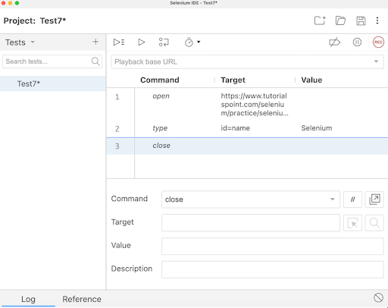
Step 10 − Click on the Run all tests from the top, and wait for the test execution to complete. In our example, we would see Runs: 1, Failures: 0, and a green bar denoting the test ran successfully without any failures. Also, the message Test7 completed successfully appeared under the Log.
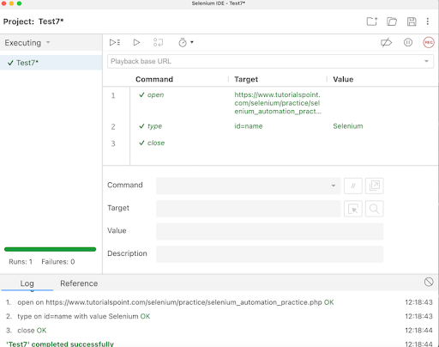
In the example above, we entered the text Selenium in an input box using the id locator which appeared under the Log. Besides, we got a green tick beside the test case name - Test7 at the top, signifying a passed test. All these were performed successfully using the actions commands like open, type, and close.
Apart from that, all the test steps, along with the test case name turned green, reflecting a PASS for all the steps. All the steps which reflected under the Log tab, showed an OK in green
Step 11 − Click on Save Project, and this project would be saved with Test7.side file.
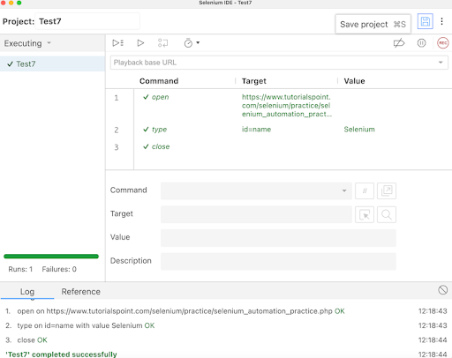
Step 12 − To run this test in the Chrome browser, we would need to run the command: npm install -g chromedriver. Similarly, for running the test in Firefox, we would need to run the command: npm install -g geckodriver. For running the test in Edge, we would need to run the command: npm install -g edgedriver. For running the test in Internet Explorer, we would need to run the command: npm install -g iedriver.
Step 13 − To launch the Selenium Side Runner, and run the test we had just saved in Step11, we would need to run the command: selenium-side-runner /path/to/<project name>.side.
Browser Capabilities for Different Browser Execution
To add Chrome browser capabilities for local execution, the command would be −
selenium-side-runner -c "browserName=chrome".
To add Safari browser capabilities for local execution, the command would be −
selenium-side-runner -c "browserName=safari".
To add Edge browser capabilities for local execution, the command would be −
selenium-side-runner -c "browserName=edge".
To add Internet Explorer browser capabilities for local execution, the command would be −
selenium-side-runner -c "browserName=internet explorer".
To add Internet Firefox browser capabilities for local execution, the command would be −
selenium-side-runner -c "browserName=firefox".
Conclusion
This concludes our comprehensive take on the tutorial on Selenium IDE Browser Execution & Command-line Runner. Weve started with describing the meaning of browser execution, why cross execution is beneficial, prerequisites to run Selenium IDE tests in cross browsers, how to run them in different browsers, and how to add browser capabilities while executing them in different browsers. This equips you with in-depth knowledge of the browser execution and command line runner in Selenium IDE. It is wise to keep practicing what youve learned and exploring others relevant to Selenium to deepen your understanding and expand your horizons.

Selenium - User Extensions

Previous
Quiz
Next
It is easy to extend Selenium IDE by adding customized actions, assertions, and locator-strategies. It is done with the help of JavaScript by adding methods to the Selenium object prototype. On startup, Selenium will automatically look through the methods on these prototypes, using name patterns to recognize which ones are actions, assertions, and locators.
Let us add a 'while' Loop in Selenium IDE with the help of JavaScript.
Step 1 − To add the js file, first navigate to https://github.com/darrenderidder/sideflow/blob/master/sideflow.js and copy the script and place save it as 'sideflow.js' in your local folder as shown below.
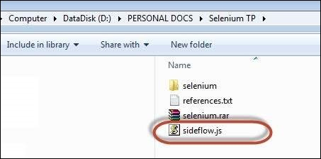
Step 2 − Now launch 'Selenium IDE' and navigate to "Options" >> "Options" as shown below.
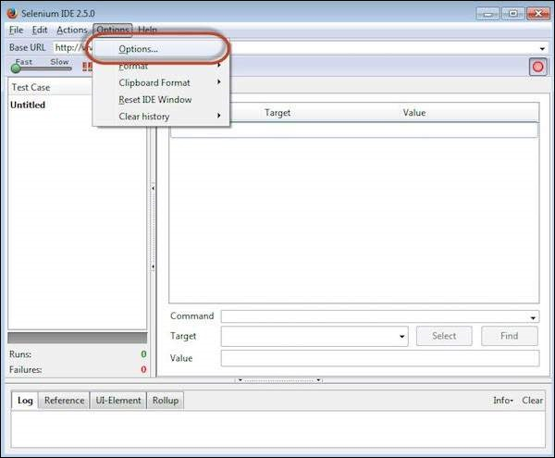
Step 3 − Click the 'Browse' button under 'Selenium Core Extensions' area and point to the js file that we have saved in Step 1.
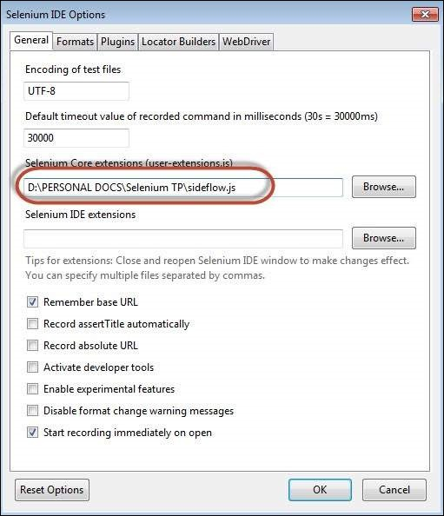
Step 4 − Restart Selenium IDE.
Step 5 − Now you will have access to a few more commands such as "Label", "While" etc.
Step 6 − Now we will be able to create a While loop within Selenium IDE and it will execute as shown below.
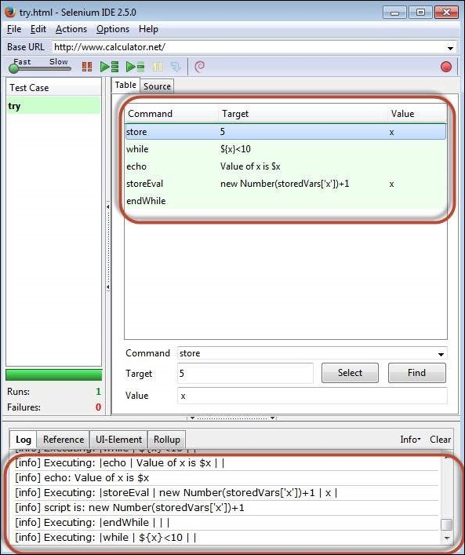

Selenium IDE - Code Export

Previous
Quiz
Next
Selenium IDE code generated by recording a test for an application can be exported to other languages like Java, C#, and so on. The generated code can be imported into other IDEs like Eclipse, IntelliJ, and so on and be used for other automation tests.
Steps To Code Export
Step 1 − Follow the Steps 1 to 8 as discussed in Selenium IDE Test Creation.
Step 2 − Save the project in a location.

Step 3 − Run the test with the help Run current test.
Step 4 − As the execution completed, the message - <TEST NAME> completed successfully appeared under the Log tab.

Step 5 − As test execution successfully completed, we can infer that the test is working fine, and its code can be reused. For this purpose of reuse, we would need to export the code generated for this test.
Click on the three dots appearing beside the test case name in the upper left corner as shown in the below image.
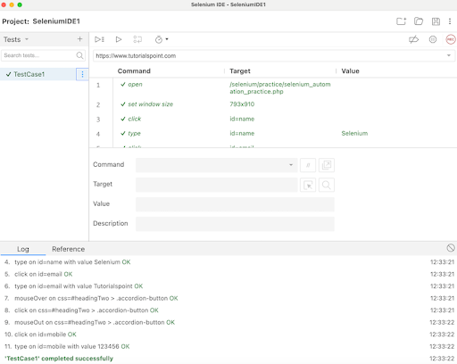
Step 6 − Select the option Export from the dropdown visible.
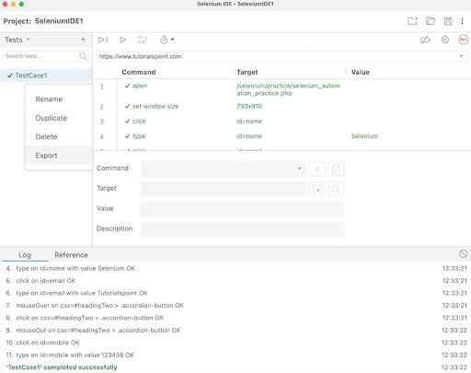
Step 7 − Select the language, and click on the Export button.
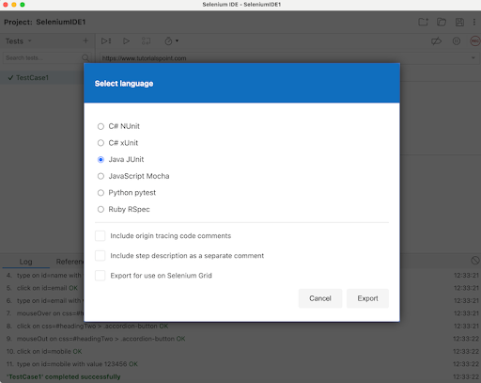
Step 8 − Specify the name, and the location where the Selenium IDE code would be exported. Then click on the Save button.
If the selected language is chosen as Java JUnit, the exported version should have the extension as .java.
Step 7 − Import this file to IntelliJ or Eclipse, and add the required dependencies to support the JUnit test generated from the Selenium IDE. Currently, Selenium IDE code can be exported to the below languages and frameworks −
- C# Unit
- Java JUnit
- JavaScript Mocha
- Python pytest
- Ruby RSpec

-
00:00
Process Exported Code and Add Dependencies to Test
Step 1 − The Java JUnit code exported would work with Java version 8 and above, JUnit 4.12, and support the latest version of Selenium available.
Step 2 − In order to reuse the code exported from Selenium IDE, add the Selenium, and JUnit Maven dependencies to the pom.xml file from the links Selenium Java and JUnit.
Please note, we have added the Selenium 4.x version dependencies to make the code compatible. With IntelliJ, the Java version in the system should be 17 or higher. However with Eclipse, Java version 8 or above would be fine.
Conclusion
This concludes our comprehensive take on the tutorial on Selenium IDE Code Export. Weve started with describing steps to code export. This equips you with in-depth knowledge of the Code Export in Selenium IDE. It is wise to keep practicing what youve learned and exploring others relevant to Selenium to deepen your understanding and expand your horizons.

Selenium IDE - Emitting Code

Previous
Quiz
Next
Selenium IDE is an important tool used extensively for its record and play back feature. It comprises of two critical components namely playback within the browser using the actions and events and playback using the command-line mode with the help of the command-line runner.
Selenium SIDE Runner Environment
The Selenium runner is built on Node. This can be used for emitting the code. The other requirements include −
- Node.js Version 8 and the Above Versions
- Jest
- Jest Environment Selenium
- Selenium Webdriver

-
00:00
How to Emit Code?
While emitting the code, certain measures need to be taken care of. As the plugins are not the only ones that are emitting the code. It also does not take care of the flow of emissions. To confirm that the plugins do not interfere in each others execution, certain measures are taken −
Avoid Using Return
The code after the usage of return keyword is never executed and stop the working of other plugins. For example,
return promise1();
plugin1func(); // after the usage of above return code, this is unreachable.
Instead the below solution with the await function works −
await promise1();
plugin1func(); // this should work
Avoid Defining Variables Globally
Defining variables at the global level points to the fact that if another plugin or Selenium IDE has defined the same variable, either an error message will be generated or make debugging difficult. For example,
- store | button | ele
- plugin click | button
- assert element present | xpath=${ele}
On defining the variable, the code will be −
let ele = "button";
let ele = await driver.findElement();
await ele.click();
expect(ele).toBePresent(); // ambiguity on which variable
Instead the below solution with the then function of Promise works −
let ele = "button";
await driver.findElement().then(ele => {
return ele.click();
});
expect(ele).toBePresent(); // hold the correct defined button
Conclusion
This concludes our comprehensive take on the tutorial on Selenium IDE - Emitting Code. Weve started with describing Selenium SIDE Runner Environment, and How to emit code. This equips you with in-depth knowledge of the Selenium IDE Emitting Code. It is wise to keep practicing what youve learned and exploring others relevant to Selenium to deepen your understanding and expand your horizons.

Selenium IDE - JavaScript Functions

Previous
Quiz
Next
Selenium IDE can be used to execute JavaScript commands to interact with the elements appearing within a browser on a page using the Target field. Sometimes, the locators available in Selenium Webdriver fail to interact with the elements on a page, in those scenarios we can take the help of the JavaScript functions.
Basic Commands to run JavaScript Functions
Execute Script Command
This command is used to execute JavaScript in a window or frame currently active. It is an anonymous function, supports various data types like WebElements, Long, String, Lists, and Boolean. In order to store the return value of the JavaScript in a variable, the return keyword is used.
Execute Async Script Command
It is a multi-threaded approach to execute individual JavaScript tasks on window or frame in currently active. It allows page parsing to continue, optimizing performance and providing great flexibility. This method enables the asynchronous JavaScript to be executed in an optimal way.
Run Script Command
This command allows to run JavaScript functions from the Selenium IDE.

Example 1
Let us create an alert - Tutorialspoint on the below web page using JavaScript functions
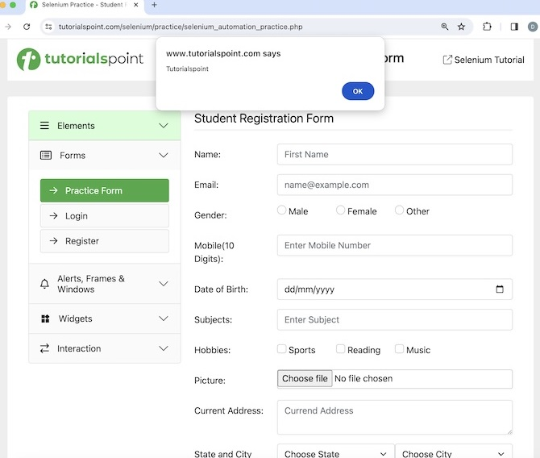
The steps to be followed are listed below −
Step 1 − Click on the Selenium IDE extension visible on the browser after its installation.
Step 2 − Selenium IDE should be launched along with it, a welcome message should be displayed with the version of the tool. In the below image, the version installed is 3.17.2.
Along with this, it gives us the option to select what we would like to do with the tool, like Record a new test in a new project, Open an existing project, Create a new project, and Close Selenium IDE.
Also, a link with the text - the Selenium IDE project page is provided, which on clicking would land us to the Selenium Integrated Development Environment documentation page.
https://www.selenium.dev/selenium-ide/.
Step 3 − Click on the Create a new project link, then enter a project name, say, Test11 under the Please provide a name for your new project. Finally, we would click on the OK button.
Step 4 − We would have the workspace ready in the Selenium IDE now.
Step 5 − Enter open in the Command field, and https://www.tutorialspoint.com/selenium/ in the Target field, to launch the application.
Step 6 − Enter execute script in the Command field and alert("Tutorialspoint") in the Target field.
Step 7 − Enter close in the Command field to close the browser window.
Step 8 − Click on the three dots appearing at the left pane, then select the Rename option.
Step 9 − Enter a name, say Test11 under the Rename Test case field, then click on Rename. The entered name would appear on the left of Selenium IDE.
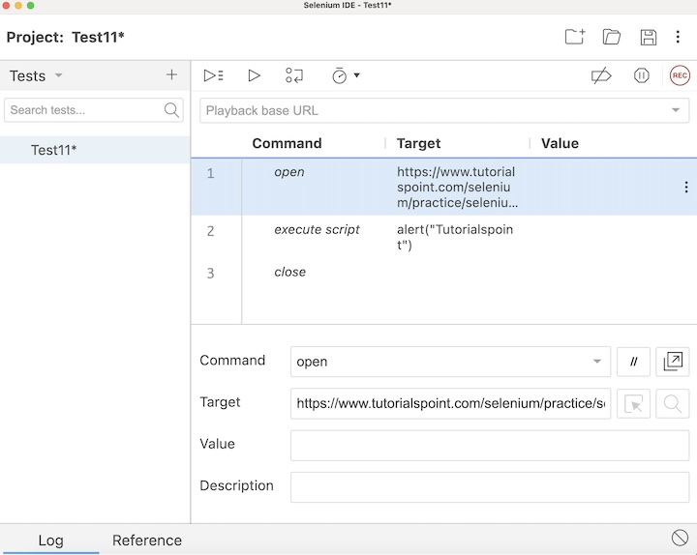
Step 10 − Click on the Run all tests from the top, and wait for the test execution to complete. In our example, we would see Runs: 1, Failures: 0, and a green bar denoting the test ran successfully without any failures. Also, the message that the completed successfully appeared under the Log.
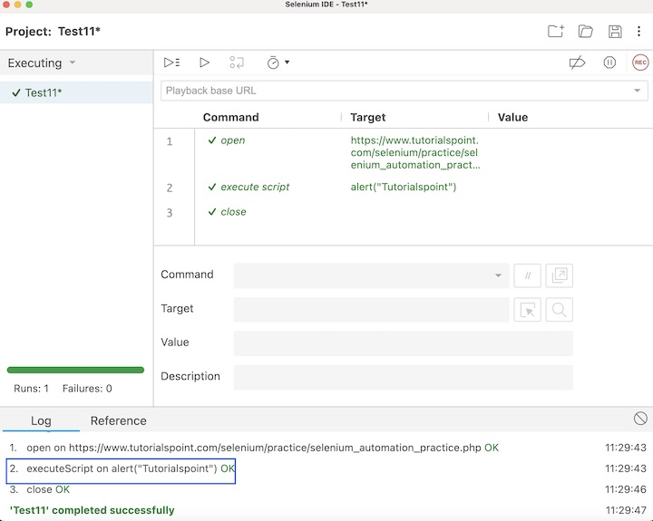
In the example above, we had launched the application, created an alert with the text Tutorialspoint using the JavaScript functions and executed script command in Selenium IDE.
Apart from that, all the test steps, along with the test case name turned green, reflecting a PASS for all the steps. All the steps which reflected under the Log tab, showed an OK in green.
Example 2
Let us take another example of the below page, where we will access the text - Selenium - Automation Practice and also retrieve the value Selenium entered in the input box beside the Name: label.
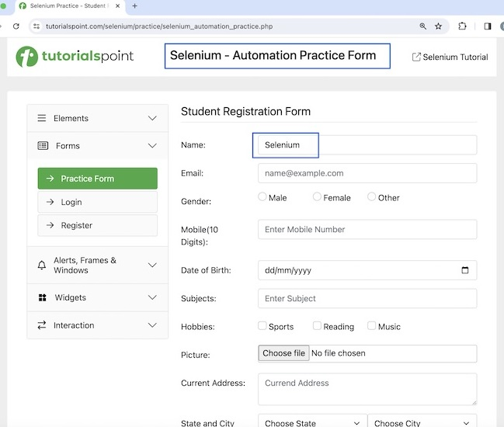
The steps to be followed are listed below −
Step 1 − Follow Steps 1 to 5 as described in the Example 1.
Step 2 − Enter execute script in the Command field and return document.getElementsByTagName('h1')[0].innerHTML in the Target field and value in the Value field.
Please note, document.getElementsByTagName('h1')[0] is the locator value of the text Selenium - Automation Practice Form.
Step 3 − Enter echo in the Command field, ${value} in the Target field. Please note, this would print the text we accessed in Step2 on the web page under the Log in Selenium IDE.
Step 4 − Enter type in the Command field, id=name in the Target field, and Selenium in the Value field. Please note, id=name is the locator value of the input box.
Step 5 − Enter execute script in the Command field and return document.getElementById('name').value in the Target field and valueEntered in the Value field.
Please note, document.getElementById('name') is the locator value of the input box.
Step 6 − Enter echo in the Command field, ${valueEntered} in the Target field. Please note, this would print the text we entered in Step4 on the web page under the Log in Selenium IDE.
Step 7 − Enter close in the Command field to close the browser window.
Step 8 − Click on the Run all tests from the top, and wait for the test execution to complete. In our example, we would see Runs: 1, Failures: 0, and a green bar denoting the test ran successfully without any failures. Also, the message that the completed successfully appeared under the Log.
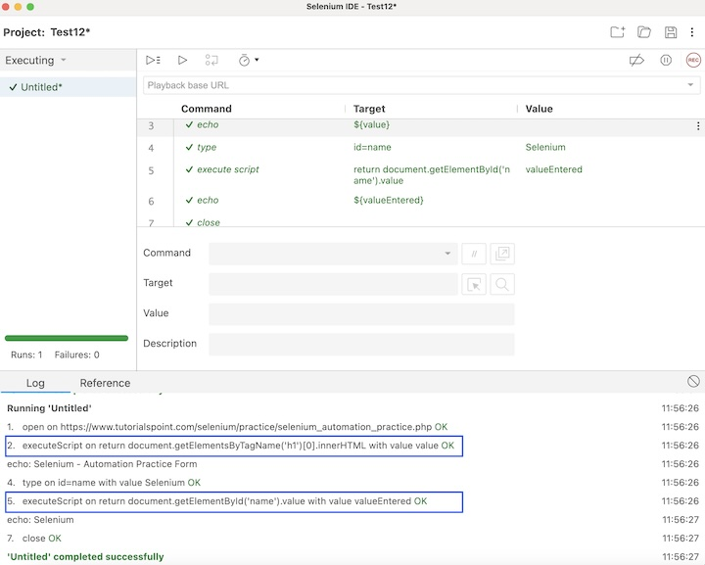
In the example above, we had launched the application and accessed the text - Selenium - Automation Practice Form using the JavaScript command - return document.getElementsByTagName('h1')[0].innerHTML. Then obtained the value entered in the input box with the JavaScript command - return document.getElementById('name').value.
Apart from that, all the test steps, along with the test case name turned green, reflecting a PASS for all the steps. All the steps which reflected under the Log tab, showed an OK in green.
Example 3
Let us take another example of the below page, where we will disable the input box beside the Full Name: label using the JavaScript functions and run script command in Selenium IDE. In the original state, the input box looks like the below image.
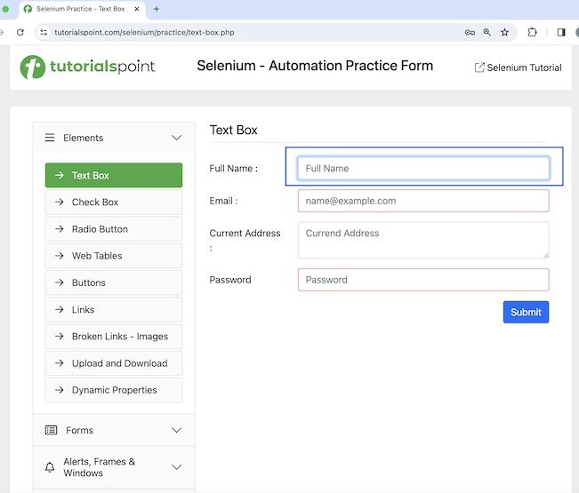
After disabling, the input box will look like the highlighted element in the below image, then we will encounter error if we try to add some text into that disabled field.
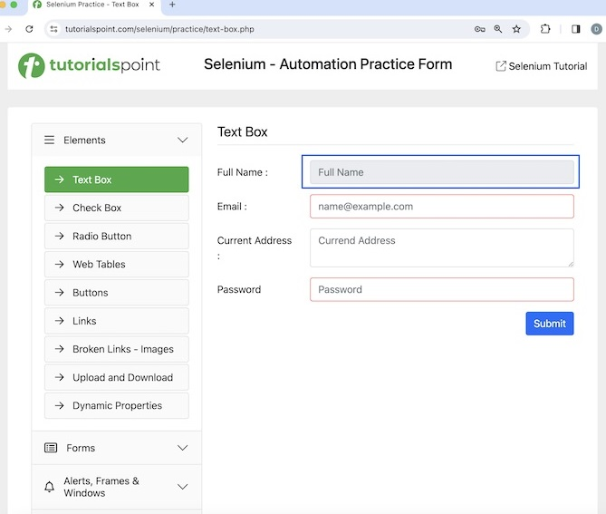
The steps to be followed are listed below −
Step 1 − Follow Steps 1 to 5 as described in the Example 1.
Step 2 − Enter run script in the Command field and document.getElementsByName('fullname')[0].setAttribute('disabled', '') in the Target field.
Please note, document.getElementsName('fullname')[0] is the locator value of the input box.
Step 3 − Enter type in the Command field, id=fullname in the Target field, and Selenium in the Value field. Please note, id=fullname is the locator value of the input box.
Step 4 − Click on the Run all tests from the top, and wait for the test execution to complete. In our example, we would see Runs: 1, Failures: 1, and a red bar denoting the test ran unsuccessfully with failures since we were trying to enter text in a disabled input box. Also, the error message - Element is not currently interactable and may not be manipulated appeared under the Log for the type command.
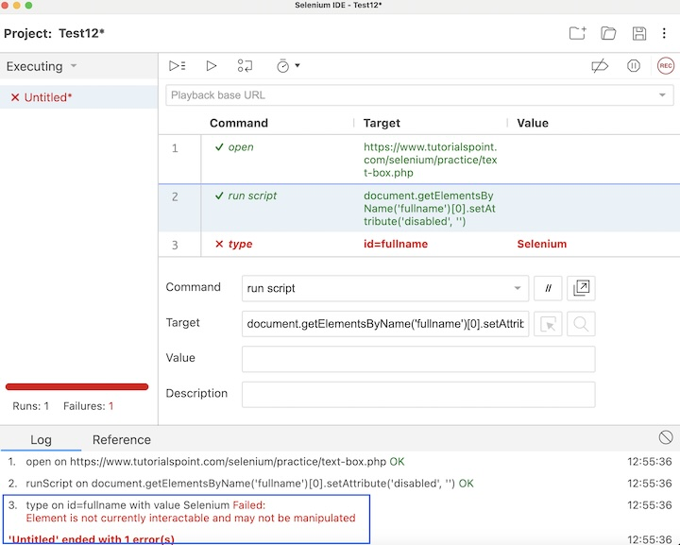
Example 4
Let us take another example of the same page, where we will first disable the input box beside the Full Name: label, then enable it using the JavaScript functions and run script command in Selenium IDE. We will also refresh the web page and navigate back and forward in the browser taking help of the JavaScript functions and execute script commands.
The steps to be followed are listed below −
Step 1 − Follow Steps 1 to 5 as described in the Example 1.
Step 2 − Enter run script in the Command field and document.getElementsByName('fullname')[0].setAttribute('disabled', '') in the Target field.
Please note, document.getElementsName('fullname')[0] is the locator value of the input box.
Step 3 − Enter run script in the Command field and document.getElementsByName('fullname')[0].removeAttribute('disabled') in the Target field.
Please note, document.getElementsName('fullname')[0] is the locator value of the input box.
Step 4 − Enter type in the Command field, id=fullname in the Target field, and Selenium in the Value field. Please note, id=fullname is the locator value of the input box.
Step 5 − Enter execute script in the Command field and history.go[0] in the Target field to refresh the browser.
Step 6 − Enter open in the Command field, and https://www.tutorialspoint.com/selenium/practice/links.php in the Target field, to launch another application.
Step 7 − Enter execute script in the Command field and window.history.go(-1) in the Target field to navigate back to the browser history.
Step 8 − Enter store title in the Command field, and val in the Value field. Please note, the page title is stored in the variable val.
Step 9 − Enter echo in the Command field, ${val} in the Target field. Please note, this would print the page title we obtained in Step8 on the web page under the Log in Selenium IDE.
Step 10 − Enter execute script in the Command field and window.history.go(1) in the Target field to navigate forward to the browser history.
Step 11 − Enter store title in the Command field, and val1 in the Value field. Please note, the page title is stored in the variable val1.
Step 12 − Enter echo in the Command field, ${val1} in the Target field. Please note, this would print the page title we obtained in Step11 on the web page under the Log in Selenium IDE.
Step 13 − Enter close in the Command field to close the browser window.
Step 14 − Click on the Run all tests from the top, and wait for the test execution to complete. In our example, we would see Runs: 1, Failures: 0, and a green bar denoting the test ran successfully without any failures. Also, the message that the completed successfully appeared under the Log.
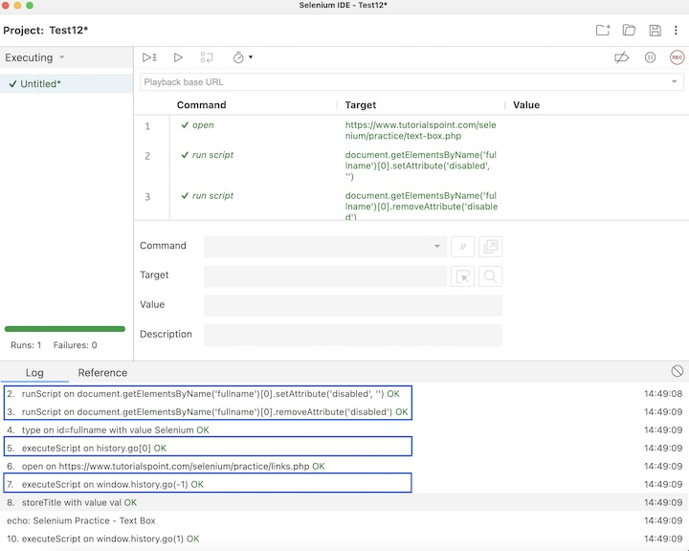
In the example above, we had disabled the input box with the JavaScript function: document.getElementsByName('fullname')[0].setAttribute('disabled', '') along with the run script command, then enabled the same input box with the JavaScript function - document.getElementsByName('fullname')[0].removeAttribute('disabled') using the run script command. We had also refreshed the browser page with the JavaScript function: history.go[0] along with the execute script command.
We had also navigated backward and forward in browser history using the JavaScript functions window.history.go(-1), and window.history.go(1) respectively with the help of the execute script command. Besides, we got a green tick beside the test case name at the top, signifying a passed test.
This concludes our comprehensive take on the tutorial on Selenium IDE - JavaScript functions. Weve started with describing some basic Selenium IDE commands to run JavaScript functions, and examples to walk through how to use the JavaScript functions along with Selenium IDE. This equips you with in-depth knowledge of the JavaScript functions in Selenium IDE. It is wise to keep practicing what youve learned and exploring others relevant to Selenium to deepen your understanding and expand your horizons.
Selenium IDE - Plugins

Previous
Quiz
Next
The functionalities of Selenium IDE can be expanded further by incorporating more commands and locators. This helps to improve the features of Selenium IDE. There are innumerable number of plugins available in Selenium IDE, and some of the most popular ones are listed below −
- Blazemaster Chrome Extension − It is used to perform load testing in Selenium IDE.
- Applitools for Selenium IDE − It is used to perform visual testing in Selenium IDE.
- Chropath − It is a Chrome plugin helpful in identifying the xpath and css locators for web elements.
- Ranorex Selocity − It is used in identifying the xpath and css locators for web elements.
- Katalon Recorder − It is used in identifying the web elements and recording the actions performed on them.
- Page Modeller − It is used in creating the automation tests on multiple languages.
How to Use Plugins in Selenium IDE?
Let us see how to use the plugin Applitools for Selenium IDE along with the Selenium IDE. This would help us to perform visual testing in Selenium IDE. The visual testing is helpful in validating if the application under test has the correct GUI for the end users. The most common example of Visual testing is verifying the logo, color of web elements, font and font size of text, overlapping text, and so on.
Selenium IDE is only capable of Functional testing and can not perform the Visual testing by default. The Applitools for Selenium IDE plugins on top of Selenium IDE is used to perform automation on both the visual testing and functional testing.
The steps to use plugin along with the Selenium IDE are listed below −
Step 1 − Execute the Steps 1 to 4 as described in the link Selenium IDE Store Variables
Step 2 − Install the plugin Applitools for Selenium IDE from the webstore as shown in the below image, then click on the Add to Chrome button.
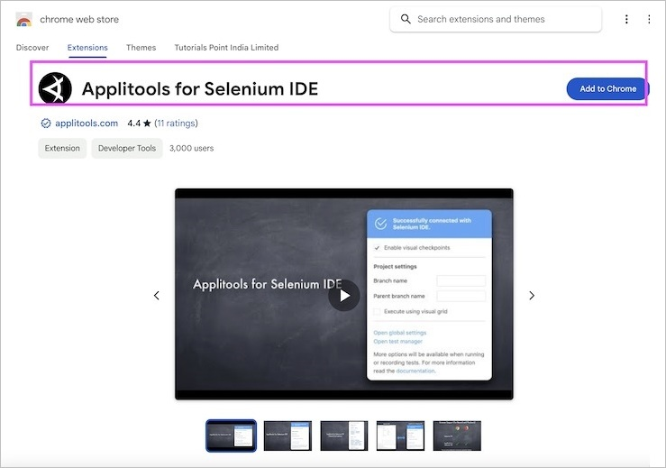
Step 3 − Click on the Add extension button on the pop-up.
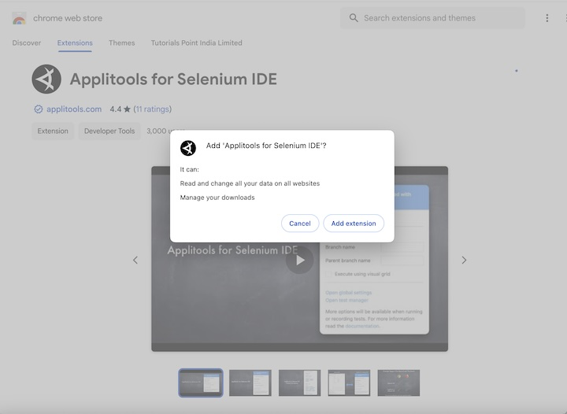
Step 4 − It is recommended that we restart the browser after Step 4. Then the Applitools for Selenium IDE icon would appear on the right upper corner of the browser. Click on it to launch the Applitools for Selenium IDE extension. Then click on the Sign up for a free account link to obtain the API KEY.
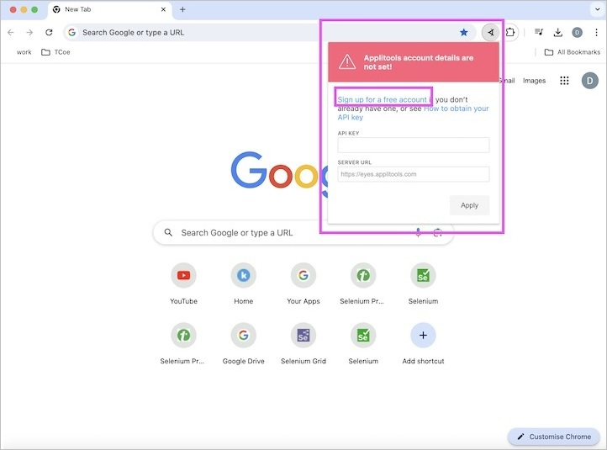
Step 5 − Create an account in the Applitools and click on Sign in.
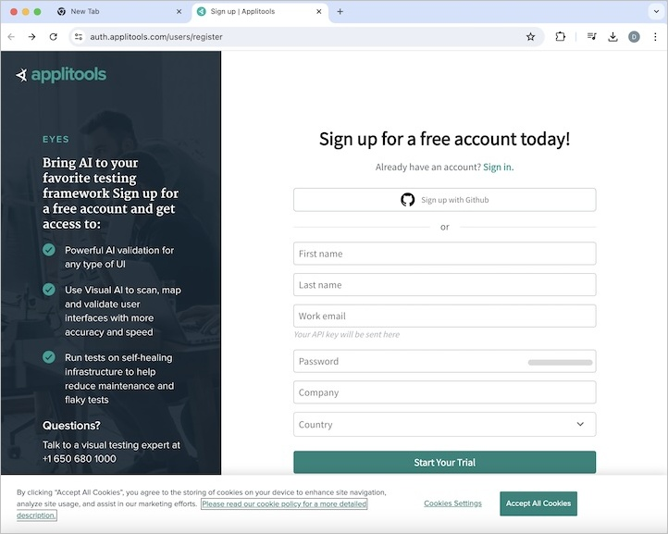
Step 6 − Navigate to the below link and sign in with the credentials set up in the Step 5 −
https://auth.applitools.com/users/login.
Step 7 − Click on the My API key link and copy the API Key.
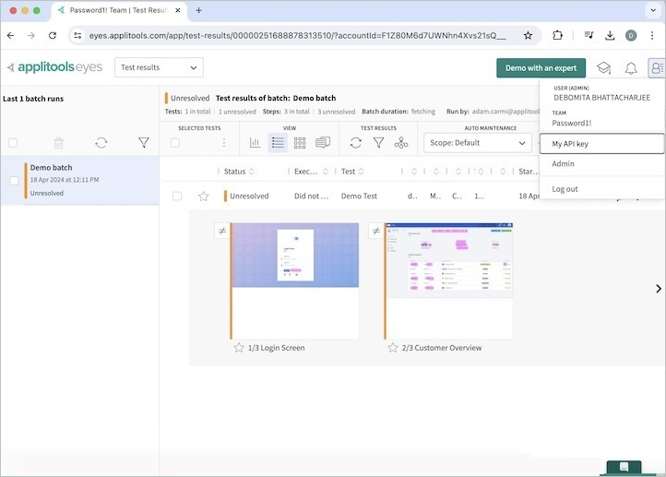
Step 8 − Click on the Applitools for Selenium IDE extension and paste the API Key copied in the Step 10. Then click on the Apply button.
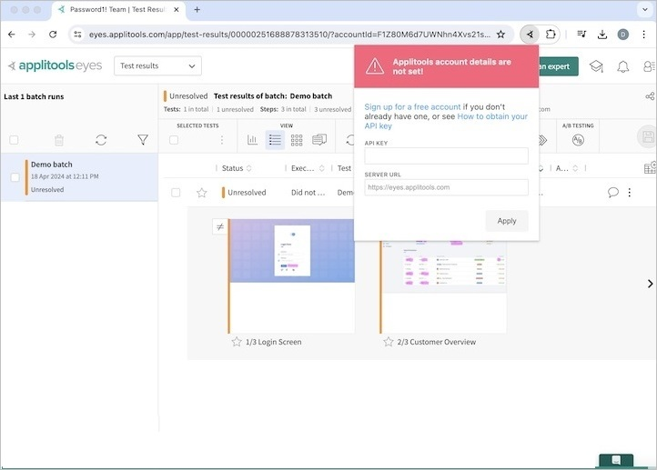
Step 9 − The message - Please open Selenium IDE should appear. Click on the Selenium IDE extension.
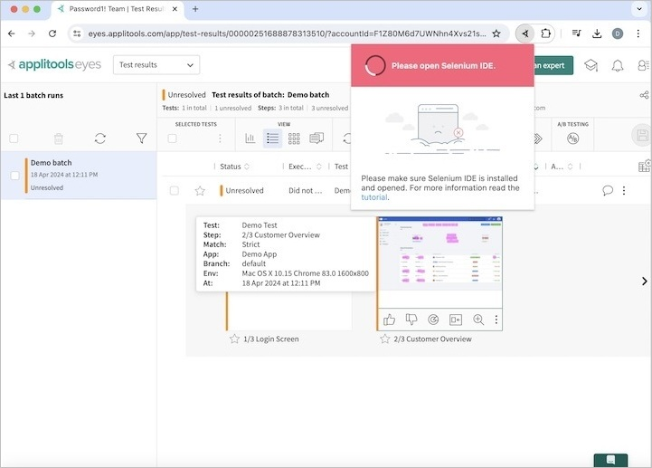
Step 10 − Click on the Create a new project link, then enter a project name, say Test12 under the Please provide a name for your new project. Finally, we would click on the OK button.
Step 11 − We would have the workspace ready in the Selenium IDE now. Check the Applitools for Selenium IDE eye commands for visual testing in Selenium IDE.
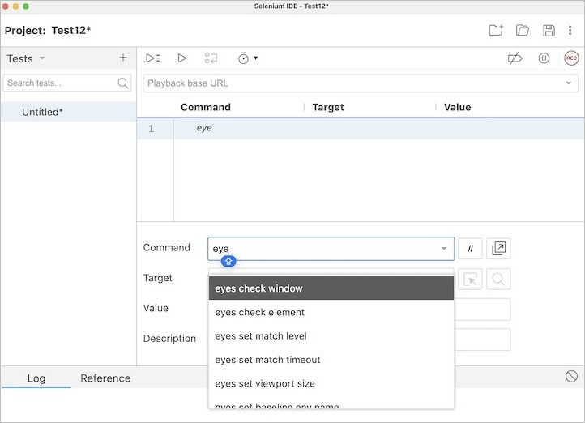
Step 12 − Let us take an example of the below page, click on the radio button beside the Yes label, then perform the visual testing of verifying the visual checkpoint of the complete window.
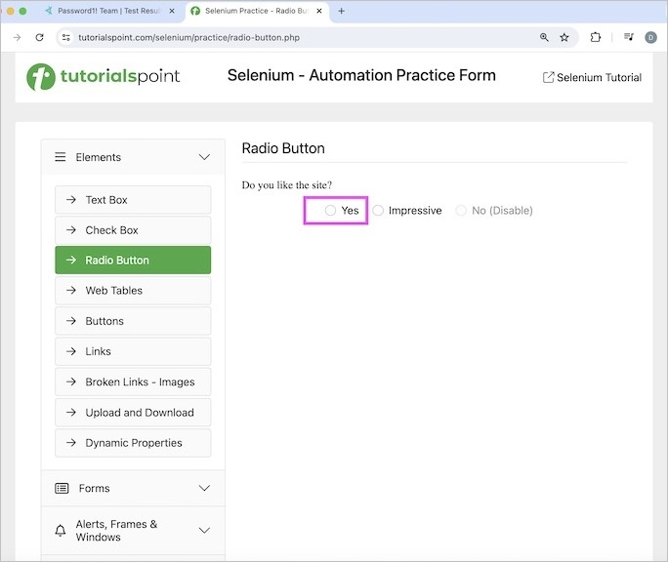
Step 13 − Enter open in the Command field, and Selenium Automation Practice Form in the Target field, to launch the application.
Step 14 − Enter click in the Command field, then enter xpath=/html/body/main/div/div/div[2]/form/div[1]/input in the Target field. Please note, /html/body/main/div/div/div[2]/form/div[1]/input is the xpath locator value of the radio button.
Step 15 − Enter the eyes check window in the Command field, and then enter Window Check in the Target field.
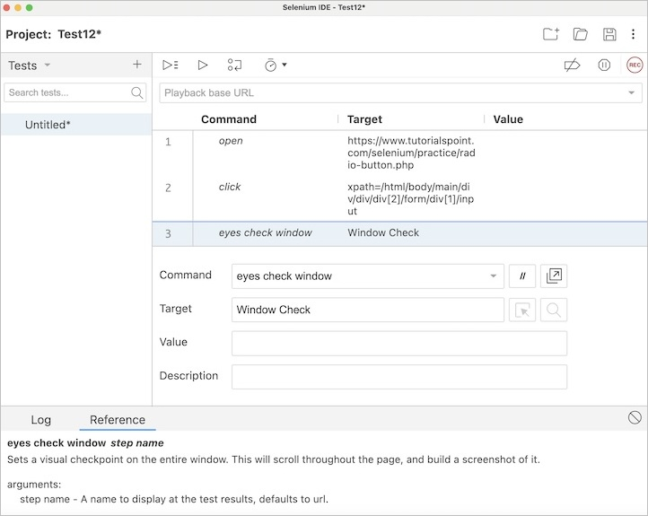
Step 16 − Run the test by clicking Run all tests from the top. The Log message - Preparing plugins for test run and the url to check the visual testing in Applitools should be displayed.
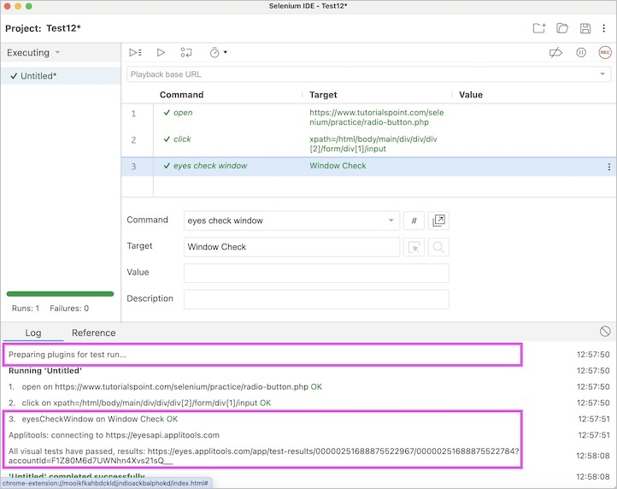
Step 17 − Click on the link displayed in the Log to view the visual testing resulting in the Applitools application.
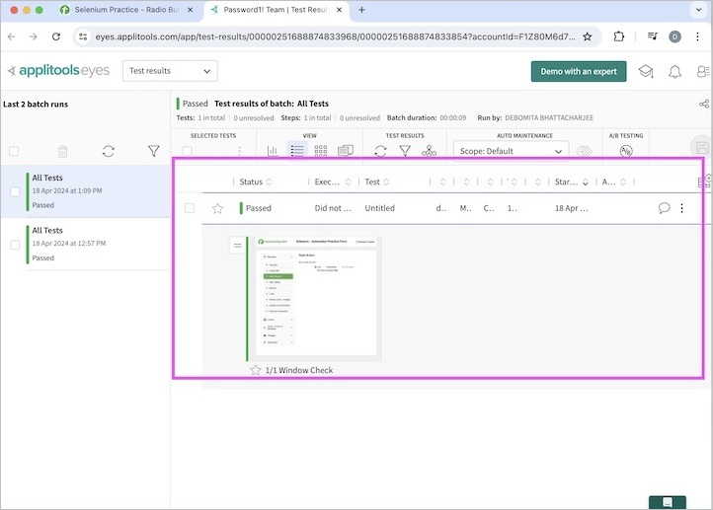
Step 18 − Click on the screenshot captured in the Applitools to get more details of the test like the date of execution, the resolution, platform, browser, and so on.
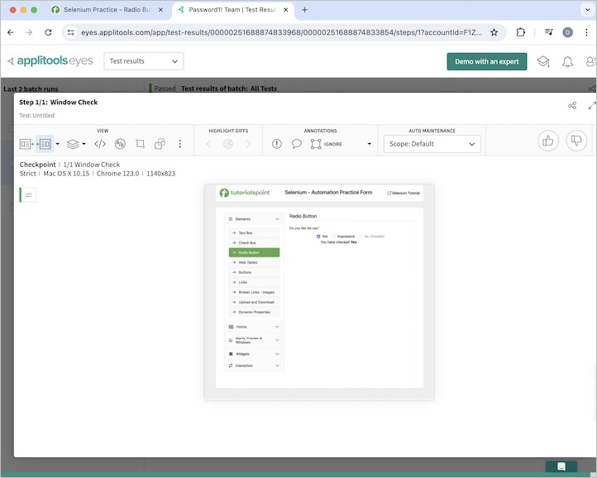
This test included both functional and visual automation testing steps and can be rerun several times to verify if the functionality and GUI of the application under test is working properly.

Conclusion
This concludes our comprehensive take on the tutorial on Selenium IDE Plugins. Weve started with describing some of the plugins used in Selenium IDE, and an example to walk through how to use the plugins with Selenium IDE. This equips you with in-depth knowledge of the plugins in Selenium IDE. It is wise to keep practicing what youve learned and exploring others relevant to Selenium to deepen your understanding and expand your horizons.

Selenium Webdriver - Introduction

Previous
Quiz
Next
Selenium is an automation tool used mainly for creating automation tests for web based applications. It comes without any licensing cost and used to automate tests on various operating systems, devices, and browsers. Selenium tests can be developed using languages like Java, Python, Kotlin, JavaScript, and so on.
Selenium Components
The following are the components of selenium −
- Selenium IDE
- Selenium RC
- Selenium Webdriver
- Selenium Grid

-
00:00
Importance of Selenium Webdriver
Selenium Webdriver came into existence to overcomes the problems of the Selenium RC. The architecture of Selenium RC is not an easy one and it requires a lot of time to complete the test execution.
Selenium Webdriver on the other hand has a simplier architecture, and communicates directly with the web browsers thereby making execution time shorter. Hence, Selenium Webdriver became more popular than Selenium RC.
Read More: Selenium WebDriver vs RC
Advantages of Selenium Webdriver
Let us discuss some of the advantages of Selenium Webdriver −
- Selenium is a free and open-source tool.
- Can be extended for various technologies that expose DOM.
- Supports multiple browsers.
- Supports multiple operating systems, and platforms.
- Supports mobile devices.
- Supports headless and parallel executions.
- Has a big community support for help in case of issues.
Disadvantages of Selenium Webdriver
Let us discuss some of the disadvantages of Selenium Webdriver −
- Supports only web based applications.
- No support for QR, captcha and barcode, scenario.
- No feature such as Object Repository/Recovery Scenario.
- No default test report generation.
- Programming and technical knowledge required.
- It requires time to be more compatible and stable with new browsers.
- Difficult to set up since no vendor support.
Configure Selenium Webdriver in Different Languages
Selenium Webdriver can be used in conjunction with multiple languages like Java, Python, C#, JavaScript, Ruby, and so on. Prior Selenium Webdriver configuration, it is mandatory to configure these languages before actually working with Selenium.
- Selenium with Java Tutorial
- Selenium with Python Tutorial
- Selenium with C# Tutorial
- Selenium with Javascript Tutorial
- Selenium with Kotlin Tutorial
This concludes our comprehensive take on the tutorial on Selenium Webdriver - Introduction. Weve started with describing what Selenium Webdriver is, why Selenium Webdriver is important, and configure Selenium Webdriver in different languages.
This equips you with in-depth knowledge of the Selenium WebDriver - Introduction. It is wise to keep practicing what youve learned and exploring others relevant to Selenium to deepen your understanding and expand your horizons.
Selenium WebDriver vs RC

Previous
Quiz
Next
There exist many differences between Selenium Webdriver and Selenium RC. Though both these tools help in creating automation tests using various programming languages, they are different in many ways.
Selenium WebDriver
Selenium WebDriver is the successor to Selenium Remote Control which sends commands directly to the browser and retrieves results. Let us now discuss the architecture of Selenium Webdriver.

Selenium WebDriver Architecture
Selenium Web Driver architecture in a simplified diagram is described below −
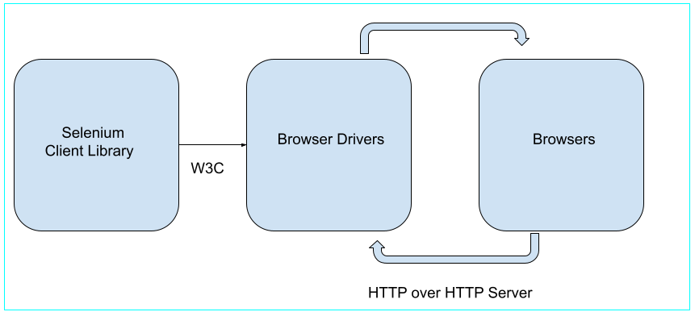
From the Selenium 4 version, the entire architecture is fully compatible with W3C - World Wide Consortium meaning Selenium 4 follows all the standards and guidelines given by W3C. We can get more information about W3C from the below link −
https://www.tutorialspoint.com/world-wide-web-consortium-w3c.
Selenium Webdriver architecture is straightforward. It does not require any proxy server and communicates directly with the browser. Only an IDE is required to develop the code for the tests, and a browser on which those tests would be performed.
Selenium WebDriver API enables interaction between browsers and browser drivers. This architecture consists of four layers namely the Selenium Client Library, W3C Protocol, Browser Drivers and Browsers. Since the browsers, browser drivers, and Selenium webdriver are compliant with W3C protocols, hence the interaction between the client libraries and the browser drivers are more efficient, faster, reliable, and stable.
- Selenium Client Library consists of languages like Java, Ruby, Python, C# and so on. A test case written in any language is used to send the command to interact with the browsers.
- After the code is triggered, it will be converted to Json or other standard similar formats by the client as per the W3C protocol.
- W3C protocol is used for the task of transferring information from the server to the client. The browser drivers act as a link between the client and browser. The browser drivers have the serialized request which is actually performed on the browsers. Browser drivers interact with their respective browsers and execute the commands by interpreting Json. As soon as the browser drivers get any instructions, they run them on the browsers. Then the response is given back in the form of HTTP response.
- The browser drivers also serialize the response it receives in a standardized format as per W3C protocols and send it back to the client. Then the client would deserialize the responses it received to confirm if there is a successful execution of the command request.
Lets consider the below block of code −
WebDriver driver = new ChromeDriver();
driver.get (https://www.tutorialspoint.com/selenium/practice/selenium_automation_practice.php);
Once we run this block of code, the entire code will be converted to JSON or any other standard formats as per W3C protocols over HTTP as a URL. The converted URL will be fed to the ChromeDriver.
The browser driver utilizes HTTP server to get the request from HTTP. As the browser driver gets the URL, it passes the request to its browser via HTTP. It will trigger the event of executing the Selenium instructions on the browser.
Now if the request is that of POST, it will trigger an action on the browser. If its a GET request, then the response will be produced at the browser end. Finally it will be passed over HTTP to the browser driver. The browser driver will in turn send it to the UI.
Selenium Remote Control (RC)
Selenium Remote Control is a server implemented in Java. Selenium Remote Control (RC) was the flagship testing framework that allowed more than simple browser actions and linear execution. It can accept commands for browsers using the HTTP. Selenium Remote Control has a Selenium Remote Control server and a Selenium Remote Control client. In the current version of Selenium, Selenium RC is outdated and it has been deprecated by Selenium.
Selenium Remote Control Architecture
Let us now discuss the architecture of Selenium Remote Control. Selenium Remote Control architecture in a simplified diagram is described below −

Selenium Remote Control architecture is not straightforward. In order to trigger tests in Selenium Remote Control, we would need to install and set up the Remote Control Server in our system. It is similar to a bridge between the web browser and the commands. Selenium Remote Control server puts the Selenium Core (a program in JavaScript) within the browser. Post this, the Selenium Core gets the message from the Selenium Remote Control server as per tests in the form of JavaScript commands. The browsers perform the commands received from the Selenium Core, and send test responses back to the server.
Thus the architecture on which Selenium Remote Control is built makes the test execution slow, as it is based on the Selenium Core, which is a JavaScript language.
This sums up the overall explanation of the Selenium WebDriver Architecture.
Difference Between Selenium WebDriver and Remote Control (RC)
The basic difference between the Selenium Remote Control and Selenium Webdriver are listed below −
Features | Selenium Webdriver | Selenium RC
Architecture | Simple and straightforward | Complex with client and server
Server | No server is required to start test execution | A server is required to start test execution
API | Has stronger APIs. | Has weeker APIs.
Recording | Cannot be used for recording purposes | Can be used for recording purposes.
Headless | Supports headless execution using the HTMLUnit browser | No support for headless execution.
iPhone/Android | Capable of testing mobile devices using the Android Driver and iPhone Driver | Not capable of testing iPhone/Android mobile devices
Report | Not capable of report generation by default | Report generation in html format is available by default
Performance | Fast as it communicates straight with the browser | Not as fast as the Selenium webdriver because it does not communicate straight with the browser.
OOP | Based entirely on OOP | Based not entirely on OOP
Browser Support | Not readily stable while supporting new browsers | Stable while supporting new browsers
User Interaction | Capable of handling cursor and mouse actions | Not capable of handling cursor and mouse actions
Ease | More complicated to understand with respect to developing tests | Less complicated to understand with respect to developing tests

