Assignment 3A

Implemented Gibbs sampling over the markov network structure using all the four factors, got the mostProbableWord as maxOccurrences of characters in the samples (after burn-in)

It is then used to calculate the modelAccuracy.

Experiments:

Loopy Belief performs better
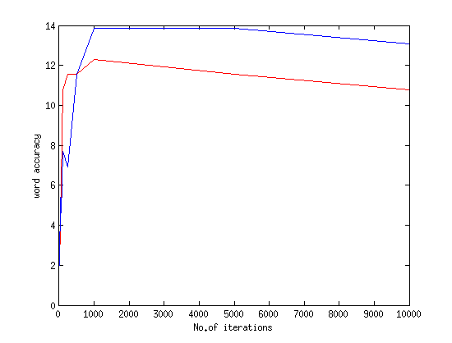

As we increase the number of iterations, the accuracy increases

It does not matter much to choose variable in turn or a random variable for generating the sample, the accuracy is almost same.

