大数据技术之Griffin

版本：V2.0

# 第1章 Griffin入门

## 1.1 Griffin概述

Apache Griffin是一个开源的大数据数据质量解决方案，它支持批处理和流模式两种数据质量检测方式，可以从不同维度度量数据资产，从而提升数据的准确度和可信度。例如：离线任务执行完毕后检查源端和目标端的数据数量是否一致，源表的数据空值等。

## 1.2 Griffin架构原理



# 第2章 Griffin安装及使用

## 2.1 安装前环境准备

### 2.1.1 安装ES5.2

1）上传elasticsearch-5.2.2.tar.gz到hadoop102的/opt/software目录，并解压到/opt/module目录

[atguigu@hadoop102 software]$ tar -zxvf elasticsearch-5.2.2.tar.gz -C /opt/module/

2）修改/opt/module/elasticsearch-5.2.2/config/elasticsearch.yml配置文件

[atguigu@hadoop102 config]$ vim elasticsearch.yml

network.host: hadoop102

http.port: 9200

http.cors.enabled: true

http.cors.allow-origin: "*"

bootstrap.memory_lock: false

bootstrap.system_call_filter: false

3）修改Linux系统配置文件/etc/security/limits.conf

[atguigu@hadoop102 elasticsearch-5.2.2]$ sudo vim /etc/security/limits.conf

#添加如下内容

* soft nproc 65536

* hard nproc 65536

* soft nofile 65536

* hard nofile 65536

[atguigu@hadoop102 elasticsearch-5.2.2]$ sudo vim /etc/sysctl.conf

#添加

vm.max_map_count=655360

[atguigu@hadoop102 elasticsearch-5.2.2]$ sudo vim /etc/security/limits.d/90-nproc.conf

#修改配置

* soft nproc 2048

[atguigu@hadoop102 elasticsearch-5.2.2]$ sudo sysctl -p

4）需要重新启动虚拟机

[atguigu@hadoop102 elasticsearch-5.2.2]$ su root

root@hadoop102 elasticsearch-5.2.2]# reboot

5）在/opt/module/elasticsearch-5.2.2路径上，启动ES

[atguigu@hadoop102 elasticsearch-5.2.2]$ bin/elasticsearch

6）在ES里创建griffin索引

[atguigu@hadoop102 ~]$ curl -XPUT http://hadoop102:9200/griffin -d '

{

"aliases": {},

"mappings": {

"accuracy": {

"properties": {

"name": {

"fields": {

"keyword": {

"ignore_above": 256,

"type": "keyword"

}

},

"type": "text"

},

"tmst": {

"type": "date"

}

}

}

},

"settings": {

"index": {

"number_of_replicas": "2",

"number_of_shards": "5"

}

}

}

'

### 2.1.2 安装JDK8、Hadoop2.7.2

注意：JDK版本至少1.8及以上，Hadoop版本至少2.6.0及以上

1）安装Hadoop集群



2）启动Hadoop集群

[atguigu@hadoop102 hadoop-2.7.2]$ sbin/start-dfs.sh

[atguigu@hadoop103 hadoop-2.7.2]$ sbin/start-yarn.sh

### 2.1.3 安装Hive2.3

注意：Hive版本至少2.2及以上

1）上传apache-hive-2.3.0-bin.tar.gz 到/opt/software目录下，并解压到/opt/module

[atguigu@hadoop102 software]$ tar -zxvf apache-hive-2.3.6-bin.tar.gz -C /opt/module/

2）修改apache-hive-2.3.6-bin名称为hive-2.3.6

[atguigu@hadoop102 module]$ mv apache-hive-2.3.6-bin hive-2.3.6

3）将Mysql的mysql-connector-java-5.1.27-bin.jar拷贝到/opt/module/hive-2.3.6/lib/

[atguigu@hadoop102 module]$ cp /opt/software/mysql-libs/mysql-connector-java-5.1.27/mysql-connector-java-5.1.27-bin.jar /opt/module/hive-2.3.6/lib/

4）在/opt/module/hive-2.3.6/conf路径上，创建hive-site.xml文件

[atguigu@hadoop102 conf]$ vim hive-site.xml

#添加如下内容

<?xml version="1.0"?>

<?xml-stylesheet type="text/xsl" href="configuration.xsl"?>

<configuration>

<property>

<name>javax.jdo.option.ConnectionURL</name>

<value>jdbc:mysql://hadoop102:3306/metastore?createDatabaseIfNotExist=true</value>

<description>JDBC connect string for a JDBC metastore</description>

</property>

<property>

<name>javax.jdo.option.ConnectionDriverName</name>

<value>com.mysql.jdbc.Driver</value>

<description>Driver class name for a JDBC metastore</description>

</property>

<property>

<name>javax.jdo.option.ConnectionUserName</name>

<value>root</value>

<description>username to use against metastore database</description>

</property>

<property>

<name>javax.jdo.option.ConnectionPassword</name>

<value>000000</value>

<description>password to use against metastore database</description>

</property>

<property>

<name>hive.metastore.warehouse.dir</name>

<value>/user/hive/warehouse</value>

<description>location of default database for the warehouse</description>

</property>

<property>

<name>hive.cli.print.header</name>

<value>true</value>

</property>

<property>

<name>hive.cli.print.current.db</name>

<value>true</value>

</property>

<property>

<name>hive.metastore.schema.verification</name>

<value>false</value>

</property>

<property>

<name>datanucleus.schema.autoCreateAll</name>

<value>true</value>

</property>

<property>

<name>hive.metastore.uris</name>

<value>thrift://hadoop102:9083</value>

</property>

</configuration>

3）启动服务

[atguigu@hadoop102 hive-2.3.6]$ nohup bin/hive --service metastore &

[atguigu@hadoop102 hive-2.3.6]$ nohup bin/hive --service hiveserver2 &

注意：hive2.x版本需要启动两个服务metastore和hiveserver2，否则会报错Exception in thread "main" java.lang.RuntimeException: org.apache.hadoop.hive.ql.metadata.HiveException: java.lang.RuntimeException: Unable to instantiate org.apache.hadoop.hive.ql.metadata.SessionHiveMetaStoreClient

4）服务启动完毕后在启动Hive

[atguigu@hadoop102 hive-2.3.6]$ bin/hive

### 2.1.4 安装Spark2.4.3

注意：Spark版本至少2.2.1及以上

1）把spark-2.4.3-bin-hadoop2.7.tgz上传到/opt/software目录，并解压到/opt/module

[atguigu@hadoop102 software]$ tar -zxvf spark-2.4.3-bin-hadoop2.7.tgz -C /opt/module/

2）修改名称/opt/module/spark-2.4.3-bin-hadoop2.7名称为spark

[atguigu@hadoop102 module]$ mv spark-2.4.3-bin-hadoop2.7/ spark

3）修改/opt/module/spark/conf/spark-defaults.conf.template名称为spark-defaults.conf

[atguigu@hadoop102 conf]$ mv spark-defaults.conf.template spark-defaults.conf

4）在hadoop集群上提前创建spark_directory日志路径

[atguigu@hadoop102 spark]$ hadoop fs -mkdir /spark_directory

5）在spark-default.conf文件中配置Spark日志路径

[atguigu@hadoop102 conf]$ vim spark-defaults.conf

#添加如下配置

spark.eventLog.enabled true

spark.eventLog.dir hdfs://hadoop102:9000/spark_directory

6）修改/opt/module/spark/conf/spark-env.sh.template名称为spark-env.sh

[atguigu@hadoop102 conf]$ mv spark-env.sh.template spark-env.sh

7）在/opt/module/spark/conf/spark-env.sh文件中配置YARN配置文件路径、配置历史服务器相关参数

[atguigu@hadoop102 conf]$ vim spark-env.sh

#添加如下参数

YARN_CONF_DIR=/opt/module/hadoop-2.7.2/etc/hadoop

export SPARK_HISTORY_OPTS="-Dspark.history.ui.port=18080

-Dspark.history.retainedApplications=30

-Dspark.history.fs.logDirectory=hdfs://hadoop102:9000/spark_directory"

8）把Hive中/opt/module/hive-2.3.6/lib/datanucleus-*.jar包拷贝到Spark的/opt/module/spark/jars路径

[atguigu@hadoop102 lib]$ cp /opt/module/hive-2.3.6/lib/datanucleus-*.jar /opt/module/spark/jars/

9）把Hive中/opt/module/hive-2.3.6/conf/hive-site.xml包拷贝到Spark的/opt/module/spark/conf路径

[atguigu@hadoop102 conf]$ cp /opt/module/hive-2.3.6/conf/hive-site.xml /opt/module/spark/conf/

10）测试环境

[atguigu@hadoop102 spark]$ bin/spark-shell

scala>spark.sql("show databases").show

### 2.1.5 安装Livy0.3

1）上传livy-server-0.3.0.zip到hadoop102的/opt/software目录下，并解压到/opt/module

[atguigu@hadoop102 software]$ unzip livy-server-0.3.0.zip -d /opt/module/

2）修改/opt/module/livy-server-0.3.0文件名称为livy

[atguigu@hadoop102 module]$ mv livy-server-0.3.0/ livy

3）修改/opt/module/livy/conf/livy.conf文件，配置livy与spark相关参数

livy.server.host = Hadoop102

livy.spark.master =yarn

livy.spark.deployMode = client

livy.repl.enableHiveContext = true

livy.server.port = 8998

4）配置需要的环境变量

[atguigu@hadoop102 conf]$ sudo vim /etc/profile

#SPARK_HOME

export SPARK_HOME=/opt/module/spark

export PATH=$PATH:$SPARK_HOME/bin

[atguigu@hadoop102 conf]$ source /etc/profile

5）在/opt/module/livy/路径上，启动livy服务

[atguigu@hadoop102 livy]$ bin/livy-server start

### 2.1.6 安装MySQL5.6

1）上传Init_quartz_mysql_innodb.sql 到hadoop102的/opt/software目录

2）使用mysql创建quartz库，执行脚本初始化表信息

[atguigu@hadoop102 ~]$ mysql -uroot -p000000

mysql> create database quartz;

mysql> use quartz;

mysql> source /opt/software/Init_quartz_mysql_innodb.sql

mysql> show tables;

### 2.1.7 安装Maven

1）Maven下载：https://maven.apache.org/download.cgi

2）把apache-maven-3.6.1-bin.tar.gz上传到linux的/opt/software目录下

3）解压apache-maven-3.6.1-bin.tar.gz到/opt/module/目录下面

[atguigu@hadoop102 software]$ tar -zxvf apache-maven-3.6.1-bin.tar.gz -C /opt/module/

4）修改apache-maven-3.6.1的名称为maven

[atguigu@hadoop102 module]$ mv apache-maven-3.6.1/ maven

5）添加环境变量到/etc/profile中

[atguigu@hadoop102 module]$ sudo vim /etc/profile

#MAVEN_HOME

export MAVEN_HOME=/opt/module/maven

export PATH=$PATH:$MAVEN_HOME/bin

6）测试安装结果

[atguigu@hadoop102 module]$ source /etc/profile

[atguigu@hadoop102 module]$ mvn -v

7）修改setting.xml，指定为阿里云

[atguigu@hadoop102 maven]$ cd conf

[atguigu@hadoop102 maven]$ vim settings.xml

<!-- 添加阿里云镜像-->

<mirror>

<id>nexus-aliyun</id>

<mirrorOf>central</mirrorOf>

<name>Nexus aliyun</name>

<url>http://maven.aliyun.com/nexus/content/groups/public</url>

</mirror>

<mirror>

<id>UK</id>

<name>UK Central</name>

<url>http://uk.maven.org/maven2</url>

<mirrorOf>central</mirrorOf>

</mirror>

<mirror>

<id>repo1</id>

<mirrorOf>central</mirrorOf>

<name>Human Readable Name for this Mirror.</name>

<url>http://repo1.maven.org/maven2/</url>

</mirror>

<mirror>

<id>repo2</id>

<mirrorOf>central</mirrorOf>

<name>Human Readable Name for this Mirror.</name>

<url>http://repo2.maven.org/maven2/</url>

</mirror>

8）在/home/atguigu目录下创建.m2文件夹

[atguigu@hadoop102 ~]$ mkdir .m2

## 2.2 编译Griffin0.4.0

### 2.2.1 修改配置文件:

1）上传griffin-master.zip到hadoop102的/opt/software目录，并解压tar.gz包到/opt/module

[atguigu@hadoop102 software]$ unzip griffin-master.zip -d /opt/module/

2）修改/opt/module/griffin-master/service/pom.xml文件，注释掉org.postgresql，添加mysql依赖。

[atguigu@hadoop102 service]$ vim pom.xml

<!--

<dependency>

<groupId>org.postgresql</groupId>

<artifactId>postgresql</artifactId>

<version>${postgresql.version}</version>

</dependency>

-->

<dependency>

<groupId>mysql</groupId>

<artifactId>mysql-connector-java</artifactId>

</dependency>

注意:版本号删除掉

3）修改/opt/module/griffin-master/service/src/main/resources/application.properties文件

[atguigu@hadoop102 service]$ vim /opt/module/griffin-master/service/src/main/resources/application.properties

# Apache Griffin应用名称

spring.application.name=griffin_service

# MySQL数据库配置信息

spring.datasource.url=jdbc:mysql://hadoop102:3306/quartz?autoReconnect=true&useSSL=false

spring.datasource.username=root

spring.datasource.password=000000

spring.jpa.generate-ddl=true

spring.datasource.driver-class-name=com.mysql.jdbc.Driver

spring.jpa.show-sql=true

# Hive metastore配置信息

hive.metastore.uris=thrift://hadoop102:9083

hive.metastore.dbname=default

hive.hmshandler.retry.attempts=15

hive.hmshandler.retry.interval=2000ms

# Hive cache time

cache.evict.hive.fixedRate.in.milliseconds=900000

# Kafka schema registry按需配置

kafka.schema.registry.url=http://hadoop102:8081

# Update job instance state at regular intervals

jobInstance.fixedDelay.in.milliseconds=60000

# Expired time of job instance which is 7 days that is 604800000 milliseconds.Time unit only supports milliseconds

jobInstance.expired.milliseconds=604800000

# schedule predicate job every 5 minutes and repeat 12 times at most

#interval time unit s:second m:minute h:hour d:day,only support these four units

predicate.job.interval=5m

predicate.job.repeat.count=12

# external properties directory location

external.config.location=

# external BATCH or STREAMING env

external.env.location=

# login strategy ("default" or "ldap")

login.strategy=default

# ldap

ldap.url=ldap://hostname:port

ldap.email=@example.com

ldap.searchBase=DC=org,DC=example

ldap.searchPattern=(sAMAccountName={0})

# hdfs default name

fs.defaultFS=

# elasticsearch

elasticsearch.host=hadoop102

elasticsearch.port=9200

elasticsearch.scheme=http

# elasticsearch.user = user

# elasticsearch.password = password

# livy

livy.uri=http://hadoop102:8998/batches

# yarn url

yarn.uri=http://hadoop103:8088

# griffin event listener

internal.event.listeners=GriffinJobEventHook

4）修改/opt/module/griffin-master/service/src/main/resources/sparkProperties.json文件

[atguigu@hadoop102 service]$ vim /opt/module/griffin-master/service/src/main/resources/sparkProperties.json

{

"file": "hdfs://hadoop102:9000/griffin/griffin-measure.jar",

"className": "org.apache.griffin.measure.Application",

"name": "griffin",

"queue": "default",

"numExecutors": 2,

"executorCores": 1,

"driverMemory": "1g",

"executorMemory": "1g",

"conf": {

"spark.yarn.dist.files": "hdfs://hadoop102:9000/home/spark_conf/hive-site.xml"

},

"files": [

]

}

5）修改/opt/module/griffin-master/service/src/main/resources/env/env_batch.json文件

[atguigu@hadoop102 service]$ vim /opt/module/griffin-master/service/src/main/resources/env/env_batch.json

{

"spark": {

"log.level": "INFO"

},

"sinks": [

{

"type": "CONSOLE",

"config": {

"max.log.lines": 10

}

},

{

"type": "HDFS",

"config": {

"path": "hdfs://hadoop102:9000/griffin/persist",

"max.persist.lines": 10000,

"max.lines.per.file": 10000

}

},

{

"type": "ELASTICSEARCH",

"config": {

"method": "post",

"api": "http://hadoop102:9200/griffin/accuracy",

"connection.timeout": "1m",

"retry": 10

}

}

],

"griffin.checkpoint": []

}

6）修改/opt/module/griffin-master/service/src/main/resources/env/env_streaming.json文件

[atguigu@hadoop102 service]$ vim /opt/module/griffin-master/service/src/main/resources/env/env_streaming.json

{

"spark": {

"log.level": "WARN",

"checkpoint.dir": "hdfs:///griffin/checkpoint/${JOB_NAME}",

"init.clear": true,

"batch.interval": "1m",

"process.interval": "5m",

"config": {

"spark.default.parallelism": 4,

"spark.task.maxFailures": 5,

"spark.streaming.kafkaMaxRatePerPartition": 1000,

"spark.streaming.concurrentJobs": 4,

"spark.yarn.maxAppAttempts": 5,

"spark.yarn.am.attemptFailuresValidityInterval": "1h",

"spark.yarn.max.executor.failures": 120,

"spark.yarn.executor.failuresValidityInterval": "1h",

"spark.hadoop.fs.hdfs.impl.disable.cache": true

}

},

"sinks": [

{

"type": "CONSOLE",

"config": {

"max.log.lines": 100

}

},

{

"type": "HDFS",

"config": {

"path": "hdfs://hadoop102:9000/griffin/persist",

"max.persist.lines": 10000,

"max.lines.per.file": 10000

}

},

{

"type": "ELASTICSEARCH",

"config": {

"method": "post",

"api": "http://hadoop102:9200/griffin/accuracy"

}

}

],

"griffin.checkpoint": [

{

"type": "zk",

"config": {

"hosts": "zk:2181",

"namespace": "griffin/infocache",

"lock.path": "lock",

"mode": "persist",

"init.clear": true,

"close.clear": false

}

}

]

}

7）修改/opt/module/griffin-master/service/src/main/resources/quartz.properties文件

[atguigu@hadoop102 service]$ vim /opt/module/griffin-master/service/src/main/resources/quartz.properties

org.quartz.scheduler.instanceName=spring-boot-quartz

org.quartz.scheduler.instanceId=AUTO

org.quartz.threadPool.threadCount=5

org.quartz.jobStore.class=org.quartz.impl.jdbcjobstore.JobStoreTX

# If you use postgresql as your database,set this property value to org.quartz.impl.jdbcjobstore.PostgreSQLDelegate

# If you use mysql as your database,set this property value to org.quartz.impl.jdbcjobstore.StdJDBCDelegate

# If you use h2 as your database, it's ok to set this property value to StdJDBCDelegate, PostgreSQLDelegate or others

org.quartz.jobStore.driverDelegateClass=org.quartz.impl.jdbcjobstore.StdJDBCDelegate

org.quartz.jobStore.useProperties=true

org.quartz.jobStore.misfireThreshold=60000

org.quartz.jobStore.tablePrefix=QRTZ_

org.quartz.jobStore.isClustered=true

org.quartz.jobStore.clusterCheckinInterval=20000

### 2.2.2 执行编译

1）在/opt/module/griffin-master路径执行maven命令，开始编译Griffin源码

[atguigu@hadoop102 griffin-master]$ mvn -Dmaven.test.skip=true clean install

2）见到如下页面，表示编译成功。（大约需要1个小时左右）

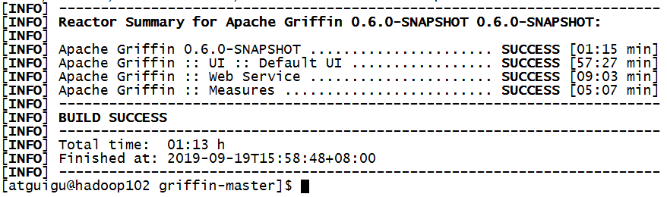

### 2.2.3 修改名称并上传HDFS

命令执行完成后，会在Service和Measure模块的target目录下分别看到service-0.6.0.jar和measure-0.6.0.jar两个jar包。

1）修改/opt/module/griffin-master/measure/target/measure-0.6.0-SNAPSHOT.jar名称

[atguigu@hadoop102 measure]$ mv measure-0.6.0-SNAPSHOT.jar griffin-measure.jar

2）上传griffin-measure.jar到HDFS文件目录里

[atguigu@hadoop102 measure]$ hadoop fs -mkdir /griffin/

[atguigu@hadoop102 measure]$ hadoop fs -put griffin-measure.jar /griffin/

注意：这样做的目的主要是因为Spark在YARN集群上执行任务时，需要到HDFS的/griffin目录下加载griffin-measure.jar，避免发生类org.apache.griffin.measure.Application找不到的错误。

3）上传hive-site.xml文件到HDFS的/home/spark_conf/路径

[atguigu@hadoop102 ~]$ hadoop fs -mkdir -p /home/spark_conf/

[atguigu@hadoop102 ~]$ hadoop fs -put /opt/module/hive-2.3.6/conf/hive-site.xml /home/spark_conf/

4）进入到/opt/module/griffin-master/service/target/路径，运行service-0.6.0-SNAPSHOT.jar

控制台启动：控制台打印信息

[atguigu@hadoop102 target]$ java -jar service-0.6.0-SNAPSHOT.jar

后台启动：启动后台并把日志归写倒service.out

[atguigu@hadoop102 ~]$ nohup java -jar service-0.6.0-SNAPSHOT.jar>service.out 2>&1 &

### 2.2.4 浏览器访问

http://hadoop102:8080 默认账户和密码都是无

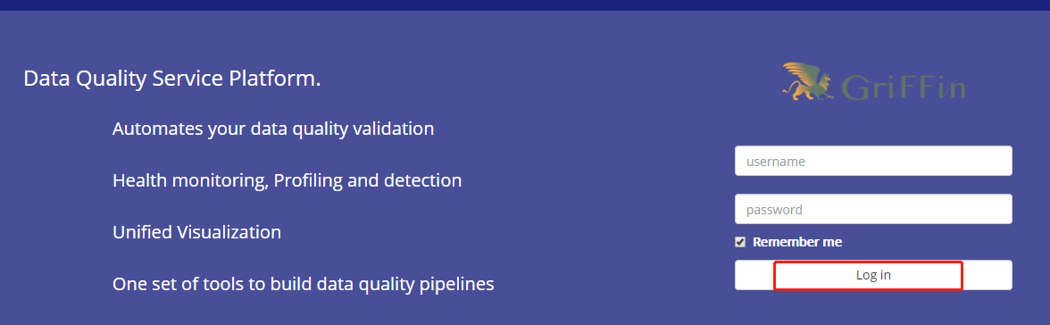

# 第3章 案例实操

## 3.1 生产测试数据

获取官网测试数据。在/opt/module/目录下创建data文件夹，并下载相关测试数据

[atguigu@hadoop102 moudle]$ mkdir data

[atguigu@hadoop102 data]$

wget http://griffin.apache.org/data/batch/gen_demo_data.sh

wget http://griffin.apache.org/data/batch/gen_delta_src.sh

wget http://griffin.apache.org/data/batch/demo_basic

wget http://griffin.apache.org/data/batch/delta_tgt

wget <http://griffin.apache.org/data/batch/insert-data.hql.template>

wget <http://griffin.apache.org/data/batch/gen-hive-data.sh>

wget http://griffin.apache.org/data/batch/create-table.hql

wget <http://griffin.apache.org/data/batch/delta_src>

wget [http://griffin.apache.org/data/batch/](http://griffin.apache.org/data/batch/delta_src)delta_tgt

[atguigu@hadoop102 data]$ chmod 777 ../data -R

#生成临时文件

[atguigu@hadoop102 data]$ ./gen_demo_data.sh

#生产测试数据

[atguigu@hadoop102 data]$ ./gen-hive-data.sh

## 3.2 UI创建Measure

注意根据官网描述，目前UI创建Measure只支持Accuracy的Measure，UI界面上虽然有其他选项但是无法运行job。

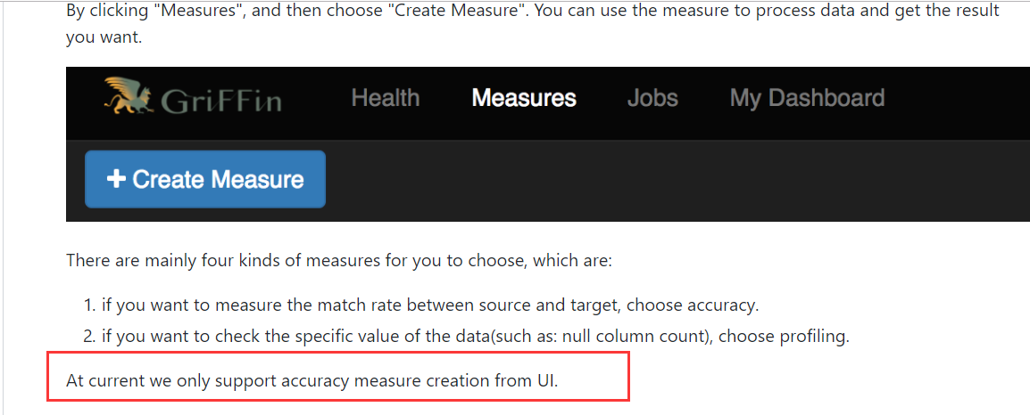

### 3.2.1 添加一个新的Measure

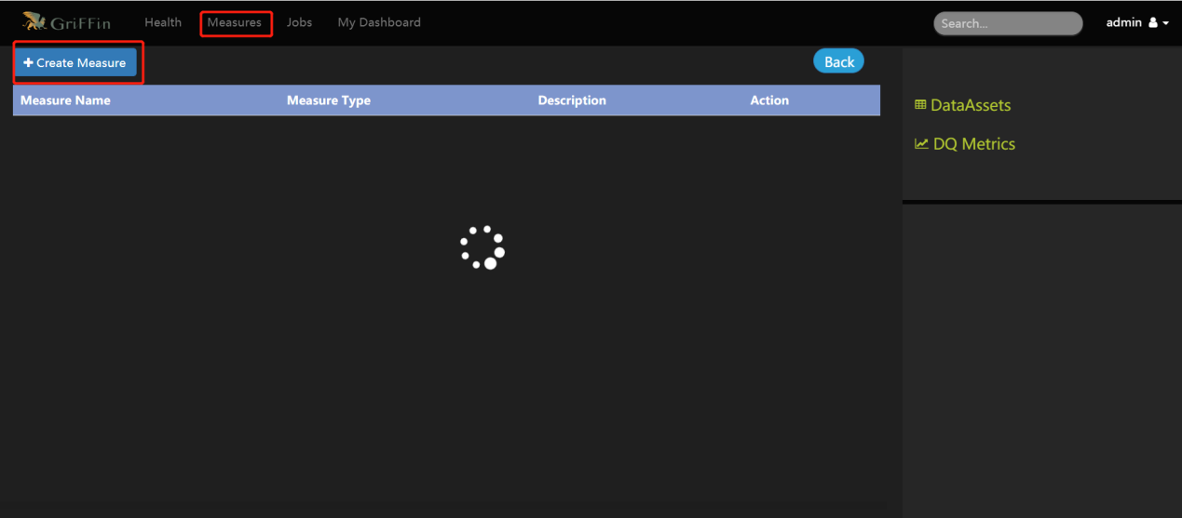

### 3.2.2 选择准确度Accuracy

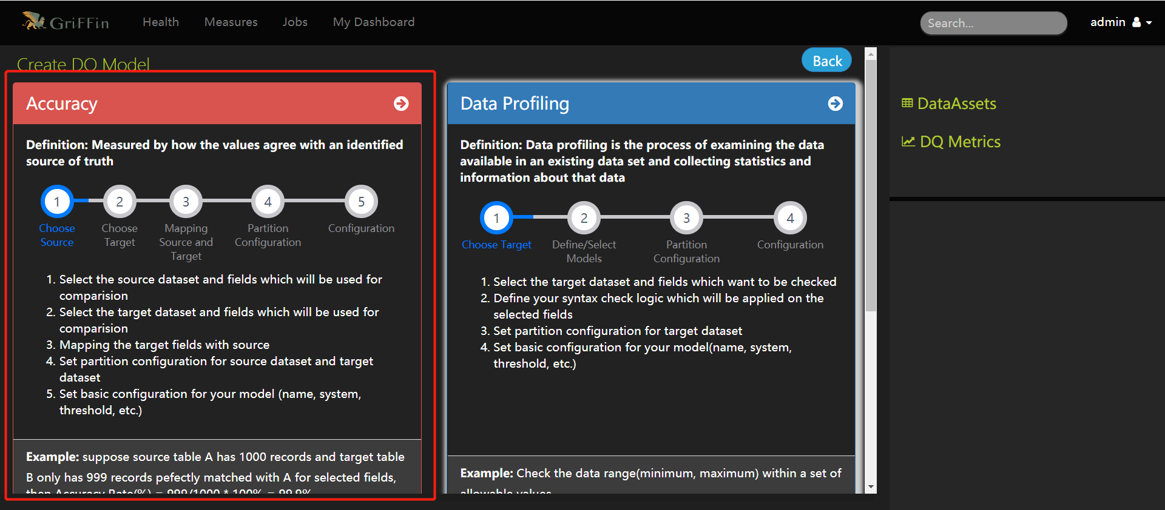

### 3.2.3 选择数据源的字段

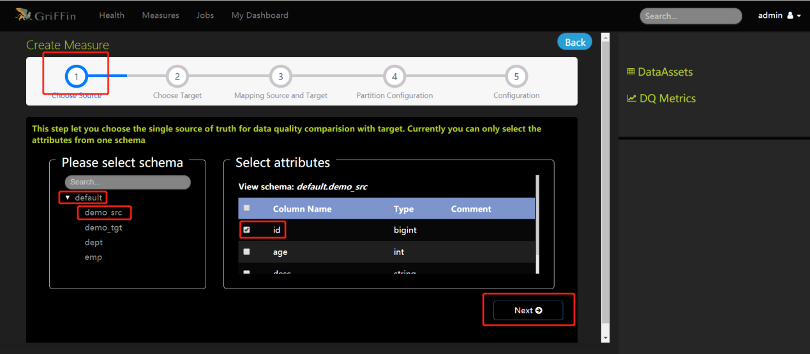

### 3.2.4 选择目标表的字段

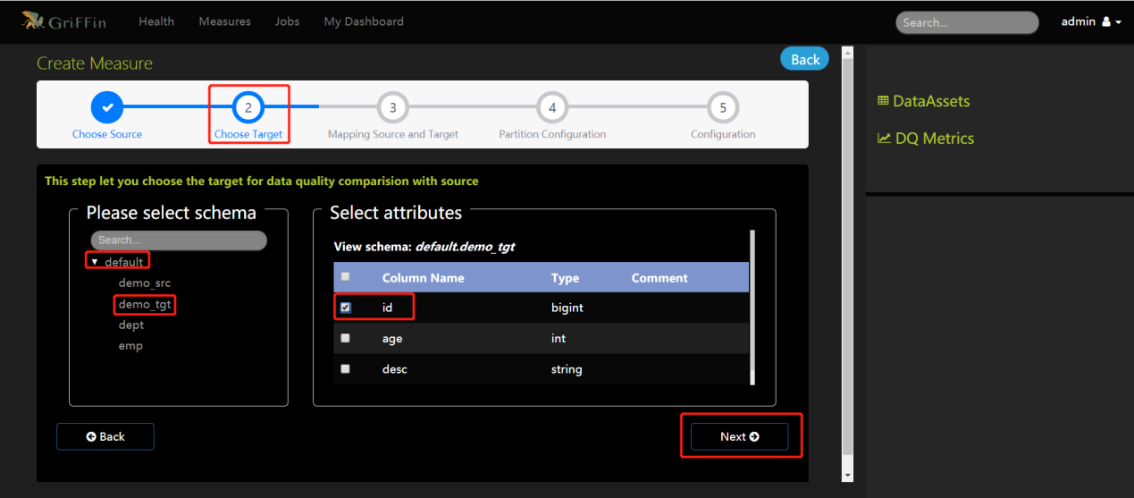

### 3.2.5 选择条件

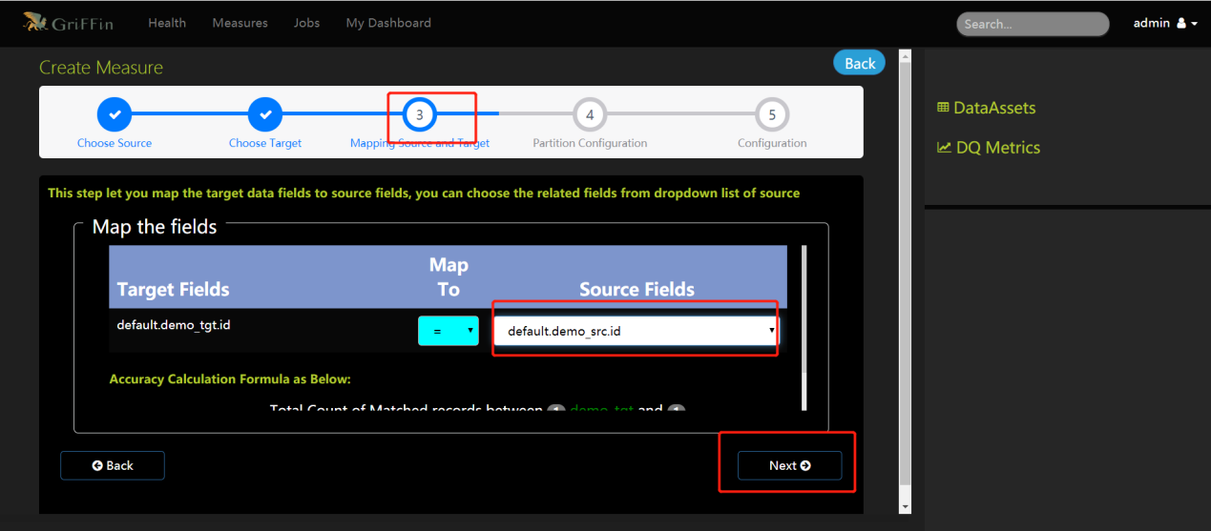

### 3.2.6 选择时间格式和分区尺度

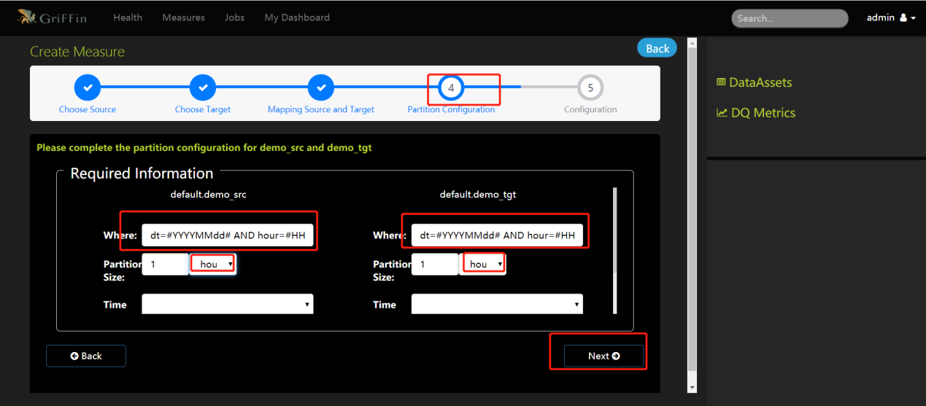

### 3.2.7 添加Measure名称和描述

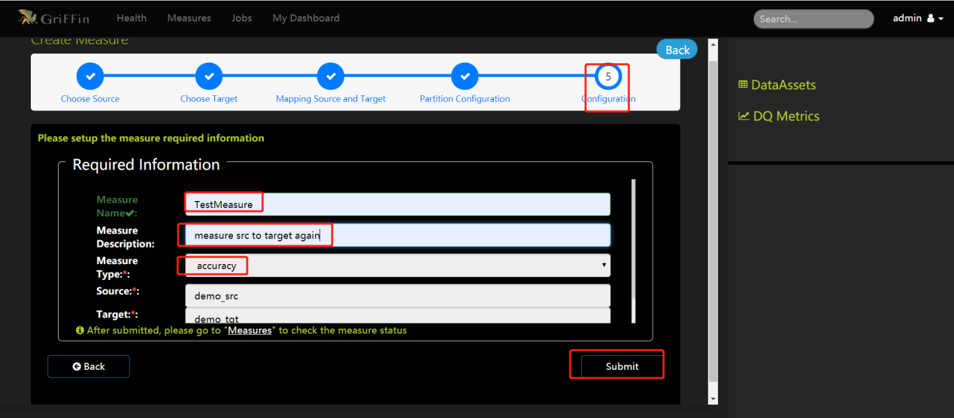

## 3.3 UI创建Job

### 3.3.1 新建一个Job

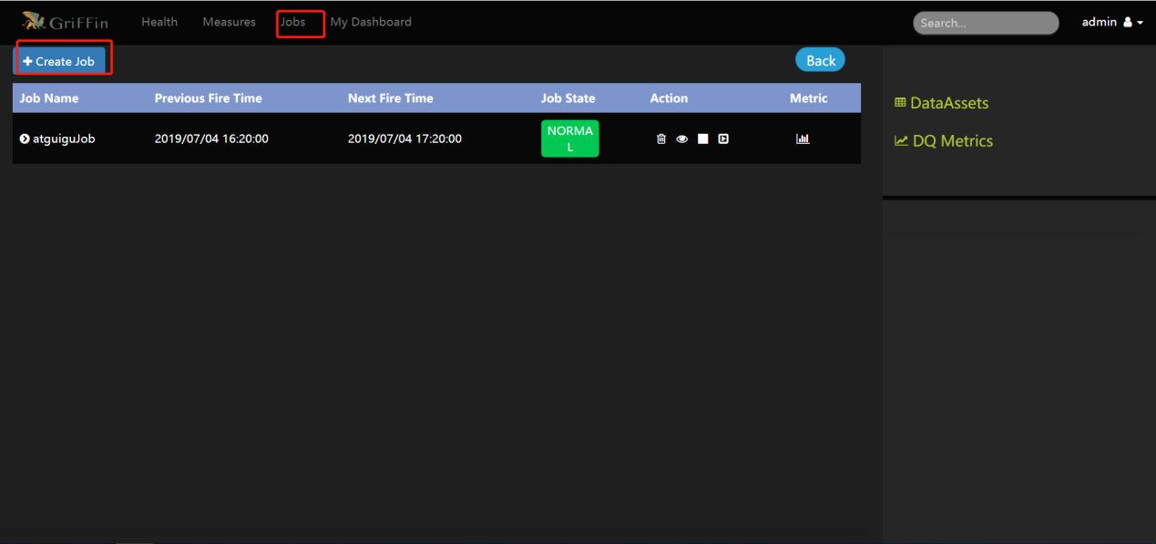

### 3.3.2 与Measure结合并调度任务执行

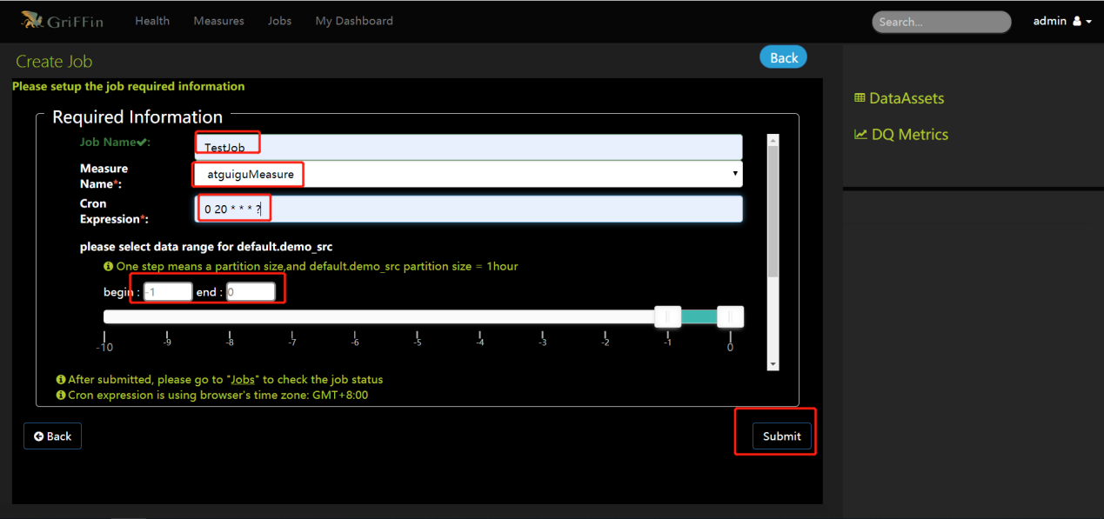

### 3.3.3 查看运行结果单击“DQ指标”

[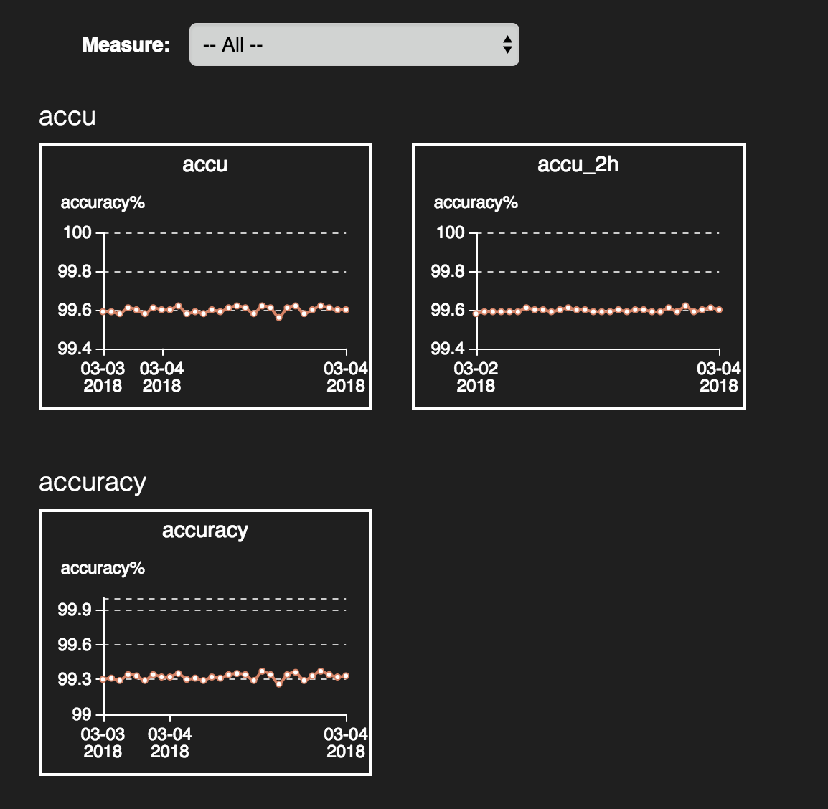](https://github.com/apache/griffin/blob/master/griffin-doc/img/userguide/metrics%20dashboard.png)

单击放大图片

[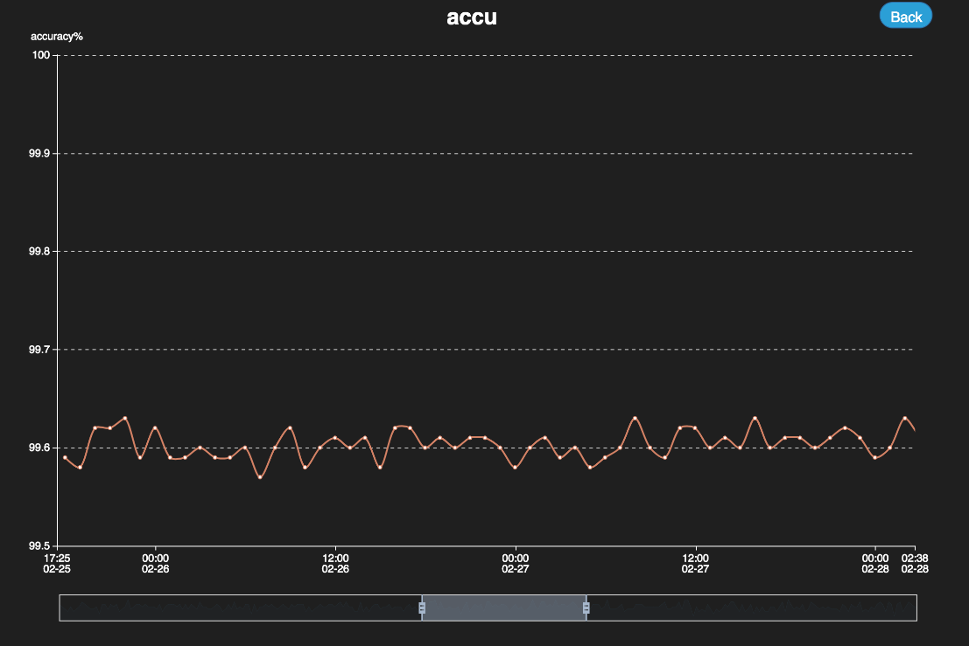](https://github.com/apache/griffin/blob/master/griffin-doc/img/userguide/dashboard%20big.png)

## 3.4 手动定制规则运行Job

### 3.4.1 准确度度量Accuracy Measure

1）创建json文件制定相应规则

在/opt/module/griffin-master/measure/target目录下创建文件dq.json

vim dq.json

{

"name": "batch_accu",

"process.type": "batch",

"data.sources": [

{

"name": "src",

"baseline": true,

"connectors": [

{

"type": "hive",

"version": "2.3",

"config": {

"database": "gmall",

"table.name": "dwd_order_info"

}

}

]

}, {

"name": "tgt",

"connectors": [

{

"type": "hive",

"version": "2.3",

"config": {

"database": "gmall",

"table.name": "dws_user_action"

}

}

]

}

],

"evaluate.rule": {

"rules": [

{

"dsl.type": "griffin-dsl",

"dq.type": "accuracy",

"out.dataframe.name": "accu",

"rule": "src.id = tgt.user_id ",

"details": {

"source": "src",

"target": "tgt",

"miss": "miss_count",

"total": "total_count",

"matched": "matched_count"

},

"out": [

{

"type": "metric",

"name": "accu"

},

{

"type": "record",

"name": "missRecords"

}

]

}

]

},

"sinks": ["CONSOLE", "HDFS"]

}

选项："rule": "src.id = tgt.id AND src.age = tgt.age AND src.desc = tgt.desc"

rule制定匹配规则如src表的id字段对应 tgt表id字段

当前规则是id age desc三者字段相同，这个规则就是接下来对应job所需监控的对应关系

2）在/opt/module/griffin-master/measure/target目录下创建文件env.json

vim env.json

{

"spark": {

"log.level": "WARN"

},

"sinks": [

{

"type": "console"

},

{

"type": "hdfs",

"config": {

"path": "hdfs://hadoop102:9000/griffin/persist"

}

},

{

"type": "elasticsearch",

"config": {

"method": "post",

"api": "http://hadoop102:9200/griffin/accuracy"

}

}

]

}

分别指定hdfs结果存储路径和elasticsearch路径

两个json文件编写完毕后 指定 /opt/module/griffin-0.4.0/measure/target 该路径下的griffin-measure.jar 运行Spark任务

（3）Spark 提交脚本命令

[atguigu@hadoop102 target]$ spark-submit --class org.apache.griffin.measure.Application --master yarn --deploy-mode client --driver-memory 1g --executor-memory 1g --num-executors 1 griffin-measure.jar env.json dq.json



跑完任务之后，可以看到对比结果总条数250000未匹配上的数有980条，匹配上的数据有249020条，匹配分数为0.99608。

也可以去HDFS上查看结果

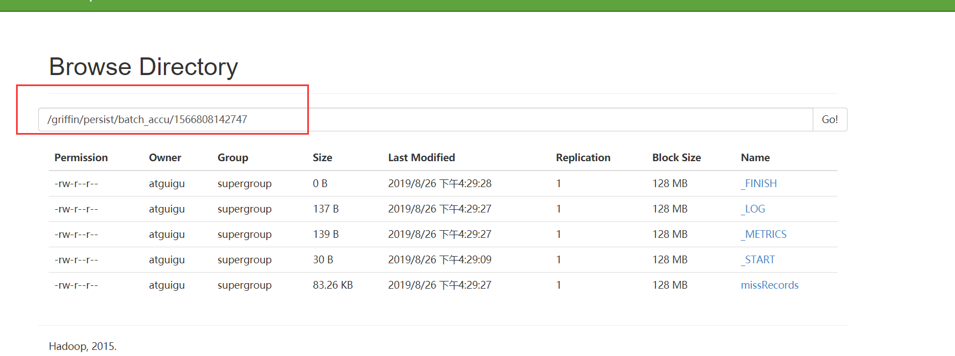

根据任务id号，下载missRecords文件，里面保存的所有没匹配上的数据，方便分析问题。

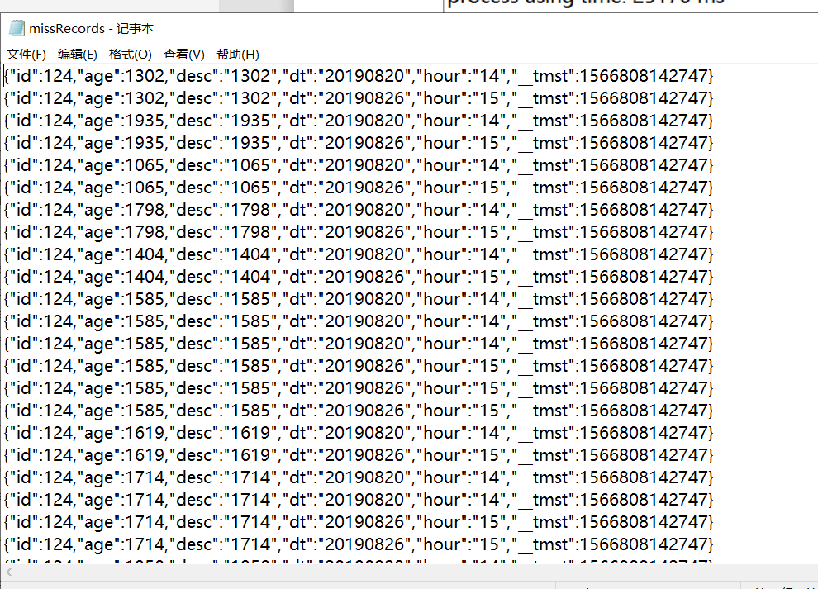

### 3.4.2 性能分析度量Profiling Measure

如果想查看最大值、总个数、空值个数、最大长度等值那就得创建profiling measure

1）创建json文件定制规则

vim dq2.json

{

"name": "batch_prof",

"process.type": "batch",

"data.sources": [

{

"name": "src",

"baseline": true,

"connectors": [

{

"type": "hive",

"version": "2.2",

"config": {

"database": "tmp",

"table.name": "demo_tgt"

}

}

]

}

],

"evaluate.rule": {

"rules": [

{

"dsl.type": "griffin-dsl",

"dq.type": "profiling",

"out.dataframe.name": "prof",

"rule": "src.id.count() AS id_count, src.age.max() AS age_max, src.desc.length().max() AS desc_length_max",

"out": [

{

"type": "metric",

"name": "prof"

}

]

}

]

},

"sinks": ["CONSOLE", "HDFS"]

}

同样rule选项编写规则，如当前规则统计id总个数、age最大值和desc最大长度。

具体rule规则可查看官网

<https://github.com/apache/griffin/blob/master/griffin-doc/measure/measure-batch-sample.md>

2）编辑env.json

vim env.json

{

"spark": {

"log.level": "WARN"

},

"sinks": [

{

"type": "console"

},

{

"type": "hdfs",

"config": {

"path": "hdfs://hadoop102:9000/griffin/persist"

}

},

{

"type": "elasticsearch",

"config": {

"method": "post",

"api": "http://hadoop102:9200/griffin/accuracy"

}

}

]

}

分别指定hdfs结果存储路径和elasticsearch路径

两个json文件编写完毕后 指定 /opt/module/griffin-0.4.0/measure/target 该路径下的griffin-measure.jar 运行spark任务

3）Spark 提交脚本命令

spark-submit --class org.apache.griffin.measure.Application --master yarn --deploy-mode client --driver-memory 1g --executor-memory 1g --num-executors 1 griffin-measure.jar env.json dq2.json



跑完任务后，显示结果 id个数一共250000条，age最大值1000，desc长度最大值4，对应hdfs路径，env.json路径加时间戳。

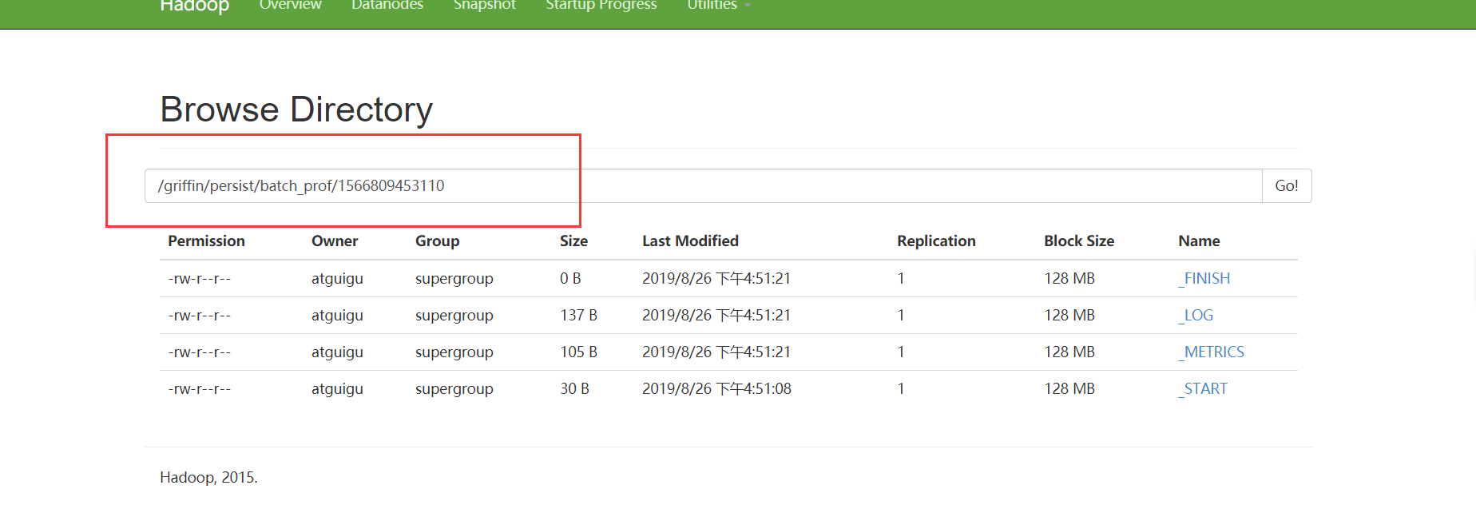

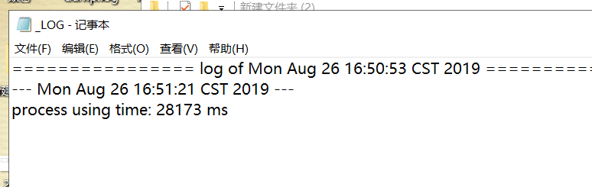

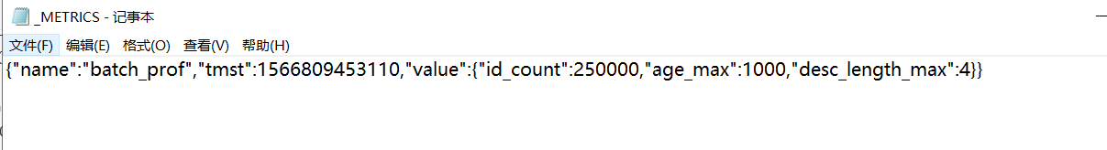

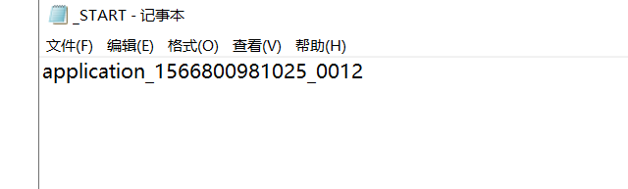

## 3.5 Rule规则编写

### 3.5.1 空值个数查询

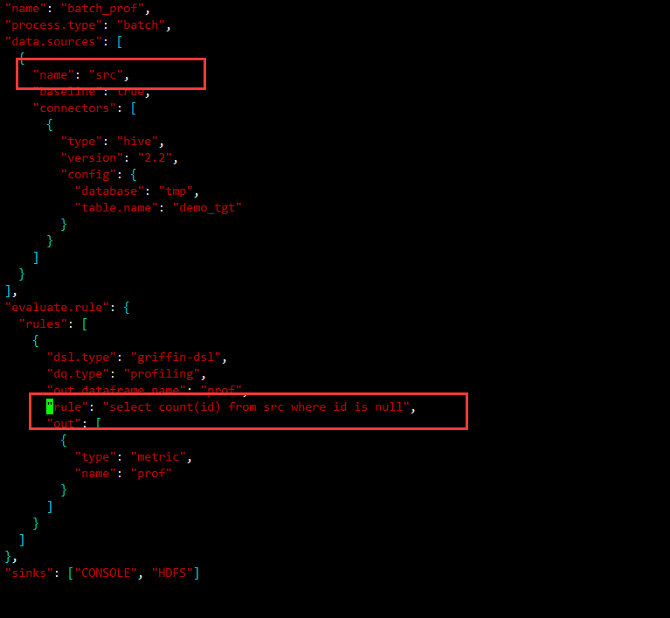

在rule里可以写sql 比如当前rule中统计id为空的个数，注意查询时，不是查询表名而是查询name名称



### 3.5.2 去重个数统计

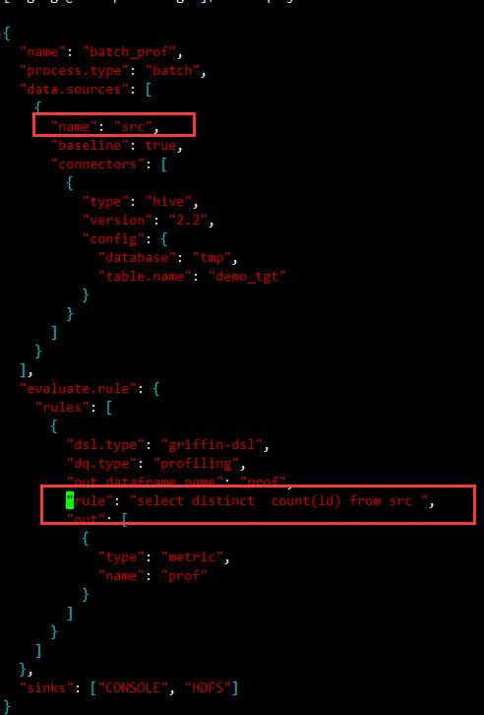



### 3.5.3 最大值、最小值

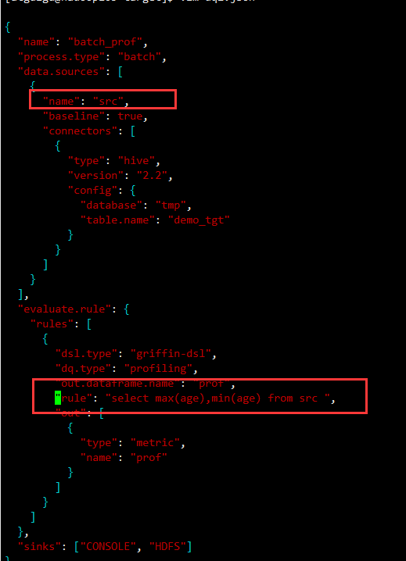



### 3.5.4 排序

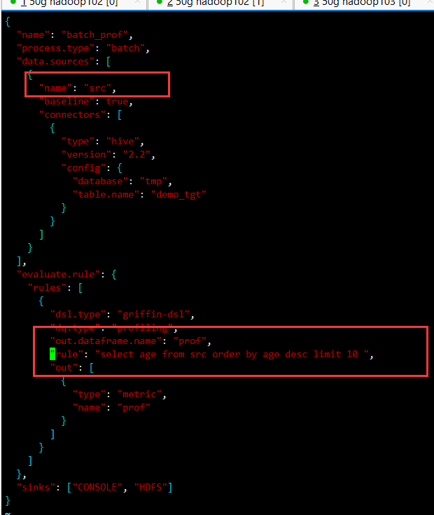



### 3.5.5 范围查询

