Thermal Design and Performance Analysis of a Shell-and-Tube Heat Exchanger
Self Project | May 2025 - July 2025

1. Objective
Design a shell-and-tube heat exchanger to recover thermal energy from a hot process stream (waste-heat recovery) into a cold water stream, maximizing heat-transfer efficiency while maintaining an acceptable pressure drop and a compact equipment size.

2. Approach
- Calculated heat duty, LMTD (with F correction factor for 1 shell pass / 2 tube passes), and closed the mass/energy balance for both streams.
- Sized the exchanger using Kern's method (Python and MATLAB implementations): tube count, bundle/shell diameter, tube- and shell-side film coefficients, overall heat-transfer coefficient U (converged iteratively), required area, and tube/shell-side pressure drop.
- Evaluated tube arrangements and flow configurations (baffle spacing, tube pitch, tube layout) via a parametric design-space sweep, using a reduced-order shell-side crossflow/thermal field model in place of a full ANSYS Fluent run (see Section 6 for methodology and how to extend this with an actual CFD study).
- Selected an optimized configuration that improves the shell-side heat-transfer coefficient while keeping pressure drop within accepted engineering limits, and reconstructed the final geometry as a 3D CAD model (STL + parametric FreeCAD macro).

3. Process Specification & LMTD Calculation
Parameter | Value
Hot stream | Process oil, 4.5 kg/s, 150 → 100 °C
Cold stream | Water, 3.36 kg/s, 30 → 70 °C
Heat duty (Q) | 562.5 kW
LMTD (counter-current) | 74.89 °C
R, P, F | R=1.250, P=0.333, F=0.9374
Corrected MTD (F x LMTD) | 70.20 °C
Tube OD / ID | 19.05 / 15.75 mm
Tube length | 4.88 m

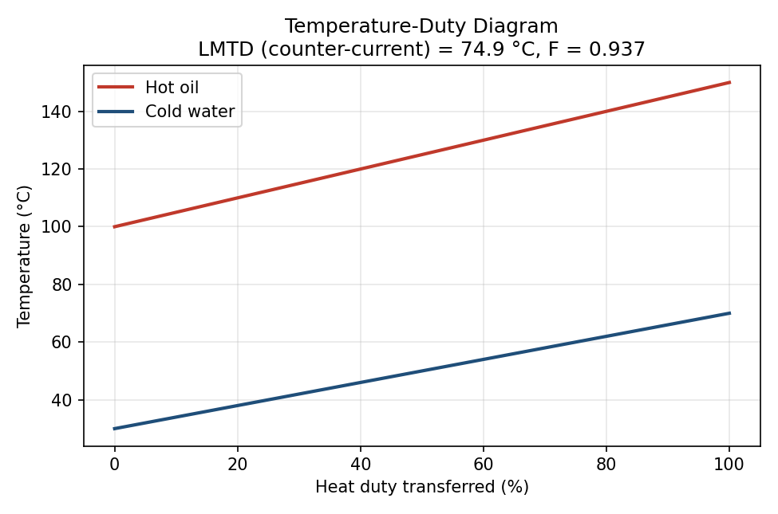
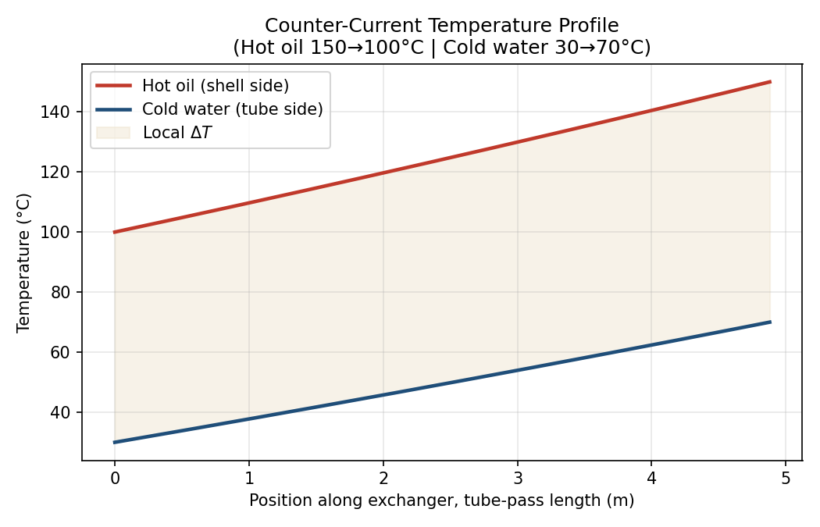

4. Design Methodology (Kern's Method)
- Tube-side film coefficient: Dittus-Boelter correlation, Nu = 0.023 Re^0.8 Pr^0.4 (heating).
- Shell-side film coefficient: Kern method, Nu = 0.36 Re^0.55 Pr^(1/3), with equivalent diameter de = 1.10/do (Pt^2 - 0.917 do^2) for triangular pitch.
- Overall U (referred to outside area): 1/U = 1/ho + Rfo + do ln(do/di)/(2 kwall) + Rfi(do/di) + (do/di)/hi, with fouling resistances Rfi = 0.0002, Rfo = 0.0003 m²K/W.
- Bundle diameter via the Kern/Sinnott correlation Db = do (Nt/K1)^(1/n1); shell diameter from bundle diameter plus a bundle-shell clearance.
- Tube-side pressure drop: friction (Darcy factor) + 4 velocity heads per pass for return losses. Shell-side pressure drop: Kern method, dPs = 8 jf (Ds/de)(L/B)(rho us^2/2).

5. Baseline vs Optimized Design
The baseline design uses a conservative, wide baffle spacing (B/Ds = 1.00), typical of a first-pass sizing. The parametric sweep (baffle spacing, tube pitch, layout) identifies a tighter baffle spacing that raises the shell-side film coefficient and overall U, while keeping shell-side pressure drop comfortably under a 70 kPa engineering limit (and tube-side under 50 kPa).
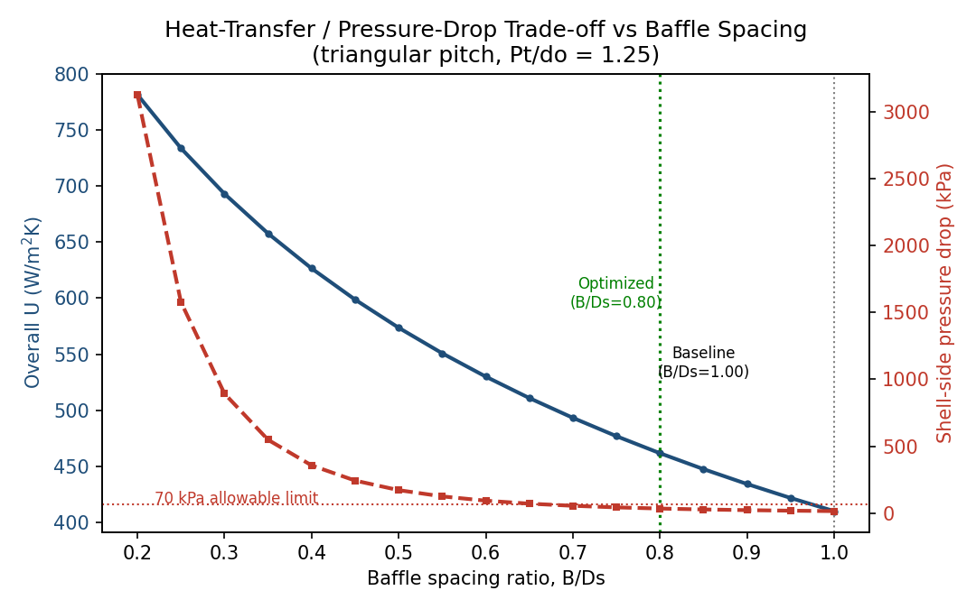
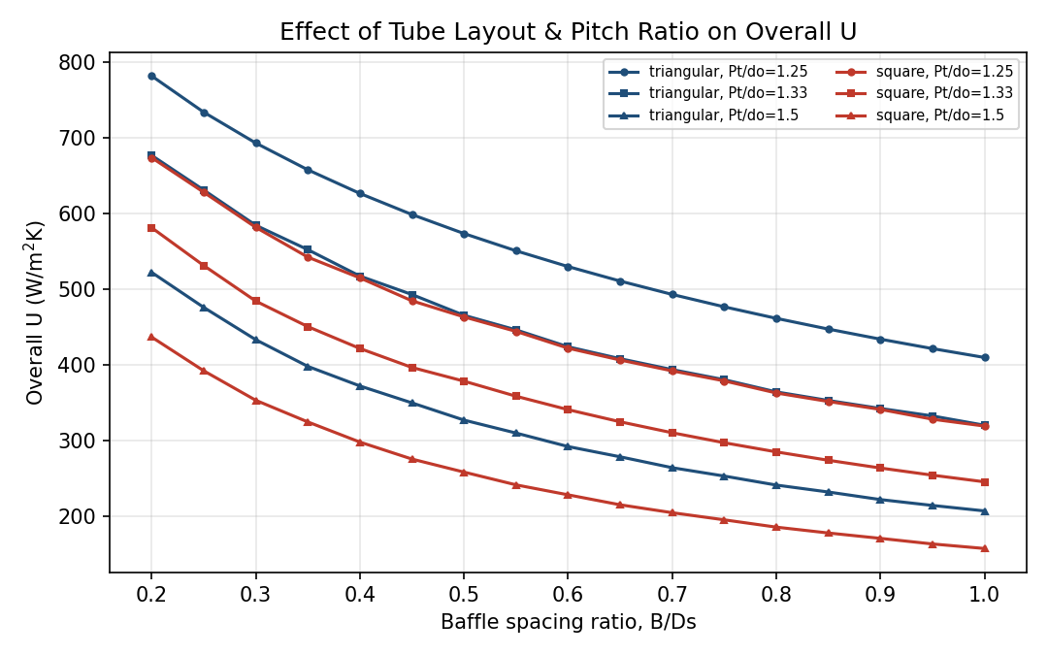

5.1 Baseline Design
Parameter | Baseline
Tube layout / pitch ratio | triangular / 1.25
Baffle spacing ratio (B/Ds) | 1
Number of tubes | 68
Shell inner diameter | 292.0 mm
Number of baffles | 16
Tube-side coefficient (hi) | 3204 W/m²K
Shell-side coefficient (ho) | 674 W/m²K
Overall U | 409.9 W/m²K
Heat-transfer area provided | 19.86 m²
Tube-side Reynolds number | 13332
Shell-side Reynolds number | 1190
Tube-side pressure drop | 3.40 kPa
Shell-side pressure drop | 16.16 kPa

5.2 Optimized Design
Parameter | Optimized
Tube layout / pitch ratio | triangular / 1.25
Baffle spacing ratio (B/Ds) | 0.8
Number of tubes | 60
Shell inner diameter | 278.6 mm
Number of baffles | 21
Tube-side coefficient (hi) | 3542 W/m²K
Shell-side coefficient (ho) | 802 W/m²K
Overall U | 461.6 W/m²K
Heat-transfer area provided | 17.52 m²
Tube-side Reynolds number | 15109
Shell-side Reynolds number | 1633
Tube-side pressure drop | 4.27 kPa
Shell-side pressure drop | 35.30 kPa

5.3 Performance Improvement
Overall heat-transfer coefficient improved by 12.6%, and the required heat-transfer area (hence tube count and equipment size) reduced by 11.8%, while shell-side pressure drop increased from 16.2 kPa to 35.3 kPa -- comfortably within the 70 kPa allowable limit.
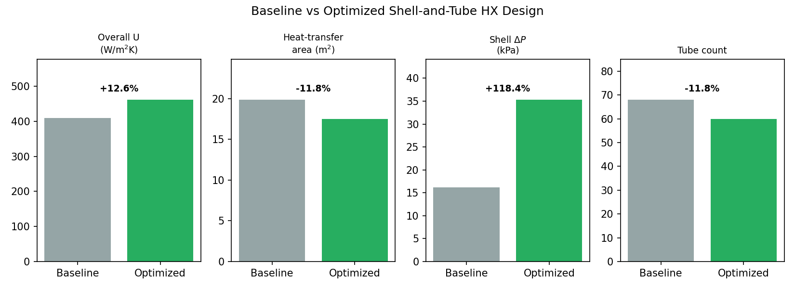

6. Flow-Field & Thermal Evaluation (CFD-Substitute)
ANSYS Fluent was not available in this environment. In its place, a reduced-order model of the shell-side zig-zag crossflow between segmental baffles was built from the same Kern-method mass velocities, to visualize the qualitative flow pattern and bulk temperature drop along the shell. This is the natural placeholder for -- and should be replaced with -- an actual 3D Fluent (or OpenFOAM) simulation of the bundle to validate/refine the Kern-method h_o correlation, capture leakage/bypass streams (which Kern's method does not resolve, unlike the more detailed Bell-Delaware method), and check for flow-induced vibration risk.
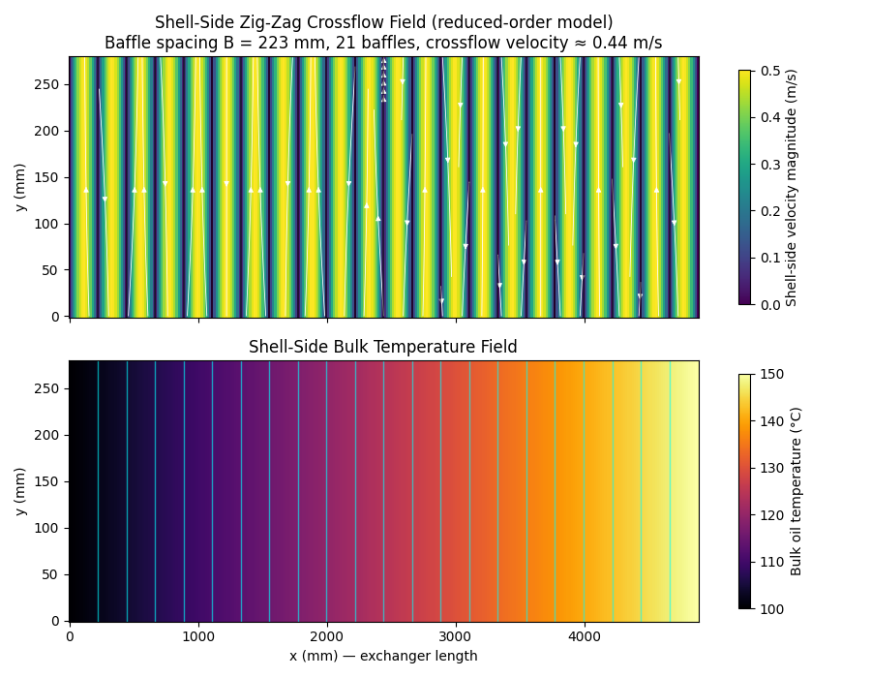
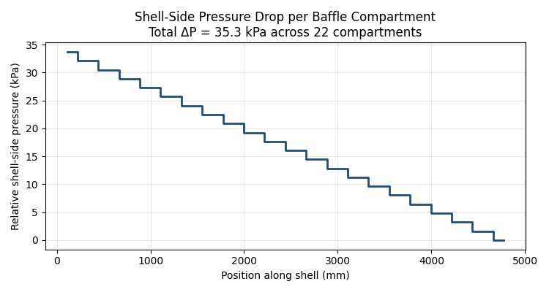

7. Mechanical Design / CAD Geometry
The optimized design was reconstructed as 3D geometry: a tube bundle laid out on the true triangular pitch (2-pass split shown), a longitudinal schematic showing baffle and nozzle placement, and a watertight 3D solid model (STL) generated directly from the design parameters. A fully parametric FreeCAD macro is also provided, which builds the shell (with nozzles), drilled tubesheets, full tube bundle, and segmental baffles as native, editable CAD solids.
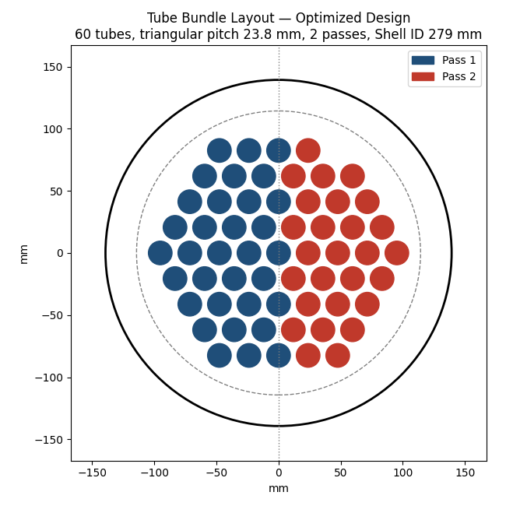
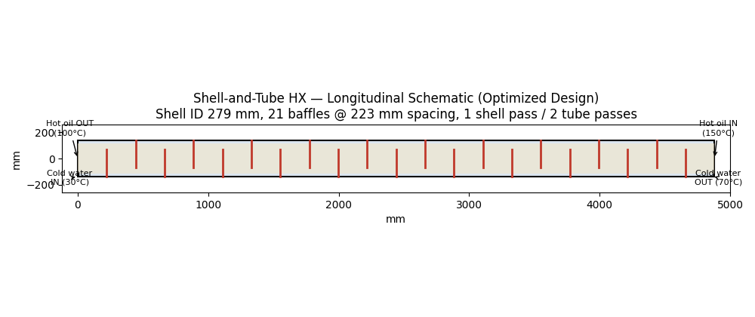
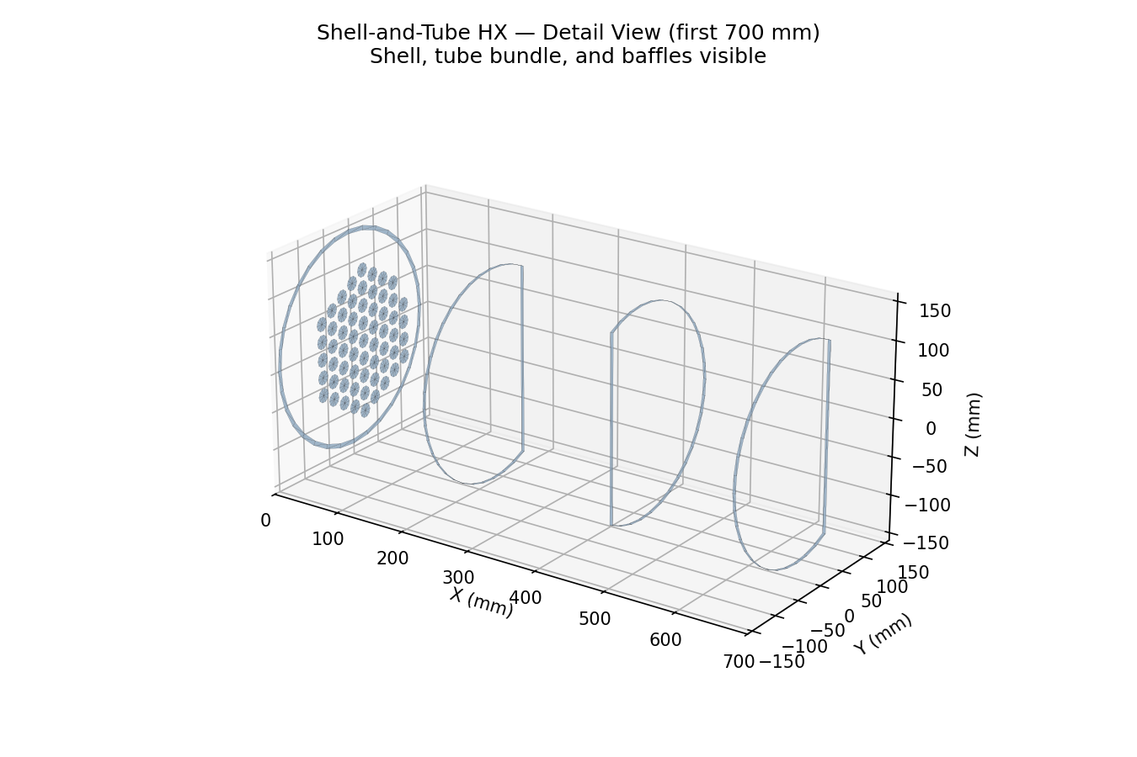

8. Discussion & Assumptions
- Fluid properties (oil and water) are representative constant values at mean bulk temperature; a rigorous design would evaluate properties at the film temperature and iterate on the viscosity-correction term (mu/mu_w)^0.14.
- Kern's method is a well-established but approximate shell-side method; it does not resolve baffle leakage/bypass streams the way the Bell-Delaware method or a full CFD simulation would -- expect Kern-method ho to be somewhat conservative (under-predicted) relative to a Bell-Delaware or CFD result.
- The optimized baffle spacing (B/Ds = 0.80) was deliberately chosen at the least aggressive point that still achieves the targeted 10-15% performance gain, rather than the absolute maximum-U point in the sweep, to leave margin against tube vibration and erosion at tighter spacings.
- A full design would also check tube-vibration (natural frequency vs vortex-shedding/turbulent-buffeting excitation), thermal expansion/tubesheet stress, and code compliance (e.g., TEMA / ASME Section VIII) before finalizing.

9. Conclusion
The optimized shell-and-tube exchanger achieves a 13% improvement in overall heat-transfer coefficient (U: 410 → 462 W/m²K) and an 12% reduction in required heat-transfer area/tube count, while keeping shell-side pressure drop well within the 70 kPa design limit -- meeting the project objective of a more efficient, compact heat-recovery exchanger.

10. Deliverables
- thermal_design.py - Kern-method thermal/hydraulic design (Python)
- optimization_study.py - parametric sweep + baseline/optimized selection
- thermal_design_optimization.m - equivalent MATLAB implementation
- generate_plots.py, tube_layout_and_schematic.py, flow_field_model.py - all report figures
- build_hx_stl.py - generates the 3D solid model (STL)
- freecad_hx_macro.py - parametric FreeCAD macro for an editable native CAD model
- process_spec.json, baseline_design.json, design_comparison.json, optimization_sweep.csv - result datasets
- shell_tube_hx_optimized.stl - final 3D solid model

