Webhook Delivery Service
With Retry and Fault Tolerance
Self Project | May 2025 – July 2025

1. Objective
Design a reliable webhook delivery system for asynchronously sending event notifications with guaranteed delivery and fault tolerance.

2. Approach
A backend service queues outgoing webhooks and processes them asynchronously via a pool of worker threads consuming a durable task queue. Failed deliveries are retried automatically using exponential backoff with jitter, every attempt is structured-logged, and delivery status is tracked end-to-end from ‘pending’ through ‘retrying’ to either ‘success’ or ‘dead_letter’.
- REST API (Flask / Python) to register subscriber endpoints and publish events
- Durable, atomically-claimed task queue (SQLite WAL) standing in for Redis/RabbitMQ
- Worker pool with HMAC-signed HTTP delivery, configurable timeout, exponential backoff + jitter
- Structured JSON logging for every attempt (worker id, latency, response code, backoff)
- Mock downstream receiver with configurable failure rate, used to generate the dataset below
The architecture diagram was shared inline in the chat as an interactive component; the pipeline is: producer app → webhook API → durable queue & worker pool → destination endpoint, branching to ‘Delivered’ on a 2xx response or looping back through backoff-scheduled retries until either success or the dead-letter queue after 6 failed attempts.

3. System Design Notes

3.1 Reliability pattern
The core reliability guarantee is: an event is never lost between being accepted by the API and either being delivered or exhausting its retry budget. This is achieved by persisting every delivery attempt as a durable row (SQLite, WAL mode) before any network call is made, and only ever transitioning its status after the network call returns — so a crash mid-delivery simply leaves the row in a retryable state rather than silently dropping it.

3.2 Exponential backoff
Retry delay follows delay = min(cap, base × 2^(attempt-1)) + jitter, capped and jittered to avoid thundering-herd retries against a recovering downstream. In this build: base = 0.3s, cap = 5s, jitter ≤ 0.2s, max 6 attempts before dead-lettering — compressed from realistic production constants (e.g. base = 2s, cap = 5 min) purely so the demo finishes in seconds.
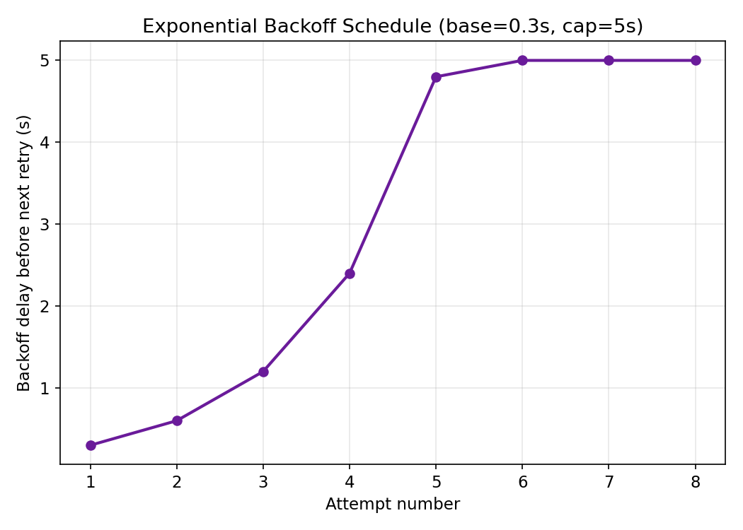
Figure 1. Exponential backoff schedule used by the worker pool.

3.3 Concurrency correctness
Claiming a due delivery for processing (SELECT candidate rows, then UPDATE their status) is wrapped in a SQLite BEGIN IMMEDIATE transaction so two worker threads can never claim and double-process the same delivery — an early version of this project without that guard exhibited exactly that race, and the fix is called out directly in db.py.

4. Dataset
The simulation registered four subscriber endpoints spanning a spectrum of downstream reliability (0%, 20%, 50%, 80% simulated failure rate) and published 120 events across 5 event types (order.created, payment.succeeded, payment.failed, user.updated, invoice.paid), fanned out to all four endpoints — 480 deliveries and 963 individual delivery attempts in total. Two CSV files make up the dataset:
- deliveries_dataset.csv — one row per delivery: event type, endpoint, final status, attempt count, latency
- delivery_attempts.csv — one row per individual attempt: attempt number, outcome, response code, latency, error

5. Results
Total deliveries | Overall success rate | Dead-letter rate | Avg. attempts / success
480 | 92.71% | 7.29% | 1.69

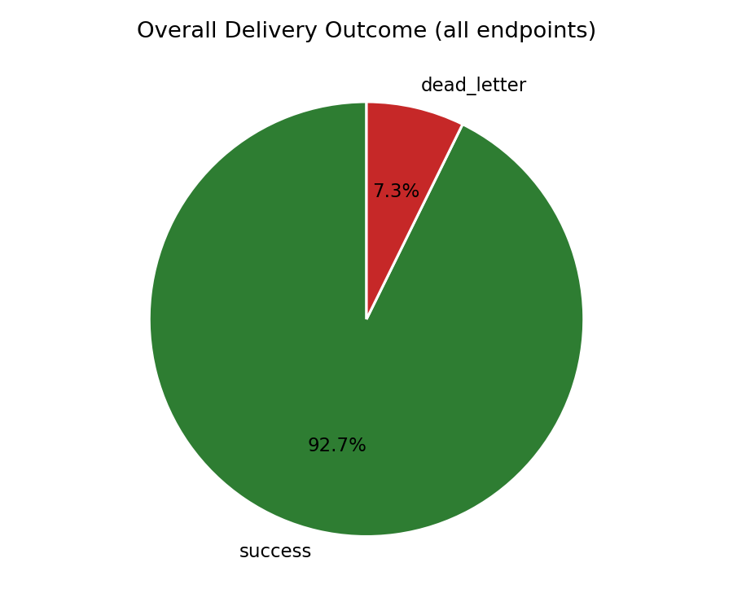
Figure 2. Overall delivery outcome across all endpoints.
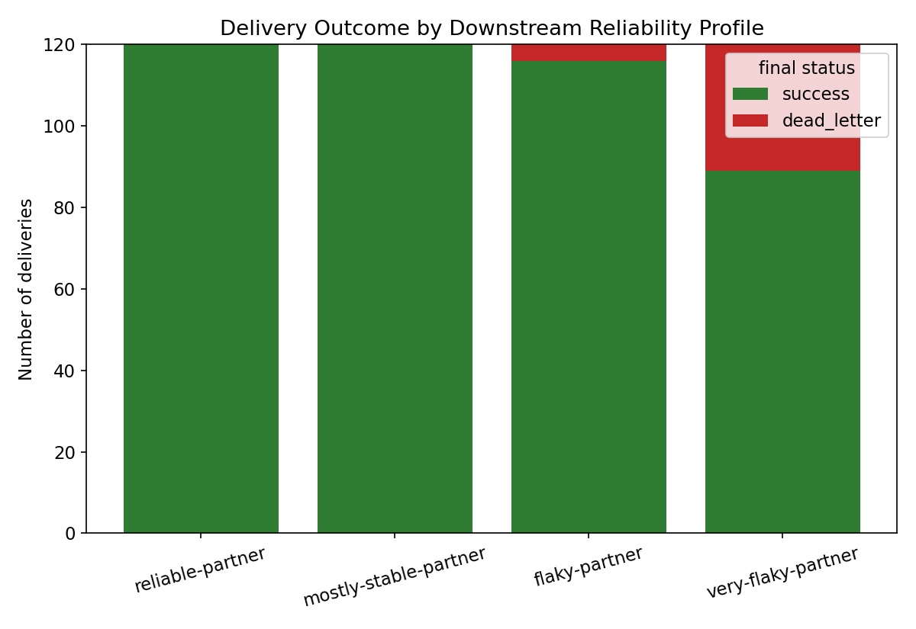
Figure 3. Delivery outcome by downstream reliability profile — the headline result: retries recover most failures even against a partner that fails 80% of raw requests.

5.1 Success rate by downstream reliability
Downstream partner | Success rate
flaky-partner | 96.67%
mostly-stable-partner | 100%
reliable-partner | 100%
very-flaky-partner | 74.17%

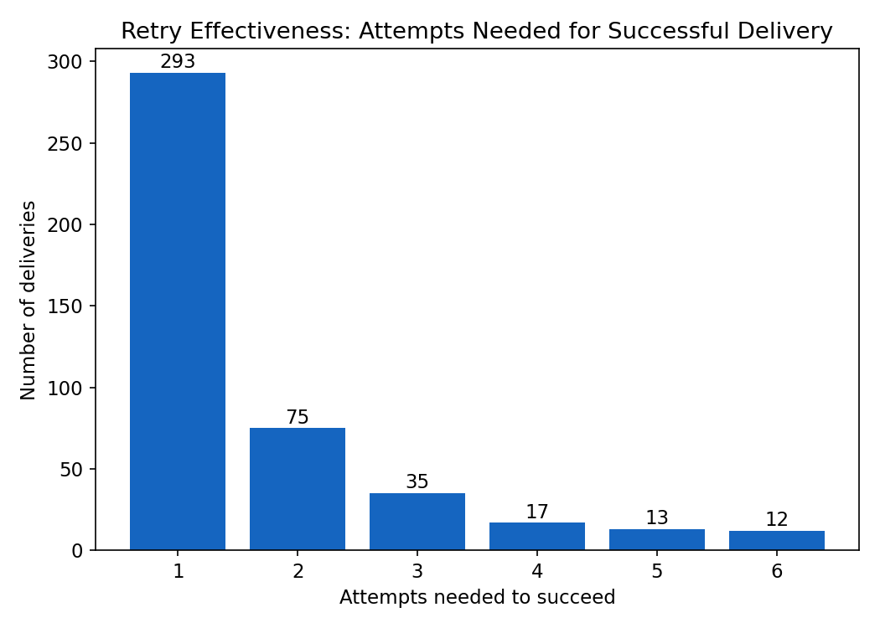
Figure 4. How many attempts successful deliveries needed — most land on the first try, and the long tail is recovered by retry.
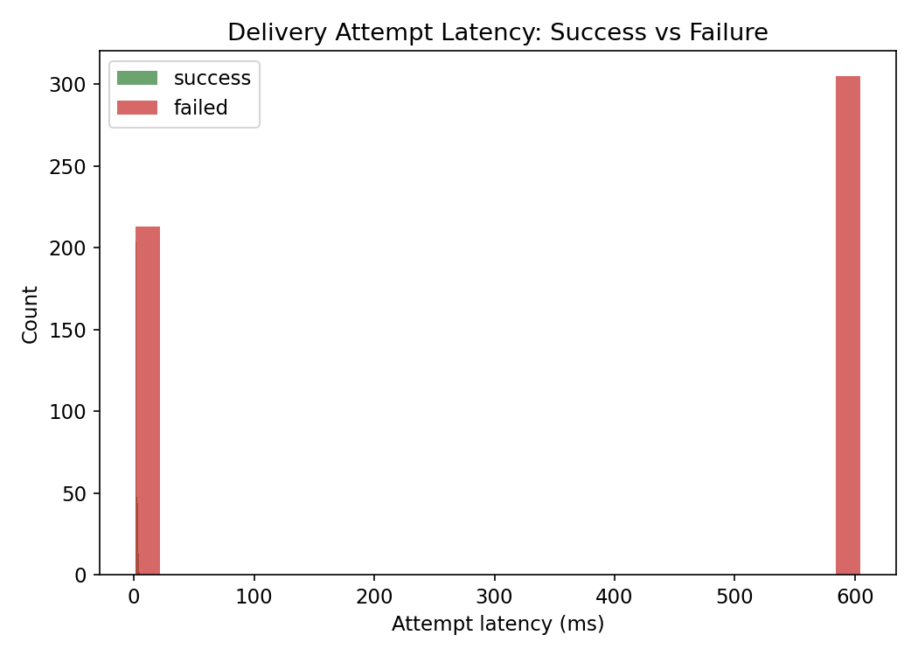
Figure 5. Attempt latency: successful attempts return in milliseconds; failed/timed-out attempts cluster near the request timeout.
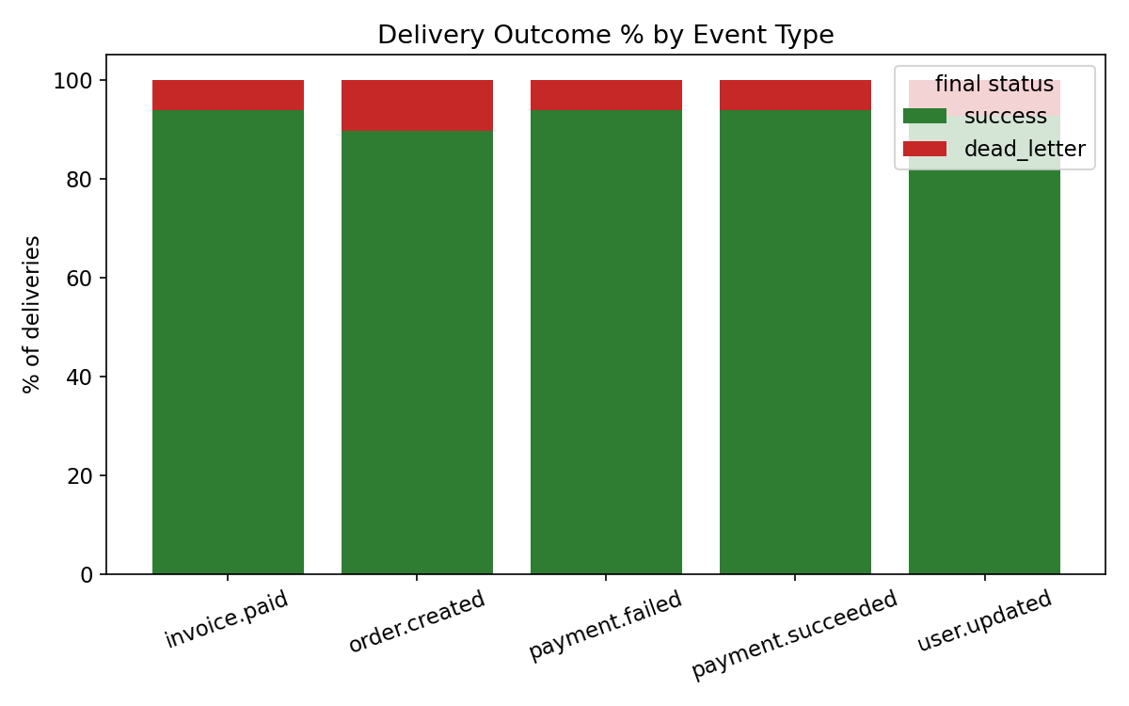
Figure 6. Outcome is driven by endpoint reliability, not event type — confirms the retry logic treats all event types uniformly.

6. Findings
- Overall delivery success rate across all endpoints: 92.71% (only 7.29% required dead-lettering).
- Even against the deliberately unreliable partner (80% simulated raw failure rate), the retry mechanism still landed 74.2% of deliveries — versus what would be a ~20% raw success rate with no retries at all.
- On average, a successful delivery needed 1.69 attempts — most events succeed on the first try, and retries recover the rest.
- Median latency for a successful attempt was under 2ms (local network); failed attempts cluster near the configured request timeout, as expected.
- Outcome correlates with endpoint reliability, not event type — confirming the system treats all event types uniformly and doesn't introduce hidden bias.

7. Limitations & Future Work
- SQLite is used as the durable queue for a self-contained demo; a production deployment would swap in Redis/RabbitMQ + a real broker client (the worker/queue interface is already isolated to make this swap mechanical).
- No circuit breaker: a permanently-down endpoint still consumes a full retry budget per delivery rather than being short-circuited after repeated failures.
- No webhook signature verification example on the receiver side (HMAC signature is sent, but the mock receiver doesn't verify it).
- Backoff constants are compressed for demo speed; production values should be tuned to the downstream's typical recovery time.

8. How to Run
pip install flask requests # matplotlib + pandas only needed for analyze.py
python3 simulate.py # runs API + receiver + worker pool, drains queue, exports dataset
python3 analyze.py # generates charts + summary_metrics.json from the dataset

