
User Guide
Unsafe Condition Unsafe Action (UCUA)

Application unit,
ICT Department,
Johor Port Berhad

Table of Contents
1 UCUA 1.0 User Manual (Desktop) 3
1.1 Chapter 1: Accessing UCUA 3
1.2 Chapter 2: UCUA Registration 4
1.3 Chapter 3: Forget Password 5
2 UNSAFE CONDITION (Desktop) 6
2.1 Chapter 4: Unsafe condition submission for public user 6
2.2 Chapter 5: Unsafe condition submission for PSSD HSE Officer 9
2.3 Chapter 6: Uploading photos for HSE Reps 11
2.4 Chapter 7: PSSD HSE Officer notify HOS 13
2.5 Chapter 8: PSSD HOS approval 14
2.6 Chapter 9: PSSD HOD approval 15
3 UNSAFE ACTION (Desktop) 16
3.1 Chapter 10: Unsafe action submission for public user 16
3.2 Chapter 11: Unsafe action submission for PSSD HSE Officer 19
3.3 Chapter 12: PSSD HSE Officer’s unsafe action approval 22
3.4 Chapter 13: PSSD HOS approval 24
3.5 Chapter 14: PSSD HOD approval 26
4 Mobile Platform 28
4.1 User Acceptance Testing for all user 28
5 UCUA 1.0 User Manual (Mobile) 31
5.1 Chapter 1: Accessing UCUA 31
5.2 Chapter 2: UCUA Registration 32
5.3 Chapter 3: Forget Password 33
6 UNSAFE CONDITION (Mobile) 35
6.1 Chapter 4: Unsafe condition submission for all user 35
7 UNSAFE ACTION (Mobile) 38
7.1 Chapter 5: Unsafe condition submission for all user 38

UCUA 1.0 User Manual (Desktop)

Chapter 1: Accessing UCUA
- Open your browser and go to this URL: http://apps.johorport.com.my/ucua300/login
- Login or register to UCUA
- You will see the login screen below:

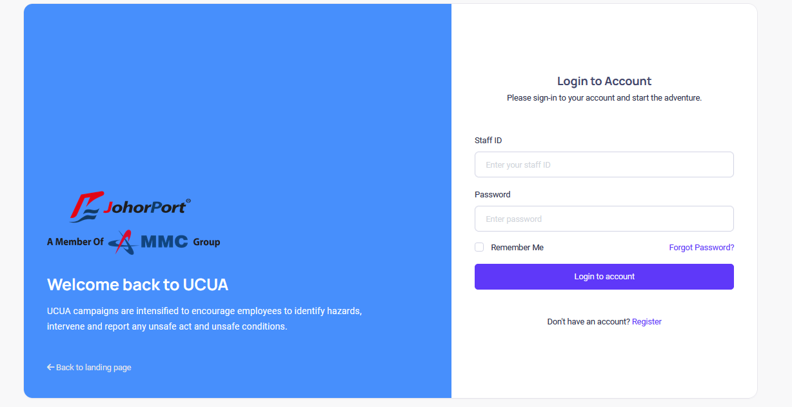

- Fill the Staff ID and Password to log in to the system

Chapter 2: UCUA Registration
- Click the Register button.

- Fill in all the required textboxes:

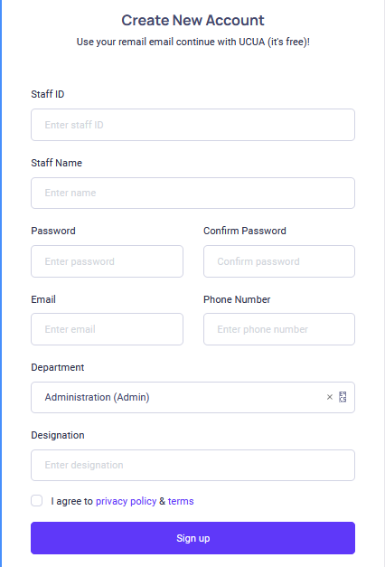

- Once done, click the Sign up button to finish the registration.
- Once your account is active, you can login to UCUA.

Chapter 3: Forget Password
- Click Forgot Password? Link

- Fill in the email address and click Send Reset Link button. The system will send an OTP by email. This OTP will act as a temporary password. Use the OTP given for user’s password and later change the password inside the system.

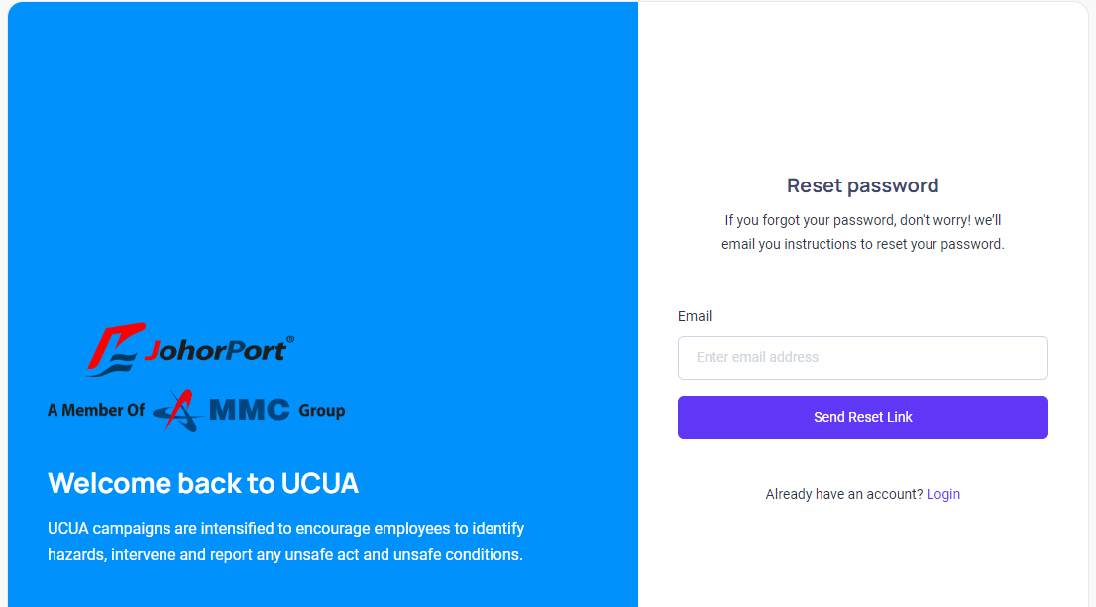

UNSAFE CONDITION (Desktop)

Chapter 4: Unsafe condition submission for public user
PUBLIC USER

- From the public user dashboard, click the Unsafe Condition card to redirect to the unsafe condition screen.

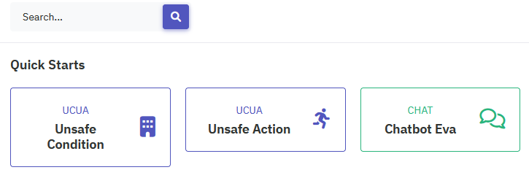

- Or, you can click the toggle bar to open the sidebar.

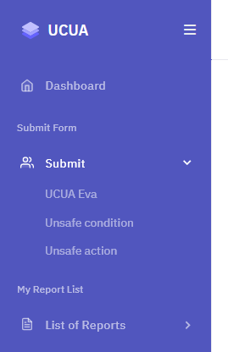

- From the sidebar click UCUA Form -> Unsafe Condition to redirect to the unsafe condition screen
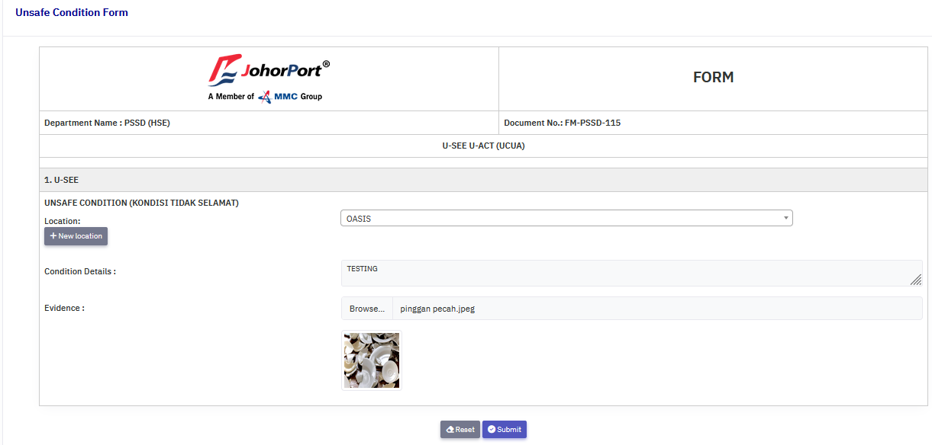

- Select location from the select box.
- Or, you can click New Location button to add new location
- Fill in the condition details text area.
- Browse for an image.
- Click the Submit to complete the submission.

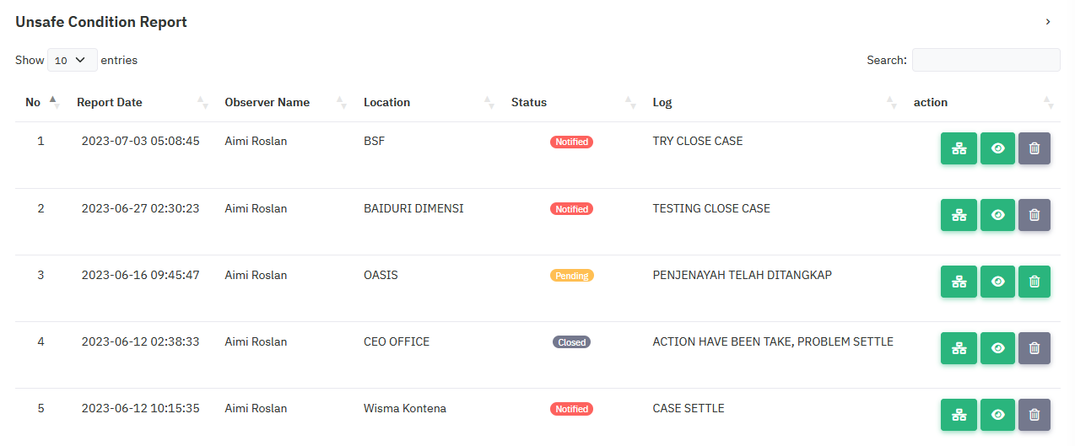

- Once the submit button is clicked, you will be redirected to the My report list screen.
- On this screen you can see all the list of submission you already created.
- On the Action section, click the History icon to view history logs for that report.
- Click the Eye icon to view report details.
- Click the Delete icon to delete report details.
- Click the History icon to view the history log.
- Click Report button to navigate back to the My report list.

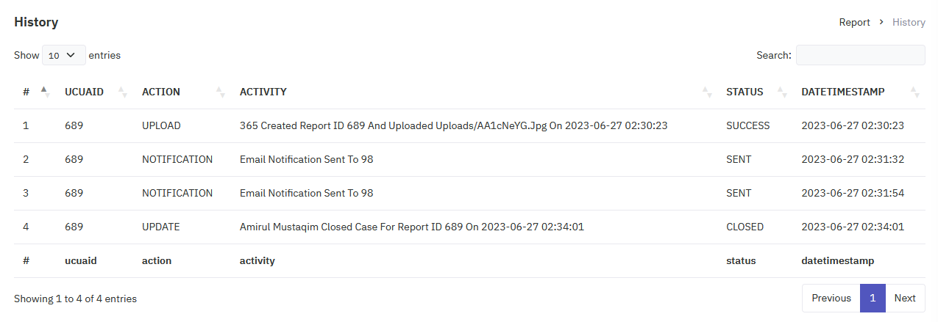

- Click the Eye icon to view details.

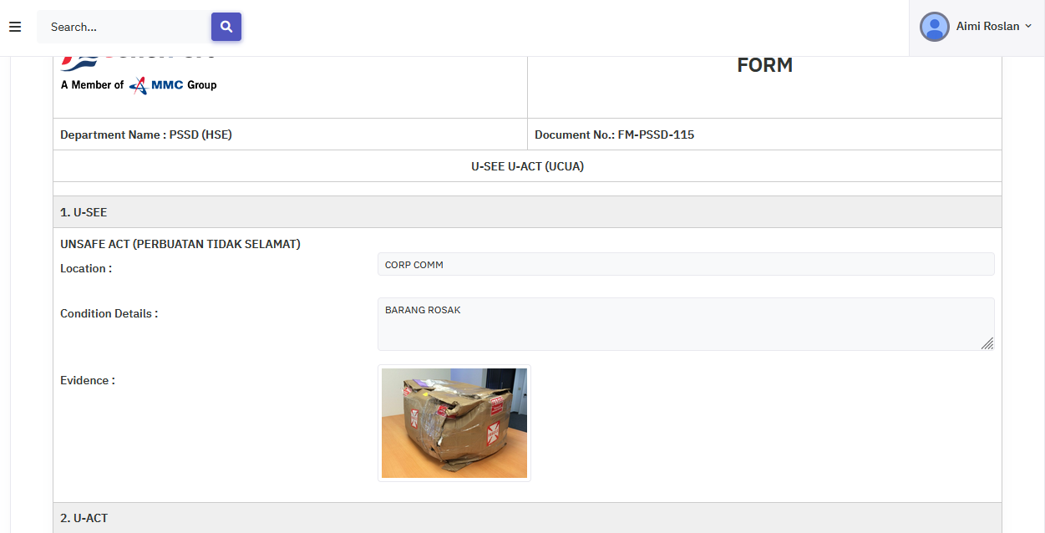

Chapter 5: Unsafe condition submission for PSSD HSE Officer
PSSD HSE OFFICER

- Click the toggle bar to open the sidebar, then go to Report -> Unsafe Condition

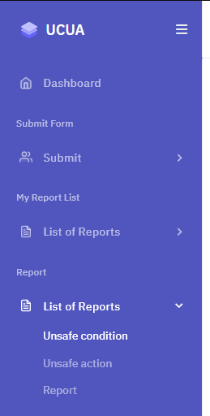

- After you clicked the Unsafe Condition link, you will be redirected to the Unsafe Condition screen
- Click the History icon to view history log.
- Click the Eye icon to view details.
- Click the Delete icon to delete report.

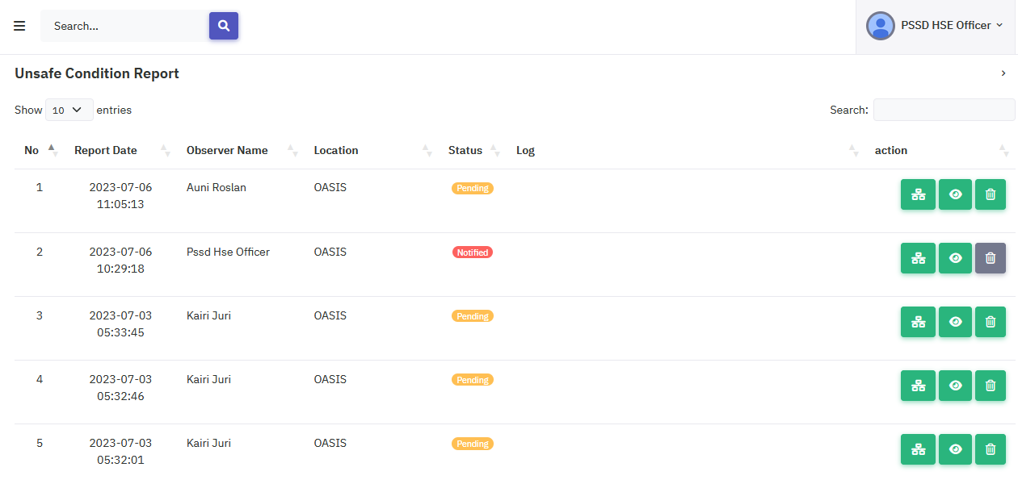

- Once you clicked the Eye icon, you will be redirected to the unsafe condition form.
- PSSD HSE Officer is required to select the notify related dept, select HSE Reps and fill in the remark text area.
- PSSD HSE Officer has the option to upload images.
- PSSD HSE Officer can then either approve or reject the unsafe condition form.
- If the form is approved PSSD HSE Officer can click the Reassign button to notify HSE Reps.

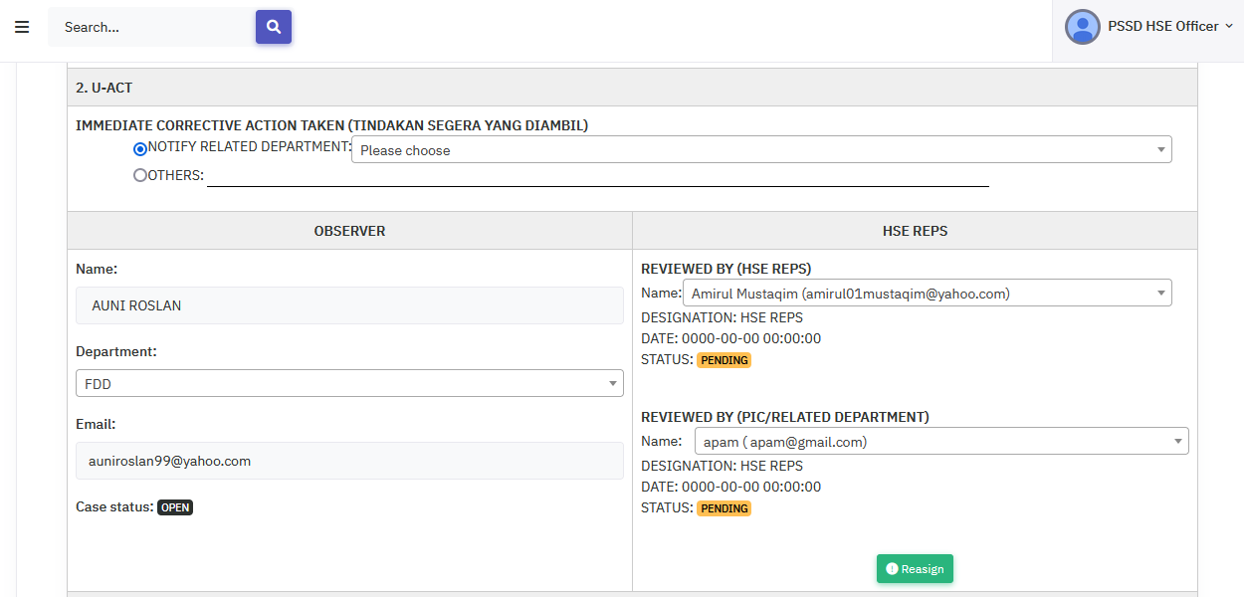

- PSSD HSE officer can add new remark or new image by clicking save button
- The remark and uploaded photo will be added to the activities.

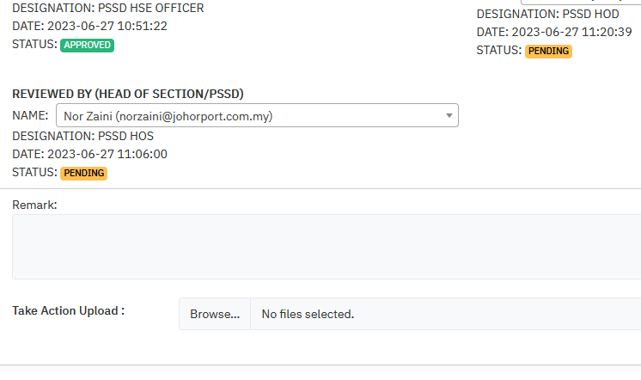
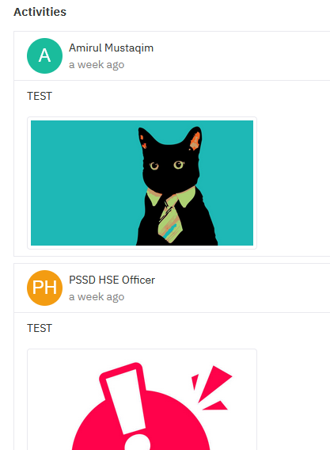

Chapter 6: Uploading photos for HSE Reps
HSE REPS

- HSE Reps can access the upload evidence for unsafe condition by click the toggle bar to open the sidebar, then go to Report -> Unsafe Condition

- Once the link is clicked HSE Reps will be redirected to the unsafe condition list.
- On this screen, HSE Reps can check every UC status and click the History icon to view history logs.
- HSE Reps can click the Eye icon to view details.
- HSE Reps can click the Delete icon to delete report.

- Once you clicked the Eye icon, you will be redirected to the unsafe condition form.
- Then, HSE Reps is required to fill in the remark text area and upload photos.
- After that, HSE Reps can click the Close Case button to request close case.
- The remark and uploaded photo will be added to the activities.

Chapter 7: PSSD HSE Officer notify HOS
PSSD HSE OFFICER

- PSSD HSE Officer can then go to the unsafe condition confirmation and check the pending status.
- Click the Eye icon to view the details.

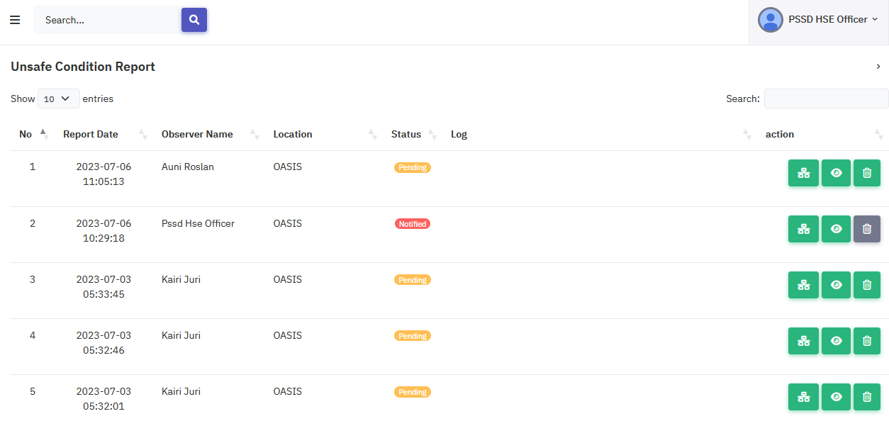

- PSSD HSE Officer require to select notify related dept, notify related PSSD HOS, fill in the remark text area and then click the Approved button to complete the process

Chapter 8: PSSD HOS approval
PSSD HOS

- PSSD HOS can access the Approved Form by clicking the toggle bar -> Report -> Unsafe Condition

- PSSD HOS can open the Approved Form for Unsafe Condition to see the list and check the status.
- Click the Eye icon to view details.

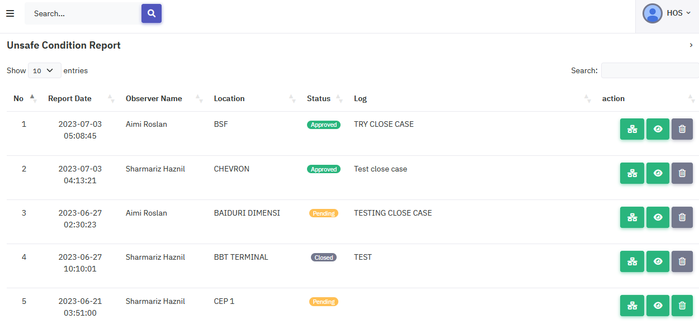
- PSSD HOS is required to fill in the remark text area and upload a photo
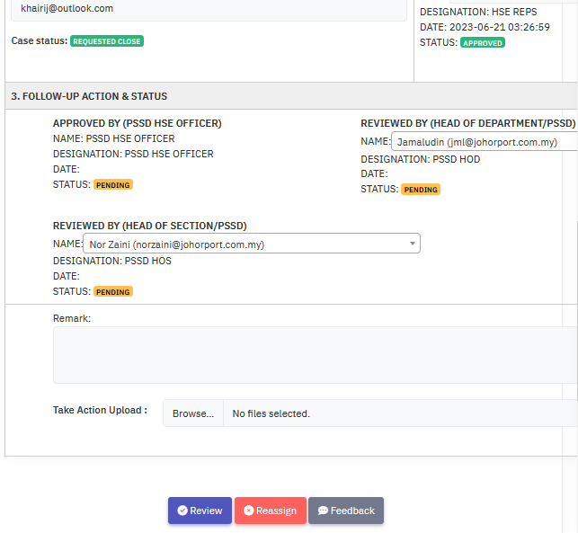
- Once done, click the Review button to complete the process.
- The remark and uploaded photo will be added to the activities.

Chapter 9: PSSD HOD approval
PSSD HOD

- PSSD HOD can access the Approved Form by clicking the toggle bar -> Report -> Unsafe Condition

- PSSD HOD will be redirected to the unsafe condition screen.
- PSSD HOD can click the History icon to view the history logs.
- Click the Eye icon to view details.
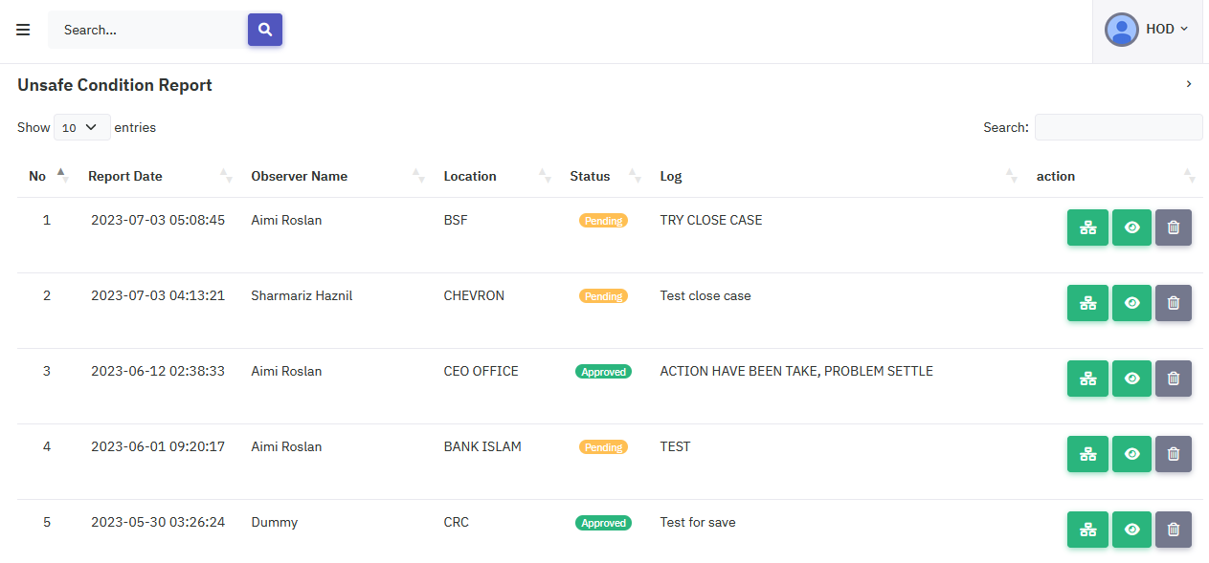

- PSSD HOD is now redirected to the unsafe condition screen.
- PSSD HOD is required to fill in the remark text and upload photos.
- Once done, PSSD HOD can click the Approved button to complete the process.
- Once approved the report is closed completely.
- The remark and photo will be added to activities.

UNSAFE ACTION (Desktop)

Chapter 10: Unsafe action submission for public user
PUBLIC USER

- From the public user dashboard, click the Unsafe Action card to redirect to the unsafe action screen.

- Or, you can click the toggle bar to open the sidebar.

- From the sidebar click UCUA Form -> Unsafe Action to redirect to the unsafe action screen

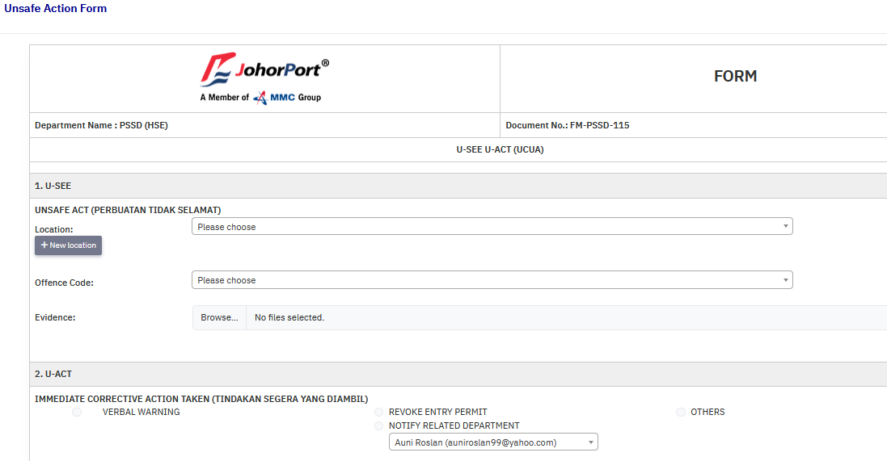

- Select location from the select box.
- Or, you can click New Location button to add new location
- Fill in the location, offence code, and upload photos.
- Fill in the name, department and IC/Passport fields.
- Click the Submit to complete the submission.
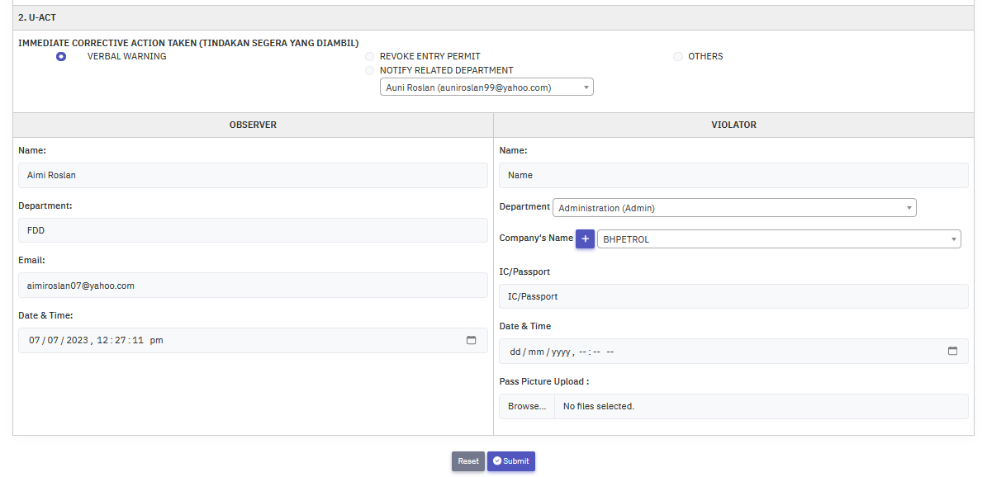

- Once the submit button is clicked, you will be redirected to the My report list screen.
- On this screen you can see all the list of submission you already created.
- On the Action section, click the History icon to view history logs for that report.
- Click the Eye icon to view report details.
- Click the Delete icon to delete report details.

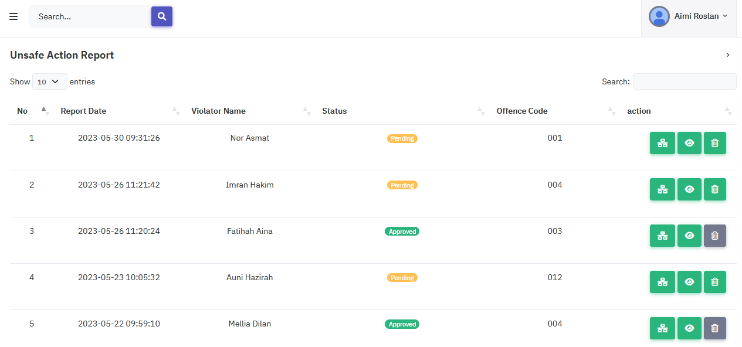

- Click the History icon to view the history log.
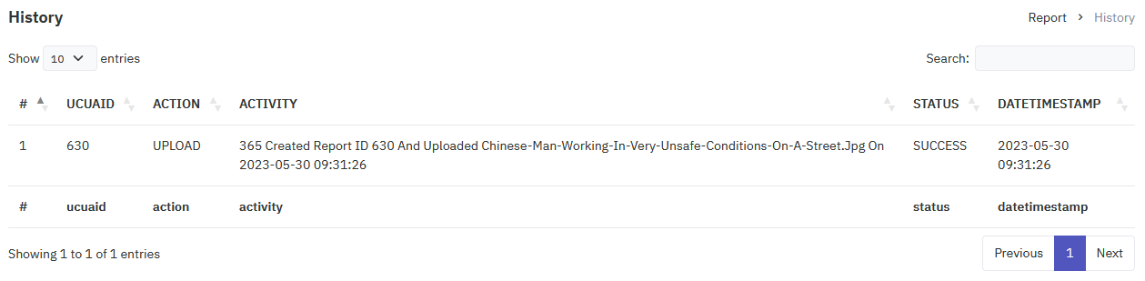

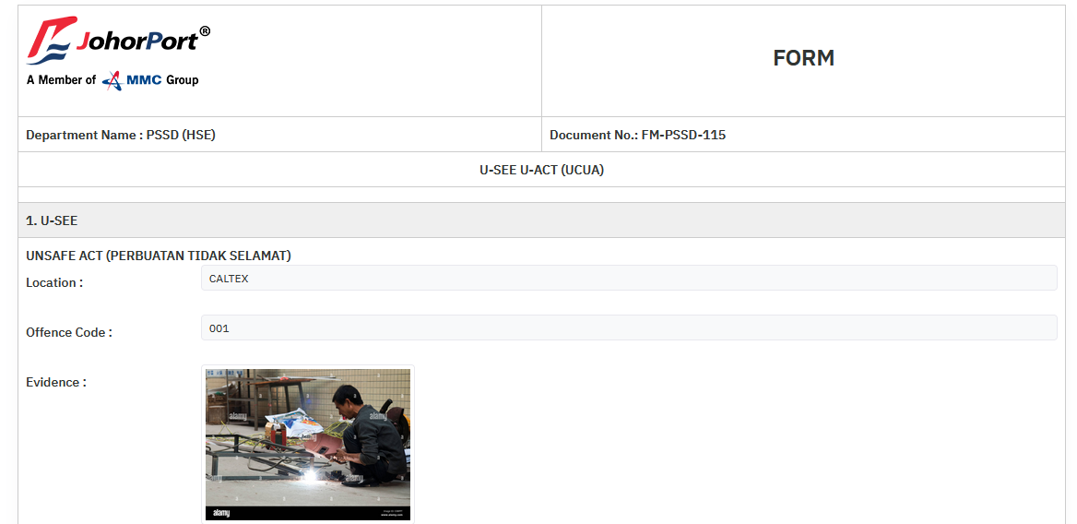

Chapter 11: Unsafe action submission for PSSD HSE Officer
PSSD HSE OFFICER

- Click the toggle bar to open the sidebar, then go to Report -> Unsafe Action

- Or, you can click the toggle bar to open the sidebar.

- From the sidebar click UCUA Form -> Unsafe Action to redirect to the unsafe action screen

- Select location from the select box.
- Or, you can click New Location button to add new location
- Fill in the location, offence code, and upload photos.
- Fill in the name, department and IC/Passport fields.
- Click the Submit to complete the submission.

- Once the submit button is clicked, you will be redirected to the My report list screen.
- On this screen you can see all the list of submission you already created.
- On the Action section, click the History icon to view history logs for that report.
- Click the Eye icon to view report details.
- Click the Delete icon to delete report details.

- Click the History icon to view the history log.

Chapter 12: PSSD HSE Officer’s unsafe action approval
PSSD HSE OFFICER

- PSSD HSE Officer can then go to the unsafe action report list and check the pending status.
- Click the Eye icon to view the details.
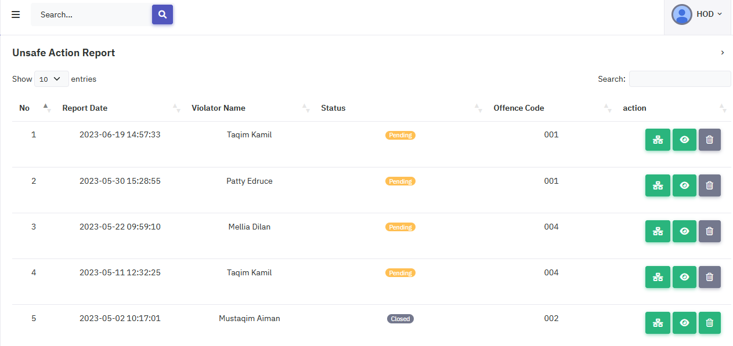

- PSSD HSE Officer require to select notify related dept, notify related PSSD HOS, fill in the remark text area and then click the Approved button to complete the process.
- Once you click the approved button the process is done.

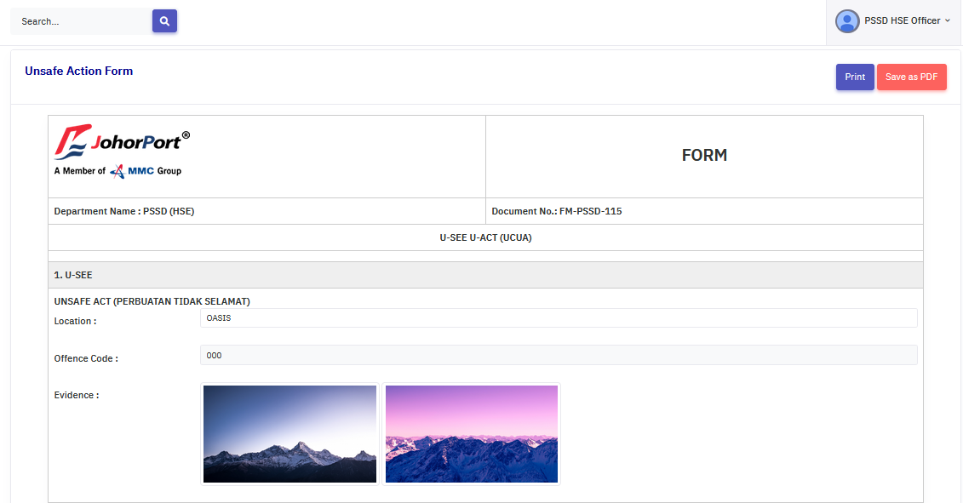
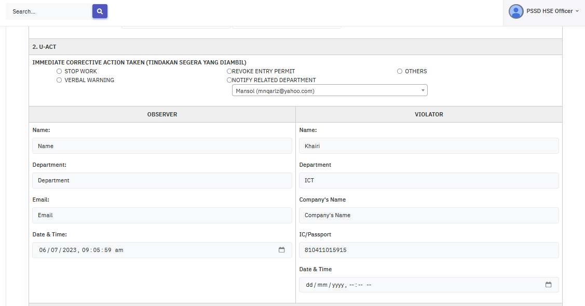

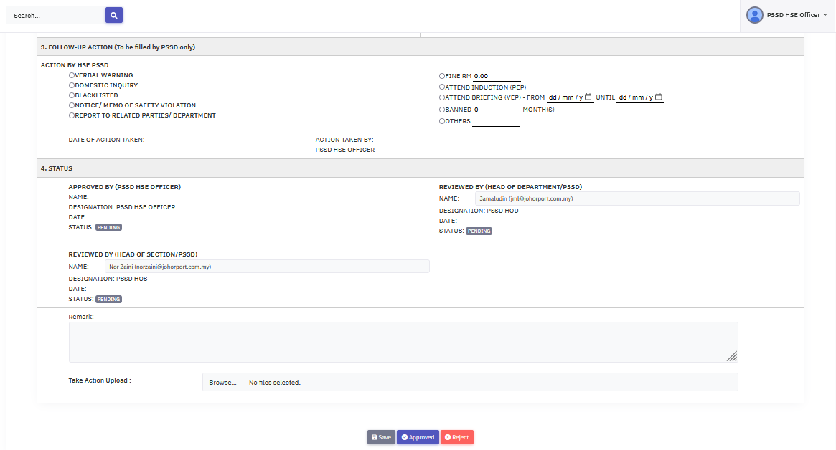

Chapter 13: PSSD HOS approval
PSSD HOS

- PSSD HOS can access the Approved Form by clicking the toggle bar -> Report -> Unsafe Action

- PSSD HOS can open the Approved Form for Unsafe Action to see the list and check the status.
- Click the Eye icon to view details.

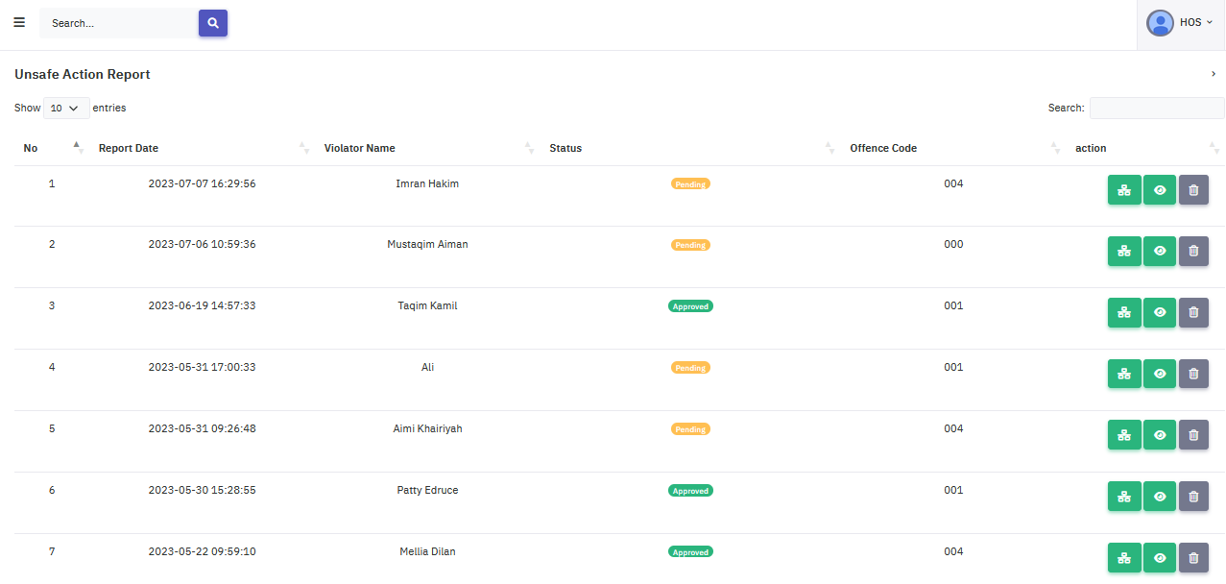
- PSSD HOS is required to fill in the remark text area and upload photos
- Once done, click the Review button to complete the process.
- The remark and uploaded photo will be added to the activities.

Chapter 14: PSSD HOD approval
PSSD HOD

- PSSD HOD can access the Approved Form by clicking the toggle bar -> Report -> Unsafe Action

- PSSD HOD will be redirected to the unsafe action screen.
- PSSD HOD can click the History icon to view the history logs.
- Click the Eye icon to view details.

- PSSD HOD is now redirected to the unsafe action screen.
- PSSD HOD is required to fill in the remark text and upload photos.

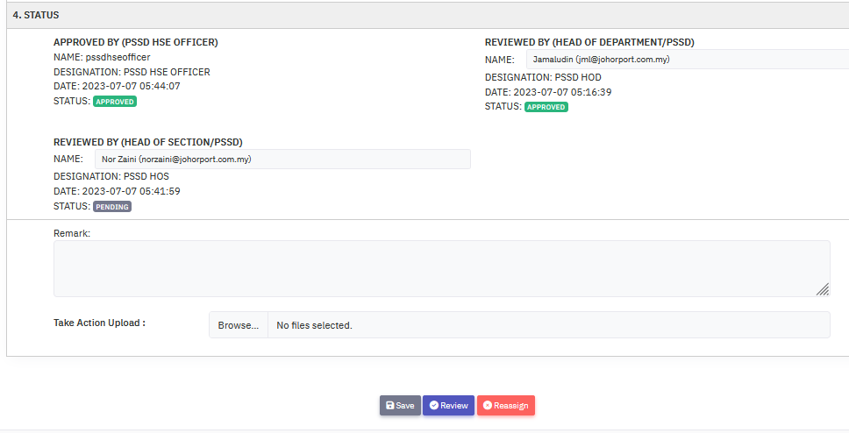

- Once done, PSSD HOD can click the Review button to complete the process.
- Once review the report is closed completely.
- The remark and photo will be added to activities.

Mobile Platform

User Acceptance Testing for all user
No | Module | Description | Approve / Reject | Remark
1 | Register | - User register by inserting all the required details  - Register a new account
2 | Login | - User login using username and password  - Display error message if public user enters the wrong credentials
3 | Forgot password | - Validate email address  - Send temporary password to user’s email  - Update new password  - Log in with new password
4 | Dashboard | - Shortcut button for unsafe condition form, unsafe action form and user’s UCUA report status
5 | Unsafe Condition Form | - Create new report  - Public user create report by inserting all the required details  - Able to upload multiple images as evidence (all supported types)
6 | Unsafe Action Form | - Create new report  - Public user create report by inserting all the required details  - Able to upload multiple images as evidence (all supported types)
7 | UCUA report status | - Display user’s UC and UA report list
8 | Sidebar Menu | - Menu for “Profile” to view user profile that contain list of user’s UC and UA report  - Menu for “Unsafe Condition” to create new UC report  - Menu for “Unsafe Action” to create new UA report  - Menu for “UC Report” to view list of user’s UC report  - Menu for “UA Report” to view list of user’s UA report  - Menu for “Settings” to go to account setting  - Menu for “Settings” to go to account setting  - Menu for “Privacy” to view system’s privacy  - Menu for “Terms” to view system’s terms  - Menu for “Log out” to log out the system
9 | Bottom bar Menu | - House icon for shortcut to go to dashboard  - image icon for shortcut to go to list of user’s UCUA report  - Plus icon for shortcut to create new UC or UA report  - Magnifier icon for shortcut to go to search  - User icon for shortcut to go to account setting
10 | Account Setting | - Menu for “View profile” to view user profile that contain list of user’s UC and UA report  - Menu for “Personal information” to view and edit user detail  - Menu for “Change password” to change password  - Menu for “Get help”, “Send feedback”, “Report error” to view contact details  - Menu for “Resources” provide tutorial video  - “LOGOUT” link to log out the system

UCUA 1.0 User Manual (Mobile)

Chapter 1: Accessing UCUA
- Open your browser and go to this URL: http://apps.johorport.com.my/ucua300/loginor you can scan QR code below:

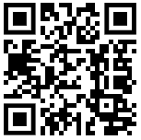

- Press “Open in browser”
- Login or register to UCUA on your phone
- You will see the login screen below:

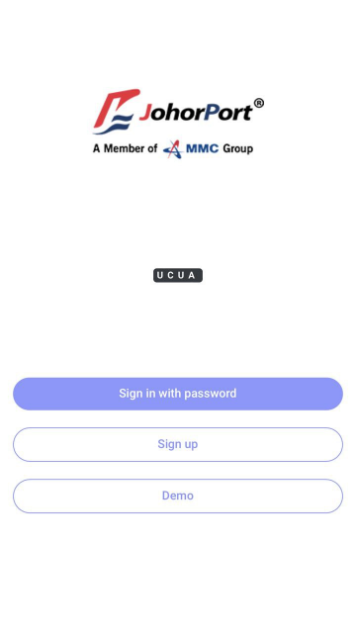

- Click Sign in with password button and the page will appear like this:
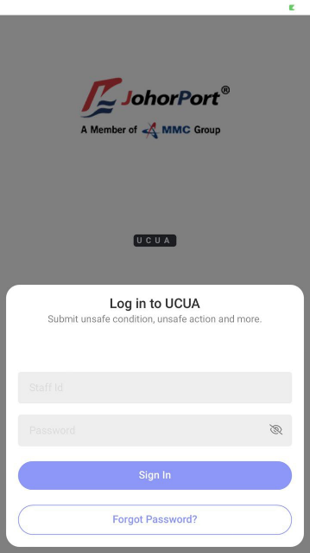

- Fill the Staff ID and Password to login to the system.

Chapter 2: UCUA Registration
- Click the Register button.

- Fill in all the required textboxes:
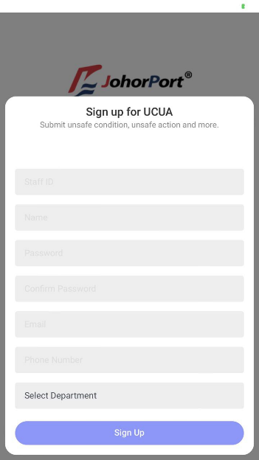

- Once done, click the Sign up button to finish the registration.
- Once your account is active, you can login to UCUA.

Chapter 3: Forget Password
- Click the Sign in with password button.

- Click Forgot Password? Button

- Fill in the email address and click Send Reset Link button. The system will sent an OTP by email. This OTP will act as a temporary password. Use the OTP given for user’s password and later change the password inside the system.

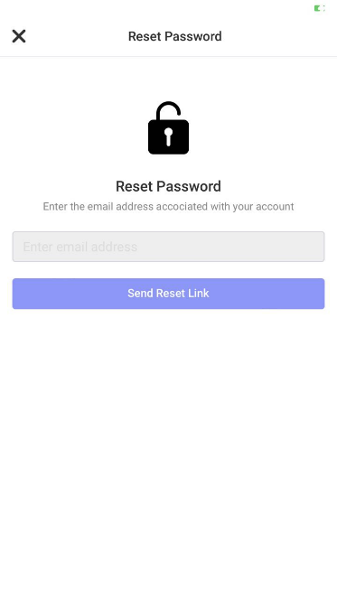

UNSAFE CONDITION (Mobile)

Chapter 4: Unsafe condition submission for all user
- From the user dashboard or sidebar menu or add icon located in bottom bar menu, click the Unsafe Condition button to redirect to the unsafe condition form screen.

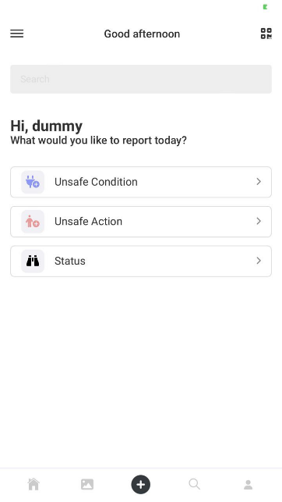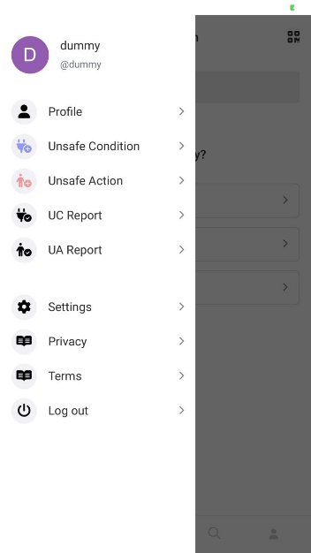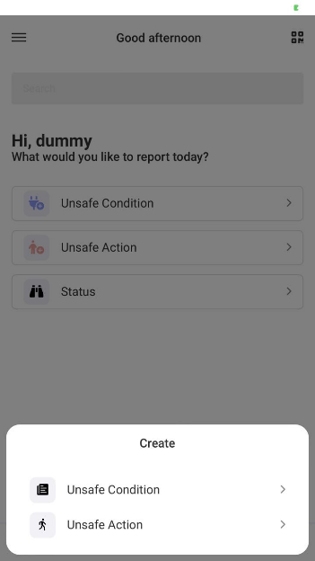

- User will be redirect to the unsafe condition form screen

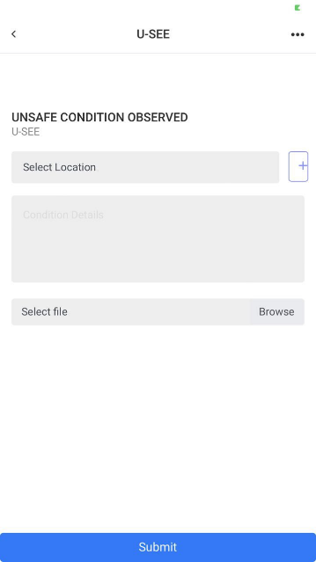

- Select location from the first select box.
- Or, user can click + button to add new location
- Fill in the condition details in text area.
- Browse for an image.
- Click the Submit to complete the submission.
- Once the submit button is clicked, user can check the report status by going back to dashboard and click “Status” button, go to sidebar menu and click “UC Report” or profile picture, or go to bottom bar menu and click image icon.

- If user click “Status” button from dashboard or image icon from bottom bar menu, it will redirect user to the user’s UC and UA report list screen.

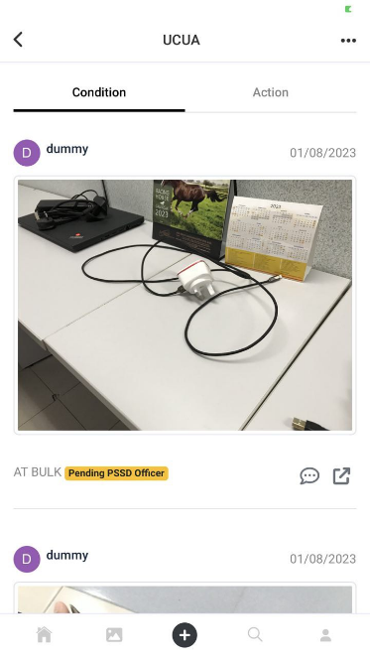

- Click the message icon to view activity log for that report.
- Click the expand icon to view report details.

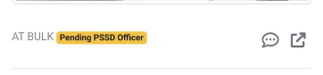
- If user click “UC Report” from sidebar menu, it will redirect user to the user’s UC report list screen.

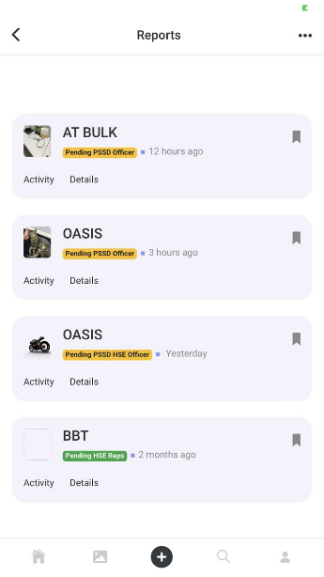

- Click the Activity to view activity log for that report.
- Click the Detail to view report details.
- If user click profile picture from sidebar menu, it will redirect user to the user’s profile that contain the user’s UC and UA report list.

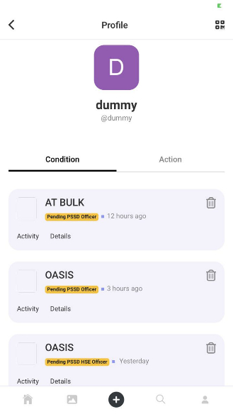

- Click the Activity to view activity log for that report.
- Click the Detail to view report details.
- This label will change according to current status for the selected report
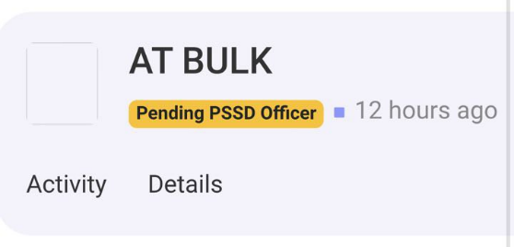

UNSAFE ACTION (Mobile)

Chapter 5: Unsafe condition submission for all user
- From the user dashboard or sidebar menu or add icon located in bottom bar menu, click the Unsafe Action button to redirect to the unsafe action form screen.

- User will be redirect to the unsafe action form screen

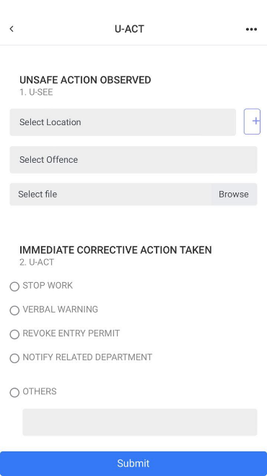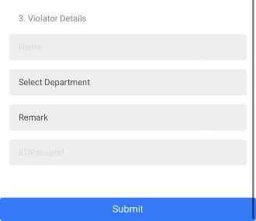
- Select location from the select box.
- Or, user can click + button to add new location
- Select offence code from the select box.
- Browse for an image.
- Choose Immediate Corrective Action Taken
- Fill in the violater’s details including name, department, company name, and IC/Passport
- Click the Submit to complete the submission.
- Once the submit button is clicked, user can check the report status by going back to dashboard and click “Status” button, go to sidebar menu and click “UA Report” or profile picture, or go to bottom bar menu and click image icon.

- If user click “Status” button from dashboard or image icon from bottom bar menu, it will redirect user to the user’s UC and UA report list screen.

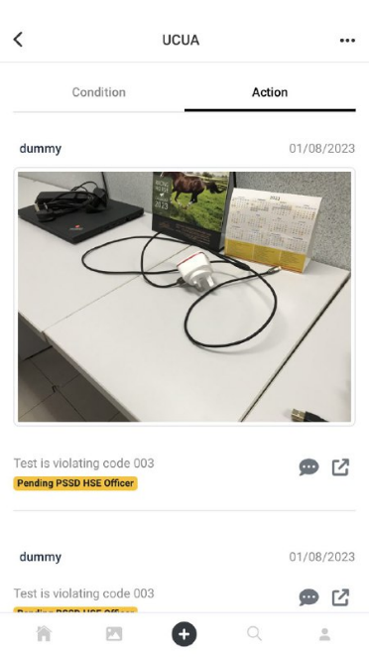
- Click the message icon to view activity log for that report.
- Click the expand icon to view report details.

- If user click “UA Report” from sidebar menu, it will redirect user to the user’s UA report list screen.

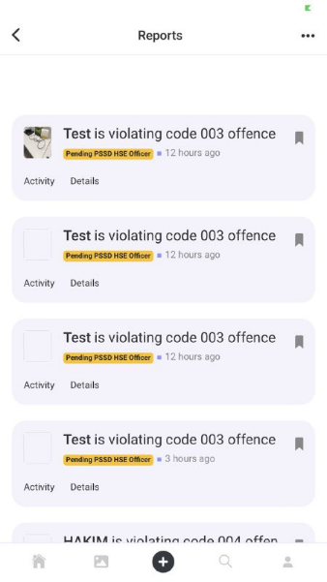

- Click the Activity to view activity log for that report.
- Click the Detail to view report details.
- If user click profile picture from sidebar menu, it will redirect user to the user’s profile that contain the user’s UC and UA report list.

- Click the Activity to view activity log for that report.
- Click the Detail to view report details.
- This label will change according to current status for the selected report

