Search
Search box component is used on global header and in several widgets. They look like this:
On global header:

In Quote Widget:


Relationship of classes in search
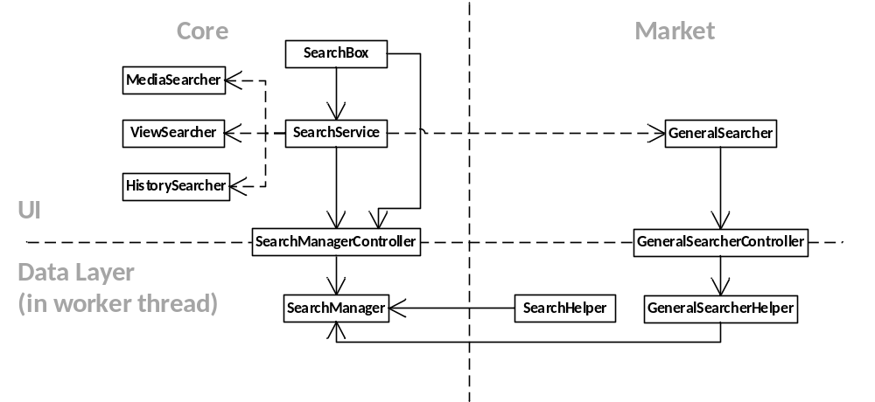

Using search
Search box component is available if you want to use it as a whole:
<div class="container-hor" data-bind="component: {name: 'search-box', params: {name: 'test10', categories: [eSearchCategory.all]}}">

<search-box class="container-hor" params="name: 'test32', categories: [eSearchCategory.equities], showAdvance: false, showFlyouts: false" />
<search-box class="container-hor" params="name: 'test20', categories: [eSearchCategory.securities, eSearchCategory.watchlists, eSearchCategory.layout, eSearchCategory.google, eSearchCategory.people], icons: {'securities': 'fa fa-lock'}, searchers: [{ id: eSearchCategory.people, name: undefined, searcher: 'Dummy' }]" />

Or you can use the custom binding if you want to bind it with an existing input:
<input type="text" class="form-control code-input input-sm" placeholder="Search.." data-bind="search: { name: 'quote', categories: [eSearchCategory.securities], autoBreakDown: true, showAdvance: false, showFlyouts: false, value: securityCode, event: {result: _onResult} }, value:securityCode, valueUpdate:'afterkeydown', event:{'keyup': enterSearch}, attr:{'data-element':'QuoteDetail_input_'+dataName()}" data-i18n="[placeholder]common.input.search">

Custom binding
SearchBox.ts:
ko.bindingHandlers["allowBindings"] = {
init: function (elem, valueAccessor) {
var shouldAllowBindings = ko.unwrap(valueAccessor());
return { controlsDescendantBindings: !shouldAllowBindings };
}
};

ko.bindingHandlers["search"] = {
init: function (element: any,
valueAccessor: () => any,
allBindingsAccessor: () => any,
viewModel: any,
bindingContext: KnockoutBindingContext) {
var options = valueAccessor();
var box = new IressTraderPlus.Search.SearchBox(options);
var childBindingContext = bindingContext.createChildContext(box);
var div = document.createElement("div");
var parent = $(element).parent();
ko.renderTemplate("Tmpl_SearchBox", childBindingContext, {}, div, "replaceChildren");
var ul = $(div).find("ul[aria-label='search-result']");
ul.attr("data-bind", "allowBindings: false");
ul.css("position", "relative");
ul.appendTo(parent);
if (!parent.hasClass("dropdown")) parent.addClass("dropdown");
var input = $(element);
if (!input.hasClass("dropdown-toggle")) input.addClass("dropdown-toggle");
input.removeAttr("data-toggle");
input.attr("data-toggle", "dropdown");
input.on("focus", function (event) {
box["_onFocus"].apply(box, [box, event, input]);
});
input.on("blur", function (event) {
box["_onBlur"].apply(box, [box, event, input]);
});
input.on("click", function (event) {
box["_onClick"].apply(box, [box, event, input]);
});
input.on("keyup", function (event) {
box["_onKeyup"].apply(box, [box, event, input]);
});
},

update: function (element, valueAccessor, allBindingsAccessor, viewModel, bindingContext) {
}
};

