CS 6375.501

ASSIGNMENT 5 – Part1

Date: Dec 2, 2016

Names of students in your group:

Gonsoo Moon, Bohao Chen

Number of free late days used: ________0___________   
Note: You are allowed a **total** of 4 free late days for the **entire semester**. You can use at most 2 for each assignment. After that, there will be a penalty of 10% for each late day.

Please list clearly all the sources/references that you have used in this assignment.

- We don’t use any sources and references.

# **I. Software**

* Language: Java
* Platform tested: Window 10

# **II. Parameters used**

* A number of clusters

# **III. How to run**

* Follow the ReadMe.txt file and run the command in the command line
* Snapshot

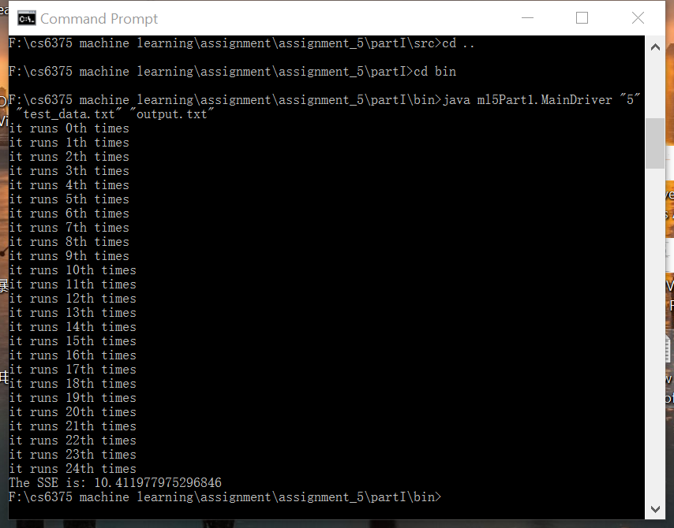

# **IV. Output file**

* First iteration with cluster = 5:
* SSE value = 10.411977975296846

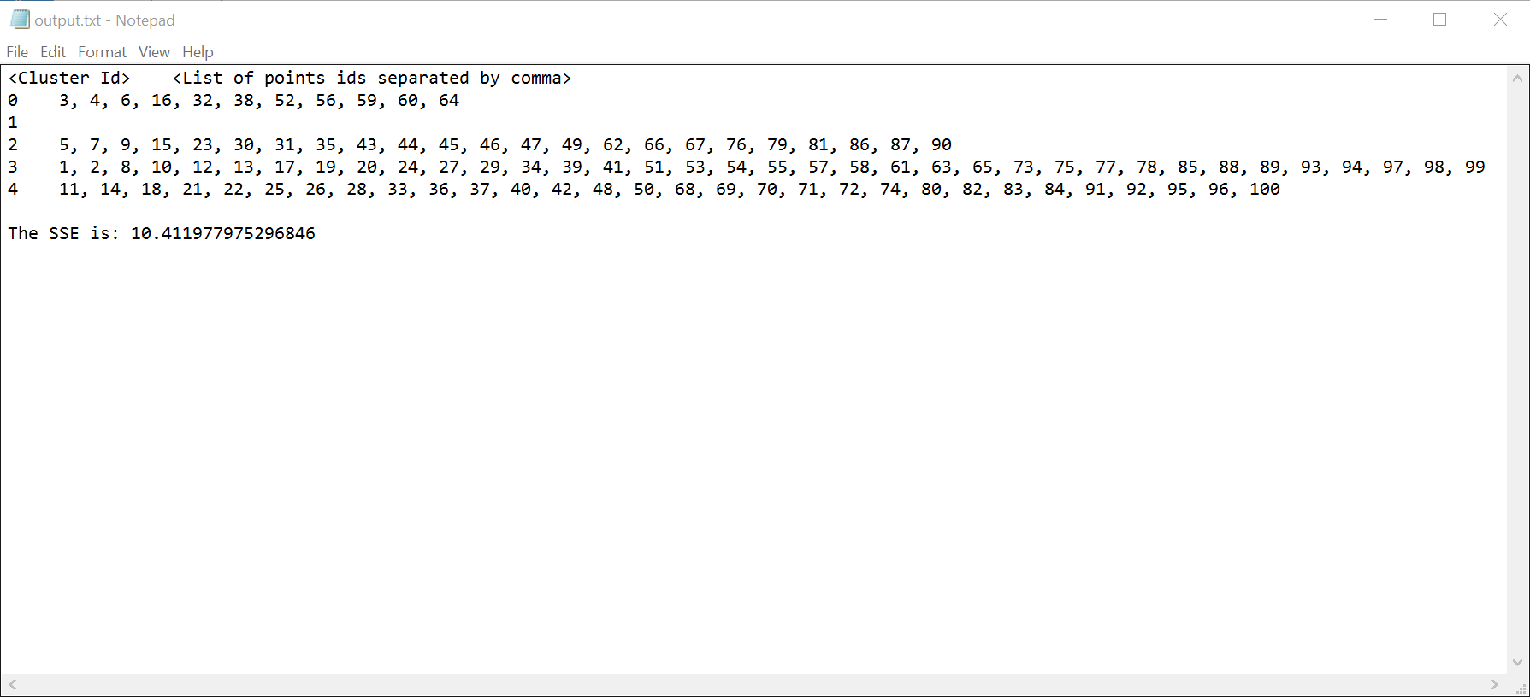

* Second iteration with cluster = 10:
* SSE = 33.87386111590921

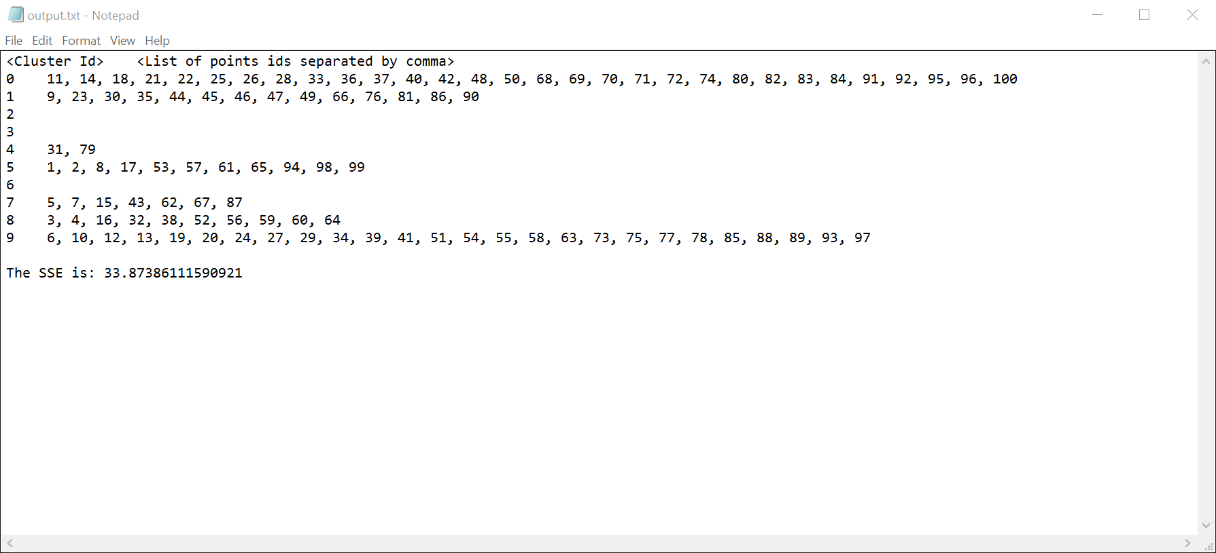

* Third iteration with cluster = 3:
* Sse = 15.829260321564892

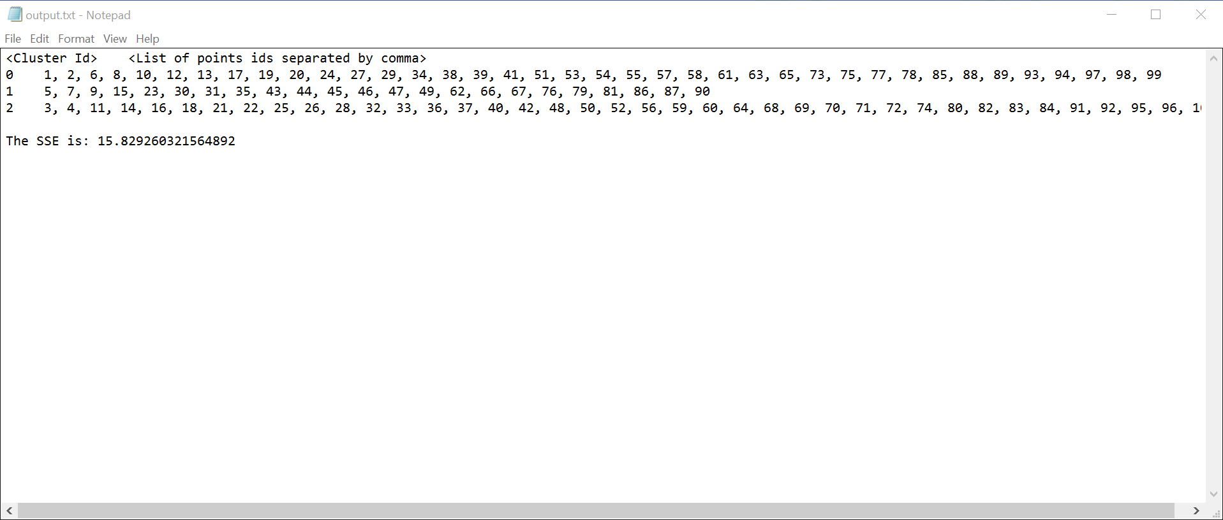

* Forth iteration with cluster = 7
* Sse = 23.997355671526776

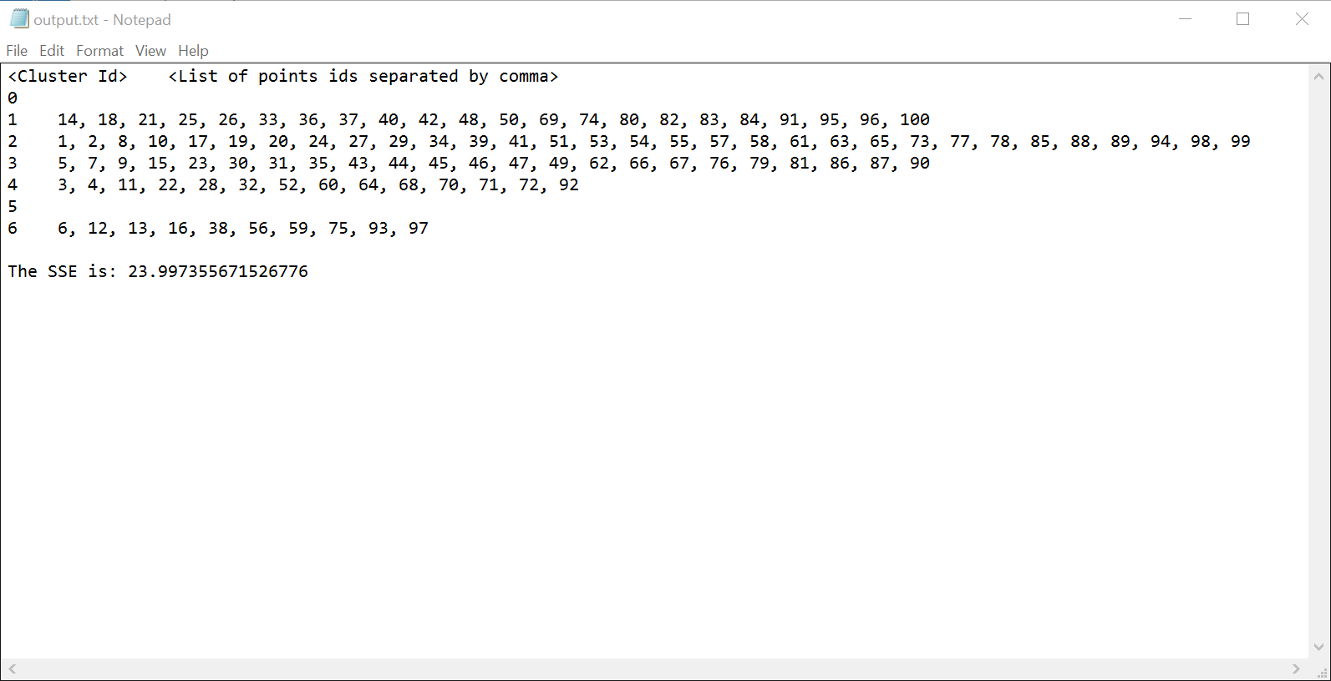

* Fifth iteration with cluster = 9
* Sse = 31.113638350977855

