CS 6375.501

ASSIGNMENT 5 – Part2 (Tweets Clustering using k-means)

Date: Dec 2, 2016

Names of students in your group:

Gonsoo Moon, Bohao Chen

Number of free late days used: ________0___________   
Note: You are allowed a **total** of 4 free late days for the **entire semester**. You can use at most 2 for each assignment. After that, there will be a penalty of 10% for each late day.

Please list clearly all the sources/references that you have used in this assignment.

- We don’t use any sources and references.

# **I. Software**

* Language: Java
* Platform tested: Window 10

# **II. Parameters used**

* A number of clusters (default = 25, can be changed between 1 to 25)

# **III. How to run**

* Follow the ReadMe.txt file and run the command in the command line
* I add two jar file in order to read the JSON file by using java
* Snapshot

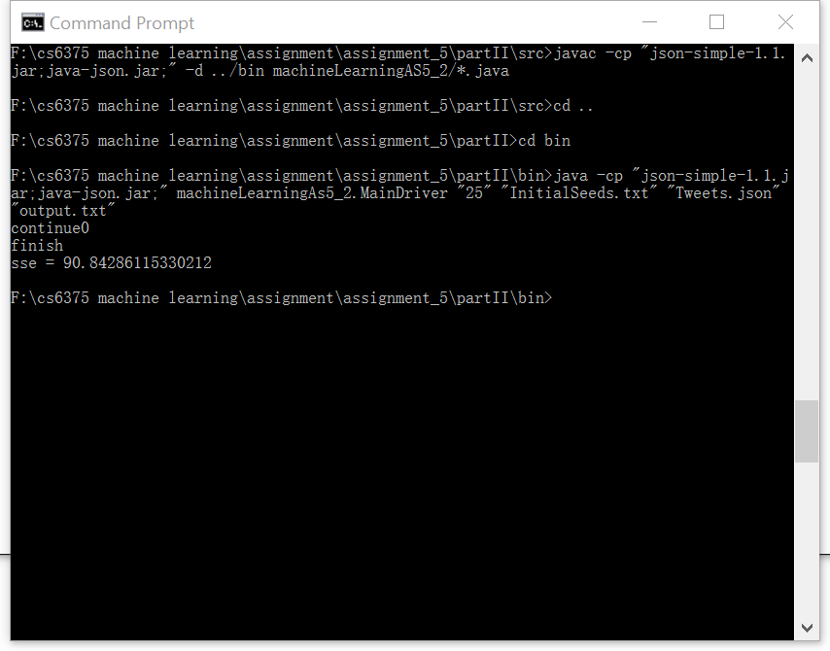

# **IV. Output file**

* Default cluster value = 25
* SSE value = 90.84286115330212

