Project Plan

GBCMart

Industry Partner | N/A
Primary Instructor | Laily Ajellu
Team Member | Woohyuk (Harry) Song
Team Member | Iqbal Qureshi
Team Member | Mitchell Stevenson
Team Member | Harrison Pape
Team Member | Amelework Murti

Document Revision History

Revision # | Date
3.0 | February 12th, 2026

Table of Contents

1. Executive Summary 3
2. Project Approvers, Reviews and Distribution List 4
3. Scope 5
4. Deliverables 5
5. Assumptions 5
6. Dependencies 5
7. Risk Management 6
8. Communication 6
9. Task Listing (WBS- Work Breakdown Structure) 7
10. Gantt Chart 7
11. Milestones 7
12. RAM – Responsibility Assignment Matrix 8
13. Approval 8

1. Executive Summary

The following describes the project to be executed.

Objective | Develop a web-based application that aggregates store flyers, enabling users to create, search, filter, and export personalized shopping lists with secure login and storage for a convenient and interactive shopping experience.
Corporate Goals Addressed | Efficiency, User friendly Interface, Time saving.
Planned Start Date | September 08, 2025
Planned End Date | April 01, 2026

2. Project Approvers, Reviews and Distribution List

Approvers, reviewers and distribution list

Project Role | Name | E-mail | Date
Instructor | Laily Ajellu | Laily.Ajellu@georgebrown.ca | February 12, 2026
Back-End Developer | Woohyuk (Harry) Song | Harry.Song@georgebrown.ca | February 12, 2026
Full-Stack developer | Iqbal Qureshi | Iqbal.Qureshi@georgebrown.ca | February 12, 2026
Database manager | Mitchell Stevenson | Mitchell.Stevenson@georgebrown.ca | February 12, 2026
Project leader | Harrison Pape | Harrison.Pape@georgebrown.ca | February 12, 2026
Front- End developer | Amelework Murti | Amelework.Murti@georgebrown.ca | February 12, 2026

3. Scope

Define the sum total of all of its products and their requirements or features.

In Scope | Out of Scope
Collect and compile store flyer information from online sources. | Deploying the platform for full public use at this stage.
Allow users to create accounts and sign into the application. | Supporting online purchasing or checkout features.
Enable users to add products to a shopping list that can be shared. | Allowing users to import new store flyers via custom URLs.
Provide a Help/About section with guidance and details about the app. | Incorporating advertisements into the application.
Display multiple grocery store options using a user-friendly tab layout. | Offering subscription-based or pain upgrades.
Ensure the interface is optimized for use on mobile devices.

4. Deliverables

This project will deliver the following.

Deliverable | Description
Database | The web app will collect promotional pricing information from multiple retailers and present it in a single, user friendly interface.
List creation | Users will be able to build a dynamic shopping list where items can be added or removed.
Data Export | The system will provide option to save the shopping list on the users device.
Search Function | Search and filtering tools will be included.
User Accounts | A secure account registration will be implemented so users have customised experience.
Pricing History | When the system record product pricing, it allows users to compare the prices from before.

5. Assumptions

This project makes the following assumptions;
- Store flyer and promotional pricing information will remain publicly available in formats that include details such as product descriptions, sale, and categories.
- The flyer data will be structured in a way that allows for semi-automated retrieval and frequent updates without requiring extensive manual intervention.
- Users will be willing to create secure accounts in order to personalize their experience.
- Users will trust that the system follows appropriate security measures to safeguard their account information.
- Internet access will be available for users while browsing the application.
- The retailers whose information we display will update their flyers regularly.
- The team will have sufficient time and collaborations.

6. Dependencies

The following are the internal and external dependencies that will have to be acknowledged and addressed;
- Consistent Access to Flyer Data-External
The Application relies on grocery retailers making promotional data publicly available online.
-Network Connectivity-External
Users must have internet access for the system to retrieve up-to-date pricing information.

- Hosting and Backend Services – External/Internal
A stable deployment environment is needed to support account features, databases, and application testing.
- Device and browser compatibility – External
The app depends on users accessing the system from supported browsers and mobile devices.
- Retailer update frequency – External
The accuracy of sale information depends on stores updating their pricing and flyers regularly
- Team Skillsets and development tools – Internal
The team must have access to necessary tools, version control systems, and the technical expertise to complete the project.
- Database reliability – Internal
The data storage used for user accounts, shopping lists, and price history must function without interruption.
- Third-Party tools and libraries – External
Continued support for data scraping, authentication services, and UI frameworks is required.

7. Risk Management

Potential Risk | Severity (H/M/L) | Likelihood (H/M/L) | Management Strategy
Data source become inaccessible | H | M | Refine the strategy to include implementing a monitoring system to alert the team of structural changes in retail domains
Security vulnerabilities with user accounts | H | L | We would use secure authentication frameworks and enforce encryption.
Lack of experience with certain technologies | M | H | Assign tasks based on strength and allocate enough time to learn.
Outdated pricing data displayed | M | M | Schedule automated refresh cycles and maintain data validation checks
User interface(UI) issues | L | M | Since the UI is roughly complete in terms of navigating between the pages, change the focus to usability testing, feedback, and bug fixing
Users not wanting to create accounts | L | M | Offering guest mode and highlight the benefit of account features.
Testing Pool Size | L | M | Mitigated by utilizing automated unit tests to compensate for the small feedback group

8. Communication

Reporting

The following reports will be produced;

Report | Audience | Frequency
Project Summary / Vision | Instructor | Once
High-Level Business Requirements | Instructor | Once
Personas & User Stories | Instructor | Once
Project Plan & Team Charter | Instructor | Monthly, as needed
Software Requirements Analysis & Design | Instructor | Once
Product & Sprint Backlogs | Instructor | Updated per Sprint cycle
Tech Requirements & Learning Plan | Instructor | Once
Interactive Figma Prototype | Instructor | Once
Meeting Minutes (MoM #1 – #8) | Instructor | Weekly/Bi-Weekly
Project Status Reports (I, II, III) | Instructor | Monthly, as needed

Meetings

The following meetings/communication will be established;

Meeting | Purpose | Attendees | Frequency
Weekly Status Meeting | Review tasks, assign responsibilities, and address issues | Entire Team | Weekly (Tuesdays)
Discord Group Chat | Daily ad-hoc communication, intermittent progress updates, and quick queries. | Entire Team | Continuous
GitHub Repository | Version control, code modification, and tracking progress of files. | Entire Team | Continuous

9. Task Listing (WBS- Work Breakdown Structure)
The following resource proposal template summarizes the resource hours committed to this project, upon final approval of this document.

Reference | Tasks | Duration | Dependency | Complete
A | Requirements gathering and finalizing Project Scope | 1 week | NONE | 100%
B | System design(UI wireframes, database design…) | 2 weeks | A | 100%
C | Front-end Development (UI implementation and responsive design) | 2 weeks | B | 70%
D | Back-end development(Database, API, account system) | 3 weeks | B | 50%
E | Flyer data integration(scraping store data) | 2 weeks | D | 0%
F | Testing (unit testing, usability testing, bug fixes) | 2 weeks | C & E | 0%

10. Gantt Chart
Create a detailed Gantt Chart from your Task Listing(Use any software tool and paste the image or upload as a separate file that can be opened as pdf/doc/xls)

Below is an example:
Task | Period |  |  |  |  |  |  |  |  |  | Completed
 | Dates | Dates | Dates | Dates | Dates | Dates | Dates | Dates | Dates | Dates
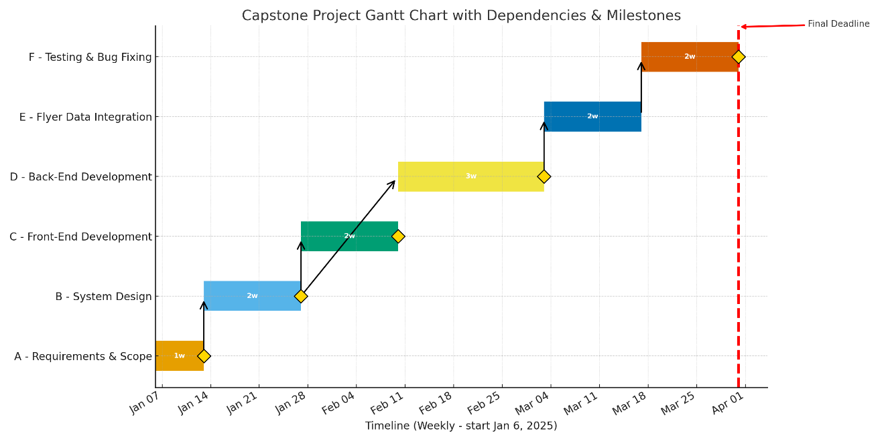

11. Milestones

Major Activity or Milestone | Estimated Milestone Target date | Owner/Reviewer Team Members
Project scope and requirements approved | Oct 26, 2025- Jan 10, 2026 | Instructor
Wireframes and UI/UX design completed | January 24, 2026 | Front-End lead
Front-End development phase completed | February 7, 2026 | Front-End lead
Back-end APIs and integrations completed | February 21, 2026 | Back-End lead
Final submission and Demonstration | April 10,26 | Entire team and Instructor

12. RAM – Responsibility Assignment Matrix

Create a RAM from your Task Listing. A sample is shown below:
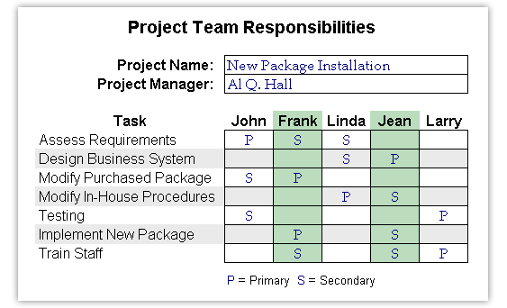
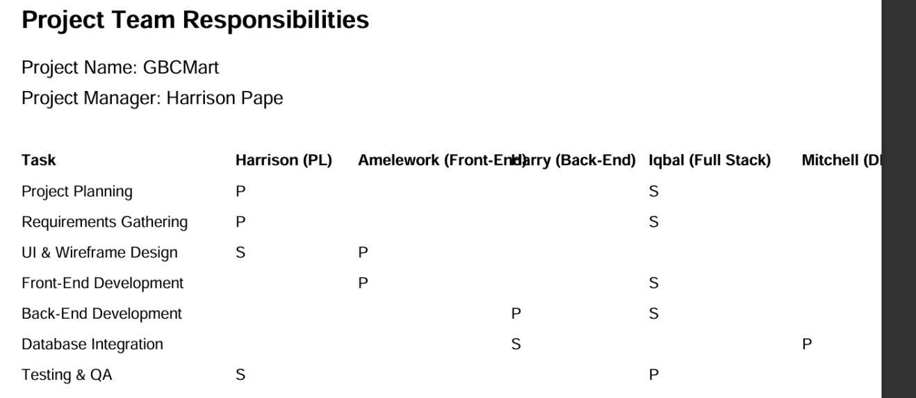

13. Approval

The signatures below indicate their approval of the contents of this document.

Project Role | Name | Signature | Date
Back-End Developer | Woohyuk (Harry) Song | H.S | Feb 12, 2026
Full Stack Developer | Iqbal Qureshi | I.Q | Oct 23, 2025
Database Manager | Mitchell Stevenson | M.S | Feb 12, 2026
Project Leader | Harrison Pape | H.P | Feb 12, 2026
Front-End Developer | Amelework Murti | A.M | Feb 12, 2026

