GBCMart
High Level Requirements Document
Version 0.1
Sept 22, 2025

Project Identification

Project: | GBCMart
Prepared By: | Group 6 (Woohyuk (Harry) Song, Mitchell Stevenson, Iqbal Qureshi, Harrison Pape, Amelework Murti)
Document Version: | 0.1
Published Date: | Sept 22, 2025

Contributors
The following individuals contributed to this document.
Name | Title
Woohyuk (Harry) Song | Back-End Developer
Iqbal Qureshi | Full Stack Developer
Mitchell Stevenson | Database Manager
Harrison Pape | Project Leader
Amelework Murti | Front-End Developer

Distribution
This document is distributed to all the following people.
Name | Title
Prof. Laily Ajellu | Course Instructor

Referenced Documents
This document refers to the following materials
Version number | Title | Author | Date | Source / Location
0.1 | Project Vision Document | Group 6 | Sept 15, 2025
0.1 | Project Summary | Group 6 | Sept 14, 2025

Revision History

Version Number | Revision Date | Summary of Changes | Modified by
0.1 | Sept 28, 2025 | Document Creation | Group 6
[Note: It is recommended that drafts be numbered 0.1 to 0.9, and that the first approved version be numbered 1.0. Thereafter, new version numbers will depend upon changes: 1.01, 1.1, etc for minor updates, 2.0, 3.0 etc for major changes.]

TABLE OF CONTENTS
1. BUSINESS CONTEXT DIAGRAM 3
2. REQUIREMENTS SCOPE STATEMENTS 4
3. HIGH LEVEL BUSINESS REQUIREMENTS SIGN-OFF 5

- Business Context Diagram
<Insert Diagram> ( Refer slides posted on Brightspace 🡪 Lecture Review)
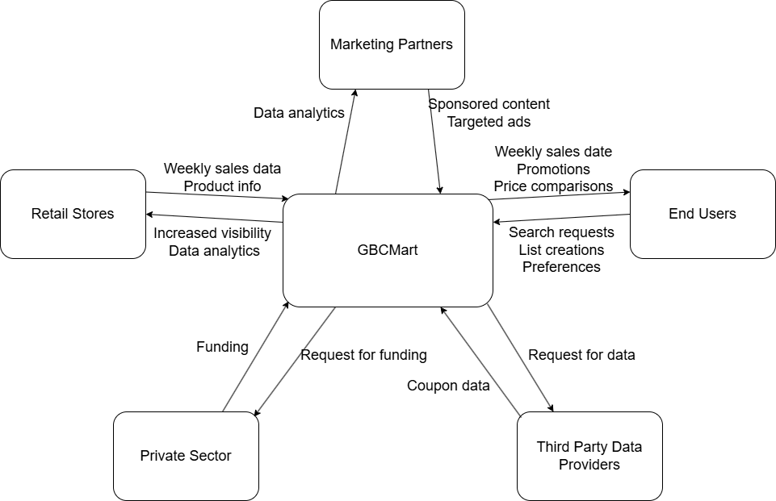

Requirement Scope Area | Description
Flyer Data | Collection of flyer data from various stores, including names, original prices, sale prices, etc.
User Management | Allows user-distinguishing, meaning the functionality for secure registration, log-in, and log-out. As such, the system must be able to create and save distinguished shopping lists on a per-user basis.
Shopping List Management | Separate from user management, the management of shopping lists enables users to create, edit, delete, and export their shopping lists.
Searching / Filtering | Provides a search function that allows for users to search for specific items using filters such as item name, price, or store.
User Interface | Provides a user-friendly display and ensures functionality remains the same. Additional mobile support if possible as well.
System Reliability / Security | Ensures that the system is accessible and secure, as it must reliably write and retrieve data, as well as stay synchronized with the backend.
Stakeholder Management | Covers the overall project progress and evaluation on the current status of deliverables with organized tasks, to-dos, and deadlines.
Customer Interaction | Provides an easy access point for feedback / bug submissions from within the webpage.

External Entity | Description
Retail Stores | Stores that supply us their flyer data or APIs so their weekly sales show up on the GBCMart website app.
Marketing partners | Companies that provide targeted grocery ads to increase the visibility of GBCMart.
Helene Chris | A 32-year-old elementary school teacher and single mom of two. Her goals are to save at least $40 a week on groceries and plan meals efficiently around weekly deals. Her current issues include the discontinuation of local paper flyers and the time-consuming process of price matching.
Robert Peterson | A 42-year-old junior software developer with a busy hybrid work schedule. He shops a few evenings a week and his goals are to grab groceries quickly, stick to a health-focused list, and spend less than $100 per week. He finds it hard to track changing weekly prices and doesn't have time to flip through multiple apps.
Jeanette Roy | A 66-year-old retired nurse who lives on a fixed income with her husband. She enjoys baking and needs to stretch her budget by comparing prices to plan bulk purchases. Her issues are that flyers often arrive late or not at all, and the small text in some apps is hard for her to read.
Third Party Data Providers | External APIs that can add additional content to the web app such as coupons
Private Sector | Outside side investors for initial project funding and start up costs.

Information Flows | Description
Flyer Data | We gather discount flyers and APIs from competitors providing processed data so users can compare deals and plan purchases.
User Feedback / Input | When users enter their preferences, budgets or feedback the system gathers that data to provide personalized interaction.
Shopping Lists | When users create a shopping list within the app it is stored in the database and can be retrieved anytime.
User Authentication Data | Login credentials are verified by an authentication system and stored in the database for easy access later.
Search Queries / Filters | As users put filters into the system’s search engine, the system retrieves matching results from the flyer data and database then displays relevant items to the user.
Maybe: System Analytics | Contains insights on user trends and shopping habits, such as frequently used filters, search queries, item types, etc. Allows the development team to gain a better understanding of user preferences.
- Requirements Scope Statements
HLR# | Description | Priority  (H, M, L)
 | Data collection of sales data from stores, including name, regular price, sale price, etc. | H
 | Secure user information handling. | H
 | Ability for users to create and manage created lists as well as export them. | H
HLR04 | Allow users to search and filter for specific products. | M
HLR05 | User friendly UI/UX. | H
HLR06 | The system should reliably handle data in a fast and secure manner. | H
HLR07 | Management of project progress to keep stakeholders readily informed. | M
HLR08 | Ability for users to provide feedback from the web app. | L

- High Level Business Requirements Sign-Off
The undersigned acknowledge their agreement with the contents of Version 0.1 of the High-Level Requirements document for GBCMart.

Following approval of this document, requirements changes will be governed by the project’s change management process, including impact analysis and appropriate reviews and approvals, under the general control of the Project Plan and according to company policy. Approved Change Request Documents, if present, will be attached to this Requirements Document as updates.

Name | Project Role and  Functional Area | Date Signed
Woohyuk (Harry) Song | Back-End Developer, responsible for the creation of the web app’s API | 9/28/2025
Iqbal Qureshi | Full Stack Developer, responsible for implementing the connection of the front-end and back-end | 9/28/2025
Mitchell Stevenson | Database Manager, responsible for the design and implementation of the database | 9/28/2025
Harrison Pape | Project Leader, responsible for overseeing the development process and assisting each member with developement | 9/28/2025
Amelework Murti | Front-End Developer, responsible for the creation of the UI/UX | 9/28/2025

* Note: physical signatures are not required. Email approvals are acceptable and should be appended to project documents.
