COMP 3059 – Capstone Project I

Software Requirements Analysis and Design Assignment

This assignment is an overview to gather the software needs with requirements analysis and help to proceed with the design.

The requirements analysis helps to break down functional and non-functional requirements to a basic design view to provide a clear system development process framework. It involves various entities, including business, stakeholders and technology requirements.

The design is the activity following requirements specification and before programming. Software design usually involves problem solving and planning a software solution.

To work on this assignment you could use the references and a sample template given below. The sample template can be customised to suit the nature of your project.

Reference Readings/Example:
http://www.uacg.bg/filebank/acadstaff/userfiles/publ_bg_397_SDP_activities_and_steps.pdf

www.cse.msu.edu/~chengb/RE-491/Papers/SRSExample-webapp.doc

Source for this template:
www.tricity.wsu.edu/~mckinnon/cpts322/cpts322-srs-v1.doc

1.0 Introduction
The Introduction section provides an overview of the system using software requirements analysis and design for the scope of the system.

GBCMart is a web-based application that centralizes local grocery flyer deals into a single user-friendly platform. Using GBCMart, users can quickly compare active deals, build a savings-focused shopping list, and share it with themselves and others. This document defines what GBCMart will provide and establish a clear vision for all stakeholders before the development begins.

Purpose
This document describes the high level software requirements for the system. It describes the what, not how, of the capabilities of the system for the intended audiences.

The purpose of this document is to clearly specify the software requirements of GBCMart and share the common understanding among the stakeholders. This document describes the system’s capabilities that the user will access, and provides the baseline reference for the design and development of the application.

Scope
This explains what the proposed system will and will not do. Describe relevant benefits, objectives and goals. The description of scope should be consistent with the Project Plan.

At this stage, the system is planned to perform the functionality of:
- Register and log in to an account for persistence
- Browse local grocery flyers by store
- Search, sort, filter products by various flags/filters
- Add products to a personal shareable shopping list
- Provide a clean, mobile-friendly UI/UX
- Provide a help/about page for users to reference

At this stage, the system will not have:
- Public deployment and live hosting
- Online ordering
- User-added grocery stores via URL
- Advertising for revenue
- Premium/paid subscriptions

System Overview
The System Overview section introduces the system context and design.

Project Perspective
The Project Perspective describes the context and origin of the system by defining whether the system is:
- a follow-on member of a system family
- a replacement for existing systems, or
- a new self-contained system.
GBCMart’s system is self-contained, as it is a new web-based system that will be created from scratch, with no reliance on previously existing systems. Although the entire purpose is to provide a centralized location to view “already-existing” grocery flyer deals, the purpose and goal the project is trying to achieve is separate and distinct enough to not count as a replacement technology, nor be categorized as a follow-up on a member of a system family.

System Context
The System Context describes the resulting software within the business case, including strategic issues in which the system is involved or which it specifically addresses.
GBCMart addresses the issue of decline in paper flyer distribution, and relatedly, the decrease of viewership for flyers as a whole. The system aims to fill this gap through the collection and presentation of grocery flyer deals in one centralized location.

General Constraints
General Constraints identify any business or system constraints that will impact the manner in which the software is to be:
- specified
- designed
- implemented, or
- tested.
GBCMart faces the following general constraints:
- Specified (Requirements)
  - The biggest constraint for the system is the accessibility and reliability of obtaining flyer data. The system itself relies heavily on having the necessary data to perform its functions, and this includes the ability to gather the required information (flyer data) reliably and consistently. Therefore, it is necessary that any data obtained from stores must be accessible either publicly or provided by stores.
- Designed (Planning)
  - The constraint in design comes from the risk that external changes which are out of our control may cause the entire functionality of the web application to break (i.e. certain grocery stores suddenly change the API endpoints or locations of where flyer data is located, or if the accessibility of the data in public domains are for any reason, discontinued).
- Implemented (Coding/Building)
  - The code must be implemented correctly, with assurance that the flyer data, such as item names, original prices, sale prices, and the other data points detailed in the project reports will be and are successfully collected from their sources. This process must be completed in a format that can be collected through semi-automation.
- Tested (Quality Assurance)
  - The constraint in testing comes from the idea that projects, especially ones with extensive user interaction, are better guided through continuous testing and feedback. However, as all of the testing will be done through reliance on family and friends, the pool to collect feedback and test the system is much smaller than if it were to be tested with public access.

Assumptions and Dependencies
List any assumptions that have been made during the initiation of the project. In addition, list any dependencies that may impact its success or the desired result.

Assumptions for our project include:
- Users will have internet access and a compatible web browser
- The flyers we will use will always be publicly available
- The flyer data will be structured in a way that allows for semi-automated retrieval
- Users will be willing to create accounts
- Our team will have sufficient time

Dependencies for our project include:
- A stable environment that will be used for database and development purposes
- The flyer source will update on their end
- Third-party tools and libraries will be supported and available throughout the development process
- Our application is compatible with the web browser being used
- Database must function without interruption

3.0 Functional Requirements
This section describes specific features of the software project. If desired, some requirements may be specified in the use-case format and listed in the Use Cases Section.

3.1.1 <Flyer Data Aggregation and Display>
- Introduction
  - The system must collect and display flyer sale data from selected stores. This is the main, crucial function as it addresses the problem trying to be solved (excessive information sources, difficult/complicated to access).
- Inputs
  - The input for the system would be the flyer data from selected stores, in whichever form that would be (API, public data, etc). More specifically, the input would include item names, original prices, discounted sale prices, and product types (category).
- Processing
  - The system’s processing would be the semi-automated data gathering as well as the filtering done by users where relevant data from the overall collection is processed to only display the wanted data. The system must reliably retrieve this data from the backend, ensuring that the handling of data is fast and secure. A slow system would be detrimental to the user experience.
- Outputs
  - The output for the system is the successful display of flyer details in one centralized location, where the user is able to filter the results to their liking.

3.1.2 <Interactive Shopping List Management>
  - Introduction
    - The system must provide the ability for users to create and manage created lists and allow users to add items to a sharable shopping list. This feature provides a sharable, interactive shopping list manager.
  - Inputs
    - Users provide input to create, edit, and delete their shopping lists. Users can add, remove, and change the quantities of the items in the list.
  - Processing
    - When users create a shopping list within the app, it is stored in the database and can be retrieved anytime. The system must allow users to export their list into a transferable format so that it can be sent to a mobile device for offline viewing. The list will also be able to track the total estimated cost of items.
  - Outputs
    - The output is an interactable "shopping list" that is both personalized and sharable. Users are able to send their list to their device for offline viewing.

3.1.3 <Secure User Account Management>
  - Introduction
    - The system must implement secure user information handling, as GBCMart requires user-based login to allow users to register and login to an account. As a result, account creation is also necessary for the shopping list management system and enables for distinguishing between users.
  - Inputs
    - The input is User Authentication Data, specifically login credentials required for registration and logging in.
  - Processing
    - Login credentials must be verified by an authentication system, so the system must implement secure account creation and maintenance to protect user data, or use a pre-existing solution (authentication through Google systems, etc). The system must reliably handle this data in a fast and secure manner.
  - Outputs
    - The output is the storage of User Authentication Data in the database for easy access later (personalization settings, not username/passwords). This allows for a personalized user experience, including saving their shopping lists and accessing their account features (night mode, etc).

3.2 Use Cases
3.2.1
Title: User Login
Primary Actor: User
Precondition: User has an account
Minimal Guarantee: Unauthorized access prevented
Success Guarantee: User logs in
Trigger: User submit login credentials
Main Success Scenario:
1. User enters username or email and password
2. System validates user’s login credentials
3. User is successfully logged in
Extensions:
2a. Invalid log in credentials
2a1. Invalid login message displayed
3.2.2
Title: Create a List
Primary Actor: User
Precondition: User is logged in
Minimal Guarantee: No list is created
Success Guarantee: A new list is created
Trigger: User selects to create a list
Main Success Scenario:
1. User selects to create a list
2. User gives list a custom name or default name
3. New list is successfully created
Extensions:
2a. System fails to create a new list
2a1. User tries to create list again
3.2.3
Title: Compare Prices
Primary Actor: User
Precondition: User has an account
Minimal Guarantee: No product added to list
Success Guarantee: Product is added to a list
Trigger: User chooses to compare products
Main Success Scenario:
1. User chooses two products
2. System fetches product data for both products
3. User views the product comparison view
4. User adds one of the products to a list
Extensions:
2a. System fails to fetch product data
2a1. User tries to compare again
4a. User does not add any products to a list
4a1. User returns to product browsing
3.2.4
Title: Share a List
Primary Actor: User
Precondition: User has a list created
Minimal Guarantee: No list is shared
Success Guarantee: Another user gains access to list
Trigger: User selects to share a list
Main Success Scenario:
1. User selects list to share
2. User enters other user’s username or email
3. User verifies other user existence
4. System grants other user access to list
5. Other user is notified
Extensions:
3a. System cannot verify other user
3a1. Main user is notified
3a2. Main user tries sharing list again
4a. Other user already has access
4a1. Main user is notified
3.2.5
Title: Remove Products From List
Primary Actor: User
Precondition: User has a list created with products in it
Minimal Guarantee: No changes made to list
Success Guarantee: Product is removed
Trigger: User selects to delete product from list
Main Success Scenario:
1. User selects product to remove
2. User confirms removal
3. System removes product from the list
4. User dynamically sees the removal of the product
Extensions:
2a. User cancels removal request
2a1. No change made to list
3.2.6
Title: Specific Product Search
Primary Actor: User
Precondition: No precondition
Minimal Guarantee: Specific product can’t be found
Success Guarantee: User sees matching products to search
Trigger: User enters a search query
Main Success Scenario:
1. User enters a search query
2. System validates the query
3. System queries the database for potential matches
4. System display matches to the user
Extensions:
2a. Invalid search term entered
2a1. Systems display no results
3a. No matches to query found
3a1. System displays no results
3.2.7
Title: Export a List
Primary Actor: User
Precondition: User has a list created
Minimal Guarantee: No list exported
Success Guarantee: Listed is export in user desired format
Trigger: User exports a list
Main Success Scenario:
1. User selects a list to export
2. User selects export format (Print or download)
3. System generates list into a clean viewable file
4. System provides file for download or opens print mode
Extensions:
1a. Selected list is empty
1a1. System warns user that the list is empty
2a. User cancels export process
2a1. No changes made
3a. File generation fails
3a1. Systems notifies user
3a2. User tires exporting again
4a. File download is blocked
4a1. System notifies user to allow download
3.2.8
Title: View Product Price History
Primary Actor: User
Precondition: Product has a price history
Minimal Guarantee: No price history available for item
Success Guarantee: All collected price history is displayed by date
Trigger: User selects to view a products price history
Main Success Scenario:
1. User selects a product
2. User selects to view price history
3. System retrieves price history
4. System displays price history by date
Extensions:
3a. Product has no price history
3a1. System notifies the user history is unavailable
3.2.9
Title: Favourite a Store
Primary Actor: User
Precondition: User has an account
Minimal Guarantee: No changes made
Success Guarantee: A new store is added to user favourites
Trigger: User chooses to favourite a store
Main Success Scenario:
1. User chooses a store to favourite
2. System checks if store is favourited
3. System add store to user favourites
Extensions:
2a. Store is already in user favourites
2a1. System notifies user store is in favourite

3.3 Data Modelling and Analysis
- Normalized Data Model Diagram
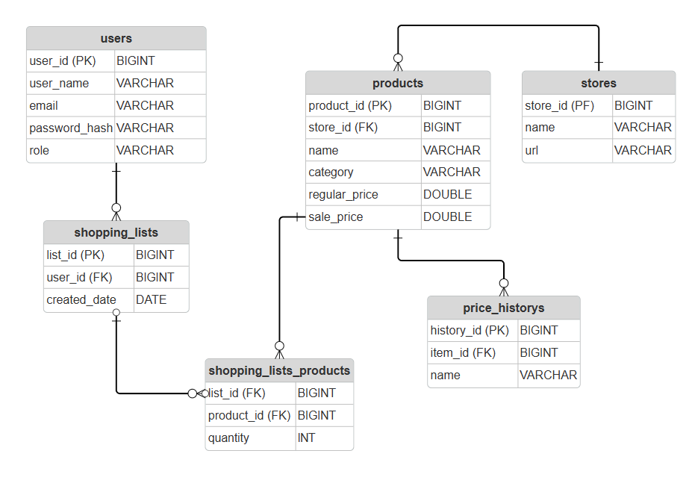
- Activity Diagrams
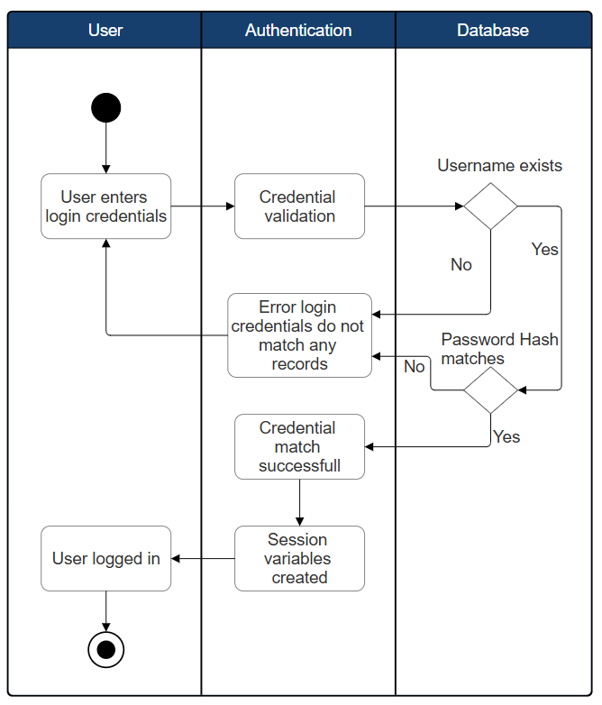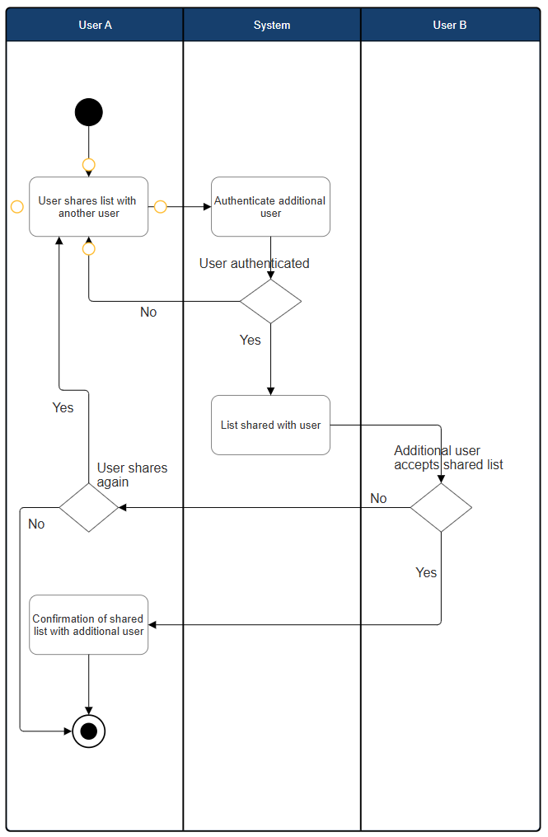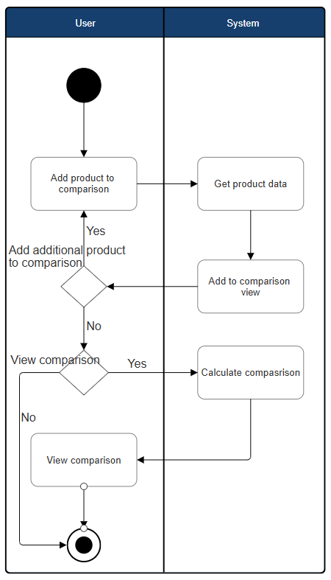
- Sequence Diagrams
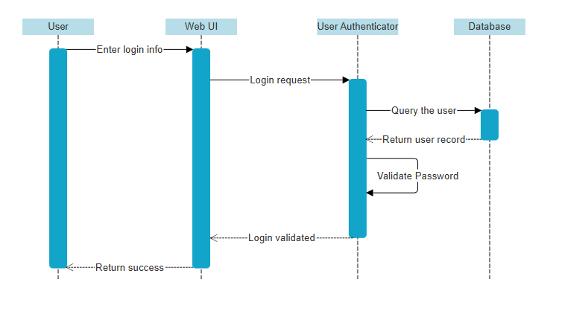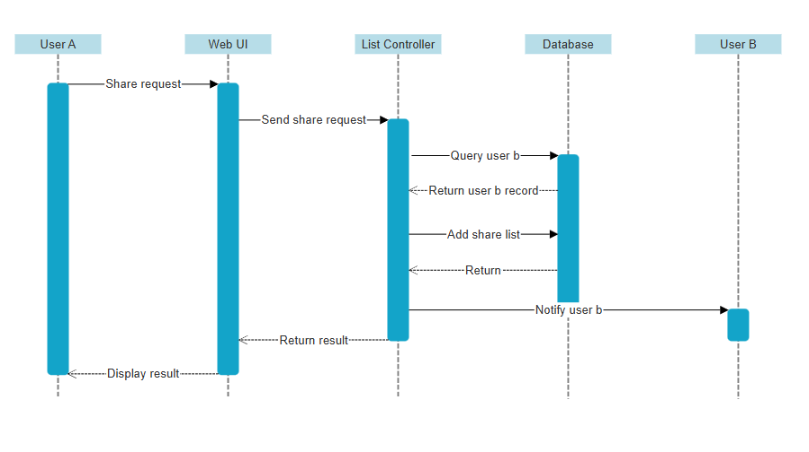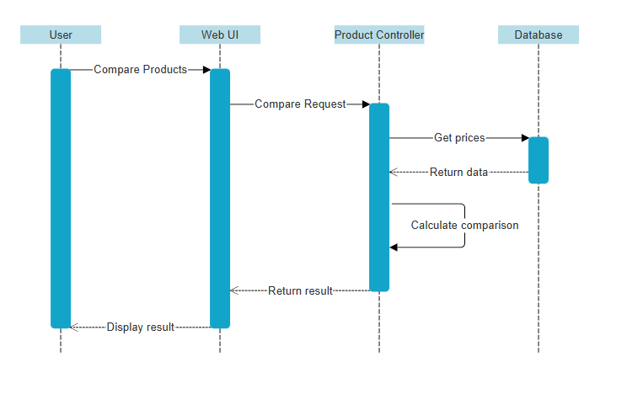
- UML Class Diagram
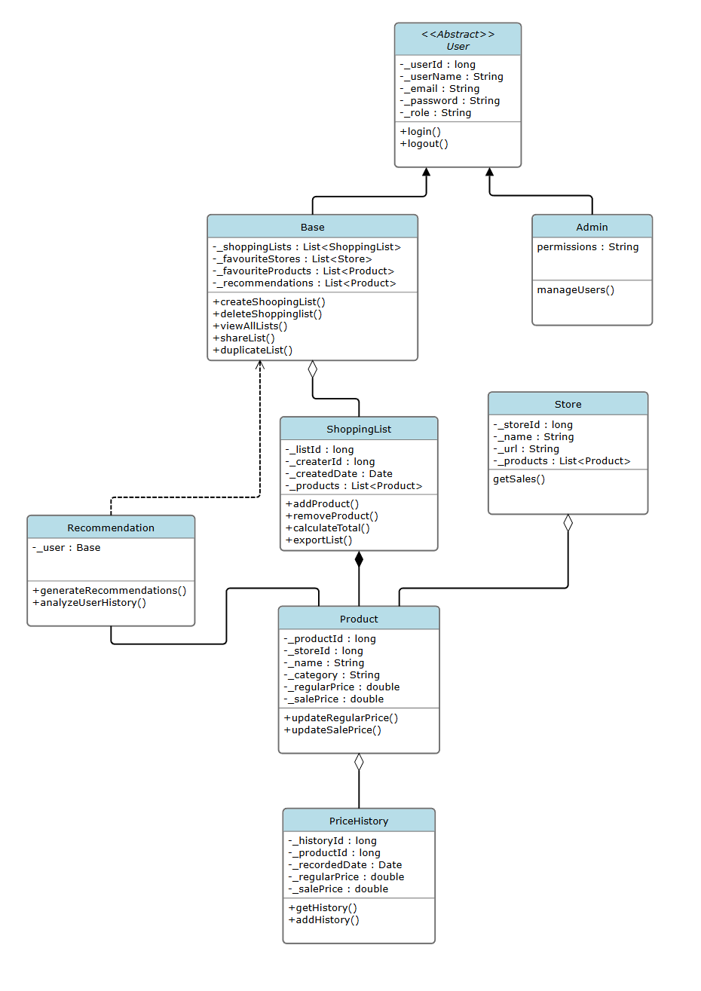

3.4 Process Modelling
- Data Flow Diagram
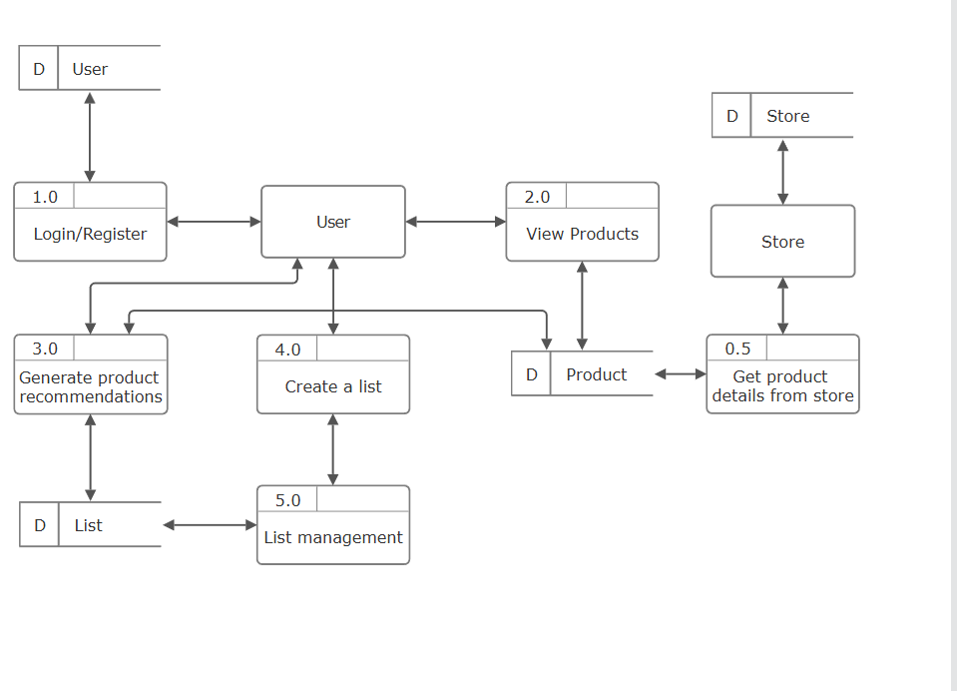

4.0 Non-Functional Requirements
The non-functional requirements for a system are typically constraints on the functional requirements – that is, not what the system does, but how it does it (e.g. how quickly, how efficiently, how easily from the user’s perspective, etc.).

Non-functional requirements may exist for any of the following attributes – Performance, Reliability, Availability, Security, Maintainability, Portability.

Often these requirements must be achieved at a system-wide level rather than at a unit level. State the requirements in the following sections in measurable terms (e.g., 95% of transaction shall be processed in less than a second, system downtime may not exceed 1 minute per day, etc).

- Performance
  - 95% of all user interactions, from the moment they are initiated, should complete and display the results within 3 seconds in order to maintain a good user experience.
- Reliability
  - Flyer data retrieval must achieve 98% accuracy or higher (collecting the correct sale prices and details during database updates)
- Availability
  - The web application must maintain a 99% uptime throughout peak usage hours (daytime), excluding maintenance hours.
- Security
  - All User Authentication Data must be encrypted in all storage methods, as well as usage during retrieval and writing.
- Maintainability
  - With the assumption that flyer data will be retrieved through a semi-automatic method, the system must also be designed in a way where updates can be reliably pushed through minimal human interaction.
- Portability
  - The end result must be a fully-functioning web application, allowing for full functionality across various screen sizes and browsers (various different types of devices, screen sizes, operating systems).

5.0 Logical Database Requirements
Will a database be used? If so, what logical requirements exist for data formats, storage capabilities, data retention, data integrity, etc?
- A database will be used, and it is essential for carrying out the purposes of the application. The system will rely on this database for several of its core functions:
  - Flyer Sale Data Storage
    - Item IDs
    - Item names
    - Original prices
    - Sale prices (discounted prices)
    - Product type (item type/category)
  - User Data and Authentication
    - Depending on the approach taken ,the database may additionally be responsible for storing the encrypted login details for users
    - Per-user personalization settings (light mode, dark mode, etc)
  - Shopping List Data
    - Per-user shopping list storage
      - Item quantities
      - Addition and removal of items
      - Calculation of estimated total costs

6.0 Other Requirements
Additional requirements, if any.
- Feedback area/form for users to provide feedback within the page
- User-friendly UI/UX
- Light mode/dark mode toggle
- Implementation of supporting visual/images for products when applicable/appropriate (non-copyright infringing images)

7.0 Approval
The signatures below indicate their approval of the contents of this document.
Project Role | Name | Signature | Date
Project Leader | Harrison Pape | HP | 11/14/25
Full-Stack Developer | Iqbal Qureshi | IQ | 11/14/25
Database Manager | Mitchell Stevenson | MS | 11/14/25
Front-End Developer | Amelework Murti | AM | 11/14/25
Back-End Developer | Woohyuk (Harry) Song | HWS | 11/14/25

