harry’s book

Harry

2017 6 16

require(moonBook)

## Loading required package: moonBook

data(acs)  
mytable(Dx~age+sex, data=acs)

##   
## Descriptive Statistics by 'Dx'   
## _________________________________________________________   
## NSTEMI STEMI Unstable Angina p   
## (N=153) (N=304) (N=400)   
## ---------------------------------------------------------   
## age 64.3 ± 12.3 62.1 ± 12.1 63.8 ± 11.0 0.073  
## sex 0.012  
## - Female 50 (32.7%) 84 (27.6%) 153 (38.2%)   
## - Male 103 (67.3%) 220 (72.4%) 247 (61.8%)   
## ---------------------------------------------------------

## R Markdown

This is an R Markdown document. Markdown is a simple formatting syntax for authoring HTML, PDF, and MS Word documents. For more details on using R Markdown see <http://rmarkdown.rstudio.com>.

When you click the **Knit** button a document will be generated that includes both content as well as the output of any embedded R code chunks within the document. You can embed an R code chunk like this:

require(mycor)

## Loading required package: mycor

out <- mycor(iris)  
plot(out, type=2, groups=Species)

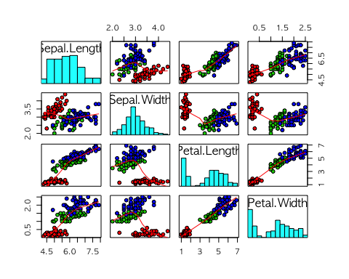

## Including Plots

You can also embed plots, for example:

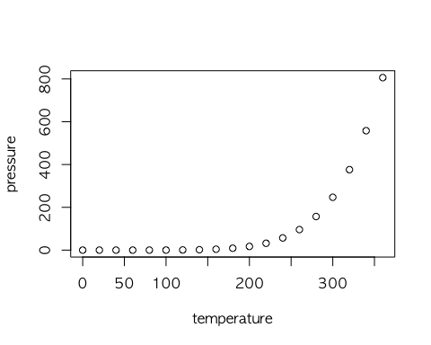

Note that the echo = FALSE parameter was added to the code chunk to prevent printing of the R code that generated the plot.