EXPERIMENT-7
USER INTERFACE AND DESIGN
ROLL.NO:240701179 Name: J.Harsan

Objective:
To design and compare different app layouts and color schemes, collect user feedback, and improve the design based on usability and visual appeal.

Prototype 1 – Alarm App (Dark Theme)
Theme: Dark
Layout: List-based
Features: Multiple alarms, toggle switches
Design Focus: Simplicity and night usability
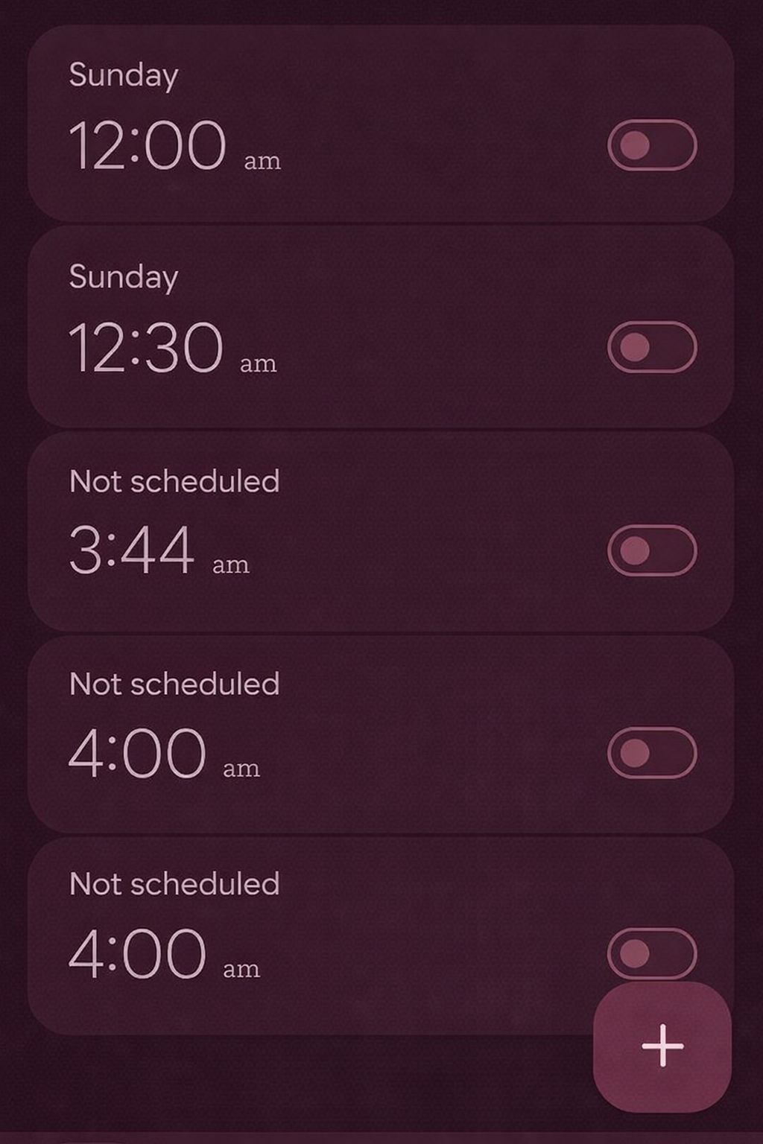

Pros:
• Easy on eyes
• Minimal and clean design
• Good readability in dark environments

Cons:
• Limited visual engagement
• Can feel repetitive

Prototype 2 – Gaming Platform UI (Dark Theme)
Theme: Dark
Layout: Grid + scroll sections
Features: Game recommendations, categories, downloads
Design Focus: Engagement and content browsing
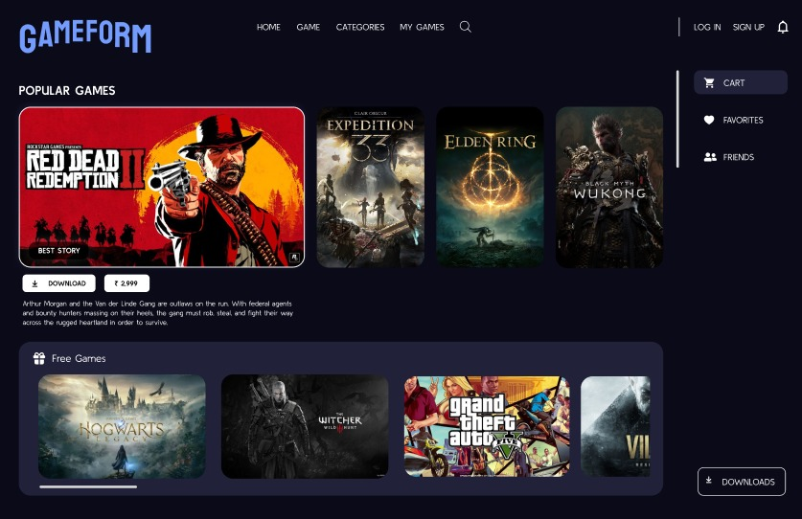

Pros:
• Visually attractive
• Interactive and engaging
• Organized content sections

Cons:
• Can feel crowded
• Heavy visual load

Prototype 3 – Smart Grocery App (Light Theme)
Theme: Light
Layout: Minimal landing screen
Features: Sign up, login
Design Focus: Simplicity and onboarding

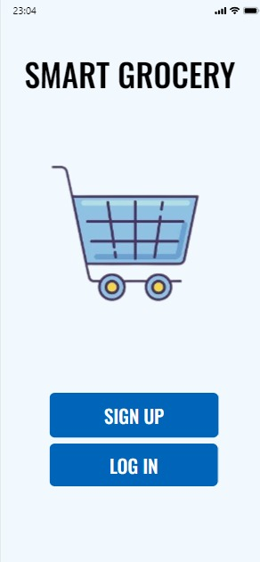

Pros:
• Clean and simple UI
• Easy navigation
• Beginner-friendly

Cons:
• Too minimal
• Limited functionality shown

Feedback Collection
Feedback was collected using Google Forms.

Analysis of Feedback
• Most Preferred: Gaming UI
• Most Usable: Alarm App
• Most Simple: Grocery App

Improvements Made
• Reduced clutter in Gaming UI
• Added visual accents to Alarm App
• Enhanced features in Grocery App

Conclusion
Different layouts and color schemes significantly impact user experience. User feedback helps improve usability and overall design quality.

