LAB-10

OBJECTIVE: Introduction of initState Method, Uri.parse Method, DateTime Class

Submitted by:

PATELWALA HARSH MITESH

ROLL NO: CE108 ID NO: 20CEUBS072

For the partial fulfilment of the award of degree

BACHELOR OF TECHNOLOGY

(COMPUTER ENGINEERING)



Department of Computer Engineering

Faculty of Technology

# DHARMSINH DESAI UNIVERSITY

NAAC ACCREDUTED, ISO 9001:2008 CERTIFIED

NADIAD – 387001

* **initState Method:**
* @protected

@mustCallSuper

void initState()

@mustCallSuper, @protected

* Called when this object is inserted into the tree. The framework will call this method exactly once for each State object it creates.
* Override this method to perform initialization that depends on the location at which this object was inserted into the tree (i.e., context) or on the widget used to configure this object (i.e., widget).
* **Uri.parse Method:**
* Uri parse(

String uri,

[int start = 0,

int? end]

)

* Creates a new Uri object by parsing a URI string. If start and end are provided, they must specify a valid substring of uri, and only the substring from start to end is parsed as a URI. If the uri string is not valid as a URI or URI reference, a FormatException is thrown.
* **jsonDecode Method:**
* dynamic jsonDecode(

String source,

{Object? reviver(

Object? key,

Object? value

)?}

)

* Parses the string and returns the resulting Json object. The optional reviver function is called once for each object or list property that has been parsed during decoding. The key argument is either the integer list index for a list property, the string map key for object properties, or null for the final result.

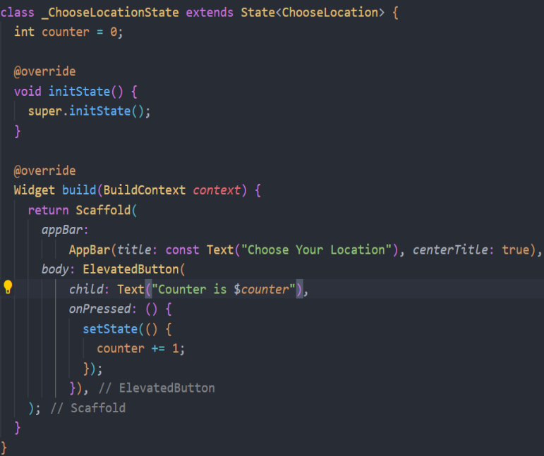

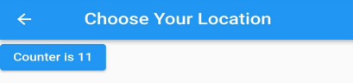

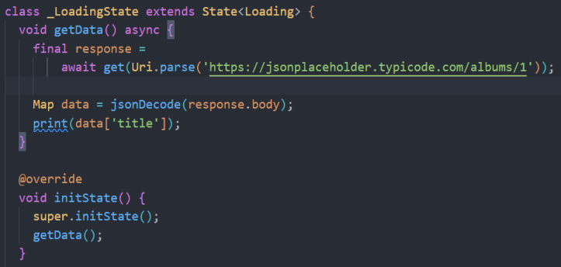

* **/pages/loading.dart**

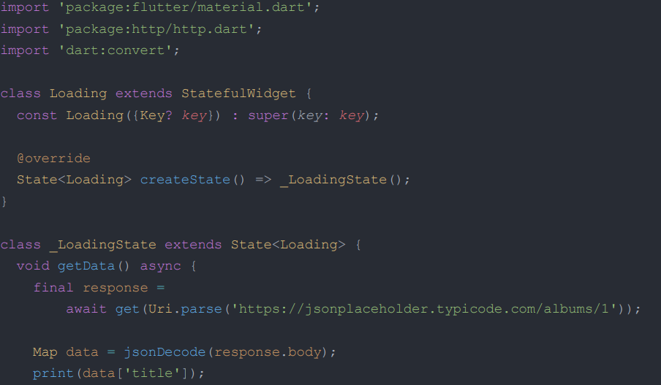

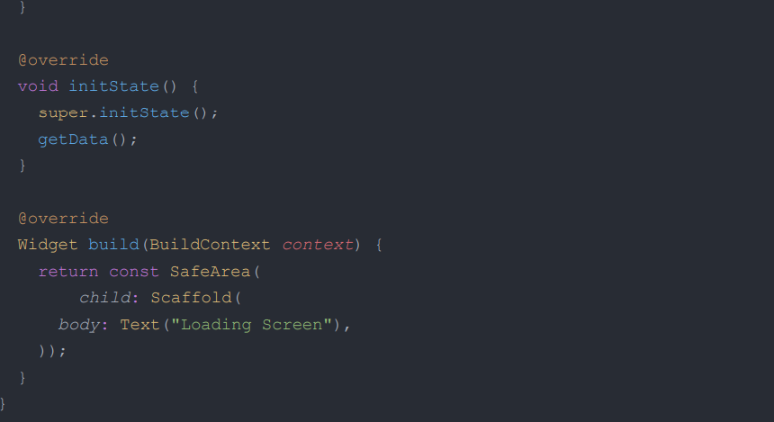

* **main.dart**

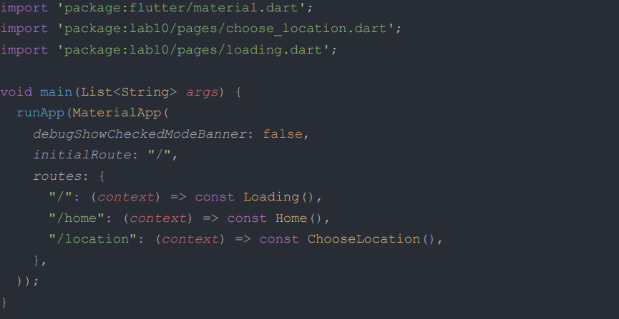

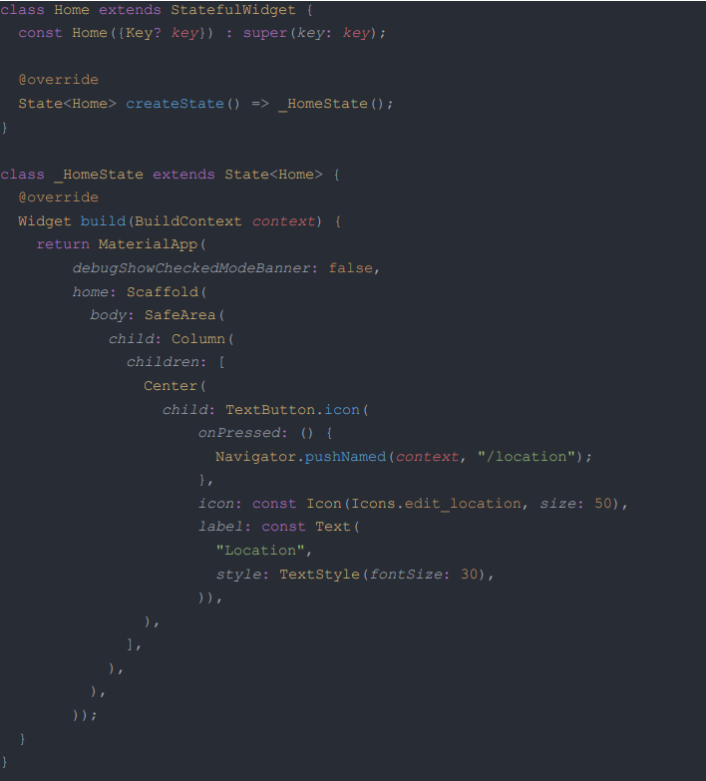

* **DateTime Class:**
* An instant in time, such as July 20, 1969, 8:18 pm GMT.
* DateTimes can represent time values that are at a distance of at most 100,000,000 days from epoch (1970-01-01 UTC): -271821-04-20 to 275760-09-13.
* Create a DateTime object by using one of the constructors or by parsing a correctly formatted string, which complies with a subset of ISO 8601. Note: hours are specified between 0 and 23, as in a 24-hour clock.

