Market Intelligence Research Brief
Student Name: Harsh Verma
Date: 25 October 2026
Topic/Company: India’s ₹30,000–₹50,000 Smartphone Segment: New Brand Entry Assessment

1. Research Objective
Objective: Evaluate whether a new smartphone brand should enter India’s ₹30,000–₹50,000 segment by assessing market demand, competitive conditions, product expectations, cost pressures, and entry barriers. The analysis is intended to help leadership decide whether to proceed now, delay entry, or conduct a smaller validation exercise before committing substantial resources.

2. Scope of Research
- Markets or industries covered: The research covers India’s smartphone industry, with a specific focus on smartphones priced between ₹30,000 and ₹50,000. It considers the wider smartphone market only where broader shipment trends, component costs, or consumer behavior affect the target segment.

- Competitor types included: The analysis includes established global smartphone brands, value-focused challengers, premium brands, and brands with strong offline or online channel presence. Key reference brands include Samsung, Apple, Vivo, OPPO, OnePlus, Xiaomi, Motorola, iQOO, Google, and Nothing.

- Timeframe considered: The external market review focuses mainly on developments between 2024 and 2026. The smartphone dataset includes listings from different device generations and should therefore be treated as a view of available products and specifications, rather than a precise snapshot of one specific period.

- Key constraints (e.g., limited research hours): The analysis relies on public market research, Quick Research outputs, and the uploaded smartphone listing dataset. It does not include proprietary sales data, retailer interviews, consumer surveys conducted specifically for this project, detailed component contracts, brand profitability figures, or channel-level margins.

3. Research Approach
- Types of questions asked: The research examined whether the ₹30,000–₹50,000 segment is expanding in a commercially attractive way, which brands dominate the segment, what features customers now expect, what could genuinely differentiate a new entrant, and how component inflation, regulation, and market contraction could affect viability.

- How research effort was prioritized: Research was prioritized around the entry decision. The first focus was overall demand and segment growth, followed by competitive concentration, price and component-cost pressure, product expectations, and practical barriers such as certification, import duties, distribution, and brand trust.

- Tools used within Amazon Quick Suite: Amazon Quick Suite was used to review the uploaded smartphone dataset, create a product-density visual by price band, and conduct Quick Research on India’s smartphone market. The Quick Research output was also used to generate a custom summary, review sources, identify risks, and download the supporting report.

4. Key Market Insights

Insight 1
- Insight Summary: The ₹30,000-and-above smartphone segment has gained importance, but the wider market outlook is weak. A new entrant would be trying to win share in a market with limited room for broad-based growth.

- Supporting Evidence or Signals: The external research summary states that the premium segment above ₹30,000 grew in 2025 and represented 22 percent of total shipments. At the same time, IDC revised its 2026 outlook toward a major market contraction, while Counterpoint projected a full-year decline.

- Why This Insight Matters: A larger premium share does not automatically mean a larger or easier market to enter. If the total market is shrinking, a new brand must take customers from established competitors rather than depend on organic demand growth.

Insight 2
- Insight Summary: Some movement into higher price bands appears to be caused by rising device costs rather than by customers voluntarily upgrading to more expensive phones.

- Supporting Evidence or Signals: The Quick Research summary links higher smartphone prices to sharp increases in memory costs. It also notes that lower-priced segments declined as rising prices pushed devices into higher brackets.

- Why This Insight Matters: Customers who are paying more because devices have become expensive may be highly price-sensitive. This makes it harder for an unfamiliar brand to charge a premium unless it offers a clear and trusted reason to switch.

Insight 3
- Insight Summary: The target segment is highly competitive, and leading brands already hold strong positions across the relevant price bands.

- Supporting Evidence or Signals: External findings identify Vivo, Samsung, and OPPO as leading brands in the ₹30,000–₹45,000 range, while Samsung and OPPO were strong in the ₹45,000–₹50,000 range. Samsung and Apple also held a dominant combined position above ₹45,000 in the cited research.

- Why This Insight Matters: A new brand would need to overcome brand familiarity, established retail relationships, existing online visibility, service networks, and customer trust. Competing only on specifications or price is unlikely to be enough.

Insight 4
- Insight Summary: Features alone are unlikely to differentiate a new smartphone in this segment because many competitive specifications are already widely available.

- Supporting Evidence or Signals: The uploaded dataset contains numerous smartphones with 5G connectivity, large batteries, fast charging, multi-camera systems, high-refresh-rate displays, and substantial RAM and storage. The external research also identifies 5G, AMOLED displays, high refresh rates, fast charging, and AI features as increasingly expected in mid-premium smartphones.

- Why This Insight Matters: A new brand should treat these features as the minimum standard. Its proposition would need to be more distinctive, such as a clearly better camera experience, refined design, strong software support, dependable after-sales service, or a compelling finance and trade-in offer.

Insight 5
- Insight Summary: Component costs, compliance requirements, and the need to build distribution and service coverage create substantial entry barriers.

- Supporting Evidence or Signals: The external research highlights memory-cost inflation, customs duties on imported finished phones, and BIS certification requirements as material challenges. It also indicates that established brands have faced cost pressure and weaker sales momentum.

- Why This Insight Matters: A new entrant without scale purchasing power or local operating capability could face lower margins than established competitors. The business would need a credible supply-chain, compliance, distribution, and service plan before a launch could be justified.

5. Visual Evidence

- Chart Type: Bar chart showing product density by smartphone price band, created from the uploaded smartphone listing dataset. (Supporting screenshots, including the product-density chart and Quick Research outputs, are included in the screenshots folder.)
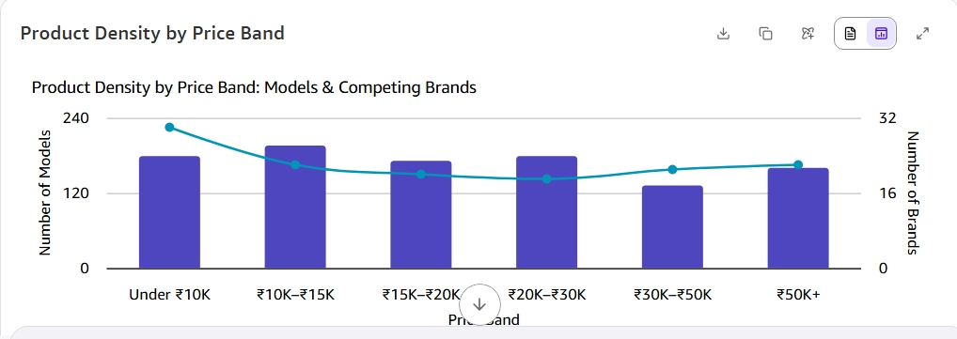

- What the visualization shows: The chart shows how many smartphone listings fall into each price range. It helps illustrate the broad availability of devices across the market and the concentration of alternatives around mid-range and premium price points.

- How it supports the insight: The visual supports the conclusion that buyers have many choices and that a new entrant would face a crowded catalogue environment. It should not be interpreted as sales volume, market share, or proof of customer demand because the dataset contains listings and specifications rather than verified commercial outcomes.

6. Confidence Assessment
- Source quality: External market findings are based on publicly available industry reporting and market-research sources referenced in the Quick Research report. The uploaded dataset is useful for visible product specifications and price positioning, but it is not a validated market-sales database.

- Consistency across sources: The sources generally align on three themes: a weaker 2026 market environment, rising cost pressure, and intense competition in higher price tiers. There is some positive evidence of premiumization and selected brand growth, so the opportunity is not absent; however, these signals do not remove the risks facing a new brand.

- Timeliness of information: The external market research covers recent developments through 2026. This is relevant to the entry decision, although smartphone demand, component prices, regulation, and competitive activity can change quickly.

- Overall confidence level: Medium. Confidence is higher for the overall market and competitive risks, and lower for the likely profitability or customer adoption of a particular new smartphone brand.

7. Limitations and Risks
- Missing data: The research does not include brand-level sales data for every model, market-share data for each price point, detailed retailer economics, customer acquisition costs, service-network costs, device-level gross margins, or primary customer research. The uploaded dataset does not measure sales, profitability, or actual consumer demand.

- Conflicting signals: Premium segments have shown growth in share and some consumers are willing to stretch their budgets for preferred devices. However, the wider market outlook is negative and part of the shift toward higher prices may be cost-led rather than caused by stronger discretionary demand.

- Potential bias or ambiguity: Public market reports can use different definitions of price bands, shipment periods, and market categories. Product listings can include older models, inaccurate specifications, duplicate variants, or phones that are no longer commercially important. Findings should therefore guide decisions rather than be treated as precise forecasts.

8. Strategic Implications
- What decisions could this inform?

- A decision to pause a broad launch into the ₹30,000–₹50,000 segment until component costs, market demand, and the differentiation case are more favorable.

- A decision to run a limited validation programme before a national launch. This could test the product concept, willingness to switch, pricing, financing, retail partnership model, service capability, and local supply-chain economics.

- What should not be concluded from this research?

- The research does not prove that no new brand can succeed in India’s mid-premium smartphone market.

- The research does not establish a sales forecast, product-level profitability estimate, or exact market share outcome for a proposed device. Those decisions would require direct customer research, financial modelling, supplier quotations, and channel validation.

9. Summary for Leadership
Executive Summary:
India’s ₹30,000–₹50,000 smartphone segment is attractive on the surface because premium devices are gaining a larger share of the market, but the current conditions do not support a broad new-brand launch. The wider smartphone market is weakening, while higher prices may partly reflect rising component costs rather than stronger willingness to pay. Samsung, Vivo, OPPO, Apple, and other established brands already have strong market positions, distribution access, and brand trust. The product dataset also shows that many commonly advertised features are already widespread, so a new entrant cannot rely on standard specifications alone. The recommended action is to pause a full-scale launch and first validate a differentiated proposition, local cost structure, retail and service model, and customer willingness to switch. Overall confidence is medium because the market-level warning signs are well supported, but brand-specific profitability and demand remain untested.

