RAG Reliability &
Hallucination Testing Platform
System Design Specification
Senior Developer Pre-Build Design
Design baseline: 25 September 2026
Design principle
Do not build another RAG chatbot. Build the quality, reliability, diagnosis and regression layer around RAG systems so teams can prove that a RAG change improved or degraded production behavior.

1. Document Control
Item | Value
Document status | Architecture baseline for implementation
Primary audience | Software/ML engineers, technical reviewers, project mentor
Target product | RAG evaluation, reliability, regression and optimization platform
Initial deployment | Single-node / single-tenant development; production-ready boundaries
Preferred backend | Python + FastAPI
Preferred UI | React/Next.js
System of record | PostgreSQL
Async execution | Redis-backed job queue
Vector store | Qdrant only where benchmark/retrieval experiments need it
Experiment/trace layer | MLflow and/or OpenTelemetry-compatible tracing
Primary artifact | DOCX architecture specification

How to read this document
Sections 2-6 define the product and boundaries. Sections 7-14 are the implementation architecture and data contracts. Sections 15-19 cover evaluation science, ML diagnosis, security, operations and testing. Sections 20-23 define the build plan, risks, ADRs and acceptance criteria.

2. Executive Summary
The RAG Reliability & Hallucination Testing Platform is a developer-facing system that evaluates an existing Retrieval-Augmented Generation application without requiring the platform to own the application's retrieval or generation implementation. It treats the RAG application as a System Under Test (SUT) behind a stable adapter contract.
The platform executes a versioned evaluation dataset against the SUT, captures full traces, scores retrieval and generation independently, validates citations and abstentions, classifies failures by likely root cause, compares the run with a baseline, and emits a machine-readable CI quality gate. This separation is intentional: end-to-end quality alone cannot distinguish a retrieval problem from a generation problem. DeepEval's current RAG guidance similarly separates contextual relevancy, precision and recall for retrieval from answer relevancy and faithfulness for generation. (DeepEval RAG evaluation documentation; see References.)
Primary value proposition
A RAG team should be able to answer four questions before shipping: Is the system correct? Is the evidence sufficient? Why did failures happen? Did the latest change improve the system without unacceptable cost/latency regression?

2.1 Success definition
- Provide reproducible evaluation runs from pinned dataset + configuration + code/version identifiers.
- Surface retrieval, generation, citation and abstention failures separately.
- Provide per-test evidence for every low-scoring case rather than only aggregate scores.
- Block deployments when configured quality thresholds or regression budgets are violated.
- Allow safe experimentation with chunk size, top-k, retriever, reranker, prompt and model settings.
- Keep an existing RAG implementation as the baseline; the platform must not require replacing production infrastructure.

3. Product Scope

3.1 In scope
- Project and environment management for multiple RAG applications.
- Dataset creation/import, tagging, versioning and golden test cases.
- RAG adapter interface for HTTP, Python and OpenAI-style endpoints.
- Synchronous single-test runs and asynchronous batch evaluation jobs.
- Trace capture for query, retrieved chunks, ranks/scores, model, prompt metadata, answer, citations, latency and cost.
- Retrieval evaluation: contextual recall, contextual precision, contextual relevancy, Recall@K, MRR/NDCG where ground truth is available.
- Generation evaluation: faithfulness/groundedness, answer correctness/relevance, contradiction and unsupported-claim analysis.
- Citation validation, abstention evaluation, adversarial test generation and failure attribution.
- Baseline comparison, regression detection, experiment tracking and CI/CD quality gates.
- Dashboard, API and downloadable run reports.

3.2 Out of scope for MVP
- Building a general-purpose LLM provider marketplace.
- Replacing mature vector databases, tracing systems or model observability products.
- Autonomous modification of a customer's production RAG code.
- Guaranteeing zero hallucinations; the platform measures and reduces risk but cannot prove absolute correctness.
- Full multi-region SaaS, billing and enterprise SSO in the first release.

3.3 Design constraints
Constraint | Design response
RAG systems differ | Use adapter abstraction and a canonical trace schema.
LLM judges are probabilistic | Combine deterministic checks, ML/NLI signals and judge-based metrics; expose evaluator confidence.
Ground truth is expensive | Support golden sets, synthetic cases, weak labels and human review queues.
Evaluation can be expensive | Use async workers, caching, sampling, tiered test suites and run budgets.
False confidence is dangerous | Require evidence links and failure diagnosis; never represent a single score as truth.
Student-project scope | Start as modular monolith; preserve service boundaries in code, not operational complexity.

4. Users and Core Use Cases
Persona | Need | Primary workflows
RAG developer | Know whether a change improved retrieval/generation. | Run benchmark; compare versions; inspect failures; tune retrieval.
ML engineer | Train and validate failure-diagnosis models. | Export labeled traces; compare classifiers; monitor drift.
Platform engineer | Prevent regressions from reaching production. | Configure thresholds; integrate GitHub Actions; manage secrets.
Reviewer/mentor | Assess technical quality and evidence. | Inspect benchmark design, metrics, trace lineage and failure cases.

4.1 Primary user journeys
1. Connect an existing RAG endpoint and run a 10-case smoke test.
2. Create a versioned benchmark with normal, unanswerable and adversarial cases.
3. Run a full evaluation asynchronously and inspect aggregate metrics.
4. Open a failed case and see question -> retrieved evidence -> answer -> citation checks -> failure classification.
5. Create a baseline from a known-good run.
6. Run a new configuration, compare against baseline, and accept or reject the change.
7. Enable CI gating so pull requests automatically run the smoke or regression suite.

5. System Architecture
The architecture is intentionally split into a control plane and execution plane. The control plane owns configuration, metadata, projects, datasets and permissions. The execution plane performs potentially expensive or failure-prone RAG calls and evaluation workloads asynchronously.
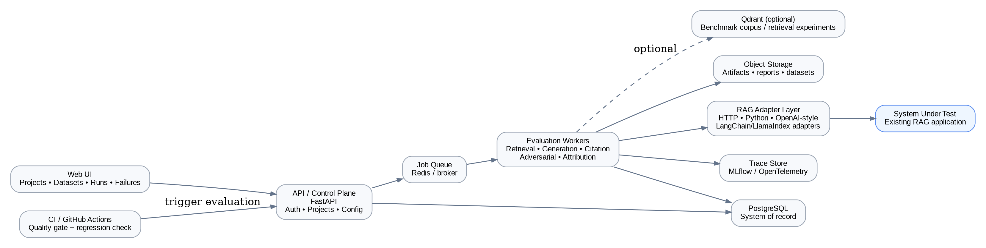
Figure 1. High-level architecture and system boundaries.

5.1 Architectural principles
- Adapter-first: the platform evaluates systems it does not own.
- Trace-first: every score must be explainable through persisted execution evidence.
- Async by default for batch evaluation; synchronous only for small interactive tests.
- Immutable runs: a completed run is a historical fact and should never be silently overwritten.
- Deterministic where possible: pin datasets, prompts, models, retrieval settings and random seeds where supported.
- Fail closed for CI gates: if the evaluator cannot establish that a gate passed, the gate should not pass silently.
- Progressive complexity: one deployable backend first; workers can be split later without rewriting domain logic.

5.2 Logical components
Component | Responsibility | State
Web UI | Projects, datasets, run dashboards, failure drill-down, experiment comparison. | Stateless
API / Control Plane | Auth, configuration, dataset APIs, run creation, result queries. | PostgreSQL
Job Orchestrator | Queues evaluation workloads and schedules retries/cancellation. | Redis + DB state
Evaluation Worker | Runs SUT adapters and evaluation stages. | Ephemeral
RAG Adapter Layer | Normalizes different RAG APIs into a canonical result. | Stateless
Metric Engine | Computes deterministic and judge-based metrics. | Stateless/cacheable
Failure Attribution Engine | Classifies likely root cause and severity. | Model + rules
Artifact Store | Stores reports, dataset exports and large trace payloads. | Object storage
Experiment/Trace Layer | Operational traces, evaluator traces and experiment runs. | MLflow/OTel-compatible
Optional Retrieval Lab | Runs controlled retrieval experiments over benchmark corpus. | Qdrant

6. End-to-End Data Flow
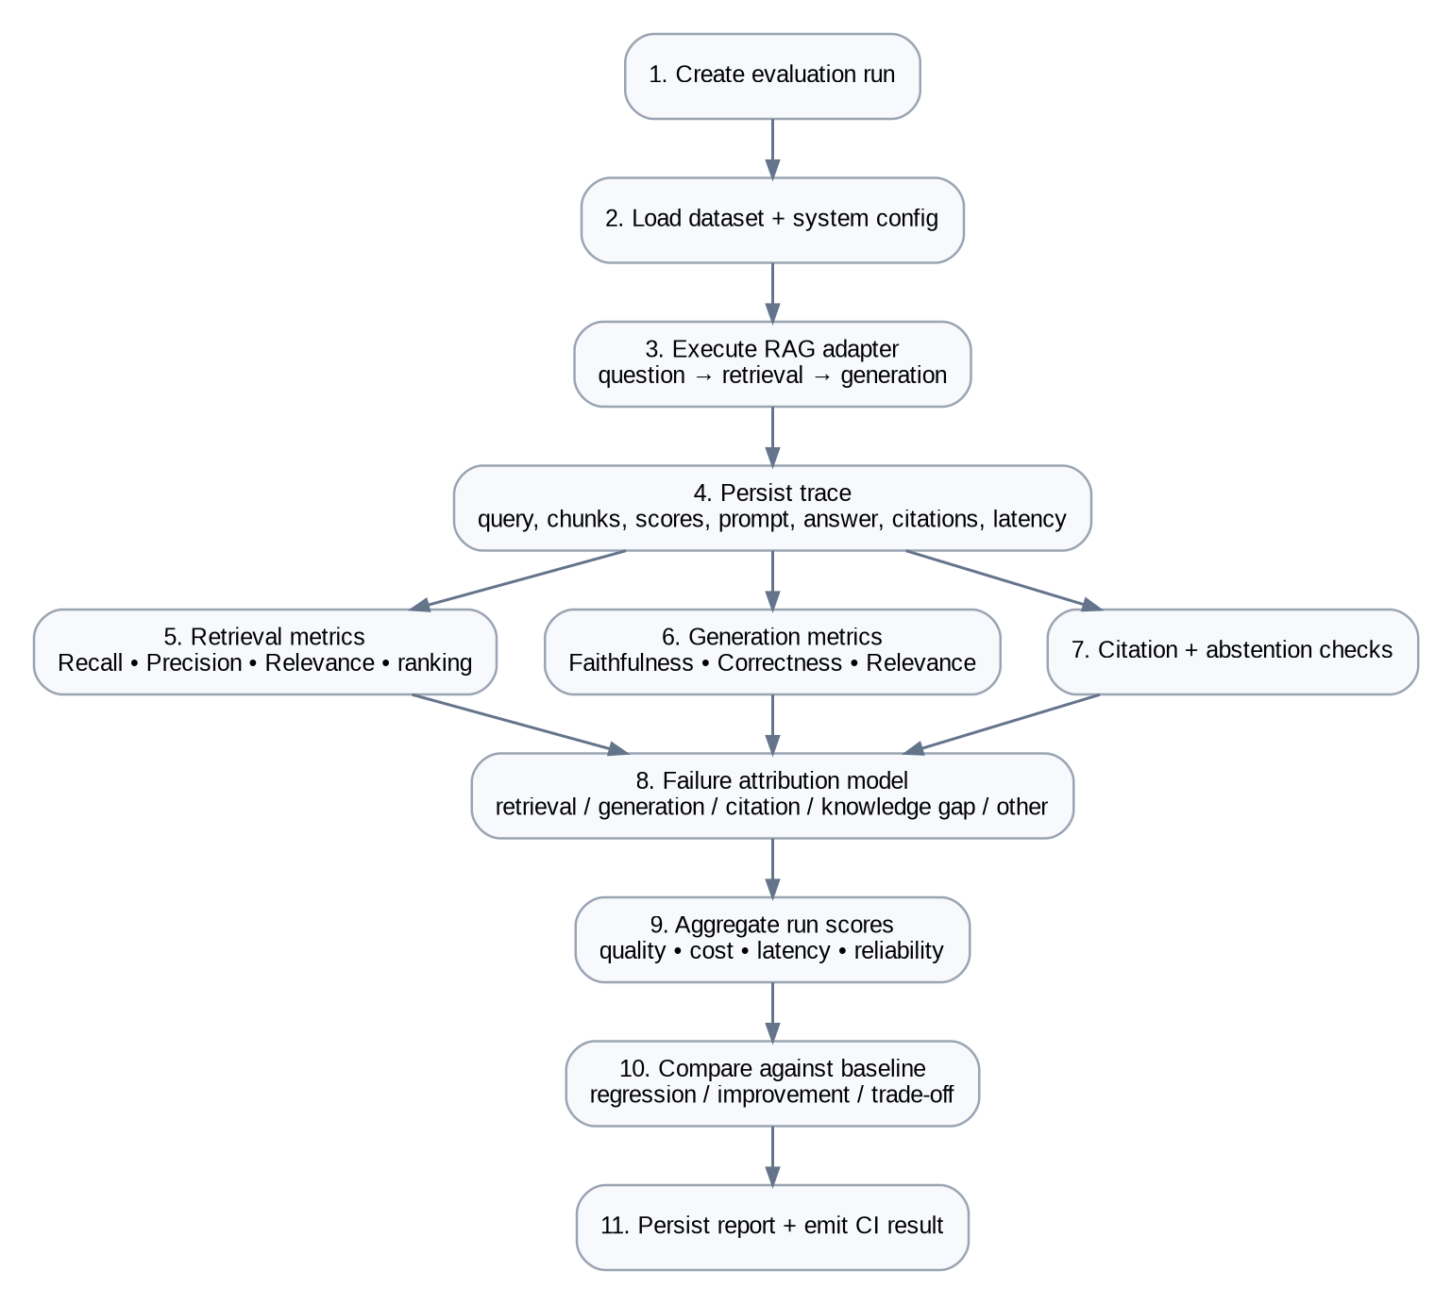
Figure 2. Evaluation sequence from run creation to CI decision.

6.1 Evaluation state machine
CREATED -> QUEUED -> RUNNING -> SCORING -> ATTRIBUTING -> COMPLETED
-> FAILED
Cancellation is terminal only after active worker cleanup.

6.2 Run lifecycle rules
- A run receives an immutable run_id and captures the exact dataset_version and system_version/config snapshot.
- Worker retries are bounded and recorded. A retry creates attempt metadata but does not create a new logical run.
- If an external RAG endpoint times out, the test case is marked INFRA_ERROR rather than HALLUCINATION.
- If the evaluator model fails, the run is marked EVALUATION_ERROR and CI gates use the configured fail-safe policy.
- Partial runs are preserved so developers can debug failure concentration and infrastructure issues.

7. Module-Level Design

7.1 Project & configuration service
Stores project identity, environments, adapter configuration, evaluator policy, baseline references and threshold policies. Secrets are referenced by key identifiers; raw API keys should not be stored in ordinary PostgreSQL columns.

7.2 Dataset service
A dataset is immutable once a version is published. Draft edits create a new version. Each test case supports expected answer, expected facts, relevant document identifiers, tags and difficulty/attack metadata.

7.3 Adapter service
The adapter converts an arbitrary RAG implementation into a canonical trace. The adapter must return the final answer and, ideally, retrieval chunks. If the target system cannot expose retrieval context, the platform can still score output relevance/correctness but must explicitly mark retrieval metrics as unavailable rather than infer them.
class RagAdapter(Protocol):
def run(self, case: TestCase, config: RunConfig) -> RagTrace:
...
@dataclass
class RagTrace:
question: str
answer: str
retrieved_chunks: list[RetrievedChunk]
citations: list[Citation]
latency_ms: int
input_tokens: int | None
output_tokens: int | None
model: str | None
metadata: dict[str, Any]

7.4 Trace service
The canonical trace is the most important internal contract. All evaluators consume the same trace object. This prevents each metric implementation from inventing a different interpretation of a RAG execution.

7.5 Metric engine
Use a plugin interface so built-in metrics, DeepEval-backed metrics, custom metrics and future learned metrics all produce the same MetricResult schema. DeepEval currently provides a useful baseline set of retrieval and generation metrics and exposes reasoning for judge-based scores. (DeepEval RAG evaluation documentation; see References.)

7.6 Failure attribution engine
Attribution is not the same as scoring. A score answers "how good?"; attribution answers "what likely caused the failure?". The engine combines evidence from retrieval ground truth, contradiction checks, citation checks, evaluator reasons and infrastructure status.

8. Evaluation Methodology
Core rule
Never use a single aggregate "RAG score" as the primary engineering decision. Keep retrieval, generation, citation, abstention, latency and cost as separate dimensions, then apply explicit release policies.

8.1 Metric families
Family | Metric | What it answers | Ground truth
Retrieval | Recall@K | Was required evidence retrieved? | Required document/chunk labels
Retrieval | MRR / NDCG | Was useful evidence ranked highly? | Relevance labels
Retrieval | Contextual recall | Does retrieved context contain expected information? | Expected answer
Retrieval | Contextual precision | Are relevant chunks ranked above irrelevant ones? | Expected answer/relevance
Retrieval | Contextual relevancy | Is the retrieved context focused on the query? | Question + context
Generation | Faithfulness / groundedness | Are answer claims supported by retrieved context? | Retrieved context
Generation | Answer correctness | Does the answer match the reference? | Expected answer
Generation | Answer relevance | Does it answer the user question? | Question + answer
Citation | Citation correctness | Does each citation point to supporting evidence? | Citation spans
Abstention | Abstention accuracy | Does the system refuse unsupported questions? | Unanswerable label
Ops | Latency / P95 | Is it fast enough? | Observed runtime
Ops | Cost / query | What is the inference/evaluation cost? | Token/provider billing data
DeepEval documents the distinction between contextual retrieval metrics and generator-focused faithfulness/answer relevance metrics; its faithfulness metric specifically checks whether the actual output aligns with retrieval context. (DeepEval faithfulness and RAG evaluation documentation; see References.)

8.2 Composite release policy
Release decision = ALL of the following are true
faithfulness >= 0.90
retrieval_recall >= 0.92
citation_accuracy >= 0.95
hallucination_rate <= 0.05
abstention_accuracy >= 0.90
p95_latency <= baseline_p95 * 1.20
cost_per_query <= baseline_cost * 1.25
no critical regression cases
Thresholds are project-specific configuration, not universal truths.
The values above are initial engineering defaults for the project, not claims about universally acceptable quality. They should be tuned against human review and business risk.

9. Hallucination and Failure Attribution

9.1 Failure taxonomy
Code | Failure | Definition | Typical evidence
RET-01 | Retrieval miss | Relevant evidence not retrieved. | Gold chunk absent from top-K.
RET-02 | Bad ranking | Relevant evidence retrieved but buried below distractors. | Low MRR/NDCG; correct chunk rank too low.
GEN-01 | Unsupported claim | Answer contains claim not supported by context. | NLI/LLM judge says no entailment.
GEN-02 | Contradiction | Answer contradicts retrieved evidence. | Entailment contradiction signal.
CIT-01 | Mis-citation | Citation exists but points to wrong passage. | Citation span unsupported by cited chunk.
CIT-02 | Missing citation | Answer contains externally-verifiable claim but no citation. | Claim extraction + missing citation.
KNW-01 | Knowledge gap | System should abstain because corpus lacks evidence. | No supporting source exists.
ABS-01 | Abstention failure | System answers an unanswerable case with fabricated content. | Unanswerable label + unsupported answer.
NUM-01 | Numerical reasoning | Evidence exists but numerical conclusion is incorrect. | Calculator/reference mismatch.
ENT-01 | Entity confusion | Evidence from a similarly named entity is used. | Entity mismatch across source metadata.
OPS-01 | Infrastructure error | Timeout, rate limit or tool failure. | HTTP/worker telemetry.

9.2 Attribution algorithm
1. Rule out infrastructure failures first; do not label timeouts as model hallucinations.
2. Check whether expected evidence or facts exist in the benchmark corpus.
3. Check whether those evidence items were retrieved in top-K.
4. Check ranking quality and retrieval scores.
5. Extract answer claims and test entailment/contradiction against retrieved context.
6. Validate each citation against the exact claim span it annotates.
7. If no evidence exists, evaluate whether the correct behavior is abstention.
8. Combine evidence into a failure type, confidence and explanation.
9. Allow human reviewers to override attribution and store the override as labeled data for future model training.

9.3 Confidence semantics
Attribution confidence should represent confidence in the diagnosis, not confidence that the answer itself is correct. A 0.92 confidence score on RET-01 means "we are highly confident this is a retrieval failure," not "the overall system is 92% correct."

10. Adversarial Benchmarking
Normal benchmark questions are insufficient because RAG failures often appear at the edge of the retrieval and grounding envelope. The platform therefore supports an attack generator that creates difficult cases while keeping provenance to the source material.
Attack type | Construction | Expected behavior
Unanswerable | Question asks for a fact absent from corpus. | Abstain / state insufficient evidence.
Distractor | Add semantically similar but irrelevant chunks. | Retrieve and use the correct evidence.
Conflict | Provide two sources with conflicting facts and explicit dates. | Surface conflict; prefer configured precedence or abstain.
Entity confusion | Use near-identical names or product IDs. | Disambiguate entity before answering.
Temporal trap | Mix old and current documents. | Use current source according to policy.
Numerical trap | Require arithmetic over retrieved numbers. | Compute correctly and cite inputs.
Multi-hop | Answer requires facts from two or more chunks. | Retrieve both and combine evidence.
Citation trap | Place correct evidence in chunk B while answer cites chunk A. | Fail citation validation.

10.1 Benchmark splits
- Train/development set: used to tune prompts, thresholds and attribution rules.
- Validation set: used for engineering choices and model selection.
- Locked test set: never used for tuning; release score comes from this set.
- Production shadow set: sampled real traces, privacy-filtered and separately governed.

11. Data Architecture
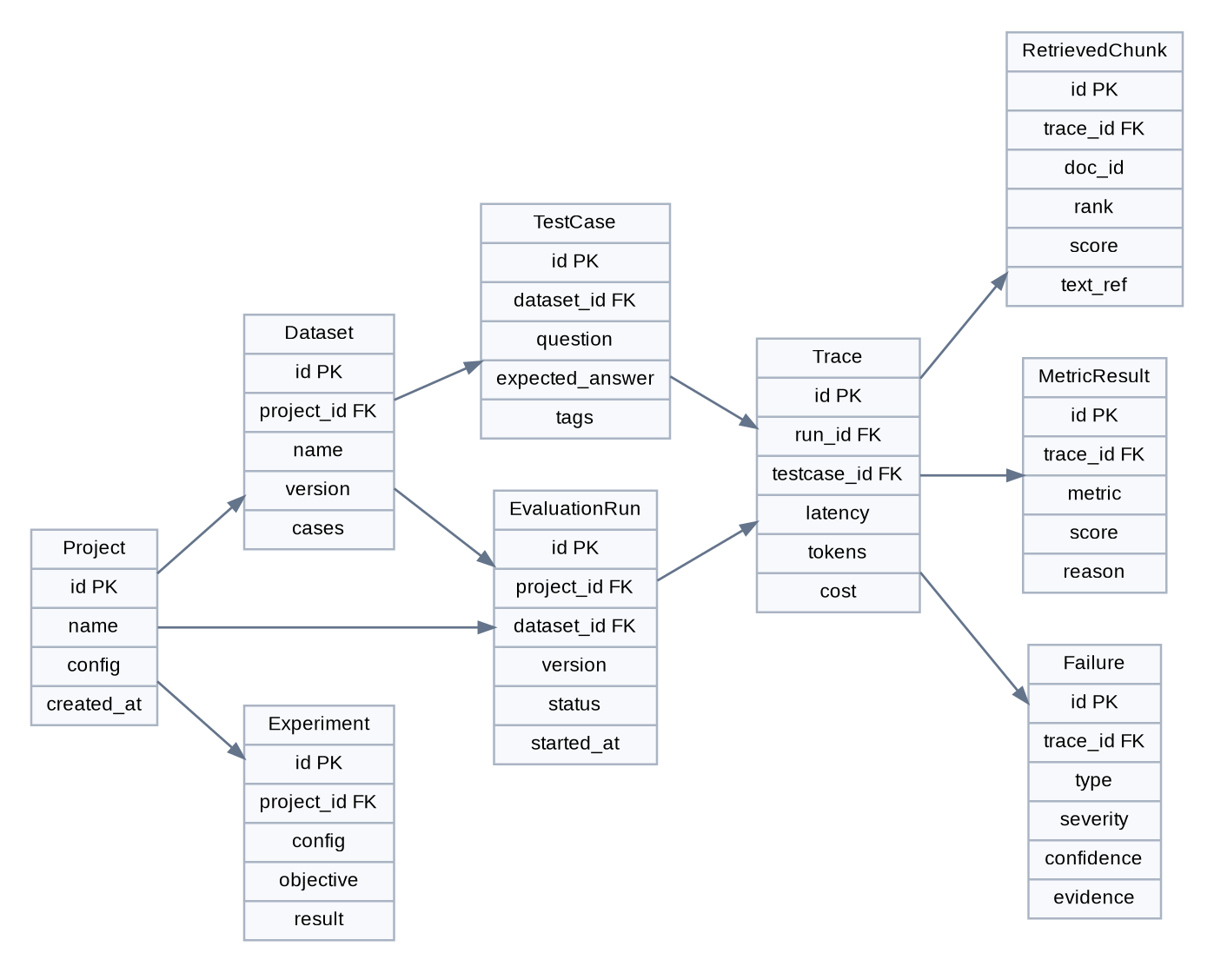
Figure 3. Simplified relational data model.

11.1 PostgreSQL schema
Table | Important fields | Notes
projects | id, name, owner_id, settings_json, created_at | Tenant/project boundary.
datasets | id, project_id, name, version, status, checksum | Versioned immutable benchmark.
test_cases | id, dataset_id, question, expected_answer, expected_facts, tags_json | Golden case and metadata.
runs | id, project_id, dataset_id, system_version, status, policy_id | Immutable evaluation run.
traces | id, run_id, test_case_id, answer, model, latency_ms, token counts, cost | Canonical trace summary.
retrieved_chunks | id, trace_id, document_id, rank, score, content_ref | Chunk-level provenance.
metric_results | id, trace_id, metric_name, score, reason, evaluator_version | Individual metric result.
failures | id, trace_id, failure_type, severity, confidence, evidence_json | Attribution output + human override.
experiments | id, project_id, config_json, objective_json, result_json | Hyperparameter/variant comparison.
api_credentials | id, project_id, provider, secret_ref | Store only secret references, not raw tokens.

11.2 Storage split
- PostgreSQL: metadata, scores, status, searchable summaries and audit records.
- Object storage: large datasets, JSONL traces, generated reports, exported benchmark artifacts.
- Redis: queue, short-lived locks and job coordination; never the source of truth.
- Qdrant: optional benchmark corpus and retrieval-experiment store. Qdrant documents dense+sparse hybrid retrieval and multi-stage reranking, which matches the experimental retrieval lab planned for later phases. (Qdrant hybrid retrieval documentation; see References.)

12. API Design

12.1 Project endpoints
Method | Endpoint | Purpose
POST | /v1/projects | Create project.
GET | /v1/projects/{id} | Read project.
PATCH | /v1/projects/{id} | Update config.
POST | /v1/projects/{id}/adapters | Register RAG adapter.
GET | /v1/projects/{id}/health | Adapter connectivity check.

12.2 Evaluation endpoints
Method | Endpoint | Purpose
POST | /v1/runs | Create evaluation run.
GET | /v1/runs/{id} | Run status + summary.
GET | /v1/runs/{id}/traces | Paged trace list.
GET | /v1/runs/{id}/failures | Failure list.
GET | /v1/runs/{id}/metrics | Aggregate metrics.
POST | /v1/runs/{id}/cancel | Cancel active run.
POST | /v1/compare | Compare two runs/baselines.

12.3 Example create-run contract
POST /v1/runs
{
"project_id": "proj_123",
"dataset_version": "support-benchmark@v4",
"system_version": "rag-main@a81c9f2",
"suite": "full",
"policy_id": "prod-default",
"options": {
"max_cases": 500,
"parallelism": 8,
"fail_fast": false
}
}
Response: 202 Accepted
{ "run_id": "run_9d31", "status": "QUEUED" }

12.4 Canonical trace contract
{
"trace_id": "tr_001",
"question": "What was 2024 revenue?",
"retrieval": {
"strategy": "hybrid",
"top_k": 5,
"chunks": [
{"document_id":"annual-2024","rank":1,"score":0.91,"text_ref":"obj://..."}
]
},
"generation": {
"provider":"openai-compatible",
"model":"...",
"answer":"...",
"citations":[{"claim_id":"c1","document_id":"annual-2024"}]
},
"telemetry": {"latency_ms":1201,"input_tokens":812,"output_tokens":173}
}

13. Evaluation Pipeline Implementation

13.1 Processing stages
1. Dataset loader validates schema and checks checksum.
2. Adapter runner executes the target RAG system under a timeout and concurrency budget.
3. Trace normalizer validates that required fields exist and emits explicit availability flags for missing retrieval/citation data.
4. Deterministic metric stage computes cheap checks first.
5. LLM/ML judge stage runs only metrics enabled by policy, with caching keyed by evaluator version + trace hash.
6. Attribution stage consumes all metric outputs.
7. Aggregation stage computes run-level distributions, not just means.
8. Baseline comparator computes absolute and relative deltas.
9. Policy engine evaluates release gates.
10. Result publisher writes PostgreSQL summaries and large artifacts to object storage.

13.2 Evaluator execution modes
Mode | Use | Cost/latency | Determinism
Smoke | PR feedback, 10-30 cases. | Low | High if deterministic checks dominate.
Regression | PR/main, 100-500 cases. | Medium | Moderate.
Full | Nightly or release candidate. | High | Moderate; more judge calls.
Adversarial | Scheduled or pre-release. | High | Depends on generator.
Production shadow | Sampled real traces. | Variable | Real-world distribution.

14. Citation and Abstention Design

14.1 Citation representation
The preferred answer representation is claim-centric: each factual claim is assigned an identifier and one or more evidence references. This makes citation validation machine-checkable rather than relying on a final markdown string.
{
"claim_id": "c1",
"text": "Revenue was $12.4B in 2024.",
"evidence": [
{"document_id":"annual-2024","chunk_id":"p42-c3","span":[12,68]}
]
}

14.2 Abstention contract
The evaluator treats a correct refusal as a valid target outcome for unanswerable cases. The preferred structured response is: answer=null, abstained=true, reason_code=INSUFFICIENT_EVIDENCE, evidence=[] . A natural-language refusal can be rendered to the user, but the underlying result should remain machine-readable.

15. ML Failure-Diagnosis Layer
The ML layer is intentionally downstream of deterministic and judge-based evaluation. It predicts failure type from a structured feature vector rather than trying to replace the evaluator wholesale.

15.1 Features
- Question embedding and lexical features.
- Top-K similarity scores, score gaps, rank of gold evidence and number of relevant chunks.
- Answer length, claim count and citation count.
- Entailment/contradiction probabilities between claims and retrieved chunks.
- Existing metric outputs such as contextual recall/precision, faithfulness and answer correctness.
- Time, token counts and infrastructure error codes.
- Entity/date metadata mismatch flags.

15.2 First model choice
Start with gradient-boosted trees (for example XGBoost/LightGBM) because the input is mixed tabular/derived features, labels are likely to be imbalanced, and explainability matters. Use calibrated probabilities and class weights. A neural classifier should only be introduced if the benchmark demonstrates a measurable advantage.

15.3 Label strategy
- Rule-generated labels for obvious cases create the first training set.
- Human review labels ambiguous cases.
- Use active learning to prioritize low-confidence and high-impact examples.
- Keep an immutable gold validation set for model selection.

15.4 Evaluation of the diagnosis model
Measure | Purpose
Macro F1 | Avoid hiding poor performance on rare failure classes.
Per-class precision/recall | Understand operational trade-offs.
Calibration error | Ensure 0.8 confidence behaves like a high-confidence prediction.
Confusion matrix | Identify categories that are routinely conflated.
Human agreement | Compare model attribution to reviewed labels.
Drift monitoring | Detect changes in failure patterns as RAG systems evolve.

16. RAG Optimization / Experiment Engine
Once reliable measurement exists, the platform can search RAG configuration space. The optimization engine must remain measurement-driven; it should never optimize a single quality score while silently worsening safety, latency or cost.

16.1 Searchable parameters
Parameter | Example search space
Chunk size | 256, 384, 512, 768, 1024 tokens
Chunk overlap | 0, 32, 64, 128 tokens
Top-K | 3, 5, 8, 10
Retriever | BM25, dense, hybrid
Reranker | off, cross-encoder, late interaction
Prompt version | v1, v2, v3
Generator | small / medium / large model family
Query rewrite | off / on

16.2 Objective
maximize quality = weighted(
faithfulness, retrieval_recall, citation_accuracy, correctness
)
subject to:
hallucination_rate <= threshold
p95_latency <= budget
cost_per_query <= budget
abstention_accuracy >= threshold
The optimizer should report a Pareto frontier instead of a single "winner" so the developer can inspect quality/cost/latency trade-offs. Qdrant's current hybrid-search documentation shows a practical dense+sparse retrieval and multi-stage reranking pattern that is suitable for the retrieval laboratory component. (Qdrant hybrid and multi-stage query documentation; see References.)

17. CI/CD Quality Gate
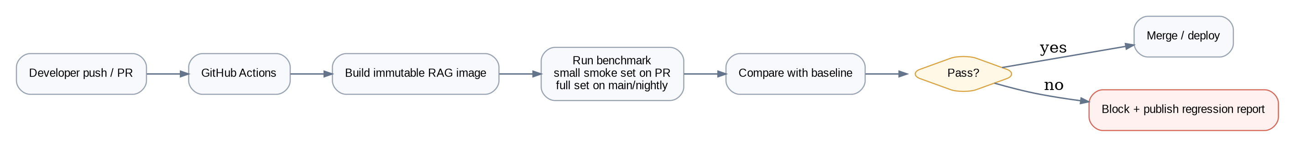
Figure 4. Pull-request and main-branch quality-gate flow.

17.1 GitHub Actions strategy
Trigger | Suite | Purpose | Typical budget
Pull request | Smoke | Fast feedback on obvious regressions. | 10-30 cases, <5 min target
Main branch | Regression | Protect integration branch. | 100-500 cases
Nightly | Full + adversarial | Comprehensive reliability check. | 500+ cases
Release candidate | Locked test set | Final release evidence. | Full locked set

17.2 Gate result contract
{
"status": "FAIL",
"baseline_run": "run_100",
"candidate_run": "run_104",
"violations": [
{"metric":"faithfulness","baseline":0.92,"candidate":0.84},
{"metric":"hallucination_rate","baseline":0.05,"candidate":0.12}
],
"critical_failures": 3,
"report_url":"artifact://reports/run_104.html"
}

18. Security, Privacy and Trust

18.1 Threat model
Threat | Risk | Mitigation
Prompt injection in evaluated documents | Evaluator may follow hostile content. | Treat retrieved text as untrusted; evaluator prompts explicitly separate evidence from instructions.
Secrets leakage | Provider keys appear in traces/logs. | Secret references only; redaction middleware; never log Authorization headers.
Sensitive benchmark data | PII or proprietary documents stored in artifacts. | Encryption, access controls, retention policy, optional redaction hooks.
Evaluator compromise | Malicious trace content manipulates judge results. | Structured inputs, escaped delimiters, evaluator isolation.
Run amplification / cost attack | Huge dataset triggers expensive LLM calls. | Per-project budgets, max cases, concurrency limits, quotas.
False confidence | Good average score hides critical failure. | Severity-weighted gates + per-case inspection + locked test set.
Cross-project data access | Tenant isolation failure. | project_id scoping on all repository queries; authorization middleware; audit logs.

18.2 Data retention
- Trace summaries: 30-90 days configurable.
- Raw large artifacts: shorter retention unless explicitly pinned.
- Locked benchmark datasets: retained until superseded.
- Human labels: retained with audit metadata because they train the diagnosis model.

19. Observability and Operations
Signal | Examples | Alert
Metrics | run_success_rate, queue_depth, worker_utilization, judge_error_rate, evaluator_cost | Threshold/budget breach
Logs | run lifecycle, adapter errors, evaluation failures | Structured JSON logs; correlation id
Traces | API span, worker span, adapter span, evaluator span | Slow spans / external call failures
Quality | faithfulness, recall, citation accuracy, abstention, hallucination rate | Quality regression
Cost | tokens, provider spend, cost/run, cost/case | Budget exceeded

19.1 SLO targets for first production-like deployment
SLO | Target
API availability | 99.5% monthly for control-plane endpoints
Run scheduling latency | p95 < 2 seconds from accepted run to queued state
Worker success | > 99% excluding external SUT failures
Trace completeness | > 99% of successful cases contain required canonical fields
Dashboard freshness | < 30 seconds after metric persistence

20. Deployment Architecture

20.1 MVP local deployment
docker-compose
├── api FastAPI
├── worker evaluation worker
├── scheduler optional periodic jobs
├── postgres metadata + metrics
├── redis queue/cache
├── qdrant optional retrieval lab
├── mlflow experiment/trace UI (optional in Phase 2)
└── frontend Next.js / React

20.2 Production-like deployment
- Frontend served behind CDN/HTTPS.
- API behind reverse proxy / load balancer.
- Workers scaled horizontally by queue depth and expected provider rate limits.
- PostgreSQL managed with automated backups and point-in-time recovery.
- Redis used only for queueing/caching; evaluation state stored durably in PostgreSQL.
- Object storage with server-side encryption for datasets/reports.
- Optional Kubernetes deployment only after queue/worker bottlenecks are demonstrated; do not add Kubernetes for prestige.

21. Performance and Cost Design

21.1 Parallelism
Evaluation cases are embarrassingly parallel until shared provider limits, dataset-level constraints or experiment scheduling introduce coupling. The worker should use bounded concurrency per project and per provider, with exponential backoff for retryable failures.

21.2 Caching
- Cache evaluator outputs by hash(trace_input + evaluator_version + prompt_version).
- Cache embeddings by text hash + embedding model identifier.
- Cache unchanged retrieval experiment artifacts.
- Do not cache across projects unless the cache key includes project data classification and authorization boundaries.

21.3 Cost controls
Control | Mechanism
Budget per run | max_cases, max_tokens, max_cost, time_limit
Evaluator tiers | cheap deterministic checks first; LLM judge only when needed
Sampling | full scoring on locked set, sampled scoring on large shadow traffic
Deduplication | trace/evaluation result cache
Concurrency | provider-aware limits and project quotas

22. Test Strategy

22.1 Test pyramid
Layer | Coverage
Unit | Metric formulas, schema validation, attribution rules, policy engine, adapters.
Contract | Adapter interface, API schemas, database migrations.
Integration | PostgreSQL/Redis/object storage, worker orchestration.
Golden evaluation | Pinned benchmark with expected metric ranges and known failures.
End-to-end | Create project -> run -> evaluate -> compare -> CI result.
Chaos / resilience | Provider timeout, rate limit, malformed response, worker restart, duplicate delivery.
Security | Authz tests, secret redaction, tenant isolation, injection-resistant evaluator prompts.

22.2 Evaluation-platform self-test
The platform must test itself. Create deliberately broken RAG adapters: one with a retriever that always returns distractors, one with a generator that ignores context, one with a citation bug, and one that correctly abstains. The evaluator should classify each failure correctly. This prevents the platform from being validated only on "mostly good" systems.

23. Repository and Code Organization
rag-reliability-platform/
├── apps/
│ ├── api/ # FastAPI control plane
│ ├── worker/ # async evaluation worker
│ └── web/ # React / Next.js UI
├── packages/
│ ├── domain/ # entities, enums, policies
│ ├── adapters/ # RAG integration contracts
│ ├── evaluation/ # metric plugins + orchestration
│ ├── attribution/ # rules + ML diagnosis
│ ├── datasets/ # schema + import/export
│ ├── tracing/ # canonical trace + exporters
│ └── common/ # logging, IDs, config, errors
├── infra/
│ ├── docker/
│ ├── compose/
│ └── migrations/
├── benchmarks/
│ ├── locked/
│ ├── dev/
│ └── adversarial/
├── tests/
│ ├── unit/
│ ├── integration/
│ └── e2e/
└── .github/workflows/
├── pr-evaluation.yml
└── nightly-evaluation.yml

23.1 Engineering conventions
- Type-check Python code and validate API payloads with Pydantic models.
- Every external provider call must have timeout, retry policy, structured error mapping and cost metadata.
- Every background task must be idempotent using a deterministic job key.
- Domain logic must not import FastAPI, SQLAlchemy sessions or provider SDKs directly; keep adapters and infrastructure at the edges.
- Use migration files for schema changes; never mutate production schema manually.

24. Architecture Decision Records

ADR-001: Modular monolith before microservices
Decision: implement control plane, evaluation orchestration and attribution as modules in one backend deployable. Reason: the dominant complexity is evaluation semantics, not network-scale service communication. Workers can be split later without changing domain contracts.

ADR-002: PostgreSQL as source of truth
Decision: PostgreSQL stores project/config/run/metric/failure metadata. Reason: relational integrity and queryability matter more than horizontal database novelty at student-project scale.

ADR-003: Adapter contract is mandatory
Decision: the platform never hardcodes one RAG framework. Reason: the product value is system-level evaluation, and adapter portability makes the platform reusable.

ADR-004: LLM judges are not the sole oracle
Decision: combine deterministic checks, retrieval labels, NLI/ML signals and judge metrics. Reason: judges are useful but probabilistic and potentially correlated with the model being evaluated.

ADR-005: CI gate is policy-based
Decision: release criteria are explicit policies over multiple metrics, not a single score. Reason: a quality gain can still be unacceptable if latency, cost, citation safety or hallucination rate regresses.

25. Implementation Plan
Phase | Scope | Exit criteria
0 - Foundations | Repo, Docker, Postgres, Redis, FastAPI, basic UI shell. | Local stack starts in one command; migrations and health checks work.
1 - Evaluator MVP | Dataset schema, adapter interface, trace normalization, 5-7 metrics. | 100-case benchmark executes reproducibly and stores results.
2 - Diagnosis | Failure taxonomy, evidence drill-down, citation/abstention checks. | Broken test RAGs are classified into expected failure categories.
3 - Regression platform | Baselines, comparisons, run history, CI quality gate. | PR can pass/fail based on RAG quality policy.
4 - Adversarial testing | Generated hard cases, locked tests, attack taxonomy. | System exposes failures hidden from normal benchmark.
5 - ML diagnosis | Train calibrated failure classifier and active learning loop. | Classifier beats rule-only baseline on held-out labels.
6 - Optimization lab | Retrieval experiments, reranking, Pareto search. | System can recommend configurations with measured trade-offs.
7 - Production hardening | Auth, quotas, encryption, retention, backup/restore, observability. | Reliable deployment runbook and incident tests complete.

25.1 Minimum viable demo
- One sample enterprise knowledge base (for example, a public annual-report corpus).
- One intentionally flawed RAG application.
- One correct-ish RAG baseline.
- 100 benchmark questions: normal + unanswerable + adversarial.
- At least five metrics plus citation and abstention checks.
- Per-case failure attribution with evidence.
- Version A vs Version B comparison.
- GitHub Actions workflow that blocks a regression.

26. Definition of Done
Area | Acceptance criterion
Reproducibility | A published dataset/version + run configuration can be re-executed and traced.
Evaluation | Retrieval and generation metrics are independently available.
Explainability | Every failing test has evidence: retrieved chunks, answer, metric reasons and attribution.
Hallucination | Unsupported claims can be detected and counted on a benchmark.
Abstention | Unanswerable benchmark cases have an explicit expected refusal outcome.
Regression | A baseline can be compared with a candidate and policy violations identified.
CI | A pull request can receive PASS/FAIL from the platform.
Security | Secrets are redacted, projects are isolated, and audit events exist.
Resilience | External timeouts/rate limits do not become false hallucination labels.
ML | Failure-diagnosis classifier is evaluated against a locked held-out set.
Documentation | Architecture, deployment, benchmark methodology and failure taxonomy are reproducible from the repository.

27. Risks and Mitigations
Risk | Impact | Mitigation
Evaluator bias | High | Cross-check with deterministic metrics + human labels; track evaluator version.
Synthetic benchmark overfitting | High | Use locked and production-shadow sets.
Too many metrics | Medium | Keep core release policy small; expose advanced metrics as diagnostics.
Provider cost explodes | High | Budgets, caching, sampling, concurrency limits.
Adapter instrumentation unavailable | Medium | Allow partial evaluation and mark unavailable dimensions explicitly.
Attribution model overconfidence | High | Calibration, abstain/unknown category, human review.
Student project becomes too large | High | Phase gates; modular monolith; postpone SaaS features.

28. Reference Documentation
The following official documentation informs the technology choices and evaluation primitives. These are implementation references, not endorsements.
- DeepEval — RAG evaluation quickstart
- DeepEval — Faithfulness metric
- DeepEval — Contextual recall
- DeepEval — Contextual precision
- Qdrant — Hybrid search and reranking
- Qdrant — Hybrid and multi-stage queries
- MLflow — End-to-end RAG evaluation

Appendix A - Example Benchmark Record
{
"id": "case-0042",
"question": "What was the 2024 gross margin?",
"expected_answer": "42.1%",
"expected_facts": [
"Gross margin in 2024 was 42.1%"
],
"relevant_documents": [
{"document_id":"annual-report-2024","page":42}
],
"answerability": "ANSWERABLE",
"tags": ["numeric", "annual-report", "citation"]
}

Appendix B - Example Failure Report
Failure: RET-01 Retrieval miss
Severity: HIGH
Confidence: 0.94
Question
What was the 2024 gross margin?
Expected evidence
annual-report-2024 / page 42
Retrieved
annual-report-2023 / page 39
annual-report-2024 / page 11
product-overview / page 7
Diagnosis
Correct evidence exists in corpus but is absent from top-5.
Recommended experiments
1. Increase top-k from 5 to 8.
2. Add lexical/hybrid retrieval.
3. Enable reranking.
4. Inspect chunk boundary around page 42.

Appendix C - Build Philosophy
The standard for success
Do not ask whether the demo looks intelligent. Ask whether the system can produce reproducible evidence that a RAG change improved reliability under a benchmark, and whether it can correctly diagnose when the system got worse.

