**City table :**

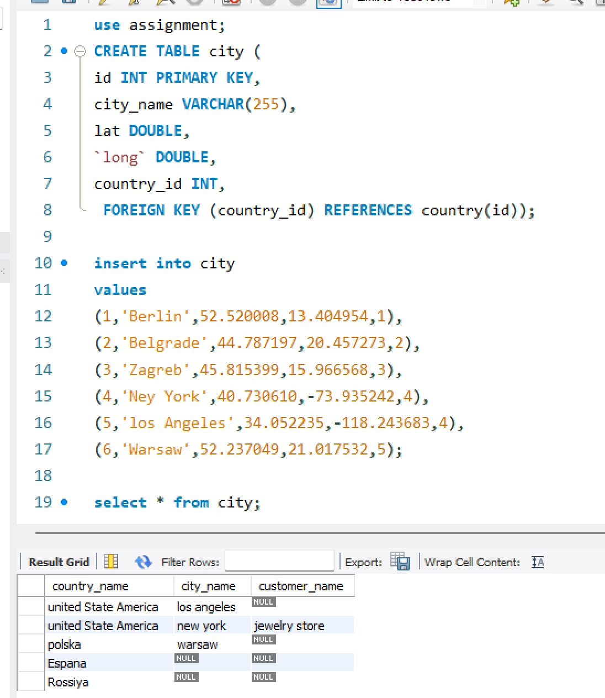

**Customer table:**

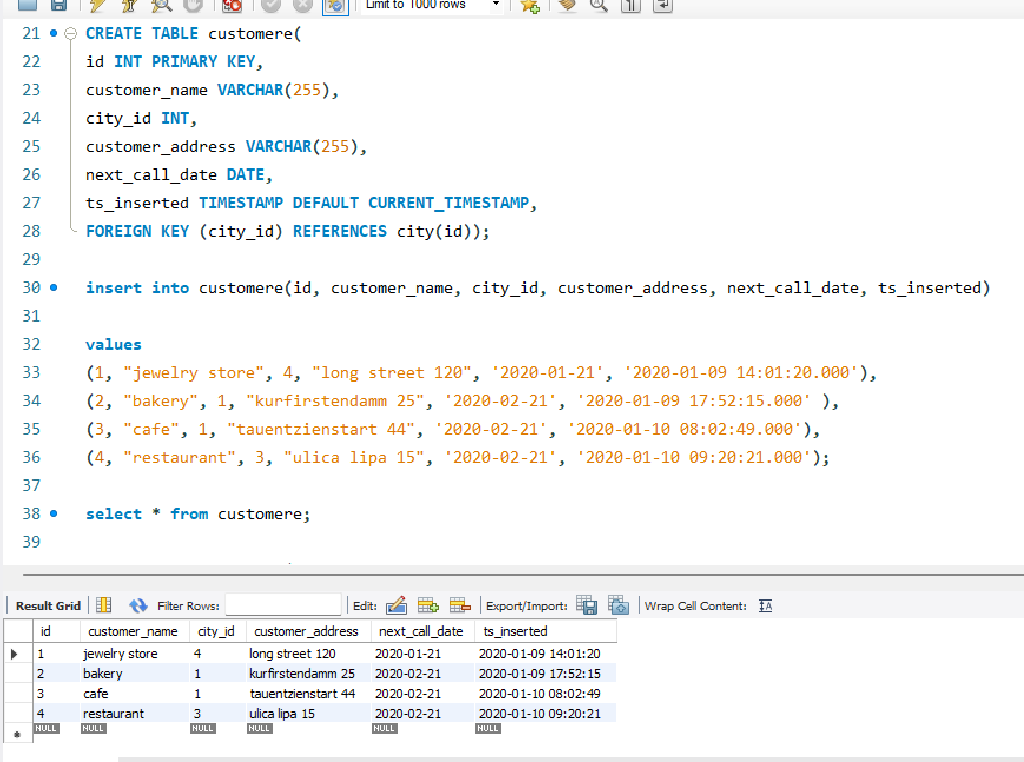

**Country table :**

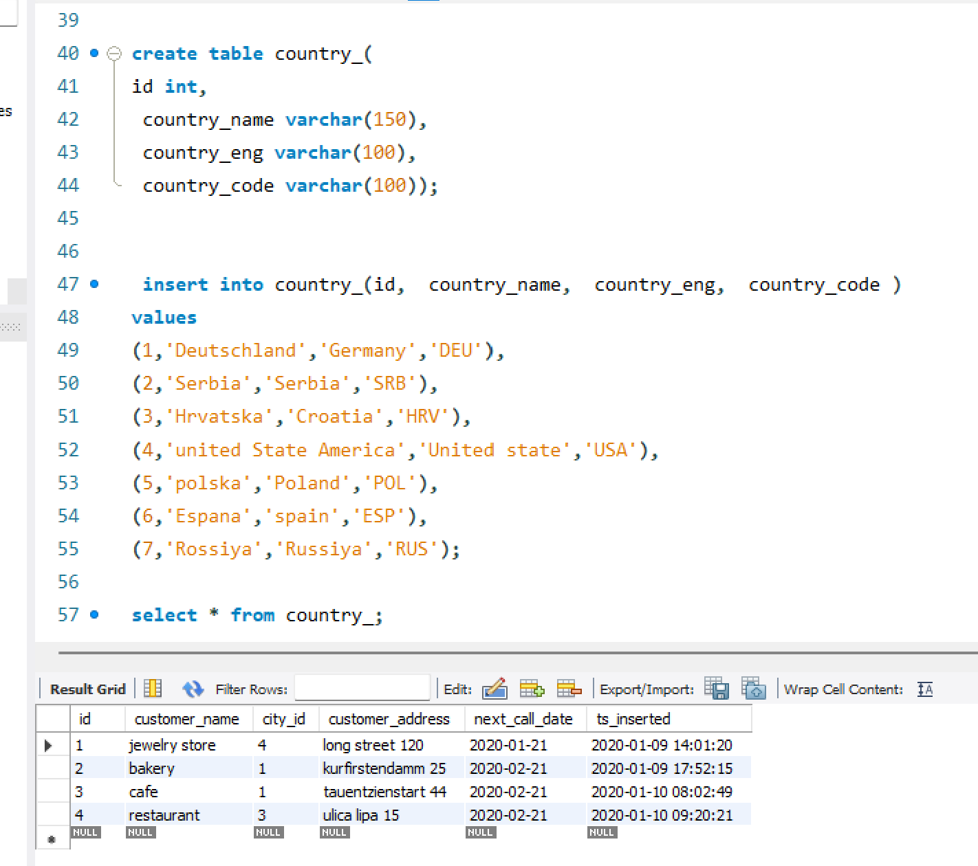

Task : 1 (join multiple tables using left join)

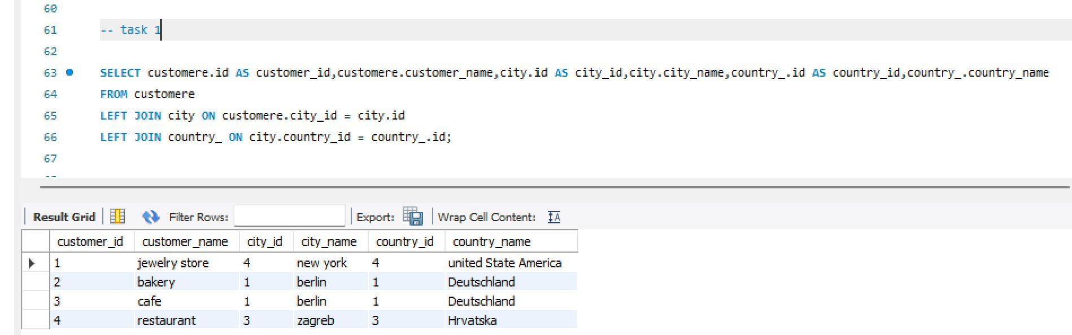

**List all Countries and customers related to these countries.**

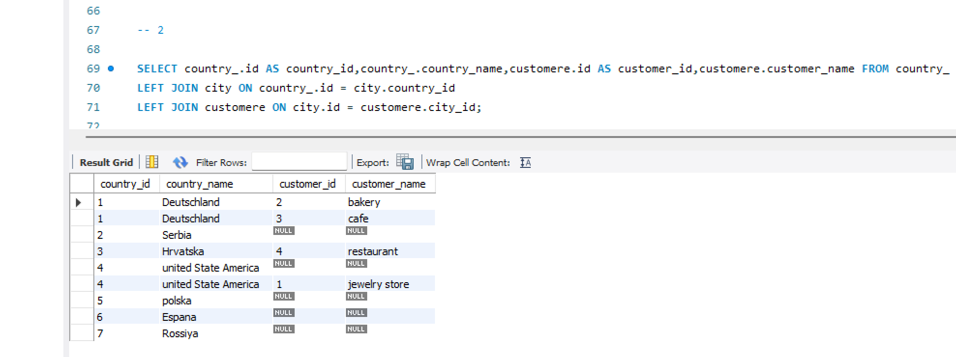

**For each country displaying its name in English, the name of the city customer is located in as well as the name of the customer.**

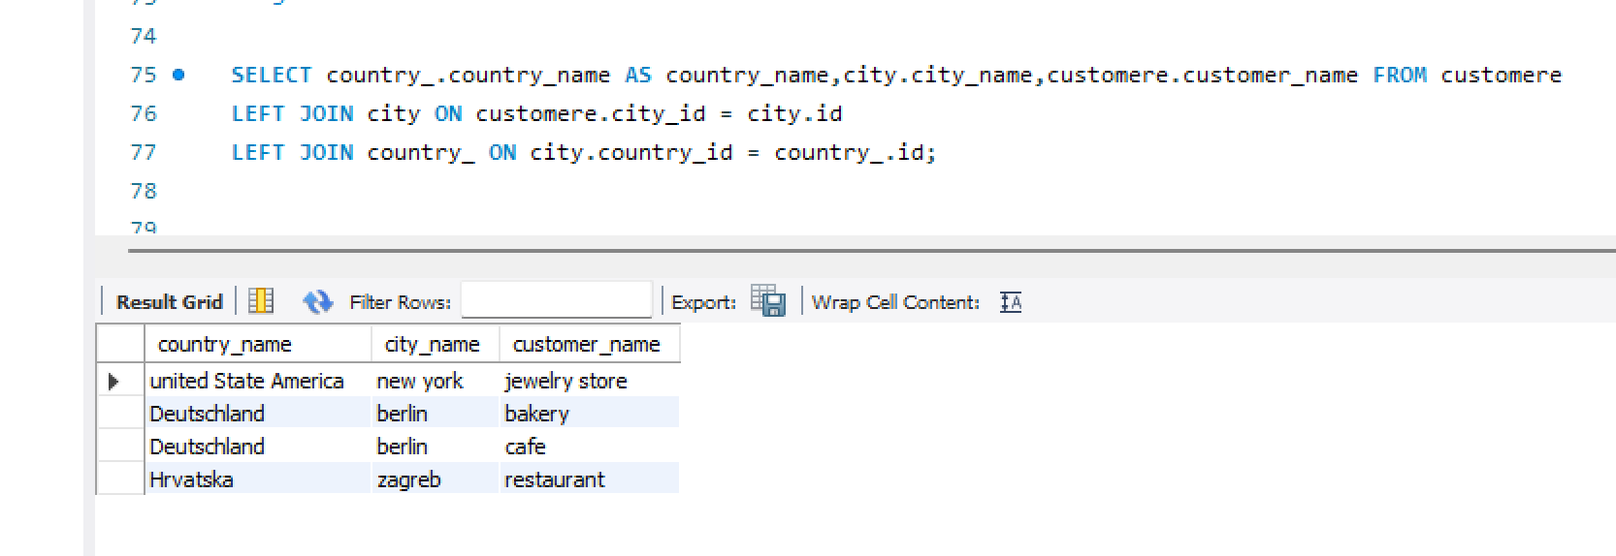

**Task : 2 (join multiple tables using both left and inner join)**

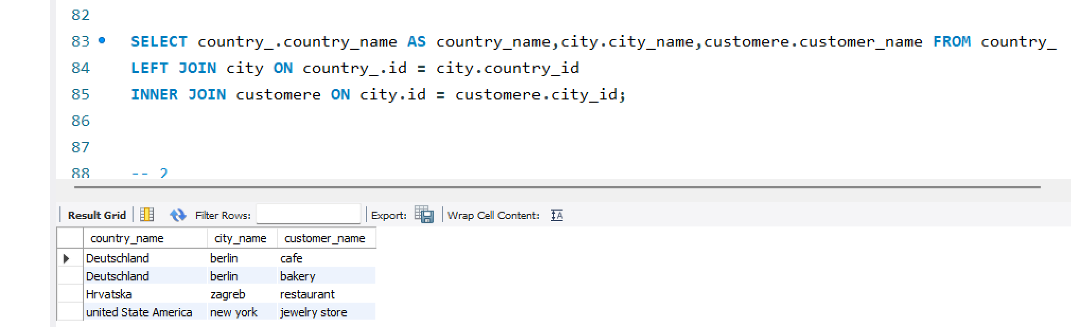

**Return the list of all countries that have pairs(exclude countries which are not referenced by any city). For such pairs return all customers.**

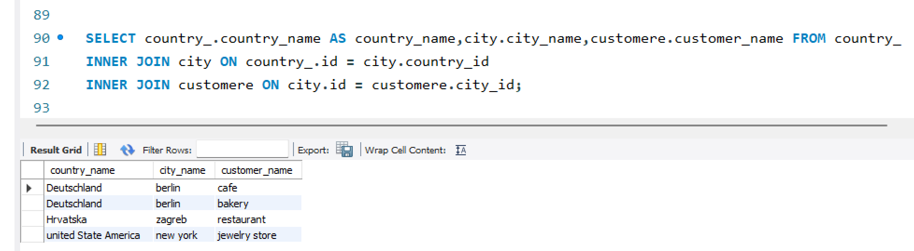

**Return even pairs of not having a single customer**

