**Indian Institute of Information Technology, Allahabad**

Database Management System

INSTRUCTIONS TO RUN THE PROJECT

**Tours & Travels Web Application**

**Project Team :**

IIB2019007 : Aditya Raj

IIB20190021 : Hitika Kumar

IIT2019018 : B Chetan Rao

IIB2019001 : Harsh Mahajan

**Step 1a: Downloading our project from github**

Prerequisites

1. Git must be installed on your desktop.

Commands to run on terminal or command prompt

1. git clone <https://github.com/harsh-8989/Tminus0-Tours-N-Travel.git>

**Step 1b: if you have our project zip file.**

1. Unzip and follow the steps mentioned below.

**Step 2: Software needed for running project seamlessly**

1. Microsoft Visual Studio Code - [Download link](https://code.visualstudio.com/download) (optional)
2. PostgreSQL (fully configured) - [Download link](https://www.postgresql.org/download/)
3. Python3 - [Download link](https://www.python.org/downloads/)
4. Pgadmin4 - [Download link](https://www.pgadmin.org/download/)
5. Django (django will be installed when you run *pip install -r requirements.txt*)

**Step 3: To run the project you must have the requirements installed on your computer, which are listed in requirements.txt**

Commands

1. cd *Tminus0-Tours-N-Travels*
2. pip3 or pip install -r requirements.txt

**Step 4: Now it's time to integrate django server and our database.**

1. First create a database in postgresql named as **‘ToursNTravel’**.
2. We have created a backup of our own database (which includes the information about travel destinations and flights, trains and hotels schedules we are providing for this project) that you can restore .

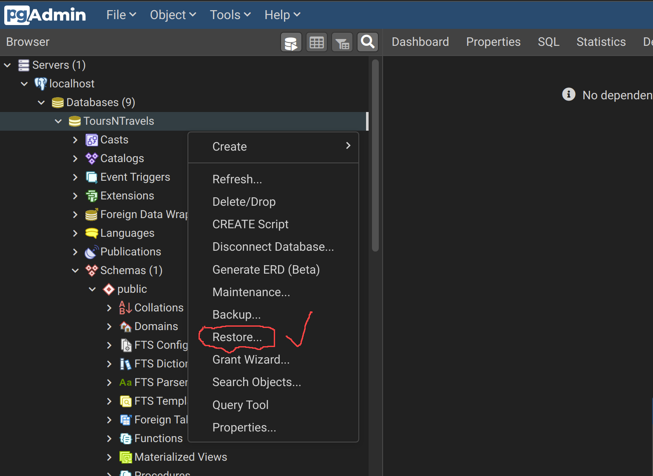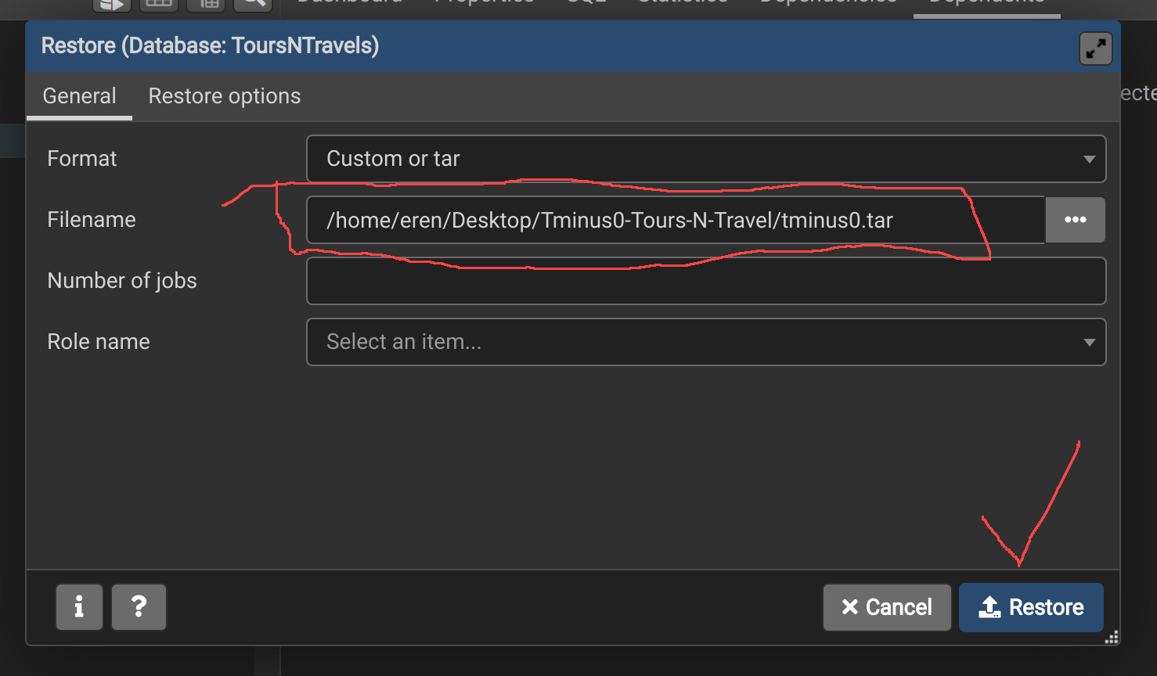

1. Then open settings.py in the code editor and change the database information, particularly username and password which you have set in your postgres (refer screenshot attached below.)

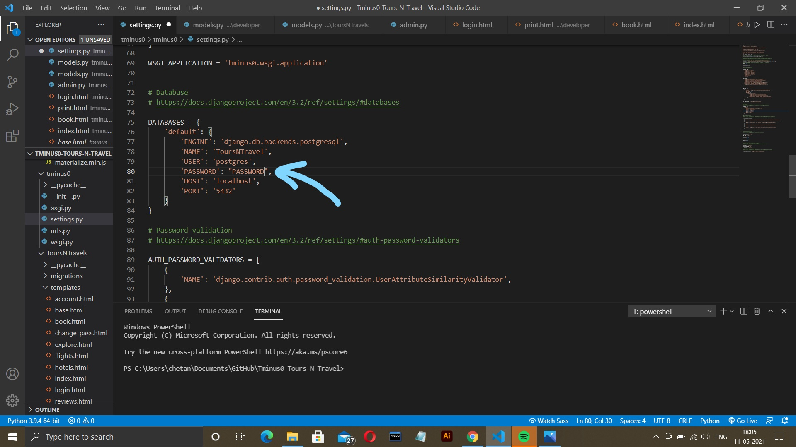

**Step 5- now to run the project run these commands in the terminal -**

1. cd .\tminus0\
2. python or python3 manage.py migrate
3. python or python3 manage.py runserver

Now, open localhost:8000 or 127.0.0.1:8000 at the browser of your choice.

Voila, now you must have landed at the beautiful homepage of our website Tours & Travels.

**NOTE-**

To book any flight, train or hotel you must be logged in. Flights, trains, and hotels are limited to the destinations and dates we have picked. So please use the dummy data provided below.

***\*\*All the fields are case sensitive.***

**Destinations -**

1. Tokyo
2. New York
3. Sydney
4. Ladakh
5. Seoul

**Flights-**

|  |  |  |
| --- | --- | --- |
| **Source** | **Destination** | **Departure Date** |
| New York | Tokyo | 1-5-2021 |
| Ladakh | Seoul | 1-5-2021 |
| Tokyo | Sydney | 1-5-2021 |
| Sydney | Ladakh | 1-5-2021 |

**Trains -**

|  |  |  |
| --- | --- | --- |
| **Source** | **Destination** | **Departure Date** |
| New York | Tokyo | 2021-05-01 |
| Ladakh | Seoul | 2021-05-01 |
| Tokyo | Sydney | 2021-05-01 |
| Seoul | New York | 2021-05-01 |
| Sydney | Ladakh | 2021-05-01 |

**Hotels -**

|  |  |  |
| --- | --- | --- |
| **Company Name** | **City** | **Address** |
| TMinus0 | Tokyo | TokyoCity |
| TMinus0 | Seoul | SeoulCity |
| TMinus0 | Sydney | SydneyCity |
| TMinus0 | New York | NewYorkCity |
| TMinus0 | Ladakh | Ladakh |