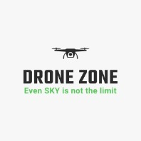

**DRONE ZONE**

Even SKY is not the limit

**Introduction**

**Welcome to the future**

**Welcome to the Drone Zone**

**We are the creator of the best drones in the world at affordable price.**

**Products:-**

* **Aerial Drones**
* **Marine Drones**

**About Our Website:-**

We hired the best designers from the globe to design our website.

We have also added a blog section people who buy our products and are interested in adding their travel blogs they can freely add their stuff.

For cost cutting we directly send our products from the industrial unit to the location this saves the work of 2-3 agencies and hence we don’t have to pay these 3rd persons.

*The thing by which we differ from all other big manufacturers in competition is we have a small quiz for the buyer, they have to attend a small quiz and by analysing that we suggest the best suitable product for them.*

Created by:

Harshit Kaushal

Shourya Chambial

Tanishq

Dhruv Sood

For more info visit contact us::dronezone@gmail.com