https://www.hackerrank.com/challenges/fizzbuzz/problem

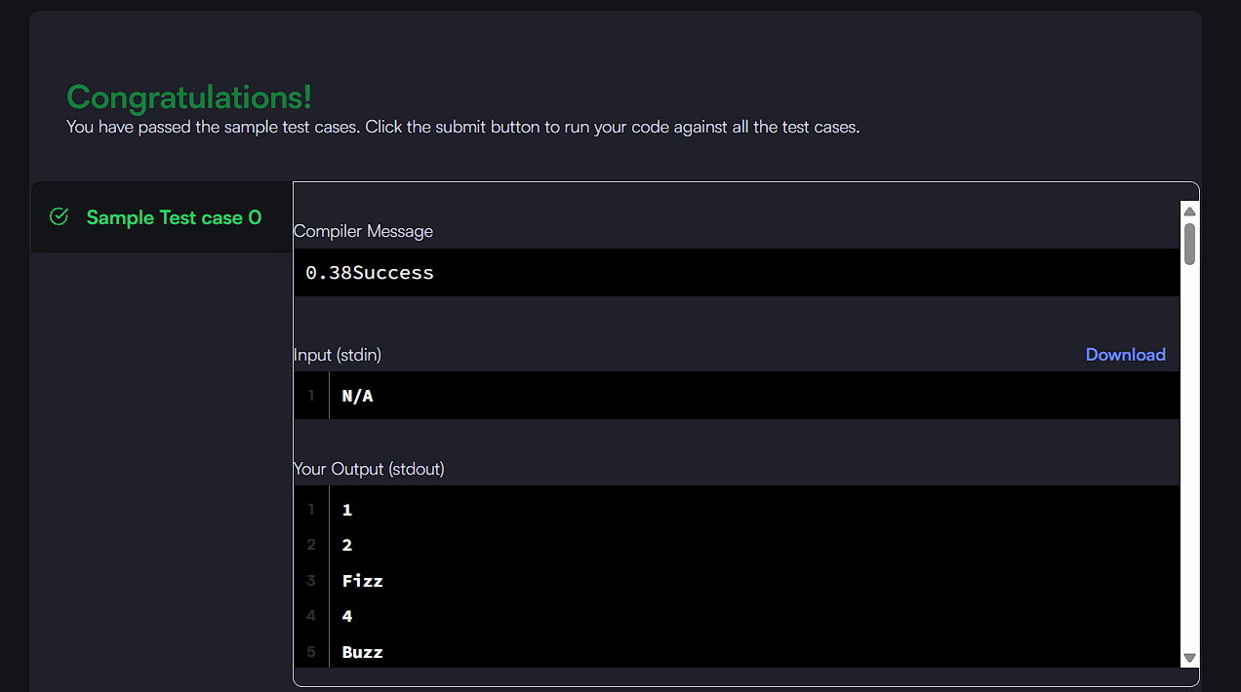

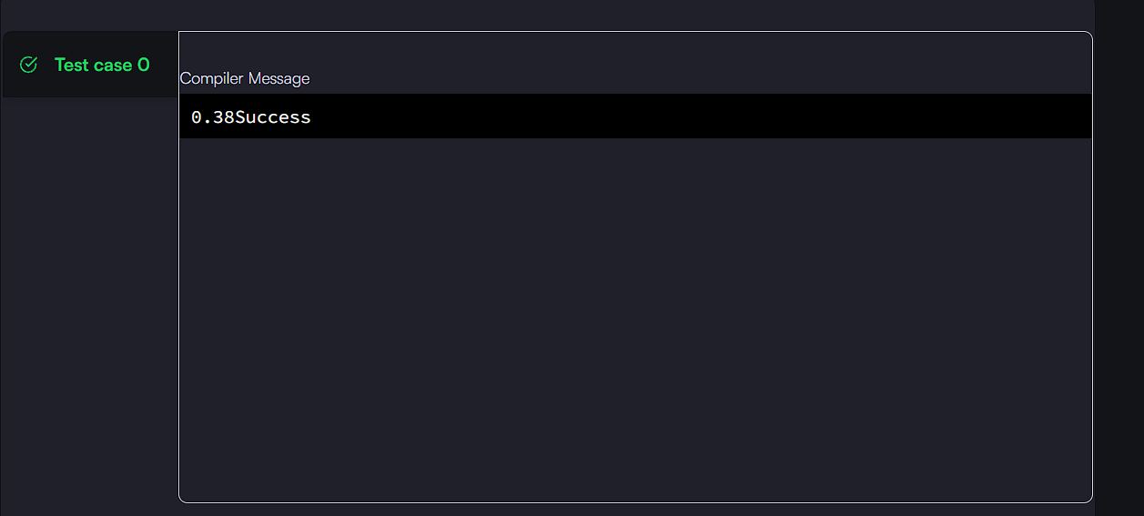
CODE:

#include<stdio.h>
int main(){for(int i=0;i++<100;)i%15?i%5?i%3?printf("%d\n",i):puts("Fizz"):puts("Buzz"):puts("FizzBuzz");}

