Chapter 1: Software Project Planning
1.1 Description of the Software System under Study
NexusFlow is a web-based, role-driven Enterprise Project and Team Collaboration Management System developed as a solo BCA summer training project. The system unifies project management, task tracking, team collaboration, and reporting into a single integrated platform, addressing the fragmentation that occurs when small organizations and student teams rely on disconnected tools such as spreadsheets, chat applications, and email for project coordination.
The system supports four distinct user roles — Admin, Project Manager, Team Member, and Client — each with role-specific permissions enforced through JWT-based authentication and authorization. Admins manage users and organizations; Project Managers create and oversee projects and assign tasks; Team Members update task status and participate in task-level discussions; Clients view project progress and reports. For the purposes of this training environment, the Project Guide, Rohit Kumar (Assistant Professor), acted as the primary user in defining and reviewing functional requirements, in line with standard summer training practice.
NexusFlow follows a three-tier client-server architecture: an Angular single-page front end communicates with an ASP.NET Core (.NET 10) REST API, which in turn persists data through Entity Framework Core to a Microsoft SQL Server database. The backend follows Clean Architecture principles, separating the system into four distinct layers — Domain, Application, Infrastructure, and API — to keep business logic independent of frameworks and easily testable.
1.2 Data Collection
Requirements and design references for NexusFlow were drawn from a combination of industry documentation and comparative study of existing project-management products:
- Official technical documentation: Microsoft Learn (ASP.NET Core, Entity Framework Core, SQL Server), Angular.dev (Angular 20 framework documentation), and the AutoMapper/FluentValidation project documentation.
- Comparative feature study of existing commercial project-management platforms — Jira, Trello, Asana, and Microsoft Planner — to identify the core module set (project, task, comment, notification, dashboard) common to enterprise-grade collaboration tools.
- Institutional guidance: IITM's Summer Training Project Guidelines (Appendix A/B) and the TuxAcademy/Linux Mantra Full Stack Development training curriculum, which structured the five-week technology ramp-up (Web Fundamentals → Angular → ASP.NET Core APIs → SQL Server → Integration & Deployment) preceding project development.
The functional modules selected for study and implementation — Authentication, User Management, Organization Management, Project Management, Task Management, Comment & Collaboration, Notification, and Dashboard & Reporting — were finalized after this comparative review and confirmed with the Project Guide before development began.
1.3 Tools and Platform
1.3.1 Hardware Specification
Component | Specification
Processor | Intel Core i5 / AMD Ryzen 5 or higher (64-bit)
RAM | 8 GB minimum (16 GB recommended for running SQL Server and Visual Studio together)
Storage | 100 GB free disk space (SSD preferred)
Display | 1366 x 768 resolution or higher
Operating System | Windows 10/11 (64-bit)
Table 1.1: Hardware Specification
1.3.2 Software Specification
Layer | Technology
Frontend | Angular 20, TypeScript, HTML5, CSS3, Angular Material
Backend | ASP.NET Core (.NET 10), C#, Entity Framework Core, AutoMapper, FluentValidation
Database | Microsoft SQL Server 2022 (Developer Edition)
Authentication | JSON Web Tokens (JWT)
IDE / Tools | Visual Studio 2022, Visual Studio Code, SQL Server Management Studio (SSMS)
Version Control | Git, GitHub
API Testing | Postman
Architecture | Clean Architecture (Domain, Application, Infrastructure, API layers)
Design Patterns | Repository Pattern, Unit of Work Pattern, Dependency Injection
Table 1.2: Software Specification

1.4 Project Planning
1.4.1 Work Distribution Table
NexusFlow is developed individually. The table below shows the distribution of work across the training period by phase, rather than by team member, since the project has a single developer.
Phase | Task / Activity | Duration | Owner
1 | Requirement analysis, topic selection, project planning | Jun 28 – Jul 1 | Harsh
2 | Synopsis preparation and submission | Jul 1 – Jul 6 | Harsh
3 | Database design and backend core modules (Auth, Project, Task) | Jul 6 – Jul 15 | Harsh
4 | Remaining backend modules + AutoMapper/FluentValidation wiring | Jul 15 – Jul 20 | Harsh
5 | Angular frontend: Auth, Dashboard, Projects, Tasks | Jul 20 – Jul 28 | Harsh
6 | Comments, Notifications, CRUD completion, testing | Jul 28 – Aug 2 | Harsh
7 | Documentation (Chapters 1–4) and final report assembly | Aug 2 – Aug 7 | Harsh
Table 1.3: Team-Member Wise Work Distribution
1.4.2 PERT Chart
The PERT chart below represents the sequence of major activities undertaken during the training period, with each numbered event marking the completion of a phase and the estimated duration of the activity leading into it.
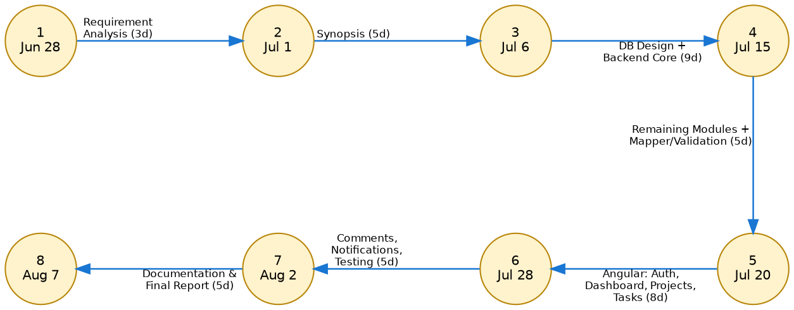
Figure 1.1: PERT Chart

1.5 Methodology
1.5.1 SDLC Model
The Incremental Model has been selected for the development of NexusFlow.
1.5.2 Justification for the Selection of Model
NexusFlow consists of multiple independent but interconnected modules — Authentication, Project Management, Task Management, Comments, Notifications, and Dashboard reporting. The Incremental Model allows each module to be designed, developed, and verified as a self-contained increment before the next begins, which proved directly applicable during actual development:
1. Backend modules were built and tested one at a time in dependency order — Authentication first (since every other module requires it), followed by Project, Task, Comment, Notification, and Dashboard — with each module verified through Postman before the next began.
2. The frontend followed the same incremental pattern: Auth and Dashboard were built and confirmed working end-to-end against the live API before Projects, then Tasks, then Comments and Notifications were added on top.
3. This structure meant that even mid-way through development, a fully working (if smaller) system existed at every stage — useful given the fixed academic submission deadlines for Synopsis, Chapters 1–2, Chapters 3–4, and the Final Report.
4. Defects were caught early and locally: for example, an AutoMapper registration error and a task-comment-count bug were each isolated to a single increment rather than requiring a search across the whole codebase, because only one module was under active change at a time.

Chapter 2: Software Analysis & Software Requirement Specification
2.1 Feasibility Study
2.1.1 Technical Feasibility
NexusFlow uses a mature, well-documented technology stack (ASP.NET Core, Angular, SQL Server) with extensive official documentation and community support. All required tools — Visual Studio 2022 Community, .NET 10 SDK, Node.js, Angular CLI, SQL Server Developer Edition, and SSMS — are freely available for student use. The technology stack was learned progressively through a structured five-week training curriculum prior to development, and the incremental development approach (Section 1.5.2) allowed technical risk to be addressed one module at a time rather than all at once. The project is therefore technically feasible within the skill level achievable during the training period.
2.1.2 Economical Feasibility
All software used in development is free for student/educational use: Visual Studio 2022 Community, SQL Server Developer Edition, Angular and its open-source ecosystem, and Postman's free tier. No paid cloud hosting, third-party APIs, or commercial licenses are required to build, run, or demonstrate the system locally. The project therefore involves no direct monetary cost.
2.1.3 Operational Feasibility
The system is accessed through a standard web browser, requiring no specialized end-user training beyond familiarity with common web application patterns (forms, dashboards, navigation menus). Role-based access control means each user type sees only the actions relevant to their role, simplifying day-to-day operation. Since the target users (small organizations, startups, and student teams) already use browser-based tools for similar purposes, adoption does not require a significant behavioural change.
2.1.4 Other Feasibility Dimensions
- Schedule Feasibility: The eight functional modules were scoped to fit the six-week training window (with an additional documentation period), and the actual development followed the planned incremental schedule in Section 1.4.1 without major slippage.
- Legal Feasibility: All frameworks, libraries, and tools used (ASP.NET Core, Angular, Entity Framework Core, AutoMapper, FluentValidation, SQL Server Developer Edition) are used under their respective free/open-source or free-for-development licenses, with no legal or licensing obstacles to development or academic submission.
2.2 Description of Information System (Block Diagram)
The diagram below illustrates the end-to-end flow of a typical request through NexusFlow — from the user's action in the Angular UI, through JWT authentication and FluentValidation checks, into the Application service layer, through Entity Framework Core to SQL Server, and back.
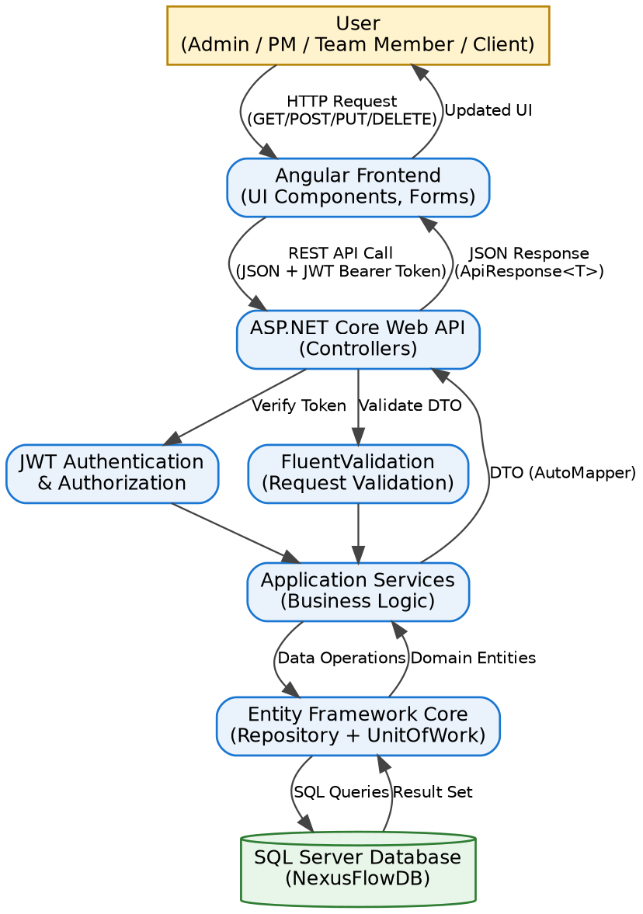
Figure 2.1: Block Diagram for NexusFlow Request Flow
2.2.1 Product Features
The following distinct processes (modules) were identified for NexusFlow:
1. Authentication & Authorization — registration, login, JWT issuance/refresh, role-based access.
2. User Management — listing and administering user accounts.
3. Organization Management — grouping projects and users under an organization entity.
4. Project Management — create, read, update, delete (CRUD) operations on projects, including status lifecycle.
5. Task Management — CRUD operations on tasks, priority levels, due dates, multi-assignee support, and status tracking.
6. Comment & Collaboration — task-scoped discussion threads.
7. Notification — automatic alerts on events such as task assignment, with read/unread tracking.
8. Dashboard & Reporting (mandatory Report Generation module) — aggregated statistics (total/active projects, task counts by status, unread notifications) and recent activity feed.
2.2.2 Input / Output Data Elements
Input / Output | Data Elements
Register Request (Input) | FullName, Email, Password, ConfirmPassword, PhoneNumber
Login Request (Input) | Email, Password
Auth Response (Output) | UserId, FullName, Email, Role, AccessToken, RefreshToken, AccessTokenExpiry
Create Project (Input) | Name, Description, StartDate, EndDate, OrganizationId
Project Details (Output) | Id, Name, Status, StartDate, EndDate, MemberCount, TaskCount, CreatedAt
Create Task (Input) | Title, Description, Priority, DueDate, ProjectId, AssigneeIds
Task Details (Output) | Id, Title, Status, Priority, ProjectName, AssigneeNames, CommentCount, SubTaskCount
Create Comment (Input) | Content, TaskId
Comment Details (Output) | Id, Content, UserName, CreatedAt
Notification (Output) | Id, Title, Message, Type, IsRead, CreatedAt
Dashboard Stats (Output) | TotalProjects, ActiveProjects, TotalTasks, CompletedTasks, PendingTasks, InProgressTasks, UnreadNotifications, RecentActivities
Table 2.1: Input/Output Data Elements
2.2.3 Procedures / Rules / Mathematical Relationships
The following business rules govern how NexusFlow converts input into output:
- Password Security Rule: Passwords are never stored in plain text. On registration, Password is transformed via BCrypt.HashPassword() into PasswordHash before persistence; on login, the supplied password is checked with BCrypt.Verify() against the stored hash.
- Token Expiry Rule: AccessTokenExpiry = CreatedAt + 60 minutes; RefreshToken.ExpiresAt = CreatedAt + 7 days. A refresh request issued after the refresh token's expiry is rejected with HTTP 401.
- Task Status Transition Rule: A newly created task always starts at Status = Todo, regardless of what the client requests; subsequent transitions (Todo → In Progress → In Review → Done, or → Cancelled at any point) are only made through an explicit Update request.
- Notification Trigger Rule: A Notification row (Type = TaskAssigned) is automatically created for every user listed in AssigneeIds at the moment a task is created.
- Dashboard Aggregation Formulas: ActiveProjects = COUNT(Projects WHERE Status = Active); CompletedTasks = COUNT(Tasks WHERE Status = Done); InProgressTasks = COUNT(Tasks WHERE Status = InProgress); PendingTasks = COUNT(Tasks WHERE Status = Todo); UnreadNotifications = COUNT(Notifications WHERE UserId = current user AND IsRead = false).
- Soft Delete Rule: Delete operations never remove a database row; they set IsDeleted = true. All read queries implicitly filter WHERE IsDeleted = false, preserving an audit trail.
2.2.4 Decision Table
The table below summarizes which of the four user roles may perform each key action (Y = allowed, N = not allowed):
Action | Admin | Project Manager | Team Member | Client
Create / Edit / Delete Project | Y | Y | N | N
Assign Task to a User | Y | Y | N | N
Update Own Task Status | Y | Y | Y | N
Add Task Comment | Y | Y | Y | N
View Dashboard / Reports | Y | Y | Y | Y
Manage Users | Y | N | N | N
Table 2.2: Role-Based Decision Table

2.3 Use Case Diagram
The diagram below shows the relationship between NexusFlow's four actors and the system's principal use cases.
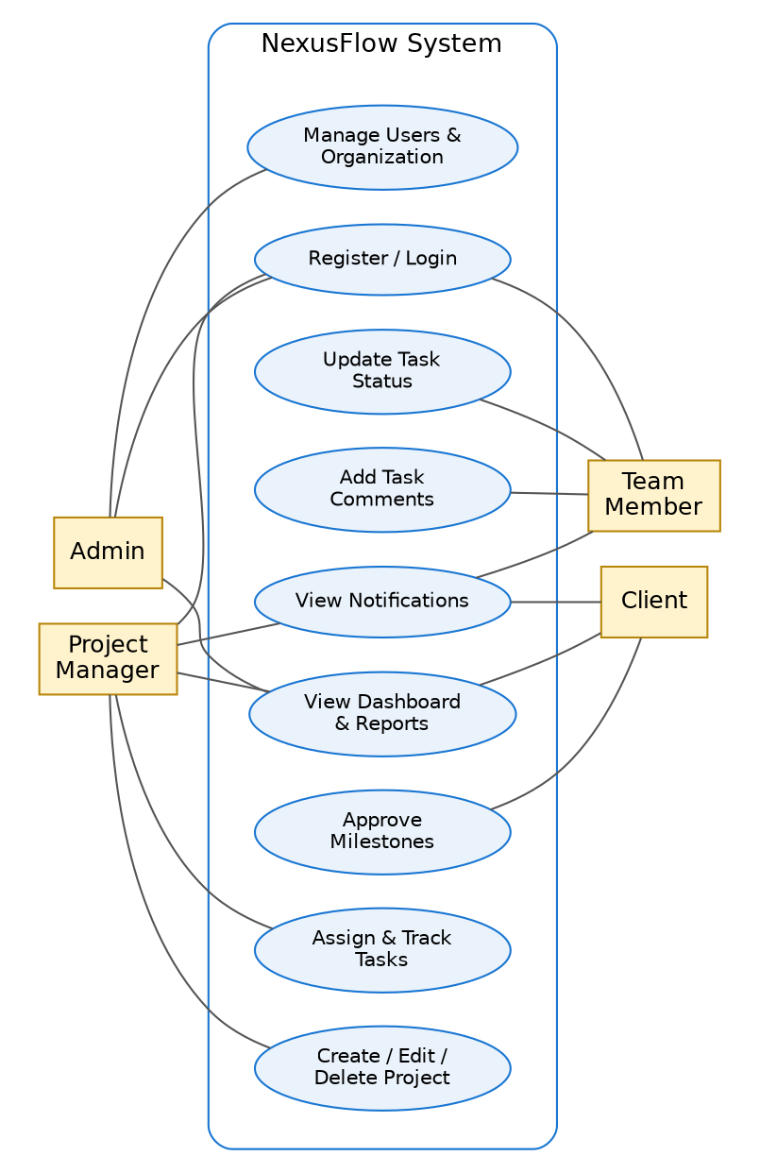
Figure 2.2: Use Case Diagram
Actor Descriptions
- Admin: Manages user accounts and organization-level settings; has full visibility into system-wide reports.
- Project Manager: Creates and manages projects, assigns and monitors tasks, reviews dashboards and notifications relevant to their projects.
- Team Member: Registers/logs in, updates the status of tasks assigned to them, participates in task comments, and receives notifications.
- Client: Views project progress and reports and receives status notifications, without edit access to projects or tasks.
2.4 Software Product Constraints
- The application requires network connectivity between the Angular client and the ASP.NET Core API (both running on localhost during development); it is not designed for offline use.
- An expired JWT access token requires either a silent refresh (via the stored refresh token) or a fresh login — there is no session that persists indefinitely without one of these.
- SQL Server must be running and reachable via the connection string in appsettings.json before the API will start correctly.
- The current build assumes a single Organization context; multi-tenant organization switching is not implemented (see Future Scope).
- Notifications are delivered via on-demand polling when the notification panel is opened, not push-based real-time delivery.
- The Angular 20 frontend requires a modern evergreen browser (Chrome, Edge, Firefox) with JavaScript enabled; it is not designed to support legacy browsers.

