Chapter 3: Software Project Analysis

3.1 Data Flow Diagram (DFD)
A Data Flow Diagram models how data moves through NexusFlow — between the user, the system's internal processes, and its data stores — without describing the internal implementation of each process. Three levels of increasing detail are presented below: a Context (Level 0) diagram showing NexusFlow as a single process, a Level 1 diagram decomposing it into its six major processes, and a Level 2 diagram further decomposing the Task Management process, since task handling — now including the full accept / clarify / status-transition workflow — is the most operationally complex module in the system.

3.1.1 Level 0 — Context Diagram
The context diagram treats NexusFlow as a single process and shows only the data exchanged with its external entity, the User (representing any of the four roles: Admin, Project Manager, Team Member, or Client). This top-level view is unchanged by the Task Workflow Engine, since the engine only adds detail inside the system, not new external data flows.
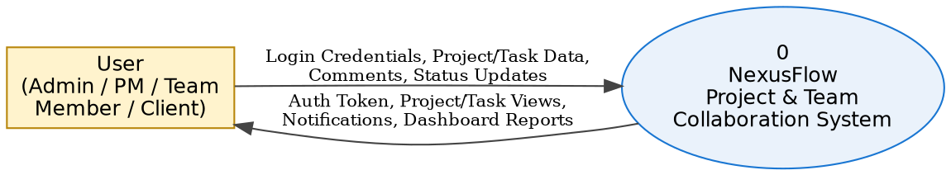
Figure 3.1: DFD Level 0 (Context Diagram)

3.1.2 Level 1 — Top-Level Decomposition
Level 1 decomposes the system into its six principal processes, each reading from and writing to its own data store. A seventh data store, D7 (AuditLogs), is introduced here — the table existed in the schema from the first migration but was inactive until the Task Workflow Engine began writing to it:
1.0 Authenticate User — validates credentials against D1 (Users) and issues a JWT.
2.0 Manage Projects — performs CRUD operations against D2 (Projects), including computing each project's completed/total task counts from D3 for the progress bar.
3.0 Manage Tasks — performs CRUD, assignment, and the full workflow (accept, clarify, status transitions) against D3 (Tasks), D6 (TaskAssignees), and D4 (Comments), writes every workflow event to D7 (AuditLogs), and triggers Process 5.0 on assignment, clarification, and status changes.
4.0 Manage Comments — reads/writes D4 (Comments, including clarification and work-log entries distinguished by Type) and looks up commenter names from D1 (Users).
5.0 Manage Notifications — writes to D5 (Notifications), tagging each with a RelatedTaskId where applicable, and delivers alerts back to the User.
6.0 Generate Dashboard — reads aggregated data from D2, D3, and D5 to compute the statistics and “My Tasks” view shown on the Dashboard.
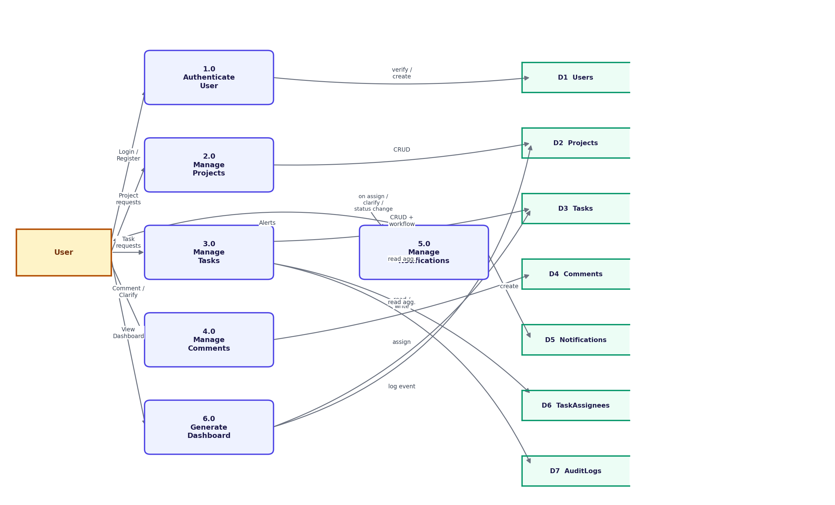
Figure 3.2: DFD Level 1

3.1.3 Level 2 — Decomposition of Process 3.0 (Manage Tasks)
Process 3.0 is further decomposed into seven sub-processes, reflecting the actual task lifecycle implemented by the Task Workflow Engine — an expansion from the four sub-processes of the original CRUD-only build:
3.1 Create Task — inserts a new row into D3 (Tasks) with Status fixed to Todo regardless of client input, then passes the new TaskId to 3.2.
3.2 Assign Task to Users — inserts rows into D6 (TaskAssignees) for each selected user, creates a corresponding alert in D5 (Notifications), and logs an “Assigned” event to D7.
3.3 Accept Task — verifies the caller is a D6 assignee and the task is still Todo, then updates D3.Status to InProgress and logs an “Accepted” event to D7. Restricted to the assignee only.
3.4 Request / Respond to Clarification — inserts a typed row into D4 (Type = Clarification or ClarificationResponse), notifies the other party via Process 5.0, and logs the event to D7. Request is restricted to an assignee; Respond is restricted to the task's creator or a Project Manager/Admin.
3.5 Update Task Status + Work Log — updates D3.Status to the caller-supplied value; if a work-log note is supplied, inserts it into D4 as Type = WorkLog; logs a “StatusChanged” event to D7. Restricted to the task's creator, its assignees, or a Project Manager/Admin.
3.6 View Activity Timeline — a read-only sub-process that queries D7 for all rows matching the given TaskId and returns them in chronological order.
3.7 Delete Task (Soft Delete) — sets IsDeleted = true on the D3 row rather than physically removing it, preserving the audit trail.
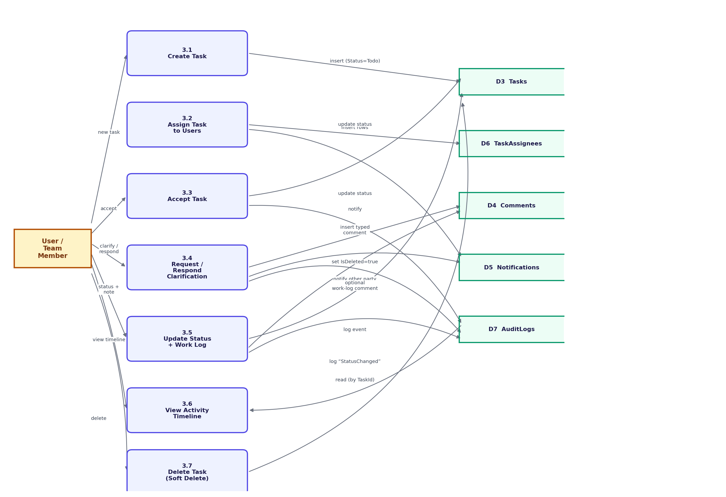
Figure 3.3: DFD Level 2 (Expansion of Process 3.0 — Manage Tasks)

3.2 Entity-Relationship Diagram
The Entity-Relationship diagram below models the ten most structurally significant entities of NexusFlow's fourteen-table schema (Organization, User, Project, ProjectMember, ProjectTask, TaskAssignee, SubTask, Comment, Notification, and RefreshToken) and the relationships between them, plus AuditLog — now shown explicitly since the Task Workflow Engine activated it. Department, Team, and TeamMember exist in the schema to support future organizational hierarchy features but are omitted here for clarity, as they do not yet participate in the core project/task workflow.
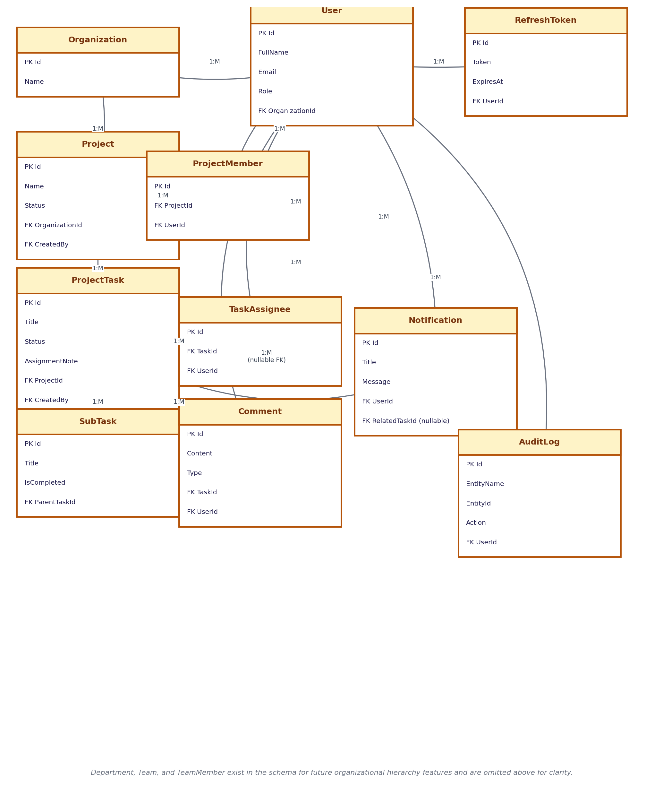
Figure 3.4: Entity-Relationship Diagram

Key Relationships
- An Organization has many Users and many Projects (1:M) — every user and project belongs to exactly one organization.
- A Project has many ProjectMembers and many ProjectTasks (1:M); a User can, through ProjectMember, belong to many projects — a many-to-many relationship between User and Project realized via the ProjectMember junction table.
- A ProjectTask has many TaskAssignees (1:M), which similarly realizes a many-to-many relationship between ProjectTask and User — a task can have multiple assignees, and a user can be assigned to multiple tasks.
- A ProjectTask has many SubTasks and many Comments (1:M); each Comment also belongs to exactly one User (the commenter) and carries a Type distinguishing a plain comment from a clarification request, a clarification response, or a work-log entry.
- A User has many Notifications and many RefreshTokens (1:M) — every login issues a new refresh token, and old tokens are revoked (not deleted) on re-login, preserving history.
- A Notification optionally references a ProjectTask via a nullable RelatedTaskId (M:1, new in this build) — this is what lets the frontend navigate directly to the task a notification is about when it is clicked.
- A User has many AuditLog entries (1:M, newly activated) — every workflow action performed by a user writes one row here, forming the Activity Timeline read back by Process 3.6.

3.3 Database Specification
The six tables below are the core operational tables of NexusFlow's fourteen-table schema. Field sizes shown are the actual constraints configured in NexusFlowDbContext (via Entity Framework Core's Fluent API); fields without a stated size are stored as nvarchar(max) or their natural SQL type.

Table: Users
Field Name | Type | Size | Description
Id | int | — | Primary key, identity
FullName | nvarchar | 100 | User's display name
Email | nvarchar | 150 | Login identifier, unique per user
PasswordHash | nvarchar | max | BCrypt hash of the password (never plain text)
Role | int | — | Enum: Admin=1, ProjectManager=2, TeamMember=3, Client=4
PhoneNumber | nvarchar | max, nullable | Optional contact number
OrganizationId | int | nullable | Foreign key to Organizations
CreatedAt / UpdatedAt | datetime2 | — | Audit timestamps (inherited from BaseEntity)
IsDeleted / IsActive | bit | — | Soft-delete and active-status flags
Table 3.1: Field Specification — Users

Table: Projects
Field Name | Type | Size | Description
Id | int | — | Primary key, identity
Name | nvarchar | 150 | Project name
Description | nvarchar | max, nullable | Free-text project description
Status | int | — | Enum: Planning=1, Active=2, OnHold=3, Completed=4, Cancelled=5
StartDate / EndDate | datetime2 | nullable | Planned project timeline
OrganizationId | int | — | Foreign key to Organizations
CreatedBy | int | — | Foreign key to Users (creator)
Table 3.2: Field Specification — Projects

Table: ProjectTasks
Field Name | Type | Size | Description
Id | int | — | Primary key, identity
Title | nvarchar | 200 | Task title
Description | nvarchar | max, nullable | Free-text task description
Status | int | — | Enum: Todo=1, InProgress=2, InReview=3, Done=4, Cancelled=5
Priority | int | — | Enum: Low=1, Medium=2, High=3, Critical=4
DueDate | datetime2 | nullable | Task deadline
AssignmentNote | nvarchar | 2000, nullable | New in this build — manager's note captured at assignment time, shown on the Task Details page
ProjectId | int | — | Foreign key to Projects
CreatedBy | int | — | Foreign key to Users (creator)
Table 3.3: Field Specification — ProjectTasks

Table: Comments
Field Name | Type | Size | Description
Id | int | — | Primary key, identity
Content | nvarchar | 1000 | Comment / clarification / work-log text
Type | int | —, default 1 | New in this build — Enum: Comment=1, Clarification=2, ClarificationResponse=3, WorkLog=4. Discriminates the four kinds of entry stored in this one table.
TaskId | int | — | Foreign key to ProjectTasks
UserId | int | — | Foreign key to Users (author)
Table 3.4: Field Specification — Comments

Table: Notifications
Field Name | Type | Size | Description
Id | int | — | Primary key, identity
Title | nvarchar | 200 | Short notification heading
Message | nvarchar | 500 | Notification body text
IsRead | bit | — | Read/unread flag, defaults to false
Type | int | — | Enum: TaskAssigned=1, TaskUpdated=2, ProjectCreated=3, CommentAdded=4, DeadlineApproaching=5, MentionedInComment=6, ClarificationRequested=7, ClarificationResponded=8
RelatedTaskId | int | nullable | New in this build — foreign key to ProjectTasks; enables click-through navigation from a notification straight to its task
UserId | int | — | Foreign key to Users (recipient)
Table 3.5: Field Specification — Notifications

Table: AuditLogs
Newly activated in this build — the table existed in the schema since the first migration but was not written to until the Task Workflow Engine began logging events. It backs the Activity Timeline shown on the Task Details page.
Field Name | Type | Size | Description
Id | int | — | Primary key, identity
EntityName | nvarchar | 100 | Name of the entity type the event relates to (e.g. “ProjectTask”)
EntityId | int | — | Id of the specific row the event relates to
Action | nvarchar | 50 | Event name, e.g. “Created”, “Accepted”, “StatusChanged”
OldValue / NewValue | nvarchar | max, nullable | Before/after values, where applicable (e.g. previous and new status)
UserId | int | — | Foreign key to Users (who performed the action)
Table 3.6: Field Specification — AuditLogs
The remaining eight tables (Organizations, Departments, Teams, TeamMembers, ProjectMembers, SubTasks, TaskAssignees, RefreshTokens) follow the same pattern — an int identity primary key, foreign keys to their parent entities, and the CreatedAt/UpdatedAt/CreatedBy/UpdatedBy/IsDeleted/IsActive audit columns inherited from the common BaseEntity base class.

3.4 Validation Specification
Input validation is enforced server-side using FluentValidation, wired through a global ValidationFilter that runs automatically before every controller action — no controller or service method needs to call a validator manually. If validation fails, the API returns HTTP 400 with a list of human-readable error messages before any business logic executes.
Input Screen / Action (DTO) | Field | Validation Rule
Register | FullName | Required, max 150 characters
Register | Email | Required, valid email format, max 256 characters
Register | Password | Required, min 8 characters, at least one uppercase, one lowercase, one digit
Register | ConfirmPassword | Required, must equal Password
Login | Email / Password | Both required
Create Project | Name | Required, max 200 characters
Create Project | EndDate | Must be on or after StartDate, when both are supplied
Update Project | Status | Must be a valid ProjectStatus enum value
Create Task | Title | Required, max 200 characters
Create Task | Priority | Must be a valid TaskPriority enum value
Create Task | AssigneeIds | Each Id, if present, must be greater than 0
Create Comment | Content | Required, max 1000 characters
Request Clarification | Message | Required (“Please describe what needs clarification.”), max 1000 characters
Respond to Clarification | Message | Required (“Response cannot be empty.”), max 1000 characters
Update Task Status | Status | Must be a valid TaskStatus enum value
Update Task Status | Note | Optional; when supplied, max 2000 characters
Table 3.7: Validation Specification

3.5 Input Design
Input screens use Angular Reactive Forms with Angular Material components, giving inline, field-level error messages the moment a field is touched and left invalid, rather than a single generic error after submission.
Screen | Input Controls Used
Register / Login | Text input, password input, inline validation messages
Create / Edit Project | Text input, multi-line textarea, status dropdown (edit only), date pickers
Create / Edit Task | Text input, textarea, priority dropdown, status dropdown (edit only), multi-select dropdown (assignees), date picker, assignment-note textarea
Task Details — Workflow Actions | Accept Task button (assignee only), Request/Respond Clarification text areas, status action buttons with an optional work-log note field
Add Comment | Single-line text input with Enter-to-submit
Table 3.8: Input Design Summary

3.6 Output Design
Output is presented as card-based layouts throughout, consistent with the visual language of the reference products studied (Jira, Trello, Asana) rather than dense tabular grids, which better suits the four distinct user roles browsing on both desktop and mobile widths.
Screen | Output Elements
Dashboard | Six stat cards (Total/Active Projects, Total/Completed/In-Progress Tasks, Unread Notifications) + a personal “My Tasks” list + Recent Activity feed
Projects List | One card per project: name, status chip, description, member/task counts, a completion progress bar, Edit/Delete/View Tasks actions
Tasks List | One card per task: title, priority chip, description, due date, status, comment thread, Edit/Delete actions
Task Details | Description, Assignment Note, status, priority, due date, assignees, comment thread, work-log history, and a chronological Activity Timeline, plus role-aware action buttons (Accept, Request/Respond Clarification, Update Status)
Notifications | Dropdown panel from the bell icon: title, message, timestamp, unread highlight, mark-as-read and navigate-to-task on click
Table 3.9: Output Design Summary

3.7 Code Design and Development
The backend follows Clean Architecture, split into four projects with a strict dependency direction — API depends on Application, Application depends on Domain, and Infrastructure implements interfaces defined in Domain, so business logic never depends on EF Core or ASP.NET Core directly:
- NexusFlow.Domain — entities, enums, and repository interfaces only. No dependency on any other project.
- NexusFlow.Application — DTOs, service interfaces and implementations (business logic), AutoMapper profiles, FluentValidation validators. Depends only on Domain.
- NexusFlow.Infrastructure — EF Core DbContext, the generic Repository and UnitOfWork implementations. Implements Domain's interfaces.
- NexusFlow.API — controllers, middleware, and DI wiring in Program.cs. The only layer aware of HTTP concerns.
Every service method follows the same pattern — fetch via the generic repository, apply business rules, map to DTO via AutoMapper, and return a uniform ApiResponse<T> wrapper. The snippet below (from TaskService) illustrates task creation as actually implemented:
public async Task<ApiResponse<TaskDto>> CreateAsync(CreateTaskDto dto, int userId)
{
var task = _mapper.Map<ProjectTask>(dto);
task.Status = TaskStatus.Todo; // business rule: always starts at Todo
task.CreatedBy = userId;
await _unitOfWork.Repository<ProjectTask>().AddAsync(task);
await _unitOfWork.SaveChangesAsync();
foreach (var assigneeId in dto.AssigneeIds)
{
await _unitOfWork.Repository<TaskAssignee>().AddAsync(
new TaskAssignee { TaskId = task.Id, UserId = assigneeId, CreatedBy = userId });
await _notificationService.CreateNotificationAsync(
assigneeId, "New Task Assigned", $"...{task.Title}",
NotificationType.TaskAssigned, task.Id);
}
return ApiResponse<TaskDto>.Created(await
EnrichAsync(_mapper.Map<TaskDto>(task), task));
}
The Task Workflow Engine's Accept Task action follows the same repository/business-rule/response pattern, but illustrates how each workflow action independently re-checks both the caller's relationship to the task and the task's current state before making any change — this is the mechanism behind the role-based rules summarized in Table 2.2:
public async Task<ApiResponse<TaskDto>> AcceptTaskAsync(int id, int userId)
{
var task = (await _unitOfWork.Repository<ProjectTask>()
.FindAsync(t => t.Id == id && !t.IsDeleted)).FirstOrDefault();
if (task == null)
return ApiResponse<TaskDto>.Fail("Task not found.", 404);
var assignees = await _unitOfWork.Repository<TaskAssignee>()
.FindAsync(a => a.TaskId == id && !a.IsDeleted);
if (!assignees.Any(a => a.UserId == userId))
return ApiResponse<TaskDto>.Fail(
"Only an assignee can accept this task.", 403);
if (task.Status != TaskStatus.Todo)
return ApiResponse<TaskDto>.Fail(
"This task has already been accepted or moved past Todo.", 400);
task.Status = TaskStatus.InProgress;
task.UpdatedBy = userId;
_unitOfWork.Repository<ProjectTask>().Update(task);
await _unitOfWork.SaveChangesAsync();
// ... AuditLog entry written here, see Section 2.2.3
}
On the frontend, Angular 20 standalone components (no NgModules) are organized by feature (features/auth, features/projects, features/tasks, including the new features/tasks/task-details and features/tasks/my-tasks) with a core/ folder for cross-cutting services, models, guards, and an HTTP interceptor that attaches the JWT to every outgoing request automatically. Component state uses Angular's signal() API rather than manual change detection, and all authenticated routes are lazy-loaded (loadComponent) and nested under a single Shell layout component so navigation and notifications are consistent across every page.

Chapter 4: Conclusion and Future Scope
NexusFlow was built to address a genuine gap in how small organizations and student teams manage projects — the fragmentation of task tracking, communication, and reporting across disconnected tools such as spreadsheets, chat applications, and email. Across the training period, the system was developed incrementally: a Clean Architecture ASP.NET Core (.NET 10) backend with eight functional modules, secured by JWT authentication and role-based authorization, paired with an Angular 20 frontend built on standalone components and signal-based state. Beyond basic CRUD, the system now implements a genuine task workflow — assignment with a note, acceptance, clarification request/response, status transitions with optional work-log entries, and a chronological Activity Timeline — verified end-to-end against a live SQL Server database as a Review Build (Release Candidate v1.0) demonstrated to the Project Guide, rather than left as an untested design on paper.

4.1 Limitations of the System
- The system currently supports a single Organization context; there is no UI for creating or switching between multiple organizations, so all projects belong to one demo organization.
- Notifications are delivered via on-demand polling (fetched when the bell icon is opened), not push-based real-time delivery — a genuinely new notification is not shown until the panel is reopened.
- No automated unit or integration test suite exists; verification was performed manually through Postman (backend) and the browser (frontend) at each development increment, including the Review Build.
- File and document attachment (for projects or tasks) is not implemented in the current build.
- The Calendar & Meetings and Admin Panel modules described in the original project scope were de-prioritized in favor of completing the core Project/Task/Workflow/Comment/Notification loop within the training timeline.
- Client-role users have read-only dashboard/report access; a dedicated milestone-approval workflow for Clients is designed into the role matrix (Chapter 2, Table 2.2) but not yet built.
- The Update Task Status action does not yet validate that a requested transition is a legal next step in the workflow (for example, Todo directly to Done) — any status value supplied by an authorized caller is currently accepted.
- Read access to an individual task (GetById), and the original Update/Delete task endpoints, do not yet verify that the requesting user is a member of that task's project — only the newer workflow actions (Accept, Update Status, Clarification) enforce this membership check.

4.2 Future Scope for Modification
1. Enforce a formal status-transition state machine on Update Task Status, and extend the project-membership authorization check already used by the workflow actions to the original GetById/Update/Delete task endpoints.
2. Real-time notifications and live updates using SignalR, replacing the current polling mechanism with instant push delivery.
3. File attachment support for tasks and projects via cloud storage integration (e.g., Azure Blob Storage).
4. Organization Management UI, allowing an Admin to create and manage multiple organizations rather than relying on a single seeded row.
5. Calendar and meeting scheduling module for coordinating team availability and deadlines.
6. Advanced analytics with visual charts (Chart.js) — burn-down charts, team workload distribution, and historical velocity, including a chart view of Activity Timeline data already being collected.
7. Automated testing (xUnit for the backend, Jasmine/Karma for the frontend) to replace the current manual verification workflow.
8. Mobile support via a Progressive Web App (PWA) build of the existing Angular frontend.
9. Integration with third-party developer tools such as GitHub, linking code commits directly to tasks.

