Chapter 1: Software Project Planning
  - Description of the Software System under Study
NexusFlow is a web-based, role-driven Enterprise Project and Team Collaboration Management System developed as a solo BCA summer training project. Where a plain CRUD system would stop at storing projects and tasks, NexusFlow's own name states its purpose: “Nexus” — connecting people through project membership, task assignment, and threaded discussion — and “Flow” — moving work through a defined lifecycle rather than a single status field. Every task in NexusFlow now moves through an explicit workflow — created, assigned, accepted by its assignee, worked on with logged progress notes, optionally clarified through a request/response exchange with the task's creator or a manager, and finally marked complete — with every step of that journey recorded on an Activity Timeline rather than silently overwritten.
The system supports four distinct user roles — Admin, Project Manager, Team Member, and Client — each with role-specific permissions enforced through JWT-based authentication and authorization, refined further at the level of individual actions: for example, only a task's assignee may Accept it or Request Clarification on it, while only its creator or a Project Manager/Admin may respond to that clarification or move its status forward. Admins manage users and organizations; Project Managers create and oversee projects and assign tasks; Team Members work through the task lifecycle described above; Clients view project progress and reports. For the purposes of this training environment, the Project Guide, Rohit Kumar (Assistant Professor), acted as the primary user in defining and reviewing functional requirements, in line with standard summer training practice.
NexusFlow follows a three-tier client-server architecture: an Angular single-page front end communicates with an ASP.NET Core (.NET 10) REST API, which in turn persists data through Entity Framework Core to a Microsoft SQL Server database. The backend follows Clean Architecture principles, separating the system into four distinct layers — Domain, Application, Infrastructure, and API — to keep business logic independent of frameworks and easily testable. As of this submission, the system has reached Release Candidate v1.0 — a Review Build demonstrated to and evaluated by the Project Guide — confirming that the workflow described above runs end-to-end against a live database rather than existing only as a design.

  - Data Collection
Requirements and design references for NexusFlow were drawn from a combination of industry documentation and comparative study of existing project-management products:
- Official technical documentation: Microsoft Learn (ASP.NET Core, Entity Framework Core, SQL Server), Angular.dev (Angular 20 framework documentation), and the AutoMapper/FluentValidation project documentation.
- Comparative feature study of existing commercial project-management platforms — Jira, Trello, Asana, and Microsoft Planner — to identify the core module set (project, task, comment, notification, dashboard) common to enterprise-grade collaboration tools.
- Workflow-pattern research: task-lifecycle and audit-trail conventions observed in Jira, Linear, and GitHub Issues (Open → Accepted → In Progress → Ready for Review → Completed, with a chronological activity feed) informed the design of NexusFlow's own task workflow and Activity Timeline.
- Institutional guidance: IITM's Summer Training Project Guidelines (Appendix A/B) and the TuxAcademy/Linux Mantra Full Stack Development training curriculum, which structured the five-week technology ramp-up (Web Fundamentals → Angular → ASP.NET Core APIs → SQL Server → Integration & Deployment) preceding project development.
The functional modules selected for study and implementation — Authentication, User Management, Organization Management, Project Management, Task Management & Workflow, Comment & Collaboration, Notification, and Dashboard & Reporting — were finalized after this comparative review and confirmed with the Project Guide before development began.
  - Tools and Platform
    - Hardware Specification
Component | Specification
Processor | Intel Core i5 / AMD Ryzen 5 or higher (64-bit)
RAM | 8 GB minimum (16 GB recommended for running SQL Server and Visual Studio together)
Storage | 100 GB free disk space (SSD preferred)
Display | 1366 x 768 resolution or higher
Operating System | Windows 10/11 (64-bit)
Table 1.1: Hardware Specification
    - Software Specification
Layer | Technology
Frontend | Angular 20, TypeScript, HTML5, CSS3, Angular Material
Backend | ASP.NET Core (.NET 10), C#, Entity Framework Core, AutoMapper, FluentValidation
Database | Microsoft SQL Server 2022 (Developer Edition)
Authentication | JSON Web Tokens (JWT)
IDE / Tools | Visual Studio 2022, Visual Studio Code, SQL Server Management Studio (SSMS)
Version Control | Git, GitHub
API Testing | Postman
Architecture | Clean Architecture (Domain, Application, Infrastructure, API layers)
Design Patterns | Repository Pattern, Unit of Work Pattern, Dependency Injection
Table 1.2: Software Specification
  - Project Planning
    - Work Distribution Table
NexusFlow is developed individually. The table below shows the distribution of work across the training period by phase, rather than by team member, since the project has a single developer.
Phase | Task / Activity | Duration | Owner
1 | Requirement analysis, topic selection, project planning | Jun 28 – Jul 1 | Harsh
2 | Synopsis preparation and submission | Jul 1 – Jul 6 | Harsh
3 | Database design and backend core modules (Auth, Project, Task) | Jul 6 – Jul 15 | Harsh
4 | Remaining backend modules + AutoMapper/FluentValidation wiring | Jul 15 – Jul 20 | Harsh
5 | Angular frontend: Auth, Dashboard, Projects, Tasks (CRUD) | Jul 20 – Jul 22 | Harsh
6 | Task Workflow Engine — Accept/Clarify/Respond/Status, Activity Timeline, My Tasks & Task Details pages (Review Build v1.0) | Jul 22 – Jul 24 | Harsh
7 | Mentor review and feedback incorporation | Jul 24 | Harsh
8 | Documentation (Chapters 1–4) and final report assembly | Jul 24 – Aug 7 | Harsh
Table 1.3: Team-Member Wise Work Distribution
    - PERT Chart
The PERT chart below represents the sequence of major activities undertaken during the training period, with each numbered event marking the completion of a phase and the estimated duration of the activity leading into it. Phase 6 — the Task Workflow Engine — was added as a distinct increment ahead of the Mentor Review, reflecting the actual project timeline rather than the originally-planned seven phases.
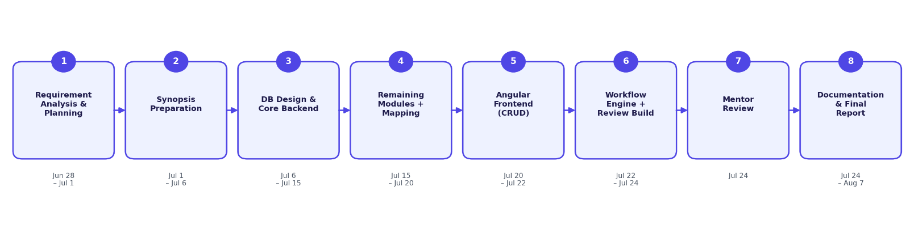
Figure 1.1: PERT Chart

  - Methodology
1.5.1 SDLC Model
The Incremental Model has been selected for the development of NexusFlow.
1.5.2 Justification for the Selection of Model
NexusFlow consists of multiple independent but interconnected modules — Authentication, Project Management, Task Management, Comments, Notifications, and Dashboard reporting. The Incremental Model allows each module to be designed, developed, and verified as a self-contained increment before the next begins, which proved directly applicable during actual development:
- Backend modules were built and tested one at a time in dependency order — Authentication first (since every other module requires it), followed by Project, Task, Comment, Notification, and Dashboard — with each module verified through Postman before the next began.
- The frontend followed the same incremental pattern: Auth and Dashboard were built and confirmed working end-to-end against the live API before Projects, then Tasks, then Comments and Notifications were added on top.
- This structure meant that even mid-way through development, a fully working (if smaller) system existed at every stage — useful given the fixed academic submission deadlines for Synopsis, Chapters 1–2, Chapters 3–4, and the Final Report.
- Defects were caught early and locally: for example, an AutoMapper registration error and a task-comment-count bug were each isolated to a single increment rather than requiring a search across the whole codebase, because only one module was under active change at a time.
- The Task Workflow Engine itself (Phase 6) was added as a further increment on top of the already-working CRUD system, without modifying any existing table or breaking any working endpoint: three additive database columns (AssignmentNote, a discriminated Type column on Comments, and a nullable RelatedTaskId on Notifications) and a set of new, narrowly-scoped endpoints were layered on top of the existing schema and services, reusing an audit-log table that had existed since the first migration but was previously unused. This is the incremental model in its most direct sense — extending, not rewriting.

Chapter 2: Software Analysis & Software Requirement Specification
2.1 Feasibility Study
2.1.1 Technical Feasibility
NexusFlow uses a mature, well-documented technology stack (ASP.NET Core, Angular, SQL Server) with extensive official documentation and community support. All required tools — Visual Studio 2022 Community, .NET 10 SDK, Node.js, Angular CLI, SQL Server Developer Edition, and SSMS — are freely available for student use. The technology stack was learned progressively through a structured five-week training curriculum prior to development, and the incremental development approach (Section 1.5.2) allowed technical risk to be addressed one module at a time rather than all at once. This is no longer a purely theoretical assessment: the Review Build (Release Candidate v1.0), including the full task workflow, was built, run locally, and demonstrated to the Project Guide, confirming the stack's feasibility in practice rather than on paper. The project is therefore technically feasible within the skill level achievable during the training period.
2.1.2 Economical Feasibility
All software used in development is free for student/educational use: Visual Studio 2022 Community, SQL Server Developer Edition, Angular and its open-source ecosystem, and Postman's free tier. No paid cloud hosting, third-party APIs, or commercial licenses are required to build, run, or demonstrate the system locally. The project therefore involves no direct monetary cost.
2.1.3 Operational Feasibility
The system is accessed through a standard web browser, requiring no specialized end-user training beyond familiarity with common web application patterns (forms, dashboards, navigation menus). Role-based access control means each user type sees only the actions relevant to their role, simplifying day-to-day operation. Since the target users (small organizations, startups, and student teams) already use browser-based tools for similar purposes, adoption does not require a significant behavioural change.
2.1.4 Other Feasibility Dimensions
- Schedule Feasibility: The functional modules were scoped to fit the six-week training window (with an additional documentation period), and the actual development — including the added Task Workflow Engine phase — followed the incremental schedule in Section 1.4.1 without major slippage.
- Legal Feasibility: All frameworks, libraries, and tools used (ASP.NET Core, Angular, Entity Framework Core, AutoMapper, FluentValidation, SQL Server Developer Edition) are used under their respective free/open-source or free-for-development licenses, with no legal or licensing obstacles to development or academic submission.

2.2 Description of Information System (Block Diagram)
The diagram below illustrates the end-to-end flow of a typical request through NexusFlow — from the user's action in the Angular UI, through JWT authentication and FluentValidation checks, into the Application service layer, through Entity Framework Core to SQL Server, and back.
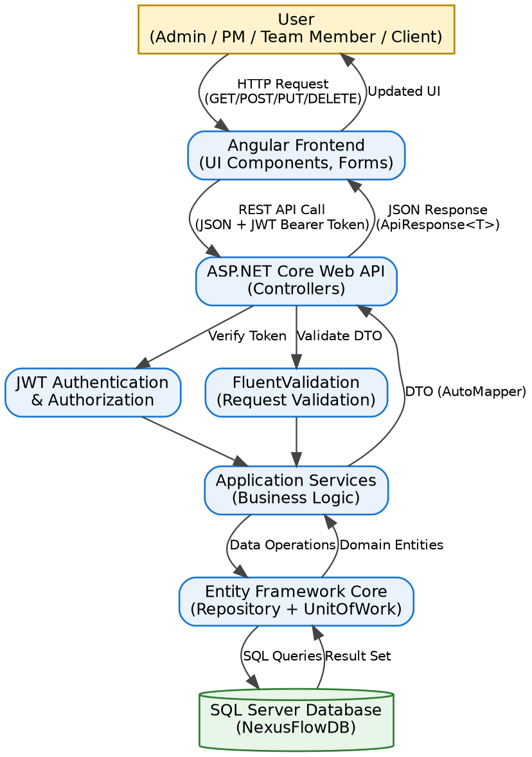
Figure 2.1: Block Diagram for NexusFlow Request Flow

2.2.1 Product Features
The following distinct processes (modules) were identified for NexusFlow:
- Authentication & Authorization — registration, login, JWT issuance/refresh, role-based access.
- User Management — listing and administering user accounts.
- Organization Management — grouping projects and users under an organization entity.
- Project Management — create, read, update, delete (CRUD) operations on projects, including status lifecycle and automatically-calculated completion progress.
- Task Management — creation, priority levels, due dates, multi-assignee support, and an Assignment Note captured at assignment time.
- Task Workflow Engine — status-transition actions — Accept Task and Update Status (optionally logging a Work Log note) — gated by whether the caller is the task's assignee, its creator, or a Project Manager/Admin.
- Clarification Exchange — an assignee may Request Clarification on a task; only its creator or a Project Manager/Admin may Respond — both stored as typed entries in the same Comment table.
- Activity Timeline — a chronological, automatically-written audit trail (created, assigned, accepted, clarification requested/added, status changed) surfaced per task.
- Notification — automatic, clickable alerts on events such as task assignment, carrying a reference back to the related task, with read/unread tracking.
- Dashboard & Reporting (mandatory Report Generation module) — aggregated statistics (total/active projects, task counts by status, unread notifications), a personal “My Tasks” view, project completion progress, and a recent activity feed.

2.2.2 Input / Output Data Elements
Input / Output | Data Elements
Register Request (Input) | FullName, Email, Password, ConfirmPassword, PhoneNumber
Login Request (Input) | Email, Password
Auth Response (Output) | UserId, FullName, Email, Role, AccessToken, RefreshToken, AccessTokenExpiry
Create Project (Input) | Name, Description, StartDate, EndDate, OrganizationId
Project Details (Output) | Id, Name, Status, StartDate, EndDate, MemberCount, TaskCount, CompletedTaskCount, CreatedAt
Create Task (Input) | Title, Description, Priority, DueDate, ProjectId, AssigneeIds, AssignmentNote
Task Details (Output) | Id, Title, Status, Priority, ProjectName, AssigneeNames, CommentCount, SubTaskCount, AssignmentNote
Accept Task (Input) | TaskId (route parameter only — no request body)
Request Clarification (Input) | Message
Clarification Response (Input) | Message
Update Task Status (Input) | Status, Note (optional work-log text)
Create Comment (Input) | Content, TaskId
Comment Details (Output) | Id, Content, UserName, CreatedAt, Type (Comment / Clarification / ClarificationResponse / WorkLog)
Task Activity (Output) | Action, OldValue, NewValue, UserId, UserName, CreatedAt
Notification (Output) | Id, Title, Message, Type, IsRead, CreatedAt, RelatedTaskId
Dashboard Stats (Output) | TotalProjects, ActiveProjects, TotalTasks, CompletedTasks, PendingTasks, InProgressTasks, UnreadNotifications, RecentActivities
Table 2.1: Input/Output Data Elements
2.2.3 Procedures / Rules / Mathematical Relationships
- The following business rules govern how NexusFlow converts input into output:
- Password Security Rule: Passwords are never stored in plain text. On registration, Password is transformed via BCrypt.HashPassword() into PasswordHash before persistence; on login, the supplied password is checked with BCrypt.Verify() against the stored hash.
- Token Expiry Rule: AccessTokenExpiry = CreatedAt + 60 minutes; RefreshToken.ExpiresAt = CreatedAt + 7 days. A refresh request issued after the refresh token's expiry is rejected with HTTP 401.
- Task Status Transition Rule: A newly created task always starts at Status = Todo, regardless of what the client requests. From there, status changes only through two authorized paths: Accept Task (Todo → InProgress, assignee only) and Update Task Status (caller-supplied status, restricted to the task's creator, its assignees, or a Project Manager/Admin). The current build does not yet enforce which specific transitions are legal beyond this permission check — this is a documented limitation (Chapter 4).
- Clarification Rule: Request Clarification is permitted only for a task's assignee; Respond to Clarification is permitted only for the task's creator or a user whose global Role is Admin or ProjectManager. Both are persisted as Comment rows distinguished by Type (Clarification / ClarificationResponse) rather than in a separate table.
- Work Log Rule: If a Note is supplied with an Update Task Status request, it is persisted as a Comment row with Type = WorkLog, preserving a running history of progress notes rather than overwriting the task's Description.
- Activity Logging Rule: Every workflow action (task creation, assignment, acceptance, clarification requested/added, status change) writes one row to the AuditLog table — EntityName, EntityId, Action, OldValue, NewValue, UserId, CreatedAt — read back by the Task Activity endpoint in chronological order to render the Activity Timeline. No workflow event is ever edited in place.
- Notification Trigger Rule: A Notification row (Type = TaskAssigned) is automatically created for every user listed in AssigneeIds at the moment a task is created, and carries a RelatedTaskId so the frontend can navigate directly to that task when the notification is clicked.
- Dashboard Aggregation Formulas: ActiveProjects = COUNT(Projects WHERE Status = Active); CompletedTasks = COUNT(Tasks WHERE Status = Done); InProgressTasks = COUNT(Tasks WHERE Status = InProgress); PendingTasks = COUNT(Tasks WHERE Status = Todo); UnreadNotifications = COUNT(Notifications WHERE UserId = current user AND IsRead = false).
- Project Progress Rule: CompletedTaskCount and TaskCount are computed per project (CompletedTaskCount = COUNT(Tasks WHERE ProjectId = p.Id AND Status = Done)) and returned on both the project list and single-project endpoints, driving the progress bar shown on the Dashboard, Project Cards, and Project Details screen.
- Soft Delete Rule: Delete operations never remove a database row; they set IsDeleted = true. All read queries implicitly filter WHERE IsDeleted = false, preserving an audit trail.
2.2.4 Decision Table
The table below summarizes which of the four user roles may perform each key action (Y = allowed, N = not allowed):
Action | Admin | Project Manager | Team Member | Client
Create / Edit / Delete Project | Y | Y | N | N
Assign Task to a User | Y | Y | N | N
Accept Task ¹ | N | N | Y | N
Request Clarification ¹ | N | N | Y | N
Respond to Clarification ² | Y | Y | N | N
Update Task Status ² | Y | Y | Y | N
Add Task Comment | Y | Y | Y | N
View Activity Timeline | Y | Y | Y | N
View Dashboard / Reports | Y | Y | Y | Y
Manage Users | Y | N | N | N
Table 2.2: Role-Based Decision Table
¹ Also requires the acting user to be an assignee of that specific task, regardless of role. ² Also succeeds for the task's creator even when their role is Team Member.

2.3 Use Case Diagram
The diagram below shows the relationship between NexusFlow's four actors and the system's principal use cases, including the task-workflow actions introduced in the Review Build.
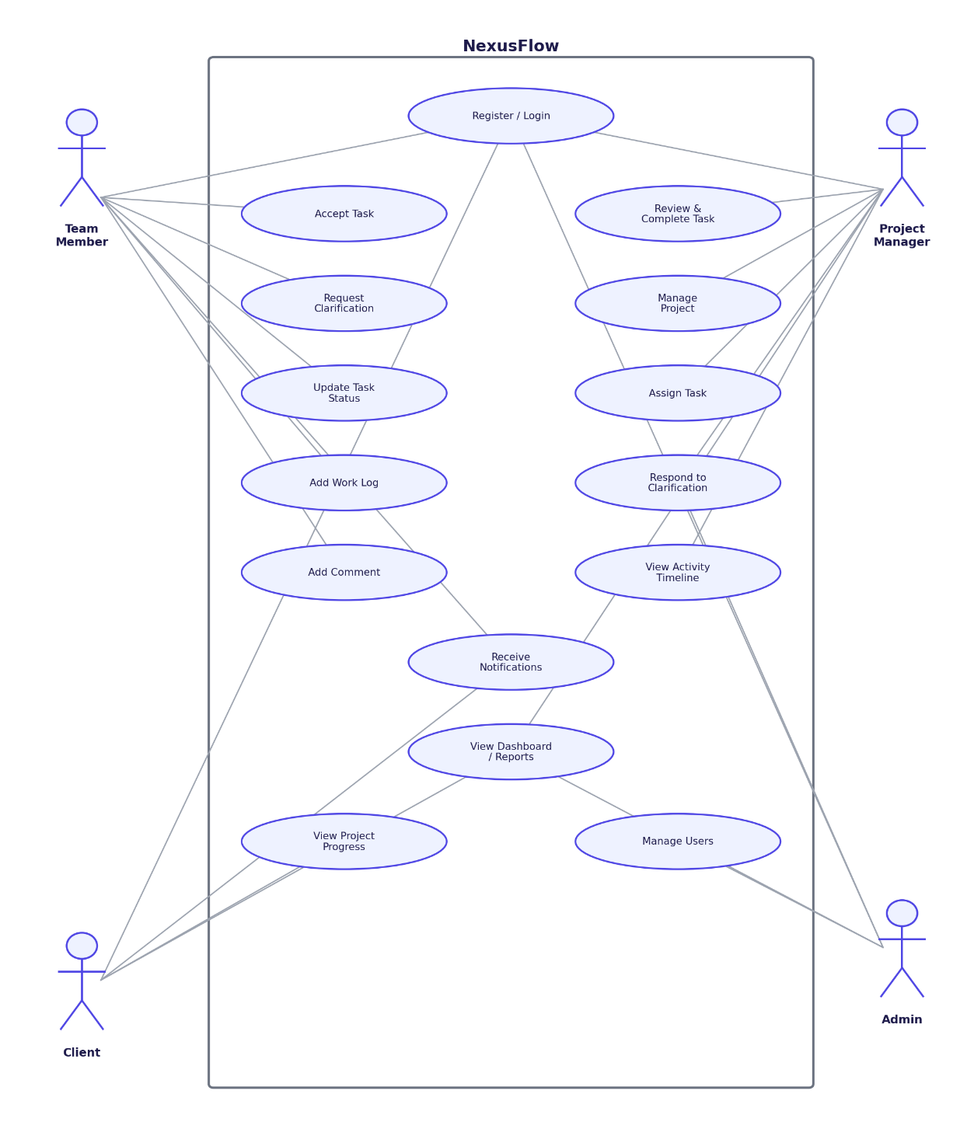
Figure 2.2: Use Case Diagram

Actor Descriptions
- Admin: Manages user accounts and organization-level settings; may also respond to clarification requests, and has full visibility into system-wide reports.
- Project Manager: Creates and manages projects, assigns tasks, responds to clarification requests, reviews and completes tasks, and monitors the Activity Timeline.
- Team Member: Registers/logs in, accepts assigned tasks, requests clarification when needed, updates task status with optional work-log notes, comments, and receives clickable notifications.
- Client: Views project progress and reports and receives status notifications, without edit access to projects or tasks.
2.4 Software Product Constraints
- The application requires network connectivity between the Angular client and the ASP.NET Core API (both running on localhost during development); it is not designed for offline use.
- An expired JWT access token requires either a silent refresh (via the stored refresh token) or a fresh login — there is no session that persists indefinitely without one of these.
- SQL Server must be running and reachable via the connection string in appsettings.json before the API will start correctly.
- The current build assumes a single Organization context; multi-tenant organization switching is not implemented (see Future Scope).
- Notifications are delivered via on-demand polling when the notification panel is opened, not push-based real-time delivery.
- The Update Task Status action does not currently validate that a requested transition is a legal next step in the workflow (for example, Todo directly to Done) — any status value supplied by an authorized caller is accepted. This is scoped as a near-term refinement (Chapter 4).
- Read access to an individual task (GetById), and the original Update/Delete task endpoints, do not yet verify that the requesting user is a member of that task's project — only the newer workflow actions (Accept, Update Status, Clarification) enforce this. Closing this gap is prioritized ahead of any new feature work.
- The Angular 20 frontend requires a modern evergreen browser (Chrome, Edge, Firefox) with JavaScript enabled; it is not designed to support legacy browsers.

