A PROJECT REPORT
ON
“AgriTrace -- Agricultural Waste Tracking \& Recycling Platform”
SUBMITTED IN PARTIALLY FULFILLMENT OF THE REQUIREMENTS FOR
THE AWARD OF
DIPLOMA IN COMPUTER ENGINEERING

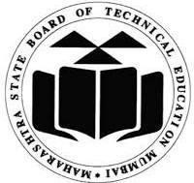
SUBMITTED TO MAHARASHTRA STATE BOAERD OF TECHNICAL EDUCATION, MUMBAI
SUBMITTED BY

Student Name 1, Student Name 2, Student Name 3, Student Name 4 | Roll No. 1, Roll No. 2, Roll No. 3, Roll No. 4
GUIDED BY
Prof. Guide Name

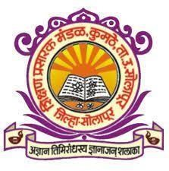

S.P.M. POLYTECHNIC KUMATHE, SOLAPUR
2025-2026
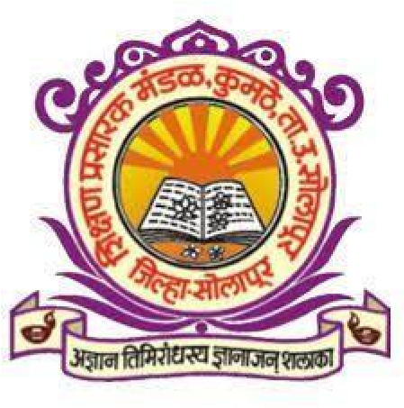
S.P.M. POLYTECHNIC KUMATHE, SOLAPUR
C E R T I F I C A T E
This is to certify that the project report entitled “AgriTrace -- Agricultural Waste Tracking \& Recycling Platform” was successfully completed by the student of sixth semester Diploma in Computer Engineering.

Student Name 1, Student Name 2, Student Name 3, Student Name 4 | Roll No. 1, Roll No. 2, Roll No. 3, Roll No. 4

In partial fulfilment of the requirements for the award of Diploma in Computer Engineering and submitted to the Department of Computer Engineering of S.P.M. Polytechnic Kumathe, Solapur work carried out during the period for the academic year 2025-26 as per curriculum.

Mrs. Chakre A.S. Mr. Rashinkar V.V
Project Guide HOD

Mrs. Rohini Chavan
External Examiner Principal

ACKNOWLEDGEMENT

.

PROJECT GROUP:

Student Name 1, Student Name 2, Student Name 3, Student Name 4 | Roll No. 1, Roll No. 2, Roll No. 3, Roll No. 4

