Adaptive Spatio-Temporal Traffic Surveillance for Granular Helmet-Compliance and Multi-Frame Vehicle Classification on Commodity CPUs – Part II: Results, Comparison and Conclusion
Shifali Doshi*1
*1[Designation], Department of Computer Science & Engineering, Walchand Institute of Technology, Solapur, Maharashtra, India
*Corresponding Author: [corresponding author email] | ORCID: [0000-0000-0000-0000]
ABSTRACT
This paper presents Part II of a two-part submission, reporting the quantitative results of the methodology proposed in Part I and comparing them numerically against the literature surveyed there. The learned scene classifier reaches 0.79 four-class accuracy versus a 0.49 rule-based baseline. Three architectures are benchmarked for wheel-count classification under an identical, leakage-free protocol: a custom convolutional network (0.787), a from-scratch CSPNeXt backbone (0.695), and an ImageNet-pretrained YOLOv8 classifier (0.861, selected). A seven-class helmet detector reaches 0.764 mean average precision at 0.50 intersection-over-union on held-out test data. Multi-frame majority voting reduces prediction flip-rate by 91.4% under measured real-world occlusion. Structured pruning combined with a brief fine-tuning step and INT8 quantization shrinks deployed models by 3.8 to 3.9 times at a measured accuracy retention of 0.98. Results are compared numerically against the systems surveyed in Part I, and every result that fell short of an initial expectation is reported with its diagnosed cause. The complete source code and trained weights are publicly available.
Keywords: CPU Inference, Helmet Detection, Model Quantization, Multi-Object Tracking, Scene-Adaptive Preprocessing, Vehicle Classification

I. Results and Discussion
A. Adaptive Preprocessing
The learned classifier reaches 0.79 four-class accuracy versus a 0.49 rule-based baseline. To rule out a dataset-provenance confound, the fog and rain pair was isolated from a single source dataset, holding provenance constant, and the model still achieved 0.68 accuracy against a 0.49 same-source baseline, evidence the model learns genuine weather signal rather than dataset fingerprints.
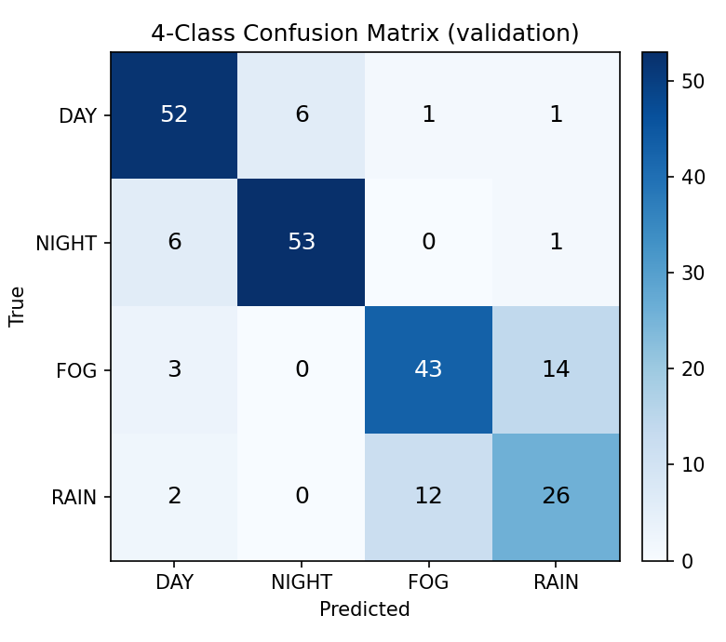
Figure 1: Four-class scene confusion matrix. Error concentrates on the fog-rain boundary, a physically overlapping condition pair.
B. Wheel-Count and Helmet Detection
Table 1. Wheel-count accuracy by architecture, leakage-free split.
Model | Accuracy | Pretrained
SmallCNN | 0.787 | No
RTMDet-CSPNeXt | 0.695 | No
YOLOv8-cls * | 0.861 | ImageNet
YOLOv8-cls was selected (0.861 accuracy), though the comparison is not pretraining-neutral, since its margin partly reflects transfer learning. After correcting an earlier crop-level split that leaked source-image information across train and validation, four-wheeler accuracy fell the most (from 0.81 to 0.70 F1), consistent with it being the most leakage-exposed class, while three-wheeler accuracy was unchanged (0.96 F1 before and after), confirming its score reflects genuine visual distinctiveness rather than a leakage or framing artifact.
The helmet detector reaches 0.764 mean average precision at 0.50 intersection-over-union on held-out test data. Passenger-helmet classes are weakest (average precision 0.545 and 0.565) due to genuinely fewer training instances. A targeted threefold oversampling fix was tested and made results worse (mean average precision falling from 0.764 to 0.711), because plain duplication adds exposure without visual diversity and causes overfitting; this negative result is reported rather than omitted.
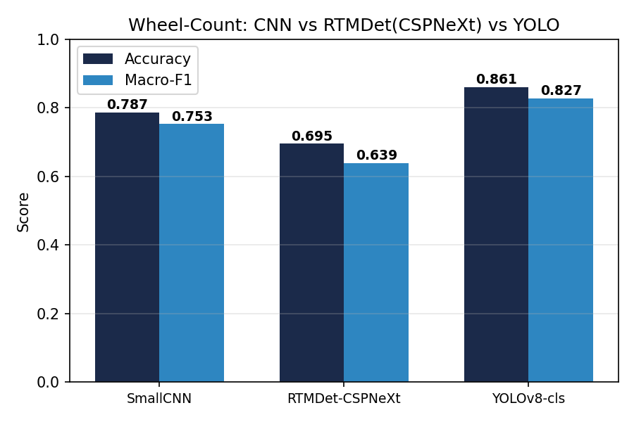
Figure 2: Wheel-count accuracy and macro-F1, leakage-free split.
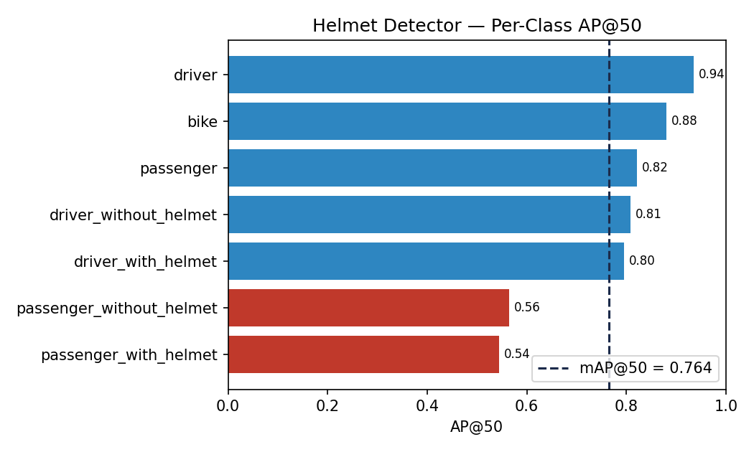
Figure 3: Per-class helmet average precision, held-out test split.
C. Tracking, Voting, and Re-Identification
Flip-rate, defined as how often the emitted label changes between consecutive frames of one tracked vehicle, fell 91.4% from a single-frame window to a thirty-frame window. Balanced accuracy improved more modestly (best at a fifteen-frame window: 0.642 versus 0.626 for a single frame), since part of the flip-rate reduction is mechanical smoothing rather than a pure accuracy gain.
On VeRi-776, off-the-shelf OSNet with no vehicle-identity metric learning applied reaches Rank-1 0.310 and mean average precision 0.095, well below fine-tuned state-of-the-art results but far above the 776-way chance level of 0.1%, confirming genuine appearance signal even without fine-tuning.
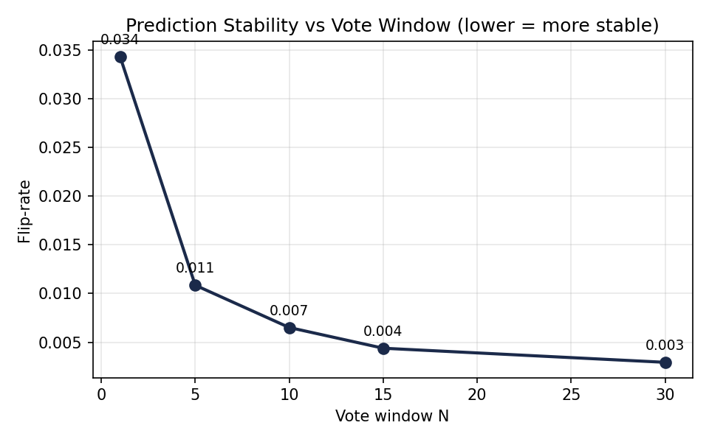
Figure 4: Prediction flip-rate versus vote window N.
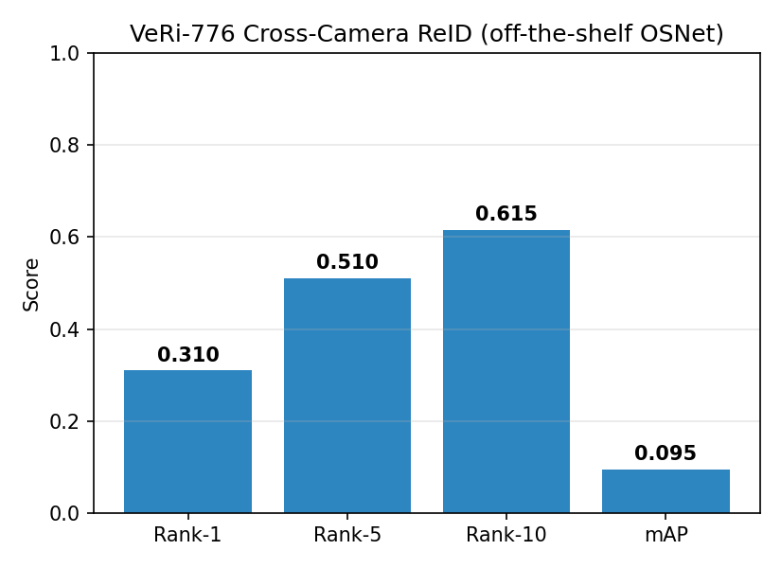
Figure 5: VeRi-776 cross-camera re-identification scores, off-the-shelf OSNet.
D. Optimization
Table 2. SmallCNN accuracy across optimization stages.
Configuration | Accuracy | Retention | Size (MB)
FP32 | 0.860 | 1.00 | 0.94
Pruned (naive) | 0.270 | 0.31 | 0.94
Pruned + fine-tune | 0.840 | 0.98 | 0.94
+ ONNX INT8 | 0.840 | 0.98 | 0.24
Thirty percent structured pruning without fine-tuning collapses accuracy to a retention of 0.31; three epochs of low-learning-rate fine-tuning restores it to 0.98. INT8 quantization is then essentially free, producing no further accuracy change, and ONNX Runtime INT8 shrinks models 3.8 to 3.9 times. Latency is not uniformly improved by ONNX at batch size one on CPU for these small models, since session overhead dominates, so the size reduction is reported as unconditional and the latency change as model-dependent.
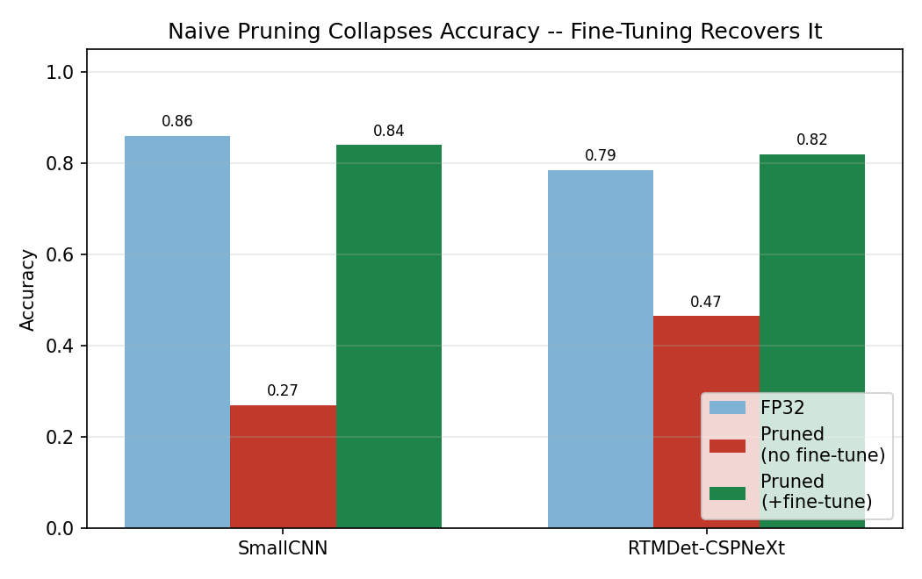
Figure 6: Naive pruning collapse versus fine-tune recovery, both benchmarked models.
II. Comparison with Existing Algorithms
Table 3 places this work's measured results against the literature surveyed in Part I, where a comparable number is available. These numbers are not evaluated on identical datasets or hardware and are reported as context for the scale of the gap or agreement, not as a like-for-like benchmark leaderboard.
Table 3. Non-identical-protocol comparison against the surveyed literature.
System | Task | Reported metric
Jia et al. [10] | Helmet detection (2-class) | 97.7% mAP
This work | Helmet detection (7-class) | 76.4% mAP@50 (test)
Anoop & Deivanathan [12] | Weather scene classification | 98.67% accuracy
This work | Weather scene classification | 79% accuracy
Chauhan et al. [9] | Vehicle classification (Indian roads) | Reported, not directly comparable
This work | Wheel-count classification (leak-free) | 86.1% accuracy
The gap on helmet detection and weather classification against Jia et al. [10] and Anoop and Deivanathan [12] respectively is explained mainly by taxonomy and dataset difficulty rather than a weaker detector: this work's seven-class taxonomy distinguishes driver from passenger and helmet status separately, a strictly harder classification problem than the two-class framing in [10], and the weather classifier here is trained and evaluated on a real, multi-source, adverse-condition dataset rather than a single controlled camera setup. Reporting the gap honestly, along with its likely cause, is preferred here over omitting the comparison or presenting the numbers as directly equivalent.
III. Conclusion
This work presented and evaluated a complete, CPU-only traffic surveillance pipeline. The learned scene classifier reaches 0.79 accuracy, the selected wheel-count classifier reaches 0.861 accuracy under a leakage-free protocol, the helmet detector reaches 0.764 mean average precision on held-out data, and model optimization recovers accuracy lost to naive pruning while shrinking deployed models 3.8 to 3.9 times. Future work includes fine-tuning the re-identification backbone on VeRi-776's own training split, sourcing data for granular helmet sub-classes not covered by the current taxonomy, and extending the per-seat helmet-violation output with a targeted gender attribute for the non-helmeted passenger, rather than a general demographics module.
REFERENCES
[1] N. Wojke, A. Bewley, and D. Paulus, “Simple Online and Realtime Tracking with a Deep Association Metric,” in Proc. IEEE Int. Conf. Image Process. (ICIP), 2017.
[2] K. Zhou, Y. Yang, A. Cavallaro, and T. Xiang, “Omni-Scale Feature Learning for Person Re-Identification,” in Proc. IEEE Int. Conf. Comput. Vis. (ICCV), 2019.
[3] X. Liu, W. Liu, H. Ma, and H. Fu, “Large-Scale Vehicle Re-Identification in Urban Surveillance Videos,” in Proc. IEEE Int. Conf. Multimedia and Expo (ICME), 2016.
[4] C. Lyu et al., “RTMDet: An Empirical Study of Designing Real-Time Object Detectors,” arXiv:2212.07784, 2022.
[5] L. Wen et al., “UA-DETRAC: A New Benchmark and Protocol for Multi-Object Detection and Tracking,” Comput. Vis. Image Understand., 2020.
[6] G. Jocher et al., “Ultralytics YOLOv8,” github.com/ultralytics/ultralytics, 2023.
[7] B. Naik et al., “HELMET: A Dataset of Helmet Use in Motorcycle Traffic,” osf.io/4pwj8, 2019.
[8] AI City Challenge, “Track 5: Detecting Violation of Helmet Rule for Motorcyclists,” aicitychallenge.org, 2023.
[9] M. S. Chauhan, A. Singh, M. Khemka, A. Prateek, and R. Sen, “Embedded CNN Based Vehicle Classification and Counting in Non-Laned Road Traffic,” in Proc. Int. Conf. Inf. Commun. Technol. Dev. (ICTD), 2019.
[10] W. Jia, S. Xu, Z. Liang, Y. Zhao, H. Min, S. Li, and Y. Yu, “Real-Time Automatic Helmet Detection of Motorcyclists in Urban Traffic Using Improved YOLOv5 Detector,” IET Image Process., vol. 15, pp. 3623–3637, 2021.
[11] T. Liang, J. Glossner, L. Wang, S. Shi, and X. Zhang, “Pruning and Quantization for Deep Neural Network Acceleration: A Survey,” Neurocomputing, vol. 461, pp. 370–403, 2021.
[12] P. P. Anoop and R. Deivanathan, “Real Time Road Scene Classification and Enhancement for Driver Assistance Under Adverse Weather,” Sci. Rep., 2025.

