**A. SALES ANALYSIS**

**1.** **Total Revenue:**

****SELECT SUM(Total_Price) AS Total_Revenue FROM [haldiram-analysis];

**2. Revenue by Category:**

SELECT Category, SUM(Total_Price) AS Revenue

FROM [haldiram-analysis]

GROUP BY Category

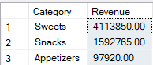ORDER BY Revenue DESC;

**3. Top 5 Products by Revenue:**

SELECT TOP 5 Product_Name, SUM(Total_Price) AS Total_Sales

FROM [haldiram-analysis]

GROUP BY Product_Name

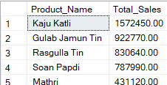ORDER BY

**B.LOCATION-BASED-ANALYSIS**

1. **City-wise Revenue:**

SELECT Store_Location, SUM(Total_Price) AS Revenue

FROM [haldiram-analysis]

GROUP BY Store_Location

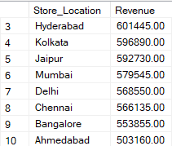ORDER BY Revenue DESC;

**2. Orders per City:**

SELECT Store_Location, COUNT(Order_ID) AS Total_Orders

FROM [haldiram-analysis]

GROUP BY Store_Location

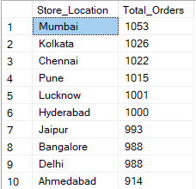ORDER BY Total_Orders DESC;

**C.Time-Based Analysis**

**1.** **Monthly Revenue:**

SELECT Month, SUM(Total_Price) AS Revenue

FROM [haldiram-analysis]

GROUP BY Month

ORDER BY Month;

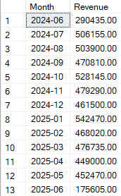

**2.Orders Trend By Months**

SELECT Order_Month, COUNT(*) AS Orders

FROM [haldiram-analysis]

GROUP BY Order_Month

ORDER BY Orders DESC;

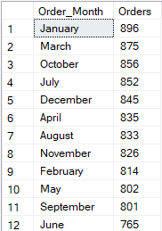

**D.Customer Rating Insights**

**1.** **Average Rating per Category:**

SELECT Category, AVG(Customer_Rating) AS Avg_Rating

FROM [haldiram-analysis]

GROUP BY Category

ORDER BY Avg_Rating DESC;

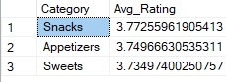

**2. Rating Category Distribution Customers:**

SELECT Rating_Category, COUNT(*) AS Total_Customers

FROM [haldiram-analysis]

GROUP BY Rating_Category;

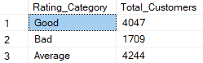

**3. Rating Category Distribution**

SELECT Revenue_Category, COUNT(*) AS Count

FROM [haldiram-analysis]

GROUP BY Revenue_Category;

